4-H Online Event Registration Instructions
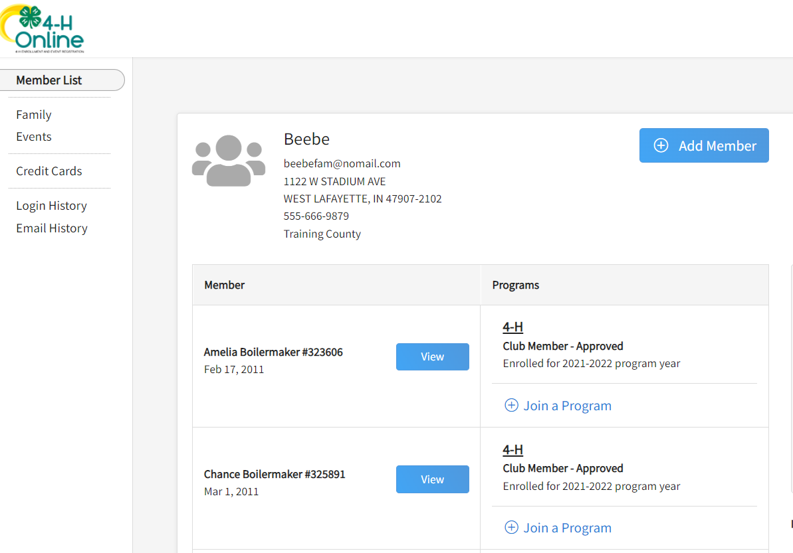
- Complete the 4-H Online login process to access your family profile and member list. Click “View” by the member you intend to register for an Event that registration has been started by your county office

- Select the Events Tab once you are in their profile and find the event that has been started for them that would be in “Incomplete” and select it.
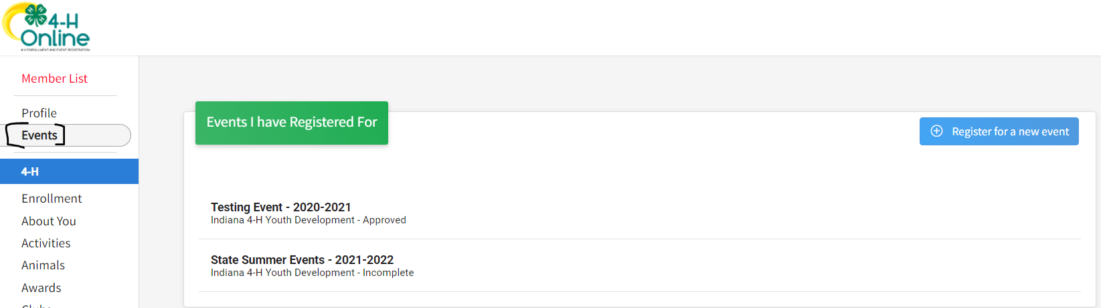

- Complete any required questions/sessions
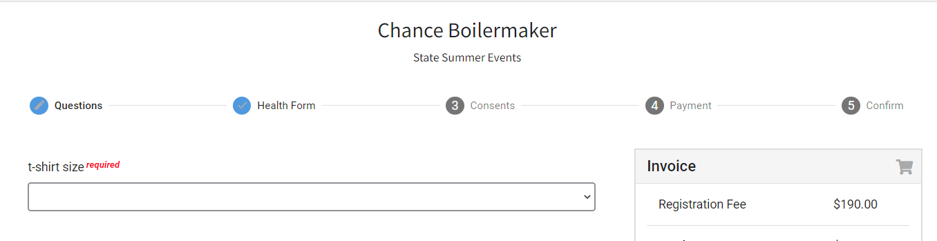
- Complete the Health Form (this is required for all summer events)

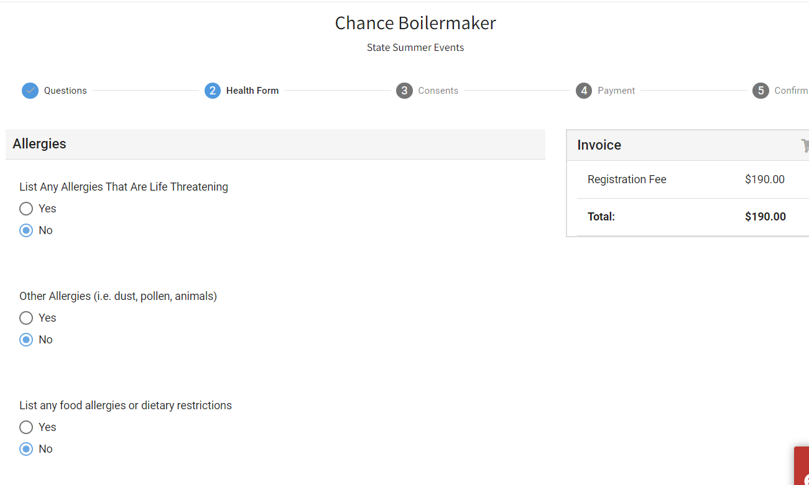
- Complete Consents
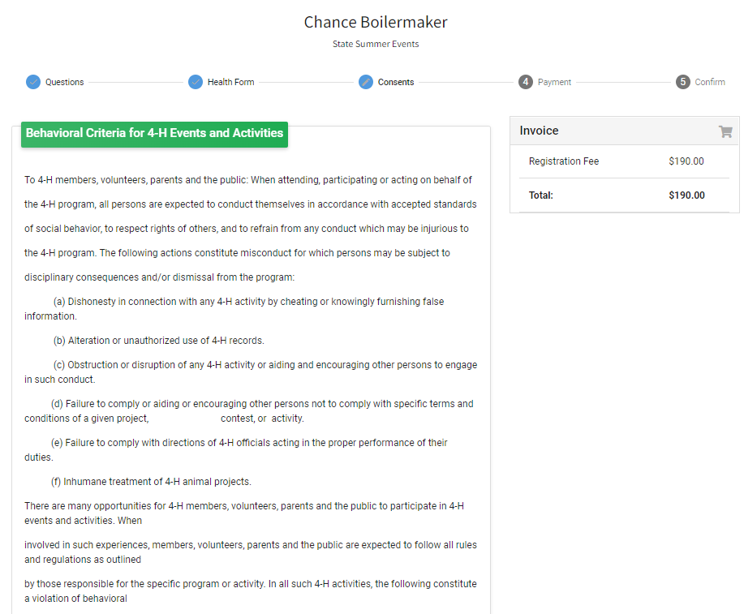
- The only allowed method of payment for these summer events is check so indicate you will pay by check and submit payment to your County Extension office.

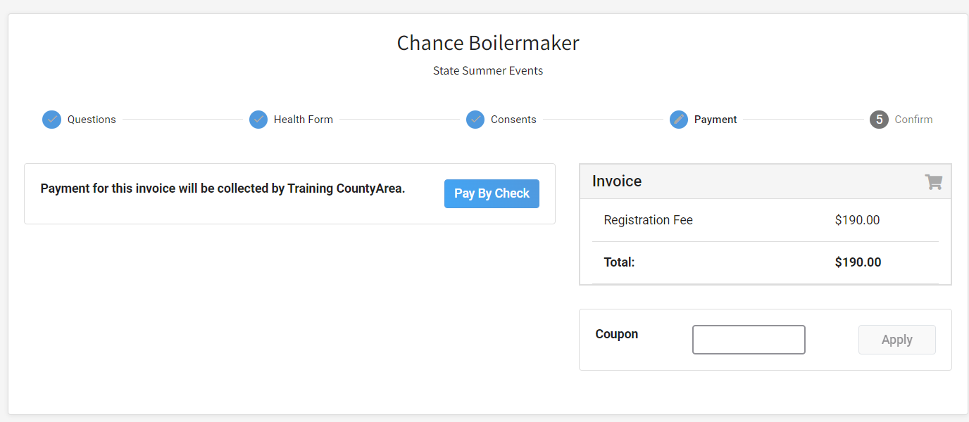
- Select Next once payment has been selected. And then Finish
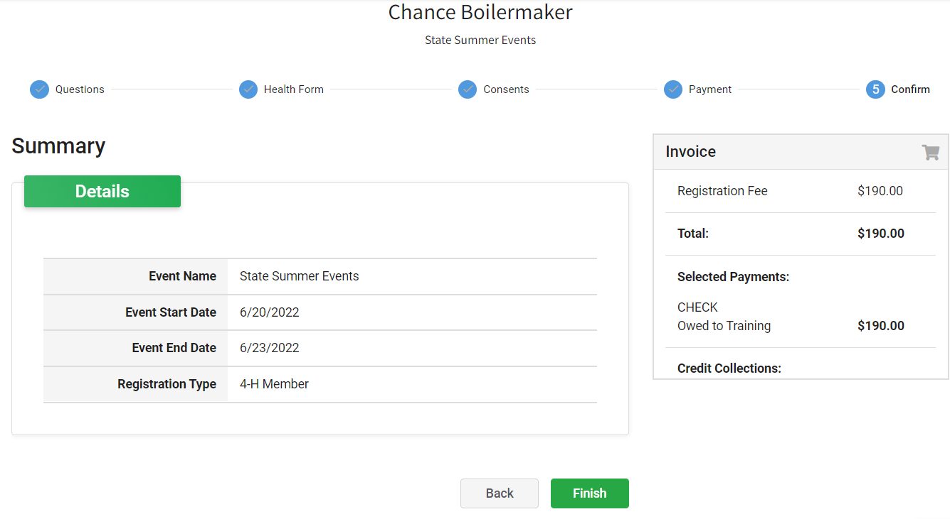
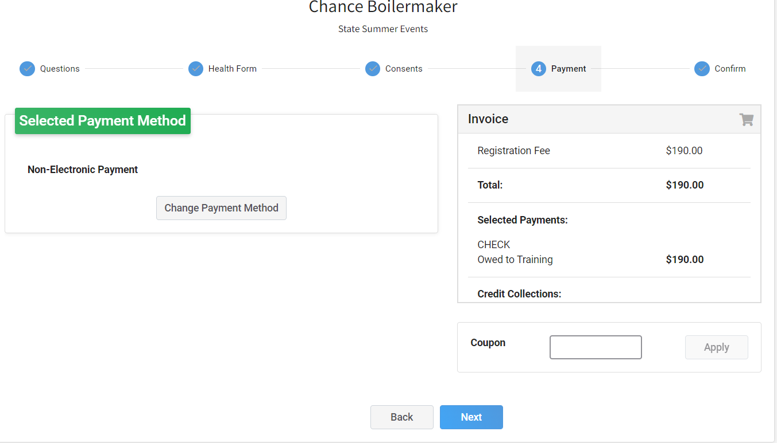
- A list of event registrations that have been submitted will appear and your county will accept your registration.

