Posey County 4-H FairEntry works in cooperation with 4-H Online, so you will use the same username and password as 4-H Online. Families will use FairEntry to pre-enter projects for the fair. This program will be used to create project labels, check in sheets, judging sheets, show programs, media reports, ribbon placings, award placings and more.

Please enter projects for the Posey County 4-H Fair by June 15. For projects by grade level you will use the grade you were enrolled in as of January 1. The 4-H projects will be listed under a specific Department. The following is a guide to help you find projects in FairEntry.

http://poseycountyindiana.fairentry.com/

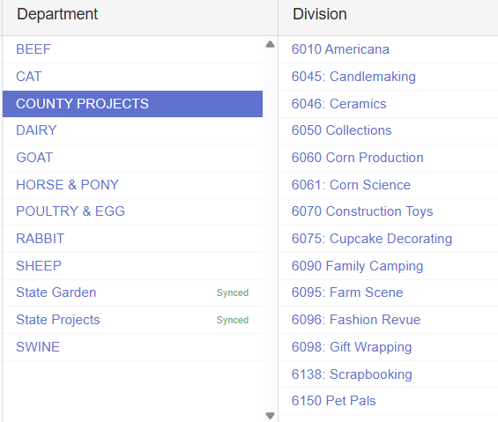

Department: County Only Projects
- Americana
- Candlemaking
- Ceramics
- Collections
- Corn Production
- Corn Science
- Construction Toys
- Cupcake Decorating
- Family Camping
- Farm Scene
- Fashion Revue (Grades 3-7)
- Gift Wrapping
- Scrapbooking
- Pet Pals
- Recycling
- Soybean Production
- Soybean Science
- Sports
- Travelogue
- Mini 4-H (Exhibit Building entries)

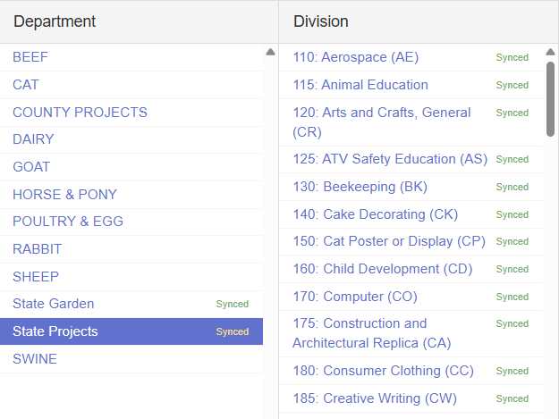
Department: State Projects
- Aerospace
- Animal Education (Beef, Dairy, Goat, Horse, Sheep, & Swine Posters)
- Arts and Crafts, General (Not Fine Arts, Model Craft, or Needle Craft)
- Beekeeping
- Cake Decorating
- Cat Poster
- Child Development
- Computer
- Consumer Clothing
- Creative Writing
- Dog Poster
- Electric
- Entomology
- Fashion Revue (Grades 8-12)
- Fine Arts
- Floriculture
- Foods, Baked
- Foods, Preserved
- Forestry
- Genealogy
- Geology
- Health
- Home Environment
- Lawn and Garden Tractor Operator Skills (Tractor Operator Contest)
- Model Craft
- Needle Craft
- Photography
- Poultry Poster
- Rabbit Poster
- Sewing Construction (Wearable and Non-Wearable)
- Small Engines
- Soil and Water Science
- Sport Fishing
- Tractor Operator Skills (Tractor Operator Contest)
- Tractor Safety Education (Ag Tractor Poster)
- Veterinary Science
- Weather and Climate Science
- Wildlife
- Woodworking
- Zero-Turn Radius Mower Operator Skills (Tractor Operator Contest)

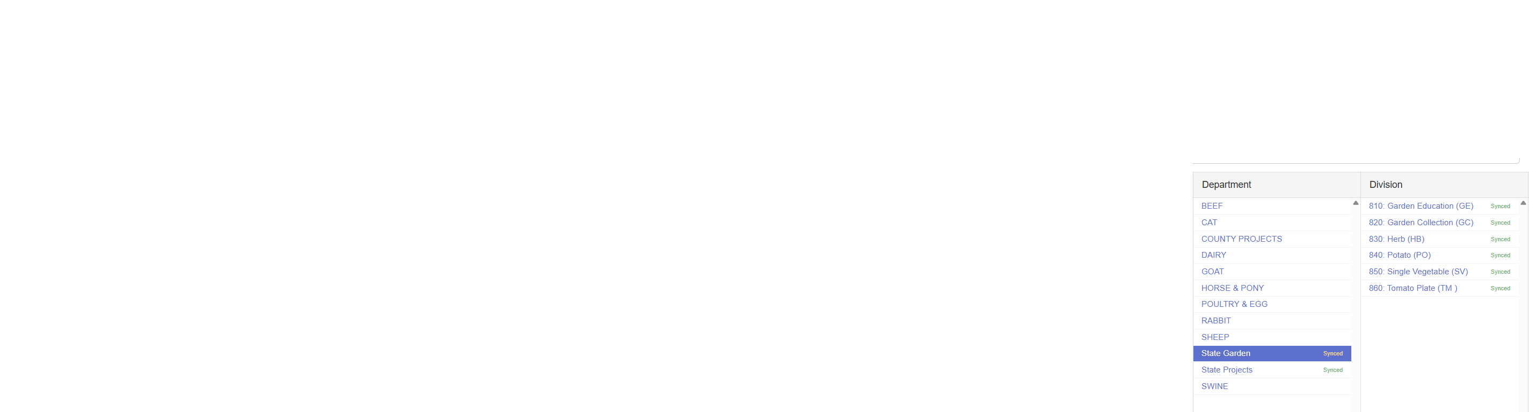

Department: State Garden
- Garden Education (Poster)
- Garden Collection
- Herb
- Potato
- Single Vegetable
- Tomato plate

Other Departments:
Beef Cattle – All classes & Mini 4-H Beef
Cat – All classes & Mini 4-H Cat
Dairy Cattle – All classes & Mini 4-H Dairy
Goats – All Classes & Mini 4-H Goat
Horse & Pony – All Classes & Mini 4-H Horse &Pony (under select Western Divisions)
Poultry & Egg – All Classes & Mini 4-H Poultry
Rabbits – All Classes & Mini 4-H Rabbit
Sheep – All Classes & Mini 4-H Sheep
Swine – All Classes & Mini 4-H Swine

