Purdue Extension Ag & Natural Resources Newsletter – October 2022
Please give me a call (812-838-1331) or send me an email at aneufeld@purdue.edu with any feedback.
Please send me events to include in the newsletter! I know I do not have a complete list and need to build a better base. Any help is greatly appreciated. Thanks!
Current Issues
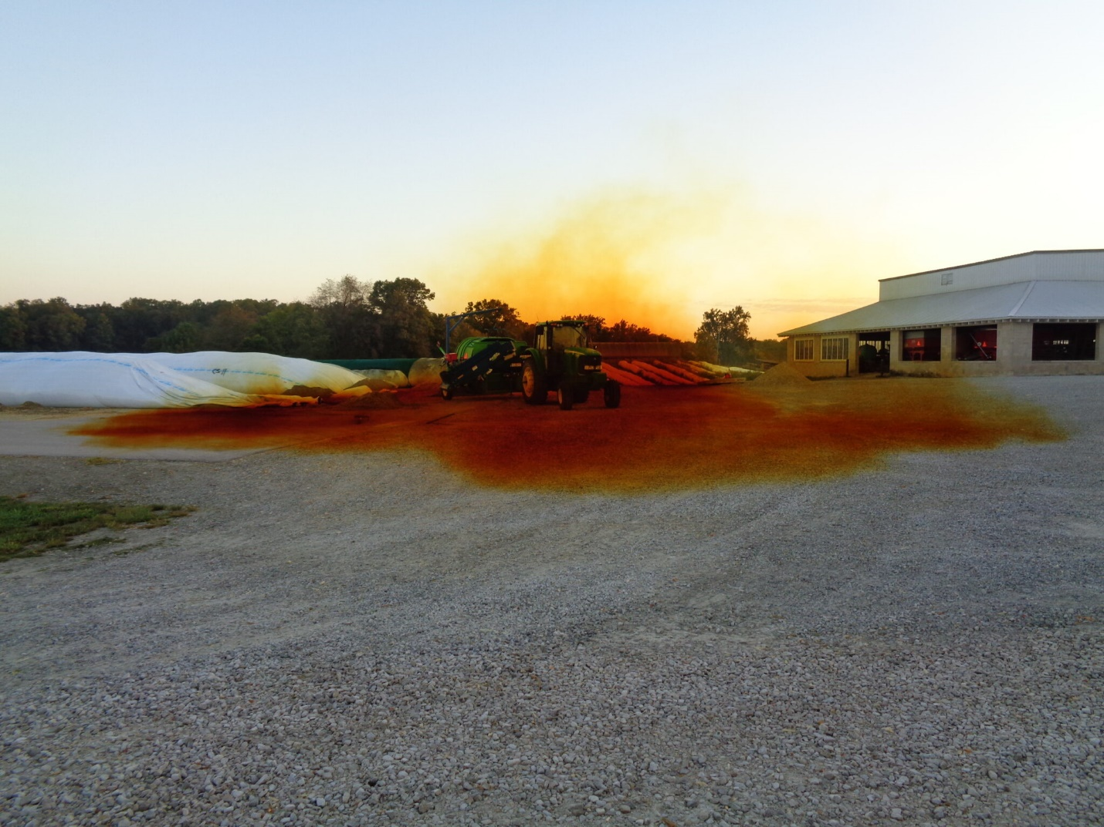
Photo credit to Keith Johnson & Brad Shelton
Dangerous silo gases- As we just concluded National Farm Safety & Health week on September 24th, I thought it would be appropriate to bring awareness to potentially deadly gases known as Silo Gases. Silo gases are released through the fermentation process of chopped forages shortly after being stored in silos or bagged. The most common gas that is produced by fermented silage is nitrogen dioxide. As pictured above, when highly concentrated it can appear yellow to reddish brown in color. Nitrogen dioxide typically peaks and starts declining about 3 days after harvesting and typically stops around 2 weeks post-harvest. Nitrogen dioxide is heavier than air so the highest concentrations will typically be found near the surface of the silage. This can pose issues as entry doors are opened and the nitrogen dioxide tries to escape as you’re walking in. Special care should be taken to educate children on this process and ensure they understand the dangers of hidden silo gas. For more information, reference this article from Penn State that details best practices for safety around freshly stored silage.
Tree Planting- On October 1st, I had the pleasure of attending a talk by Dr. Doug Tallamy about how to do our part to try and rebuild some of the ecosystem diversity that we’ve lost due to many factors. Something I learned was that planting trees, specifically Oak trees in our area is vital to protecting our caterpillars. I found it interesting that Oak trees are host to over 400 different caterpillar species, and that those caterpillars transfer more energy from plants to other animals than any other plant-eaters. I say all of that to say this, now is a great time to plant trees. If you are going to plant a tree this fall, select a balled and burlapped plant rather than a bare-root plant. Those should be saved for late winter or early spring. Plan to water about 1” per week if no rainfall and water until the ground is frozen. A 2-4” layer of mulch can help prevent wide soil temperature fluctuations. Consult page 16-17 of this planting guide for information on depth and post-planting care. If you do not have room for any more trees consider planting native landscape plants. Insects such as bees, moths, and butterflies are responsible for 90% of the pollination of our flowering plants. If you are unsure of what native plants you should be planting please contact me and I’d be happy to assist you with selecting the right plant for the correct spot.
Ag & Natural Resources Events
October 6 What's killing our trees? (Webinar)
October 8 Purdue Fencing School @ SIPAC (Dubois, IN)
October 16 Scare at the Fair (Posey)
October 18 IAA Tree Risk Assessment Qualification Course (Franklin, IN)
October 27 Small Ruminant Lunch & Learn (Hoof Care) (Webinar)
PARP Events
Nov. 2 9am-11 Knox Co.
Nov. 2 5-7 pm-Daviess Co.
Nov. 3 9-11 am Martin Co.
Nov. 3 5-7 pm-Pike Co.
PARP Events | Purdue Pesticide Programs Click this link for an updated list. They are adding more events daily. This is the most up-to-date site to find events in the state.

Standing Resources

Area Educators Have a YouTube Channel

Purdue Fast Start Program for High School Aged Youth.

Calendar of Purdue Extension Community Development Events

Pest and Crop Newsletter

Hoosier Ag Today

The Kernel-Purdue Corn Extension

Tools For Today’s Farmers podcast

Purdue Landscape Report

 | Purdue Extension – Posey County
 | 126 E 3rd St., Rm. 29 | Mt. Vernon, IN 47620
 | Phone: (812) 838-1331 | Fax: (812) 838-1353
 | Website

Unsubscribe | EEO Statement | Privacy Policy

