A P R I L - M A Y 2 0 2 2

THE EXTENSION

LINE

Bringing University information to the local level to strengthen families, spend smart, eat right, and live well.

SPRING HAS SPRUNG!
KRISTEN LOWRY

HEALTH AND HUMAN SCIENCES EXTENSION EDUCATOR
Contact: klowry@purdue.edu 812-838-1331
126 E 3rd Street, Rm. 29
Mt. Vernon, IN 47620

The birds are chirping and the days are getting longer. All a great combination to welcome spring with a smile and outdoor activities!
Take the time today to write down ten outdoor activities you would like to partake in this month. It can be anything from pulling your weeds to going on a bike ride or walking the trails at Harmony State Park. Invite a friend to join you on your adventures! Getting sunshine can increase your vitamin D intake, increase your spirits, and improve your mental health.

Parenting Forever is our extension program that will now take the place for Co-Parenting for Successful Kids. If you would like to have more information about this class, please call our office.
If you have particular topics or programs that you are interested in learning more about, please send me an email and tell me about them. I always like to hear what the community's interest is.

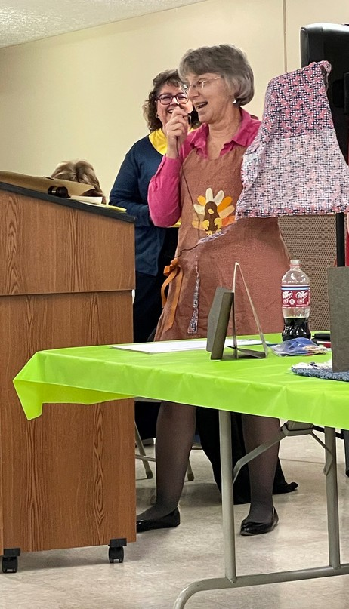
BITS FROM BETH
Good morning, homemakers!!
As I write this, we are five days away from spring! The birds are singing, the sun is rising, temperatures are in the 60s – what a day!
We are heading into a busy few weeks for Extension Homemakers in Posey County.
Achievement Night is Monday, May 2. More details will be provided when they are available, but be sure to join us as we celebrate our accomplishments of the past year. High school scholarships will be shared. We will be providing two, $500 scholarships this year, to be awarded to a child or grandchild of an Extension Homemaker. The student must be a Posey County resident. Applications are in the club secretary’s book and are due at the April Council meeting.
The Outstanding Homemaker will also be recognized at Achievement Night. Nominations are also due at the April Council meeting. I would like to have each club submit a nomination. We have so many amazing homemakers; let’s share the joy!
The President’s Luncheon will be on Tuesday, June 14, and will be held this year at Trinity UCC in Mt. Vernon. Again, details will be shared as soon as they are completed.
Our annual Indiana Extension Homemakers Association (IEHA) Conference will be held June 6-8 in Indianapolis. I will be attending, and at least one other homemaker has indicated an interest going, too. Let me know if you want to join the fun!
The Spring District Meeting was held March 8 in Washington, Indiana. We had twelve members, a guest, and our Extension Educator in attendance!! What a great day it was! We learned about upcoming IEHA programs, ate some wonderful food, and shared lots of fun and laughter! Thank you to those who shared their vintage and special aprons in our fashion show. Ladies from several other counties told me how much they enjoyed this!!
We have updated the schedule for Precious Poseys. Please let me know if there are major problems with the new schedule. And if you can’t work one of your dates, please contact Marilyn Schmitzer (812-575-9699) as soon as possible.
The fair!!! Coming soon to a location near you!! Posey County Fair is July 17-23. The delicious meals we prepare are welcomed by many in the community. Open Class allows those special talents of local residents to be showcased and recognized. This week is busy for our homemakers, but it is so much fun! Movers, Shakers, Modern Homemakers and Friendship Circle are the clubs who are “in charge” of Open Class this year, but all clubs need to send volunteers. Be watching for further information about assignments for the week. Invite friends to exhibit, and be sure they come share a meal with us!
In these times of anxiety and uncertainty, remember that we are ALL members of “. . .the greatest institution in the world: the home.” Share the joy and love of that great membership with all you meet.
Thanks to all of you for all you do to help me in any way. You are most appreciated. Beth

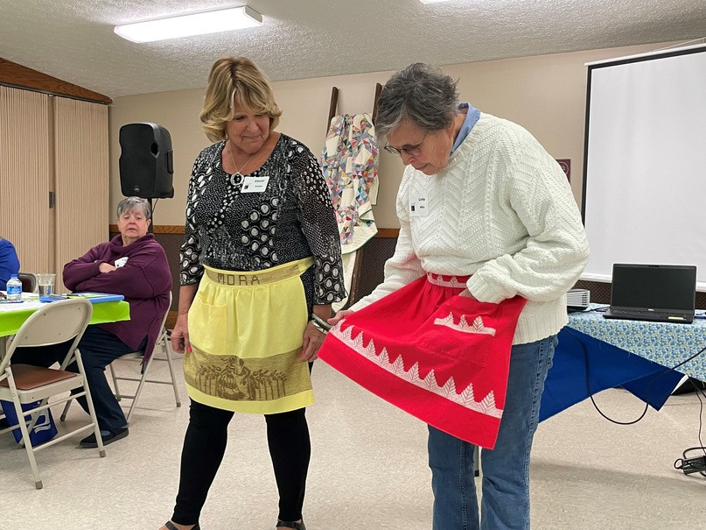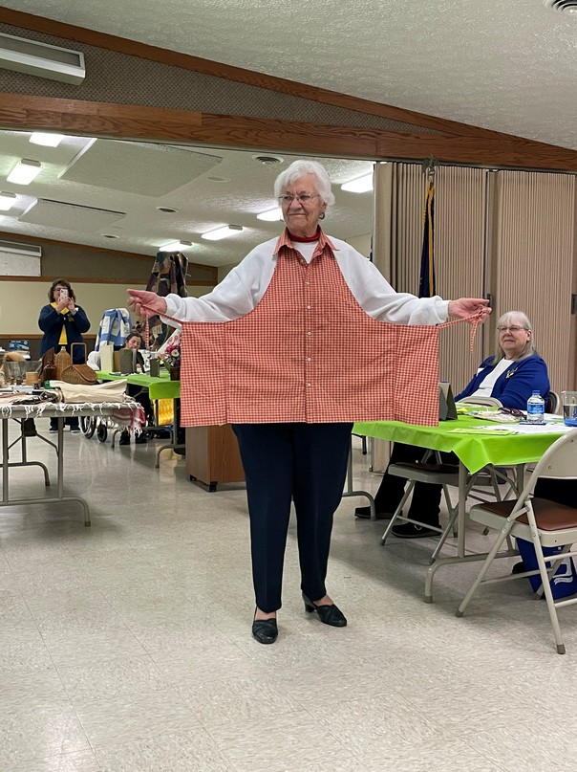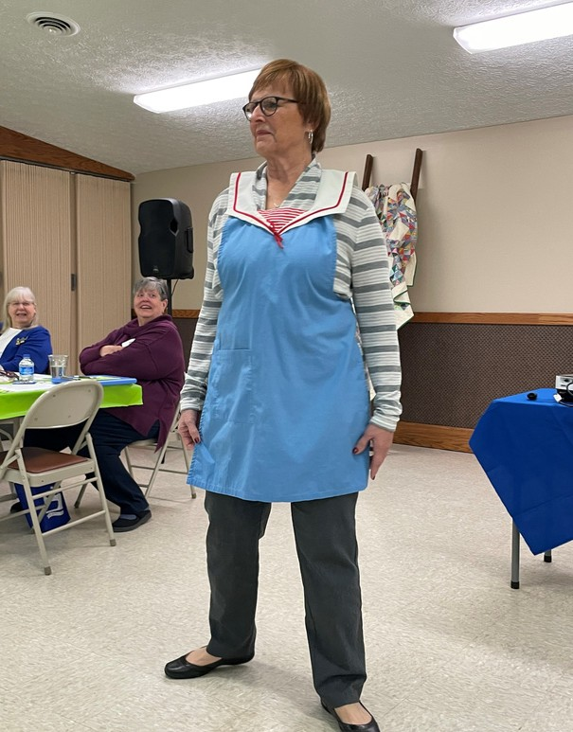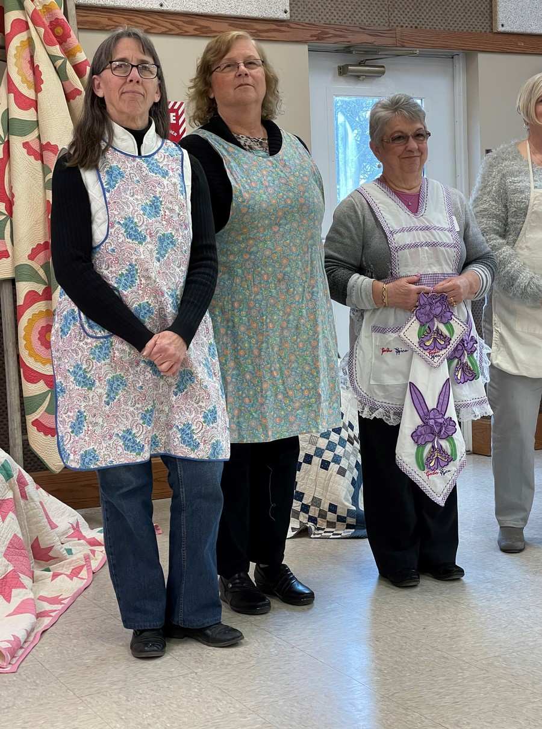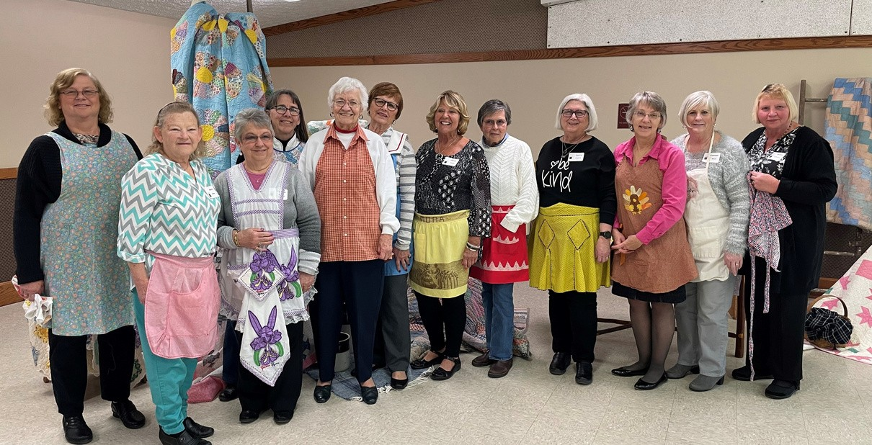
Spring District Meeting Fun
Upcoming meetings/events:

Council meeting – April 5, 2022 Achievement Night - May 3rd Posey County 4-H Fair – July 18-23
National Volunteer Outreach Network (NVON) National Conference – July 25-17. Save the date – more details later!!!!

Register by March 25th at 765-653-8411 or sampsona@purdue.edu

to partic1p.:ite 1n th, program
ampson at 765-653 8411 or sampsona@purclue.edu by Marc 25th
c_:r-' UNIVERSITY
PURDUE f,;ctn 1on Pu1na111 County
need reasonable accommodation
or 1f you

Safe & Simple
Home Food Preservation

Learn safe and simple ways to preserve food in your own home! All workshops include lecture with resources and hands-on practice

Fermenting

Mayll,2022 5:30-7:30

May 18, 2022
5:30-7:30
Jams& Jellies

Pickling

May 25, 2022
5:30-7:30

Salsa

COST: $25 per session (includes hands-on workshop and take-home product)

*scholarships available

June 1, 2022
5:30-7:30

SPACE IS LIMITED­ REGISTER TODAY!

Location: Ascension St. Vincent YMCA (516 Court St., Evansville)

To register, call Ascension St. Vincent YMCA at 812-423-9622
For more information, including scholarships, contact Meagan Brothers at 812-435-5287 or brotherm@purdue.edu

An Equal Access/Equal OpportunttyUniversity

ServSafe Food Manager
1-day Class & Examination
This class and examination is for the ServSafe Food Protection Manager certification. This certification is recognized by the State of Indiana to become a "certified food handler".
2021-2022 class and examination dates

For questions, contact your nearest

August 10, 2021
October 4, 2021
October 18, 2021
December 3, 2021

January 24, 2022
March 21, 2022
April 23, 2022
Vanderburgh County 4-H Center Daviess County 4-H Fairgrounds
Daviess County 4-H Fairgrounds *Spanish class* VU Agricultural Center, Vincennes *
*No class, exam only - 1PM ET* Gibson County 4-H Fairgrounds Daviess County 4-H Fairgrounds
Daviess County 4-H Fairgrounds *Spanish class*
Purdue Extension ServSafe Educator

Daviess County
Jennifer Stefancik, 812-254-8668

Gibson County
Andrew Hays, 812-385-3491

Knox County

June 13, 2022 VU Agricultural Center, Vincennes
All classes begin at 8:30 local time and exams begin at approximately 4PM local time unless otherwise noted. See reverse for course costs.
For more information and registration links visit:
www.purdue.edu/servsafe/workshops

You must score 75 percent or greater to earn the certificate. The certification is valid for five years. A photo ID with signature is required to take the exam (driver license, state ID, student ID, military ID, employee ID, U.S. green card, or valid passport).
Tonya Short, 812-882-3509

Vanderburgh County
Meagan Brothers, 812-435-5287

Warrick County
Jo Gilreath, 812-897-6101

or visit www.purdue.edu/servsafe

PURDUE I Extension
C, J""-' UNIVERSITY.
Purdue University is an equal access/equal opportunity institution.

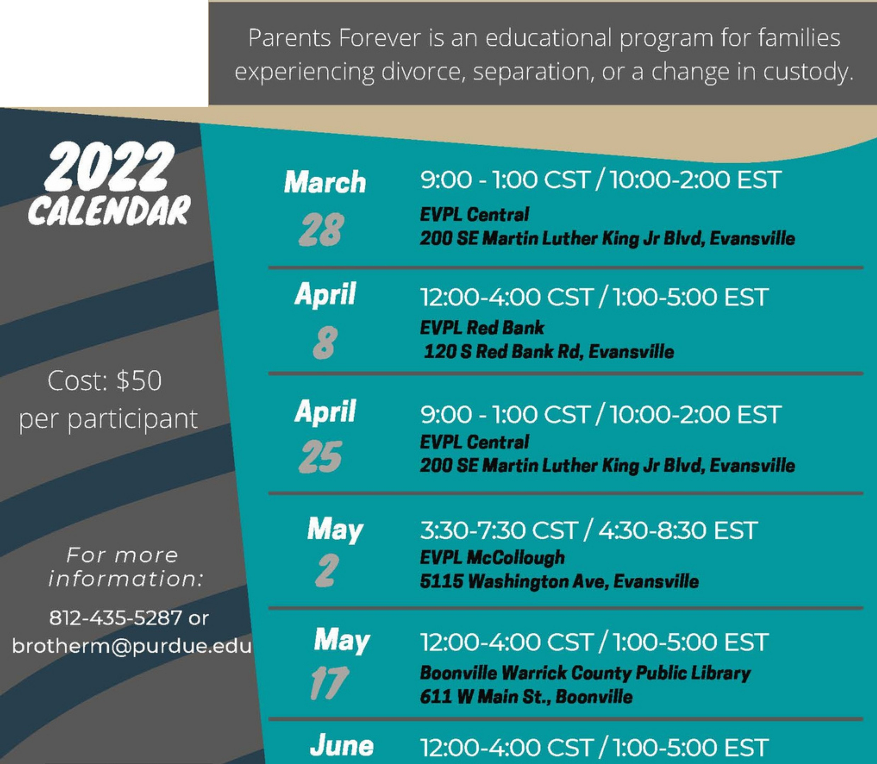
LP
PURDUE
UNIVERSITY

Purdue University is an equal access/ equal opportunity university
15
Register here: https://bit.ly/ParentsForever2022

POSEY COUNTY EXTENSION HOMEMAKERS 2022 ACHIEVEMENT NIGHT

"Thanks for the Memories"
Tribute to Domestic Doers
65 years as a club and members of the Indiana Extension Homemakers Association!!

Homemaker of the Year and High School Scholarship Awards Presentation

Date: Monday, May 2, 2022 Time: 5:30-Registration 6:00-Dinner
Location: Posey County Community Events Center Cost of Meal: $14.00
Reservations: Due by APRIL 22, 2022 Send check and RSVP to
Jaina Paciorkowski/Members on the Move 1230 Old Plank Road S
New Harmony, IN 47631 Questions?: 812-483-1821

Please remember your cultural arts items!
We enjoy seeing your gift sand talents!!

PURDUE EXTENSION-POSEY COUNTY 126 E. THIRD STREET, ROOM 29
MT. VERNON IN 47620

It is the polky of the Pufdue Unive,slty Cooperative E)(tension se,vlce that all, ersons have equal oppoflunity to its educatlOJlal programs, services, act'rvlties, and fadtltles without regard to race, religion, color, 00)(, age, national origin or ancestry, marital status, parental statlls, sexual orientation, disability or status as a veteran. Purdue University is an Affirmative Action institution.This material may be available in alternative format&,
Precious Poseys - 2022 | Second Wednesday  1-3 p.m. | Second Saturday  9-11 a.m. | Fourth Wednesday  9-11 a.m. | Club
January | 13 | 9 | 27 | Members on the Move
February | 10 | 13 | 24 | Roadrunners
March | 10 | 13 | 24 | Town & Country
April | 13 | 16 | 27 | Busy Homemakers
May | 11 | 14 | 25 | Domestic Doers
June | 8 | 11 | 22 | Friendship Circle
July | 13 | 9 | 27 | Friendship Circle
August | 10 | 13 | 24 | Busy Homemakers
September | 14 | 10 | 28 | Members on the Move
October | 12 | 8 | 26 | Roadrunners
November | 9 | 12 | 16 (3rd Wednesday) | Town & Country
December | 14 | 10 | 21 (3rd Wednesday) | Busy Homemakers

