Posey County 4-H FairEntry works in cooperation with 4-H Online, so you will use the same username and password as 4-H Online. Families will use FairEntry to pre-enter projects for the fair. This program will be used to create project labels, check in sheets, judging sheets, show programs, media reports, ribbon placings, award placings and more.

Please enter projects for the Posey County 4-H Fair by June 15. For projects by grade level you will use the grade you were enrolled in as of January 1. The 4-H projects will be listed under a specific Department. The following is a guide to help you find projects in FairEntry.

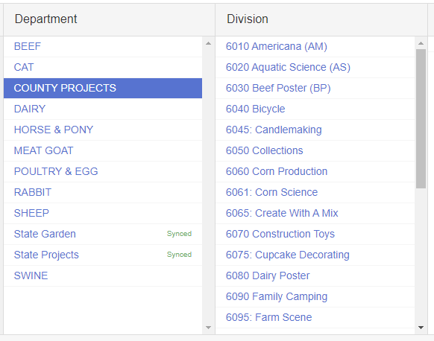
Department: County Only Projects
- Americana
- Aquatic Science
- Beef Poster
- Bicycle
- Candlemaking
- Ceramics
- Collections
- Corn Production
- Corn Science
- Create With A Mix
- Construction Toys
- Cupcake Decorating
- Dairy Poster
- Family Camping
- Farm Scene
- Fashion Revue (all grades)
- Gift Wrapping
- Goat Poster
- Horse Poster
- Scrapbooking
- Sheep Poster
- Pet Pals
- Recycling
- Soybean Production
- Soybean Science
- Sports
- Swine Poster
- Travelogue
- Mini 4-H

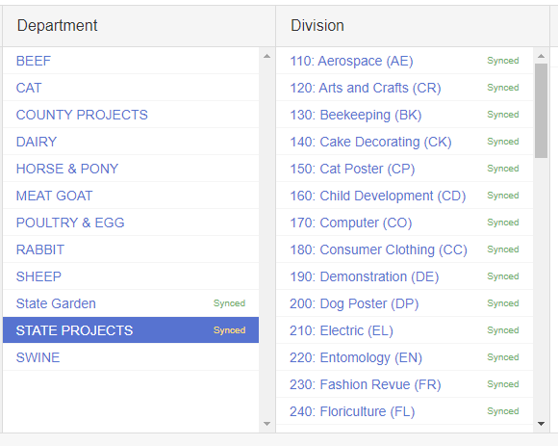
Department: State Projects
- Aerospace
- Arts and Crafts, General
  - Select this for Miscellaneous
- Beekeeping
- Cake Decorating
- Cat Poster
- Child Development
- Computer
- Consumer Clothing
- Creative Writing
- Dog Poster
- Electric
- Entomology
- Fashion Revue (Grades 8-12)
- Fine Arts
- Floriculture
- Foods, Baked
- Foods, Preserved
- Forestry
- Genealogy
- Geology
- Health
- Home Environment
- Lawn and Garden Tractor Operator Skills (Tractor Operator Contest)
- Model Craft
- Needle Craft
- Photography
- Poultry Poster
- Rabbit Poster
- Sewing Construction (Wearable and Non-Wearable)
- Small Engines
- Soil and Water Science
- Sport Fishing
- Tractor Operator Skills (Tractor Operator Contest)
- Tractor Safety Education (Ag Tractor Poster)
- Veterinary Science
- Weather and Climate Science
- Wildlife
- Woodworking
- Zero-Turn Radius Mower Operator Skills (Tractor Operator Contest)

Department: State Garden
- Education (Poster)
- Garden Collection
- Herb
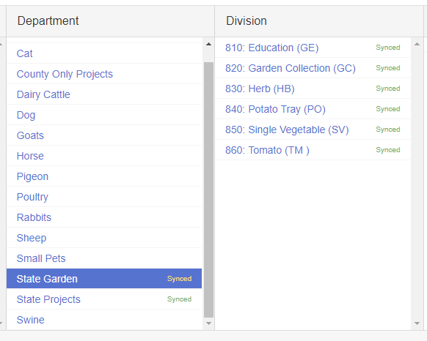
- Potato Tray
- Single Vegetable
- Tomato

Other Departments:
Beef Cattle – All classes
Cat – All classes
Dairy Cattle – All classes
Meat Goats – All Classes
Horse & Pony – All Classes
Poultry & Egg – All Classes
Rabbits – All Classes
Sheep – All Classes
Swine – All Classes

