|  |  |  |
| --- | --- | --- |
| Clover Connection | | |
| Nov/Dec 2021 | | |
| Posey County | | |
| Purdue Extension | | |
| Dear Posey County 4-H Families,  Welcome to all new 4-H members! If this is your first time receiving this newsletter, please read over it carefully. This will be an important source of information in the upcoming year. If you have any questions, please reach out to the Purdue Extension-Posey County office or your club leaders.  4-H updates will be shared via newsletters and emails from 4-H Online. There will be changes to many 4-H projects this year, so be on the look out for these guidelines. For state projects, visit <https://extension.purdue.edu/4-H/>. Click on the ‘projects’ tab at the top of the page to find a full list of projects. There will be no new projects added this year. Please note that some projects have been removed from our program or guidelines have been adjusted. More details on these changes are discussed further in this newsletter.  Feel free to reach out to me with any questions!  Sincerely,  Amanda Bender  Extension Educator  4-H Youth Development  [bender14@purdue.edu](mailto:bender14@purdue.edu) |  | Newsletter at a glance:   * Upcoming dates—page 2 * Now Hiring—page 3 * 4-H Enrollment—page 4 * Scholarships/Trips—page 4 * Jr. Leaders—page 5 * Mini 4-H—page 6 * 4-H Council—page 7 * Project changes—page 8 * Animal ID—page 9 |
| Contact the office with any questions: 812-838-1331 or [bender14@purdue.edu](mailto:bender14@purdue.edu) |  |

# UPCOMING DATES

|  |
| --- |
| **November 2021**  Nov. 9: Extension Board Annual Meeting  Nov. 11: Junior Leader Meeting  Nov. 16: 4-H Achievement Banquet |
| **December 2021**  Dec. 2: 4-H Council Meeting  Dec. 9: Mini 4-H & Junior Leader Meeting |
| **January 2022**  Jan. 6: 4-H Council Meeting  Jan. 15: 4-H Enrollment Deadline  Jan. 25: Trip & Scholarship Applications Due |
| **February 2022**  Feb. 1: 4-H Club Financial Reports due to Extension Office  Feb. 3: 4-H Council Meeting  Feb. 10: Mini 4-H & Junior Leader Meeting  Feb. (TBD): 4-H Club Leader Meeting |
| **March 2022**  Mar. 2: 4-H Council Meeting  Mar. 10: Junior Leader Meeting  Mar. 16: YQCA Training  Mar. (TBD): Club Officer Training |
| **April 2022**  Apr. 7: 4-H Council Meeting  Apr. 14: Mini 4-H Event & Junior Leader Meeting  Apr. 16: YQCA Training  Apr. (TBD): Share-the-Fun |
| **May 2022**  May 5: 4-H Council Meeting  May 12: YQCA Training & Junior Leader Meeting  May 15: Animal ID Deadline & Add/Drop Deadline  May (TBD): 4-H Club Leader Meeting |
| **June 2022**  June 2: 4-H Council Meeting  June 6-8: 4-H Camp  June 9: Mini 4-H Event & Junior Leader Meeting  June 16: YQCA Training  June (TBD): Public Speaking Contest |
| **July 2022**  July 1: YQCA deadline  July 18-23: Posey Co. Fair |

*Please note:* ***Dates are subject to change****. Junior Leader Meetings, 4-H Council Meetings, Mini 4-H and YQCA are held at the Posey County Community Event Center on the Fairgrounds unless otherwise notified.*

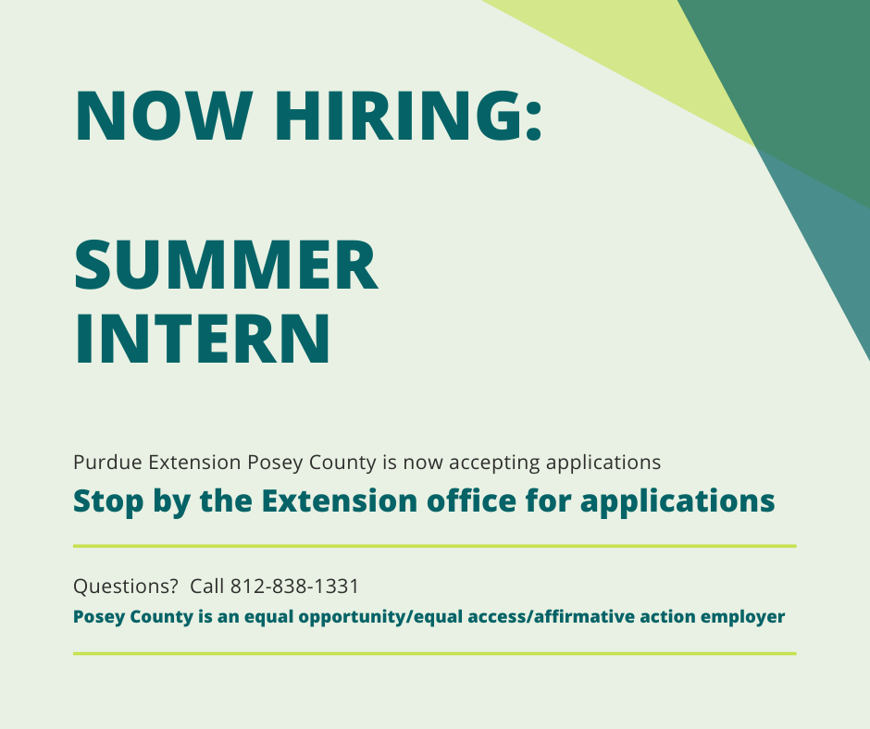



As more events and important dates are scheduled, be sure to check:

* Email
* Extension website <https://extension.purdue.edu/posey>
* [Purdue Extension-Posey County Facebook page](https://www.facebook.com/purdueextension.poseycounty)

Find us on Facebook at:

[“Purdue Extension-Posey County”](https://www.facebook.com/purdueextension.poseycounty)

# 4-H Enrollment

Parents can go to 4H Online (<https://v2.4honline.com>)

Enroll/Re-Enroll youth in 4-H for 2022

**Starts:** October 1, 2021

**Ends**: January 15, 2022

**Certificated adult volunteers** need to go into 4-H Online to re-enroll as an adult volunteer and to sign your 2022 Adult Behavior Expectations by January 15.

If you do not have internet access, please contact the Extension Office (812-838-1331) so we can help!

**Scholarship Applications & Trip Dates**

Scholarship applications are due **January 25**. Submit applications via 4-H Online. For scholarship information, visit: <https://extension.purdue.edu/4-H/get-involved/scholarships.html>

4-H Camp: June 6-8, 2022

4-H Academy: June 8-10, 2022

4-H Round Up: June 20-22, 2022

More information to come!

4-H Camp Counselors

Be on the look out for more information about applications in the upcoming newsletters and emails.

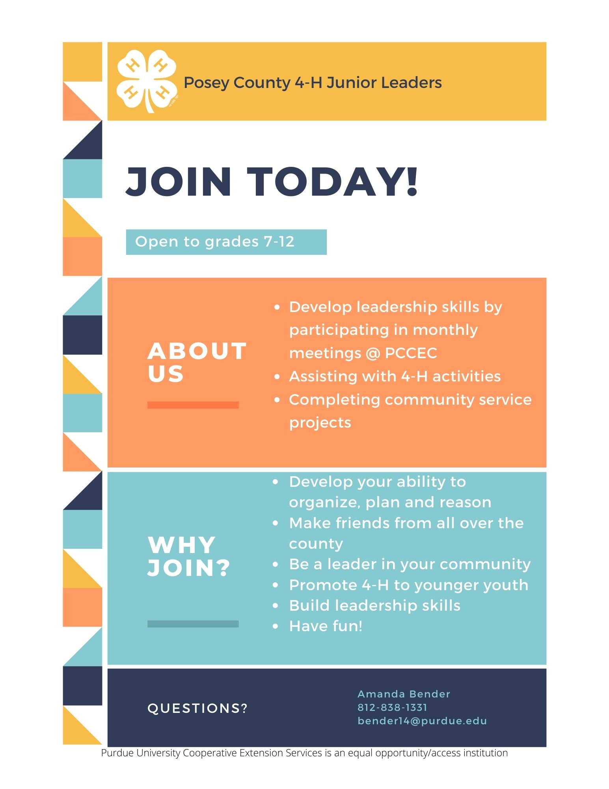The next Junior Leader meeting is November 11 @ 7pm. Officer Elections will take place at this meeting. Be sure to attend!

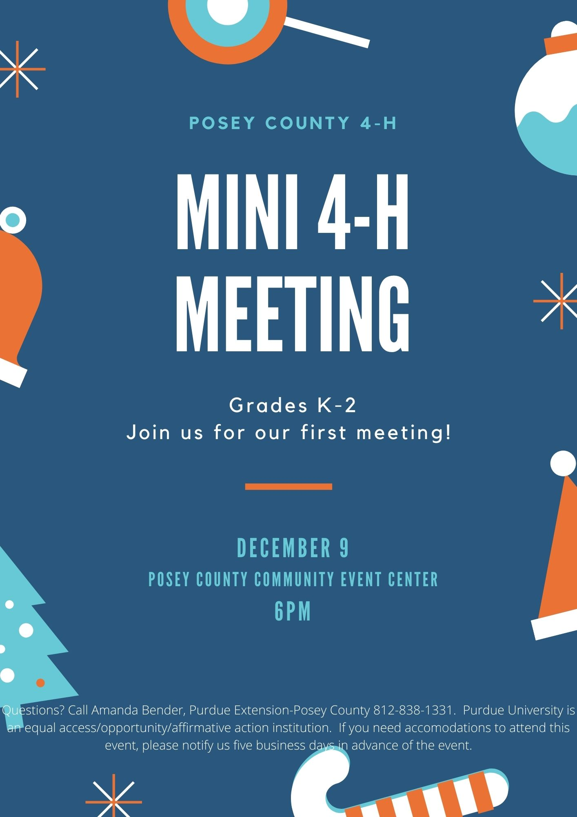

# Posey County 4-H Council Application

The Posey County 4-H Council is seeking members to join their board. If you have any questions, please reach out to the Extension Office or 4-H Council President, Chris Woods.

If you are interested or would like to nominate someone, fill out the application and return to:

Purdue Extension-Posey County

126 E. Third St. Room 29

Mt. Vernon, IN 47620

Email: [bender14@purdue.edu](mailto:bender14@purdue.edu)

Name:

Address:

City: State Zip Code:

Phone: Email:

4-H Affiliation (Parent, Alumni, etc.):

*It is the policy of the Purdue University Cooperative Extension Service that all persons have equal opportunity and access to its educational programs, services, activities, and facilities without regard to race, religion, color, sex, age, national origin or ancestry, marital status, parental status, sexual orientation, disability or status as a veteran. Purdue University is an Affirmative Action institution. This material may be available in alternative formats.*

# 4-H Project Update

*Many changes have been made to all state projects. The following list will be the updated changes as seen on 4-H Online for Posey County. The handbook will reflect these changes.*

*4-H Online will be where youth select general projects. Fair Entry will be where youth specify exactly what they will exhibit at the Fair.*

Aerospace: State guidelines have changed.

Americana: Name change on 4-H Online to “County Project-Americana”

Aquatic Science: Name change on 4-H Online to “County Project-Aquatic Science”

Animal Posters: Name change on 4-H Online to “Animal Education”. State guidelines changed. Beef, Dairy, Goat, Horse, Sheep are still county only projects.

Arts & Crafts:

* Name change on 4-H Online to “Arts & Crafts, General” select this for basic crafts such as candle making, ceramics, miscellaneous. State guidelines changed.
* Name change on 4-H Online to “Fine Arts” select this for Arts & Crafts: Fine Arts. State guidelines changed.
* Name change on 4-H Online to “Needle Craft” select this for Arts & Crafts: Needle Crafts. State guidelines changed.
* Name change on 4-H Online to “County Project-Gift Wrapping”. Select this for gift wrapping.

Beekeeping: State guidelines changed.

Bicycle: No guideline changes.

Cake Decorating: State guidelines changed.

Child Development: State guidelines changed.

Collections: Name change on 4-H Online to “County Project-Collections”

Computer: State guidelines changed.

Construction Toys: Moved under new name “Construction & Architectural Replica” State guidelines apply.

Consumer Clothing: Guidelines to come sometime in January 2022.

Corn Production: Name changed on 4-H Online to “County Project-Crops”

Corn Science: Name change on 4-H Online to “County Project-Crops”

Creative Writing: Moved under new name “Communications” State guidelines changed.

Creating with a Mix: Name change on 4-H Online to “County Project-Creating with a Mix”

Cupcake Decorating: Name change on 4-H Online to “County Project-Cupcake Decorating”

Electric: State guidelines changed.

Entomology: State guidelines changed.

Family Camping: Name change on 4-H Online to “County Project-Family Camping”

Farm Scene: Moved under new name “Construction & Architectural Replica”. State guidelines apply.

Fashion Revue: State guidelines changed.

Floriculture: State guidelines changed.

Foods: State guidelines changed. Foods Baked and Food Preserved are under “Foods”

Forestry: State guidelines changed.

Garden: State guidelines changed.

Geology: State guidelines changed.

Genealogy: State guidelines changed.

Health: State guidelines changed.

Home Environment: State guidelines changed.

Junior Leaders: same

Models: Name change to “Model Craft”. State guidelines changed.

Pet Pals: Name change on 4-H Online to “County Project-Pet Pals”

Photography: State guidelines changed.

Recycling: Name change on 4-H Online to “County Project-Recycling”

Scrapbooking: Name change on 4-H Online to “County Project-Scrapbooking”

Sewing: State guidelines changed. Wearable and Non-wearable are both under “Sewing”

Small Engines: State guidelines changed.

Soil & Water Science: State guidelines changed.

Soybean Production: Name change on 4-H Online to “County Project-Crops”

Soybean Science: Name change on 4-H Online to “County Project-Crops”

Sportfishing: State guidelines changed.

Sports: Name change on 4-H Online to “County Project-Sports”

Tractor: Select Tractor Safety and Operator Skills. State guidelines changed.

Travelogue: Name change on 4-H Online to “County Project-Travelogue”

Video Gaming & Coding: Project deleted.

Wildlife: State guidelines changed.

Zero-Turn Mower Safety & Operation Skills: State guidelines changed.

****Please note****

* Construction & Architectural Replica: Encompasses Farm Scene and Construction Toys. Updates will be listed in handbook.
* Communication: Encompasses Creative Writing & Public Speaking
* Video Gaming & Coding has been deleted. 4-H’ers should select Computer if interested in a similar project.

Once the handbook is updated it will be posted on our website.

Animal ID

Stay tuned for more information about tagging days for livestock.

All animal identification is to be submitted on 4-H Online by May 15.

For more information about animal identification and requirements, visit:

<https://extension.purdue.edu/4-H/projects/animal-identification.html>