The Knox County 4-H Fair Issue
Fair 2026
Please read very carefully!

Knox County Fair: July 27 - August 1
Indiana State Fair: August 7 - 23

The Knox County Fair is getting close and this edition of the Fair Issue has all the information that you need to feel best prepared. See you at the fair!
__________________________________________________________________
Parents are asked to supervise their children during the Fair. Please do not drop your children off at the Fair unsupervised.
Back in the day, yes it was ok for a youth to be at the Fair with no supervisor.
Not in today’s environment!
A minor at the Fair must have someone to supervise them, just in case there is an emergency.
__________________________________________________________________
New Facebook for Extension Office
Exciting news!
Purdue Extension - Knox County has a new Facebook page that includes news from our Health and Human Sciences, Ag & Natural Resources and 4-H Youth Development Educators! Make sure to give the page a follow/like to keep up to date with news and programs from the Purdue Extension - Knox County Office.

https://www.facebook.com/PurdueExtKnoxCo
Pre-Fair Judging & Activities
Tractor Driving Contest:
The Knox County Tractor Driving contest was held on Sunday, June 7 at the Knox County Fairgrounds at 2:00 pm.
The Area Tractor Driving contest will be on Saturday, June 27 in Warrick County.
Consumer Clothing Judging:
The consumer clothing judging will be held on Friday, July 24 at the Monroe City First Church of God. Registration will be at 5:45 pm and Judging will begin at 6:00 p.m. and the order is Advanced, Intermediate, then Beginning.
Fashion Review:
The fashion review will be held Friday, July 24 at the Monroe City First Church of God. The program will begin at 6:30 p.m. Participants need to arrive at 6:15 p.m.
4-H members may participate if they are enrolled in the following projects: Consumer Clothing & Sewing “

4-H Fair Set-Up & Tear-Down Schedule
We are asking 4-H clubs to help assist with set-up and tear-down of the 4-H Hall. This is a huge undertaking and we could really use your help!
Livestock Clean-up: Livestock members are responsible for helping with livestock area clean-up on Saturday, July 18 at 8:00 a.m.
All 4-H Clubs and Jr. Leaders are responsible for helping with set-up & tear-down.
Building Set-Up: Monday, July 20 starting at 6:00 p.m.
Building Tear-Down: Sunday, August 2 starting at 6:00 p.m.
Species specific:
Rabbit members will be hanging cages on Saturday, July 18 at 8 am.
Dog members setup for both contests is TBA and will be announced at the Dog Club meetings.
Building Project Information
Creative Writing & Genealogy:
Creative Writing projects are due to Extension Office by July 1 by 4:00 pm.
Project Check-in Times:
- All non-perishable: projects (except sewing) are to be at the fair on:
  - Wednesday, July 22 between 5 - 8 pm for open judging.
- Perishables: foods, crops, cake decorating, flowers, and ALL Sewing are due on:
  - Saturday, July 25, between 8 - 11 am for open judging.
Exhibit Tags for Regular 4-H:
The Extension Office will print the exhibit tags again this year. Families will pick them up during Check-in. This will allow the Extension Office to make sure all projects are checked-in.
You can NOT pick them up early from the Extension Office.
Required Skills Sheets:
The following projects require some type of skills sheet “aka. recipe card” depending on what you exhibit. Please see handbook for more information:
Projects: Arts & Crafts (Fine, Model, Needle, & Other), Gift Wrapping, Cake Decorating, Collections, Crops, Electrics, Some Floriculture, Farm Scene, Foods, Home Environment; Recycling, Sewing, & Woodworking.
4-H Manuals:
Only 4-H Manuals that need to be turned into Extension Office before July 18 are Dog, Poultry, Rabbit, and Horse & Pony manuals.
Please complete 3 activities in the manual. They do not have to be signed by a leader.
Record Sheets:
Your White and/or Green Records Sheets are due during check-in times for you to receive your Fair Pass. Please call if you have questions about filling out your record sheet.

Premiums:
Livestock project premiums may be picked up by the species superintendent on Friday, July 31 during the Auction.
Building project premiums may be picked up in the 4-H Building
- Thursday, July 30 between 4 - 10 pm
- Friday, July 31 when the 4-H Building is Open.
- Saturday, August 1 from 9:00 - 11:00 pm
If Livestock Members also have building Projects, both premiums will be with a Livestock Superintendent.

Building Project Release Times:
The 4-H Exhibit Hall on Saturday, August 1 will close at 8:45 p.m. to prepare for projects release.
- You may pick up your 4-H projects from:
- Saturday, August 1st from 9:00 p.m. until 11:00 p.m.
- Sunday, August 2nd from 5:00—6:00 pm
No projects will be released early.
Please make every effort to get your projects at this time.
Mini 4-H projects will be released the same time as general projects.
Due to Lack of Space ANY project not picked up will be disposed of!!

Building Projects to State Fair
The Extension Office once again will provide transportation for eligible projects to & from State Fair. Exhibitors are asked to donate $5 per exhibitor to help with the cost.
- Monday, August 3: All Projects expect Food & Garden
- Monday, August 10: Food and Garden
- Monday, August 24: Projects picked up from State Fair

Mini 4-H
Project Check-in Times for Mini:
Mini 4-H projects may be entered on either
- Wednesday, July 22 from 5:00—8:00 p.m.
- Saturday, July 25 from 8:00 —11:00 a.m.
Exhibit Tags for Mini
We will be using the same exhibit tag as past years. You may pick them up at the office or during check-in at the fairgrounds.
All Mini 4-H exhibitors will get a ribbon and premium for the projects when their project is judged.
Premiums for Mini:
Mini 4-H’er will receive their premium of a Quarter $.25 per project at check-in.
Building Project Release Times:
Mini 4-H projects will be released the same time as general projects.

Available Supplies for Purchase
These supplies are available at the Knox County Extension Office.
They must be picked up by Friday, July 17 by 4:00 p.m.
Poster Board & Velcro = $5.00
Poster & Salon Print Sleeves = $1.00
Electric 1 kit = $20.00
Electric 2 kit = $22.00
Posters and Salon prints must be wrapped. Remember, we have the sleeve at the office for just $1.00 and they work great for County & State fairs.
The Velcro on the back of your poster board needs 24 hours to properly “cure”.
Please keep this in mind as you prepare your projects for the fair!
We do not accept $100 or Card. Checks payable to Purdue University
Cat & Dog Project Information
Dog Shows
The dog agility show will take place on Sunday, July 26th at 6:30 pm at the same location as the Dog Club meetings behind Four-On the Floor Pet Grooming.
The showmanship and obedience show will be held on Tuesday, July 28th at the fairgrounds in the Old Commercial building starting at 8:30 a.m.
Cat Show
The cat show will be held in the Farm Bureau Hall on Wednesday, July 29th at 3:00 p.m.
Dog & Cat Vaccinations
All 4-H members exhibiting a dog or a cat at the 2026 Knox County Fair must have a valid Certificate of Vaccination. The form is required by the Indiana Board of Animal Health. Forms are available in the Extension Office or on the Indiana 4-H website under projects dogs and cats: https://extension.purdue.edu/4-h/projects/index.html

Tips for a Successful Project
- Read your project manual carefully for detailed instructions on exhibit preparation.
- If differences exists between the manual and the handbook, always follow the handbook.
- Remember, exhibits not completed according to the project rules will be judged on their own merit and will be dropped one ribbon placing.
- Remember, the poster is to be horizontal with the 28-inch side on the top. Posters not displayed horizontally will be dropped one ribbon placing as well.
- All posters must be no heavier than a foam board and covered with plastic prior to judging.
- No changes will be made after the judge has left.

Not sure if your exhibits are completed and meet all requirements?
Exhibit Checklist
Remember that failure to meet all requirements for a project could result in a docked one ribbon color (at the judges discretion). It is your responsibility to make sure your project meets all requirements. If you have questions don’t wait until the last minute to ask for help.
- Is the project itself complete?
- Have you filled out your record sheet?
- Have you checked your poster against the poster checklist?
- Is your cake decorating skills card filled out and attached?
- Is your sewing skills card filled out and attached?
- Is your exhibit tag attached to the lower right-hand side of project?
- FOODS- do you have a recipe card?
- Is your craft project ready to use & has “Craft Information Card” (4-H 618A) attached?
- Does your project require you to bring your manual?
Poster Checklist
Each poster should have the following to be judged. If the poster is missing one of the following it should be docked one ribbon color (at the judges discretion) and cannot be considered for a Champion.
- Is it 22” by 28”?
- Is it horizontal?
- Does it have a firm backing? Foam core board does not need additional backing. Plywood backing is not allowed*
- Is it covered with clear plastic sleeve (not saran-wrap)?
- Is your exhibit tag in the lower right-hand corner?
- Do other labels meet requirements if applicable?

Fair Information
Farm Bureau Exhibit Hall hours for public viewing of the 4-H projects.
Monday, July 27: 11:00 am—1:00 pm then 4:00 pm—10:00 pm.
Tuesday, July 28: 8:00 am—1:00 pm then 4:00 pm—10:00 pm.
Wednesday, July 29: 11:00 am—1:00 pm then 4:00 pm—10:00 pm.
Thursday, July 30: 11:00 am—1:00 pm then 4:00 pm—10:00 pm.
Friday, July 31: 11:00 am—1:00 pm then 4:00 pm—10:00 pm.
Saturday, August 1: 4:00 pm—9:00 pm

4-H Parade of Champions
On Thursday, July 30 at 3:00 pm in the VU Pavilion the Grand and Reserve Grand Champion projects from the 4-H Building will be showcased.
Pictures of Grand and Reserve Grand Champion
will be taken after Parade of Champions on Thursday, July 30 at 2:00 pm.
Grand Champion Plaque
Be sure to check out the new Grand Champion Plaques with project winners from 2025 through 2023. They will be hanging in the 4-H Exhibit Hall during the Knox County Fair. This year’s grand champions will be displayed next year.

4-H Fair Passes
Each 4-H member will get a fair pass if they turn in their general record sheet! These are to be picked-up at the fair after you have turned in your projects for judging.
Mini 4-H members get into the fair free due to their age and do not need a fair pass.

Livestock Shows
Sunday: July 26
Dog Agility - 6:30 p.m., behind Four-On the Floor Pet Grooming
Monday: July 27
Poultry - 8:00 a.m., Poultry Barn
Rabbit - 9:00 am., Livestock Arena
Horse & Pony Contesting - 4:00 pm., Horse Arena
Tuesday: July 28
Swine - 8:00 a.m., Livestock Arena
Dog Obedience - 8:30 a.m., Old Commercial Building
Sheep - 4:30 p.m., Livestock Arena
Wednesday: July 29
Beef & Dairy - 9:00 a.m. Livestock Arena
Cat - 3:00 p.m., A/C Building TBA
Goat - 4:30 p.m., Livestock Arena
Thursday: July 30
Horse & Pony Show - 9:00 a.m. Horse Arena
Llama & Alpaca Show - 9:00 am., Livestock Arena
Round Robin - 7:00 p.m., Livestock Arena
Round Robin: This showmanship activity is for the Senior Showman winners of beef, dairy, sheep, swine, horse and goat. See the last page of the handbook for more details.
Friday: July 31
Horse & Pony Show—9:00 am., Horse Arena
Ag Olympics, Color Me Green, & Water Slide - 11:00 am., Livestock Arena
10 Year Member Recognition—5:00 p.m., Livestock Arena
4-H Livestock Auction - 5:30 p.m., Livestock Arena
Livestock Information
Livestock Arrival:
- Sunday, July 26 from 8:00 am to 4:00 pm: All animals may arrive on the grounds.
Livestock Official Check-in:
- Sunday, July 26 from 4:00 to 9:00 pm: Official Check-in for ALL animals.
- All animals MUST be in the barns by 9:00 pm.
Bedding:
- 2026 bedding fees:
  - poultry (1-9 birds)-$5;
  - poultry (over 9 birds)-$10.
- Beef & Dairy: provided
- Sheep & goats: provide your own.
- Swine: provide your own. WOOD SHAVINGS ONLY.
Bedding fees are to be paid at the Extension Office when you turn in your green livestock record books.
Registered Animals:
If showing registered animal “Goat, Swine, or Beef”, the superintendents MUST check papers.
Swine Information:
Correct ear notches on ALL hogs MUST match swine enrollment form. If they do not match hogs cannot be unloaded & will not be allowed to show.
Questionable ear notches will be subject to review by screening committee; animal may be disqualified if the committee feels ear notches are fresh.
Remove old ear tags before weigh-in.
Please note weight requirements:
- Barrows: 200-300 lbs.
- Crossbred gilts: at least 200 lbs., no upper limit
- Purebred gilts with papers: no less than 180 lbs., no upper limit.

FANS IN BARNS:
Only fans approved by superintendents will be allowed in ALL barns. Please make sure your fan is pointed in the same direction as everyone else in the barn. This will help with air circulation.
Rabbits are not allowed to have personal fans in the Rabbit Barn.
Rule for Swine Barn:
- Limit 1 approved fan per pen
- NO Turbo fans
- All fans must pull less than 2 amps!!!
- Blowing the same direction
Beef:
With the new Cattle Barn, more information on cattle movement & tie-outs to come.
Beef Superintendents will designate the grooming area for beef cattle for the Knox County Fair.
Rabbits:
On Monday, July 27th the Rabbit show will start at 9:00 a.m. in the Livestock Show Arena. Showmanship will show first. Please take all rabbit carriers home after the rabbit show.
Mentor Showmanship Class:
Again, this year we will have a mentor showmanship class for Mini 4-H & 4-H members who do not own that species of animal. This is for 4-H members ONLY. Mentor showman will use another 4-H member’s animal to show. Mini 4-H members showing animals over 300 lbs. must have the animal’s owner in control at all times. Goats, Swine, Sheep, Beef, Dairy, Llama & Alpaca.
MAKE-UP RING:
Please make every effort to keep the make-up ring cluster free. Only the next class of animals should be in the make-up ring. This is not the place for you to tie up your animals for the entire show.

Knox County Livestock Grooming Rule
The Knox County 4-H Council has not changed from 2025 Livestock Grooming Assistance polices: “All species: Grooming must be done within 100 feet of respective barn or in case of horses, from horse show arena. 4-H animal exhibitors shall be responsible for the continuous care, grooming, and preparation of their own animals entered into the Indiana State Fair. An exhibitor may receive assistance in the care, grooming, and preparation of the livestock entered in the Indiana State Fair, provided that the assistance shall be limited to explanation or demonstration and that the exhibitor is involved in the preparation.”
Clarification: This rule means that exhibitors are expected to take an active, hands-on role in the care, grooming, and fitting of their animals for show. While guidance, demonstration, and hands-on assistance by family and non-family members are allowed, the exhibitor must be physically involved in the preparation process. We recognize that there are certain instances where an exhibitor is showing in multiple barns while an animal is being prepared, and that is ok. We just don’t want an exhibitor riding rides in the midway while someone else prepares their animal. This expectation reinforces our commitment to youth development and skill-building through participation.

Updated Livestock Release for 2026:
The official release of livestock is on Friday, July 31 after the auction at 10:30 pm.
- Trucks & trailers must stay in the parking lot until after 10:30 pm.
- Trucks & trailers are not allowed to be pulled up waiting beside the barns.
- After 10:30 pm, then trucks & trailers can be moved beside the barns to load animals.

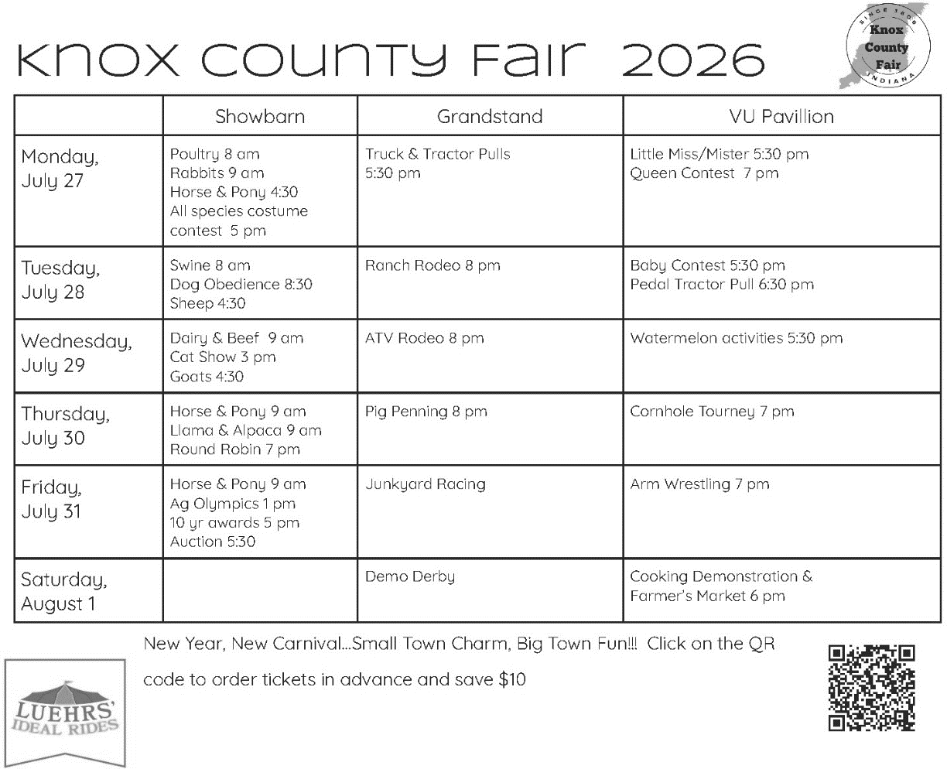
Youth Activities not during shows:
More information will be posted during the Fair.
July 28: Games at 2:00 pm around Livestock Arena.
July 29: Watermelon Day from 5-8 pm Watermelon Eating contest & More!
July 30: Kiddy Day from 5-8 pm.
July 31: Ag Olympics starts at 11:00 am around Livestock Arena.
Then Color Me Green 4-H Dash then the Water Slide ending around 2:00 pm.
Did you know that there is a NEW Carnival coming to the Knox Co Fair for 2026??
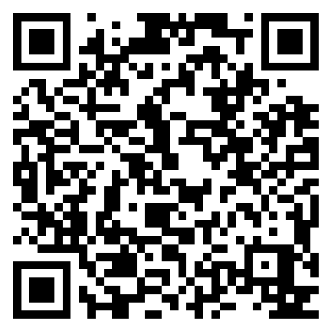

Luehrs’ Ideal Rides
Knox County Fair Carnival:

Scan QR code to
preorder tickets
& Save $10!

Knox County Fair Carnival
Dates, Times & Prices:
- Tuesday (Opens 6 pm)
  - “Grand Opening”
  - $30 wristband
- Wednesday (Opens 6 pm)
  - “Watermelon Day”
  - $30 wristband
- Thursday (Opens 5 pm)
  - “Kiddie Day”
  - All rides 1 ticket!
- Friday (Opens 6 pm)
  - “Buddy Night”
  - 2 people ride for price of 1
- Saturday (Opens 2 pm–7 pm)
  - “Last Blast”
  - $30 wristband
Vehicle & Golf Cart/Side-by-Side Policy
Please see the Fair Board publications for the POLICY Updates and COST for vehicles and golf carts/ side-by-sides!
- Passenger number should not exceed seating capacity.
- All drivers must have a current drivers licensed!
- After 4:00 p.m. NO vehicles should be driven on the grounds except for fair officials and handicap use.
- The fair board is not responsible for injuries or damaged vehicles.
- Any vehicle caught abusing these guidelines is subject to removal from grounds.

Parking/Driving Rules will be enforced during the Knox County Fair!
Please read below for more details:
During the 2026 Knox County Fair, all vehicles who will use the road around the fairgrounds will enter the fairgrounds on the west-side (Vincennes side). The eastside (Bicknell side) will be closed after 4:00 pm each day of the fair. There will be one-way traffic around the loop of the fairgrounds going west towards Vincennes, making it safer for fairgoers.
For those 4-H Families who need to drive up to the barns to feed/water their animals after 4:00 p.m., you must use the west-side entrance and drive down the first isle to use the specified gate. This gate will be located between the rabbit and poultry barns. YOU MUST HAVE A CAR PASS IN ORDER TO GET INTO THE FAIRGROUNDS WITH A VEHICLE. This pass will allow the driver plus one person into the grounds. Any other people in the vehicle must show their 4-H pass or pay to get in. THIS WILL BE ENFORCED!
Car passes may be purchased at the Fair Office.
Parking is prohibited along the rabbit and poultry barn or across the road from the rabbit and poultry barn along the fence. Violators will be towed.

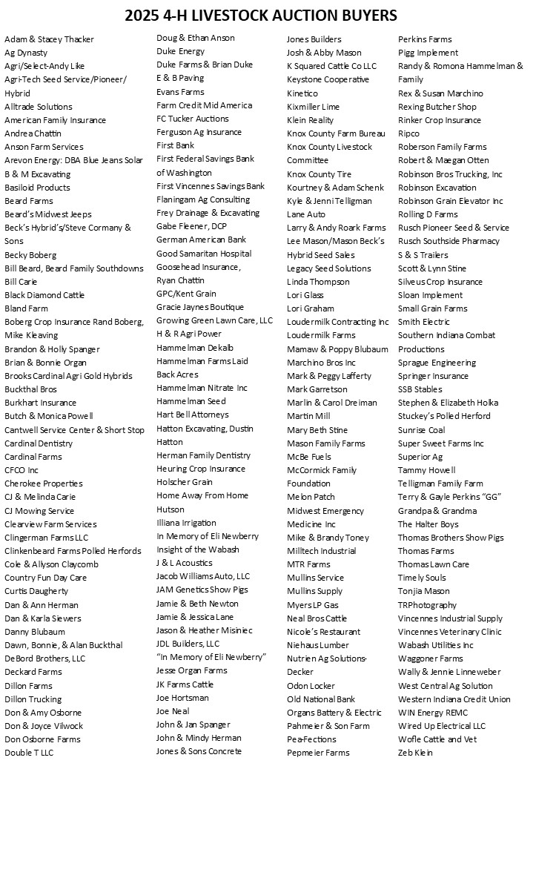

Ten Year Members

Jayna Althoff
Lauren Candler
Morgan Carter
Addison Chattin
Laura Daughtery
Chloe Decker
Kyle Evans
Sarah French
Taylor Gladish
Alli Hayden
Hollyn Holscher
Leslie Kaetzel
Landon Keasling
Kadie Lafferty
Mac McCormick
Clayton Newton
Dayton Piper
Kyndall Quarterman
Natalee Rickard
Cole Smith
Hazel Smith
Iva Summers
Samuel Sydow
Trenton Wilson

- The 4-H Pledge -
I pledge my Head to clearer thinking,
my Heart to greater loyalty, my Hands to larger service my Health to better living for my club, my community, my country and my world.


4-H Fair
Information Enclosed
Open Immediately
Purdue University Cooperative Extension Service
Knox County
4259 North Purdue Rd.
Vincennes, IN 47591

Nonprofit Organization
U.S. Postage
PAID
Vincennes, IN
Permit No. 39

