In this issue
4-H & Youth Development
- 4-H Deadlines (pg. 2)
- Setup & Tear Down (pg. 2)
- 4-H Exhibit Hall (pg. 2)
- Mini 4-H (pg.3)
- Animal Shows (pg. 3)
- 4-H Bingo (pg. 3)
- Other Fair Information (pg. 4)
- 4-H Activities (pg.4
- 4-H State Fair (pg. 4)
- Stock the Trailer: (pg. 5)

Health and Human Sciences
- Extension Homemakers (pg.6)
- Leadership Knox County (pg. 6)
- Pressure canner testing (pg.7)
- Servsafe Courses (pg. 7)
- Children’s Eye Health(pg. 8)

Agriculture, Natural Resources, and Horticulture
- Upcoming Events/Hoosier Hay Contest (pg. 9)
- Clean Sweep/Shop Talk
(pg. 10)
- DIY Lawncare (pg. 11)
- Irrigation Workshop (pg. 11)
- Vegetable concerns (pg. 11)

Office contact information:
4259 N Purdue Rd.
Vincennes, IN 47591

Phone: 812-882-3509
Fax: 812-882-3537

Website: www.extension.purdue.edu/knox

Email: knoxces@purdue.edu

Fair time is here, make sure you check out this issue for important dates. There are many other programs and deadlines coming up please visit the 4-H, health and human science, or agriculture and natural resource sections to find more details.

If you have questions feel free to contact us at 812-882-3509. Our office is open Monday-Friday 8:00am-4:00pm eastern and we are closed on County Holidays. Thank you!

Valerie Clingerman Extension Educator
Agriculture and Natural Resources/County Extension Director

Jr. Master Gardener Program at the YMCA
For many years now we have had the opportunity to bring programs to the YMCA Summer Day Camp youth. This year we offered the Jr. Master Gardener Program. Up to 34 youth attended this program daily over the course of a week. Youth got to do activities while learning about different aspects of gardening.
Topics included:
*Introduction to plants, what plants need to grow
*Plant parts we eat and nutrition we need to grow
*Plant spacing and paper towel gardening
*Fruit beauty and blind taste testing-encourages youth to try new foods and not base foods off their appearance
*Growing new from old (potatoes) and greasy grid evaluation-where we discuss how we cook foods impact if it is a whoa or go food (example chips versus baked potato).
Youth got to try different fruit and vegetables each day while participating in activities. If you have questions about this program, call the office, 812-882-3509.
4-H & Youth Development
Mitch Wagoner
Extension Educator - 4-H Youth Development
mwagoner@purdue.edu

4-H Fair Schedule

Deadlines:
- June 21: Creative Writing and Genealogy projects due to Extension Office by 3:00pm (hard copies or email to Mitch)
- June 28: Fair Entry closes.
- July 1: State Fair 4-H early bird registration deadline.
  - State Fair website: https://exhibitorscorner.indianastatefair.com/
- July 1: Livestock penning paperwork due to the Extension Office by 4:00 pm.
- July 5-12: General Record Sheets and Livestock Record Sheets can be turned in to the Extension Office to receive your 4-H Fair Pass.
- July 18: Auction animals need identified and auction pictures are due by 12:00 pm.

4-H Fair Set-up & Tear Down:
- July 6: Livestock cleanup day at the Fairgrounds and building setup at the Farm Bureau Exhibit Hall at 8:00 am for ALL Clubs!
- July 6: Rabbit members will be hanging cages at 8:00 am
- July TBA: Horse & Pony clean-up will be announced during a Horse & Pony Club Meeting.
- July 20: Building tear down at the Farm Building Exhibit Hall at 10:00 am. Clubs responsible: Junior Leaders.

The Farm Bureau Exhibit Hall Information
- July 8: In-person non-perishable project judging at the Farm Bureau Exhibit Hall from 5:00 to 8:00 pm.
- July 11: In-person perishable and sewing project judging at the Farm Bureau Exhibit Hall from 5:00 to 8:00 pm.
- July 12-19: Farm Bureau Exhibit Hall hours to the public
  - July 12 from 4:00 to 10:00 pm.
  - July 13 from 11:00 am to 1:00 pm & 4:00 to 10:00 pm.
  - July 14 from 1:00 to 10 pm
  - July 15 – 19 from 11:00 am to 1:00 pm & 4:00 to 10:00 pm
- July 19: Building projects released from 9:00 to 11:00 pm
- July 20: Building projects released from 9:00 to 11:00 am.

Mini 4-H Information
- Mini 4-H building projects can be turned in either day during judging on Monday, July 8 and Thursday, July 11 from 5:00 – 8:00 pm.

Animal Show Information:
- July 12: All animals but Poultry may arrive on the grounds from 8:00 am to 4:00 pm
- July 12: Rabbit official check-in from 4:00 to 9:00 pm. They must be in the barn by 9:00 pm.
- July 13: Official check-in for ALL animals but Rabbit from 8:00 am to 11:00 am. All animals must be in the barn by 11:00 am.
- July 13: Horse and Pony Show starts at 9:00 am at the Horse & Pony Arena.
- July 13: Rabbit Showmanship will start in the Rabbit Barn at 9:30 am. The Rabbit Show in the Show Barn Arena will start at 11:00 am.
- July 14: Horse and Pony Contest Show starts at 3:00 pm at the Horse & Pony Arena.
- July 14: Llama and Alpaca Show starts at 4:00 pm at the Show Barn.
- July 14: Dog Agility at the Fairground starting at 6:30 pm
- July 15: Poultry Show starts at 8:00 am at the Poultry Barn.
- July 16: Swine Show starts at 8:00 am at the Show Barn.
- July 16: Dog Obedience & Showmanship starts at 8:30 am location TBA.
- July 16: Goat Show starts at 5:30 pm at the Show Barn.
- July 17: Beef show starts at 8:00 am with the Dairy Show between the Heifer and Steer Show at the Show Barn.
- July 17: Cat Show starts at 3:00 pm in an A/C building.
- July 17: Sheep Show starts at 5:30 pm at the Show Barn.
- July 18: Horse and Pony Show starts at 9:00 am at the Horse & Pony Arena.
- July 18: Round Robin starts at 7:00 pm at the Show Barn.
- July 19: 4-H Livestock Auction starts at 5:30 pm at the Show Barn.
- July 19: Livestock released is from 11:59 pm.

4-H Bingo in the 4-H Exhibit Hall all week to win candy!!
You can pick up your bingo card and check your boxes in the Exhibit Hall.

Other Fair Information:
- July 5: Extension Office moves to the Fairgrounds.
- July 9: Consumer Clothing Judging at 6:00 pm and Fashion Revue at 7:00 pm at the First Church of God in Monroe City.
- July 18: 4-H Premium money will be available to be picked up starting at 4:00 pm.
- July 18: 4-H Parade of Champions for the Grand & Reserve Grand Champions for Exhibit Hall, Dog, & Cat starts at 6:00 pm
- July 19: 10 Year Member Awards starts at 5:00 pm at the Show Barn.

Youth Activities not during shows:
- July 14: 4-H games & activities around Exhibit Hall from 1:00 – 3:00 pm
  - Watermelon eating contest & painting with squirt guns
- July 15: 4-H games & activities from 2:00 – 5:00 pm
  - Activities will be around the livestock barns
- July 18: Color Me Green 4-H Dash starts at 10:00 am at Show Barn
- July 18: Ag Olympics starts at 11:00 am
- July 19: Water Game & Water Slide at 12:00 – 4:00 pm

State Fair Project Information:
- For 2024, The Purdue Extension – Knox County Office will NOT be providing transportation for projects to and from the Indiana State Fair. It is up to exhibitors to transport their projects.
  - July 27: All projects except Foods & Gardening to be check-in at the State Fair from 8:00 am to 8:00 pm.
  - July 31: Foods & Gardening projects to be check-in at the State Fair from 9:00 am to 3:00 pm.
  - August 19: All State Fair Projects must be checked out from 8:00 am to 8:00 pm.
  - Preserved food exhibits will NOT be returned and will be destroyed, including canning jars!
  - August 20: All ribbons, non-animal exhibitor pins, judge’s score cards can be picked up from the Extension Office.

General Information:
- July 4: Independence Day – Office Closed
- October 1: 4-H Enrollment begins for the 2024-2025 program year

Stock the Trailer

Hours to turn in the food at the Knox County Fairgrounds:
Monday, July 8 & Thursday, July 11 (Building Judging)
- 5:00 - 7:30 pm
Saturday, July 13 (Rabbit Show)
- 10:00 – 11:00 am
- 4:30 - 5:30 pm
Sunday, July 14 (Llama, Alpaca, & Dog Shows)
- 4:00 – 5:00 pm
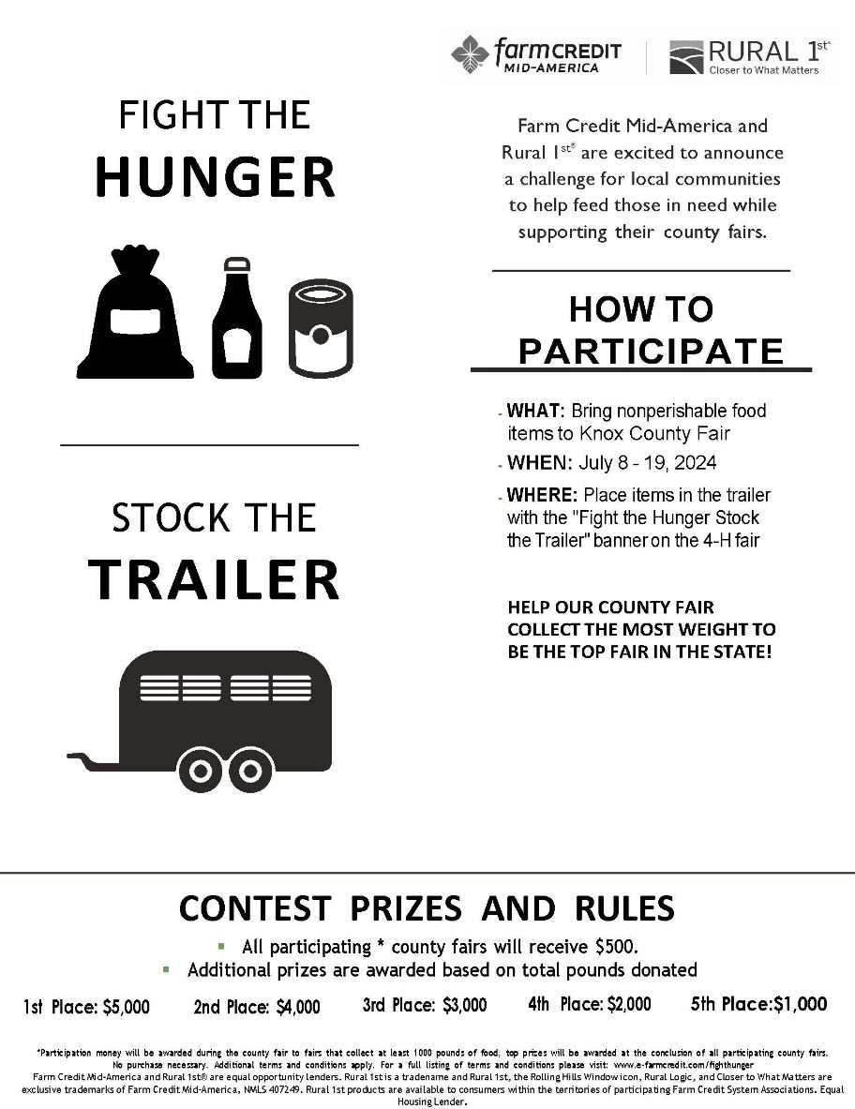
Monday, July 15 (Poultry & Horse Show)
- 8:00 – 9:00 am
- 3:00 – 4:00 pm
Tuesday, July 16 (Dog, Goat, & Swine Show)
- 8:00 – 9:00 am
- 4:00 – 5:00 pm
Wednesday, July 17 (Beef, Dairy, & Sheep Show)
- 8:00 – 9:00 am
- 4:00 – 5:00 pm
Thursday, July 18 (Round Robin)
- 6:00 - 7:00 pm
Friday, July 17 (Auction)
- 5:00 - 5:30 pm

Prizes for bringing canned goods to Stock the Trailer:
- Battle of the Barns & Building: which building/barn collects the most wins a Pizza Party on Thursday, July 18 after the Ag Olympics.
- Pie in the face: 4-Hers that bring 5 or more cans will be able to vote for the person that will receive a pie in the face between the 10-year awards and the 4-H auction.
  - Volunteers for a Pie in the Face: Josh Anthis or Dan Short

Health & Human Sciences
Tonya Short, Extension Educator - Health & Human Sciences
Short43@purdue.edu www.facebook.com/KnoxCoHHS

Extension Homemakers—Updates
Program books are currently being printed. Presidents will receive a phone call when they are ready to pick up.
Next County Council meeting is July 1, 2024 at 10:30AM at the library. This meeting is for county officers, club presidents, and anyone else who cares about Knox County Extension Homemakers.
Club Presidents: if you have activities or announcements to include in the newsletter, get that information to Tonya by the 15th of even numbered months. E.g. Information to Tonya by June 15 for printing in the July-August newsletter.

Leadership Knox County grows

A few years ago, the Knox County Chamber of Commerce approached us and said “we want to bring an adult leadership class back to Knox County.” And that’s exactly what we did! This course meets monthly throughout the school year and is open to anyone who lives or works in Knox County. Through a series of interactive modules, participants will learn about their own leadership capacity, the people, organizations and institutions that make up Knox County and how they can engage in serving our community more deeply. By fostering and nurturing confident, skilled and knowledgeable leaders we are more equipped to build our community from within.
We are preparing to announce our third class this summer which will begin in August. If you want to develop leadership skills, network, or learn more about Knox County, then this class is for you.
To learn more or inquire about being a part of the next cohort, contact Tonya Short short43@purdue.edu; 812-882-3509 or Jamie Neal jamie@knoxcountychamber.com

Is your Pressure Canner Accurate?
If your pressure canner dial gauge is not accurate, you could be producing unsafe food. Get your dial gauge tested annually before each canning season to ensure you are canning at the proper pressure. If your dial gauge is off only by a pound or two, adjustments can be made to still safely use your pressure canner. If your dial gauge is off by more than 2 PSI a new gauge is necessary. Remember, even new gauges can be incorrect. Recommendations are to have your gauge checked for accuracy before every canning season. You can even bring in your entire canner for inspection by your local Purdue Extension office. Pressure canners that use a “jiggler” rather than a gauge do not need to be tested; however, you are still free to bring the canner in for an overall inspection, if desired.
For canning related questions or to schedule a time to test your dial gauge contact Tonya at 812-882-3509.

ServSafe Manager and Food Handler courses
ServSafe Manager Certification is an approved training in the state of Indiana to become a certified food protection manager.
ServSafe Food Handler is for anyone else who needs basic food safety and food handling training, including home-based vendors, food service workers, volunteers, or others who work with food who only need the basic training. This course is NOT intended for food service managers.
Here are upcoming classes scheduled in our area. For more information including registration links visit www.purdue.edu/servsafe/workshops or https://extension.purdue.edu/county/knox/ServSafe.html
ServSafe Manager Classes
When | Where
October 22, 2024 | Washington, IN contact Jennifer 812-254-8668
February 19, 2025 | Dubois County contact Chelsea 812-482-1782
June 3, 2025 | Vincennes, IN contact Tonya 812-882-3509

August is Children’s Eye Health and Safety Month
As children and parents are gearing up for the back to school, remember that healthy vision is critical to academic and social success. Make getting an eye exam part of your back-to-school routine.
Did you know?
- Vision disorders can negatively impact a babies’ ability to bond with their parent/caregiver, their ability to explore the world by reaching and grasping, and also impede development of fine and gross motor skills.
- One in every 4 school-age children and 1 in every 17 preschool-aged children have some form of vision problem requiring treatment.
- More than one-quarter of teens with correctable vision have the wrong prescription.
- 80% of all blindness and vision impairment is either preventable or treatable.
As a child grows, an untreated eye disease or condition becomes more difficult to correct. These can worsen and lead to other serious problems as well as affect reading ability, focus, classroom behavior, and social adjustment in school. Vision problems that can affect children include amblyopia, (“lazy eye”), strabismus, (“crossed eyes”), and the most common forms of refractive error: myopia (nearsightedness) and hyperopia (farsightedness) and astigmatism.
If your child is not deemed at high risk for eye conditions or diseases, experts recommend seeing your eye doctor based on the following age-related guidelines:
- 6-12 months of age: Your child should have their first comprehensive eye exam. Visit the InfantSEE website to learn more and locate a doctor in your area who can provide a free infant assessment.
- 3 years of age: You should have their second eye exam unless otherwise recommended by your child’s eye doctor
- 5-6 years of age: Your child should receive their third eye exam just before they enter the first grade
- 6-18 years of age- Once your child has reached school-age, they should have an eye exam every two years
- Children (and adults!) who have any type of vision problems should have exams at least annually or more frequently as recommended by your eye doctor.
To learn more, check out these resources:
https://www.aoa.org/healthy-eyes/eye-health-for-life/infant-vision?sso=y
https://www.aao.org/eye-health/resources/articles
https://medodamerica.com/how-often-do-kids-need-eye-exams/
This event has been pre-approved for 1.75 CEUs from the IU School of Social Work

Agriculture & Natural Resources
Valerie Clingerman-Extension Educator
Agriculture & Natural Resources
clingerman@purdue.edu

**Like Purdue Extension Knox County Ag and Natural Resources on Facebook.
**To receive monthly e-newsletters call 812-882-3509 or e-mail me to be added.

Upcoming Events
Date | Event | Time (Eastern) | Location | Contact info.
July 24 | Shop Talk and PARP* (see details on pg. 10) | 8:00-11:30am | Vincennes | Register by contacting emcniff@indianasoybean.com
July 27 | Nature Days | 9:00am-2:00pm | Vincennes | Register at https://tinyurl.com/2024NatureDays
Aug. 1, 8, 15, 22 | DIY Lawncare (Details on page 11) | 5:30-7:30pm | Vincennes | 812-882-3509
Aug. 2-3 | Indiana Grazing School | Aug. 2: 1:00pm  Aug. 3: 8:00am | Loogootee | Registration form: https://tinyurl.com/GrazingSchool24
Aug. 20 | OISC Clean Sweep Pesticide Disposal (see details on pg. 10) | 9:00am-2:00pm | Loogootee | Registration form at: https://oisc.purdue.edu/pesticide/clean_sweep.html
Mondays Aug 26- Dec. 9 | Master Gardener Basic Training | 1:00-4:00pm | Vincennes and Washington | Get registration packet by calling 812-882-3509
Sept. 4 | Irrigation Workshop for Small-Scale Vegetable Producers | 3:00-8:00pm | Vincennes | Register at: https://tinyurl.com/24VegIrrigationWksp or call 812-882-3509
Sept. 17, 24, Oct. 1, 8, 15, 22 & 29 | Becoming the Employer of Choice | 12:00-1:00pm | Virtual | Register at https://tinyurl.com/BTEOC2024lunchnlearn or call 812-882-3509

*PARP=Private Applicator Recertification Program

2024 Hoosier Hay Contest
This contest is open to any hay or baleage producer in Indiana. Entries must be submitted by the farm that manages or owns where the forage was grown. Each sample will need its own entry form and fee and can be submitted between June 1-Sept. 30, 2024. Hay or baleage must be taken from a single lot of hay and from a minimum of 20 bales. Samples must be collected using a hay probe. Winners will be recognized by the Indiana Forage Council at their annual meeting. Complete rules and entry form can be found at https://indianaforage.org
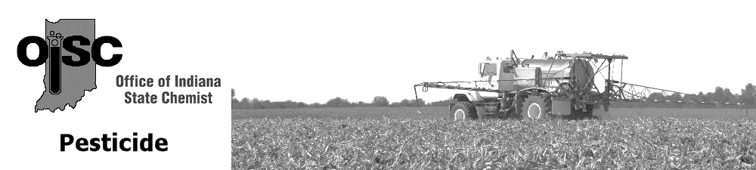
OISC Clean Sweep Pesticide Disposal Program
This program is designed to collect and dispose of suspended, canceled, banned, unusable, opened, unopened or just unwanted pesticides (herbicides, insecticides, rodenticides, fungicides, miticides, etc.) is being sponsored by the Office of Indiana State Chemist (OISC). This disposal service is free of charge up to 250 pounds per participant. Over 250 pounds there will be a $3.00 per pound charge. This is a great opportunity for you to legally dispose of unwanted products at little or no cost.
All public and private schools, golf courses, nurseries, farmers, ag dealers, public, cities, towns, municipalities and county units of government or others receiving this notice are eligible to participate.
WHEN: 9:00 am to 2:00 pm Local Time
WHERE: August 20, 2024: Premier Ag – Daviess County
11815 US-50 Loogootee, Indiana 47553

Complete the Clean Sweep Pesticide Disposal Participant Form to the best of your ability. Mail, fax or e-mail the completed form to Nathan Davis at 765494-4331 or cleansweep@groups.purdue.edu no later than Fri., August 9, 2024.
You can find the form and more information about this program at https://oisc.purdue.edu/pesticide/clean_sweep.html

Shop Talk and Private Applicator Recertification Program (PARP)
Join us at the Brocksmith Farm (678 S Hickory Corner Rd. Vincennes 47591) on July 24th at 8:00am for breakfast and discussion on agriculture policy issues with special guest ISDA Director Lamb.
PARP will be offered after the policy discussion from 9:30-11:30am. PARP special guest Dr. Daniel Quinn, Purdue Extension Corn Specialist will be discussing agronomic management of corn following a rye cover crop: nitrogen and planter considerations. Other topics will include weed seed in cover cover crop seed and worker protection standards.
Contact Emily McNiff (emcniff@indianasoybean.com) with questions or to register. You can also visit https://tinyurl.com/2024ShopTalkKnoxCo.
DIY Lawncare Program

Do you want to know how to have a greener, healthier lawn? Join us for this series where you will receive information on essential turf basics needed to lay the groundwork for creating, establishing, and maintaining your lawn.
What will you learn?
Session 1: Basics of Taking Care of Lawns
Session 2: Lawn Pests and Problems
Session 3: Weed Identification and Management
Session 4: Seeding Establishment and Lawn Renovation
We will meet Aug. 1, 8, 15, and 22 from 5:30pm-7:30pm at the Purdue Extension-Knox County Office (4259 N Purdue Rd. Vincennes, 47591). Register and pay $20 by July 25th. Send checks to the Extension Office payable to Purdue Ext. Knox County Ed Fund. Register at http://tinyurl.com/2024DIYLawncare.
If you have additional questions call 812-882-3509.

Irrigation Workshop for Small-Scale Vegetable Producers
Join us Sept. 4 from 3:00-8:00pm at the Southwest Purdue Agricultural Center (4369 N Purdue Rd. Vincennes 47591) for dinner and to learn about irrigation.
Topics will include understanding NRCS EQUIP programs, irrigation scheduling, water and soil health, estimating soil moisture, automatic irrigation and more. The evening will blend indoor presentations and outdoor demonstrations.
This program is limited to 50 participants. Register at https://tinyurl.com/24VegIrrigationWksp or contact Valerie Clingerman at 812-882-3509 or clingerman@purdue.edu

Vegetable Crops Suffering? You Have Help.

The last few weeks I have been very busy with many garden questions. Between our cold/wet to hot/dry temperatures many of our garden plants are suffering.
A few things I have been seeing and hearing are that some plants are stunted or not growing well, this is likely due to this weather stress. Many other plants and trees are having aphid problems which are typical when it is dry. Tomatoes always seem to be doing something and right now many of them are rolling their bottom leaves due to heat stress. Overwatering and disease issues also are problems.
If you are struggling to figure out what is going on with your plants feel free to call/email (812-882-3509, clingerman@purdue.edu) or bring samples to the Extension Office
(4259 N Purdue Rd. Vincennes, 47591).
Purdue also has a Plant and Pest Diagnostic Laboratory that you can mail samples to for diagnosis. You will need to submit a form along with your sample. The form and sample collection/shipping guidelines can be found at https://ag.purdue.edu/department/btny/ppdl/submit-samples/submit-sample.html.

locust, and poplar are labelled as
Nonprofit Organization
U.S. Postage
PAID
Vincennes, IN
Permit No. 39
Purdue University Cooperative Extension Service
Knox County
4259 North Purdue Rd.
Vincennes, IN 47591

Nonprofit Organization
U.S. Postage
PAID
Vincennes, IN
Permit No. 39

Check our Knox County Fair Facebook page and website for more information and updates!!!! This is going to be a great year!!!
Look inside for agriculture and natural resource, health and human science, and 4-H updates.
Meet your Purdue Extension-Knox County Office
Valerie Clingerman, Agriculture and Natural Resource Extension Educator/County Extension Director, clingerman@purdue.edu
Tonya Short, Health and Human Sciences Extension Educator, short43@purdue.edu
Mitch Wagoner, 4-H and Youth Development Extension Educator, mwagone@purdue.edu
Kim King, Office Manager, king286@purdue.edu
JoAnn Smith, Part-time secretary, smit3004@purdue.edu

