In this issue
4-H & Youth Development
- Livestock Tagging dates (pg. 2)
- Livestock ID (pg. 2)
- Quality Assurance (pg. 3)
- Stock the Trailer (pg. 3)
- 4-H Pool Party (pg. 3)
- 2024 Fair Schedule (pg. 4)
- Upcoming Dates (pg. 5)
Health and Human Sciences
- Spring Clean Your Finances (pg. 6)
- Pressure canner testing (pg.7)
- Servsafe Courses (pg. 7)
- Gardening with arthritis (pg. 7)
- Prepare for Canning Season(pg. 8)

Agriculture, Natural Resources, and Horticulture
- Upcoming Events/Road Closures (pg. 9)
- Field Crop Diseases (pg. 10)
- DIY Lawncare (pg. 11)
- No Mow May? (pg. 11)

Office contact information:
4259 N Purdue Rd.
Vincennes, IN 47591

Phone: 812-882-3509
Fax: 812-882-3537

Website: www.extension.purdue.edu/knox

Email: knoxces@purdue.edu

There are many programs and deadlines coming up please visit the 4-H, health and human science, or agriculture and natural resource sections to find more details.

If you have questions feel free to contact us at 812-882-3509. Our office is open Monday-Friday 8:00am-4:00pm eastern and we are closed on County Holidays. Thank you!

Valerie Clingerman Extension Educator
Agriculture and Natural Resources/County Extension Director

UAV (drone) program help participants prepare for remote pilot exam
The UAV Technology Program was offered March 25-26. The main goal is to prepare participants to take the FAA Part 107 remote pilot exam.
*All participants reported that, as a result of this program, they were more aware of legal issues, more aware of safety protocols, better understood the applications associated with UAV technology, and learned something that relates to their career.
*90% were more aware of troubleshooting techniques.
*60% plan to take the remote pilot exam and 80% feel more prepared to take the exam.
*70% are extremely likely to recommend this program to a friend or colleague.
*Participants took a pre and post-test to evaluate knowledge gained during the program. The average pretest score was 52% and the average post test score was 78%.
Testimonials: "Very well taught course. I feel like I will be able to pass the remote pilot exam", "Great, course! Love the activities!", and " I learned a lot and feel as if others could do the same. The course was well taught and easy to follow."
4-H & Youth Development
Mitch Wagoner
Extension Educator - 4-H Youth Development
mwagoner@purdue.edu

Livestock Tagging & Tattoo Dates
All livestock “BUT poultry at this time” must be ID’d on 4HOnline by May 15!
Possession date for rabbits & poultry is the date of tagging! All others are May 15!
- Steers & Commercial Heifers: tagging was on February 24 at Producers.
- For Beef Cattle & Dairy Cattle if you need an 840 RFID-tag please contact the Extension Office.
- Poultry leg banding & blood testing is on May 11 at the Southwest Purdue Ag Center from 8:00-10:00 am. *Poultry must be large enough to blood test and band (based off of breed)
- Rabbit tattooing is on May 11 at the Southwest Purdue Ag Center from 2:00–4:00 pm.
- Sheep & Goat tagging is on May 11 at the Extension Office Parking Lot from 9:00—11:00 am.
  - Animals that need to come to tagging. Any sheep planning to go to State Fair, all market lambs / commercial breeding ewes. All meat goat wethers and meat goat wether dams.
- Swine: No tagging date for swine. All exhibitors need to pick up tags from Extension Office before May 15.
State Fair DNA Hair Samples envelopes for beef cattle, dairy cattle, meat goats, sheep, & swine can be picked up from the Extension Office and are due back to the Extension Office by May 15!

How to ID Animals on 4HOnline
All livestock must be ID’d by May 15!
All Livestock “BUT poultry at this time” are to be ID’d on “https://v2.4honline.com”.
Instructions on how to ID your livestock will be mailed out. Worksheets are NOT enrollment forms. Worksheets should be used to help collect information to be inputted into 4HOnline 2.0.
If you have problems, please contact the Extension Office at 812-882-3509.
Indiana 4-H Quality Livestock Care Program
Indiana 4-H is still requiring exhibitors of the following animals: Beef, Dairy, Goats, Poultry, Rabbits, Sheep, and Swine to have Quality Assurance training. There are two options that will be accepted at the County Fair and State Fair.

- In-person ONLY option, the Indiana 4-H Quality Livestock Assurance Program. This is a new program with more hands-on activities. The training is still one hour. You do not have to sign into a website. At the end of the training, the youth need to write down their name. The cost of the program is $3. The Livestock Committee will cover the cost of any Knox County youth attending a training in Knox County. In Knox County we have 2 workshops left.
  - Monday, May 6, 2024 at 6:00 pm at Extension Office in classroom 115.
  - Tuesday, May 14, 2024 at 6:00 pm at Extension Office in classroom 115.
If you are not available to attend a training in Knox County. You are able to attend a training in another county. You will need to pay $3 cash to that county.
This training will not meet the National Livestock Show requirements!

- Virtual ONLY option, Youth for the Quality Care of Animal “YQCA” Program. This is required for the National Livestock Shows. Visit http://www.yqcaprogram.org/. Youth will need to complete the online training and pay the $12 fee. The Extension Office has a few coupons available.
After you have completed YQCA training, you must submit a copy of your certificate to the Extension Office (email mwagone@purdue.edu). Also, print a copy for your records. The Extension Office cannot verify your information to see if you have received YQCA training.

Stock the Trailer
During Fair Week the Knox County 4-H is participating in Stock the Tailer with can food goods to donate to food banks to help Fight the Hunger in our community.
More information on challenges to come!

Knox County 4-H Pool Party
@ Rainbow Beach
Knox County 4-H is hosting a Pool Party for members at Rainbow Beach on Saturday, June 8 from 6:30 – 8:00 pm. Free admission from 6:30 – 8:00 pm. Make sure you bring your swim suit, towel, & sun screen for a beautiful 4-H event.
https://www.creativefabrica.com/product/pool-party/
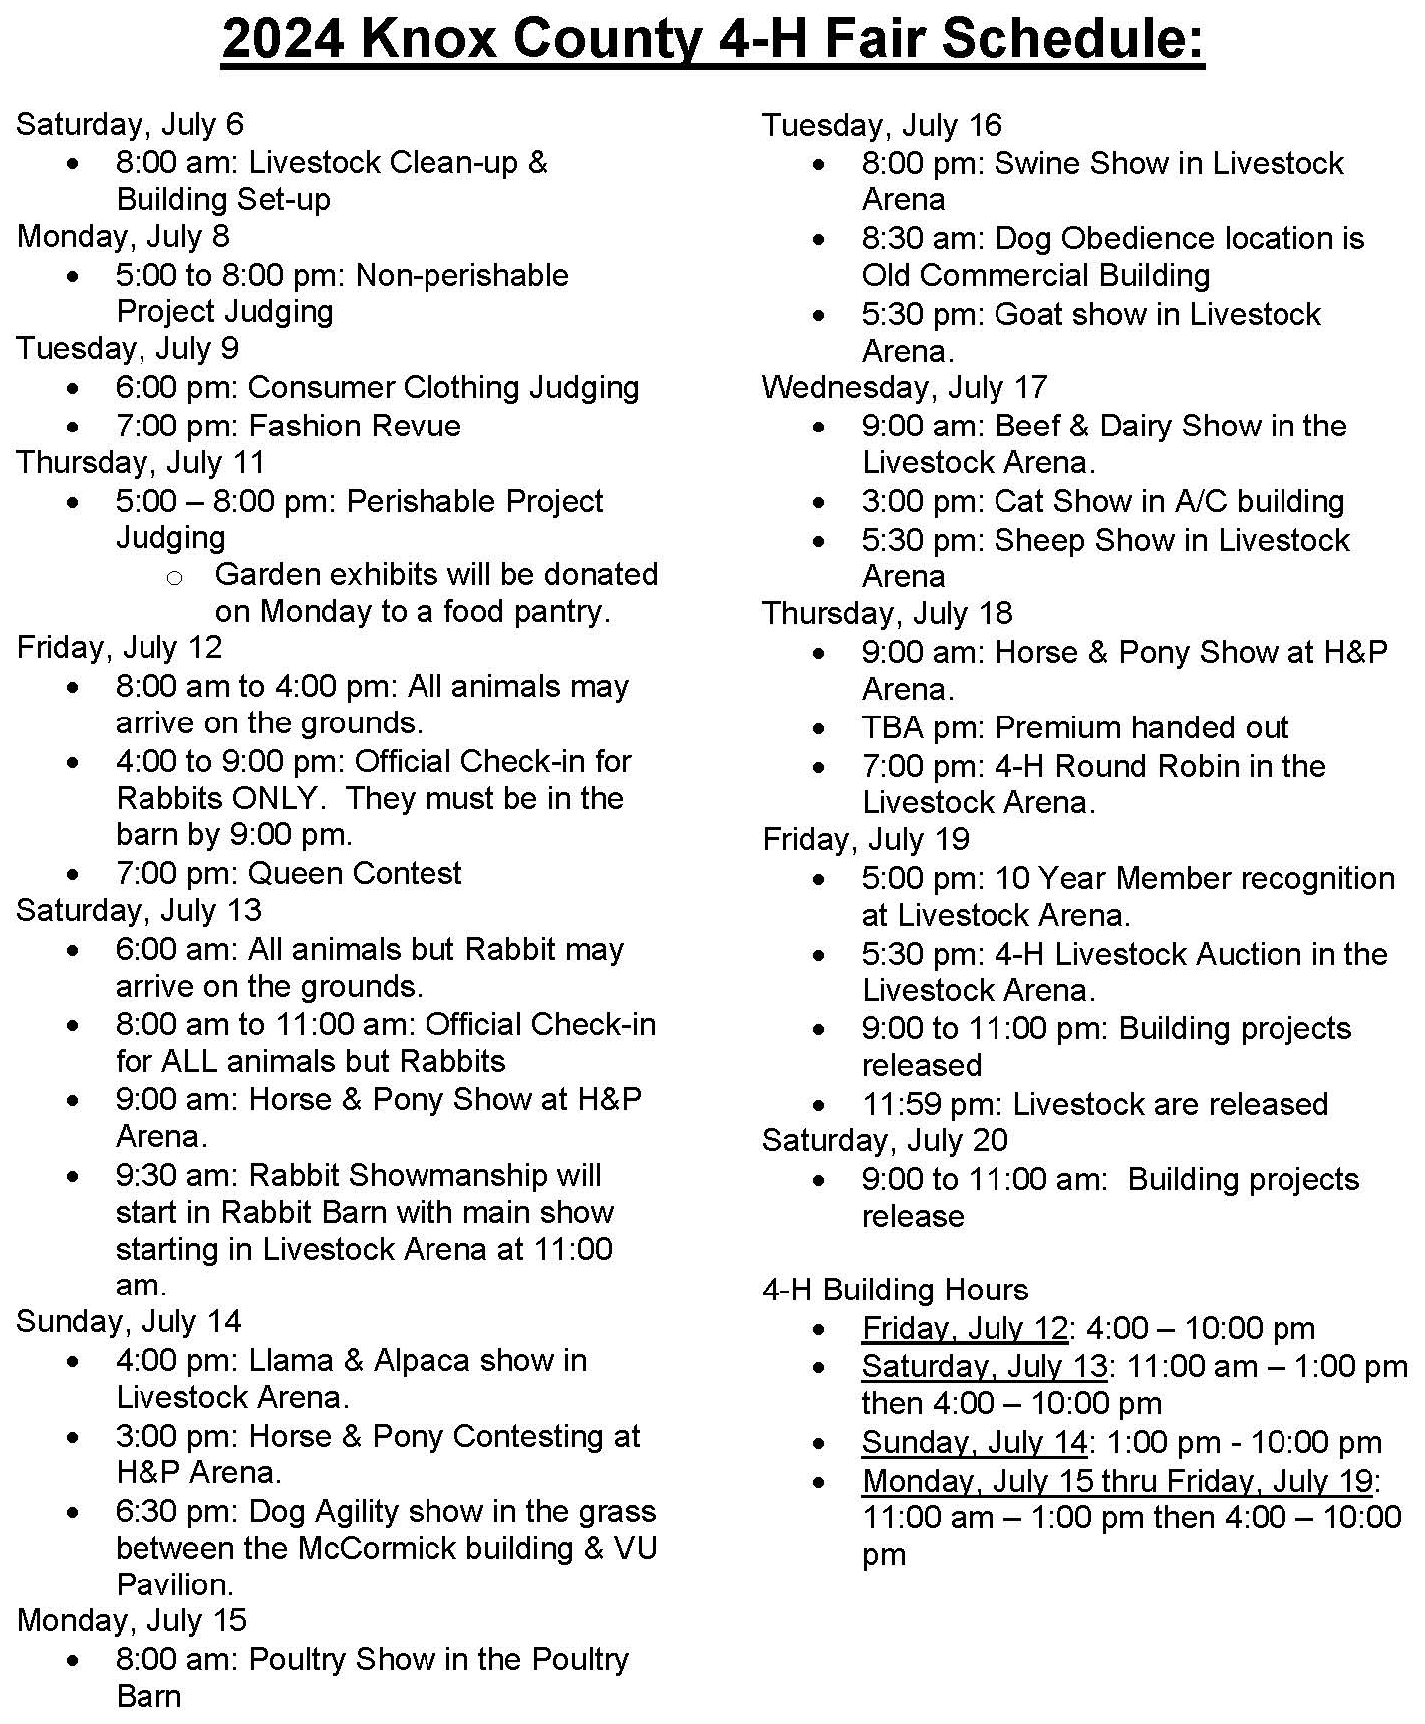

Upcoming Dates

- Day on the Farm for 3rd grader: May 2
- IN 4-H Quality Livestock Care Program: May 6
- Poultry banding, Rabbit tattooing, Sheep/ Goat tagging: May 11
- IN 4-H Quality Livestock Care Program: May 14
- Animal ID Deadline: May 15
- Project Add & Drop Deadline: May 15
- Fair Entry Opens: June 1
- 4-H Camp: June 3 – 5.
- 4-H Pool Party @ Rainbow Beach: June 8
- County Tractor Driving Contest: June 9
- 4-H Academy @ Purdue: June 12 – 14. Open to grades 9-12.
- FYI, IN FFA State Convention: June 17 – 20.
- 4-H Band Workshop: June 22 – 24. Open to grades 9-12.
- 4-H Chorus Workshop “aka. Show Choir”: June 22 - 25. Open to grades 9-12.
- 4-H Round Up: June 24 – 26. Open to grades 7-9.
- Fair Entry Deadlines: June 28
- Area Tractor Driving Contest in Vanderburgh County: June 29
- Livestock & Building Clean-up/ Setup: July 6 at 8:00 am
- Non-Perishable Judging: July 8 from 5:00 – 8:00 pm
- Perishable & Sewing Judging: July 11 from 5:00 – 8:00 pm
- Knox County Fair: July 12 – 19, 2024.
- State Fair 4-H Projects Check-in: July 29 & August 5, 2024
  - Extension Office will provide more information.
- Indiana State Fair: August 2 – 18, 2024.
- State Fair 4-H Projects pick up: August 19, 2024

Social Media

Facebook: “KnoxCountyIN4H”
Instagram: “@knoxcountyin4h”

Health & Human Sciences
Tonya Short, Extension Educator - Health & Human Sciences
Short43@purdue.edu www.facebook.com/KnoxCoHHS

Extension Homemakers—Updates
May 6: May Brunch, Ponderosa, 11AM

Spring Cleaning for Your Finances

Spring cleaning is upon us, but it shouldn’t be limited to tidying up your home. An annual financial clean-up will help keep you on track and will give peace of mind for the rest of the year. Here are some things to keep in mind:
- Do you have an emergency savings account? If you answer no, set a goal of saving $500-$1000 just to give yourself a little cushion when unexpected expenses come in - and you know they will. Your ultimate goal should be to have 3-6 months of living expenses on hand. You don’t have to save it all at once but regular savings contributions, however small, will add up over time.
- Make sure you are contributing to right amount to a retirement fund. Experts recommend saving at least 15% of your income (you and your employer’s combined contributions). If that is too much for your budget right now, start by trying to maximize your employer’s contributions. For example, if your employer matches the first 4% you contribute try to contribute at least 4% so you can get that extra 4% for free!
- Meet with your financial advisor at least once per year to make sure you are on track to meet your financial goals.
- Maximize other tax-sheltered accounts that you may have access to. For example, if your employer offers an HSA or FSA account you can set aside money – tax free – to use for qualified medical or dependent care expenses.
- Check your credit report at www.annualcreditreport.com. Review the report for accuracy and report any errors you find. They could negatively impact your credit score. Even if you are not planning on applying for a loan, a low credit score can cost you money through increased costs like insurance rates.
- Review all your accounts and make sure your beneficiaries are up to date. No one plans for things to happen but it’s better to be prepared and easier on your loved ones if all your records are current and accurate.
- Make a plan to pay down debt. The less debt you have the more money you have every month to do things you want.

Is your Pressure Canner Accurate?
If your pressure canner dial gauge is not accurate, you could be producing unsafe food. Get your dial gauge tested annually before each canning season to ensure you are canning at the proper pressure. Remember, even new gauges can be incorrect. Recommendations are to have your gauge checked for accuracy before every canning season. You can even bring in your entire canner for inspection by your local Purdue Extension office. For canning related questions or to schedule a time to test your dial gauge contact Tonya at 812-882-3509.

ServSafe Manager and Food Handler courses
ServSafe Manager Certification is an approved training in the state of Indiana to become a certified food protection manager.
ServSafe Food Handler is for anyone else who needs basic food safety and food handling training, including home-based vendors, food service workers, volunteers, or others who work with food who only need the basic training. This course is NOT intended for food service managers.
Here are upcoming classes scheduled in our area. For more information including registration links visit www.purdue.edu/servsafe/workshops or https://extension.purdue.edu/county/knox/ServSafe.html
ServSafe Manager Classes
When | Where
June 7, 2024 | Vincennes, IN - register at: https://cvent.me/1mYOml
October 22, 2024 | Washington, IN contact Jennifer 812-254-8668
February 19, 2025 | Dubois County contact Chelsea 812-482-1782

Gardening and Arthritis
Gardening is good for the body, mind, and soul. It gives us exercise that doesn’t feel like a boring treadmill; it gives us pleasure in cultivating the earth to produce our own bounty; it gives us peace and calm in finding quiet time to nuture our spirit. But, if you experience arthritis or any other condition involving chronic pain or limited mobility, the enjoyment of gardening seems to fizzle at little. If this is you, know that there are many adaptations that can allow you to continue “having fun playing in the dirt.”
Depending on your needs and gardening goals there are a number of ways you can adapt including raised beds to special tools and equipment. AgrAbility together with the Arthritis Foundation has put together an informational booklet that provides tips on tools, garden-types, activity modifications, and even warm-ups to prepare your body for some time in the garden.
Check out the booklet here:
www.agrability.org/wp-content/uploads/2016/04/Arthritis_Gardening_Web_sm.pdf
or give the Extension office a call to have a copy printed for you. 812-882-3509

Plan Ahead for Home Canning this Summer
Whether you are a veteran canner or brand new to home food preservation, get ready for this canning season by checking your equipment and supplies. Proper equipment in good condition is required for safe, high quality home canned food.
A pressure canner is essential for canning low-acid vegetables, meats, fish, and poultry. Two basic types are available. One has a dial gauge to indicate the pressure inside the canner; the other has a metal weighted gauge that “jiggles” when the canner is pressurized. Dial gauges must be tested for accuracy before each canning season. Additionally, check the rubber gasket if your canner has one; it should be flexible and soft, not brittle, sticky or cracked. Also make sure any small pipes or vent ports with openings are clean and open all the way through. For information on inspecting your pressure canner including dial gauge testing contact Tonya Short at Purdue Extension Knox County, 812-882-3509 or short43@purdue.edu.
A boiling water canner can be used for canning other foods such as fruits, pickles, jellies and jams. The canner should be deep enough to allow at least one to two inches of water to boil over the tops of the jars.
Both types of canners should have a rack in the bottom to keep jars off the bottom of the canner.
Inventory your jars and decide if you should buy new jars this year. Inspect jars for nicks, cracks or chips, especially around the top sealing edge. Nicks can prevent lids from sealing. Very old jars can weaken with age and repeated use and can break under pressure and heat. Consider investing in new jars if you need to, and be wary of buying used jars for the same reasons just listed.
Mason-type jars specifically designed for home canning along with two-piece self-sealing metal lids are recommended for optimal safety. A must every canning season is new lid flats. Lids should not be reused. Be aware not all lids are alike. During the pandemic, a shortage of lids led to a flood of off-brand lids. Some of these look-a-likes proved to have a higher failure rate likely due to inadequate sealing compound. Name brand manufacturers only contract with well-known, reputable retailers. To ensure you are getting quality, genuine materials be sure to purchase directly from the manufacturer or the store they contract with and not from a third-party vendor. The screw bands are re-usable if they are not bent, dented or rusted.
A final must is reliable, up-to-date canning instructions. Publications and information are available at the Extension office, or on the website for the National Center for Home Food Preservation. The Purdue Extension Education Store also offers a series of free downloadable food preservation publications entitled Let’s Preserve. Visit edustore.purdue.edu and search keyword preserve. Canning recipe books are also available for sale at the Extension office.
Planning ahead can save you time, money, and frustration with home canning. Make it a happy, successful canning season by getting prepared before your harvest is ready. If you would like more information on home food preservation and upcoming programs, please contact Tonya Short at Purdue Extension Knox County, 812-882-3509 or short43@purdue.edu.
This event has been pre-approved for 1.75 CEUs from the IU School of Social Work

Agriculture & Natural Resources
Valerie Clingerman-Extension Educator
Agriculture & Natural Resources
clingerman@purdue.edu

**Like Purdue Extension Knox County Ag and Natural Resources on Facebook.
**To receive monthly e-newsletters call 812-882-3509 or e-mail me to be added.

Upcoming Events
Date | Event | Time (Eastern) | Location | Contact info.
May 2 | Spotted Lanternfly in Indiana | 11:00am | Virtual | https://www.emeraldashborer. info/EABU
May 14 | Ruminations of a Goat Herder on Invasive Species and Forest Stewardship | 12:30pm | Virtual | https://tinyurl.com/ mipnwebinars
May 15 | Making a Container Salsa Garden | TBD | Knox County Library, Vincennes | 812-882-3509
May 16 | Spongy Moth in Indiana | 11:00am | Virtual | https://www.emeraldashborer. info/EABU
July 27 | Nature Days | TBD | TBD | 812-882-8210
Aug. 1, 8, 15, 22 | DIY Lawncare (Details on page 11) | 5:30-7:30pm | Extension Office, Vincennes | 812-882-3509
Mondays Aug 26- Dec. 9 | Master Gardener Basic Training | 1:00-4:00pm | Vincennes and Washington | 812-882-3509

INDOT Road Closure Announcement

SR61 from Kimmel Rd. to SR241 in Monroe City will have one lane closed for road resurfacing from 6:00am to 10:00pm until May 24,2024. The open lane width will be 10-12 ft. There will be a flagger and speed limit is 55 unless posted otherwise. For more information visit: https://tinyurl.com/Mayroadclosure

Field Crop Disease Monitoring Resources for Indiana

Written by: Darcy Telenko, Purdue University

There are a number of resources available for monitoring field crop diseases here in Indiana. The Purdue Field Crop Pathology Team will be tracking diseases across Indiana and will post updates here in Pest & Crop and on our website https://indianafieldcroppathology.com/. You can also follow me on Twitter @DTelenko
National disease tracking and prediction programs are place to monitor for some the more economically important diseases in the Unites States, such as Fusarium head blight in wheat, wheat stripe rust, southern rust of corn, and tar spot. In addition, the Crop Protection Network site hosts collaborative outputs on important issues affecting field crops in the United States and Canada, this site has numerous resources and fungicide efficacy tables for corn, soybean, and wheat. General resources for all field crops:
Purdue Field Crop Pathology Extension site: https://indianafieldcroppathology.com/
-Applied Research in Field Crop Pathology for Indiana, Tar spot and southern rust in season maps, In-season updates on diseases in Indiana
Crop Protection Network: https://cropprotectionnetwork.org/
-Fungicide efficacy tables can be found here for foliar diseases of corn, foliar and seedling diseases of soybean, and foliar diseases of wheat, Web books on tar spot, biopesticides, white mold, and fungicide use, Numerous crop protection resources – disease cycles, images, crop loss calculator, severity estimation tool and many more
This article can be found at https://extension.entm.purdue.edu/newsletters/pestandcrop/

Weed Management Strategies for Vegetable Farms
Written by Stephen Meyers, Purdue University
*Sanitation-When moving from weed-infested fields to “clean” ones, remove soil and plant parts from boots, tools, tractor tires, and implements to avoid spreading problematic weeds.
*Exclusion-Limit the risk of introducing weeds to your farm by using only inspected/tested seeds.
*Crop rotation-Rotating crops can disrupt weed life cycles and reduce their population over time.
*Cover crops-Cover crops compete with weeds for light, water, and nutrients.
*Plant spacing-Planting crops at appropriate distances can reduce the time it takes to form a full crop canopy, thus shading out weeds more quickly
*Cultivar selection-Choose varieties that grow well in your region or on your farm. Vigorous plants are more competitive with weeds.
*Tillage/Cultivation-A traditional plow can be used to deeply bury seeds and prevent them from germinating. Cultivation can be used to uproot small weed seedlings.
*Hand-weeding-These practices are labor-intensive but can be an effective.
*Flame weeding-Burning weeds with propane torches or flame weeders (Figure 6) is particularly effective for young, annual, broadleaf weeds
*Mulches-Can smother weeds and prevent sunlight from reaching weed seeds.
*Tarps-Plastic tarps can be used to create a stale seedbed or provide early-season weed control.
*Electrocution-Controlled electrical pulses directly to the weeds disrupts their cellular structure and kills them.
*Living mulches- Grown in tandem with a cash crop. Act as a natural barrier, reducing detrimental weed establishment and growth
*Seed predation-Consumption of weed seeds by natural predators, such as insects, birds, or rodents.
*Livestock-Can selectively consume certain weed species while grazing.
*Bioherbicides/chemical herbicides-Bioherbicides are naturally occurring substances derived from plants, microbes, or other organisms that suppress weed growth. For the full article visit: https://vegcropshotline.org/article/weed-management-strategies-for-vegetable-farms/
DIY Lawncare Program

Do you want to know how to have a greener, healthier lawn? Join us for this series where you will receive information on essential turf basics needed to lay the groundwork for creating, establishing, and maintaining your lawn.
What will you learn?
Session 1: Basics of Taking Care of Lawns
Session 2: Lawn Pests and Problems
Session 3: Weed Identification and Management
Session 4: Seeding Establishment and Lawn Renovation
We will meet Aug. 1, 8, 15, and 22 from 5:30pm-7:30pm at the Purdue Extension-Knox County Office (4259 N Purdue Rd. Vincennes, 47591). Register and pay $20 by July 25th. Send checks to the Extension Office payable to Purdue Ext. Knox County Ed Fund. Register at http://tinyurl.com/2024DIYLawncare.
If you have additional questions call 812-882-3509.

No Mow May?
Written by Karen Mitchell, Purdue University
This catchy phrase is rooted in good intentions of protecting pollinators and reducing carbon emissions. However, these benefits will only apply if there are wild flowers in the lawn. A solid turfgrass lawn, void of low growing flowers, will not provide benefits to pollinators regardless of how tall it gets. If turfgrass is left to grow through May, more mowing may be needed in June to compensate, contributing to an increase in carbon emissions. As some are beginning to understand the impracticality of a “no mow May,” the saying “low mow May” has emerged. Let’s counter that with a “low mow lawn.” Instead of focusing on one month, consider making a low mow lawn year-round.
If the goal is to provide direct benefits for pollinators, there is a clear way to achieve a low-mow lawn. Encourage or establish low growing wildflowers, instead of turfgrass. A “weedy lawn” filled with clover, violets and dandelions provides a food source for pollinators and reduces mowing frequency. If a manicured turfgrass is required, but there’s still desire to protect pollinators, take steps to reduce mowing frequency and chemical inputs. Lawns that are 3 inches or taller are more resistant to weeds decreasing the need for herbicide applications. Utilizing a mulching lawnmower returns nutrients from grass clippings and decreases the amount of chemical fertilizer needed. While one method provides direct benefits and the other minimizes harm, both provide pollinator protection.
Ultimately, pollinator protection should not be considered an all-or-nothing endeavor. Save the stems that don’t get in the way, leave the leaves where appropriate, and mow only when needed. To read the full article visit https://www.purduelandscapereport.org/ or contact the Extension Office.

locust, and poplar are labelled as
Nonprofit Organization
U.S. Postage
PAID
Vincennes, IN
Permit No. 39
Purdue University Cooperative Extension Service
Knox County
4259 North Purdue Rd.
Vincennes, IN 47591

Nonprofit Organization
U.S. Postage
PAID
Vincennes, IN
Permit No. 39

Check our Knox County Fair Facebook page and website for more information and updates!!!! This is going to be a great year!!!
Look inside for agriculture and natural resource, health and human science, and 4-H updates.

