
In this issue
4-H & Youth Development
- Livestock Tagging dates (pg. 2)
- Livestock ID (pg. 2)
- 4-H Camp (pg. 3)
- Quality Assurance (pg. 3)
- 4-H Club Meeting (pg. 4)
- 4-H Volunteer (pg. 5)
- Upcoming Dates (pg. 6)
Health and Human Sciences
- Extension Homemakers
(pg. 7)
- Food Preservation (pg.7)
- Broadband #SpeedTestBlitz
(pg. 8)
- Servsafe Courses (pg. 9)
- IYI Youth Worker Café (pg. 9)
- Mental Health First Aid (pg.10)

Agriculture, Natural Resources, and Horticulture
- Upcoming Events (pg. 11)
- OISC CORE and Cat. 14 Training (pg. 12)
- UAV(drone) Technology Program (pg. 12)
- Invasive Species Program
(pg. 13)
- Homesteading Conference (pg.13)

Office contact information:
4259 N Purdue Rd.
Vincennes, IN 47591

Phone: 812-882-3509
Fax: 812-882-3537

Website: www.extension.purdue.edu/knox

Email: knoxces@purdue.edu

There are many programs and deadlines coming up please visit the 4-H, health and human science, or agriculture and natural resource sections to find more details.

If you have questions feel free to contact us at 812-882-3509. Our office is open Monday-Friday 8:00am-4:00pm eastern and we are closed on County Holidays.

Valerie Clingerman Extension Educator
Agriculture and Natural Resources/County Extension Director

2024 sprayer school teaches pesticide applicators proper mixing, safety, nozzle selection, calibration, drift reduction, and sprayer maintenance
Area Extension Educators teamed up to offer the first sprayer school that 84 people attended.
Attendees were asked to rank their knowledge before the program and after the program in the topics covered below.
1) Pesticide mixing procedures and adjuvants
2) Spray nozzle selection
3) Equipment on the road
4) PPE safety
5) Pesticide calculations/equipment calibration
6) Winterization of equipment
7) Drift management and volatilization
8) Machine cleanout and maintenance
In each of the topics there was a knowledge gain.
When asked how likely they were to recommend this program to others (0=not likely, 10=extremely likely), 81% of participants ranked it an 8 or higher.
Testimonials: “Was a great school. Very informative for both newer sprayer operators and older operators”, “Everyone that sprays should know how and why this is done”, “Very informative, thank you to all that put this together”, “I learned a lot about calibration and nozzles”, “Educational and the ever-changing industry information updates are necessary”
4-H & Youth Development
Mitch Wagoner
Extension Educator - 4-H Youth Development
mwagoner@purdue.edu

Livestock Tagging & Tattoo Dates
All livestock “BUT poultry at this time” must be ID’d on 4HOnline by May 15!
Possession date for rabbits & poultry is the date of tagging! All others are May 15!
- Steers & Commercial Heifers: tagging was on February 24 at Producers.
- For Beef Cattle & Dairy Cattle if you need an 840 RFID-tag please contact the Extension Office.
- Poultry leg banding & blood testing is on May 11 at the Southwest Purdue Ag Center from 8:00-10:00 am. *Poultry must be large enough to blood test and band (based off of breed)
- Rabbit tattooing is on May 11 at the Southwest Purdue Ag Center from 2:00–4:00 pm.
- Sheep & Goat tagging is on May 11 at the Extension Office Parking Lot from 9:00—11:00 am.
  - Animals that need to come to tagging. Any sheep planning to go to State Fair, all market lambs / commercial breeding ewes. All meat goat wethers and meat goat wether dams.
- Swine: No tagging date for swine. All exhibitors need to pick up tags from Extension Office before May 15.
State Fair DNA Hair Samples envelopes for beef cattle, dairy cattle, meat goats, sheep, & swine can be picked up from the Extension Office and are due back to the Extension Office by May 15!

How to ID Animals on 4HOnline
All livestock must be ID’d by May 15!
All Livestock “BUT poultry at this time” are to be ID’d on “https://v2.4honline.com”.
Instructions on how to ID your livestock will be mailed out. Worksheets are NOT enrollment forms. Worksheets should be used to help collect information to be inputted into 4HOnline 2.0.
If you have problems, please contact the Extension Office at 812-882-3509.

4-H Camp
Who: 3rd-6th Graders
Where: United Methodist Campground, Santa Claus
When: June 3 – 5, 2024
Cost: $95.00 to be paid by cash or check to “Knox County 4-H Council” at the Extension Office by April 15.
Camp registration is currently OPEN!!
To register for camp, please complete the event registration on 4HOnline by April 15.
The cost covers: transportation to & from camp, 2 nights lodging, 7 meals/ 2 snacks, Camp shirt, and ALL the games, craft, and fun!

Indiana 4-H Quality Livestock Care Program
Indiana 4-H is still requiring exhibitors of the following animals: Beef, Dairy, Goats, Poultry, Rabbits, Sheep, and Swine to have Quality Assurance training. There are two options that will be accepted at the County Fair and State Fair.

- In-person ONLY option, the Indiana 4-H Quality Livestock Assurance Program. This is a new program with more hands-on activities. The training is still one hour. You do not have to sign into a website. At the end of the training, the youth need to write down their name. The cost of the program is $3. The Livestock Committee will cover the cost of any Knox County youth attending a training in Knox County. In Knox County we will be hosting 3 workshops.
  - Thursday, April 18, 2024 at 6:00 pm at Extension Office in classroom 115.
  - Sunday, April 21, 2024 at 4:30 pm at the Farm Bureau Exhibit Hall at the Knox County Fairgrounds.
  - Monday, May 6, 2024 at 6:00 pm at Extension Office in classroom 115.
  - Tuesday, May 14, 2024 at 6:00 pm at Extension Office in classroom 115.
If you are not available to attend a training in Knox County. You are able to attend a training in another county. You will need to pay $3 cash to that county.
This training will not meet the National Livestock Show requirements!

- Virtual ONLY option, Youth for the Quality Care of Animal “YQCA” Program. This is required for the National Livestock Shows. Visit http://www.yqcaprogram.org/. Youth will need to complete the online training and pay the $12 fee. The Extension Office has a few coupons available.
After you have completed YQCA training, you must submit a copy of your certificate to the Extension Office (email mwagone@purdue.edu). Also, print a copy for your records. The Extension Office cannot verify your information to see if you have received YQCA training.

4-H Club Meetings

4-H Club meeting dates below as of February 22, 2024.
For the most up-to-date information, please see our website.
https://extension.purdue.edu/county/knox/knox-4-h-information.html

Decker/ St. Thomas 4-H Club:
- TBA

Dog Club:
- TBA

Horse & Pony 4-H Club:
- First meeting is May 2. Eat at 6:30 & meeting 7 pm.
- Every Thursday at 7 pm until Fair

Junior Leader meeting:
- Oct 24, 2023; Nov 13; Jan 9, 2024; Feb 12, March 11; April __; May 13; June 10 at 6:30 pm at Extension Office classroom 115

Little Rascals/ Vincennes 4-H Club & Vincennes Mini:
- Feb 27, March 26, April 30, May 21, June 11at 6 pm at Extension Office classroom 115

Livestock Club:
- TBA

Monroe City:

- Blue Jean Center at 6:00 pm.
Feb 28, March 27, April 17, May 15, June 5, June 19

North Knox:
- Fairgrounds, Farm Bureau Bldg at 6:30 pm.
March 17, April 21, May 5, May 19, June 2, June 30

North Knox Mini:
- TBA

Rabbit Club:
- Fairgrounds, Farm Bureau Bldg at 2:00 pm
March 24, April 7, April 21, May 5, May 19, June 2, June 23

Tractor Club:
- TBA
- County Contest: TBA
- Area Contest: June 19

Vigo Powers:
- Bethel Church Shelter House
Feb 19 at 10:00 am, March 16 at 10:00 am, April 10 at 6:00 pm, May 1 at 6:00 pm, May 1 at 6:00 pm, June 12 at 6:00 pm, June 29 at 10:00 am

Image source: https://genesee.cce.cornell.edu/4-h-youth-development/club-information-resources
Call out for 4-H Volunteers!!
Volunteers and parents are valuable partners in the 4-H program, and their contributions can have a profound impact on the lives of 4-H members long after they reach adulthood. The research-based, learn-by-doing 4-H model equips kids with skills such as problem solving, decision making and communicating — essential for them to succeed in school, college, careers and communities. Volunteers have a vital role to play in 4-H clubs, after-school programs, community service, civic engagement and camping programs.
As a volunteer, you may be able to
- Teach young people in an area of personal passion
- Feel pride in making a big impact in the lives of others, youth & adults
- Develop new and current skills in teaching and in your area of interest
- Understand your community better and make a positive difference in it
There are many ways to volunteer, including volunteering short-term in a special interest club, as a trip chaperone, or longer-term volunteering such as leading an after-school or traditional club.


Sources: https://extension.umaine.edu/plugged-in/program-volunteer-resources/4h/4-h-volunteer-handbook/table-of-contents/roles-of-the-4-h-volunteer/ and https://www.news-journalonline.com/story/news/2022/03/09/4-h-seeking-local-adult-volunteers-start-new-clubs/9409012002/

Upcoming Dates

- Knox Co Ag Day: March 7
- All Knox County School Spring Breaks: March 18-22
- Easter: March 31
- Total Eclipse: April 8 “NO 4-H Day Camp!”
- IN 4-H Quality Livestock Care Program: April 18
- IN 4-H Quality Livestock Care Program: April 21
- Purdue Day of Giving: April 24
- Day on the Farm for 3rd grader: May 2
- IN 4-H Quality Livestock Care Program: May 6
- Poultry banding, Rabbit tattooing, Sheep/ Goat tagging: May 11
- IN 4-H Quality Livestock Care Program: May 14
- Animal ID Deadline: May 15
- Project Add & Drop Deadline: May 15
- 4-H Camp: June 3 – 5.
- 4-H Academy @ Purdue: June 12 – 14. Open to grades 9-12.
- FYI, IN FFA State Convention: June 17 – 20.
- 4-H Band Workshop: June 22 – 24. Open to grades 9-12.
- 4-H Chorus Workshop “aka. Show Choir”: June 22 - 25. Open to grades 9-12.
- 4-H Round Up: June 24 – 26. Open to grades 7-9.
- Fair Entry Deadlines: June 28
- Livestock & Building Clean-up/ Setup: July 6 at 8:00 am
- Non-Perishable Judging: July 8 from 5:00 – 8:00 pm
- Perishable & Sewing Judging: July 11 from 5:00 – 8:00 pm
- Knox County Fair: July 12 – 19, 2024.
- Indiana State Fair: August 2 – 18, 2024.

Social Media

Facebook: “KnoxCountyIN4H”
Instagram: “@knoxcountyin4h”

Health & Human Sciences
Tonya Short, Extension Educator - Health & Human Sciences
Short43@purdue.edu www.facebook.com/KnoxCoHHS
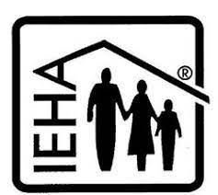

Extension Homemakers—Updates

March 7: Ag Day; thanks to those who are volunteering!
March 13: Spring District Meeting – Dubois County; contact Mary Louise by March 4 if you plan to attend. 812-887-4228
May Brunch: TBD; watch for details, or better yet, volunteer to help arrange!
April 1: Names of county officers due to DR – ARE YOU WILLING TO SERVE?
April 15: Club officers & member list due to Extension office. – Presidents, watch for forms in the mail.
Contact your club president for details on upcoming events as dates may have changed.

Mastering Home Food Preservation
Mastering Home Food Preservation is a 4-day intensive workshop on home food preservation practices. The course covers the science behind food preservation, proper preservation techniques, and where to find reliable, up-to-date resources. Each day includes lecture and discussion followed by time in the kitchen practicing different food preservation techniques. Workshop fee includes course instruction, lab materials, and Mastering Home Food Preservation notebook. Participants will also have opportunity to take home the foods they helped preserve. Food preservation topics covered include: food safety, freezing, drying, pickling, fermenting, jams and jellies, boiling water bath canning and pressure canning. The course includes labs for all listed food preservation processes except drying and fermentation, due to the length of those specific preservation processes. For inquiries, contact Tonya at 812-882-3509; short43@purdue.edu
When: June 11-14, 2024 9A-5P ET each day Where: VU Shircliff Humanities building
Cost: $275 Register at: https://cvent.me/PE1zxO
https://cvent.me/PE1zxO
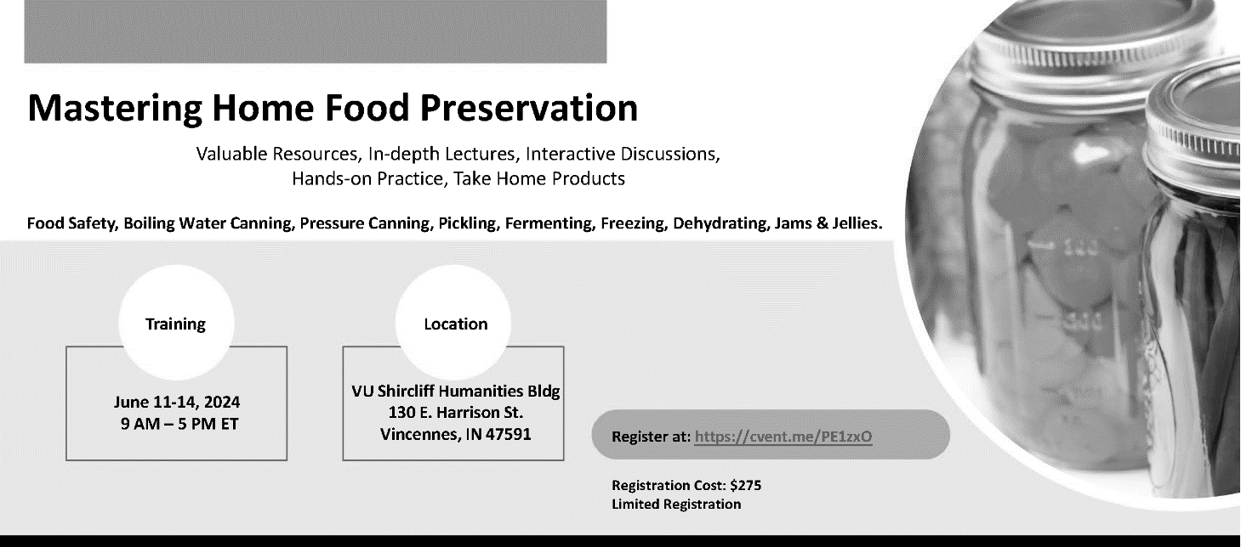

You’ve seen this before but we are in the final stretch. Please join in the upcoming weeks for a #SpeedTestBlitz. Complete at least 3 speed tests on 3 different days at 3 different times throughout the day & night from your address.

Indiana is receiving close to $870 million for broadband

– how much Knox County gets is up to you

A huge investment is underway to make sure rural and underserved communities have equal access to broadband. Where the money goes will be based on data collected. We need as many people as possible to submit information about their internet in order for Knox County to get the most funds possible. You may have completed similar speed tests over the past year or two – but this is the one that will determine where the money will go. Here’s what to do to make sure your location is counted:
- If you do not have internet, call 463-946-4699 or email IndianaBroadband@iot.IN.gov with your name, address, and contact number.
- If you do have internet of any kind (excluding cell data):
  - Visit https://connectingindiana.com/ to submit a speed test
    - Make sure you are connected to your home (or business) internet and not to cellular data.
    - It is important to do this multiple times at different times of the day
  - Visit https://broadbandmap.fcc.gov, enter your address and look to see which internet providers are listed as available for your address
    - Make sure the “fixed broadband” tab is selected
    - If your address comes up at the wrong spot, click on the dot that is closest to the address pin and verify that it is the correct address. If it is not, click location challenge on the right
    - If your provider availability list is incorrect, click availability challenge on the right
A couple of important notes:
- If your tested internet speed is less than 100Mbps download and 20Mbps upload (aka 100/20) you are considered underserved
- If your only internet option is satellite – you are considered unserved.
- If you have dedicated wireless (not cell phone data) that is considered served.
- This is not for cellular data. However, you can follow step 2 above and select the “mobile broadband” tab to see which services are listed as available for your address.
For step-by-step instructions with screen shots visit: https://pcrd.purdue.edu/3-steps-to-bring-better-broadband-to-indiana

IF YOU DO NOT HAVE ACCESS TO INTERNET OR YOUR SPEED IS LESS THAN 100/20, you should also visit https://www.in.gov/ocra/broadband/icp/ and click at the top where it says “click here to register” This will allow you to call special attention to your address. If you don’t know all the questions, that is ok. What is most important is your name, phone number, physical address, email address if you have one, and county. The rest can be left blank if you don’t know the answer.

Financial assistance is available to those within certain income levels. Visit https://www.fcc.gov/acp to learn more and apply for assistance.

ServSafe Manager and Food Handler courses
ServSafe Manager Certification is an approved training in the state of Indiana to become a certified food protection manager.
ServSafe Food Handler is for anyone else who needs basic food safety and food handling training, including home-based vendors, food service workers, volunteers, or others who work with food who only need the basic training. This course is NOT intended for food service managers.
Here are upcoming classes scheduled in our area. For more information including registration links visit www.purdue.edu/servsafe/workshops or https://extension.purdue.edu/county/knox/ServSafe.html
ServSafe Manager Classes
When | Where
April 18, 2024 | Washington, IN contact Jennifer 812-254-8668
June 7, 2024 | Vincennes, IN - register at: https://cvent.me/1mYOml
October 22, 2024 | Washington, IN contact Jennifer 812-254-8668
February 19, 2025 | Dubois County contact Chelsea 812-482-1782

ServSafe Food Handler Classes
When | Where
March 12, 2024 | Vincennes – More info or register at: https://cvent.me/0xKynD

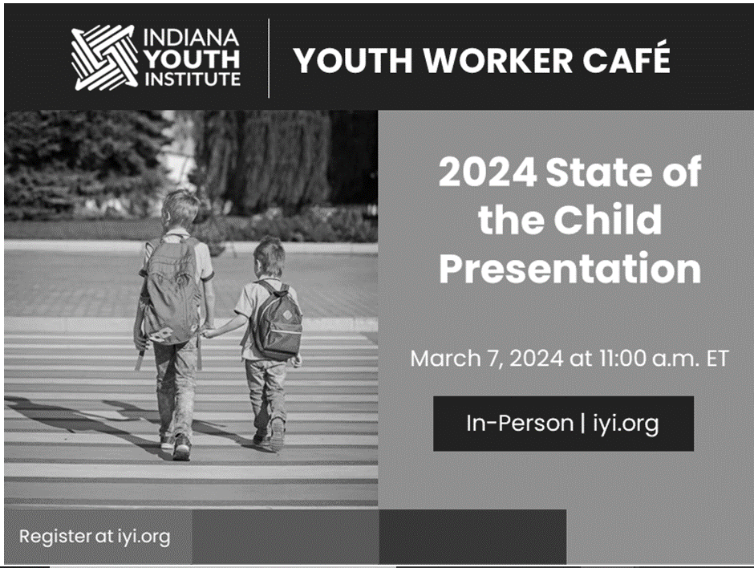
IYI Youth Worker Café: State of the Child

Join the Knox County System of Care and Purdue Extension - Knox County on March 7, from 11A-1P for Indiana Youth Institute’s 2024 State of the Child presentation.
We will discuss what the data means for youth in our community, how we might celebrate our successes, and address areas that need improvement.
Bring your knowledge of Knox County and passion for our youth to this important discussion! Lunch is provided.
Learn more and register at https://indianayouthinstitute.my.salesforce-sites.com/event/home/knox240307

This event has been pre-approved for 1.75 CEUs from the IU School of Social Work

Agriculture & Natural Resources
Valerie Clingerman-Extension Educator
Agriculture & Natural Resources
clingerman@purdue.edu

**Like Purdue Extension Knox County Ag and Natural Resources on Facebook.
**To receive monthly e-newsletters call 812-882-3509 or e-mail me to be added.

Upcoming Events
Date | Event | Time (Eastern) | Location | Contact info.
Mar. 5, 7, 12 &14 | Emergency Preparedness for Rural Families | 5:30-8:30pm | Gibson Co. Fairgrounds, Princeton | Register at:  wia.unl.edu/prep
Mar. 7 | Ag Day | 5:00-7:30pm | VU PE Complex, Vincennes | 812-882-3509
Mar. 8-9 | Southwest Indiana Homesteading Conference (see details on page 13) | 8th: 1:00-6:00pm  9th: 8:00am-4:00pm | Friedman Park, Newburgh | Register at Https://bit.ly/SWIHC2024
Mar. 12 | Spencer County PARP*, CCH** | 7:00pm-9:45pm | Spencer | Register by calling 812-362-8066
Mar. 13 | Daviess County Landwise Workshop PARP*, CCH** | 8:30am-3:00pm | Montgomery | Register by Mar. 4 by calling 812-254-8668
Mar. 15 | CORE training and testing (see details on page 12) | 9:30am-1:00pm | Evansville | Register due by Mar. 6th by contacting Amanda Mosiman at 812 897 6100 or bailey1@purdue.edu and then contact Metro Institute at 1 877 533 2900 to register and pay for exam
Mar. 25-26 | UAV(drone) Part 107 Preparation Program (see details on page 12) | 9:00am-5:00pm | Martin Co. 4-H Event Center, Loogootee | Registration due Mar. 15. Questions call 812-882-3509
Apr. 16, 23, 30 | Invasive Species Program (see details on page 13) | 5:30pm-8:30pm | Multiple locations | Registration due Apr. 9 at http://tinyurl.com/24InvasiveSpecies
*PARP=Private Applicator Recertification Program **CCH=Commercial Applicator Credits

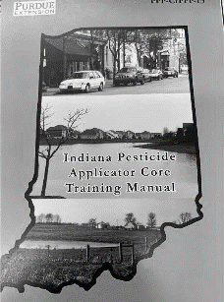
OISC CORE and Category 14 Training and Testing
Purdue Extension is providing a training program to help Private
Applicators prepare to take the Core Exam and Category 14 exam (for those
interested), in order to obtain their Private Applicator’s Permit.
The program objective is that once you’ve completed this training, you will
register to test on the Core Exam proctored by Ivy Tech testing center / Metro
Institute immediately following. This training is patterned off the one offered at
Purdue held by the Indiana Office of the State Chemist staff.
The training program is being offered at no charge, except the testing fee of $55.
This training will be held March 15th, 2024 at Ivy Tech Room 107 located at
3501 N First Ave, Evansville, IN 47710 from 9:30 am to 1:00 pm Eastern Standard
Time. Testing will occur from 1:00 PM to 6:00 PM on site. You are allowed 90
minutes to complete exam, but most complete the exam in about an hour.
If you need to take an additional exam, please schedule a second slot with
Metro.
The testing site has specific instructions, so if interested, one must register
first by contacting Amanda Mosiman at 812 897 6100 or bailey1@purdue.edu
and then contacting Metro Institute at 1 877 533 2900 to register and pay for
exam slot by March 6th, 2024.
If you require reasonable accommodation, please contact your local Purdue Extension Office prior to the program or call Purdue Extension-Warrick County at: 812-316-6258.

UAV (Drone) Technology Program
Interested in becoming a Commercial Unmanned Aerial Vehicle (UAV) remote pilot or already flying without the required Federal Aviation Administration (FAA) Certification?
You’re in luck! The Purdue Cooperative Extension Service is offering a UAV Signature Program teaching individuals UAV technology legal requirements, FAA Part 107 Remote Pilot Knowledge Test preparation, and useful UAV applications . Every participant will get hands-on experience flying manual and planned UAV flights.
Course topics are listed below:
- Camera Settings
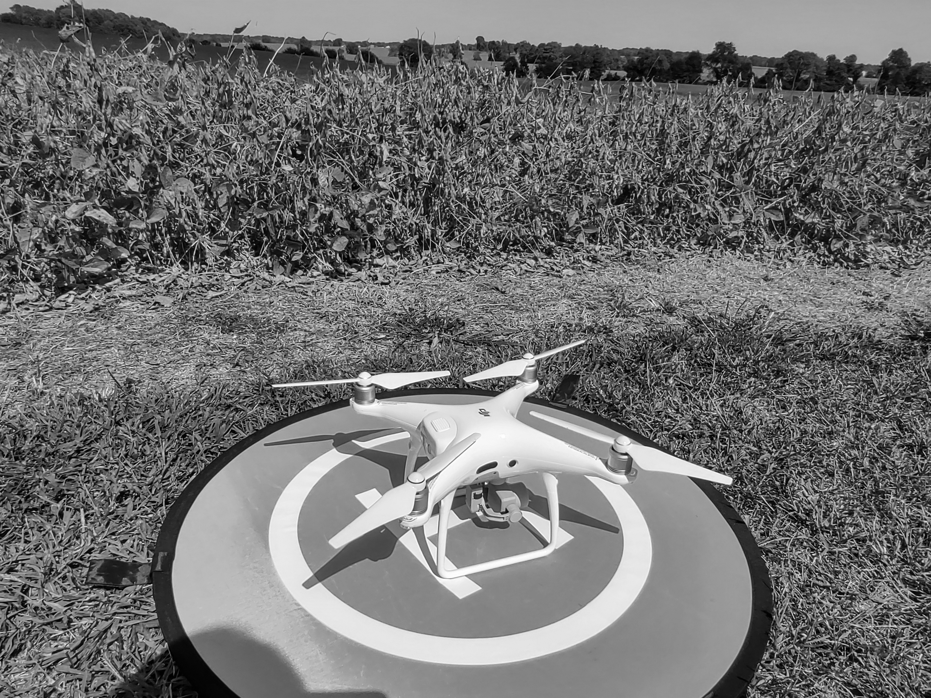
- Sensors and Artificial Intelligence
- FAA Part 107 Test Preparation
- Flight Plans & Record Keeping
- Flight Instructions
- Data management
- Image Quality & Troubleshooting
- Emergency Preparation
Our next class will be March 25-26 from 9:00am-5:00pm at the Martin County 4-H Fairgrounds Community Building. Registration and payment ($200/person) is due by March 15 by visiting https://cvent.me/8XR4KE. Contact Valerie Clingerman for additional questions 812-882-3509 or clingerman@purdue.edu.
Invasive Species Program
Invasive species are a threat to ecosystems and economy. They cause harm to native plants, animals, and habitats. These species outcompete native species, leading to loss of biodiversity and increased costs for management.
Purdue Extension Knox and Daviess Counties are proud to present the 2024 invasive species program.
April 16 – Introduction to Invasive Species and Reporting, Recording, and Tracking
*Meeting Location: Southwest Purdue Agricultural Center (4669 Purdue Rd. Vincennes, 47591)
April 23 – Invasive Forest Plants: ID and Management
*Meeting Location: Ouabache Trails Nature Center (3500 N Lower Fort Knox Rd. Vincennes, 47591)
April 30 – Invasive Fish & Aquatic Invertebrates : ID and Preventing Spread
*Meeting Location: East Fork State Fish Hatchery (5807 E 825 S Montgomery, 47558)
Each session will meet from 5:30-8:30pm eastern. Registration and payment are due by April 9th. Register at http://tinyurl.com/24InvasiveSpecies and send payment to Purdue Extension Daviess County (300 E Hefron St. Suite 119 Washington, IN 47501). If you have any questions, please contact the Extension Office 812-882-3509.

Southwest Indiana Homesteading Conference
Purdue Extension will offer the Southwest Indiana Homesteading Conference to help current, beginning, and prospective small farmers improve and diversify their small farm and homestead operations.
Friday’s sessions focus on food preservation, with topics such as boiling water bath, jams and jellies, pressure canning, and fermenting and pickling with hands-on practice in the kitchen.
Saturday’s topics include vegetable production, fruit production, soil fertility, composting, beekeeping, backyard poultry, urban agriculture, cover crops, organic systems, food storage panel discussion, small business resources, rain harvesting and storage, and mushroom cultivation. The event will feature vendor booths with products and services geared towards small farm and homestead operations.
The conference will be held on Friday and Saturday, March 8 & 9, at Friedman Park Event Center, 2700 Park Blvd., Newburgh, IN. Friday registration begins at 12:00 PM, with sessions from 1:00 PM – 6:00 PM eastern. Saturday registration begins at 8:00 AM EDT, with presentations running from 9:00 AM - 4:00 PM EDT. On Saturday, childcare for ages K-12 will be available.
Fees for this event are $35.00 per person (Friday), $40 per person (Saturday), and $20.00 for childcare (Saturday only), with registration available on-line at https://bit.ly/SWIHC2024. Registrations are due by March 1. Information is available at https://bit.ly/426IcYD or you can call 812-882-3509.


locust, and poplar are labelled as
Nonprofit Organization
U.S. Postage
PAID
Vincennes, IN
Permit No. 39
Purdue University Cooperative Extension Service
Knox County
4259 North Purdue Rd.
Vincennes, IN 47591

Nonprofit Organization
U.S. Postage
PAID
Vincennes, IN
Permit No. 39

Look inside for agriculture and natural resource, health and human science, and 4-H updates.
Meet your Purdue Extension-Knox County Office
Valerie Clingerman, Agriculture and Natural Resource Extension Educator/County Extension Director, clingerman@purdue.edu
Tonya Short, Health and Human Sciences Extension Educator, short43@purdue.edu
Mitch Wagoner, 4-H and Youth Development Extension Educator, mwagone@purdue.edu
Kim King, Office Manager, king286@purdue.edu
JoAnn Smith, Part-time secretary, smit3004@purdue.edu

