

In this issue
4-H & Youth Development
- 4-H Enrollment (pg. 2)
- 4-H Scholarship (pg. 2)
- Day at Statehouse (pg. 3)
- 4-H Camp (pg. 3)
- 4-H Bowling Party (pg. 3)
- 4-H Shirt Sponsorship (pg. 4)
- Fair Schedule (pg. 5)
- Upcoming Dates (pg. 6)
Health and Human Sciences
- Extension Homemakers
(pg. 7)
- Winter Blues (pg.7)
- Broadband Funding
(pg. 8)
- Servsafe Courses (pg. 9)
- Mastering Home Food Preservation (pg.9)
- Mental Health First Aid (pg.10)

Agriculture, Natural Resources, and Horticulture
- Upcoming Events (pg. 11)
- Irrigation Workshop (pg. 11)
- Fusarium Ear Rot (pg. 12)
- Soybean Cyst Nematode (pg. 12)
- Plant Hardiness Zones (pg. 13)

Office contact information:
4259 N Purdue Rd.
Vincennes, IN 47591

Phone: 812-882-3509
Fax: 812-882-3537

Website: www.extension.purdue.edu/knox

Email: knoxces@purdue.edu

Happy New Year to all!! I hope everyone had a prosperous and great 2024. If you need help with this the Extension Office probably has a program that teaches any topics you need, just let us know.
Help us to get broadband funding from the state by following the instructions listed in the Health and Human Section of this newsletter. If you need ServSafe, home preservation or mental first aid courses visit this section as well.
4-H enrollment and scholarships are all due soon. There are many other important 4-H dates listed inside.
In January and February there will be many agriculture related programs offered. See dates inside and let me know if you have questions about any of them.
If you have 4-H, health, human science, agriculture, natural resource, or gardening questions feel free to contact us at 812-882-3509. Our office is open Monday-Friday 8:00am-4:00pm eastern and we are closed on County Holidays.

Valerie Clingerman Extension Educator
Agriculture and Natural Resources/County Extension Director

Bite by Bite: Nutrition for Life

Podcast

Anywhere you look you can find a magic pill or formula promising to protect your health and transform your body in three easy steps. And, many of these claims do have (or at least started with) a speck of valid science. So, how to you cut through all the hype and separate truth from false marketing claims? The truth is, it doesn’t have to be that complicated! Join us as we explore and dissect different fads and trends to discover the real science behind food and nutrition.
Find us on Apple and Google podcasts, Radio Public and Spotify. Follow us on Facebook and Instagram @BiteByBiteNutritionForLife

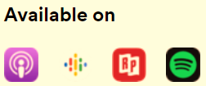

4-H & Youth Development
Mitch Wagoner
Extension Educator - 4-H Youth Development
mwagoner@purdue.edu

4-H Enrollment for 2023-2024

Parents can go into 4HOnline (https://v2.4honline.com) to enroll/re-enroll their children in 4-H for 2023
Push Ends: January 15, 2024
Certificated adult volunteers need to go into 4hOnline (https://v2.4honline.com) to re-enroll as an adult volunteer and to sign your 2024 Adult Behavior Expectations by Jan. 15!

If you do not have internet access, please contact the Extension Office (812-882-3509) so we can help!

2024 4-H Scholarships

4-H Accomplishment Scholarship – Sophomores, Juniors, Seniors, & College Freshman are eligible to apply for this scholarship!

4-H Senior Year Scholarship – All Seniors are eligible to apply. This one application will cover both County & State Scholarship.

4-H Club Scholarship - Senior in high school or currently enrolled in a post-secondary institution and will be transferring to Purdue University in the fall semester.

2024 4-H scholarship applications must be uploaded & submitted through 4HOnline by January 25, 2024!

Scholarship Workshop: January 9 at 6:00 pm at the Extension Office in the 1st classroom before the Junior Leader meeting.

For scholarship forms please visit this website:
https://extension.purdue.edu/4-H/get-involved/scholarships.html
4-H Day at the Statehouse

Join Indiana 4-H’ers in 7th-12th grade on February 13 on a trip to the Indiana Statehouse! They will learn about their state government through a day full of civic engagement & leadership opportunities. Participants will tour the state house, meet representatives, and have the opportunity to serve as student pages!
Please contact the Extension Office ASAP if you are interested. Spots are limited to attend. Depending on numbers of youth going, 4-H Council may cover the cost of $20 & round-trip transportation. The State will close registration on January 15 or when all the spots are taken!

4-H Camp
4-H Camp is June 3-5 at Historical Santa Claus Campground.
Camp Counselor “grade 9 - 12”
Counselor applications are DUE by February 15 via 4HOnline. Counselor trainings: April 11, May 9, & June 2.
Camper “grade 3 – 6”
Camper applications will open soon on 4HOnline. Extension Office will mail out a letter & post on social media when it opens. Camper registration will close on April 15.
Camp COST will be decided at the January 4-H Council meeting.

4-H Bowling Party at VU

On Tuesday, January 23 from 6:30 to 7:30 pm Knox County 4-H will be hosting a free Bowling Party at the VU Bowling Lanes for 4-H members.
4-H Members are welcome to invite a friend!
We would like to try to get a head count for the event. Please RSVP with the Extension Office at 812-882-3509 but you do not have to RSVP to attend.
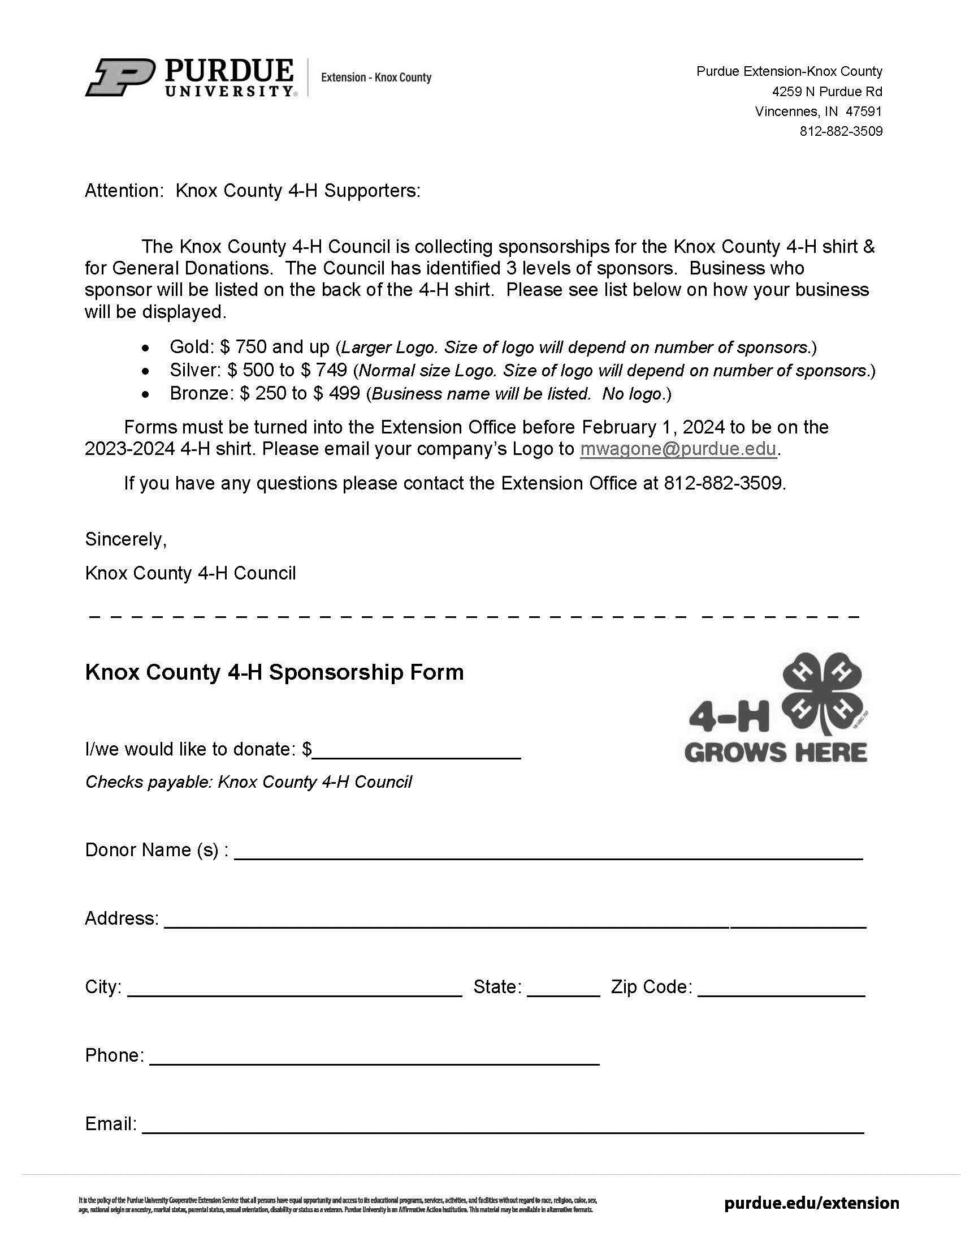
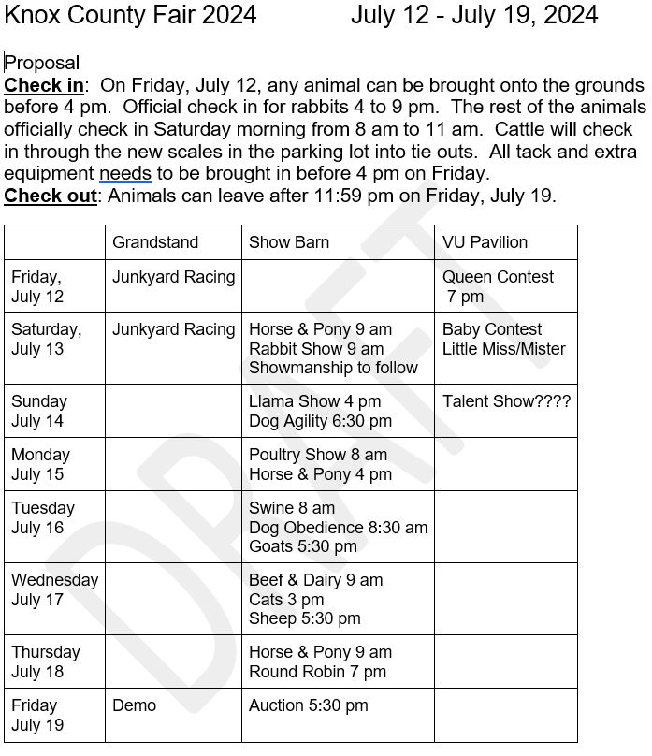

Upcoming Dates

- 4-H Scholarship workshop: January 9
- Junior Leader meeting: January 9
- 4-H Enrollment push ENDS: January 15
- 4-H Scholarships “Senior Year & Accomplishment” DUE: January 25
- 4-H Bowling Party at VU: January 23
- 4-H Day at the Indiana Statehouse: Feb 13. For grades 7-12.
- Cattle tagging: TBA
- Total Eclipse Day Camp: April 8
- Purdue Day of Giving: April 24
- Knox Co Ag Day: March 7
- State Robotics contest: March 9
- Poultry banding, Rabbit tattooing, Sheep/ Goat tagging: May 11
- Animal ID Deadline: May 15
- Project Add & Drop Deadline: May 15
- 4-H Camp: June 3 – 5.
- 4-H Academy @ Purdue: June 12 – 14. Open to grades 9-12.
- FYI, IN FFA State Convention: June 17 – 20.
- 4-H Band Workshop: June 22 – 24. Open to grades 9-12.
- 4-H Chorus Workshop “aka. Show Choir”: June 22 - 25. Open to grades 9-12.
- 4-H Round Up: June 24 – 26. Open to grades 7-9.
- Fair Deadlines: June 28
- Knox County Fair: July 12 – 19, 2024.
- Indiana State Fair: August 2 – 18, 2024.

Social Media

Facebook: “KnoxCountyIN4H”
Instagram: “@knoxcountyin4h”

Health & Human Sciences
Tonya Short, Extension Educator - Health & Human Sciences
Short43@purdue.edu www.facebook.com/KnoxCoHHS
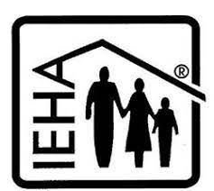

Extension Homemakers—Save the Date

January 8: County Council Meeting
March 4: County Council Meeting
See your program book for other IEHA due dates.

Beating the Winter Blues
Living in a region that fully experiences all four seasons has its benefits. The beauty of emerging spring, the joy of a cool pool on a hot summer day and the vibrance of a country drive on an autumn afternoon. Even winter can bring its own special spirit with the holidays and blanket of crisp white snow. But for many the long, dreary days can also evoke SAD - Seasonal Affective Disorder. SAD is a type of depression related to changes in season. For many afflicted persons this begins in the fall and continues through the winter. Symptoms of SAD include changes in energy, appetite or sleep patterns, inability to concentrate, increased irritability, social withdrawal or a sense of sadness, anxiety or hopelessness. No doubt, the ongoing aftershock of the pandemic has added to these symptoms.
As many as 20% of people in the US may be impacted by Seasonal Affective Disorder or a less severe version of the winter blues. SAD is most common among women, those who have a history of depression and those who live farther from the equator. A report last winter showed that Indiana ranked third in the number of Google searches made about the winter blues.
Whatever the cause, here are some things you can do to take care of yourself during the winter months. First, take care of your body. Try to stay on schedule. Eat regular balanced meals, maintain regular sleep patterns and stay active as much as possible. Studies show that those with mild depression find great benefit from regular exercise. Next, take care of your soul. Find a way to connect. Call a friend, volunteer, or join a club. It doesn’t matter how you connect; what matters is that you have genuine interactions with another person. Make time for activities you enjoy or start a new hobby. Whatever you do, be mindful and focus on that task and let go of the idea of multi-tasking. Lastly, seek help when needed. If symptoms are interfering with your ability to carry out daily activities and zapping your joy, talk to someone. That someone may be a trusted friend or it may be a medical provider or mental health professional.
The number one fact to know is that you are not alone and do not need to suffer alone. To learn more about managing depressive symptoms or how you can offer help to another person check out the resources at www.mhfirstaid.tools/diytools. Be Well Indiana (www.in.gov/bewellindiana/) also offers a great variety of resources including a helpline. To reach someone any time of the day call 211, enter your zip code then press 3 for free, confidential assistance. We are in this together and support is available.

Indiana is receiving close to $870 million for broadband

– how much Knox County gets is up to you

A huge investment is underway to make sure rural and underserved communities have equal access to broadband. Where the money goes will be based on data collected. We need as many people as possible to submit information about their internet in order for Knox County to get the most funds possible. You may have completed similar speed tests over the past year or two – but this is the one that will determine where the money will go. Here’s what to do to make sure your location is counted:
- If you do not have internet, call 463-946-4699 or email IndianaBroadband@iot.IN.gov with your name, address, and contact number.
- If you do have internet of any kind (excluding cell data):
  - Visit https://connectingindiana.com/ to submit a speed test
    - Make sure you are connected to your home (or business) internet and not to cellular data.
    - It is important to do this multiple times at different times of the day
  - Visit https://broadbandmap.fcc.gov, enter your address and look to see which internet providers are listed as available for your address
    - Make sure the “fixed broadband” tab is selected
    - If your address comes up at the wrong spot, click on the dot that is closest to the address pin and verify that it is the correct address. If it is not, click location challenge on the right
    - If your provider availability list is incorrect, click availability challenge on the right
A couple of important notes:
- If your tested internet speed is less than 100Mbps download and 20Mbps upload (aka 100/20) you are considered underserved
- If your only internet option is satellite – you are considered unserved.
- If you have dedicated wireless (not cell phone data) that is considered served.
- This is not for cellular data. However, you can follow step 2 above and select the “mobile broadband” tab to see which services are listed as available for your address.
For step by step instructions with screen shots visit: https://pcrd.purdue.edu/3-steps-to-bring-better-broadband-to-indiana

IF YOU DO NOT HAVE ACCESS TO INTERNET OR YOUR SPEED IS LESS THAN 100/20, you should also visit https://www.in.gov/ocra/broadband/icp/ and click at the top where it says “click here to register” This will allow you to call special attention to your address. If you don’t know all the questions, that is ok. What is most important is your name, phone number, physical address, email address if you have one, and county. The rest can be left blank if you don’t know the answer.

Financial assistance is available to those within certain income levels. Visit https://www.fcc.gov/acp to learn more and apply for assistance.

ServSafe Manager and Food Handler courses
ServSafe Manager Certification is an approved training in the state of Indiana to become a certified food protection manager.
ServSafe Food Handler is for anyone else who needs basic food safety and food handling training, including home-based vendors, food service workers, volunteers, or others who work with food who only need the basic training. This course is NOT intended for food service managers.
Here are upcoming classes scheduled in our area. For more information including registration links visit www.purdue.edu/servsafe/workshops or https://extension.purdue.edu/county/knox/ServSafe.html
ServSafe Manager Classes
When | Where
April 18, 2024 | Washington, IN contact Jennifer 812-254-8668
June 7, 2024 | Vincennes, IN - register at: https://cvent.me/1mYOml
October 22, 2024 | Washington, IN contact Jennifer 812-254-8668
February 19, 2025 | Dubois County contact Chelsea 812-482-1782

ServSafe Food Handler Classes
When | Where
March 12, 2024 | Vincennes – More info or register at: https://cvent.me/0xKynD

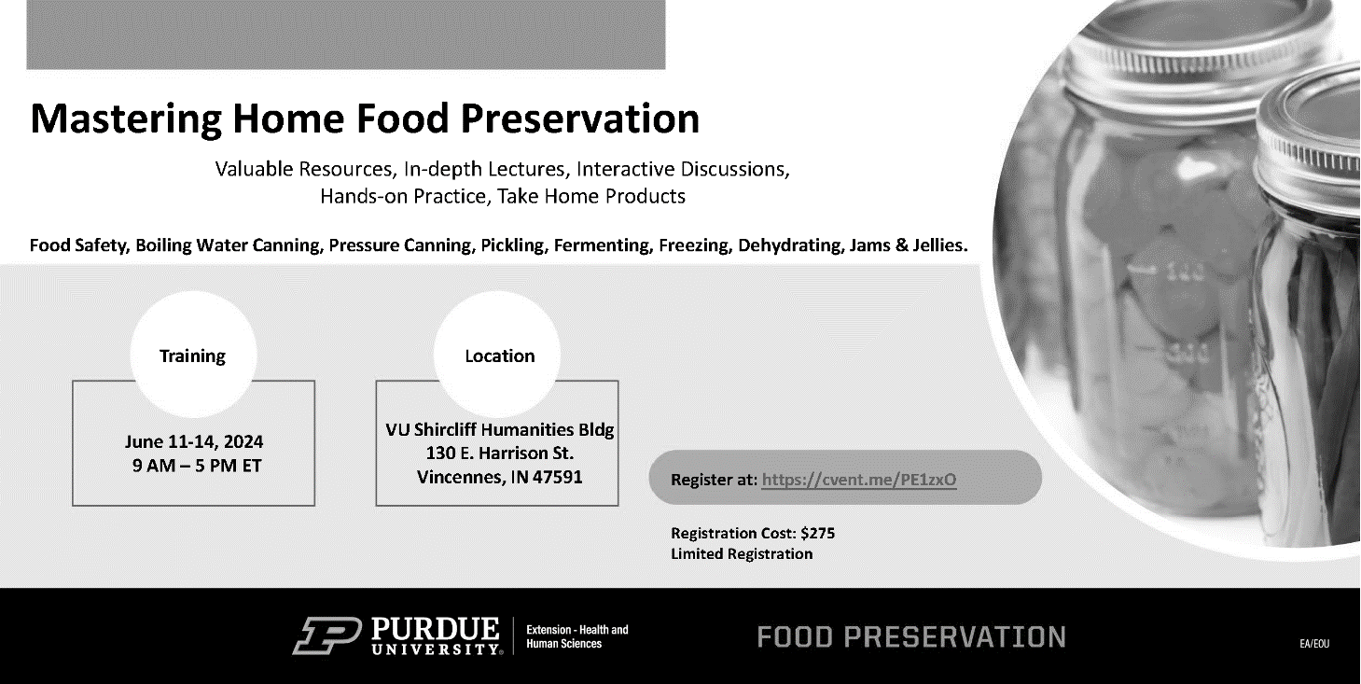
https://cvent.me/PE1zxO


Agriculture & Natural Resources
Valerie Clingerman-Extension Educator
Agriculture & Natural Resources
clingerman@purdue.edu

**Like Purdue Extension Knox County Ag and Natural Resources on Facebook.
**To receive monthly e-newsletters call 812-882-3509 or e-mail me to be added.

Upcoming Events
Date | Event | Time (Eastern) | Location | Contact info.
Jan. 1 | Office Closed | - | - | -
Jan. 15 | Office Closed | - | - | -
Jan. 18 | Irrigation Workshop (PARP*, CCH**, CEU***) See details below. | 9:00am-12:00pm | VU Ag Center, Vincennes | Register by Jan. 9th by calling 812-882-3509
Jan. 29 | Annual Extension Board Meeting | 5:00pm | Beckes Student Union, Vincennes | Register by calling 812-882-3509
Jan. 31 | Sprayer School | TBD | VU Ag Center, Vincennes | 812-882-3509
Feb. 7 | Area Corn and Soybean Day | TBD | Evansville | 812-882-3509
Feb. 15 | Pork Quality Assurance Plus Training | TBD | Jasper | 812-482-1782
Mar. 7 | Ag Day | TBD | VU PE Complex, Vincennes | 812-882-3509
Mar. 8-9 | Southwest Indiana Homesteading Conference | TBD | Friedman Park, Newburgh | 812-882-3509
Mar. 15 | CORE training and testing | TBD | Evansville | 812-882-3509
Mar. 25-26 | UAV(drone) Part 107 Preparation Program | 9:00am-5:00pm | Martin Co. 4-H Event Center, Loogootee | Registration due Mar. 15. Questions call 812-882-3509
*PARP=Private Applicator Recertification Program **CCH=Commercial Applicator Credits ***CEU=Certified Crop Adviser

2024 Irrigation Workshop
Join us January 18, 2024 at the Vincennes University Agricultural Center (4207 N Purdue Rd. Vincennes, 47591) from 9:00am-noon to learn about irrigation systems. Lyndon Kelley the Purdue and Michigan State Irrigation Educator will join us to discuss Irrigation scheduling and efficiency and chemigation water volume and other issues. Dr. Darcy Telenko, Purdue Field Crop Pathologist will be discussing timing and efficacy of fungicide applications. Private, Commercial, and Certified Crop Adviser credits have been applied for. Please register by Jan. 9th by calling 812-882-3509 or email clingerman@purdue.edu.

Fusarium ear rot in corn
Fusarium ear rot is caused by a fungal disease that can infect corn seedlings and developing kernels. This disease can grow for awhile before showing symptoms and once symptoms appear the plants will have a stalk or ear rot. Typically yield is minimally impacted however this disease can form a mycotoxin called fumonisin which can affect livestock and people.
Identification will be critical to determine a management plan. Kernels are in patches on the ear and kernels damaged by insects are most at risk for developing fusarium symptoms. Kernels can be a tan to brown color. When fungal growth is visible infected kernels can appear salmon, pink, or white in color. Sometimes kernels will have white streaks.
Fumonisin poisoning can cause many toxic effects. Equine and swine are the most sensitive. The USDA has published guidelines for the maximum amounts of fumonisin allowed in food and feeds. This table can be found at https://extension.purdue.edu/extmedia/BP/BP-86-W.pdf.
To minimize economic loss scout fields when corn reaches R6 to determine presence of fusarium ear rot. If there is significant rot or insect damage harvest this field first. Once corn reaches 17% moisture fungal growth and fumonisin production should stop. Dry grain to 15% for safe storage.
Reducing insect damage will reduce the impact of Fusarium ear rot. Corn hybrids with Bt traits to manage insects have less fusarium ear rot and fumonisin. There are few foliar fungicides on the market but check efficacy for this disease prior to use. Planting hybrids with less susceptibility to fusarium ear rot will also reduce the risk of fumonisin.
For more information visit https://extension.purdue.edu/extmedia/BP/BP-86-W.pdf. Or contact the Extension Office.
Soybean Cyst Nematode, Know Your Numbers
Soybean Cyst Nematode (SCN) is a plant parasitic roundworm that caused yield loss in soybean. Oftentimes a gradual yield loss over time is how it starts and sometimes it can go unnoticed until plant stunting and yellowing start appearing. SCN prefers sandier soils and can be confused with drought stress, wet areas, nutrient deficiencies, herbicide injury, and other diseases.
Many soybean varieties state that they are resistant to SCN however over 95% use the PI88788 source of resistance. The second most common source is “Peking” resistance. As with herbicides, insecticides, and fungicides using the same active ingredient over time (in the case the same source of resistance) is leading to SCN populations that are increasing on the PI88788 resistant varieties in some locations. Rotating sources of resistance will be important in these locations. Reducing plant stress, crop rotation, cleaning equipment between fields, and some seed treatments can also help manage SCN populations. The best way to monitor your SCN population is through sampling every six years. To learn more visit: https://cropwatch.unl.edu/plantdisease/soybean/soybean-cyst-nematode or contact the Extension Office.
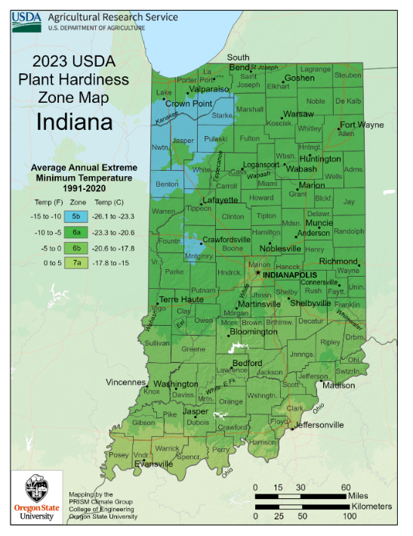
Plant hardiness zone changed, what does that mean for us?

The United States Department of Agriculture (USDA) revised their cold hardiness zone maps. These maps are used to help us understand what perennial plants can survive our winters. These hardiness zones are created based off average annual extreme minimum winter temperatures. These data have been collected for over 30 years and the last time this map was updated was in 2012.
So what has changed? In 2012, most of northern Indiana was a zone 5b (-15 to -10 degrees F) and is now mostly a 6a (-10 to -5 degrees F). Most of southern Indiana was a 6a but in the southwest corner it was a 6b (-5 to 0 degrees F). In 2012, Knox County was split in half, the northern half was a 6a and the southern half was a 6b. All of Knox County is now a 6b but the counties south of us start zone 7a (0-5 degrees F). Basically, all the zones shifted north.
So what does this mean? When choosing trees, shrubs, and other perennials for our gardens and landscapes we want to make sure to choose things that will survive our winter. When purchasing these items make sure to read the tags as they should state what zone they will survive in. If a plant is rated as good for zones 6b and we get temperatures down to -15 it could sustain damage depending on the situation. If the plant is good for zones 6-7 then it could get damage especially if we get a cold winter. If it can survive in a zone 4-6 it should be fine though. The lower numbered zones are further north therefore the plants can tolerate cooler temperatures versus the higher numbered zones which are warmer climates with milder winters. Typically, plant tags will list a range of zones that you can use to determine if you would like to purchase the plants. Remember these hardiness zone maps are based on average cold temperatures and we do experience temperatures lower that -5 degrees F.
Another take home from this map is that we could warm earlier in the spring and stay warmer longer in the fall. To me that is great since I am not much of a winter person but it also means pests could come in earlier. We are experiencing a slight warming of temperatures but we are seeing more extreme weather events more frequently such as heavy rain events, flooding, drought, and tornadoes. Since we are still a zone 6 there are no major changes in what plants we can use but we can adapt to these extreme weather events. This could mean adding mulch to areas to conserve moisture, installing irrigation, and choosing plants that don’t have weak branches that can break easily in storms.
You can visit the plant hardiness zone maps at https://planthardiness.ars.usda.gov/ or you can contact the Purdue Extension-Knox County office by calling (812) 882-3509 or by emailing clingerman@purdue.edu


locust, and poplar are labelled as
Nonprofit Organization
U.S. Postage
PAID
Vincennes, IN
Permit No. 39
Purdue University Cooperative Extension Service
Knox County
4259 North Purdue Rd.
Vincennes, IN 47591

Nonprofit Organization
U.S. Postage
PAID
Vincennes, IN
Permit No. 39

