In this issue
4-H & Youth Development
- 4-H Enrollment (pg. 2)
- 2022/2023 4-H Numbers
(pg. 2)
- State Fair Exhibitors (pg.3)
- Upcoming Dates (pg. 4)
- Solar Eclipse (pg.4)
Health and Human Sciences
- Extension Homemakers
(pg. 5)
- IEHA Fall District Meeting
(pg. 6)
- Pressure Canner Gauges
(pg. 7)
- Servsafe Courses (pg. 8)
- Nutrition Podcast (pg. 8)

Agriculture, Natural Resources, and Horticulture
- Upcoming Events (pg. 9)
- DIY Lawncare (pg. 9)
- Farm Values and Cash Rental Rates (pg. 10)
- Confined Space Casualties (pg. 10)
- How to plant trees (pg. 11)
Office contact information:
4259 N Purdue Rd.
Vincennes, IN 47591

Phone: 812-882-3509

Fax: 812-882-3537

Website: www.extension.purdue.edu/knox

Email: knoxces@purdue.edu

One of my favorite fall activities is to visit our local farm stands and get apples, pumpkin, and pretty much any other late season produce I can stock up on. I hope everyone enjoys the last of the fresh produce until winter arrives.
Fall is also a great time to do lawn maintenance. If you are not sure what to do in the fall, I will be offering a DIY Lawncare class in September to answer those questions (see details inside).
Canning season is also here, if you need pressure gauges checked learn more inside.
4-H enrollment will begin October 1st so if you have youth K-12 interested in 4-H now is the time to register. Also, check out all our youth that participated in state fair. Congratulations to all of them for a job well done! See details inside.
If you have 4-H, health, human science, agriculture, natural resource, or gardening questions feel free to call us at 812-882-3509.

Valerie Clingerman Extension Educator
Agriculture and Natural Resources/County Extension Director

Mental Health First Aid for Rural Communities
“It takes a village to raise a child” is true yet incomplete. We never outgrow the need for social connection and empathetic support; a guiding hand or caring word. While rural communities may be challenged by a deficit of local services, they make up for it with connections and mutual support.
Mental Health First Aid for Rural Communities is a course designed to prompt participants to examine the strengths and needs of their community related to mental wellness. The course examines common mental health challenges, and teaches how to recognize when someone might be struggling and confidently offer support. What participants are saying:
“I will be more observant and feel more equipped to have difficult conversations.” “Helped me understand more and change my outlook and gave me new understanding and tools to use.” “I enjoyed the class. The material was heavy, but the instructor handled it well.”
To learn more, contact the Extension office or visit www.mentalhealthfirstaid.org
4-H & Youth Development
Mitch Wagoner
Extension Educator - 4-H Youth Development
mwagoner@purdue.edu

4-H Enrollment for 2023-2024

Parents can go into 4HOnline (https://v2.4honline.com) to enroll/re-enroll their children in 4-H for 2023
Starts: October 1, 2023 Ends: January 15, 2024
Certificated adult volunteers need to go into 4hOnline (https://v2.4honline.com) to re-enroll as an adult volunteer and to sign your 2024 Adult Behavior Expectations by Jan. 15!

If you do not have internet access, please contact the Extension Office (812-882-3509) so we can help!

Knox County Fair: July 12-19, 2024
Indiana State Fair: TBA for 2024

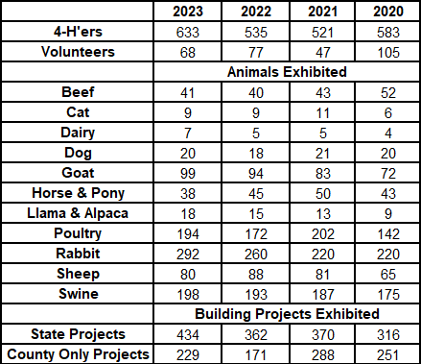
As the 2022-2023 4-H program year comes to a close, we reflect on the past year as we plan for the 2023-2024 4-H program year.
Youth reported they spent 30,213 hours learning by doing and contributed $402,916 to the local economy.
The future still looks bright to continue to develop youth.

Knox County 4-H Exhibitors at State Fair:

Abel, Aaliyah
Abel, Brylee
Althoff, Jayna
Althoff, Jon
Anderson, Andi
Anthis, Lillian
Baldwin, Kieran
Beard, Caroline
Beard, Makinley
Bilskie, Isabelle
Black, Kevi
Blubaum, Taylor
Bolger, Allison
Brown, Bryar
Bunte, Josie
Candler, Lauren
Cardinal, Bennett
Cardinal, Bryson
Cardinal, Dallas
Cardinal, Jonathan
Carter, Landon
Carter, Morgan
Catt Jr Robbie
Cockerham, Katelyn
Combs, Kayla
Davis, Brinxley
Deckard, Alea
Decker, Adron
Decker, Chloe
DeCoursey, Jenna
DeLisle, Addyson
Dellinger, Baxter
Dellinger, Eliza
Dellinger, Lee
Detweiler, Grace
Dillon, Jacob
Duckworth, Bryn
Dunn, Abigail
Dunn, Landon
Dyer, Jocelyn
Ferguson, Samantha
Fields, Sirkka
Garretson, Avery
Gladish, Braelyn
Gladish, Taylor
Gomez, Anthony
Hammelman, Jackson
Hammelman, Jeremiah
Hammelman, Taylor
Hatcher, Angel
Hatfield, Hattie
Hays, Meredith
Hedge, Madison
Hughes-Pritchard, Lewis
Kahre, Briar
Kahre, Sidney
Kaiser, Cora
Kaiser, Hazel
Kaiser, Madeleine
Keller, Harlee
Kixmiller, Gavin
Klem, Kali
Lafferty, Kadie
Lamanske, Hayden
Lee, Jacob
Loudermilk, Braydon
Loudermilk, Levi
McGuyer, Molly
Misiniec, Jacob
Misiniec, Alexis
Nettles, Caleb
Noland, Addy
Norrick, Mason
Nowaskie, Hayden
Nowaskie, Holt
Nowaskie, Sarah
Oakes, Laney
Peltier, Ryan
Perry, Macyn
Quarterman, Kyndall
Rickard, Natalee
Ricketts, Jace
Risley, Alexa
Roark, Avery
Robinson, Paris
Rode, Kaelyn
Rode, Kambric
Rode, Krawford
Schopmeyer, Evelynn
Schopmeyer, Orrin
Schroeder, Luke
Small, Dillon
Smith, Hazel
Smith, Kadee
Smith, Nathan
Spanger, Conner
Sprague, Leah
Stoltz, Rylee
Sydow, Samuel
Tiek, Brennen
Trabant, Olivia
Vieke, Maggie
Vieke, William
Wagoner, Abigail
Wells, Regan
Whipkey, Jada
Will, John
Will, Madison
Wilson, Caleb
Wilson, Trenton
Wolters, Adalin
Wonning, Alli
Wonning, Brady
Young, Madilyn

Upcoming Dates

- Area 3 4-H/FFA Livestock Skill-a-thon CDE at Vanderburgh Co Fairgrounds: September 12
- 4-H Enrollment Begins: October 1!!
- National 4-H Week: October 2-8
- Area 3 4-H/FFA Soils CDE at SWPIC: October 3
- Indiana 4-H Leadership Summit: October 21
- Area 3 4-H/FFA Crops, Forestry, & Entomology CDE: November 8
- 4-H Enrollment push ENDS: January 15, 2024
- 4-H Scholarships “Senior Year & Accomplishment” DUE: January 25, 2024

Solar Eclipse

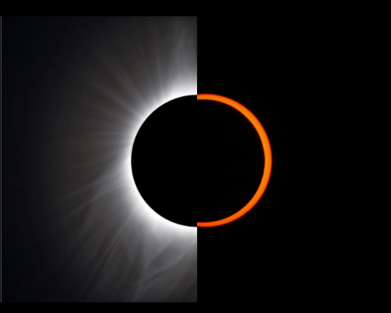
- Annular solar eclipse: Oct 14, 2023.
An annular eclipse occurs when the Sun and Moon are exactly in line with the Earth, but the apparent size of the Moon is smaller than that of the Sun.
Image: https://www.greatamericaneclipse.com/basics
Info: https://en.wikipedia.org/wiki/Solar_eclipse

- Total solar eclipse: April 8, 2024.
A total eclipse occurs when the dark silhouette of the Moon completely obscures the intensely bright light of the Sun, allowing the much fainter solar corona to be visible.

Social Media

Facebook: “KnoxCountyIN4H”
Instagram: “@knoxcountyin4h”

Health & Human Sciences
Tonya Short, Extension Educator - Health & Human Sciences
Short43@purdue.edu www.facebook.com/KnoxCoHHS

Extension Homemakers—Save the Date

September 11: Final planning meeting for district meeting
Sept 26: Fall District Meeting – see next page
November 6: County Council Meeting

A note to Knox County Extension Homemaker members
Fall District Meeting is soon approaching. Please read below for more details and reach out to Barbara if you have questions.

Fall District Meeting is September 26th at Community Methodist Church in Vincennes, IN. Registrations begins at 8:30. Our guest speaker will be Ann Pratt from the Red Skelton Museum. The theme of our meeting will be about the Red Skelton and the other interesting sites Vincennes has to offer.

Here are some details on how everyone can pitch in to make this a super success.
- Each club is asked to help in providing breakfast items. Each Club President will address this at their monthly meeting. We are planning on 100 guests for the day.
- Volunteers are needed to help set up the venue on Monday, September 25th.
- Volunteers are needed the day of the event. If you can help, but cannot stay for the meeting this is ok. Let your club president know what day and time you can help.
- There will be a silent auction. Please bring an item for auction. If you cannot attend, consider giving your donation to your club president. This is also a way for us to earn money to defray expenses for our hosting the District Meeting.

I am very excited about the response I have gotten from our Knox County Extension Homemakers Club members. Hope you can attend and join the fun. Watch for additional information about registration, cost and registration deadline.

Sincerely,

Barbara Holscher, President
812-881-7688

IEHA Fall District Meeting
September 26, 2023
Explore Knox County!

Where: Community Church of Vincennes, 1548 S Hart Street Rd, Vincennes, IN 47591
Registration and Refreshments: Time TBA
Lunch: McAllister’s, macaroni salad, fruit, dessert
Guest Speaker: Anne Pratt, Executive Director, Red Skelton Museum of American Comedy
Cost: $15 payable to Knox County Extension Homemakers
RSVP: Must be received by September 16.
Please submit one list of attendees and one check per county (payable to Knox County Extension Homemakers) to: Mary Louise Hess, 1873 W. Carie Rd., Vincennes, IN 47591
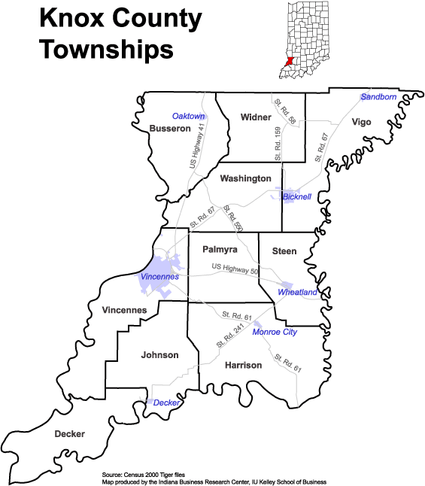

Complete and return with payment
Name: ____ _______________________ Phone: __________________________
County: _________________________ Any dietary restrictions: __________________

A pressure canner story
When we are pressure canning at 11PSI, it is the heat, not the pressure, that destroys microorganisms to make your canned food safe. A pressure canner at 11 pounds pressure is cooking at 240°F. Water boils at 212°F, so we’re cooking pretty hot! However, if your dial gauge is incorrect, you might not reach that magical botulism-killing temperature. Or, the inverse, your canner might get too hot resulting in possible mishaps like excess liquid loss or worse.
The age of your dial gauge is also not a great predictor of reliability. Last season a gentleman brought in two gauges to test. One had belonged to his great-grandmother; the other was new. The antique gauge tested perfect – spot on. The new one was inaccurate and unsafe to use.
It is important to have your dial gauge tested at the beginning of each season. Things that could impact your gauge include being bumped or knocked around or being stored somewhere that is exposed to extreme temperatures like a garage or shed.
The Knox County Extension office has a master gauge and is able to test your pressure canner gauge. Contact Tonya at 812-882-3509 to schedule an appointment.
Pressure canners that use a “jiggler” rather than a gauge do not need to be tested; however you are still free to bring the canner in for an overall inspection, if desired.
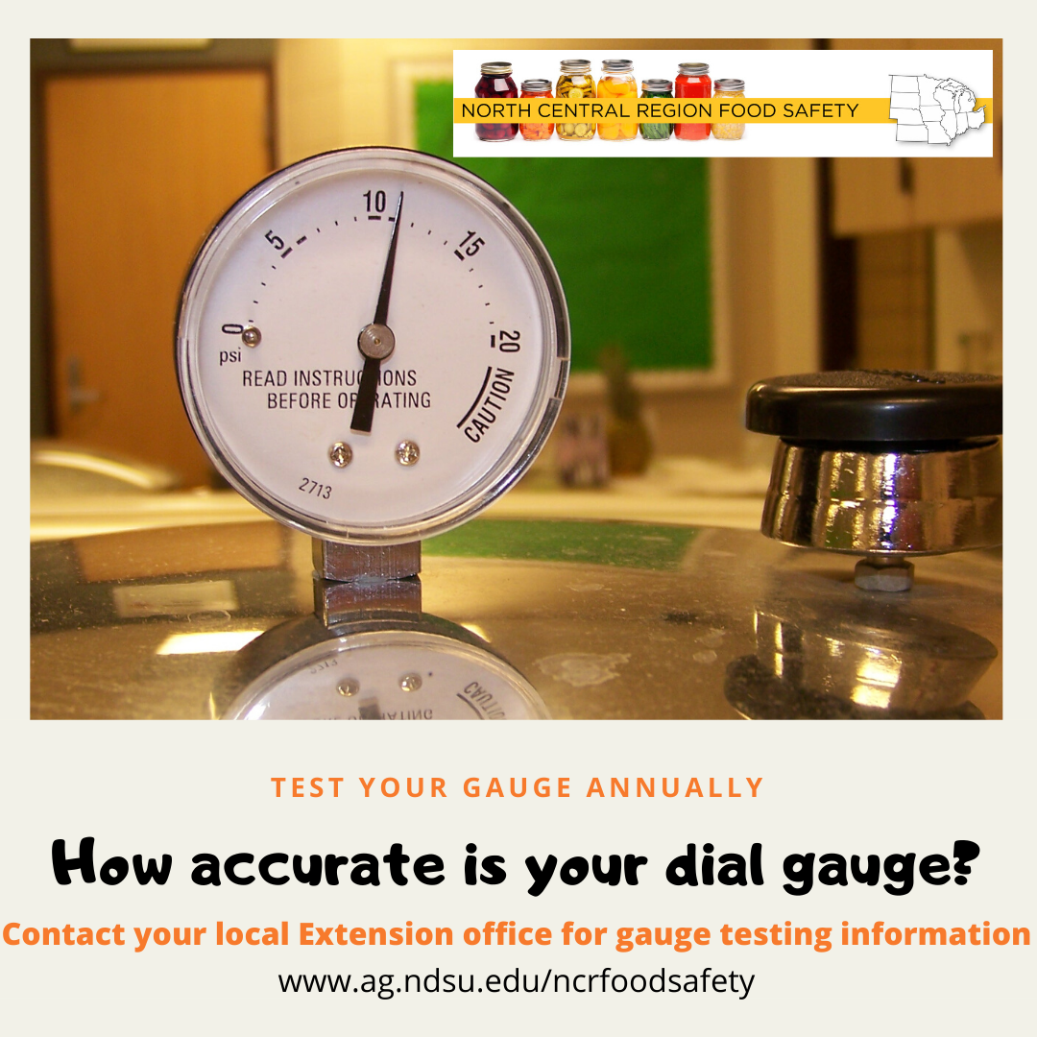

ServSafe Manager and Food Handler courses
ServSafe Manager Certification is an approved training in the state of Indiana to become a certified food protection manager.
ServSafe Food Handler is for anyone else who needs basic food safety and food handling training, including home-based vendors, food service workers, volunteers, or others who work with food who only need the basic training. This course is NOT intended for food service managers.
Here are upcoming classes scheduled in our area. For more information including registration links visit www.purdue.edu/servsafe/workshops or https://extension.purdue.edu/county/knox/ServSafe.html
ServSafe Manager Classes
When | Where
November 2, 2023 | Washington, IN contact Jennifer 812-254-8668

ServSafe Food Handler Classes
When | Where
October 10, 2023 | Vincennes - More info or register at: https://cvent.me/wYQRwm
March 12, 2024 | Vincennes – More info or register at: https://cvent.me/0xKynD

Bite by Bite: Nutrition for Life

Podcast

Anywhere you look you can find a magic pill or formula promising to protect your health and transform your body in three easy steps. And, many of these claims do have (or at least started with) a speck of valid science. So, how to you cut through all the hype and separate truth from false marketing claims? The truth is, it doesn’t have to be that complicated! Join us as we explore and dissect different fads and trends to discover the real science behind food and nutrition.
Find us on Apple and Google podcasts, Radio Public and Spotify. Follow us on Facebook and Instagram @BiteByBiteNutritionForLife

Agriculture & Natural Resources
Valerie Clingerman-Extension Educator
Agriculture & Natural Resources
clingerman@purdue.edu

**Like Purdue Extension Knox County Ag and Natural Resources on Facebook.
**To receive monthly e-newsletters call 812-882-3509 or e-mail me to be added.

Upcoming Events
Date | Event | Time (Eastern) | Location | Contact info.
Sept. 9 | Southern Indiana Purdue Agriculture Invasive Species Control for Woodlands Field Day | 9:00am-5:00pm | Dubois | Register by calling  812-482-1171 Ext. 3
Sept. 12,13, 19, 20 | DIY Lawncare (see detail below) | 5:30pm | Knox Co. Public Library, Vincennes | RSVP by Sept 5th at https://tinyurl.com/DIYLawn23
Sept. 23 | Monarch Madness | 11:00am-2:00pm | Fox Ridge Park, Vincennes | 812-882-3509
Sept. 29 | Stockmanship for beef | 1:00pm-7:00pm | Dubois | Register at www.indianaforage.org Questions call 812-678-4427
Sept. 30 | Stockmanship for goats, and sheep | 10:00am-5:00pm | Dubois | Register at www.indianaforage.org Questions call 812-678-4427
Nov. 13 | Knox County PARP*/CCH** | 10:00am | TBD | 812-882-3509
Dec. 12 | Agriculture Outlook | Morning, TBD | TBD | 812-882-3509
Dec. 12 | Knox County PARP*/CCH** | TBD | Vincennes | 812-882-3509
*PARP=Private Applicator Recertification Program **CCH=Commercial Applicator Credits

DIY Lawncare Class to help answer your lawn questions

Attention homeowners, property renters, and homeowner associations. This may be a class for you if you would like to learn about the basics of lawncare, lawn pest problems, weed identification and management, and establishing or renovating a lawn.

Sessions will meet Sept. 12, 13, 19, & 20th at the Knox County Public Library (502 N 7th St. Vincennes) from 5:30pm-7:30pm.

Cost: $10 (for binders, handouts, and snacks)

Register by Sept. 5th at https://tinyurl.com/DIYLawn23

Questions? Call the Extension Office 812-882-3509 or email clingerman@purdue.edu.
New Purdue Agricultural Economics Report Reveals Farm Values and Cash Rental Rates
Two of the most common questions I get are about farmland values or cash rental rates. Every August Purdue releases these data and it is broken down by regions in the state. These data were collected in June of 2023 and is also determined by average corn yields for the property.
In southwest Indiana, top farm land is expected to yield an average of 227 bu/a and the average price was $12,857/a. Average ground averages 193 bu/a and average price was $9,179, and poor ground averages 160 bu/a and the average price was $7,182.
Cash rent values are determined the same way as land prices. In southwest Indiana, top farm ground average price was $296/a, average was $239/a, and poor was $173/a.
For those readers that enjoy numbers this report also shares value of land per bushel, projected land values, drivers on Indiana farmland values, interest rates, corn and soybean prices, and more. You can find the report at https://tinyurl.com/23PAER or contact the Extension Office 812-882-3509.
Image by Memed_Nurrohmad from Pixabay

2022 Summary of U.S. Agricultural Confined Space-Related Injuries and Fatalities
Written by: Bill Field, Purdue University

The following are highlight from the 2022 findings:
• No fewer than 83 cases, 24 fatal and 59 non-fatal,1 involving agricultural confined spaces were documented in 2022, representing a 40.7% increase over the 59 cases in 2021
• There were no fewer than 42 grain related entrapments in 2022 representing a 44.8% increase over 2021. This was the highest number of grain entrapments in over a decade. The balance of 41 cases involved livestock waste handling facilities, entanglements inside confined spaces, falls from confined space structures, and grain dust explosions or fires
• Eight incidents involved more than one victim
• Eleven cases involved livestock waste storage pits or lagoons, eight of which were fatal
• Three grain dust explosions resulting in 18 non-fatal injuries were documented2. Fifteen of these injuries were attributed to a single incident in Iowa.
• One female case was documented in 2022, which occurred inside a cotton module builder
• 29% (24) of 2022 cases were fatal compared to 59% historically
• Iowa reported the most cases, 24, including those relating to fires and explosions (fifteen of these cases resulted from a single explosion incident), followed by Indiana (6), Minnesota (6) and Ohio (6)
• Iowa reported the most grain-entrapment cases in 2022 (9). Indiana, Iowa, Minnesota and Illinois, in that order, have historically recorded the most grain entrapment cases
• OSHA Regions 5 and 7 have historically accounted for 67.9% of all documented agricultural confined space-related incidents

To read this complete report see the link below: https://tinyurl.com/ConfinedSpaceInjuries

Fall can be a great time to plant trees, follow these steps for proper planting

Incorrect planting is typically the most common reason I see trees die. Sometimes trees will die shortly after planting due to poor root contact with the soil or other times it may take many years and there may be a girdled root due to planting too deep. If you follow the below tips that will help you have a healthy tree for many years.

- Select proper tree for site. Pick a tree that will do well for your location. Make sure to plan for the mature size of the tree and give it plenty of vertical and horizontal space. This includes plenty of space for roots.
- Dig planting hole 1-1.5x the size of the root ball. Dig the hole no deeper than the depth of the root system. This will give space for roots to expand. Shave perimeter roots to prevent circling roots. Find the root flare and make sure it is not below the soil.
- Provide proper drainage. Trees typically don’t like being in areas with prolonged wetness. You can test drainage by digging a hole and filling it half full with water. If the water is gone in two hours than drainage is great.
- Prune tree. Remove dead, broken, and damaged limbs. Remove weak branches and codominant stems.
- Place root collar even or slightly elevated above existing grade. Planting too deep is the main reason I see trees die. Make sure the root flare is visible. Do not pick up tree by trunk always lift by the container or root ball.
- Remove foreign material. Remove all wires, tags, cords, and non-biodegradable bags/containers. For balled and burlap trees, remove the upper1/2 to 1/3 of the material.
- Back fill hole with native soil. Soil amendments and fertilizer are no necessary. Settle soil with water and tamp to remove any air pockets.
- Stake tree, if necessary. Support systems for trees are not recommended. However, in challenging areas trees may need additional support. Do not leave stakes in place for longer than one year.
- Mulch planting area. Mulch 2-3 inches deep to the trees drip-line. Do not mound mulch around the trunk.
- Water tree. A thorough watering is better than frequent watering. One inch of water per week from rain and/or supplemental watering is preferred.
- Protect the tree. Tree wraps can protect against sun scald, deer, and other furry creatures. Mowers and string trimmers can be fatal to trees if allowed to harm bark. Mulch can also assist with preventing this injury.
- Avoid fertilizing in first growing season. Adding fertilizer to newly planted trees can cause damage and create more stress. Drought stressed plants also should not be fertilized.

For more guidelines on selecting and planting trees visit https://tinyurl.com/TreeInstallation or contact the Extension Office 812-882-3509.

Image by Gordon Johnson from Pixabay

by Gordon Johnson from Pixabay

locust, and poplar are labelled as
Nonprofit Organization
U.S. Postage
PAID
Vincennes, IN
Permit No. 39
Purdue University Cooperative Extension Service
Knox County
4259 North Purdue Rd.
Vincennes, IN 47591

Nonprofit Organization
U.S. Postage
PAID
Vincennes, IN
Permit No. 39

