May 22, 2023

To: All Johnson County 4-H Members & Mini 4-H Members
Re: Fair Entries and Record Sheets

The 2023 4-H Fair will be here soon! We hope that you are looking forward to the fair and have already started to complete your projects. In order to help us prepare, we need you to submit your project entries and record sheets by July 1st! ***Please note that July 1st is a Saturday and our office will be closed that day as well as Monday, July 3rd and Tuesday, July 4th.

All entries (4-H & Mini 4-H) will be done in the FairEntry system located at http://johnsoncountyindiana.fairentry.com/.

Enclosed is a list of every 4-H project in Johnson County and what department you will find it under in FairEntry. Be sure to follow the step-by-step guide.

4-H Record Sheets will be done with a Google Form submitted online. This year it will send you a confirmation email when you submit that includes a link to sign back in if editing is needed.
- Record Sheet Link for youth in Grades 3-5 : https://bit.ly/436v1X8
- Record Sheet Link for youth in Grades 6-8 : https://bit.ly/42Pxp4z
- Record Sheet Link for youth in Grades 9-12 : https://bit.ly/3MC19wi
Mini 4-H Record Sheets are from the back page of each project book and will be turned in with the project.
Please remember that 4-H grade is always based on the grade the child was in January 1 of this year. (The grade just completed, not the grade they will be in the fall.)

Refer to the 2023 Johnson County 4-H Handbook for project rules & clarifications. The judging schedule is also listed in the Handbook, please refer to that list to know when to turn in your projects.

ILQC or YQCA Certification must be completed by July 1st for all of those in the Beef, Dairy, Goats, Sheep, Swine, Poultry & Rabbit projects.

Both FairEntry and the Google Form Record Sheets will lock at 11:59 pm on July 1st. If your entries and record sheets are not received by that time or you have not completed your IQLC or YQCA Certification if needed, you will ineligible to exhibit/show or sell your animals.

If you have any questions about an exhibit, consult your 4-H Handbook, call your 4-H Leader, or call the Extension Office at 317-736-3724 during office hours, Monday - Friday, 8 am – 4:30 pm. Good luck and have fun as you exhibit at the fair!

Sincerely,
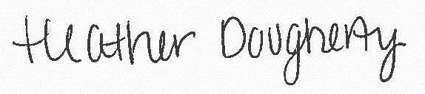
Heather Dougherty Amy Spurgeon
4-H Youth Extension Educator 4-H Secretary
hdougher@purdue.edu spurgeoa@purdue.edu
Purdue University is an equal access/opportunity institution.

