Jennings County Swine Requirements

Animal ID Requirements
These requirements must be met to complete 4HOnline Animal ID and to exhibit at the Jennings County Fair.
Swine | 840-RFID Tag and Ear Notch and (DNA Hair Sample for State Fair Only)

DNA Hair Samples to Exhibit at the Indiana State Fair 4-H Swine Show:
The DNA hair sample is required for all swine that members want to exhibit at the 4-H swine show at the Indiana State Fair. Collection envelopes are available at the Extension Office and will be available at the Animal ID Day on May 6. Members will be required to do their own animal’s DNA hair sample and return the sample to the Extension Office by May 15. The member MUST ask for the DNA hair sample envelope at the Animal ID Day or make arraignments to pick one up at the Extension office.

Animal ID Day(s)
All swine must attend the Animal ID day on Thursday, May 6 from 5:00-7:00 pm at the Jennings County Fairgrounds. The tagging will take place at the north end of the swine barn. Please line up in the parking lot and be prepared to pull up to and/or back up to the north end of the swine barn.

Lost Tags:
If your animal loses a county ear tag or an 840-RFID tag, contact the county Extension Office immediately to schedule a time for the new tag to be replaced.

Animal ID Worksheet: BRING COMPLETED WORKSHEET TO ANIMAL ID DAY!
The enclosed triplicate Indiana 4-H Swine ID Worksheet MUST be completed as much as possible and brought to the Animal ID (tagging) Day. This information will include: Premise ID, the animal’s breed, gender and birthdate and whether the animal is born and raised in Jennings County. Volunteers will tag the animal and write the county tag number and 840-RFID number on the worksheet. 4-H families will use the information on the worksheet to complete their Animal ID entry in 4HOnline. This is a requirement and 4-H’ers will not be allowed to show an animal at the Jennings County Fair unless the animal is properly identified in 4HOnline by the May 15.

Animal ID in 4HOnline:
Please follow the enclosed Animal Identification instructions to enter your Animal ID into 4HOnline by May 15.

Mini 4-H Members (Grades K-2):
Mini 4-H members are encouraged to use another 4-H member’s animal already enrolled in 4HOnline and registered in the Jennings County 4-H Fairentry system to exhibit during the Jennings County Mini 4-H Showmanship class.

Mini 4-H members who choose to bring their own animal to the fair are NOT required to bring their animals to Animal ID Day and will NOT enter their animal’s information into 4HOnline, however, their animals MUST meet the Animal ID requirements listed in this document. Contact the Extension office if you have questions about Animal ID or exhibit requirements.

Premise ID:
The Indiana State Fair references the following: The Indiana State Fair requires all Indiana Exhibitors to provide the Indiana State Board of Animal Health required Premises ID number on all entry forms for beef and dairy cattle, goats, swine and sheep. Indiana exhibitors of horses, poultry, llamas and alpacas as well as out of state exhibitors will be requested to voluntarily provide Premises ID numbers. To obtain a Premises ID #, please contact the Indiana State Board of Animal Health at 877- 747-3038. Information can be found on the Indiana State Board of Animal Health website at www.in.gov/boah or https://www.in.gov/boah/traceability-and-premise-id/.

Indiana State Fair 4-H Livestock Shows:
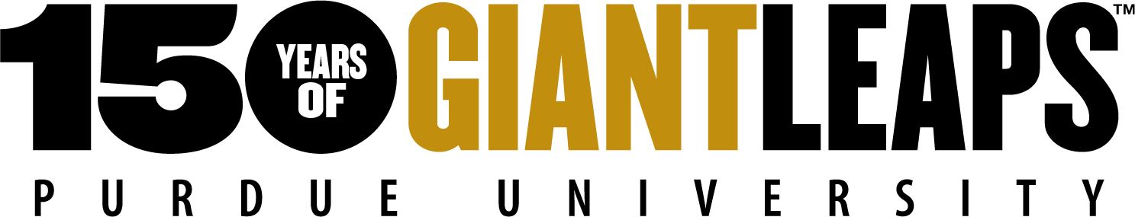
Visit: https://www.indianastatefair.com/p/state-fair/competitions--contests/4-h-competitions-entry-information to sign up for Indiana State Fair 4-H Livestock Shows. The Indiana State Fair dates are August 6 -22, 2021
Sincerely,
Melessa Wiesehan
Melessa Wiesehan, Extension Educator- 4-H Youth Development

