Jennings County Rabbit Requirements

Animal ID Requirements and Animal ID Day
4-H Rabbits must have a legible ear tattoo in the rabbit’s left ear. ALL rabbit project members must turn in a Rabbit Enrollment Form at the Animal ID Day on Thursday, May 20 from 5-7 pm at the Jennings County Fairgrounds. The only rabbits that MUST be brought to Animal ID Day are those still needing a tattoo.

Please complete the enclosed forms and bring them with you to the Animal ID Day on May 20. All rabbit Enrollment Forms MUST be turned in at Animal ID Day even if you do not have to bring your rabbit to the Animal ID Day.

Online Animal ID
4-H members exhibiting rabbits DO NOT need to enter the rabbit’s animal ID information into 4HOnline, however you will enter your rabbit’s animal ID information into Fairentry. A separate Fairentry instructional mailing will be sent to all 4-H members.

Rabbit Born, Bred & Raised
Members no longer need to fill out a special form to enter the Rabbit Bred, Born & Raised class. Please complete the County Bred, Born & Raised section of the enclosed enrollment form.
This is the updated rule in the 2021 Livestock Handbook:
  - Jennings County 4-H Member Bred, Born & Raised Rabbit Meat Pen is defined as: A rabbit meat pen that was produced from a doe that is owned by the 4-H member at least 5 weeks prior to the birth date of the meat pen rabbits entered for the show and all of these rabbits are housed at the 4-H members residence from the time of breeding until the day of the show. Eligible Jennings County Bred, Born and Raised meat pen entries will show in the Meat Pen class. The highest placed eligible meat pen entry will be the Grand Champion 4-H Member Bred, Born & Raised Meat Pen.

Mini 4-H Members (Grades K-2):
Mini 4-H members are encouraged to use another 4-H member’s animal already enrolled in 4HOnline and registered in the Jennings County 4-H Fairentry system to exhibit during the Jennings County Mini 4-H Showmanship class.

Mini 4-H members who choose to bring their own animal to the fair are NOT required to bring their animals to Animal ID Day and will NOT enter their animal’s information into 4HOnline, however, their animals MUST meet the Animal ID requirements listed in this document. Contact the Extension office if you have questions about Animal ID or exhibit requirements.

Indiana State Fair 4-H Livestock Shows:
Visit: https://www.indianastatefair.com/p/state-fair/competitions--contests/4-h-competitions-entry-information to sign up for Indiana State Fair 4-H Livestock Shows. The Indiana State Fair dates are August 6 -22, 2021

Sincerely,
Melessa Wiesehan
Melessa Wiesehan
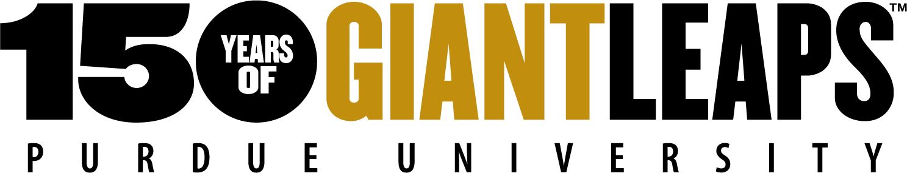
Extension Educator- 4-H Youth Development

