Jennings County Llama and Alpaca Requirements

Animal ID Requirements
Llama and Alpacas
Color Photo uploaded into 4HOnline by May 15. (Must show all four feet and face)
Lease Agreement (Must be turned in to county office by May 15.)

Animal ID Day
There is no scheduled Animal ID Day for lamas. If you are unable to take a color photo of your animal, please contact the Extension Office for assistance.

Online Animal ID
All alpaca and llama entries must be entered and color photos uploaded into 4Honline by May 15. Please use the enclosed Animal ID instructions to enter your lama into 4HOnline. For more information about 4HOnline Animal ID, contact Melessa at 812-352-3033 or mwieseha@purdue.edu.

Mini 4-H Members (Grades K-2):
Mini 4-H members are encouraged to use another 4-H member’s animal already enrolled in 4HOnline and registered in the Jennings County 4-H Fairentry system to exhibit during the Jennings County Mini 4-H Showmanship class.

Mini 4-H members who choose to bring their own animal to the fair are NOT required to bring their animals to Animal ID Day and will NOT enter their animal’s information into 4HOnline, however, their animals MUST meet the Animal ID requirements listed in this document. Contact the Extension office if you have questions about Animal ID or exhibit requirements.

Premise ID:
The Indiana State Fair references the following: The Indiana State Fair requires all Indiana Exhibitors to provide the Indiana State Board of Animal Health required Premises ID number on all entry forms for beef and dairy cattle, goats, swine and sheep. Indiana exhibitors of horses, poultry, llamas and alpacas as well as out of state exhibitors will be requested to voluntarily provide Premises ID numbers. To obtain a Premises ID #, please contact the Indiana State Board of Animal Health at 877- 747-3038. Information can be found on the Indiana State Board of Animal Health website at www.in.gov/boah or https://www.in.gov/boah/traceability-and-premise-id/.

Indiana State Fair 4-H Livestock Shows:
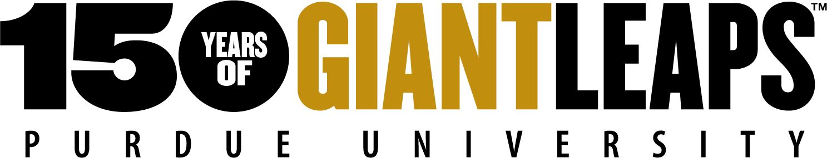
Visit: https://www.indianastatefair.com/p/state-fair/competitions--contests/4-h-competitions-entry-information to sign up for Indiana State Fair 4-H Livestock Shows. The Indiana State Fair dates are August 6 -22, 2021

Sincerely,
Melessa Wiesehan
Extension Educator- 4-H Youth Development

