Jennings County Horse Requirements

Animal ID Requirements
Horses and Ponies
Color Photo (Must show all four feet and face) uploaded into 4HOnline by May 15.
Lease Agreement must be turned in to Extension Office by May 15.

Horse Vaccination Requirements
*There is a vaccination (certificate of completion of Indiana 4-H requirements for exhibition of 4-H horse and pony) form that must be filled out. The form is enclosed but it is also available at: https://extension.purdue.edu/article/27581

These are Required Vaccinations:
Eastern and Western Equine Encephalomyelitis
Rhinopneumonitis/EHV type 1 and 4
Equine Influenza
Tetanus
West Nile Virus (NEW 2021)
Rabies 2

Animal ID Day
If you are unable to take a color photo of your animal or need your horse or pony measured, please attend the Animal ID Day on Saturday, May 1 from 9:00 -11:00 am at the Jennings County Fairgrounds. Please park next to or near the horse barn.

Online Animal ID
All horse and pony entries must be entered and color photos uploaded into 4HOnline by May 15. Please use the enclosed Animal Identification information to help you enter your animal’s information into 4HOnline. For more information, contact Melessa Wiesehan at 812-352-3033 or mwieseha@purdue.edu.

Mini 4-H Members (Grades K-2):
Mini 4-H members are encouraged to use another 4-H member’s animal already enrolled in 4HOnline and registered in the Jennings County 4-H Fairentry system to exhibit during the Jennings County Mini 4-H Showmanship class.

Mini 4-H members who choose to bring their own animal to the fair are NOT required to bring their animals to Animal ID Day and will NOT enter their animal’s information into 4HOnline, however, their animals MUST meet the Animal ID requirements listed in this document. Contact the Extension office if you have questions about Animal ID or exhibit requirements.

Premise ID:
The Indiana State Fair references the following: The Indiana State Fair requires all Indiana Exhibitors to provide the Indiana State Board of Animal Health required Premises ID number on all entry forms for beef and dairy cattle, goats, swine and sheep. Indiana exhibitors of horses, poultry, llamas and alpacas as well as out of state exhibitors will be requested to voluntarily provide Premises ID numbers. To obtain a Premises ID #, please contact the Indiana State Board of Animal Health at 877- 747-3038. Information can be found on the Indiana State Board of Animal Health website at www.in.gov/boah or https://www.in.gov/boah/traceability-and-premise-id/.

Indiana State Fair 4-H Livestock Shows:
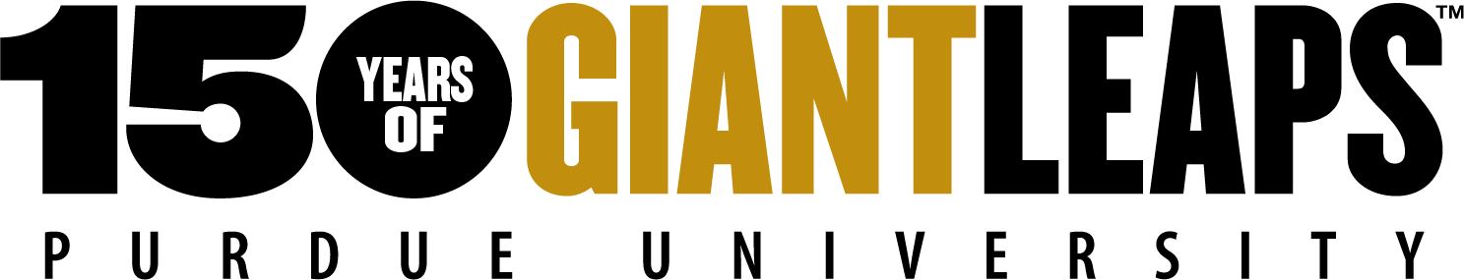
Visit: https://www.indianastatefair.com/p/state-fair/competitions--contests/4-h-competitions-entry-information to sign up for Indiana State Fair 4-H Livestock Shows. The Indiana State Fair dates are August 6 -22, 2021

Sincerely,
Melessa Wiesehan
Melessa Wiesehan
Extension Educator- 4-H Youth Development

