Jennings County Goat Requirements

Animal ID Requirements
These requirements must be met to complete 4HOnline Animal ID and to exhibit at the Jennings County Fair.
Dairy goat females, registered | Breed Registry Tattoo
Dairy goat wethers | 5-digit county tag or Tattoo
Meat goat wethers | 5-digit county tag and (840-RFID Tag and DNA hair sample for state fair only)
Market goat does | 5-digit county tag and (840 RFID Tag and DNA hair sample for state fair only)
Boer goat females, registered | Breed Registry Tattoo and (DNA hair sample for state fair only)
Pygmy goats, registered | Breed Registry Tattoo or Microchip that matches registration papers
Pygmy goats, unregistered | Official USDA Scrapie Tag or Official Scrapie Tattoo
Non-Registered females | 5-digit county tag or tattoo or scrapie tag (not state fair eligible)

DNA Hair Samples to Exhibit at the Indiana State Fair 4-H Goat Show:
The DNA hair sample is required for all meat goat wethers, market goat does and Boer goat registered females that members want to exhibit at the 4-H goat show at the Indiana State Fair. Collection envelopes are available at the Extension Office and will be available at the Animal ID Day on May 1 and May 6. Members will be required to do their own animal’s DNA hair sample and return the sample to the Extension Office by May 15. The member MUST ask for the DNA hair sample envelope at the Animal ID Day or make arraignments to pick one up at the Extension office.

Animal ID Day(s)
Does your goat need a 5-digit county tag and/or an 840-RFID tag? ONLY Goats requiring a 5-digit county tag and/or an 840-RFID tag MUST attend the Animal ID day on either Saturday, May 1, from 9-11 am or Thursday, May 6, from 4:30-7 pm at the Jennings County Fairgrounds. Please drive up to the east side of the show arena.
Lost Tags:
If your animal loses a county ear tag or an 840-RFID tag, contact the county Extension Office immediately to schedule a time for the new tag to be replaced.

Animal ID Worksheet: BRING COMPLETED WORKSHEET TO ANIMAL ID DAY!
The enclosed triplicate Indiana 4-H Goat ID Worksheet MUST be completed as much as possible and brought to the Animal ID (tagging) Day. This information will include: Premise ID, the animal’s breed, gender and birthdate and whether the animal is born and raised in Jennings County. Volunteers will tag the animal and write the county tag number and 840-RFID number on the worksheet. 4-H families will use the information on the worksheet to complete their Animal ID entry in 4HOnline. This is a requirement and 4-H’ers will not be allowed to show an animal at the Jennings County Fair unless the animal is properly identified in 4HOnline by the May 15.

Animal ID in 4HOnline:
Please follow the enclosed Animal Identification instructions to enter your Animal ID into 4HOnline by May 15.

Mini 4-H Members (Grades K-2):
Mini 4-H members are encouraged to use another 4-H member’s animal already enrolled in 4HOnline and registered in the Jennings County 4-H Fairentry system to exhibit during the Jennings County Mini 4-H Showmanship class.

Mini 4-H members who choose to bring their own animal to the fair are NOT required to bring their animals to Animal ID Day and will NOT enter their animal’s information into 4HOnline, however, their animals MUST meet the Animal ID requirements listed in this document. Contact the Extension office if you have questions about Animal ID or exhibit requirements.

Premise ID:
The Indiana State Fair references the following: The Indiana State Fair requires all Indiana Exhibitors to provide the Indiana State Board of Animal Health required Premises ID number on all entry forms for beef and dairy cattle, goats, swine and sheep. Indiana exhibitors of horses, poultry, llamas and alpacas as well as out of state exhibitors will be requested to voluntarily provide Premises ID numbers. To obtain a Premises ID #, please contact the Indiana State Board of Animal Health at 877- 747-3038. Information can be found on the Indiana State Board of Animal Health website at www.in.gov/boah or https://www.in.gov/boah/traceability-and-premise-id/.

Indiana State Fair 4-H Livestock Shows:
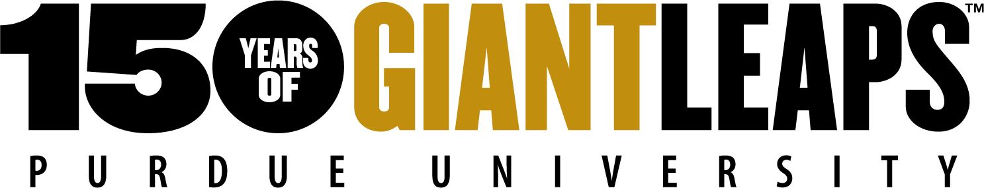
Visit: https://www.indianastatefair.com/p/state-fair/competitions--contests/4-h-competitions-entry-information to sign up for Indiana State Fair 4-H Livestock Shows. The Indiana State Fair dates are August 6 -22, 2021
It is the policy of the Purdue University Cooperative Extension Service that all persons have equal opportunity and access to its educational programs, services, activities, and facilities without regard to race, religion, color, sex, age, national origin or ancestry, marital status, parental status, sexual orientation, disability or status as a veteran. Purdue University is an Affirmative Action institution. This material may be available in alternative formats.
Sincerely,
Melessa Wiesehan
Melessa Wiesehan, Extension Educator- 4-H Youth Development

