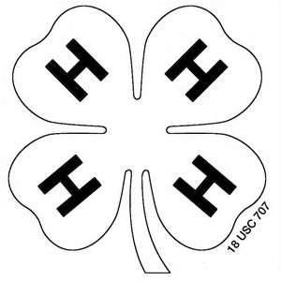
4-H Sheep
Jasper County Derived from Pulaski Record Sheet A
Grade 3

Name ___________________________________ 4-H Club ________________________
Leader Signature _______________________________________________

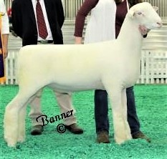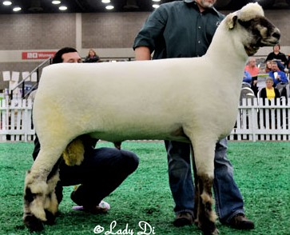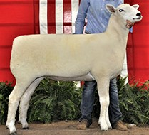

1 2 3

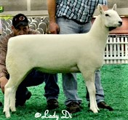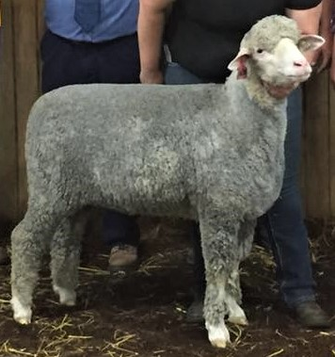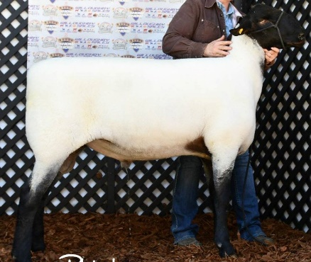

4 |  |  |  | 5 |  |  | 6
 | ___ | Cheviot | _____ | Dorset | ___ | Merino
 | ___ | Montadale | _____ | Oxford | ___ | Suffolk

- A male sheep is called a ____________ .

- The wool from a sheep is called the_______________ .

- Match the following:

__ | Ram Breed | A. Superior mothering ability
__  __ | Ewe Breed  Dual Purpose Breed | - Either ram or ewe  - Meat-type

PURDUE UNIVERSITY, INDIANA COUNTIES & U.S. DEPARTMENT OF AGRICULTURE COOPERATING AN AFFIRMATIVE ACTION/EQUAL OPPORTUNITY INSTITUTION

- Sheep Equipment Word Search
S | Y | X | V | J | P | P | Y | R | M | D | S | X | S | H
E | Z | X | C | Y | R | Q | S | W | E | S | E | L | C | E
L | S | T | H | E | R | M | O | M | E | T | E | R | S | A
A | R | B | O | S | M | S | U | A | Y | W | L | R | D | T
C | E | Y | R | O | R | A | R | F | O | M | E | A | T | L
S | M | V | C | C | G | T | S | T | K | P | D | W | H | A
R | M | C | L | B | A | U | X | C | P | A | R | F | D | M
X | I | J | M | G | Q | U | U | I | U | D | Z | X | D | P
H | R | H | S | B | V | E | L | A | X | L | N | I | B | S
N | T | M | I | X | D | C | H | F | L | L | A | Z | M | W
M | F | D | P | D | L | H | C | V | H | O | I | T | D | O
K | O | D | Y | O | S | I | O | J | P | M | S | K | O | D
E | O | D | O | W | B | T | L | Z | Q | L | M | U | X | R
U | H | W | G | E | G | N | I | R | Y | S | I | T | Z | R
L | W | U | Z | L | C | M | Y | O | A | E | W | C | T | F

EAR TAGS EMASCULATOR HALTER
HEAT LAMP HOOF TRIMMERS SCALES
SYRINGE THERMOMETER TOWELS
WOOL CLIPPERS

Match the following retail cuts with its wholesale part:
LAMB STARTER MEDICATED
Starter For Growing Lambs
FOR THE PREVENTION OF COCCIDIOSIS CAUSED BY
Eimeria ovina, Eimeria crandullis, Eimeria ovinoidalis, Eimeria ninekohlyakimovae, Eimeriaa parva AND Eimeria intricate IN SHEEP MAINTAINED IN CONFINEMENT.
ACTIVE DRUG INGREDIENT
LASALOCID (AS LASALOCID SODIUM) 90 G/TON
GUARANTEED ANALYSIS
CRUDE PROTEIN MIN 20.00%
CRUDE FAT MIN 2.50%
CRUDE FIBER MAX 10.00%
CALCIUM MIN 0.75%
CALCIUM MAX 1.25%
PHOSPHORUS MIN 0.55%
SALT MIN 0.40%
SALT MAX 0.90%
SELENIUM MIN 0.30 PPM
VITAMIN A MIN 2,000.00 IU/LB
INGREDIENT USAGE
Processed Grain By-Products, Grain Products, Plant Protein Products, Forage Products, Roughage Products, Molasses Products, Ground Limestone, Salt, Lignin, Sulfonate, Potassi- um Sulfate, Magnesium, Sulfur, Vitamin E Supplement, Vita- min A, Acetate, Vitamin D Supplement, Zinc Sulfate, Zinc oxide, Sodium Molybdate, Munganous Oxide, Calcium Iodate, Cobalt Carbonate, Ferrous Sulfate.
FEEDING DIRECTIONS
Lamb Starter contains 45 mgs. Of lasalocid per pound. Feed continuously as the sole ration to growing lambs from 1 to 6 weeks of age at the rate of 0.33-1.55 pounds per head per day to provide no less than 15 mgs. And no more than 70 mgs. Of lasolocid per head per day. Provide clean, fresh water at all times.
CAUTION
The safety of lasalocid in unapproved species has not been established; do not allow horses or other equines access to lasalocid as ingestion may be fatal, feeding undiluted or lasolo- cid could be fatal to sheep.
MANUFACTURED BY: SKILLATHON FEEDS NET WEIGHT 50 POUNDS (22.7 KILOGRAMS)

1.
2.
3.
4.
5.
Leg of Lamb A. Shoulder
Spareribs B. Rack
Rib Chops C. Loin
Arm Chop D. Leg
Sirloin Steaks E. Breast

- If you give a lamb a shot into the muscle it is
called a _____________________________.

- Find the following items on the feed tag:

% Crude Protein Min ___________

Disease it prevents _ ____________

Age of lambs being fed __________

Warning type _____________________________
_________________________________________

% Crude Fiber Max ________________

Answers to these questions can be found in the “Sheep Resource Handbook” 4-H 194R

