4-H Online Event Registration Instructions for Chef U
- Visit v2.4honline.com. If you are a CURRENT 4-H MEMBER or have a 4-HOnline Account from a previous event, you will skip to Step # 3. If you are NOT a Current 4-H Member (and do not have a 4-HOnline account) or are a 4-H member participating from a different state, you will click the button “Don’t have an account?” at the bottom of the screen.

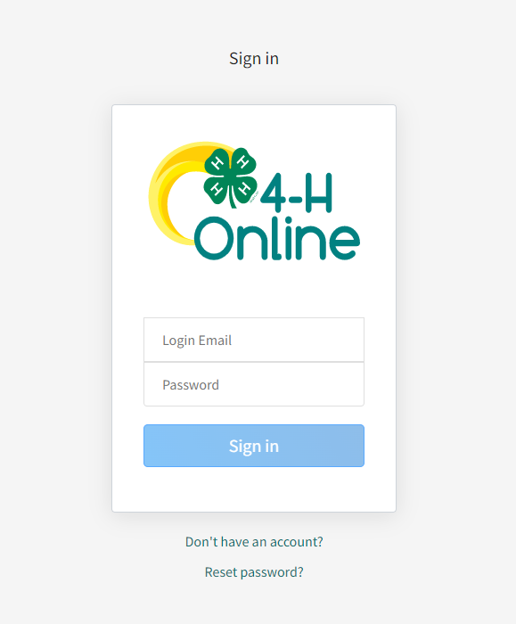
Current 4-H Members log in here
NOT CURRENT 4-H members click here

- Not Current 4-H Members/Outside of Indiana 4-H members will follow the steps to create a basic
4-HOnline Account. Once you have created an account, skip to step # 4.

- Current 4-H Members will complete the 4-HOnline login process to access your family profile and member list and continue to step #4.
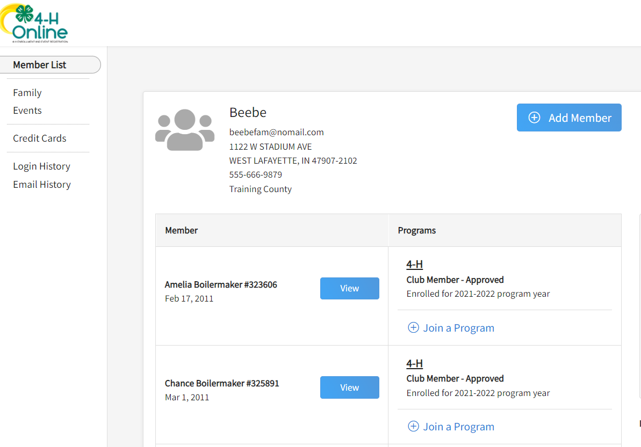
- Click “View” by the member you intend to register for Chef U

- Select the Events Tab once you are in their profile and click “Register for an event” to find the event titled “2024 Chef U”
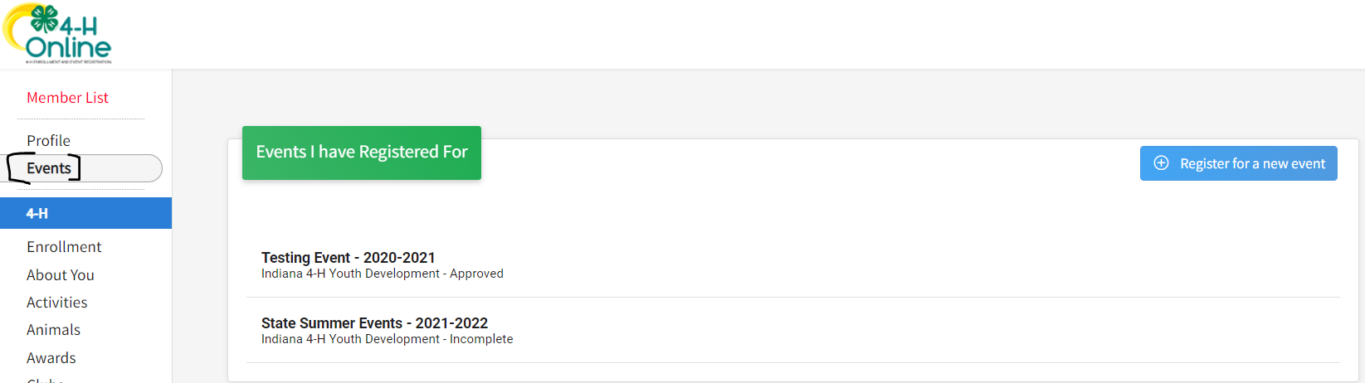

- There will be four options for registration on the Chef U Program. Select the one that best fits your situation:
  - Morning Session – Current 4-H Member – Current 4-H Members that want to participate in the morning session will register here.
  - Morning Session – Non-4-H Member – Participants who are NOT 4-H Members and want to participate in the morning session will register here.
  - Afternoon Session – Current 4-H Member – Current 4-H Members that want to participate in the afternoon session will register here.
  - Afternoon Session – Non-4-H Member – Participants who are NOT 4-H Members and want to participate in the afternoon session will register here.

- Complete any required questions.
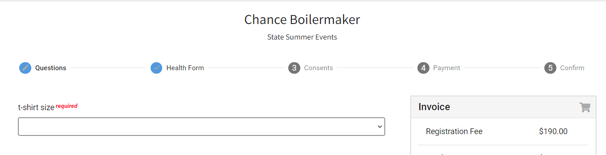
- Complete Consents (if any are listed).
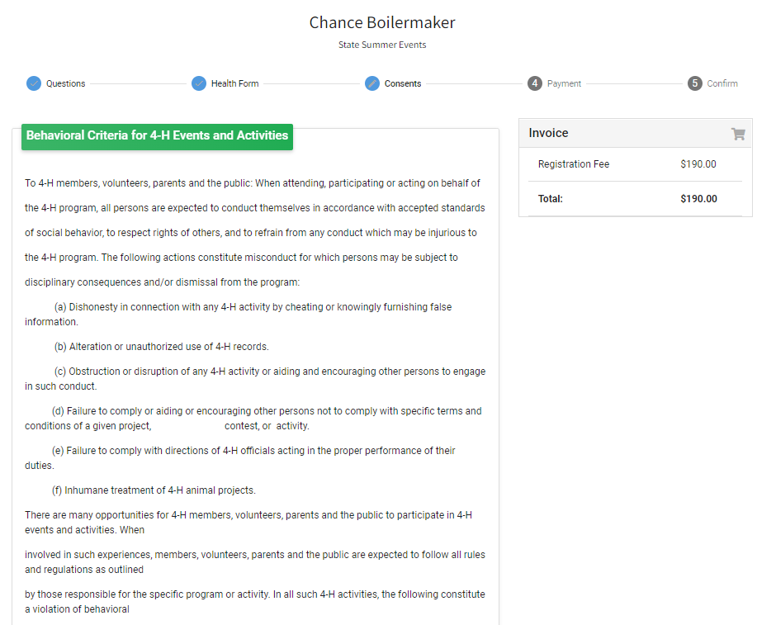

- You will be able to by card, cash, or check for this program.

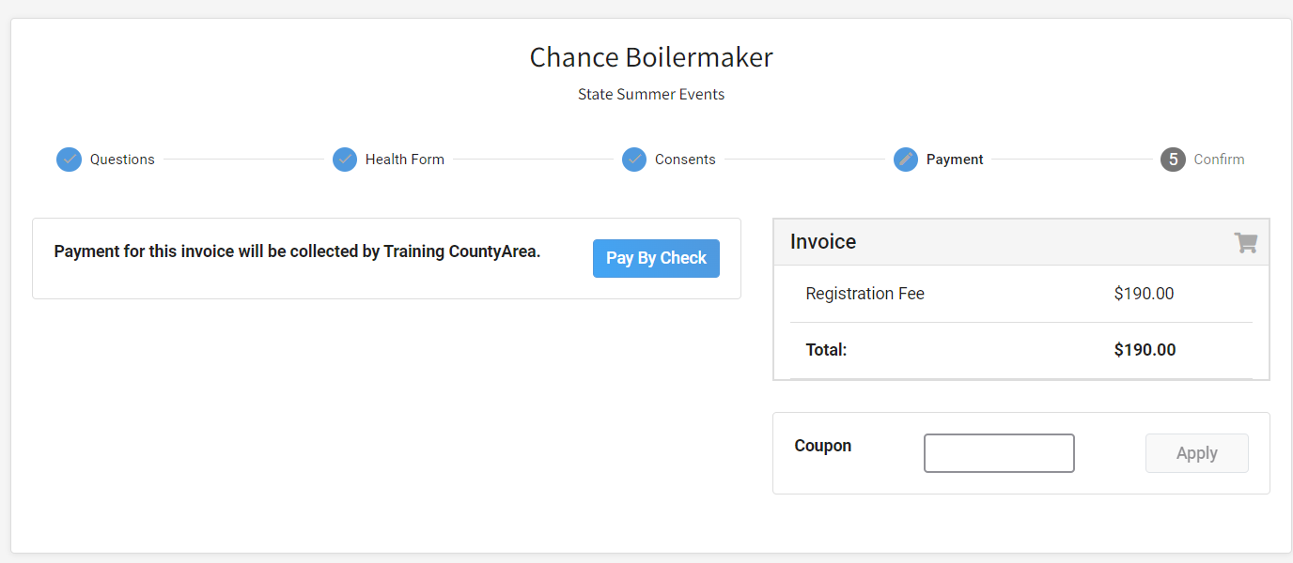

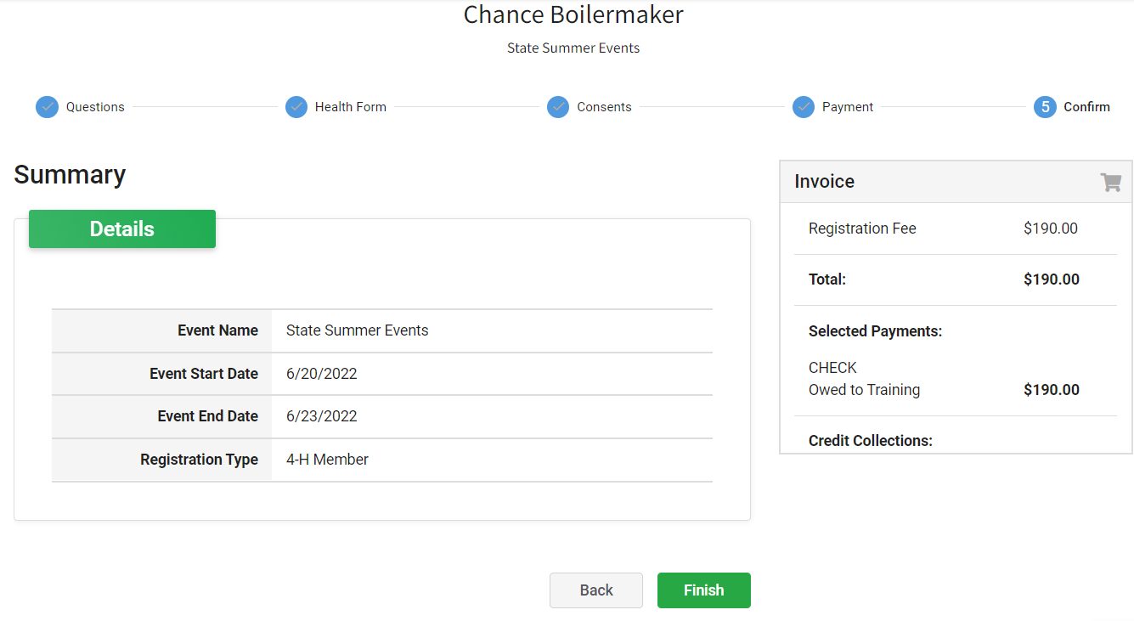
- Select Next once payment has been selected. And then Finish.

- A list of event registrations that have been submitted will appear and your county will accept your registration.

- If you selected to pay with cash or check, you have two options:
  - Pay by cash at your local Purdue Extension Office.
  - Pay by check by making checks payable to Trustees of Purdue and sending to the address below:
Purdue Extension – Hendricks County
ATTN: Chef U
PO Box 7
Danville, IN 46122

If you have questions or need assistance, please contact Purdue Extension – Hendricks County at 317-745-9260 or email hendrces@purdue.edu.

