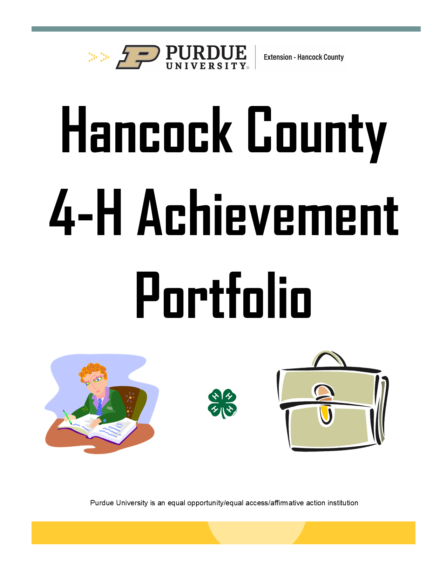

ACHIEVEMENT PORTFOLIO

Current School Photo in Center

Grades 8-10

TABLE OF CONTENTS
GRADES 8-10

- Demographic Page
- 4-H Profile – Section A
- 4-H Leadership Profile – Section B
- 4-H Citizenship – Section C
- My Three 4-H Projects
- 4-H Narrative
- Pictures
- Project Year Records
- Additional Included Items
- Past Years’ Projects

INDIANA 4-H ACCOMPLISHMENT DEMOGRAPHICS FORM

County ________________________ Category ___________________Years Completed in 4-H ____

Name ______________________________________________________ Male _____ Female ______
(first) (middle) (last)

Grade in school this year __________________________ Date and year of birth ________________________
Home address __________________________________________________ Home telephone ______________
(street) (city) (state) (zip code)

Place of home residence (check one)
_____ Farm (number of acres ____) _____ Town or city of 10,000 to 50,000
_____ Town under 10,000 or open country _____ Suburb of city over 50,000
_____ Central City of over 50,000

Name (s) of parent (s) or guardian (s) ___________________________________________________________

Name of 4-H club/group or program ____________________________________________________________

Date you graduated or will graduate from high school ______________________________________________

College Trade or Technical School you plan to attend ________________________ Number of years ________

Major or course of study _____________________________________________________________________

Not attending school: Occupation ______________________________________________________________

What career do you plan to follow? _____________________________________________________________

List all 4-H projects you have completed or programs you participated in for at least one year, and the number of years involved.

___________________________________________________________________________________________________
___________________________________________________________________________________________________
___________________________________________________________________________________________________

News Releases are to be sent to: ______________________________________________________________________

STATEMENT BY 4-H MEMBER
I personally have prepared this resume and certify that it accurately reflects my work:
Date __________________ *Signature of 4-H Member _________________________________________________

APPROVAL OF THIS REPORT
We have reviewed this resume and believe it to be correct:
Date __________________ *Signature of Parent/Guardian ______________________________________________

Date __________________ Signature of 4-H Leader __________________________________________________

Date __________________ Signature of County Extension Educator _____________________________________

*Signature indicates implied consent that these materials will be reviewed by a selection committee and shared with the award donor.
4-H Profile – Section A

Name of 4-H Project:___________________________________________

Member's Name:_______________________ Year: ______ School Grade (on Jan 1): ______

- Size and Scope:
List the highlights of your project for this year, including the size, scope, and growth of the project, savings to your family, etc. when appropriate.

Project Submitted Date Article Level

- Participation in Project:
Indicate the level of participation with the appropriate letters – local (L), county (C), regional (R), state (S), national (N). Include tours, conferences, workshops, judging events, project groups, camps, knowledge bowls, etc. you have attended during this year.

Month Name or Kind of Event No of Times/Level

- Awards and Recognition Received in This Project:
List the awards, trips, medals, plaques, trophies, ribbons, scholarships and other recognition received this year. Indicate the level on which the recognition was received.

4-H Leadership Profile – Section B

Member's Name: _______________________ Year: ______ School Grade (on Jan 1): ______

  - Leadership with 4-H groups:
Summarize this year's experiences as a junior or teen leader with one or more of the following kinds of 4-H groups: a) project group, b) club, c) judging team, d) special interest group and/or e) camp.

  - Leadership with individual 4-H members (one on one)

Kind of Assistance Given No of Members Assisted

  - Leadership experiences at 4-H events:
List all 4-H events in which you participated in a leadership role.
Indicate level of the event – local (L), county (C), regional (R), state (S), national (N).
Month Event Type of Leadership Assistance Given Level

- Leadership in the 4-H club and/or project group of which you are a member:
List offices held, committees served on, leadership training received, etc.
Indicate level – local (L), county (C), regional (R), state (S), national (N).

Year Office Held, Committee Work or Activity Your Responsibility Level

- Leadership in marketing 4-H:
List things done to promote 4-H. Indicate level – local (L), county (C), regional (R), state (S), national (N).

Year Type of Promotion Your Responsibility/Involvement Level

4-H Citizenship Profile – Section C

Member's Name: ____________________________ Year: _____School Grade (on Jan 1): ___

List things done as an individual 4-H member or as a member of a 4-H group that contributed to the welfare of your club or group members, other individuals, your community, nation, and/or world. Include the kind, size and scope of each activity. This may include the number of people involved, hours of service, length of project, items made, etc.

  - 4-H project citizenship: List this year's citizenship and community service experiences related to
the project you are profiling in Section A.

Name of 4-H Project _________________________________________________________________

Kind of Project or Activity Size and Scope of What You Did

  - Other citizenship activities: Report activities which do not relate to your main project under one
of the following headings:

Government: List activities related to local, county, state, and national government.

Kind of Project or Activity Size and Scope of What You Did

Global: List activities which contributed to a better understanding of world issues and/or increased cultural awareness.

Kind of Project or Activity Size and Scope of What You Did

Family, friends, and community: List activities which contributed to the welfare and/or understanding of your family, friends and community.

Kind of Project or Activity Size and Scope of What You Did

My Three 4-H Projects

Insert “My Three 4-H Projects” explanations here.

Select a maximum of 3 projects that were completed and reflect on what you did on the project(s), including strengths and skills you gained as part of your involvement.
Include a picture of your completed project.
Refer to “Achievement Portfolio Example” link on the county website for an example.

My 4-H Narrative

Insert “My 4-H Narrative” here.

Refer to “Achievement Portfolio Example” link on the county website for an example.

Pictures

Insert up to three (3) pages of photos here.

My 1st year in 4-H was 20___

Club:
Advisors:
Projects Completed:
Project Summary:
Offices Held:
Community Service Projects I worked on:
Committees I served on:
Contests I participated in:
Awards I received during the year:
Other accomplishments:

To be completed for grades 8, 9, and 10.
My 2nd year in 4-H was 20___

Club:
Advisors:
Projects Completed:
Project Summary:
Offices Held:
Community Service Projects I worked on:
Committees I served on:
Contests I participated in:
Awards I received during the year:
Other accomplishments:

To be completed for grades 8, 9, and 10.
My 3rd year in 4-H was 20___

Club:
Advisors:
Projects Completed:
Project Summary:
Offices Held:
Community Service Projects I worked on:
Committees I served on:
Contests I participated in:
Awards I received during the year:
Other accomplishments:

To be completed for grades 8, 9, and 10.
My 4th year in 4-H was 20___

Club:
Advisors:
Projects Completed:
Project Summary:
Offices Held:
Community Service Projects I worked on:
Committees I served on:
Contests I participated in:
Awards I received during the year:
Other accomplishments:

To be completed for grades 8, 9, and 10.
My 5th year in 4-H was 20___

Club:
Advisors:
Projects Completed:
Project Summary:
Offices Held:
Community Service Projects I worked on:
Committees I served on:
Contests I participated in:
Awards I received during the year:
Other accomplishments:

To be completed for grades 8, 9, and 10.
My 6th year in 4-H was 20___

Club:
Advisors:
Projects Completed:
Project Summary:
Offices Held:
Community Service Projects I worked on:
Committees I served on:
Contests I participated in:
Awards I received during the year:
Other accomplishments:

To be completed for grades 9 and 10.
My 7th year in 4-H was 20___

Club:
Advisors:
Projects Completed:
Project Summary:
Offices Held:
Community Service Projects I worked on:
Committees I served on:
Contests I participated in:
Awards I received during the year:
Other accomplishments:

To be completed for grade 10.
Additional Included Items

Include one of the following in the back of the binder:
A. A one (1) page paper and/or pictures from a job- shadowing experience or interview with a professional in a career of interest.
B. A one (1) page paper describing an occupation of interest.
C. A list of short- and long-term personal goals, how you plan to achieve them, and when you want to achieve them by.

**Remember to include all past years’ projects.

**These years will also include a personal interview with the judge upon project turn-in.

REMINDER: Always cross reference this material with the handbook.

