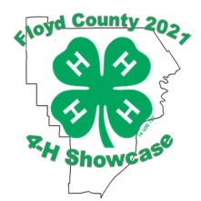

Dear Prospective Auction Buyer,
I am a 4-H Club member in Floyd County, Indiana. I would like to invite you to our 4-H Showcase Livestock Auction on Friday, June 11th, 2021 at the 4-H Fairgrounds located at 2818 Green Valley Road in New Albany, Indiana.
The auction will begin at 7:00 p.m. in Newlin Hall with a live auctioneer and a live feed showing which animal is up for auction. Social distancing is required and masks are strongly recommended. We hope the auction will offer: Market Swine, Poultry, Lambs, Goats, Rabbits and Beef for sale. Beef will be sold by the pound; Swine, Sheep and Goats will be sold by the head; and Rabbit Meat Pens and Poultry Meat Pens will be sold by the lot. The auction will be a premium only auction. What you bid is what you pay. Animals can still be returned to the child. (RTC)
I hope to auction_____________________________________________.
If you have further questions, please do not hesitate to contact the Floyd County Extension office, 812-948-5470 or 4-H Fairgrounds Office at (812) 949-8119. Whether this will be your first time or a repeat visit to our auction, I welcome you to come out and visit with me while viewing my animal. I would really appreciate your help in making the auction successful.

__________________________________
Floyd County 4-H Member

