BCEH Educational Lessons 2021-2022
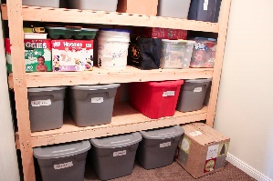
October 19, 2021 (Tuesday)

10:00 am Simplify Your Life

Are you looking for ways to simplify the demands on your time and energy? Do you have an endless to-do list or endless amounts of clutter making you feel overwhelmed? Then be sure to join us as we explore some tactical approaches and systems to help you navigate to a more balanced you! We will navigate through tips and tricks on decluttering your home, meal planning strategies and more! Amanda Veenhuizen, Johnson County

11:00 am Memory, Forgetfulness, and Aging: What's Normal and What's Not?

Changes in thinking and memory are common as we age. We might find that it takes longer than before to learn new things, or we might occasionally forget to pay a bill. Nonetheless, how can we determine what’s normal and what’s not when it comes to changes in our thinking or memory? Join us for this lesson as we discuss some of the differences between normal (age-related) forgetfulness and serious memory problems. Christiana Owusu-Ankomah, Shelby County

March 17, 2022 (Thursday)

1:00 pm Eating for Your Health
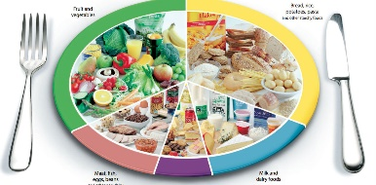
What you eat is an important component to living a healthy life and impacts how you feel from day to day. Eating for your health can be simple and improve your quality of life. Join us to learn about what steps you can take to improve your diet and in turn your overall health! Cheryl Jones, Hancock County

2:00 pm Code Red

Is a program that shows how the Code Red Spreadsheets can be used - one for personal information and the other for business information. In the event of a crisis the need for timely information about the people in the family or home business and their contacts are very important. The spreadsheet keeps important information such as passwords, bank account information, rental agreements, insurance papers and power-of-attorney documents in one location. Beth Switzer, Hendricks County

Additional educational lessons are available on the IEHA website
http://ieha-families.org

