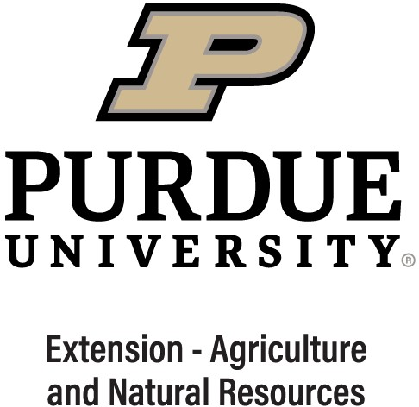ANR Programmatic Goals for Educators

# Diversified Farming and Food Systems

Goal 1: To build capacity for all forms of farm diversification throughout the state through innovative educational programs, practical research, connecting people, relationship building, and networking.

## -OR-

Goal 2: To enhance the sustainability of farmers and local businesses to position themselves to take advantage of opportunities and technology adoption in the local and regional food supply chains, including the supply, procurement, and consumption of Indiana food products.

# Farm Management

Goal: To build capacity of agribusinesses and farms to address economic issues in business planning, operational management, strategic decision making, marketing and business transition. To assist farmers in dealing with stress related to volatile markets and unusual weather.

# Field Crops

Goal: To enhance Indiana stakeholders’ understanding of crop production issues; to support decision-making by farmers in the production, protection, and storage of agronomic crops, including corn, soybeans, wheat, hay/forage, and other field crops; to enhance the long-term sustainability of field crop production by improving soil health; and to improve profitability through the use of digital agriculture techniques.

# Food and Farm Safety

Goal: To enhance the adoption of farm and food safety practices and emergency preparedness to reduce risk and mitigate impact of foodborne illness, farm accidents, and farm and community emergencies.

# Horticulture

Goal: To enhance Indiana stakeholders’ understanding of commercial horticulture issues, including production, protection, and marketing; to enhance understanding of the opportunities and challenges of production of horticultural crops in protected environments; to improve production, protection and decision- making in the turf industry; to improve practices and decision-making of homeowners/backyard gardeners.

# Livestock

Goal 1: Educate and train producers on best management practices across food animal species to increase the financial stability for producers.

## -OR-

Goal 2: Help producers identify and address issues affecting forage quality and to increase utilization of forage testing techniques to better address forage feeding requirements.

## -OR-

Goal 3: Provide stakeholders with resources and training regarding health, wellbeing, safe handling, nutrition, reproductive management, marketing, and processing to support informed decision making and timely interventions for commercial and small scale production of livestock, poultry and companion animals.

# Natural Resources

Goal 1: To foster integrative decision making and natural resource management plans to sustain and improve resources for food, fiber, fuel and drinking water, promote economic growth, create recreation opportunities, improve health of forests, waterbodies, and other ecosystems, provide wildlife habitat, or conserve open space and wildlands.

## -OR-

Goal 2: To enhance Indiana stakeholder’s understanding and decision making about land use planning, policies, and practices that enhance their local environment and community quality of life.

*An Equal Access/Equal Opportunity University*

*v. 01.2021*

**Signature Programs:**

|  |  |
| --- | --- |
| [American Citizen Planner-Indiana](https://extension.purdue.edu/hub/anr/signature-programs/american-citizen-planner/) | [Invasive Species](https://extension.purdue.edu/hub/anr/invasive-species/) |
| [Annie’s Project](https://extension.purdue.edu/hub/anr/signature-programs/annies-project/) | [Junior Master Gardener](https://extension.purdue.edu/hub/anr/junior-master-gardener/) |
| [Beginning Farmer](https://extension.purdue.edu/hub/anr/signature-programs/beginning-farmer/) | [Keeping the Business in the Family](https://extension.purdue.edu/hub/anr/signature-programs/keeping-the-business-in-the-family/) |
| [Beginning Livestock & Poultry 101](https://extension.purdue.edu/hub/anr/signature-programs/beginning-livestock-poultry-101/) | [Master Gardener Program](https://extension.purdue.edu/hub/anr/signature-programs/master-gardener-program/) |
| [Conservation through Community Leadership](https://extension.purdue.edu/hub/anr/signature-programs/conservation-through-community-leadership/) | [Rainscaping Education](https://extension.purdue.edu/hub/anr/rainscaping-education/) |
| [Enhancing the Value of Public Spaces](https://extension.purdue.edu/hub/anr/signature-programs/enhancing-the-value-of-public-spaces/) | [The Nature of Teaching](https://extension.purdue.edu/hub/anr/signature-programs/the-nature-of-teaching/) |
| [Grass to Garden](https://extension.purdue.edu/hub/anr/signature-programs/grass-to-garden/) | [UAV Technology](https://extension.purdue.edu/hub/anr/signature-programs/uav-technology/) |
| [IPM Field Crops](https://extension.purdue.edu/hub/anr/signature-programs/ipm-field-crops/) |  |

**Statewide Programs:**

Area Field Day/PAC Field Day

[Farm to School](https://www.purdue.edu/dffs/farmtoschool/)

[Indiana Hort Conference & Expo](https://www.indianahortconference.org/)

[Indiana Green Expo](http://indianagreenexpo.com/)

In Field Advantage

[Indiana Organic Grain Conference](https://www.purdue.edu/dffs/organicag/org-grain-farmer-meeting/)

[Invasive Species](https://www.purdue.edu/fnr/extension/scep/invasive-species-resources/)

[Land Use](https://www.cdext.purdue.edu/collaborative-projects/land-use/)

[Local Food](https://www.purdue.edu/dffs/localfood/)

[Managing Farm Stress](https://extension.purdue.edu/farmstress/)

[Master Cattlemen](https://www.ansc.purdue.edu/SP/MC/)  
[Indiana Master Cattleman Host Interest Form and Host Map](https://app.box.com/s/dukgkbl40ghaozbdi06a4fsuv0hq4kis)  
[Indiana Master Cattleman Facilitator’s Guide](https://app.box.com/s/dp0rwzmmoidhcjud6d45zp6xgd4k8sqj)

[Mental Health First Aid](https://extension.purdue.edu/mhfa/)

[Small Farm Conferences](https://www.purdue.edu/dffs/smallfarms/)

[Succession Planning](https://www.cdext.purdue.edu/collaborative-projects/succession-planning/)

Timber Management

[Urban Agriculture](https://www.purdue.edu/dffs/urbanag/)

USDA Farm Bill Training

ANR Program Expectations

2021-2022

Program Delivery:

* **20-25 events to be delivered for meets expectations.** The chart below shows that on average ANR educators deliver between 20 and 30 learning events (blue bars) regardless of tenure (years of service). If people are concerns about multi-session learning events, the yellow bar indicates that on average 30 is a good minimum number. New educators that have not reached 1 year of service will have lower numbers, but after 1 year, ANR educators seem to be up to speed hitting targets on average. As you can see in terms of years of experience, those with 7 or more reach 30 learning events on average and those with 11 -19 average almost 40 learning events.
* If **P2 are expected to be 20-25**, **P3 would be expected between 25-30** and **P4 would be 30+**

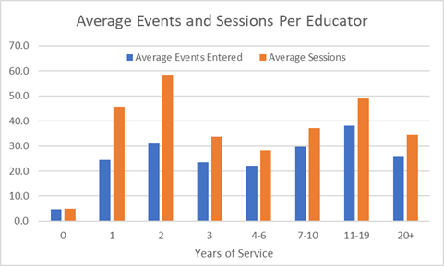

* **The number of attendees should average between 20 – 30 people.** The chart below shows that on average, after 2 years of service the number of contacts per event averages out to more than 20 when measured per session (orange) and more than 30 on a per event basis (blue bar). Similar to number of events, there is a little bit of increase in contacts with tenure.
* **P2 would be expected 20-25 people,**
* **P3 would be 25-30** and
* **P4 would be 30+**

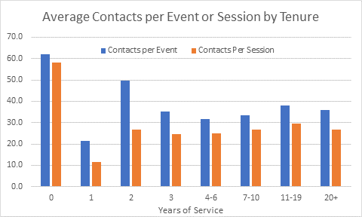

Number of Signature Programs:

* 4 signature or statewide programs would be the expectation for P2 as there are 15 signature programs for ANR and another 15 statewide programs.
  + P3 would be required to participate in 5 signature or statewide program.
  + P4 6 signature or statewide programs.

Impact Statements:

* 2 impact statement per year that can be used to help glean stories for annual reports, social media etc. for a P 2
* 3 impact statements for a P3
* 4 impact statements for a P4.

Split Positions or Part-Time Educators:

* If they are a part-time educator or educators in split positions, I would pro-rate their expectations. 50% FTE would mean they cut the number of ANR events in half from 20-25 to 10-12 events.
* Signature programs and impact statements would be cut in half as well.
* FYI: for ANR educators in ANR only programs delivered 23.2 sessions and educators in split positions delivered 12 sessions, so expectations fits reality here.