Importing Contacts in Salesforce

Overview

The following document details importing contacts from an excel spreadsheet into your contacts in Salesforce.

Importing contacts.

- Add all your contacts into the Contact-Import-Template: https://extension.purdue.edu/hub/wp-content/uploads/2018/12/Contact-Import-Template.csv

- You can find the Account ID needed in the report by going to the following public report in Salesforce: https://na35.salesforce.com/00O41000008lwKj

Note: You can also find this report by going to the “Reports” tab, and selecting the “Unified Public Reports” folder.

- From your Contacts or Organizations Home page click on “Import Organizations & Contacts”
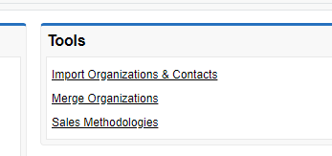

- Click on Organizations and Contacts then, select what you want to do. Typically, you are adding new records.

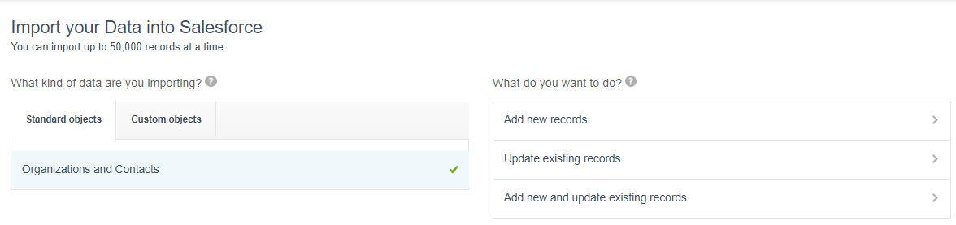
- Match your contact by name or email and then upload your .CSV document and click next. Note: if you file is not showing up to select make sure you select all files and then .CSV documents will appear.

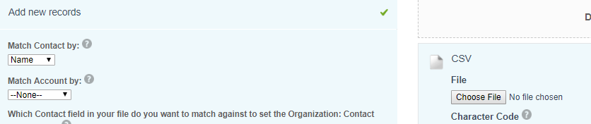

- You will need to map any areas that show up as unmapped. Account = Organization Name, Account ID = Contact Account ID, Select “Next” at the bottom of screen and then the green button that says “Start Import”

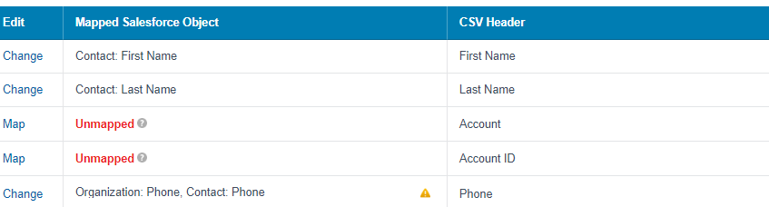

- You will receive an email when your upload is complete telling you how many contacts were created and if any were rejected and why.

