Sample Youth Participant Enrollment Form

Notes for Purdue Extension staff who coordinate enrollment for ANR, CD, or HHS Programs involving youth participants. Extension staff may want to utilize this sample enrollment form as they plan youth programming efforts. (IMPORTANT: 4-H Youth Development staff should follow established procedures for program enrollment built into 4-H Online.)

- If you are responsible for organizing enrollment for a program involving youth participants, this sample enrollment form contains required waivers and information that will help you fulfill the requirements of section X of Purdue’s policy for programs involving minors. Purdue University’s policy can be found here: https://www.purdue.edu/ethics/resources/programs-involving-minors.php. This documentation will allow you to confidently check the box below on the registration form you’ll complete when you register the program with Purdue University.

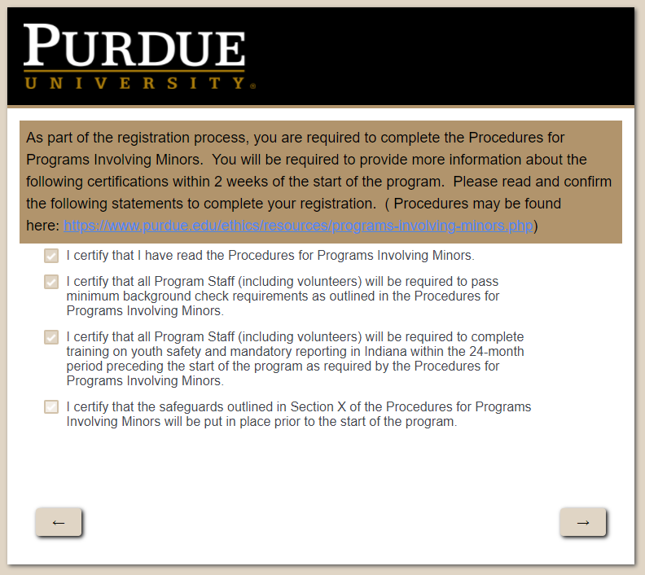

Required checklist from https://www.purdue.edu/ethics/resources/programs-involving-minors.php:

  - The Sponsor has a list of all program participants (for programs where registration of participants is required) and Program Staff, including current emergency contact information, and has a plan in place for notifying parents or legal guardians in the event of an emergency. Please note that the Purdue University Risk Management Office must be notified following an emergency.

  - All appropriate permission forms, liability waivers, media releases and medical treatment authorization forms for minors participating in the program have been obtained and are on file with the Sponsor. These forms should be safeguarded and readily available.

  - Arrangements have been made to ensure all activities involving minors will be supervised by the child's parent or legal guardian or an appropriate ratio of Program Staff at all times. If they are staying in University housing, a plan for supervision of minors while in University housing has been approved by the applicable campus housing authority.
    - Precaution for all programs involving minors: At least two approved adult volunteers/staff are present at all times; one-on-one interactions are limited to times when approved adults are within line of sight of other approved adults.

- The following template can be edited to meet your program enrollment needs. Additional templates for Purdue Risk Management forms can be found here: https://www.purdue.edu/business/risk_mgmt/Forms/
Purdue Extension
Youth Program Participant Registration Form - SAMPLE

Youth Participant’s Name _____________________________________________________

Parent or Guardian’s Name(s) ______________________________________________

Address _____________________________________________________

_____________________________________________________

Phone ________________________ Age ______ Current Grade _______

Email address __________________________________________

My youth participant requires special dietary restrictions? Yes ____ No_____

If yes, please explain: ______________________________________________________________________

Is there any other information that Purdue Extension staff should know about your child to ensure their safety while participating in this program? ____________________________________________________________________________________________________________________________________________________________________________________________________
Adult authorized to pick up child:

_____________________________________ ______________________________________
Print name of adult to pick up youth participant Signature of parent or guardian authorizing this person to pick up youth participant

Note: The authorized adult must sign out the child with an official youth program representative.

Emergency Contact Information:

In case we cannot reach you, please list the name and phone number of a second party to contact:

Name___________________________________________________

Address_________________________________________________

Telephone: Home ___________________ Work___________________ Cell _________________

Photo Release:
I grant permission to Purdue University, its agents, trustees, and others working under its authority, to reproduce the photographs/video taken of the above program participant for the purpose of promotional, news, research, and/or educational purposes, without my review. I hereby release, discharge, and hold harmless Purdue University and its agents and trustees from any and all claims, demands, or causes of action that I may hereafter have by reason of anything contained in the photographs or video.

Personal Liability Waiver:

I understand that participating in Purdue Extension activities can involve certain risks to my child. Those risks may include injury or harm, including, but not limited to, bodily injury, disability, exposure to COVID-19 and other viruses and or illnesses, and death. During virtual Purdue Extension activities, I understand that program staff are not providing supervision for my child during the online program, and the Released Parties do not have control over the information available through the internet or other electronic data sources beyond that which is a part of the Purdue Extension activity. On behalf of my child, I fully assume the inherent risks associated with my child participating in Purdue Extension activities and assert that my child has chosen to participate in this program with my express approval. I hereby release and discharge Purdue University, The Trustees of Purdue University, the ________________ County Commissioners, the ________________County Cooperative Extension Service, and each of their trustees, officers, appointees, agents, employees, and volunteers ("Released Parties") from all claims which my child or I might have for any injury or harm to my child, arising out of my child’s participation in any activity related to the Purdue Extension program, even if such injury or harm is caused by the negligence or fault of any of the Released Parties. I do not, however, release these individuals and entities from liability for intentional, willful or wanton acts and this release shall not be construed to include such acts.

(Note: The following suggested codes of conduct were originally prepared for conventional in-person and virtual classroom settings. Please feel free to use these samples as a guide for developing a code of conduct for your broader Extension programming.)

Youth Participant Code of Conduct (SAMPLE for In-Person Programs)

- I shall use language appropriate to the classroom during all conversations, including written conversations with program staff and fellow participants.
- I shall arrive each day with a positive attitude prepared to actively engage the program.
- I shall respect the individuality and rights of others in the program. I understand that harassment, discrimination, sexual harassment and bullying, including cyberbullying, will not be tolerated and can lead to immediate expulsion from the program.
- I shall contact the program director or another member of the program staff at any time, if I experience any form of harassment during the program or outside of program hours.
- I shall not capture the image of any other participant. This includes taking photos or recordings of any type that would include the images of any other participant in the program. The only exception to this rule is if the image has a curricular purpose for the specific course and permission has been granted by parent(s)/guardian(s) and the participant whose image is captured.
- I understand that no communication between myself and a program staff member shall occur in a one-on-one context. If I am invited by a staff member to engage in a one-on-one meeting or otherwise communicate with a staff member one-on-one, I should immediately inform my parent(s)/guardian(s) and the program director.
- I shall invite the program director or authorized personnel to all shared documents or locations of my work that will receive comments by my instructor.
- I shall demonstrate respect to program staff and volunteers at all times.
- I shall wear clothing appropriate for the classroom to all program meetings. I shall not wear clothing that disrupts the learning environment, such as displaying offensive images or language.
- I understand that I am encouraged to contact the program director and/or instructor about any concerns that I have about my experiences in the program, at any time. If I do contact the director or instructor via email, I shall carbon copy the appropriate authorized personnel of the program.
- I understand that any violation of the program rules may lead to disciplinary action including immediate dismissal from the program and forfeiture of all fees paid. As a participant in the {Program Name}, I have read and fully understand the agreements, operating assumptions, rules, and regulations described above. I have had opportunity to ask questions about these materials and have my questions answered. I am aware that any behavior contrary to the guidelines cited above may result in disciplinary action or expulsion from the Program.

Youth Participant Code of Conduct (SAMPLE for Virtual Programs):

- I shall enter all online instruction with my microphone on mute.
- I shall use language appropriate to the classroom during all conversations, including written conversations in chat windows, emails, and during live video discussions.
- I shall adhere to the protocols governing online learning as established by the instructor and program. This includes how to reach out to course instructor for additional instruction and clarification of instruction.
- I shall attend each learning session prepared to actively engage with the course material.
- I shall respect the individuality and rights of others in the program. Cyberbullying, harassment, discrimination, and sexual harassment will not be tolerated and can lead to immediate expulsion from the program.
- I shall contact the program director and instructor, at any time, if I experience any form of harassment.
- I shall not capture the image of any other participant. This includes taking screen shots or recording of any type that would include the images of any other participant in the program. The only exception to this rule is if the image has a curricular purpose for the course and permission has been granted by parent(s)/guardian(s) and the participant whose image is captured.
- I shall not display the image of any other participant online or through any other medium or channel.
- I understand that all computer mediated written communication shall only occur through the public chat window of the software program utilized during video instruction.
- I understand that no written communication between myself and a program staff member shall occur in a one-on-one context. If I am invited by a staff member to communicate through a written channel on a one-on-one basis, I should immediately inform my parent(s)/guardian(s) and the program director.
- I understand that if a program staff member requests to communicate with me in a one-on-one video environment that this conversation will be recorded and the video will be submitted to the program director or authorized personnel for evaluation.
- I shall invite the program director or authorized personnel to all shared documents or locations of my work that will receive comments by my instructor.
- I shall demonstrate respect to program staff and volunteers at all times.
- I shall wear clothing appropriate for the classroom to all live video instruction. I shall not wear clothing that disrupts the learning environment, such as displaying offensive images or language. I understand that different instructors have different standards regarding appropriate dress and will work with instructors to develop a reasonable solution if I am asked to alter my attire.
- I shall manage my environment to promote a positive learning environment for others. This includes controlling the visible background of my live image and the noise levels of my environment.
- I understand that the Program Staff reserves the right to disable my microphone or video capabilities as they deem necessary or appropriate.
- I understand it is my sole responsibility to possess the necessary computer hardware and acquire the required computer software to participate in a meaningful way in all aspects of the program.
- I understand that I am encouraged to contact the program director and/or instructor about any concerns that I have about my experiences in the program, at any time. If I do contact the director or instructor, I shall carbon copy the appropriate authorized personnel of the program.
- I understand that any violation of the program rules may lead to disciplinary action including immediate dismissal from the program and forfeiture of all fees paid.

As a participant or parent/guardian of a participant in the {Program Name}, I have read and fully understand the waivers, releases, agreements, operating assumptions, rules, and regulations described above. I have had the opportunity to ask questions about these materials and have my questions answered. I am aware that any behavior contrary to the guidelines cited above may result in disciplinary action or expulsion from the Program.

Participant Signature:_______________________________ Date: ___________________________

Parent/Guardian Signature:___________________________ Date:____________________________

It is the policy of the Purdue University Cooperative Extension Service that all persons have equal opportunity and access to its educational programs, services, activities, and facilities without regard to race, religion, color, sex, age, national origin or ancestry, marital status, parental status, sexual orientation, disability or status as a veteran. Purdue University is an Affirmative Action institution. If you require auxiliary aids and services due to a disability, please contact us at least 3 weeks prior to the event at ______
Ask for_________, Extension Educator

