YOUTUBE
UPLOADING VIDEO

Uploading a Video to YouTube
- Open YouTube and ensure that you are logged in under the correct account

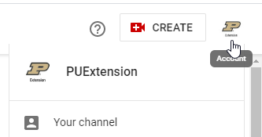

2. Select the Create tab at the top, left hand of the screen
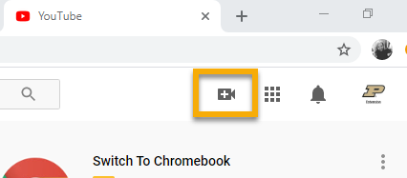
3. Select Upload Video
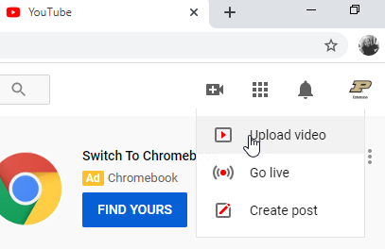
4. Drag and drop or select your edited video that is set to be published
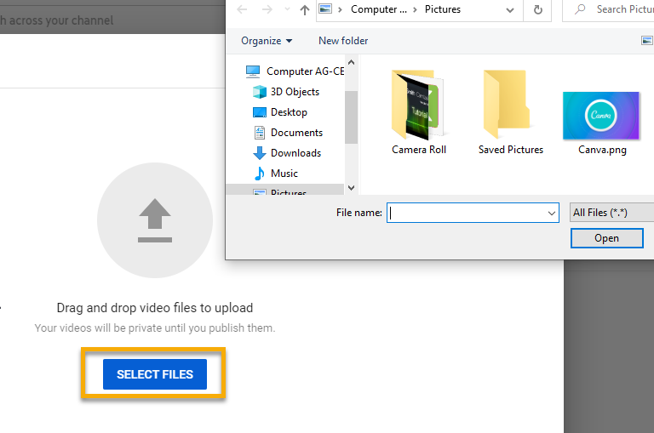
5. Name the video that you are uploading. This is the name that viewers will search for, ensure that it is something that accurately states what the video is about.
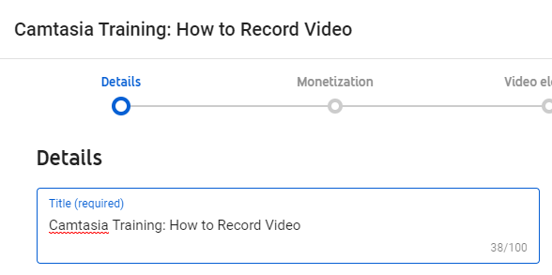
6. Add a description of your video that is to be published. By plugging in the domain of your channel, you will be able to drive a larger audience to your video and to all other videos that are on your channel.
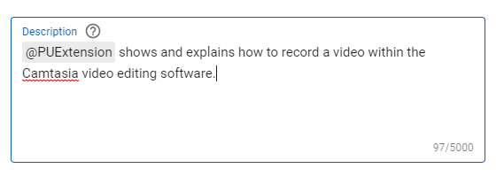
7. Select an appealing thumbnail for your video. Your thumbnail should be descriptive and attractive for viewers to click on. YouTube will generate a few options for you to chose from or you can upload one of your own.
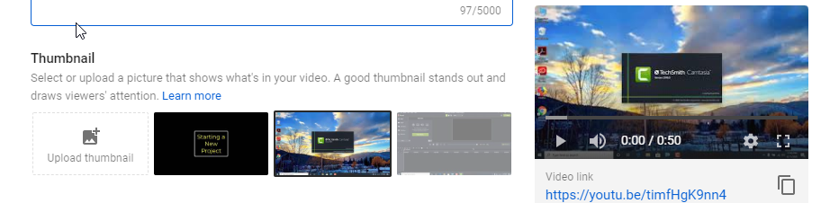
8. Add your video to a playlist. By adding the video that you are uploading to a playlist, your video will appear after related videos and play as a series if your video is a part of a larger topic. YouTube allows for you to add your video to multiple playlists and also to create a new playlist within this feature.
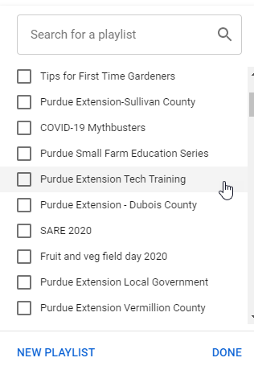
9. Chose how or if you want to receive money from displaying advertisements on your video. Purdue does not enforce this, therefor it is recommended to select Off.
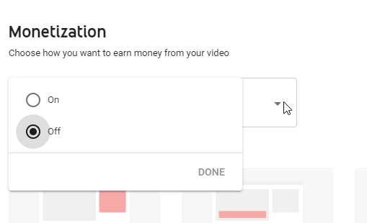
10. If you are ready to publish your video, and have it live for all others to view, select the Public option. It is recommended that if you are not quite ready for it to be viewed, select the Unlisted option and share the link with anyone that you wish to review it before publishing it live for all others to watch.
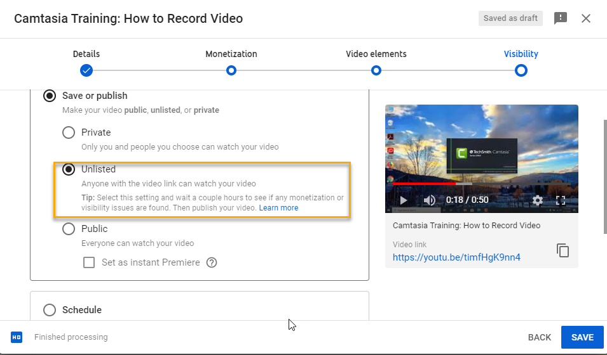
11. To schedule a video to publish at a later date, select the Schedule option to arrange for a date and time that your video will be posted publicly for all others to watch.
