CAMTASIA VIDEO EDITING SOFTWARE
BASIC USES

Starting a New Project
Plan the shots that you intend on showing and the graphics that you wish to include in your video. Start by making a document that you can study or read off of during your recording.
- Determine the equipment that you will be using to record your video. Techsmith recommends using a microphone that plugs into the side of your USB port to ensure sound quality. If you do not have a microphone, you may use the built-in microphone on your computer. Determine how you will be recording your video. You may record your video on Camtasia, or you may use another device such as an iPhone.
If you chose to use an iPhone, make sure that your camera is steady by using a tripod or propping it up.
NOTE: Hold your iPhone horizontally when capturing footage
- Adjust the lighting in your footage if you will be showing subjects other than your computer screen.

- Close all unnecessary tabs on your computer screen while recording the video.

- Open Camtasia on your computer and chose “New Project.” You can also choose to continue working on a project that you have already started.
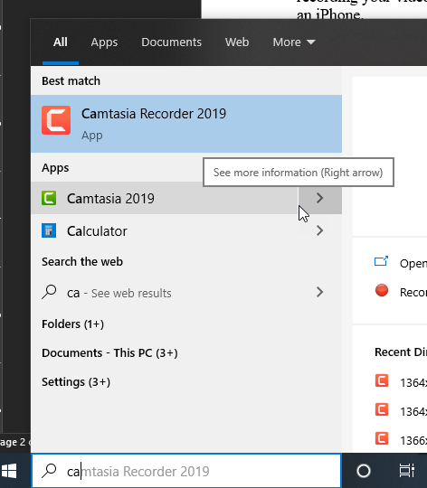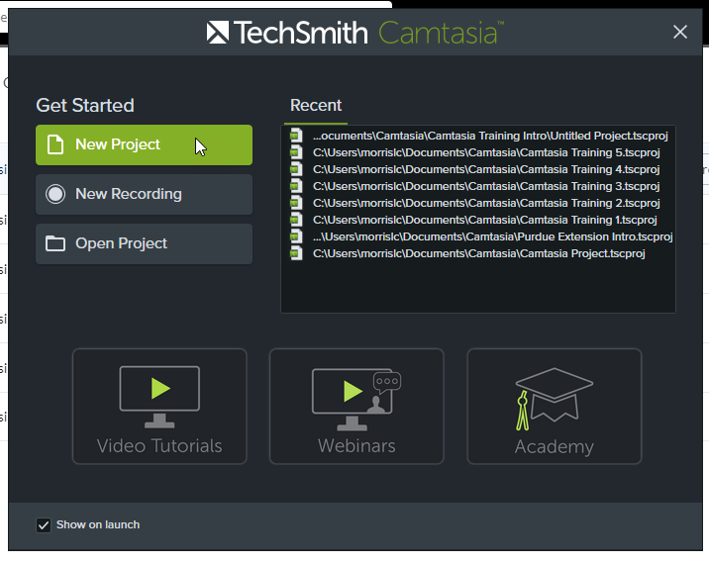
- Add any photos or media to your media bin by selecting “Import Media” and dragging in any materials that you wish to incorporate into your video.
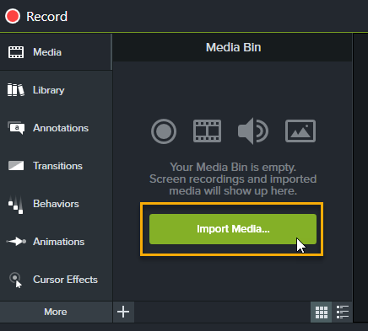
Recording
- For the purpose of this document, recording will be made possible through the Camtasia application itself. Click Record at the top left of the screen. Camtasia will automatically start a new project or add it to an existing project if you chose.
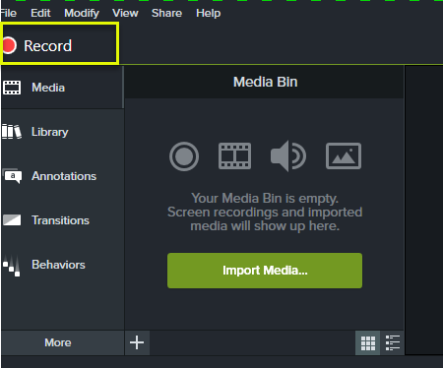
If you have recorded on another device, TechSmith recommends using the TechSmith mobile app. This app allows for you to record video and directly send your footage or pictures to Camtasia or SnagIt. Select Import Media and add the files that you have uploaded
Note: it is recommended that all files are saved and exported as an mp4 file
- After selecting Record, a box will appear in the lower right hand of the screen. Select the area of your computer screen that you are wanting to display in your video.
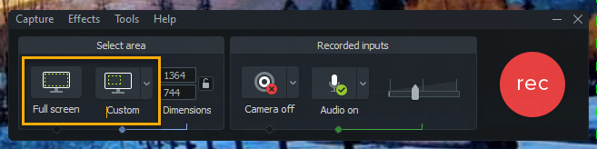

- Select the red Record button, and begin recording your screen.
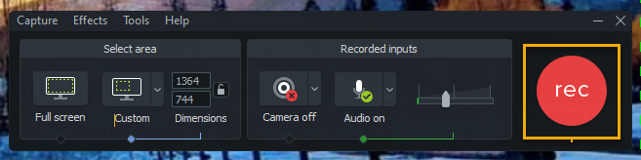

Note: When making errors in your recording, pause, and try again rather than making many videos. This will help when editing your videos

- Once you are finished recording, your slides will appear in the media bin. If you are using clips or screenshots that were taken from another device or project, you can import the media by selecting the Import Media button and adding your file.
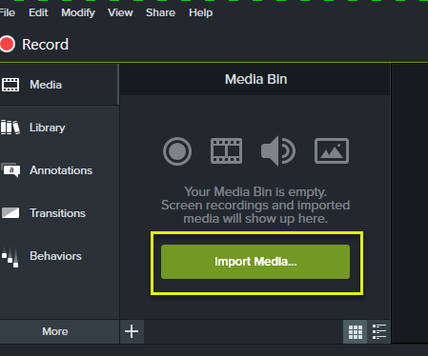

- Arrange your video clips in the order that you want them to appear in the video. Your video will be split in tracks. Each track will host a separate feature of your media. One track will be for your sound, another for your footage, one for annotations, etc.
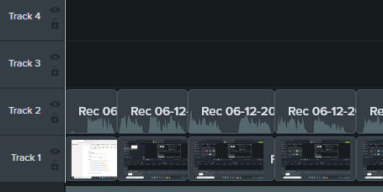

Simple Edits
- Splitting a video in the middle is essential when there may be a pause or a blooper in your footage that you need to cut out. Split the video by placing the timemarker at the time frame where you would like to make the split. Then click the Split tool.
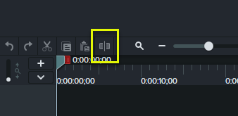

- You can undo or redo any edit that you have made by selecting the undo or redo buttons in the ribbon.
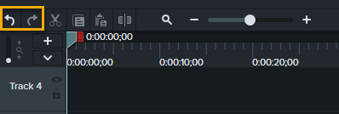

- Highlight the footage that you would like to delete and click the Cut tool in order to get rid of part of the recording that you do not want in your video.

Note: You can also hold Ctrl X to make a cut
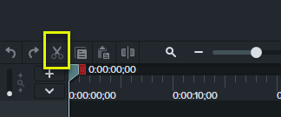

- It may be easier to view your timeline and see your footage by adjusting the zoom in and zoom out features. You can zoom in when cutting footage out of your video and zoom out when checking the duration of your time.
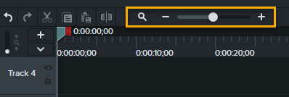
Adding an Introduction and Transitions
- Add an introduction in your video by creating some space at the beginning of your timeline. To do this, hold the Shift key on your keyboard and drag your play head back. Set the play head back to the approximate time that you would like your introduction to play for.
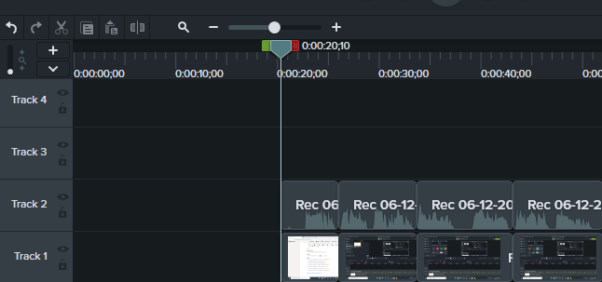

- Open the Media bin and select the Library tab. From the Motion Graphics-Intro Clip folder you can drag and drop the selected clip into your timeline.
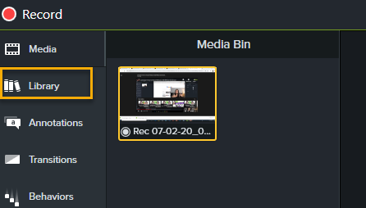
- You can customize your introduction by selecting it on the timeline and then editing the font, shapes, and colors in the Properties panel. If you don’t want a text box or symbol that is provided for you, you can double click it and click delete to remove the item.
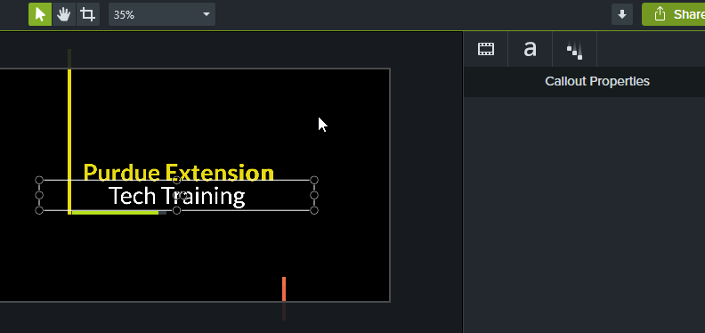

- To add transitions, select the Transitions tab at the left hand of the screen.
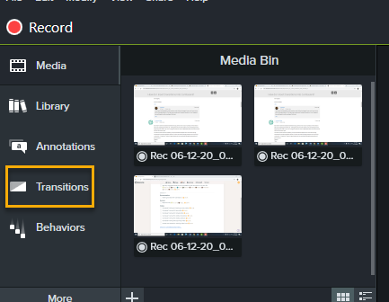

- Hover your mouse over the transition to preview.
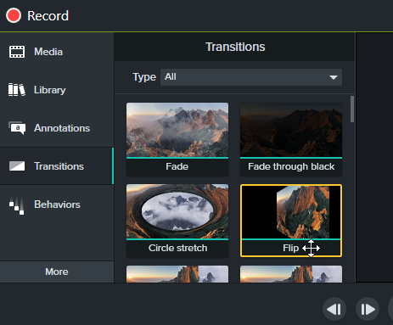

- Once you have selected a transition that you would like to add to your video, click and drag it in between the two slides that you would like it to show.
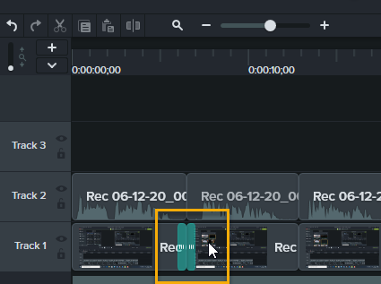
- You can adjust the length that the transition plays for by moving the blue area to the exact time frame that you would like.
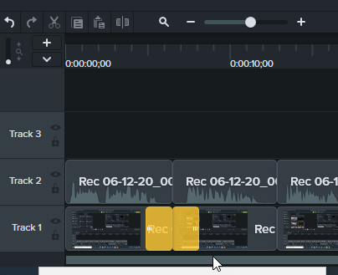

Adding Callouts
- Callouts can help viewers focus on an area that you are wanting them to. They can also add side notes in an area that you may have forgotten to mention. To add a Callout, select the Annotations tab at the top left of the screen.
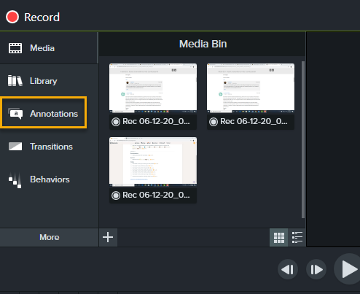

- From here, you can select what kind of callout you are wanting to add. Select from thought bubbles, arrows, shapes, keyboard strokes and more.

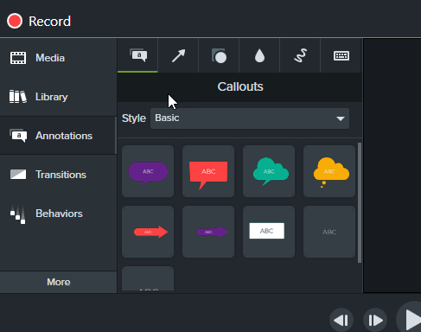
Note: For a more presentable video, make sure the callouts follow a central theme. (ex: make all thought bubbles the same design)

- Click and drag the callout that you selected onto a separate track. Make sure that you are adding it into the time frame that you would like it to appear. You can adjust the length that the callout displays for by adjusting the horizontal arrows.
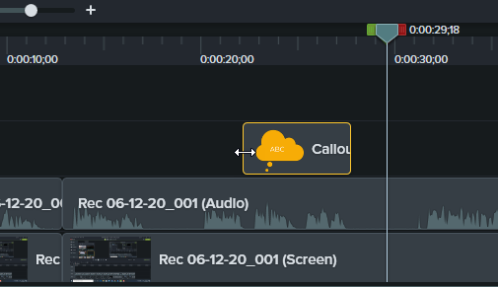

- Review the callout by watching it appear on the preview screen. Here, you can adjust the text, size, and placement of the callout.
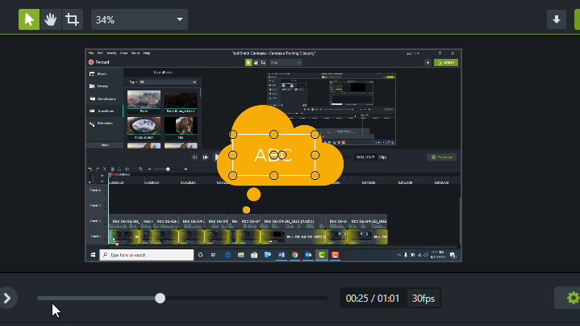
Exporting Video
- Once you have finished your video and are ready to publish, select the Share button at the upper right hand of the screen. Select Local File.
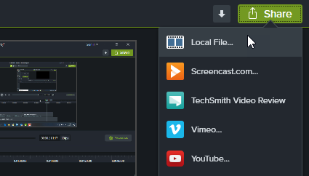

- It is recommended that you save this video as an MP4 file. The lower the pexels that it is saved, the more you are risking the quality and clarity of your footage. The higher the pexels that it is saved, the more space that it takes to store on your computer and will also have a longer load time. For this reason, it is recommended that you select the middle option. (MP4 up to 720p)
