Quicken 2016 Premier Edition Manual

For

Purdue Cooperative Extension Service

County Ed Fund

June 2011

Counties must store their Quicken data files on their P:\drives
(county servers) S:\EdFund

For example: \\42tippecanoe\Home\EdFund

Table of Contents
Setting up an Account 3
Using Organization Categories 8
Using Income and Expense Categories 11
Entering Transactions 12
Reconciling A Bank Statement 17
Creating A Financial Report 20
Appendix A: Policies and Procedures 22
Appendix B: Standard Organization Categories 23
Appendix C: Standard Income/Expenses Categories 24
Appendix D: Check WRITING AND Printing Feature 25
Appendix E: How to Hide/Delete Accounts 29
Appendix F: Default Settings for Backups 31
Appendix G: Warnings about Modifying Data 32
APPENDIX H: RESOURCES……………………………………….………………………………………….………………………………………………… 33

Account Set-up

After you have completed the registration process, you will see the Get Started Page under the Home tab. You will want to select- “Add an Account”. (Figure 1)

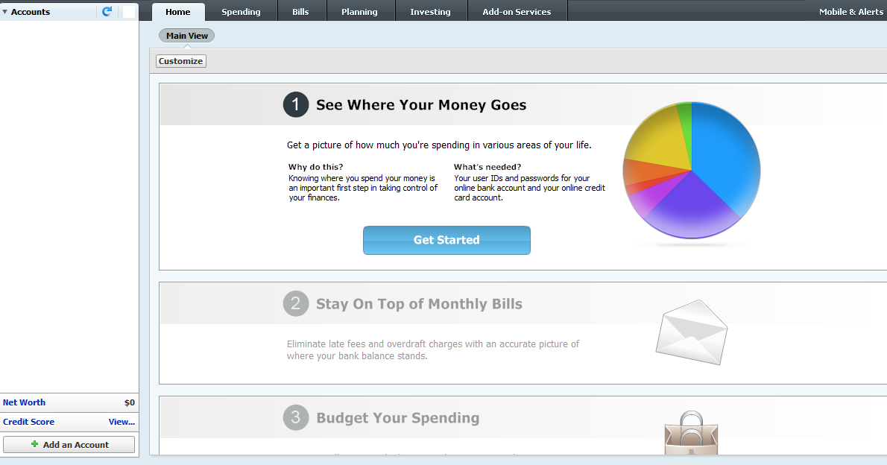
Figure 1

You will then select “Checking”. (Figure 2)
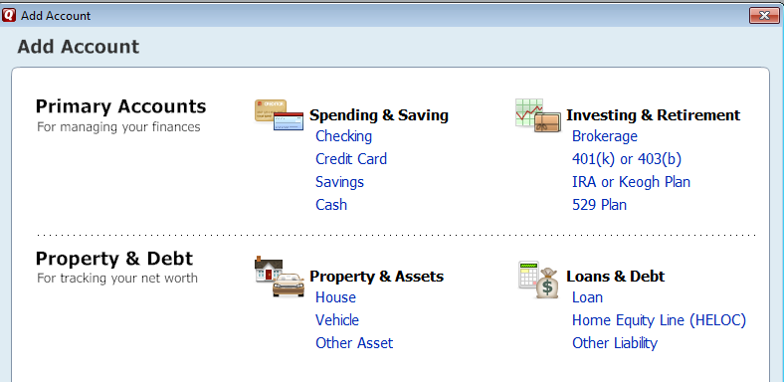 Figure 2
Figure 3
Since you will not be downloading transactions from your bank account, you will click the words Advanced Setup at the bottom of (Figure 3).
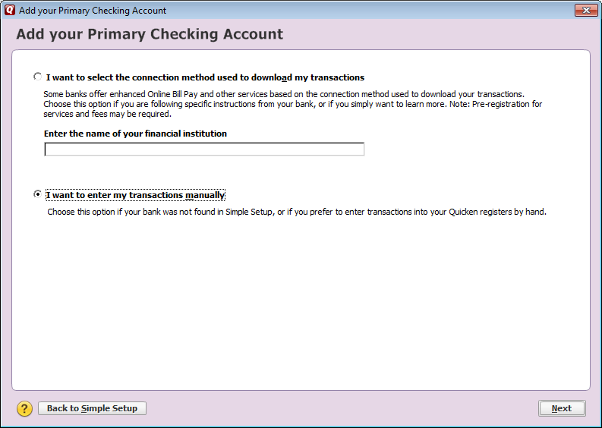
Figure 4

Select the radio button next to “I want to enter my transactions manually” as seen above. ( Figure 4)

In the Account Name/Nickname enter “Checking”. Click the Next button in the lower right side. (Figure 5)

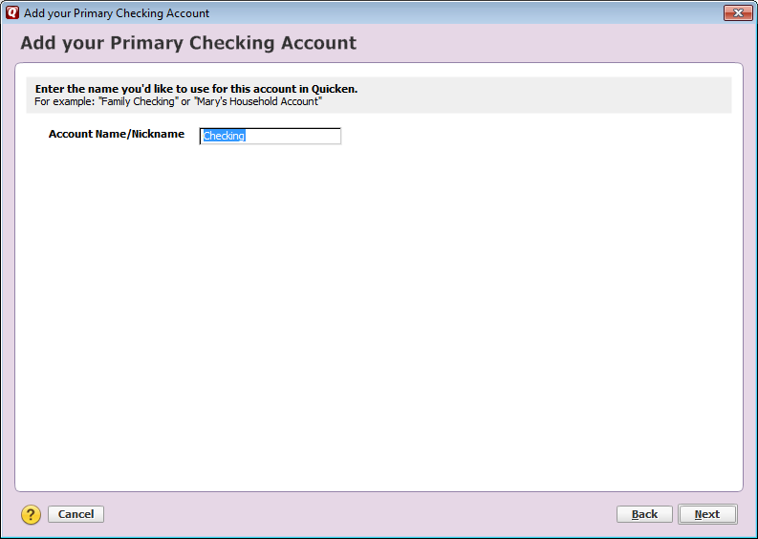
Figure 5

In the Statement Ending Date enter 11/30/2009 or click on the calendar icon to choose a date. In the Statement Ending Balance enter 13,000.00 or use the calculator icon to enter the amount. Review what you have entered. Click the Next button at the lower right. (Figure 6)

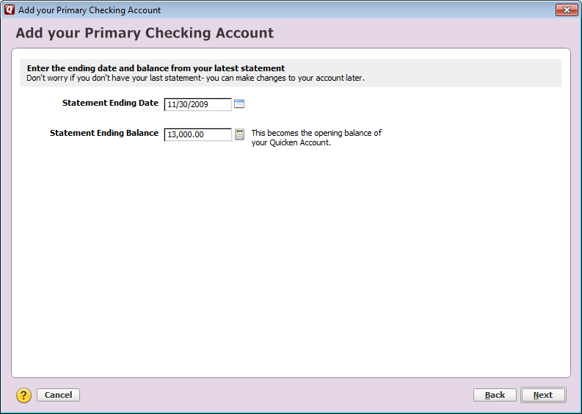
Figure 6

A confirmation of the setup will appear. Click the Finish button. Do not check the box next to “Sync to Quicken Cloud for Mobile & Alerts”. (Figure 7)
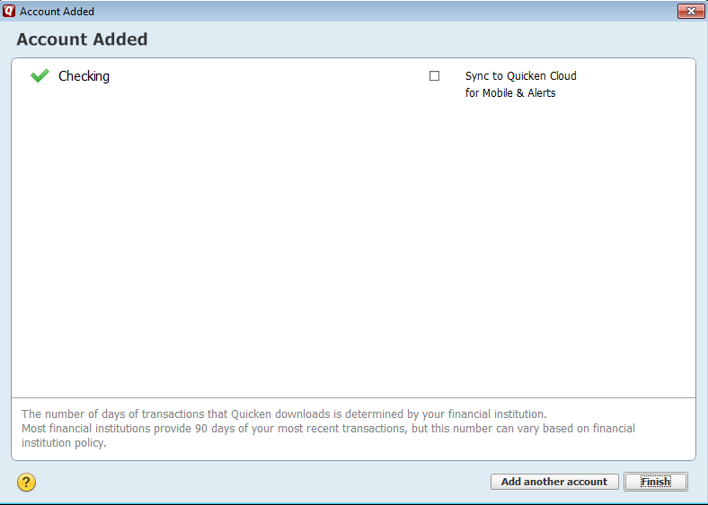
Figure 7

Note that the Checking account is now set-up showing a beginning balance of $13,000. (Figure 8)
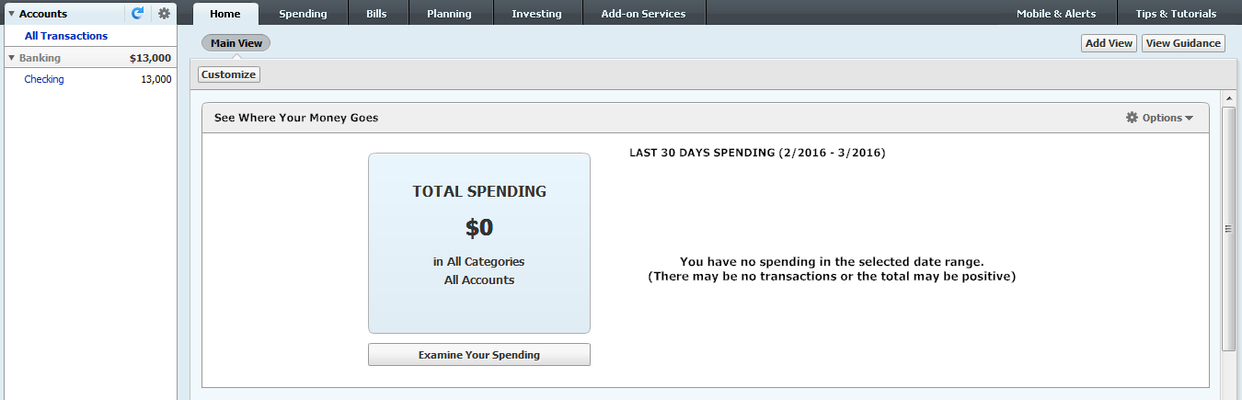
Figure 8

Entering transactions into this Register along with the use of Tools, Reports and Actions will come later in the training.
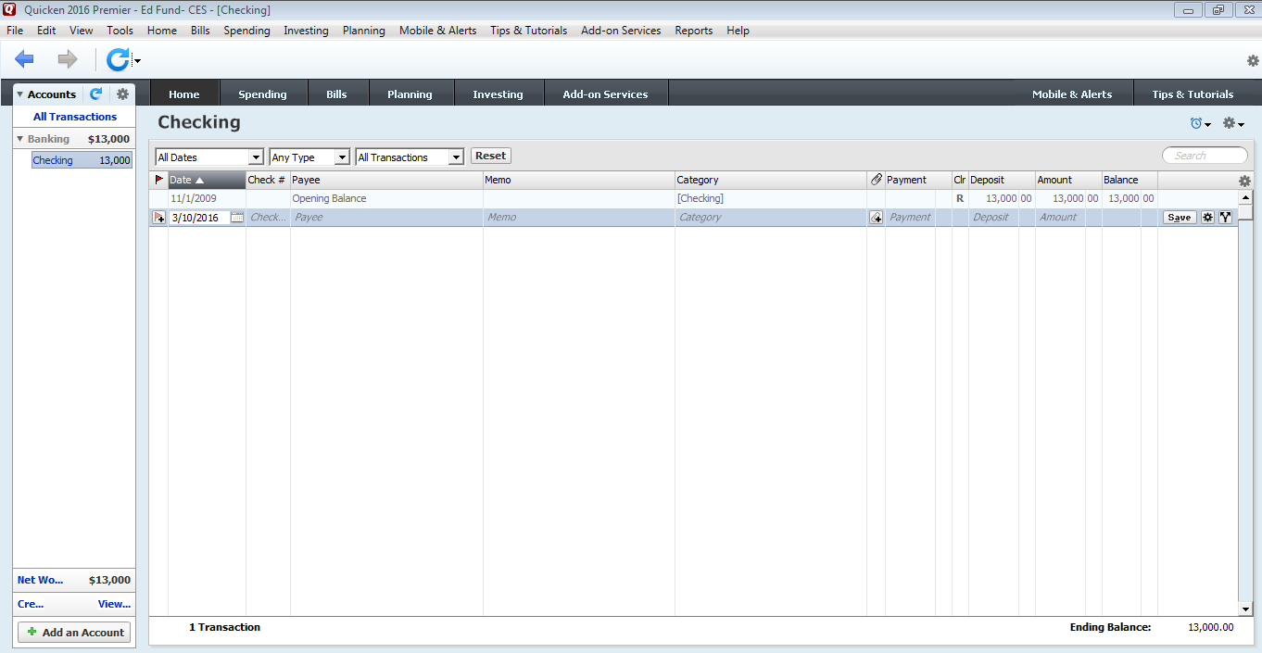
Figure 9

Using Organization Categories

Before we can enter transactions, we need to set up Categories to be able to report on the activity in the accounts. Categories are ways to group and report on transactions.

We will use several levels of categories for both income and expense transactions that identify different areas within the organization. The highest level will be: 4-H Youth Development, ANR, HHS, CD, General/Miscellaneous, Grants, and PCARET. The next levels are called Subcategories. The subcategories under the highest level organization categories are shown below and in Appendix B.

4-H YOUTH DEVELOPMENT
After School Program
Camp
Flow Through
4-H Association
Auction
Judging
Junior Leaders
Livestock
Trophies
Trips
Manuals
State Fees
ANR (Ag & Natural Resources)
Flow Through
Livestock
Master Gardener
Master Naturalist
PARP
Farm Record Books
Diagnostic Testing
HHS (Health & Human Sciences)
Family Nutrition Program
Flow Through
Extension Homemakers
Food Safety
Have a Healthy Baby
CD (Community Development)
Flow Through
GENERAL – MISCELLANEOUS
Flow Through
Publications
Postage
Office Supplies
Annual Meetings
Interest/Bank Charges
GRANTS
Flow Through
PCARET (Purdue Council for Agriculture Research Extension & Training)
Flow Through

In Quicken we will set up the Organization category ANR (Ag & Natural Resources) for both Income and Expense along with its Subcategories: Flow Through, Livestock, Master Gardener, Master Naturalist, and PARP.

To enter your first Organization category, choose Tools menu > Category List (Figure 10).

Figure 10

You will now see the Category List screen (Figure 11). To hide the standard categories you will right click on the category and check the Hide box.

Figure 11

To add a new category in Quicken, click on the Add Category button in the top right corner of the category list box (Figure 12).
Figure 12

This will open the Set Up Category screen (Figure 13). Enter the Category Name ANR - Inc and select the Type- Income. Then click OK. This will return you to the Category List screen (Figure 12).
Click radio button; Income

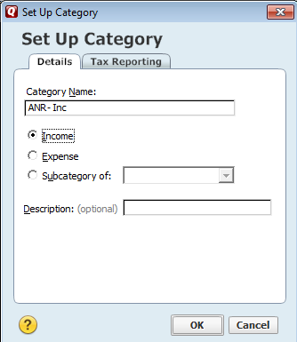
Figure 13

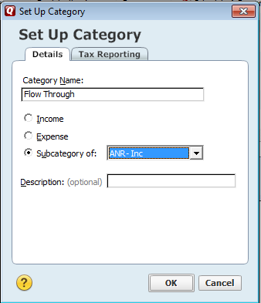
Figure 14

Repeat the steps shown in Figures 12 – 14 to create the same categories and subcategories for ANR expenses that you have set up for ANR income. Name the main category ANR – Exp instead of ANR – Inc (see Figure 13). Under ANR – Exp enter the subcategories Flow Through, Livestock,
Master Gardener, Master Naturalist, and PARP in the same way as shown in Figure 14.

Because of the importance of having each county’s data being reported consistently, all Organization Categories must be set up in Quicken. See Appendix B for the Organization Categories List.

Using Income and Expense Categories

We can add additional subcategories within the Organization categories to further identify the type of income or expense. Examples of income categories include gifts, rental income, or income from certification fees, leases, and workshops. Examples of expense categories would be equipment, printing, or expense associated with banquets, workshops, or the county fair. A list of the standard income and expense categories that will be used by all areas is in Appendix C.

There are two (2) ways to enter these categories in Quicken: By using the Tools menu > Category List method that was used to enter the Organization Categories or by typing the subcategory in the transaction line and being prompted to set up a new category.

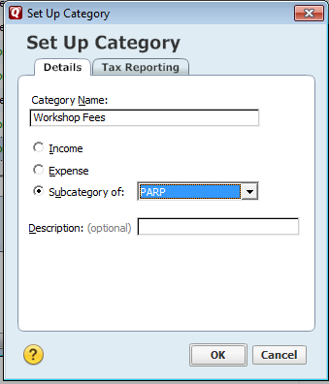 | For the first method, go to the Tools menu > Category List to see the Category List screen (Figure 11). We will enter a subcategory for Workshop Fees under subcategory PARP within category ANR-Exp. Click the New button in the upper right to open the Set Up Category screen (Figure 14). Enter the Category Name-Workshop Fees and select the type Subcategory of. Then click the arrow on the right to see the drop down of possible choices and choose PARP (under ANR – Inc). Click OK. This method can be used if you want to pre-set all standard income and expense categories under each Organization category and subcategory. Click Done when finished setting up categories.
Figure 15

The second method for setting up an income and expense category will be explained in the next section on Entering Transactions.

Entering Transactions

Now we will enter transactions (payments and deposits) into the Training account. Click on the Banking tab to see the Transactions screen, also called the Check Register, for the Training account (Figure 16). The only transaction on this screen now is the Opening Balance entered when you set up the account Training. You can add payments and deposits directly here by typing in the information on the first blank line.
Shows one transaction – Opening Balance

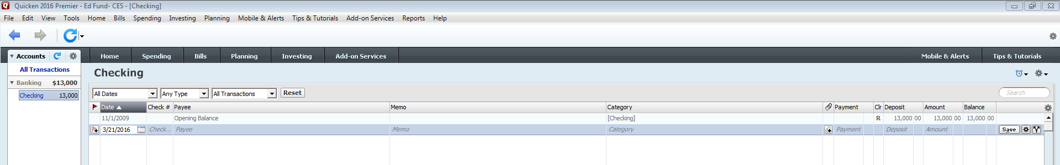
Type new transaction information on this line.

Figure 16

NOTE: Each county can decide whether to write checks manually or use the check printing feature in Quicken. YOU MUST CHOOSE ONE METHOD OR THE OTHER. More about Quicken’s Check Printing can be found in Appendix D.

You need to record a payment to Purdue University for $203.00 for workshop fees associated with PARP in ANR. The payment was made on 12/2/2009 on check #1245. Type the information as shown in (Figure 17) below.

The Category is always entered with the main category first, then the subcategories with a colon and no spaces between, so for the payment above enter: ANR - Exp:PARP:Workshop Fees. When you start to enter the category, Quicken will fill in what it thinks is required. You can also click the right down arrow and choose from the Category List as a drop down menu (Figure 18). When you have entered information in all fields, click Enter. Notice that the Balance on the right hand column has been updated to reflect the payment ($13,000.00 - $203.00 = $12,797.00).

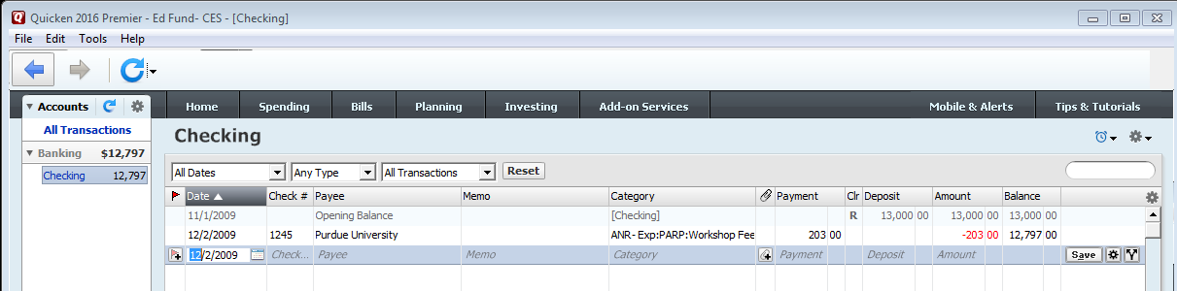
Balance has been updated.
Figure 17

TIP: When entering transactions you can use the tab key to move to the next field.

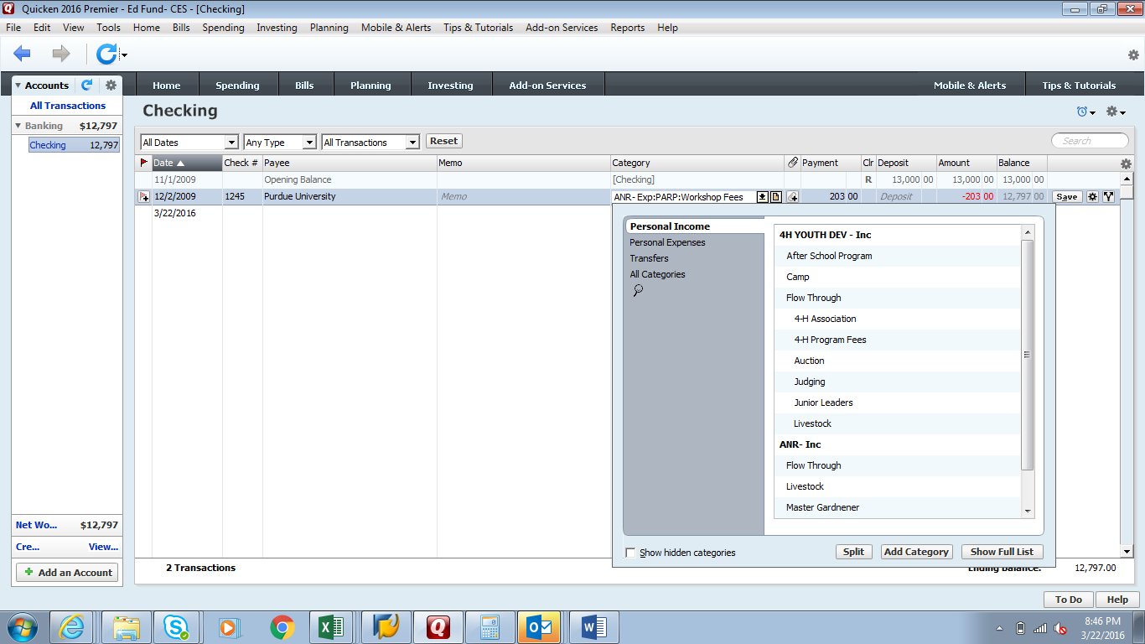
Figure 18

Now you need to record a deposit of $10.00 for Farm Record Books on 12/3/2009 associated with Flow Through in ANR. In the Num column choose Deposit from the drop down box. See Figure 19 to the right. | Figure 19
Type the information on the next line of the Transaction screen as shown in Figure 20 below. When you enter the Category, choose ANR – Inc:Flow Through from the drop down. Then type a colon (:), then Farm Record Books. You will see a box (Figure 21) asking if you want to create a new category. Click Yes to see the Set Up Category box (Figure 22). It will already have the Name of the category and show it as a Subcategory of Flow Through in ANR. All you have to do is review the information and click OK.

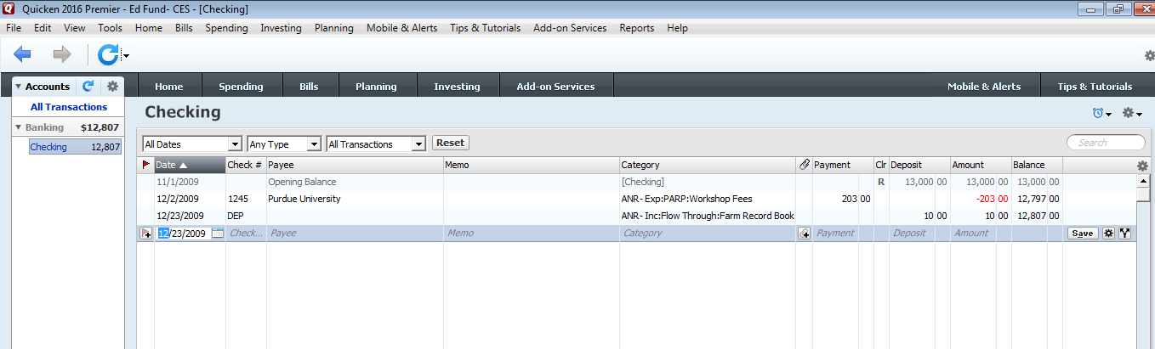
Figure 20

Figure 21

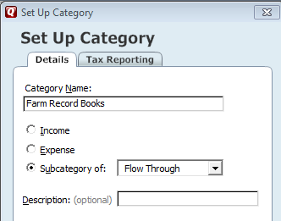
Figure 22

Enter Check #1246 dated 12/3/2009 to Wal-Mart for $80.32 to purchase office supplies for the Office Category General /Miscellaneous. Enter a note on the transaction “Office Supplies” by right clicking anywhere on the category box. Select Transaction Notes and Flags. Enter the note you want to appear and click OK to save. Notice that the icon now appears on the far left of the transaction line Figure 23.

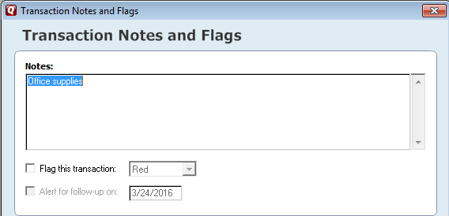
Figure 23

Enter a deposit on 12/4/2009 for $1,276.25 that includes $1,244.25 for camper fees associated with Camp in 4-H Youth Development and $32.00 for fees for Livestock in ANR. NOTE: You can enter amounts for more than one category. Just click on the Split button on the Check Register or on the Category drop down to see the Split Transaction screen (Figure 24) and enter each category. Enter a comment in the Memo field if desired (for example, the number of camper fees or the title of a workshop) and the amount. Your total must match the total of your deposit. When finished, click OK.
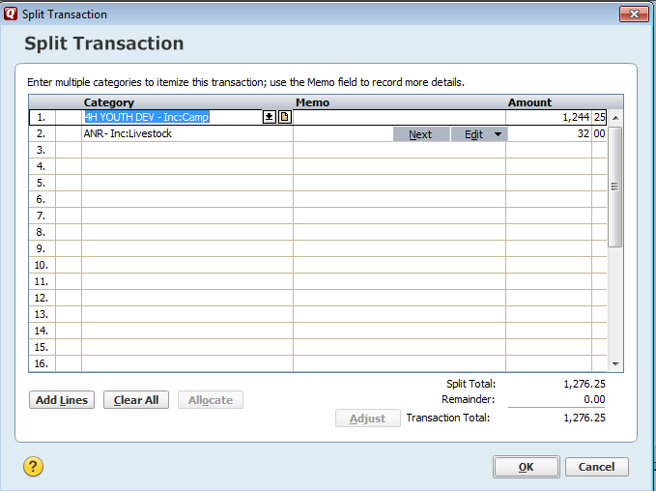
Figure 24

Use the same method to enter the additional transactions below:

Date | Ck Num | Paid by/to | Category/Memo | Amount
12/4/09 | 1247 | Kinser Bakery | ANR-Exp:PARP:Workshop Fees | $21.00
12/5/09 | Deposit |  | Split a Total of $375.00 as follows:  ANR-Inc:PARP: Publications  ANR-Inc:Flow Through:Farm Record Books  ANR-Inc:PARP:Workshop Fees  ANR-Inc:PARP  ANR-Inc:PARP:Institutional Memberships | $15.00  $30.00  $10.00  $250.00  $70.00
12/5/09 | 1248 | R&M Wholesale | ANR-Exp:PARP:Workshop Fees  Memo: Coffee, Cups and Supplies | $14.97
12/7/09 | 1249 | Purdue University | ANR-Exp:Farm Record Books | $400.00

We write check #1250 dated 12/8/2009 to Purdue University and realize that we wrote the wrong information in the pay to the order field and have to void this check. We still want to enter the check in the Quicken check register so we are not missing a check number. To void the check in Quicken, click on the line to be voided. Under Edit in the toolbar, select Transaction; then click on Void transaction (Figure 25).
Figure 25

Continue entering the transactions below:

Date | Ck Num | Paid by/to | Category/Memo | Amount
12/8/09 | 1251 | Wayne Pederson | ANR-Exp:Consultants  Memo: Soybean Rust Workshop | $422.00
12/9/09 | 1252 | Jane DeCamp | ANR-Exp:PARP:Workshop Fees | $30.00
12/10/09 | 1253 | Purdue University | ANR-Exp:PARP:Workshop Fees | $224.00
12/12/09 | 1254 | Purdue University | ANR-Exp:PARP:Workshop Fees | $49.00
12/14/09 | Deposit |  | Split a Total of $533.00 as follows:  ANR-Inc:PARP: Publications  ANR-Inc:Master Gardener  ANR-Inc:PARP Workshop Fees | $95.00  $310.00  $128.00
12/15/09 | 1255 | WhiteCounty SWCD | ANR-Exp:Farm Record Books | $130.00

Your check register should look like the screen in Figure 26 below. The ending balance in the lower right corner should be $13,619.96.
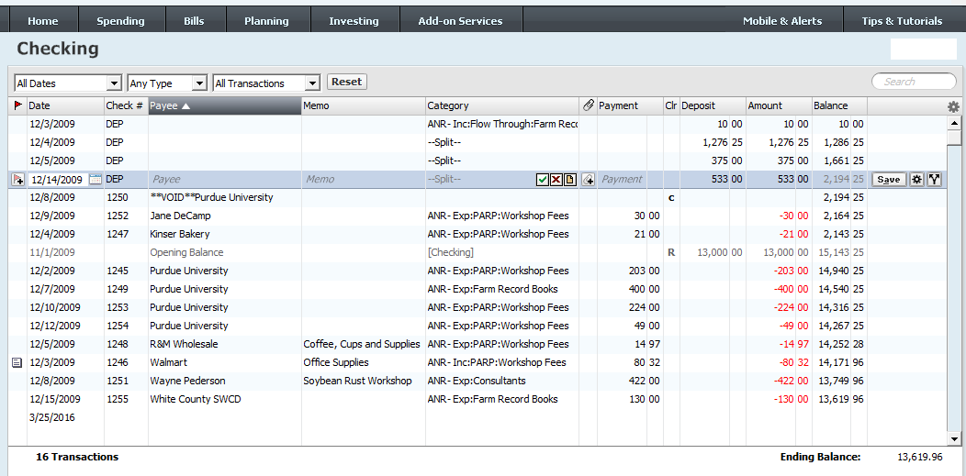
Figure 26

Bank Statement Reconciliation

On 12/31/2009, you receive the following bank statement for December 2009.

Opening Balance……………………………………………………………….…….$13,000.00
Ending Balance ………………………………………………………………….......$13,620.98
Interest……………………………………………………………………………………....$1.02
Deposits ………………………………………………………………………………..$2,194.25

Withdrawals
Check #1245………………………………………………………….…………………$203.00
Check #1246 ……………………………………………………………………………. $80.32
Check #1247 ……………………………………………………………………………..$21.00
Check #1248 ……………………………………………………………………………. $14.97
Check #1249 ……………………………………………………………………………$400.00
Check #1251 ……………………………………………………………………………$422.00
Check #1252 ……………………………………………………………………………..$30.00
Check #1253 ……………………………………………………………………………$224.00
Check #1254 ……………………………………………………………………………. $49.00
Check #1255 ……………………………………………………………………………$130.00
To reconcile Quicken to your bank statement, make sure you are in the correct account if you have more than one. Then choose Tools Menu > Reconcile an Account OR click Account Actions on the transaction screen and choose Reconcile to see the Reconcile Details screen (Figure 27).

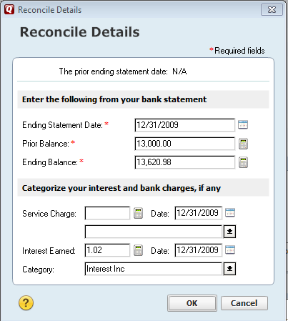
Figure 27
Enter the Ending Balance amount from your current bank statement $13,620.98, and the date of your bank statement 12/31/2009. Service Charge remains blank. Enter Interest Earned of $1.02. Then click OK.

The reconciling details appear with payments and checks on the left, and deposits on the right (Figure 28). Notice that some items are already marked as Cleared with a green check mark; see voided check and the interest earned on the bank statement. The current Difference in the lower right corner is -619.96. As transactions are marked as Cleared, the Difference will automatically be updated. Check off the transactions in the window that also appear on your statement or click Mark All to automatically check off all transactions.

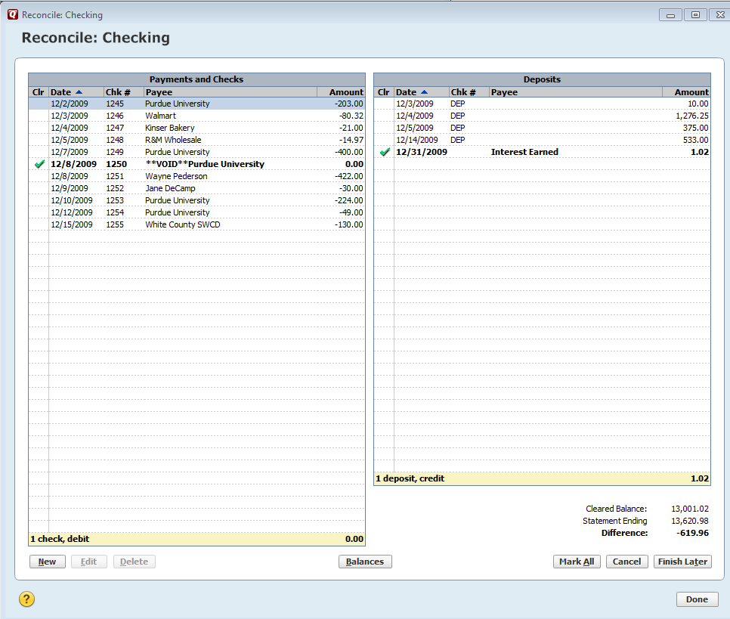
Figure 28
Click here to automatically mark all transactions as cleared
As transactions are cleared/reconciled, this balance will be updated.

When all transactions are reconciled, you should see the information as displayed above (Figure 29). If the Difference in the lower-right corner is zero, click Finished. If the difference is not zero, you will need to check your entries and make appropriate corrections. If you need more time to research this, you can click Finish Later, and Quicken will save your work.

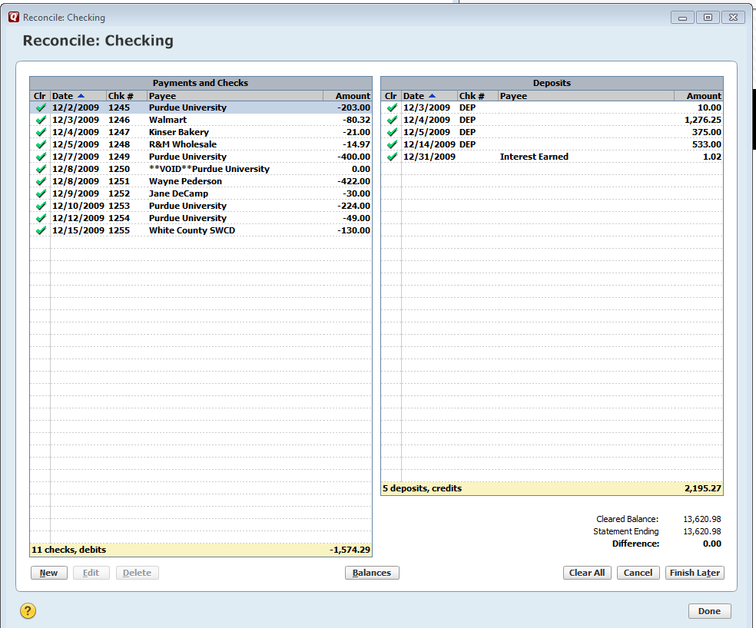
Figure 29

WARNING: Be cautious when modifying or deleting transactions. Quicken will usually give you a pop-up warning to help you remember to check your changes. You should always verify that you have made the change that you intended to make. As a rule, you should never modify or delete transactions once they have been reconciled. See Appendix H for additional information about warnings when modifying transactions.

When you click Finish, you’ll be asked if you want to create a reconciliation report (Figure 30). You may do this now, or you can get a reconciliation report at any time by going to the Reports tab at the top in the menu bar, drop-down to Banking, then Reconciliation. (Figure 31). Please note - The reconciliation report will print all current information, so when you enter new information it will also be included in the report. It is best to print your reconciliation report at the time you complete it.

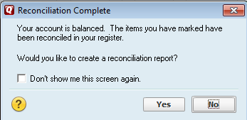  Figure 30 | Figure 31

Creating a Financial Report

To obtain information for financial reporting use the Reports tab in the menu bar. Drop-down and click on Reports and Graphs Center (Figure 32). You will see the Reports and Graphs screen in (Figure 33). Click on Itemized Categories to see (Figure 34) that describes the report (Account transactions, grouped by category) and gives you a box to choose from various date range options- choose “Quarter to date” then click Show Report. | Figure 32

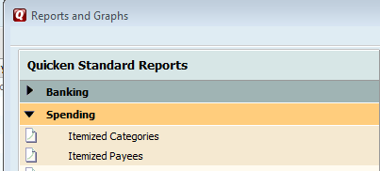
Figure 33

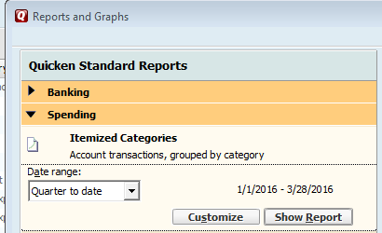
Figure 34

In Figure 34 click the Show Report button to see the Itemized Category Report.

You can Print or Save the report (see icons at the top of the report). You can also Expand the report to include more detail either by using the Expand All button at the top or by clicking the plus icon at the beginning each line. Note that the report shows only the Organization categories for which we entered transactions (4-H Youth Development and ANR). Figure 35 is an example of a report that contains all of the categories used on the standard financial report.

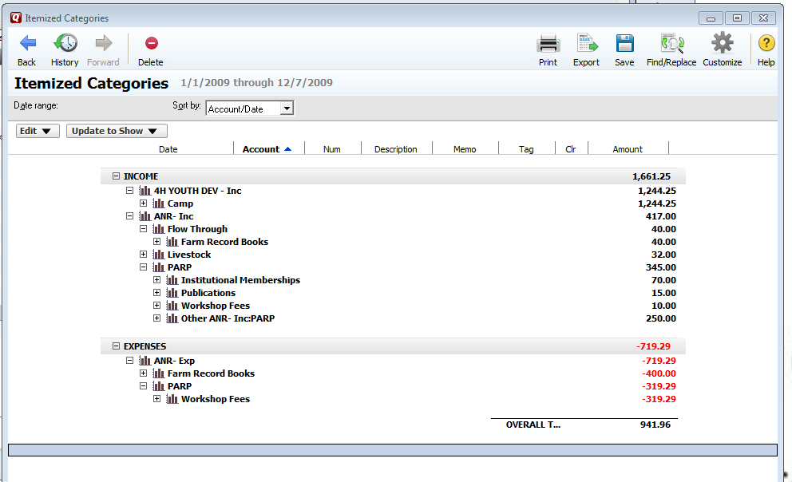
Figure 35

Appendix A: Policies and Procedures

- All counties are expected to use the most current Quicken version software, as instructed by the CES Business Office, in order to track their Ed Fund Account beginning January 1, 2010.

- Each CED must ensure that the support person in charge of managing the Quicken account has time to set up the software account and to integrate the data.

- Approved Area Accounts must be set up and stored using the same software and format.

- Software accounts that Counties may currently be using must be archived by April 1, 2010.

- All data must be stored on the S drive.

- Counties must reconcile the Ed Fund Account monthly and ensure that the data is stored on the S drive.

Appendix B: Standard Organization Categories

4-H YOUTH DEVELOPMENT
After School Program
Camp
Flow Through
4-H Association
Auction
Judging
Junior Leaders
Livestock
Trophies
Trips
Manuals
State Fees
ANR (Ag & Natural Resources)
Flow Through
Livestock
Master Gardener
Master Naturalist
PARP
Farm Record Books
Diagnostic Testing
HHS (Health & Human Sciences)
Family Nutrition Program
Flow Through
Extension Homemakers
Food Safety
Have a Healthy Baby
CD (Community Development)
Flow Through
GENERAL – MISCELLANEOUS
Flow Through
Publications
Postage
Office Supplies
Annual Meetings
Interest/Bank Charges
GRANTS
Flow Through
PCARET (Purdue Council for Agriculture Research Extension & Training)
Flow Through

Appendix C: Standard Income/Expenses Categories

Type – Income or Expense | Name
Income | Banquets-inc
Income | Camp-inc
Income | Certification-inc
Income | Computer Supplies-inc
Income | Consultants-inc
Income | County Fair-inc
Income | Diagnostic Lab-inc
Income | Equipment-inc
Income | Exhibit Board-inc
Income | Farm Record Books-inc
Income | Gifts-inc
Income | Institutional Memberships-inc
Income | Interest-inc
Income | Leases-inc
Income | Manuals-inc
Income | Miscellaneous-inc
Income | Office Supplies-inc
Income | Postage-inc
Income | Printing-inc
Income | Publications-inc
Income | Record Books-inc
Income | Rental (equipment, rooms, etc.)-inc
Income | Subscriptions-inc
Income | Travel-inc
Income | Workshop fees-inc
Expenses | Bank Fees-exp
Expenses | Banquets- exp
Expenses | Camp- exp
Expenses | Certification- exp
Expenses | Computer supplies- exp
Expenses | Consultants- exp
Expenses | County Fair- exp
Expenses | Diagnostic lab- exp
Expenses | Equipment- exp
Expenses | Exhibit Board- exp
Expenses | Farm Record Books- exp
Expenses | Gifts- exp
Expenses | Institutional Membership- exp
Expenses | Leases- exp
Expenses | Manuals- exp
Expenses | Miscellaneous- exp
Expenses | Office Supplies- exp
Expenses | Postage- exp
Expenses | Printing- exp
Expenses | Publications- exp
Expenses | Record Books- exp
Expenses | Rental (equipment, rooms, etc.)- exp
Expenses | Subscriptions- exp
Expenses | Travel- exp
Expenses | Workshop fees- exp

Appendix D: Writing Checks and Check Printing Feature with Quicken

Each county can decide whether to write checks manually or use the check printing feature in Quicken. YOU MUST CHOOSE ONE METHOD OR THE OTHER.

Setting up Check Preferences

Select the Edit tab on the menu bar. Select Preferences. This displays the screen that allows check writing preferences to be set-up. See (Figure 1).

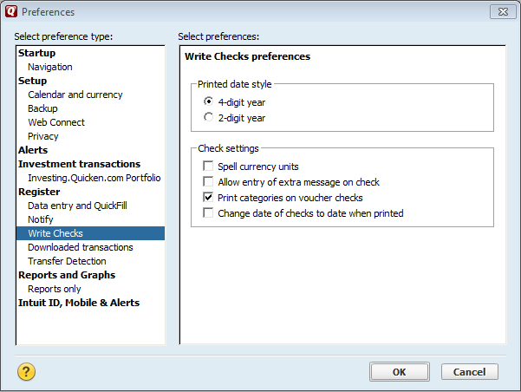
Figure 1

- The Write Checks window doesn't display check numbers. Intuit checks are pre-numbered because most banks require pre-numbered checks for stop-payment purposes. Quicken inserts the correct check number in the register when it prints the check.

- Until the checks print, Quicken displays PRINT in the Num (Number) column of each printable transaction in the register. When you print the check, Quicken changes PRINT to the correct check number. Quicken displays the total amount of checks you've written, but have not been printed, at the bottom of the register window.

- When you order your Intuit checks, indicate a starting number considerably higher than your existing paper check numbers. For example, if your personal check numbers are in the 1000 range, begin your Intuit checks at 3001. That way, you avoid confusion or possible duplication of numbers.

- Quicken can easily manage two sets of check numbers in one account. The bank isn’t concerned about the numbers that are used on your checks. Check numbers are for your own records.

- To write a postdated check, change the date to the date on which you would like the check to be payable.

- For checks that are written away from the office, use any paper checks you already have, or fill in an Intuit check by hand. The next time you use Quicken, enter the transactions in your checking account register. See below for instructions.

Check Writing Instructions

- Choose Tools menu > Write and Print Checks.
- Select the account into which you'd like to record the payment.
- Enter the payee name.
- On the $ line, enter the amount of the check.
- Enter the payee's address. (Optional)
- On the Category line, enter a category.
- Enter a memo. (Optional)
Is the memo confidential?

Because the memo may be visible if you mail the check in a window envelope, you may prefer to enter confidential information in a message box. To display the message box, choose Options and select Allow Entry of Extra Message on Check.

- Select the Online Payment check box, for online payments. (Optional)
Will the memo be included?

The contents of the Memo field may not be included on any physical check printed, depending on your payment processor.

To use the Check Printing feature, go to Tools >Write and Print Checks (Figure 2).  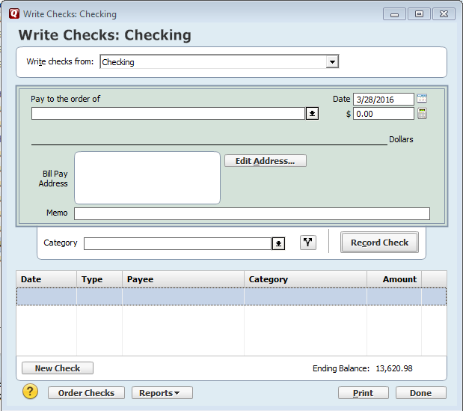  Figure 3 | Figure 2

You will then see the Write Checks screen in Figure 3. At the top of the screen fill in the check with Pay to the Order of, Amount, and Memo (if desired). In the middle of the screen complete the Category information. Then Click Record Check to save the check in the register. Click Print to print the check. The account will be flagged in the Accounts List with a message “You have checks to print” until you have printed the check.

After entering checks, splitting expenses to your preference and recording checks it shows in checks to print box. When you press the print button you get this next box where you can change the check number or check layout Figure 4.

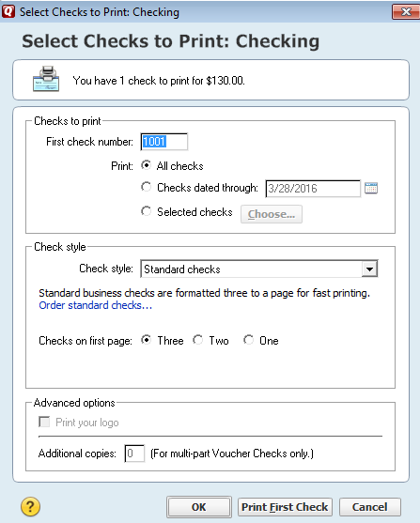
Figure 4

You will have a chance to void the check if it didn’t print correctly Figure 5.

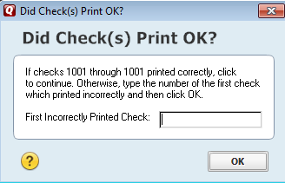
Figure 5

NOTE: For more information about using the check writing feature, click on the “How Do I?” in the lower left corner of the check writing screen to access Quicken Help.

Appendix E: How to Hide/Delete Accounts

You can hide or delete an account by going to Tools > Account List. See (Figure 1) below. Click on the Edit button.

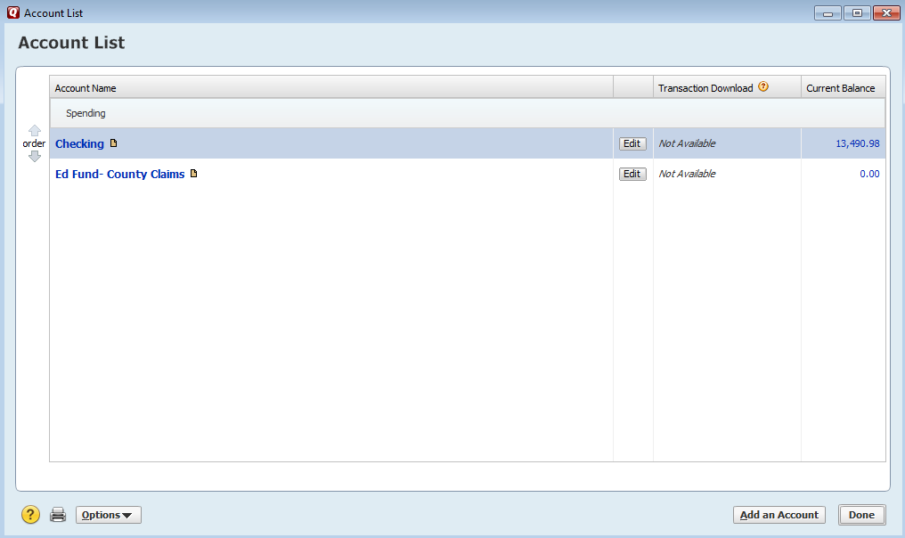
Figure 1

You will now see the Account Details screen (Figure 2). Click the Display Options tab on the Account Details screen.

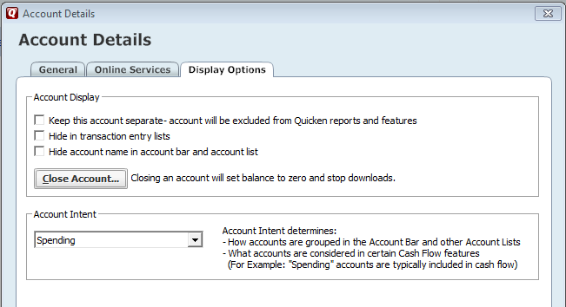
Figure 2

This screen allows accounts to be hidden or deleted. If you check Hide this account in Quicken (the first box), it will no longer show up in lists, menus, reports, and the other 2 boxes will automatically be checked. If you click Delete Account, you will see the box in Figure 3. You will need to confirm that you want to delete the account by typing “yes” in this box.

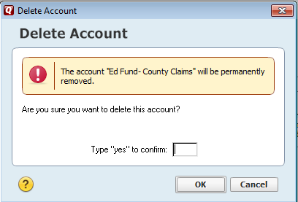
Figure 3

Appendix F: Default Settings for Backups

The Quicken software and data files are stored on a secure server that has regular back-ups done. Therefore there is no need to create additional backup files. Please follow the instructions below.

Choose Edit > Preferences (Figure 1). This is the Quicken Preferences screen.

Click Backup in the menu on the left to see the Backup Preferences. The Automatic Backup box and the Manual Backup Reminder box will need to be unchecked; as shown in Figure 1.

Click OK to save changes.

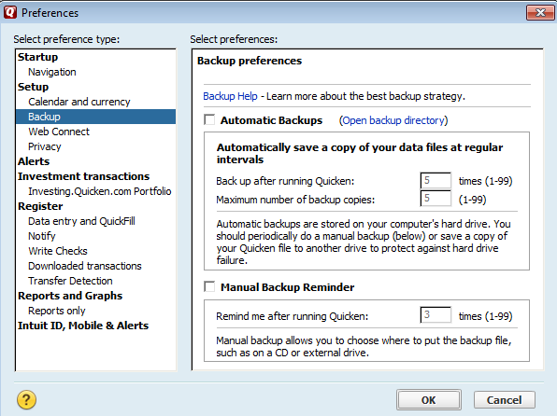
Figure 1

Appendix G: Warnings about Modifying Data

In general, DO NOT modify or delete transactions once they have been reconciled.

Be cautious when modifying a transaction. Quicken will allow you to modify any field in an unreconciled transaction without a pop-up warning. However, you should still verify that you have made the change that you intended to make before clicking Enter. REMINDER: THERE IS NO UNDO BUTTON IN QUICKEN.

When you delete a transaction BEFORE it has been reconciled, you will see the box on the right. This allows to you verify that you want to take this action. | 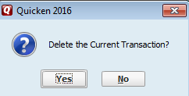

If you try to change the date or the dollar amount in a transaction that has been reconciled, you will see the box on the right. | 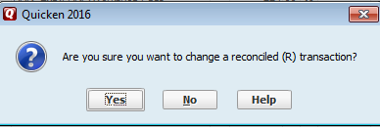

If you try to delete a transaction that has been reconciled, you will see the box on the right. | 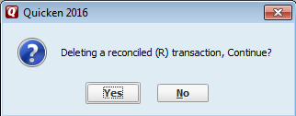

Appendix H: Resources

Accounting Questions: McKenna Williams –765-494-8501– mailto:mckwilli@purdue.edu

AgIT Support Services at 888-226-2438 or 765-494-8333.

