This QRC provides instruction to add a mileage rate vehicle for the County Extension Offices.

Log in to Concur
Go to the Employee Portal at www.purdue.edu/employeeportal

Choose Travel System (Concur).

Log in using Purdue Career Account login and password.

Click Login.
Adding New Vehicle Rate
Click Profile.  Click Profile Settings. | 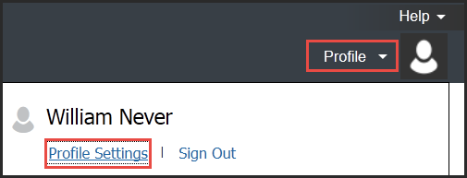
Select Personal Car from the tool bar on the left or from the middle of the page. | 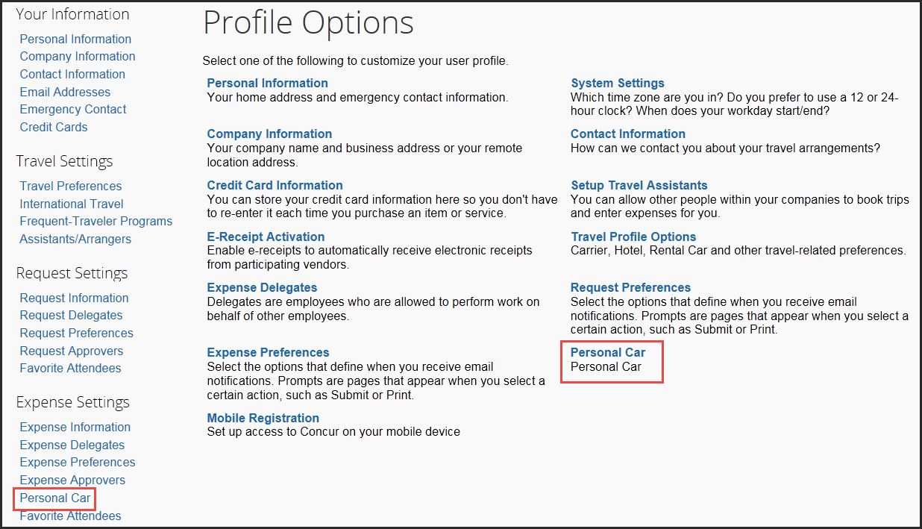
Click New. | 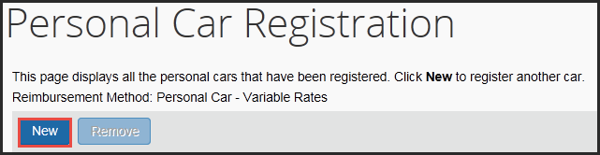
Enter Vehicle ID.  Select appropriate Reimbursement Rate for this Vehicle from drop-down list.  Click Save.  NOTE: Marking Preferred Car checkbox will have all mileage rates to default to this vehicle. | 