CD Retreat
9/21/2015
Outcome Indicators in Digital Measures

Contacts
NC – Educational contacts
NC - # of racial contacts
NC - # of Hispanic contacts

Digital Measures - Learning Events
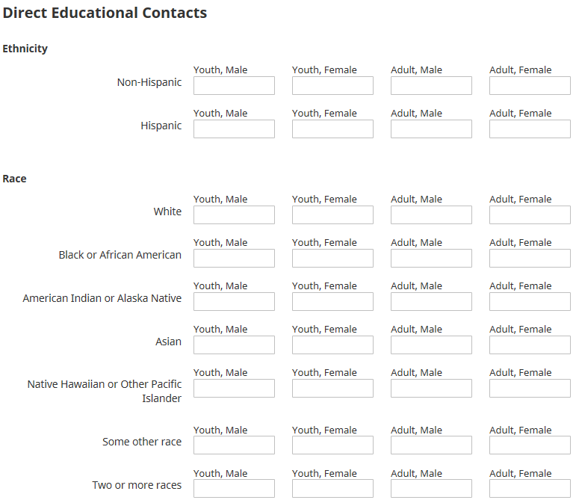

Short-term Outcome Indicators

Digital Measures - Learning Events
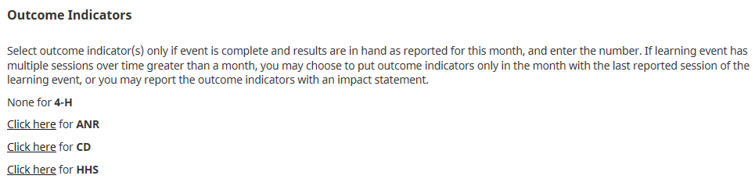

CD - Outcome Indicators
(Note: Outcome indicators with “NC” refer to North Central measures.)
Community & organizational planning
# of participants that increase deeper appreciation for the complexity of organizations/ communities, need to plan strategically and important skills
# of training participants engaging in facilitating meetings, workshops and other planning efforts
$ value of efficiencies and savings
# of participants engaged in a planning process
# of participants increasing knowledge, skills, and desire to design and facilitate planning processes
NC - # of participants reporting new leadership roles and opportunities undertaken
# of new and direct contacts
NC - # of participants reporting new leadership roles and opportunities undertaken
# of participants indicating they felt actively engaged and able to contribute in board meetings
NC - # of participants reporting new leadership roles and opportunities undertaken
Estimated effort (# of FTE’s) by participant using learned competency
Economic & Business development
# of participants indicating an increased understanding of and level of competency employing business planning and management concepts and tools
# of communities involved in economic and business development
# of community planning participants
# of communities that have identified potential strategies to adopt
# of participants indicating an increased understanding of the role of social capital in entrepreneurial development
# of key stakeholders engaged and active in community and economic development locally, countywide and regionally
NC - # of participants reporting new leadership roles and opportunities undertaken
Leadership & civic engagement
# of participants that increase appreciation of the value of engaging the public meaningfully
# of participants increasing desire to lead in community settings
# of participants indicating increased awareness of leadership and civic engagement
# of participants indicating increased understanding of leadership and its application
# of participants increasing leadership skills
# of participants increasing cultural competency
# of participants building relationships
# of participants increasing dialogue skills
# of participants gaining deeper understanding of a public issue
# of participants increasing ability to design and facilitate planning and decision-making processes
Local government education
# of participants increasing understanding of local government structure
# of participants increasing knowledge of local government processes
# of participants indicating an increase in understanding of government's role in economic and community development
# of collaborations between government and economic and development organizations
# of communities that have identified potential strategies to adopt
# of redevelopment commissions organized
# of participants indicating an increase in knowledge of elected and appointed positions
# of participants indicating competency in employing new skills and knowledge in governmental roles
# of governmental boards indicating increased level of informed discussion
# of participants indicating increased appreciation of informed citizenry
# of community members indicating participating in local government through serving on boards, contacting elected officials, or attending public meetings
% increase in public meeting attendance
# of communities considering policies to improve government accessibility
# of participants reporting new leadership roles and opportunities undertaken
# of community members indicating participating in local government through serving on boards, contacting elected officials, or attending public meetings
% increase in public meeting attendance
% decrease in governmental board openings or length of opening
% increase in voter turnout
NC - $ value of volunteer hours leveraged to deliver programs
NC - $ value of organization and/or community-generated volunteer hours (based on Independent Sector hour value)
NC - # of volunteer hours for community generated work
Quality places
# of participants indicating a deeper appreciation for the complexity of organizations/ communities
# of participants indicating an increased awareness of how quality places influence residents' quality of life
NC - $ value of volunteer hours leveraged to deliver programs (Independent Sector value)
NC - $ value of organization and/or community-generated volunteer hours (based on Independent Sector hour value)
NC - # of volunteer hours for community generated work
# of participants indicating a deeper appreciation for the complexity of organizations/ communities
# of participants increasing knowledge about planning
# of participants increasing knowledge, skills, and desire to design and facilitate planning processes
# of participants indicating an increased understanding of the environmental, economic, and social impacts of planning, implementing, and maintaining quality places
NC - # of participants reporting new leadership roles and opportunities undertaken
# of participants indicating an increased understanding of important issues related to quality places
# of participants indicating an increase in knowledge and skills related to decision making for quality places
# of participants indicating an increase in understanding how to access the resources, data, and technical assistance needed to create and sustain quality places

Medium & Long-Term Outcome Indicators

Digital Measures - Impact Statements
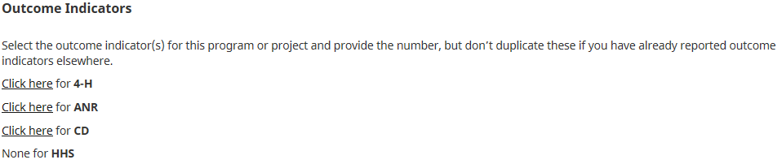

CD - Outcome Indicators
(Medium and Long-Term)
(Note: Outcome indicators with “NC” refer to North Central measures.)
Community & organizational planning
# of training participants who used their facilitation skills
$ value of grants sought and applied for by the participants
NC - $ value of grants and resources leveraged/generated by communities
# of participants implementing a strategy or plan for pursuing grant opportunities
NC - # of participants reporting new leadership roles and opportunities undertaken
NC - # of community or organizational plans developed
NC - # of community and organizational policies/plans adopted or implemented
NC - # of community and organizational policies/plans adopted or implemented
# of civic engagement events held
NC - $ value of volunteer hours leveraged to deliver programs
NC - $ value of organization and/or community-generated volunteer hours (based on Independent Sector hour value)
NC - # of volunteer hours for community generated work
% of general population of a community that engages in meaningful community planning process
NC - # of participants reporting new leadership roles and opportunities undertaken
$ value of resources leveraged by businesses, communities and organizations as a result of skilled grant-writing individuals
NC - $ value of resources leveraged by businesses
NC - $ value of grants and resources leveraged/generated by communities
Quantity of meaningful public discussions lead by skilled facilitator
NC - $ value of volunteer hours leveraged to deliver programs (Independent Sector value)
NC - # of community or organizational plans developed
NC - # of community and organizational policies/plans adopted or implemented
NC - $ value of volunteer hours leveraged to deliver programs (Independent Sector value)
NC - $ value of organization and/or community-generated volunteer hours (based on Independent Sector hour value)
NC - # of volunteer hours for community generated work
NC - $ value of efficiencies and savings
Economic & Business development
# of participants that implement a new strategy
# of strategies adopted
NC - # of community or organizational plans developed
NC - # of community and organizational policies/plans adopted or implemented
NC - $ value of efficiencies and savings
NC - # of business plans developed
Public investment in entrepreneurship development activities (pre vs. post project investment in $)
Increased collaboration among support providers (as measured by the # of partners contributing resources to entrepreneurship development)
NC - # of businesses created
NC - # of jobs created
NC - # of jobs retained
NC - $ value of resources leveraged by businesses
NC - $ value of volunteer hours leveraged to deliver programs
NC - $ value of organization and/or community-generated volunteer hours (based on Independent Sector hour value)
NC - # of volunteer hours for community generated work
#of individual participants in networking meetings
# of governmental and non-governmental organizations involved in network
NC - # of participants reporting new leadership roles and opportunities undertaken
# of participants that attend entrepreneur networking events
# of stakeholders participating and representing a diverse group of economic, social and sector backgrounds
# of specific goals developed to measure jobs, wages, and investment
# of strategies discussed and evaluated to determine their impact including jobs and networking meetings
# of participants that start and sustain their business
Percent change in profitability
NC - # of businesses created
NC - # of jobs created
NC - # of jobs retained
NC - $ value of resources leveraged by businesses
# of new and existing businesses report positive impact of strategy on their efforts
# of concerns, problems resolved or opportunities realized through activities
NC - $ value of efficiencies and savings
Private capital ($) raised by participants
# of members in network meetings (change over time)
NC - $ value of volunteer hours leveraged to deliver programs
NC - $ value of organization and/or community-generated volunteer hours (based on Independent Sector hour value)
NC - # of volunteer hours for community generated work
# of participants that stay or return to the service area
# of businesses, owned by program participants, that enter the local economy
Private investment leveraged ($) as a result of project investment in entrepreneurship development
Average wage/job created
NC - # of community or organizational plans developed
NC - # of community and organizational policies/plans adopted or implemented
NC - # of business plans developed
Leadership & civic engagement
# of participants applying new leadership knowledge, skills, and attitudes
NC - # of participants reporting new leadership roles and opportunities undertaken
# of diversity and inclusion strategies implemented
NC - # of community or organizational plans developed
NC - # of community and organizational policies/plans adopted or implemented
# of policies enacted that foster increased civic engagement
# of residents achieving certification through a leadership program
# of action plans developed
# of community members engaged in community dialogues
% of general population engaged in a public issue process
# of communities addressing a public issue
# of participants increasing cultural competency
# of civic engagement events held
NC - $ value of volunteer hours leveraged to deliver programs
NC - $ value of organization and/or community-generated volunteer hours (based on Independent Sector hour value)
NC - # of volunteer hours for community generated work
# of community members engaged in community issues
NC - # of participants reporting new leadership roles and opportunities undertaken
# of new community leadership programs instituted
# of communities experiencing increased civility and inclusive civic engagement in addressing community issues and opportunities
# of community members engaged in community issues
# of community members reporting an increase in quality of life
# of Indiana communities using formal community development processes to address public issues
% of general population engaged in a public issue process
$ of grants received
NC - $ value of volunteer hours leveraged to deliver programs (Independent Sector value)
NC - $ value of organization and/or community-generated volunteer hours (based on Independent Sector hour value)
NC - # of volunteer hours for community generated work
NC - $ value of efficiencies and savings
NC - $ value of grants and resources leveraged/generated by communities
NC - $ value of resources leveraged by businesses
Local government education
# of participants indicating they feel confident in their understanding of local government
# of community members indicating participating in local government through serving on boards, contacting elected officials, or attending public meetings
NC - # of participants reporting new leadership roles and opportunities undertaken
NC - $ value of efficiencies and savings
# of communities reporting increased government accessibility
% increase in public meeting attendance
% increase in local government website traffic
# of community members indicating knowledge of local government issues
# of community members indicating knowledge of where to find their local government information
NC - # of community or organizational plans developed
NC - # of community and organizational policies/plans adopted or implemented
# of local governments accessing and using data and resources from Purdue Extension, state government agencies, or other public institutions
NC - $ value of volunteer hours leveraged to deliver programs
NC - $ value of organization and/or community-generated volunteer hours (based on Independent Sector hour value)
NC - # of volunteer hours for community generated work
# of communities experiencing increased civil engagement from a broad base of citizens
Increase of communities with government boards and positions demonstrating parity to their community population in gender, age, race, and ethnicity
NC - # of participants reporting new leadership roles and opportunities undertaken
# of communities indicating evaluation of government projects and programs
NC - $ value of efficiencies and savings
# of communities experiencing increased civility and inclusive civil engagement in addressing community issues and opportunities
% increase in public meeting attendance
# of communities reporting increased engagement with citizens through public hearings and forums
NC - $ value of volunteer hours leveraged to deliver programs (Independent Sector value)
NC - $ value of organization and/or community-generated volunteer hours (based on Independent Sector hour value)
NC - # of volunteer hours for community generated work
Quality places
NC - $ value of grants and resources leveraged/generated by communities
NC - $ value of volunteer hours leveraged to deliver programs (Independent Sector value)
NC - $ value of resources leveraged by businesses
NC - # of community or organizational plans developed
NC - # of community and organizational, policies, plans adopted or implemented
NC - $ value of organization and/or community-generated volunteer hours (based on Independent Sector hour value)
# of participants indicating they felt engaged in a planning process
NC - # of participants reporting new leadership roles and opportunities undertaken
# of participants engaged in a planning process
Percent of general population of a community that engages in a community planning process
Programs and activities initiated or completed by organizations or communities that reflect participation by a broad base of stakeholders
NC - # of volunteer hours for community generated work
# of participants indicating they have adopted and modeled new personal behaviors related to the creation, management and usage of quality places
# of acres created or conserved as green and/or recreational space
# of miles that have been positively impacted by efforts to enhance walkability, bikeability, connectivity and/or accessibility
# of civic engagement events held
NC - $ value of volunteer hours leveraged to deliver programs (Independent Sector value)
NC - $ value of grants and resources leveraged/generated by communities
NC - $ value of resources leveraged by businesses
NC - # of community and organizational, policies, plans adopted or implemented
Percent increase in public space acreage
Percent change in obesity rate
NC - # of businesses created
NC - # of jobs created
NC - # of jobs retained
NC - $ value of organization and/or community-generated volunteer hours (based on Independent Sector hour value)
NC - # of volunteer hours for community generated work
NC - $ value of efficiencies and savings
Percent change in median household income
Percent change in unemployment rate
# of volunteer hours for community generated work
$ value of programs and activities initiated or completed by organizations or communities
$ value of other and in-kind resources leveraged by organizations or communities
Collaborative activities initiated by organizations or communities
# of organizations identifying strategies to achieve their mission
Percent change in public and private financial support of conversation organizations
# of participants indicating they felt engaged in a planning process
NC - # of participants reporting new leadership roles and opportunities undertaken

