Salesforce
Duplicate Check

Contents

1 Overview 3
2 Use the DC Check Feature 3
3 Search in Duplicate Check 4

Overview

Duplicate Check is an app in Salesforce that allows you to search for duplicate contacts that you own and merge those duplicates. This feature is essential in cleaning up your contact list and can be used any time.

Use the DC Check Feature

If you notice any duplicates when going through your contact list you can use the DC Check button to search for and consolidate duplicates of contacts that you own. Additionally, you can also simply search the name of a contact and then use the DC Check button from the contact’s profile page.

- Click on the contact you want to run the duplicate check for.

- Click DC Check from the top of the profile page. The duplicate checker will run.

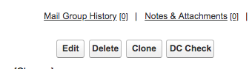
Click

- Review the duplicates to make sure you only merge the contacts that are actually duplicates. For example, you can click the Open button next to one of the duplicate contacts and then review that contact information against the contact you ran the Duplicate Check for.

- Select the duplicates in your county only.

Note: With Duplicate Check you still cannot edit, delete, or consolidate duplicate contacts that are owned by another user.

- Click Merge.
Click
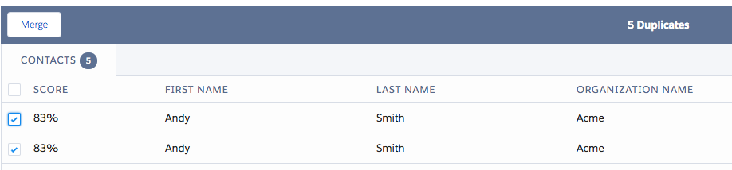

- You will then see the difference between the contacts you want to merge. For example, if both contacts have the same email address but only one has a phone number, you’ll make sure the phone number is merged for the one contact.

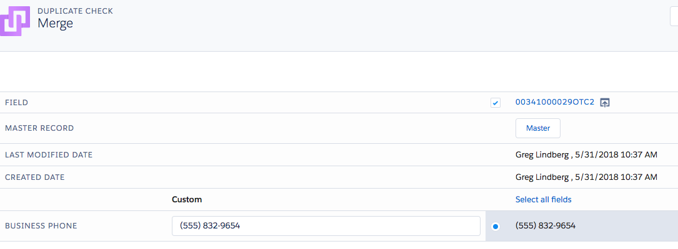

- Click Merge when you’re ready to complete the merging process.

After the merge process you’ll no longer have those duplicate contacts, and in most cases you’ll have more updated information for a single contact.

Search in Duplicate Check

- From the Salesforce home page, click the top right drop-down menu. Click Duplicate Check.

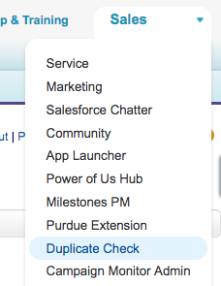
Click

- Click DC Search from the top of the page.

- Click the Contact tab.

- Enter in the First Name, Last Name, or Email to search by.

- Select your county from the Organization Name drop-down.

- Click Search Contact.

Click

- Review the results and merge any duplicate contacts that you find.

