
The Clover Leaf
Tipton County 4-H Newsletter June 2026
1200 S. Main St. Tipton, IN 46072 765-675-1177
4 - H is a community of young people across America, learning leadership, citizenship and l ife skills.
4 - H Mission: Provide real- life educational opportunities that develop young people who will have a positive impact
in their communities and the world.
4 - H Vision: Be the state's premier, community- based program empowering young people to reach their full potential

Bonus Bits from Brian
The 4-H Fair is approaching fast! Please look through this newsletter VERY CAREFULLY. There is A LOT of important information that you will need as you prepare for the fair and exhibiting your projects. It is your responsibility to be aware of the information in this newsletter and how it applies to your family. There are some significant changes this year, along with new dates.
Please save this newsletter. Highlight it, mark on it, copy it, post it on your refrigerator, keep
a copy in the vehicle, and save the link to your phone.
If you have questions please contact your club leader, project superintendent, or the Purdue Extension Office at the number above.

Did your project guidelines change?
Everyone should be reading updated project guidelines every year to make sure there aren’t any major changes in the exhibition options or materials. All project guidelines sheets and other forms, can be found on the Purdue Extension- Tipton County 4-H website:

https://bit.ly/TiptonIN4H
Look under ‘County Projects,’ ‘State Projects,’ and ‘County Livestock Projects’ for information.
Updated Policies and Procedures are Online
You are responsible for knowing and following the Indiana and Tipton County 4-H Policies and Procedures. Some things have changed, been updated, or finally been put in writing. Major changes were made in 2023 and include livestock showmanship classes and supreme showmanship procedures, clear consequences for late entries or projects released early without
permission. Please take a moment to review the booklet. Full Indiana Policies and Procedures can be found on the State 4-H Website.


2026 Tipton County 4-H Fair June 23-28
Auction July 29
2026 Indiana State Fair August 7-23
(closed Mondays)

FFAAIIRR SSCCHHEEDDUULLEE

Please make sure you are aware of the dates and times for all of your events and deadlines.

Building Project Check-In- Sunday, June 21, 3:00-7:00 pm
All building (static) projects (including Consumer Clothing Notebooks)
(except Foods projects)
4-H members will check-in their building 4-H projects (other than foods) by EXHIBITOR. Please pay attention to the signs for project check-in to help find your table.
All Mini 4-H’ers will check their projects, including foods, on the West side of the tables (closest to the stage).
Families will enter from the East front doors of the 4-H project building and leave through the south door in the Cicero Room.
Monday, June 22, 8-9 am
Project Check-In– ONLY Aquatic Science, Garden, and Floriculture
All other static projects (except Foods) must be checked in on SUNDAY evening
Pocket Pets check-in- Tuesday, June 23, 1:00 pm Cat check-in- Tuesday, June 23, 3:00 pm
Foods- Baked and Preserved Check-In- Wednesday, June 24, 8:30-10:00 am
Exhibitors will also sign up for the Foods Auction at this time- Deadline is 10:00 am; there is a $5 entry fee that will be taken out of the product’s selling price.
***Only Foods- Baked projects are eligible to be in the Foods Auction
Projects not checked in by the designated times will be judged for exhibition only and will not be considered for an honor higher than a blue ribbon.

Project Check-Out and Exhibit Hall Clean Up
Sunday, June 28, 11:00 am- 1:00 pm
It is the hope of the Purdue Extension Staff that all projects will be picked up by 1:00 p.m., with clean up continuing until 2:00 pm or whenever it is complete. Please plan to have someone pick up your projects if you are not available at this time. Projects are NOT to be released early without permission from the 4-H Council- see Policies and Procedures.
Building Project Record Sheets - Update
Project Activity Record Sheets are NO LONGER REQUIRED for a project to be considered complete
If you choose not to exhibit a project but would still like to complete the project, you can turn in a completed record sheet for that project and it will be marked as “Complete,” although there will be no judging
Exhibitors are still HIGHLY ENCOURAGED to keep the “My Record of 4-H Achievement” (white stiff sheet) up to date each year. This will be essential for scholarship and award applications in the future.
Completion of record sheets and activities is highly encouraged; there are many life skills to be gained from the activities and record keeping.
We still have several record books from the past. You can pick those up at any time, or during project check-in on June 21. Any old record books left in the office after the fair will be thrown out.
Please remember to pick these up next time you're in the Extension Office!!!

Cat Exhibitors Can Now Show in

Additional Category in Arts & Crafts
There is now a category for Diamond Art projects in the Arts & Crafts division. If you are working on an project that involves this technique, look for the category under County Arts & Crafts in FairEntry.

More Categories
Cat exhibitors can now show up to four (4) animals. You may now enter a long-haired cat, short haired cat, long haired kitten, and short haired kitten. Previously they could only show 2 animals. However, the State Fair still limits exhibitors to two animals- see ISF guidelines if you plan to enter

4-H Building Project Judging
Project judging will be OPEN, which will allow 4-H members to talk to the judges and get direct feedback on their projects. Due to space and the potential for accidents and harming projects, please no extra family members on judging day: plan to make babysitting arrangements for younger family members who are not 4-H members. The building will be open on Tuesday evening, and each day during the fair from 11 am-9 pm, starting Wednesday. Please wait until Tuesday evening to come and check project results.
Monday, June 22, 2026
10:00 am: Open project judging for:

Arts and Crafts, including Model Craft and Construction and Architectural Replica (formerly Ag Education) Aerospace
Electric
- Consumer Clothing Notebooks (new time this year)
Photography Fine Arts
Garden Crops
- Sewing Construction (new time this year)
- Genealogy and Scrapbook (new time this year)
1:00 pm: Open project judging for all other building projects (except Foods, Cats, and Pocket Pets)
- 3:00 pm: Fashion Revue Judging (Purdue Extension Office Prairie Room)
Tuesday, June 23, 2026
- Noon: Speech and Action Demonstrations, Prairie Room
- 1:00 pm: Open judging for Pocket Pets, 4-H Building
- 3:00 pm: Cat Poster judging and Cat Show, Cicero Room
- 5:00 pm: Mini 4-H Mock Judging
Wednesday, June 24, 2026-
- 12:00 noon- All Foods Project Judging- Baked and Preserved
Thursday, June 25, 2026
- 1:00 pm: 4-H Tractor Driving Contest- location TBD
- 2:00 pm: Micro Mini Tractor Pull
Saturday, June 27, 2026
3:00 pm: Outdoor Chef- set up may begin at 2:30 pm on the south patio of the 4-H Building

4-H Foods Auction- Wednesday, June 24, 5:00 pm
Any exhibitor that has a Foods- Baked project is eligible to participate in the 4-H Foods Auction on Wednesday, June 24 at 5:00 pm. Foods- Preserved projects are not eligible. The auction will take place on the West (Main) Stage.
Exhibitors will indicate if they want to participate in the Foods Auction during the Foods project check-in on Wednesday morning. If the person checking in your project doesn’t ask, please make sure you tell them you are interested!
If you are selling something that has multiple items (cookies, muffins, biscuits, etc.) bring a separate set of 6 that will be sold. These will NOT be used for judging, but should be the same product you enter for judging.
There is a $5 fee to participate in the Foods Auction. This fee will be taken out of your premium check.
Please tell the person signing you up if you are a 10-year member or are involved in the Horse and Pony show or Dog Demonstrations that afternoon and may have a conflict.
An exhibitor must be present to sell their food product. No substitute exhibitors. If there is a conflict, please see Brian Howell, 4-H Educator, or a 4-H Council member. (Sports games and practices, family vacations, camps, and job schedules are not considered exempt conflicts.)
- Checks will be distributed at times during the fair after the Foods Auction. Look for posted times during sign up.
Be sure to thank your buyers in person and with a handwritten thank you note!!!
***New in 2026- Buyers are encouraged to register prior to the Auction. Please fill out the form at https://bit.ly/26tiptonfoodsauctionbuyer
prior to June 24. You may also register during auction sign up on Wednesday morning, and at a designated table one hour before the auction begins.

Help Needed for Tipton County 4-H Fair
It takes a lot of volunteer man-power to make the 4-H Fair happen. Please consider helping out. Some of the jobs require lifting so please consider that when deciding where and when to help. Sign up now at:



https://bit.ly/2026tiptonfairhelp
Jobs include: Project Building set-up, building project check-in, building project assistance, project check out, and project building display tear down
Please sign up by Monday, June 15. If you don't get signed up, don't worry- your help will still be needed and appreciated if you just happen to show up!

HANDS to Larger Service!


4-H Project Pre-Entry– Please do by Wednesday, June 10! Building and Livestock
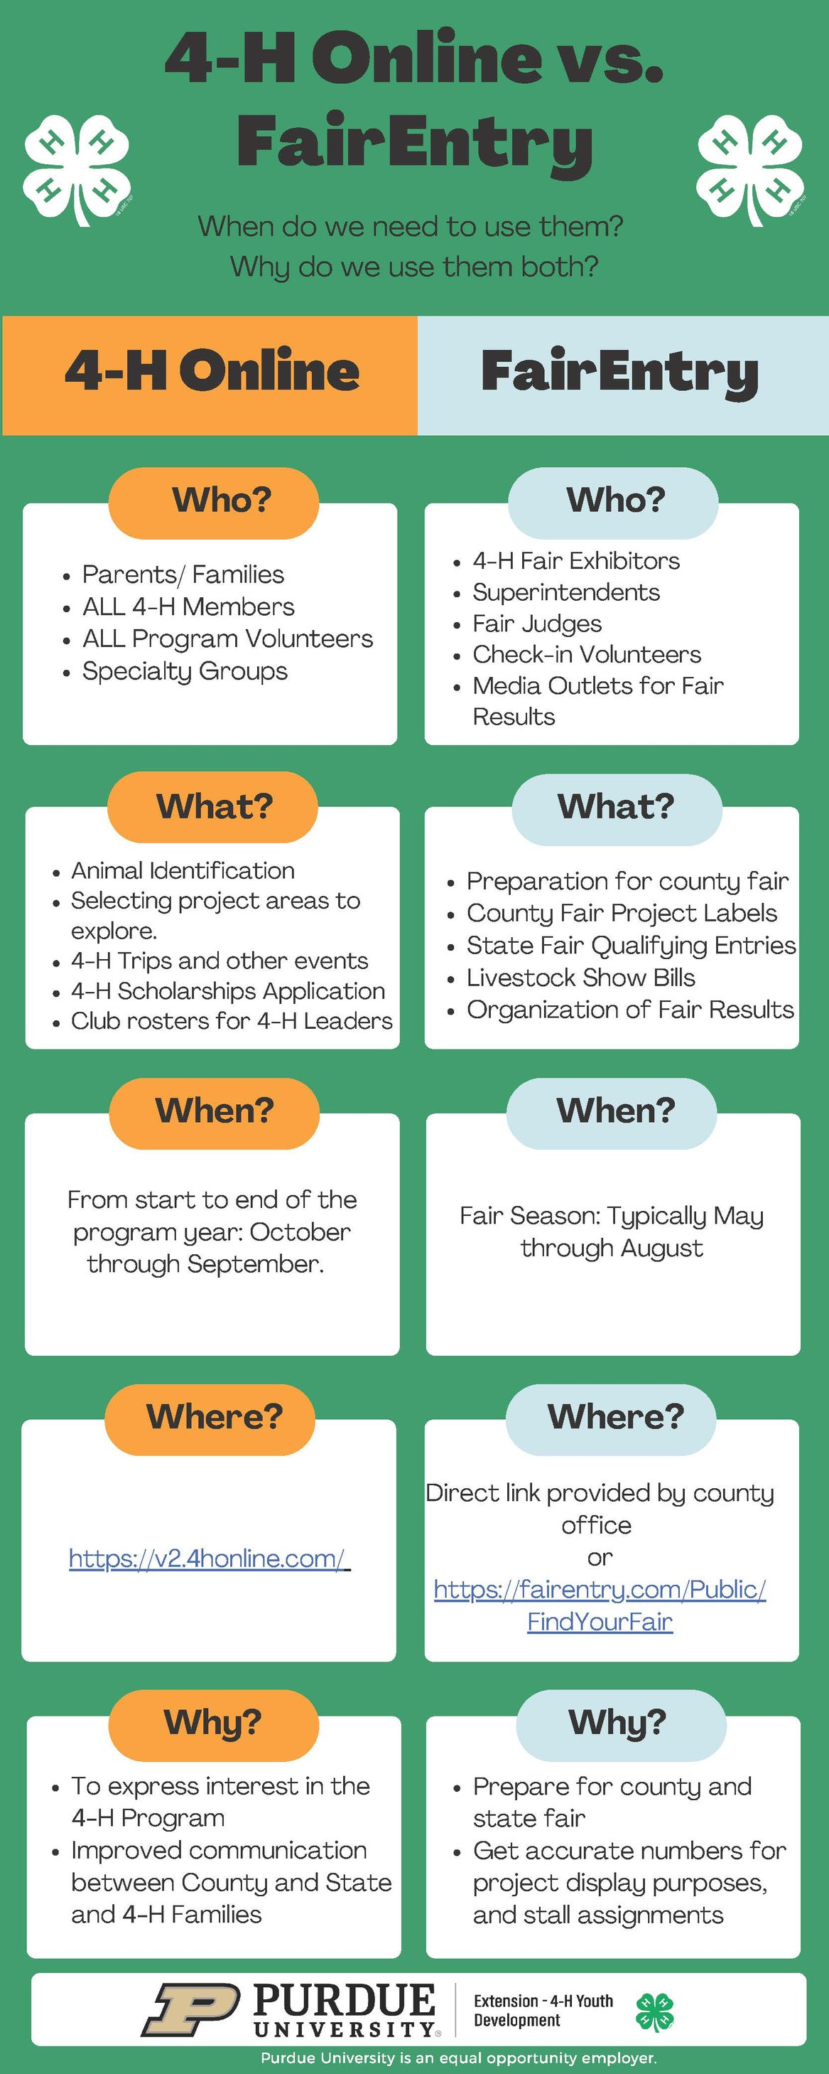
All 4-H projects that you plan to bring to the 4-H Fair need to be pre-entered by Wednesday, June 10. This includes building and livestock projects.
Go to http://tiptonindiana-county .fairentry .com Detailed instructions are available on our county website at
https://bit.ly/TiptonIN4H
under "Important Information" or on the next page of this newsletter.
Although it looks a little overwhelming at first sight, it is a relatively simple process. Follow the instructions very carefully, especially the one about not hitting submit until you have all of the youth in your household entered. By completing the pre-enrollment steps you will help the check-in and judging of your projects go so much smoother and less stressful for you, check-in volunteers, judging helpers, judges, and the Extension Office staff. If you do not pre- enroll before check-in you will have to do so once you come to check-in. Projects MUST be entered this year; it will be easier and cause less headaches to do so beforehand.
***Livestock Exhibitors, including Horse & Pony Exhibitors*** You will be required to enter your animals
through FairEntry. You must have first entered your animals in 4-H Online by May 15. You will be asked several important questions- please answer them honestly. The superintendents will use this information to plan stall assignments and work on setting up classes prior to the fair.

Are you a Tipton County 4-H Alumni?
Have you saved ribbons, awards, projects, photographs, and/or trophies from your 4-H career?
We are asking you to share these momentos!
Think of a way to display your items- perhaps a poster or display box. Be sure to label your items. Bring them to the 4- H Building on Sunday, June 21 from 3-7 pm during project entry- there will be a special place to check in and display these items.
Please pick up the items on Sunday, June 28 from 11:00 am-1:00 pm to reduce the risk of harm after the fair.
We’ve had outstanding displays the last few years! We are hoping to return with a huge display this year!!!
Questions? Call the Purdue Extension Office at 765-675-1177.

OVERNIGHT POLICY AT THE FAIR
Youth are not permitted to stay at the fair overnight unless parents (or guardians) have reviewed the policy set forth by the Tipton County Fair Board.
If you camped at the fair in 2025 and would like to camp at the same spot as last year you should have received information from the Purdue Extension Office a while ago.
Cost for 4-H families to camp for the week is $150.00. All others is $35/night. Campers may be parked from Sunday, June 21- Sunday, June 28. Campers staying before or after those dates will be charged the regular $35/night fee.
NO SMOKING
By order of the State Fire Marshall, the livestock facilities are designated a NO SMOKING area. Please abide by this state law and do not smoke in any livestock facility, or any building on the 4-H Fairgrounds.

FAIRGROUNDS POLICY ON DOGS
Any dogs that might be on the Tipton County Fairgrounds must be on a leash. This goes for dogs that are part of 4-H projects. Also, NO dogs are allowed in the 4-H Project Building except for those providing handicapped assistance.

Look, but please don't touch the community gardens!
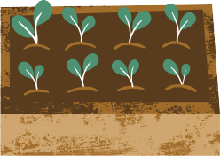
The Tipton Master gardeners and other citizens have been working hard on their gardens located on the south side of the fairgrounds. Please stay out of the gardens- the produce is for the gardeners, not the public. Be respectful of their produce and their garden area!

Do you have a question about 4-H?
Check out the website, https://bit.ly/TiptonIN4H
Chances are many of your questions can be answered here. This site contains the Family Resource Guide, Policies and Procedures, some helpful check lists to help you prepare for the fair, FairEntry instructions, all of the information you will need for projects (printable project guidelines, record sheets, additional forms, helpful videos, and more), links to the State 4-H website, past 4-H newsletters, and so much more helpful information. Please use this resource that is available at your fingertips 24/7!


Mini 4-H Information

Project Check-In
All Mini 4-H Building projects (including Foods) should be checked in on Sunday, June 21 from 3:00-7:00 pm in the 4-H Community Building. All Mini 4-H projects will register at the far west table, closest to the stage. (You do not check in by name like the traditional 4-H projects.)

Mini 4-H Livestock Shows
A schedule of Mini 4-H Livestock Shows can be found on page 11 of this newsletter. Mini 4-Hers will borrow animals from older 4-H members to show in the class; unless you have spoken to your superintendent Mini 4-Hers will not bring their own animals. Classes are not judged, but they will get comments and a ribbon.

Project Mock 'Judging'
Mini 4-H projects are NOT judged. However, Mini 4-H members are invited to get feedback on their projects from
4-H Junior Leaders.
When: Tuesday, June 23, 5:00 pm
Where: 4-H Community Building small south room beside the kitchen

Mini 4-H Introductions
When: Wednesday, June 24, 6:30 pm
Where: Main Stage. Mini 4-Hers should gather in the 4-H Building at 6:15 to line up for the presentation
What: Mini 4-Hers will get to walk onto the stage, answer a
question about their experience from an older 4-Her, and wave to friends and family! Wear your Mini 4-H t-shirt if you have one!

4-H Fair Livestock Information
Although this section contains information about livestock projects, Livestock Exhibitors should still read and be familiar with the information throughout this whole newsletter. Ignorance does not equal exemption.

Livestock Check-In
Beef, Goat, Poultry, Rabbit, Sheep, Swine- Wednesday, June 24-
everything is penned and stalled by 10:00 am
Horse and Pony- Wednesday, June 24- 6:00 am- 10:00 am
Swine will be weighed in off of the trailer. Sheep and Goat weigh in will start at 11:00 on Wednesday in the Livestock Barn. Beef will use declared weights.
Animals will be inspected for visible health problems by species superintendents during check-in.
A vet will be called to make the final decision. Just because health papers aren’t required doesn’t mean you should try to bring unhealthy animals to the fair!!! If your livestock projects seem unhealthy in any way prior to the fair (fungus, coughing, fever, pink eye, parasites, etc.) please have your animal inspected by your vet. DO NOT bring your animals against your veterinarian’s recommendation.

Livestock Trailer Traffic
All Trailers- Trucks and trailers will enter the fairgrounds on Fairgrounds Road from the far west "Tractor Pull" entrance (Gate #6)
Swine- Go as far south as you can, looping around the Horse and Pony Complex, and then back east and then north towards the barns. Trailers will back up and animals will be unloaded on the south end of the swine barn.
All other trailers (non swine)- You can use the north drive and the drive just west of the Livestock Barns to unload your animals. Exit using the drive between the Horse Barn and Horse Arena.

Parking of Livestock Trailers
There should not be any trailers parked on the fairgrounds, except for those being used during the Horse and Pony show. Trailers may be parked in the Tipton Elementary School parking lot during the 4-H Fair.
The south area of the Fairgrounds and old Tractor Pull strip are NOT for parking trailers, but for public parking and campers.
There is also NO PARKING of any vehicles north of the barns, south of the barns by the restrooms, or in the grass west of the Livestock barn. Vehicles in these areas will be moved.
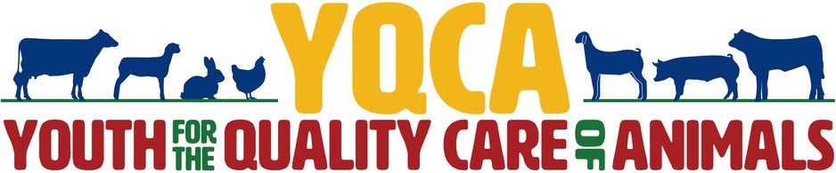

For all Beef, Goat, Poultry, Rabbit, Sheep, and Swine Exhibitors that have NOT completed a Quality Assurance Training
All livestock exhibitors are required to participate in a quality assurance educational program.If you did NOT attend a 4-HQLC program, you will need to complete YQCA online. This program is designed to help 4- Hers understand their role in the food animal industry and help them learn how to promote the livestock industry.
Online option ($12 payable online when registering): available at any time, www.yqcaprogram.org
The Purdue Extension Office does not have any access to your YQCA profile. Sign in using the profile credentials you created in the past. If you are new, you will need to go to the "More Info" menu on the YQCA website to see how to create a new account and register for a training.
Be sure to print your YQCA completion certificate, or save a screenshot on your phone, and bring it to penning and stalling on June 20; there is not a record of YQCA participants being kept in the Purdue Extension Office in 2026. The Extension Office will have record if you participated in face-to-face 4-HQLC.
You MUST complete one of the two Quality Assurance programs in order to exhibit and sell your animal at the Tipton County and/or Indiana State Fair!

www.yqcaprogram.org

PEN – STALL - CAGE SET UP Saturday, June 20 starting at 9:00 am
All pens/stalls/cages will be assigned after:
All pens are set up and work is complete.
Livestock 4-H Member meeting in the Show Arena at 10:00 am, OR after barns are set up and ready.
Pen/Stall fee is paid. Fees for pens and/or stall MUST be paid when pen/stalls are assigned and claimed.
Superintendent will have final decision on pen/stall/cage assignments. Assignments or plans will be made based on the information entered in FairEntry.
If pen/stalls are not reserved on Saturday, then pens/stalls will be available on first come basis as animals are unloaded on Wednesday, June 24.
After pen/stall is assigned, a sign MUST be hung above the pen/stall with 4-Her’s name. Cards will be available. Moving another 4-Her’s sign without the permission of the 4-Her and superintendent is prohibited.
ABSOLUTELY no pen or stall space is to be used for tack, feed, or grooming chutes until all livestock are entered. If you reserve more pens/stalls than actually needed there will be NO refund of pen/stall fee.
If you have not completed Quality Assurance (see page 10), you will be moved to the end of the line. This MUST be completed before checking in your animals on Wednesday, June 24.
Please bring brooms and rakes on pen set up day. Make sure they are labeled with your name.

PEN FEES
Beef- Per Head - $5 Dog - Per Head - $5
Goat - Per Pen - $5 Rabbit - Per Cage - $2
Horse/Pony - Per Head - $5 Swine - Per Pen - $5 Sheep -Per Pen-$5
This money is used to update livestock facilities.
No tack pens until all animals are penned. No large show boxes in aisle – move to show arena!

Mini 4-H Animal Shows
Mini 4-H members can show in a non-competitive showmanship class in each species. They will borrow the animal of a 4-H mentor. It is highly recommended that the Mini 4-Her and the mentor work together prior to the fair!
Mini 4-H Cat Show- Tuesday, June 23, 3:00 pm
Mini 4-H Goat Show- Thursday, June 25, 9:00 am
Mini 4-H Horse and Pony Show- Thurs. June 25, 11:00 am
Mini 4-H Poultry Show- Thursday, June 25, 4:00 pm Mini 4-H Mini 4-H Sheep Show- Friday, June 26, 9:00 am
Mini 4-H Rabbit Show- Friday, June 26, 2:00 pm
Mini 4-H Beef Show- Friday, June 26 6:00 pm
(Mini 4-Hers must have completed 2nd grade and have worked with a 4-H mentor prior to showing BEEF at the Fair)
Mini 4-H Dog Show- Saturday, June 27, 9:00 am
Mini 4-H Swine Show- Saturday, June 27, 10:00 am

Swine ID
Make sure the ear notches of your pigs match what was entered in 4-H Online. You can log into your 4-H Online profile at any time to check what you entered. If you plan to enter or exhibit at the Indiana State Fair, you must have your 840 RFID tags applied in the ears BEFORE coming to the fair- Tipton county volunteers will NOT apply tags into State Fair entered animals. Make sure the tag and ear notches match with your ISF entries.
Livestock Superintendent Reviews
Prior to 2020, Livestock Superintendent positions were reviewed on a three-year rotation. This does not mean the positions have a term, and it is not to be seen as an effort to remove a superintendent. It is more of a chance for superintendents to take a break if needed and allow other interested parties have an opportunity to share ideas or be considered for the position. Starting this fall we will resume this rotation. Superintendent positions that will be reviewed in Fall, 2026 are:
Swine (Bryan Cline is current superintendent) and Poultry (Lynn Calloway is current superintendent). All others have newer supers.
Livestock Showmanship Divisions
First Year (grade 3),
Junior (grades 4-5),
Intermediate (grades 6-8), and
Senior (grades 9-12)
Youth will still move up the next year once they win their division, regardless of grade. Dog will use their own divisions.
***An animal must be shown in a class during the show to be able to be shown in showmanship, by the same exhibitor (a brother’s showmanship animal can’t be one his sister showed in class).
Supreme Showmanship
Small Animal Supreme Showmanship- Sunday, June 28, 1:00 pm in the Dog Building. Senior Showmanship winners in Dog, Cat, Rabbit, Poultry, and the Champion Level 3 Pocket Pet exhibitors (The Pocket Pet portion will be a written test.)
Large Animal Supreme Showmanship- Sunday, June 28, 4:00 pm, starting in the Horse Arena and then move to the Show Arena. Senior Showmanship winners in Horse and Pony, Goat, Sheep, Swine, and Beef.

Registration Papers
Livestock superintendents are encouraged to check papers on all registered animals. Please make sure you have current, accurate papers that are in the name of the 4-H member, family name, or a family farm or partnership (Joe Smith, John Smith and Children, Joe and Jane Smith, Smith Family Farm).
Enter Livestock in FairEntry by June 10 Exhibitors need to enter their animals and request pens/stalls in FairEntry by June 10. See pages 4 and 5 of this newsletter for more information.

Livestock Premium Auction Announcement
The Tipton County Livestock Auction Committee is launching the "2026 Tipton County Livestock Project Recognition Auction," shifting to a new format that focuses on the youth’s livestock project experience rather than selling a specific animal. This update aims to enhance the buyer experience, address rising project costs, and encourage continued 4-H participation, with only Champion meat pens exempted from the new structure. These changes, which have received support from consulted buyers, allow 4-Hers to retain animals for State Fair eligibility while strengthening the human element of the event. More information about these updates for the 2026 Tipton County Livestock Project Recognition Auction will be shared between now and the 4-H Fair. Eligibility requirements to participate in the Livestock Auction will remain the same as in previous years- participants must exhibit beef, goat, sheep, or swine projects, or exhibit the champion Meat Pen.
No animals (beef, sheep, goat, swine, poultry, rabbit) will be released until 9:00 pm Saturday evening without the formal approval of a written request submitted to 4-H Council prior to the 4-H Fair.

Livestock Release
Non-Out Truck Swine and All other Animals (beef, sheep, goat, poultry, rabbit)- Saturday evening starting at 9:00 p.m.
Horse & Pony- after 9 pm on the days they show.
With the exception Horse & Pony that are choosing to go in and out, all livestock must stay on the grounds until Saturday evening unless an early release request letter is approved by the 4-H Council PRIOR to Thursday, June 18.


Indiana State Fair Livestock Exhibitor Information
Links for the following items can be found at https://www.indianastatefair.com/p/state- fair/competitions--contests/livestock-information
4-H Animal Affidavit & Animal Husbandry Form
4-H Exhibitors in the Beef, Dairy, Swine, Sheep, Dairy Goat, Boer Goat, and Meat Goat Departments are required to complete the new 4-H Animal Affidavit & Animal Husbandry Form. Have this notarized BEFORE arriving at the State Fair. HELPFUL TIPS:
The Animal Husbandry Form must be maintained from the 4-H Animal Ownership Deadline (May 15, 2026) through check in at the Indiana State Fair.
One form is required for each State Fair Animal.
All medications, vaccinations, injections, medical treatments, and any foreign substances administered in any form or manner must be documented.
Disclosing drugs and/or alterations on the Animal Affidavit and Animal Husbandry Form does not affect the imposition of penalties should there be a violation of the Code of Ethics or drug testing /examination principles outlined in the Entry Book. Attaching accompanying veterinary documentation to support any Animal Affidavit claims is recommended.

Indiana State Fair Livestock Entries
The Indiana State Fair continues to use the Exhibitor Corner system for entries. The Purdue Extension- Tipton County Office has no access to this system, so if you have any questions please contact the Indiana State Fair Entry Department at entry@indianastatefair.com or call (317) 927-7515.
For beef, sheep, goats, and swine to be eligible for exhibition at the Indiana State Fair, you must have submitted a DNA hair sample by May 15 and checked in 4-H Online that you were interested in exhibiting that animal at the State Fair. Marking this DOES NOT automatically enter you for the State Fair, you must go through the Exhibitor Corner. Entries are now open until July 1; entry fees will increase the closer we get to the dates of the shows.

Livestock Judges
The following judges have been confirmed for the 2026 livestock shows:
Swine- Clay Kretzmeier Goats(dairy & pygmy)- Aron Leininger
Meat Goats- Brad Berlet
Sheep- Joe Meggison
Beef- Chuck Lemenager Poultry- Curt Campbell Rabbit- Mark Jacobs
Horse and Pony (Wednesday's classes)- Kim Nobbe


extension.purdue.edu/tipton
 Purdue Extension- Tipton County



TiptonCES
Purdue Extension- Tipton County Purdue Extension- Tipton County 4-H

Join the new 4-H Fair After Party Celebration!!!
When: Sunday, June 28 after Supreme Showmanship
What: Battle of the Barns, followed by a Pizza Party and Fireworks celebration
Where: Show Arena
For ALL 4-H members!!!

Congratulations to Youth Who Participated in Summer Workshops
Several Tipton County youth took advantage of the opportunities made possible through Purdue University, the West Central 4-H Camp Association, and sponsored by the Tipton County 4-H Council and the
Tipton County Foundation, who sponsored bus transportation to 4-H Camp.
4-H Academy @ Purdue- Henry Longfellow, Aadyn Carter, and Rebekah Organ
4-H members attended intensive subject based labs and sessions. Participants explored potential college majors and careers and experienced life in a university lab and classroom!
4-H Camp at Shakamak State Park- Audree Whitehead, Clara Davis, Collette Hiatt, Elliott Ungersma, Hallee Whitehead, Harper Burger, Isabelle Lamkin, Jack Grandon, Kaylee Organ, Lorelai Ogden, Maci Gasho, Maya Bitner, Samuel Howell, Solomon Organ, Waylon Kramer, Josephine Hiatt, Madi Murphy, Rebekah Organ and adult chaperones KC Hiatt, Michael Lamkin, Steve Dollahan, and Brian Howell
These 4-Hers unplugged from devices and cooled off in the pool, boated, cooked over a camp fire, played several types of recreation, and
met campers from three other counties.
Watch the newsletter this winter and next spring for details about these trips, and many other opportunities available to 4-H members.

Thank you to the Tipton


County Foundation

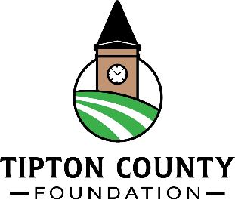
The Tipton County Foundation sponsored charter transportation to and from Shakamak State Park for 4-H Camp. This sponsorship has allowed the 4-H Council keep the cost of camp affordable for participants and ensure a comfortable and safe ride on the long trip.



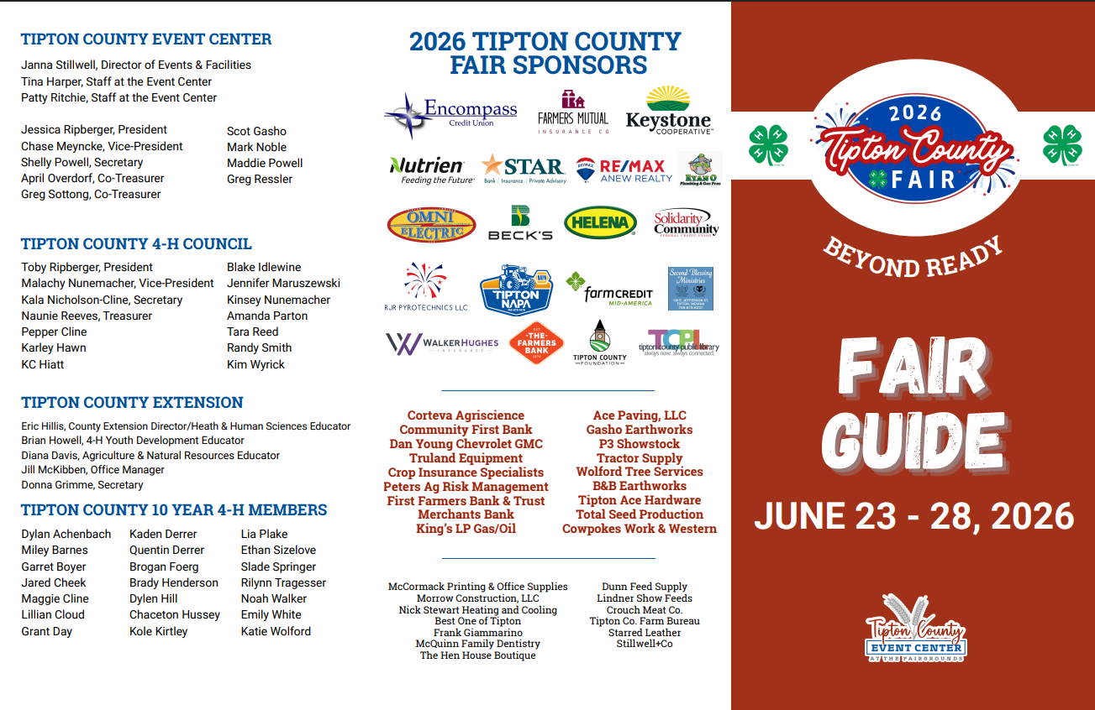
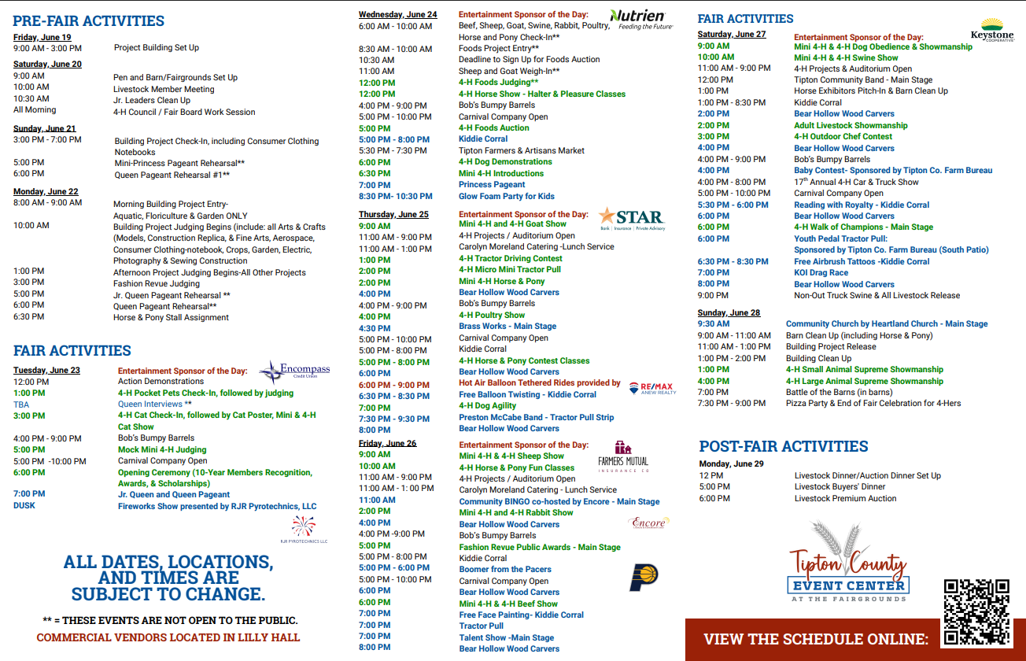
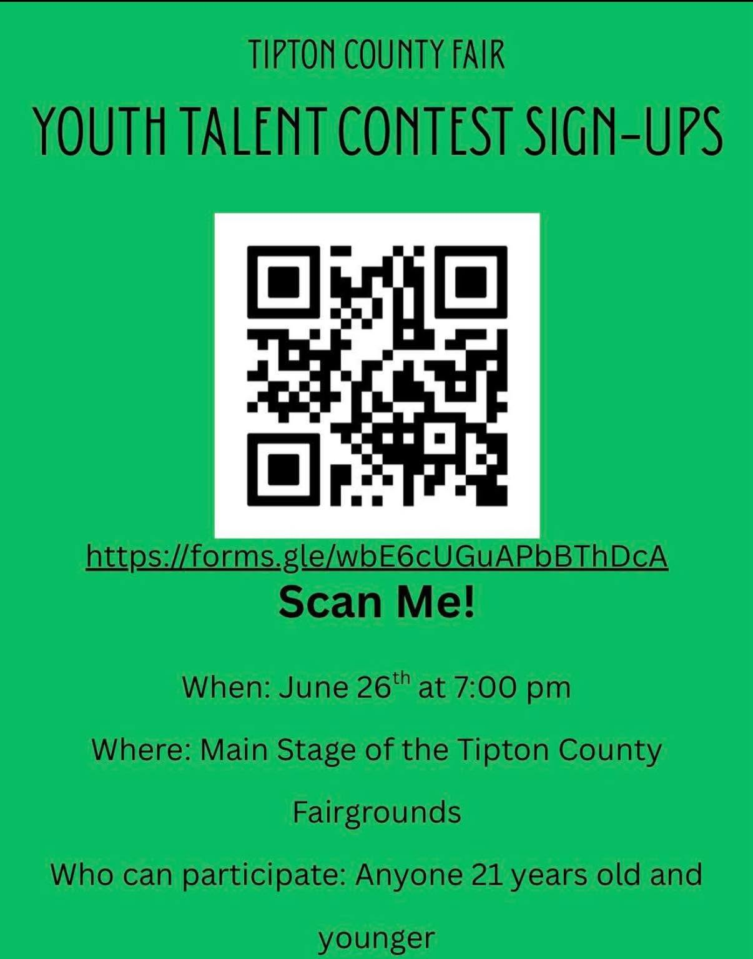

Entries due by June 15!!!


Purdue Extension- Tipton County 1200 S Main Street Tipton, IN 46072
765-675-1177

It is the policy of the Purdue University Cooperative Extension Service that all persons have equal opportunity and access to its educational programs, services, activities, and facilities without regard to race, religion, color, sex, age, national origin or ancestry, marital status, parental status, sexual orientation, disability or status as a veteran. Purdue University is an Affirmative Action
institution.

