4-H Foods Recipe Card
Project Level A____ B____ C____ D____ | Name _________________________________________
Exhibit Type Baked____ Preserved____ | County ________________________________________
Name of Product: ________________________________ | Recipe Source: __________________________________
Date Product was Made: __________________________
INGREDIENTS: | 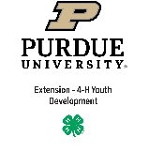
Ingredients that could potentially cause an allergic reaction:
INSTRUCTIONS:  01/2021 | (continue on back if needed)

4-H Foods Recipe Card
Project Level A____ B____ C____ D____ | Name _________________________________________
Exhibit Type Baked____ Preserved____ | County ________________________________________
Name of Product: ________________________________ | Recipe Source: __________________________________
Date Product was Made: __________________________
INGREDIENTS:
Ingredients that could potentially cause an allergic reaction:
INSTRUCTIONS:  01/2021 | (continue on back if needed)

