4-H

COLLECTIONS MANUAL

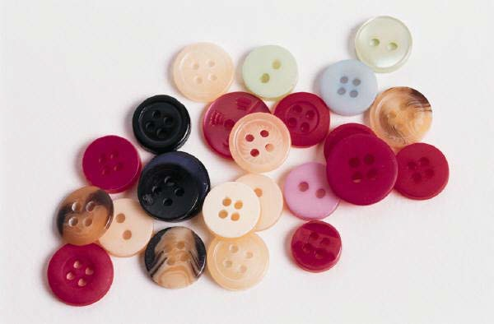

4-H Collections Project

Exhibit Suggestions
The Fair Board and 4-H Council cannot take responsibility for the damage, loss, or theft of a collection exhibit. Protection and precaution will be used to safeguard the exhibits. It is recommended that valuable objects be protected in a display case or left at home.
A complete collection could be shown using photographs if the items are valuable or too large to display in the required dimensions. Photos should be securely mounted and labeled in a notebook with the completed record sheets.
Before you turn in your exhibit:
- check to see that all items are neatly labeled
- your collection “Story” is included
- as many 4-H Collection record sheets as needed are included
- the project question sheet is included

Judging Guidelines:
- Judging will be based on neatness and completeness of records.
- The judge will review the “Story” on your collection, taking into account the age of the member.
- Primary consideration will be given to items collected since last year’s fair.
- The judge will look for originality and arrangement of the display and/notebook.

Scorecard

CATEGORY | POSSIBLE POINTS | POINTS AWARDED
Neatness of display/notebook | 30
“Story” on collection | 20
Completeness of records on each  item | 15
Completeness of project record sheet | 15
Originality | 10
Creativity | 10
Total | 100

Comments:

YOUR STORY ON YOUR COLLECTION
Each record book should begin with a story about your collection. It can be written or typed. It is recommended that the story be approximately 100 words or less in Levels A & B, and approximately 150 words or less in Levels C & D.

Each member needs to write their own story, with assistance in editing or typing only. Stories should be titled, and titles should mention the item being collected. Your story should tell how and why your collection started. Tell where you keep your collection at home. Tell some interesting facts about your items and why you value them. Division C & D may want to tell about the history of your items and how you hope to continue your collection.
The following is an example of a story by a boy named Bueford, who is in Division B:

Collection Hubcaps – Legally
By Bueford Q. Zidfuddle My collection began with my first trip to the junkyard with dad. These shiny
chrome objects attracted my attention. Their low price and many styles seemed appealing.
After purchase, I polished each one and hung them in the garage. The nicer ones decorate my bedroom wall. Several hubcaps are antiques, with the “Packard” being my favorite. The 1993 Chevrolet hubcap is rare because that was during the Depression when cars and metal were scare.
Hubcaps are bright, shiny, stylish, and teach automotive history. Maybe you should consider collecting hubcaps.

Bueford’s story avoided obvious statements that hubcaps are neat, fun, and that he enjoys his collection. Few people collect anything they do not enjoy. Avoid wordiness and try to tell as much as you can in the space you have.

4-H Collection’s Project Question Sheet
- Why do you enjoy collecting these items?

- Where were some of your articles originally made or manufactured? Remember that some companies make containers or parts for other companies.

- How do you plan to add to your collection?

- Where did you purchase or find most of your articles?

- Do you expect your collection to become more valuable? Why?

- Would you ever sell your collection?

- Should other people be interested in collecting this item and why?

- What is your favorite article?

- Have you purchased any books about your collection? (if so, please list them!)

The remaining pages should be a complete list of your collection on the “4-H Collections Records Sheets”. Below is an example of how to complete the Record Sheet. Answers should be as complete as possible. Accurate records are important in collecting so that you know the value of your collection, what items are needed, and where you found or purchased your items.

Name or description of article (be  complete) | Date purchased  or added | Approximate  cost or value | Location of purchase or find
1965 Ford Falcon Futura hubcap | Aug. 1979 | Found | side ditch south of house
1967 Ford Mustang hubcap | Sept. 1979 | Gift | from Dad
1978 Dodge Dart hubcap | Sept. 20, 1980 | $2.00 | Kokomo Scrap

4-H COLLECTIONS RECORD SHEET

Name or description of article (be  complete) | Date purchased  or added | Approximate  cost or value | Location of purchase or find
(Use additional pages if necessary)

