Dear 4-H Members & Supporters,

Welcome to Posey County 4-H!

By joining 4-H, you are part of the largest informal education program in the USA. 4-H provides today’s youth with fun and educational ways to learn and grow, and this handbook contains 4-H exhibit guidelines and information about annual 4-H activities and awards.

Each 4-H family will receive a county handbook. Any changes will be shared via email as deemed necessary by the 4-H Youth Educator.

If you have any questions about the 4-H information listed here, please feel free to stop by the Extension Office, check out our website, or contact the 4-H Youth Educator via phone or email at your convenience.

We look forward to helping you to make the best better!

PURDUE EXTENSION-POSEY COUNTY
126 East Third Street, Coliseum Building, Room 29
Mt. Vernon, IN 47620
Office: 812-838-1331 Fax: 812-838-1353
www.extension.purdue.edu/posey

Kristen Lowry, klowry@purdue.edu
Health & Human Sciences Educator
County Extension Director

Cheven Meyncke May, maycm@purdue.edu
4-H Youth Educator

Hans Schmitz, hschmitz@purdue.edu
Agriculture & Natural Resources Educator

Lacy Wilson, wilso766@purdue.edu
NEP Community Wellness Coordinator

OFFICE HOURS
Monday - Friday
8:00 AM - 12:00 PM & 1:00 - 4:00 PM Daily

TABLE OF CONTENTS
4-H Annual Activities 3
4-H Clubs & Volunteer Adult Leaders 2
4-H Council Board of Directors 2
4-H Dress Code 61
4-H Exhibit Requirements (Listed by Project) 10
4-H Fashion Revue…………………………………….53
4-H General Animal Project Rules 60
4-H General Rules (Includes Poster Requirements) 3
4-H Livestock Auction Rules 64
4-H Livestock Auction Donors 77
4-H Supreme Showmanship Rules ………..65
4-H Tractor Operator’s Contest……………………….57
4-H Trips & Awards 3
Extension Homemaker Open Class Info 78-79
General Animal Health Rules (All Species) 62-64
Indiana 4-H Program Statement of Policy 6-10
Mini 4-H Guidelines 60
Open Beef Show 66

4-H PROJECTS IN EXHIBIT BUILDING

Aerospace 10
Americana 11
Animal Posters…….11
Aquatic Science 12
Arts & Crafts 12
Beekeeping………..13
Bicycle 13
Cake Decorating 14
Child Development 15
Collections 15
Computer 16
Construction Toys 20
Consumer Clothing. 20
Corn Production...... 21
Corn Science………21
Create With A Mix .21
Creative Writing 22
Cupcake Dec………22
Electric 23
Entomology 24
Family Camping 27
Farm Scene………..28
Floriculture 28
Food Preservation.. 32
Foods 33
Forestry 34
Garden 37
Genealogy 38
Geology 40
Health 42
Home Environment.43
Junior Leaders…….45
Models... ............46
Pet Pals... ........46
Photography... 47
Recycling............... 49
Scrapbooking..........49
Sewing 50
Small Engines 54
Soil & Water Sci. 54
Soybean Production 55
Soybean Science….55
Sportfishing 55
Sports 57
Tractor 57
Travelogue 55
Veterinary Science 58
Video Gaming &
Computer Coding....58
Weather. 58
Wildlife 59
Wood Science 59

4-H PROJECTS IN LIVESTOCK BUILDINGS

Beef 65
Cat 67
Dairy 68
Horse & Pony 69
Meat Goat 71
Poultry & Egg 72
Rabbit 73
Sheep 75
Swine 76

4-H CLUBS & VOLUNTEER ADULT LEADERS
BLAZING SADDLES
Allison Hatfield
Phillona Steele
COUNTRY BUMPKINS
Heather Allyn
Dana Jarvis
CRAFTY COMETS
Jeanette Head
Carol Hordynski
DILIGENT ONES
Rachel Deno
Cathy Defur
HOOSIER BOOSTERS
Emma Carner
Laura DeShields
Chris Mulkey
Todd & Angela Wiley

JUNIOR LEADERS
Robyn Bender
Kendra Glaser
KINGS & QUEENS
Laura Kuhn
Katy Lang
ROUSING ROOKIES
Shayna Ray
Russell Roehr
Carla Schenk
SAVAH ROCKETS
Cody Pate
John Pate
Dana Pate
TARTY TUCKERS
Heather Morlan
Dave Morlock
VICTORY BEES
Shelley Hargrove
Robin Price

4-H COUNCIL BOARD OF DIRECTORS
Chris Woods, President
Brooke Axton, Vice Pres.
Johnny Hargrove, Secretary
Ross Heathcotte, Treasurer
Krystle Anderson
Cheyenne Angermeier
Sydney Deno
Stephanie Fifer
Grace Glaser
Steve Glaser
Josh Harris
Hayley Kueber
Kelsey Lang
Andrea McFadin
Daniel Motz
John Pate

4-H TRIPS AND AWARDS
What follows is a list of trips and awards available to Posey County 4-H members. To learn more about these opportunities, please contact the Extension Office.

4-H ACADEMY
4-H BAND WORKSHOP
4-H CHORUS WORKSHOP
4-H ROUND-UP
4-H’ER OF THE MONTH AWARDS
ACCOMPLISHMENT SCHOLARSHIPS
CITIZENSHIP WASHINGTON FOCUS
CLUB SECRETARY’S BOOK AWARDS
FARM BUREAU TENURE AWARDS
INDIANA 4-H FOUNDATION SCHOLARSHIPS
LAST YEAR MEMBER AWARDS
PENMANSHIP AWARDS
STATE 4-H ELECTRIC WORKSHOP
STATE 4-H SCHOLARSHIPS
STATE FAIR YOUTH LEADERSHIP CONFERENCE
STATE JUNIOR LEADER CONFERENCE
TIMMY LEE SCHMIDT AWARD

4-H ANNUAL ACTIVITIES
What follows is a list of annual activities available to Posey County 4-H members. To learn more about these opportunities, please contact the Extension Office.
CAMP
CLUB OFFICER TRAINING
FASHION REVUE
PROJECT WORKSHOPS
PUBLIC SPEAKING CONTEST
SHARE-THE-FUN TALENT SHOW
TRACTOR OPERATOR CONTEST
4-H GENERAL RULES
1. All 4-H Exhibits displayed in the Exhibit Building must be entered between 2:00 & 4:00 PM on Sunday, July 18. See “4-H General Animal Project Rules” for specific times that animals are entered.

2. It is the responsibility of the exhibitor to see that each of his/her exhibits is properly entered.

3. Member completion awards are distributed as follows and must be picked up on Friday, July 23, 1:00-6:00 PM in the Exhibit Building:
Year 1 Completed Members……$10
Year 2 Completed Members……$5
Year 3 Completed Members……$5
Year 4 Completed Members……$5
Year 5 Completed Members……$50
Year 6 Completed Members……$15
Year 7 Completed Members……$15
Year 8 Completed Members……$20
Year 9 Completed Members……$25
Year 10 Completed Members…..$150

4. Each 4-H member is limited to one entry per project unless specific project guidelines state otherwise. Members are encouraged to begin at age-appropriate levels. If a 4-H’er enrolls at a higher division, he/she may not enroll in a lower division in future years.
5. 4-H Exhibit Building projects are to be removed from the fairgrounds 1:00-7:00 PM on Friday, July 23. Projects removed prior to 1:00 PM will forfeit any and all awards as well as recognition of project completion. Projects left after 7:00 PM will be discarded.

6. Decisions of the judges are final. The Posey County 4-H Youth Educator obtains judges for all 4-H events. Judges’ names are kept confidential.

7. General Poster Guidelines: All poster exhibits MUST be displayed horizontally, mounted on 22" x 28" plywood or other stiff material, & covered with a clear plastic or transparent material. Any color poster board is acceptable. A label no larger than 4” tall x 3” wide & consisting of name, project division & club name must be placed in lower right-hand corner of poster. See also Rule #20. OPTIONAL: Exhibits may be labeled on the back/underside with the year & owner’s name.

8. All project exhibits will be judged by the exhibit requirements in this handbook, which is subject to changes made by Indiana 4-H, Indiana State Fair, & the Posey County 4-H Council, as they see fit. Exhibits not meeting basic minimum requirements as stated in this handbook will receive a green ribbon.

9. All 4-H project exhibits will be judged according to these division, class or grade categories:

CLOVER: Grades 3, 4, 5
JUNIOR: Grades 6, 7, 8
SENIOR: Grades 9, 10, 11, 12

10. Each 4-H Club is assigned one day to clean an area of the fairgrounds during the 4-H Fair. All 4-H’ers are expected to help clean the fairgrounds on the Saturday before the week of the 4-H Fair. Livestock members are also responsible for cleaning the barns & animal pens. Pen assignments for all animal exhibits will be determined by the Animal Project Superintendents at 8:00 AM on Saturday, July 17.

11. Exhibits selected for State Fair that are larger than one person can carry must be taken to/from the State Fair by the exhibitor. In the case of projects that require specific set-up for exhibit, precise directions are required.

12. Animal identification is required for all auction-eligible species and horses/ponies by May 15 in 4HOnline. Specific requirements are determined by Indiana 4-H and are shared as they become available. Failure to properly identify one’s animals in 4HOnline by May 15 will result in the 4-H member not being allowed to exhibit and/or sell their animals at the county fair. Exhibits must be entered in Fair Entry by June 15 in order to be judged at the county fair.

13. Alternative project exhibit requirements can be made for 4-H members with special needs. Contact the Posey County 4-H Youth Educator prior to July 1 for more information.

14. When a difference exists between a project manual & this handbook, always follow this handbook.
15. 4-H exhibits may not be re-exhibited. If an exhibit is found to be re-exhibited, the 4-H’er will be considered Incomplete for that project.

16. Envelopes with completion awards & scorecards are distributed 1:00-6:00 PM on Friday, July 23, in the Exhibit Building. You MUST arrange for someone to pick up your envelope at this time, or you will forfeit your awards. Scorecards will be available in the Extension Office until September 1. Horse & Pony exhibitors receive their envelopes from the Horse & Pony Club Leader following final stall checks.

17. All changes in 4-H enrollment, including project changes and animal identification, must be completed in 4HOnline by May 15. All project materials must be returned to the Extension Office or paid for by the 4-H member by May 15 in order for a project to not count against the 4-H member as an Incomplete for the year. 4-H Council upholds State Fair entry deadlines for all projects. Exhibits must be entered in Fair Entry by June 15 in order to be judged at the county fair. Photos will not be required unless we cannot hold an in-person event.

18. Community Judging Policy: No persons are allowed to sit with a 4-H exhibitor during Community Judging.
19. Food Safety Rule for Food Competitions (2021): Fillings, frostings, glazes, and meringues are not permitted to contain cream cheese, sour cream, heavy cream, or whipped cream if they are not fully cooked/baked. These items are allowed as ingredients in food products IF the final product is cooked/baked. Additionally, raw milk, raw milk products or uncooked eggs/egg whites are not permitted. Eggs/egg whites that have been cooked to 160oF (i.e. pasteurized or included as part of a batter and baked) are acceptable. No home-canned fruits, vegetables, or meats are permitted as ingredients in food products. Fresh-cut, uncooked, fruits and/or vegetables are not permitted to be used in food products or used as garnishes for the product. Foods should be transported to the competition in a way that minimizes contamination and maintains the quality of the food (i.e. foods that are judged as frozen should remain frozen at all times). Recipes must be provided that identifies all ingredients that were used in each part of the product. Any ingredient that could be a potential allergen must be clearly identified. Each food product must be labeled with the following information: Name & Date the food product was made. Contestants should carefully wash their hands and make sure that their hands do not have any open cuts before preparing foods. If cuts are present, the wound should be bandaged and a single use food service glove worn on the hand during all stages of food production. Contestants should not be preparing food exhibits for competition within 48 hours of recovering from any illness. People experiencing symptoms of vomiting, diarrhea, fever, and/or jaundice should not be allowed to prepare food. Judges and individuals who will consume products from county and/or state competitions should be informed that they are at risk for foodborne illness since the established policy cannot guarantee that an entry has been properly prepared or handled before, during or following the competition. The food products for competitions are home produced and processed and the production area is not inspected by the Indiana State Department of Health. Tasting of a food product is solely at the discretion of the judge and consumers. Judges are NOT to taste any home- preserved foods such as low-acid or acidified foods like green beans, tomatoes or tomato products, jams/jellies/fruit preserves or fermented products produced in the home.
20. All posters, notebooks & display boards must include a reference list indicating where information was obtained, giving credit to the original author, to complete the exhibit. This list should/might include web sites, people interviewed, books, magazines, etc. It’s recommended this list be attached to the back of a poster or display board, be the last page of a notebook, or be included as part of the display visible to the public. A judge is not to discredit an exhibit for the manner in which references are listed.

INDIANA 4-H PROGRAM
POLICIES AND PROCEDURES
The Indiana 4-H Program Philosophy and Expectations: The Indiana 4-H program serves the youth of Indiana by providing a strong educational youth development program. This program delivers educational experiences in a variety of settings. Caring, capable and contributing adults assist in the 4-H program as models for youth. The rich heritage of the 4-H Program is one to be valued and passed along to future generations. The Indiana 4-H Youth Policy and Procedures Book sets out certain standards and guidelines to be used to assure that 4-H is a positive youth development program. County 4-H policy is guided by the county 4-H policy making or governing board (i.e., 4-H Council) as provided by the County Extension Board. Legal authority for the 4-H Program rests with the Director of the Cooperative Extension Service at Purdue University. No county 4-H policy may conflict with state 4-H policy or with federal guidelines and requirements. Deadlines for county and state participation should be carefully constructed so as to encourage rather than to discourage participation. Such deadlines should be well published. Members not complying with established and published dates and deadlines for exhibition may be denied the opportunity to exhibit. It is the policy of 4-H to be an inclusive organization. No county policy or practice should be used to arbitrarily exclude youth from either membership or participation. Youth should participate in 4-H Youth Development opportunities at levels and times that best suit the youth's development and support family involvement.
4-H Mission: The Indiana 4-H Youth Development mission is to provide real-life educational opportunities that develop young people who positively impact their community and world.
4-H Vision: Indiana 4-H Youth Development strives to be the premier, community-based program empowering young people to reach their full potential.
4-H Club Membership: Youth may become 4-H members when they enter the third grade and may continue their membership through the completion of grade 12. Each individual may continue membership for a maximum of 10 consecutive years. Exceptions: (1) Youth who enroll in grade three and are advanced academically (thus graduating early) may continue for a total of 10 years ONLY if the enrollment occurs in consecutive years. (2) Those youth who are academically advanced and “skip” 3rd grade, may begin the program as a 4th grader and may continue for a total of 10 years ONLY if the enrollment occurs in consecutive years. (3) Those youth who enroll in grade three and are retained a grade in school may continue to progress through the 4-H Program by adding subsequent years of participation, but MAY NOT exceed 10 years of participation. For example, if a member is retained one year in school (public, private, or home), their final year of 4-H membership would conclude the summer following their junior year of
high school. (4) Those youth who entered the program in 3rd grade and for one reason or another leave formal education prior to the completion of 12th grade may continue for a total of 10 years ONLY if the enrollment occurs in consecutive years. NOTE: 10 years of membership in the 4-H Youth Development Program is an opportunity --- not an entitlement. Those youth who do not enroll as 3rd grade students or meet the exceptions above, conclude their involvement with the program during the summer immediately following the completion of their senior year in high school. An individual’s 4-H grade is determined by the school grade in which he or she is classified at the time of year he or she enrolls in 4-H. A member does not advance in 4-H grade until he or she enrolls in 4-H for the subsequent year. Each member should enroll in the division of a project/subject that would best suit his/her interest and potential for personal growth and would enhance their family involvement. Opportunities in the 4-H program are available to all Indiana youth as defined regardless of race, religion, color, sex, age, national origin or ancestry, marital status, parental status, sexual orientation or disability. Married young men and women of 4-H age may participate in any of the 4-H projects and activities. However, married persons must participate by the same terms and conditions and/or guidelines as unmarried participants. Membership in 4-H is gained by annually enrolling through a Purdue University Cooperative Extension Service Office located in each of Indiana's 92 counties. The Indiana 4-H Youth Development program year is October 1 to September 30 annually. Enrollment is an annual process attained by completing individual 4-H enrollment via the 4HOnline enrollment process. Statewide 4HOnline enrollment occurs annually October 1 through January 15.
Mini 4-H Non-Competitive Policy: Mini 4-H is a program designed to encourage positive development of children, Kindergarten through second grade. The goal of Mini 4-H is to help young children explore friendships outside the family; explore the way in which things work; practice both small and large muscle control; and think about the ways people work together on projects. This NON-COMPETITIVE learning environment includes:
1. Planned learning activities in which children are invited to be active and explore materials and ideas without the pressure of completing a specific product or exhibit.
2. Low adult/leader to child ratio that allows time for adults/leaders to provide individual, positive encouragement and assistance.
3. Simple, interesting activities that are fun.
4. Encouragement of children to participate in a group activity by sharing and or displaying their activity projects.
5. Rewards that are identical and/or ribbons of the same color for everyone.
DO NOT JUDGE projects, but instead discuss them with the child. NOTE: Purdue University and the Indiana 4-H Youth Development Program do not support, endorse, or encourage 4-H programming for children prior to Kindergarten. 4-H Youth Development Extension staff members and 4-H Volunteers may not offer, or encourage others to offer, programming for children prior to Kindergarten.
Residence: Indiana youth typically enroll in 4-H Youth Development programs in the county or state in which they reside. However, individuals living in one county may join 4-H in another county. There may be educational or social reasons for an individual joining 4-H in a different county than that of their primary residence. During a single program year, a 4-H member enrolled in a given project is expected to enroll and exhibit that project only in one county of enrollment. In the event that a project is not offered in the county of primary 4-H enrollment, a 4-H member may enroll in that specific project in a different county. Approval of this special exception rests with the county 4-H policy-making or governing board (i.e. 4-H Council) and/or the Extension Board of the receiving county. Participation in 4-H related activities and events (i.e., judging; share-the-fun) must be in the county of primary 4-H enrollment. The above policy is not intended to provide an escape mechanism for 4-H members and families who are unwilling to follow the terms and/or conditions in their current county of 4-H membership. Decisions regarding 4-H membership in a non-resident county (a county you do not live in), rest with the County 4-H Council and/or the Extension Board in the receiving county. Note: In a statement from our federal partner in Washington, DC, the following statement appears: "Anytime there are procedures for exclusion of individuals from events which use the 4-H name there are potential challenges to enforcement of the exclusions. The challenges have a substantial potential to prevail and they frequently result in negative publicity for the organization. Therefore, before choosing a policy of exclusion it is wise to evaluate the exclusion being considered, to be sure there is an overwhelming educationally based need for the exclusion". Extension employees and volunteers are obligated to eliminate (and should not create) any practices that limit, deprive, or tend to deprive any youth of opportunities for membership and/or participation in the Indiana 4-H program.
Behavioral Criteria for 4-H Events and Activities: To 4-H members, volunteers, parents and the public: When attending, participating or acting on behalf of the 4-H program, all persons are expected to conduct themselves in accordance with accepted standards of social behavior, to respect rights of others, and to refrain from any conduct which may be injurious to the 4-H program. The following actions constitute misconduct for which persons may be subject to disciplinary consequences and/or dismissal from the program:
(a) Dishonesty in connection with any 4-H activity by cheating or knowingly furnishing false information.
(b) Alteration or unauthorized use of 4-H records.
(c) Obstruction or disruption of any 4-H activity or aiding and encouraging other persons to engage in such conduct.
(d) Failure to comply or aiding or encouraging other persons not to comply with specific terms and conditions of a given project, contest, or activity.
(e) Failure to comply with directions of 4-H officials acting in the proper performance of their duties.
(f) Inhumane treatment of 4-H animal projects.
There are many opportunities for 4-H members, volunteers, parents and the public to participate in 4-H events and activities. When involved in such experiences, members, volunteers, parents and the public are expected to follow all rules and regulations as outlined by those responsible for the specific program or activity. In all such 4-H activities, the following constitute a violation of behavioral expectations:
1. Possession or use of fire crackers, gun powder, firearms, chemicals or other materials that can be used to create an explosive mixture.
2. Misuse of fire equipment or sounding a false fire alarm.
3. Having a guest of a different gender in your sleeping quarters, or inappropriate sexual behavior.
4. Physical or verbal abuse of any person or conduct which threatens or endangers the health or safety of any person.
5. Theft of or malicious damage to property.
6. Possession, use, or distribution of alcohol, illegal drugs, tobacco and tobacco-like products, electronic smoking devices (including, but not limited to, e-cigs, vapes, juuls), or other dangerous substances.
7. Inappropriate displays of affection towards another person(s).
8. Distribution, misuse, or abuse of over-the-counter, homeopathic (including supplements and vitamins), or prescription medications.
9. Inappropriate clothing or lack of clothing during the event or activity. 10. Lewd, indecent, or obscene conduct or language.
11. Unauthorized entry, use or occupancy of any facility.
12. Any conduct which threatens or interferes with maintenance of appropriate order and discipline or invades the rights of others.
13. Unwillingness to follow appropriate health and safety procedures. 14. Reckless or inappropriate behavior. When violations occur at out-of-county, district, area, and/or state and/or national 4-H events, the following procedures will be followed:
(a) The parents/legal guardians may be contacted to arrange transportation home for the violator(s) and
(b) The local Extension Educator may be notified.
Guidelines for Exhibition and Completion: Following are policies that govern exhibition and completion of 4-H Projects:
Exhibition: Exhibition of 4-H projects in local, county, or state exhibits/fairs, in person or virtually, is voluntary on the part of the exhibitor. The exhibition of 4-H projects provides 4-H members an opportunity to display their 4-H projects, enter into competition and participate in an educational/social environment with peers. With exhibition also comes the responsibility for abiding by all the terms and conditions pertaining to the respective 4-H project.
Completion: The completion of a 4-H project must not be misinterpreted as exhibition of said project at a local, county, or state fair. 4-H members are considered complete in their project work for that year when they have (1) completed an "official" 4-H member enrollment form prior to the established and published date for enrolling; (2) turned in a completed 4-H project record sheet prior to the established and published date; and (3) had an officially recognized 4-H leader/extension educator verify the existence of the completed project or activity. Though exhibiting in local, county, and state exhibits/fairs is not required for project completion, as it does not necessarily relate directly to content and skills learned in the development of the 4-H project, project exhibition is encouraged as a continuation of the educational experience. Note: In a statement from our federal partner in Washington, DC, the following statement appears: “Anytime there are procedures for exclusion of individuals from events which use the 4-H name there are potential challenges to enforcement of the exclusions. The challenges have a substantial potential to prevail and they frequently result in negative publicity for the organization. Therefore, before choosing a policy of exclusion it is wise to evaluate the exclusion being considered, to be sure there is an overwhelming educationally based need for the exclusion.”
Extension employees and volunteers are obligated to eliminate (and should not create) any practices that limit, deprive, or tend to deprive any youth of opportunities for membership and/or participation in Indiana 4-H.
Guidelines for Animal Exhibits: Each 4-H member shall own his/her 4-H exhibit. Ownership, personal possession, and regular care of the animal must be in effect on or before the county and state enrollment deadlines and continuously until after the 4-H show at the county and/or state fair.
1. For 4-H breeding animals: family corporations and/or partnerships of 4-H members with one or more parents, siblings, grandparents, aunts, uncles, or legal guardians are acceptable.
2. For 4-H dairy cattle: family corporations and/or partnerships of the 4-H member with unrelated persons or dairy operations are also acceptable.
3. Dairy heifers, horses, ponies, and llamas may be leased by a single 4-H member in a single program year, subject to approval of both the county 4-H dairy, horse and pony, or llama committee and the respective County Extension Educator.
4. 4-H animals are expected to be in the possession and regular care of the 4-H member who owns/leases them (unless other arrangements have been agreed upon by the County 4-H Extension Educator) from the animal ID deadline until the conclusion of the county and/or state fair.
5. 4-H animals purchased, sold or offered for sale after the ID deadline and prior to the Indiana State Fair (including animals that have gone through a "Premium Only Auction"), shall not be eligible to show in the 4-H show at the Indiana State Fair. Sale of products of animals (milk, cheese, wool, etc.) in lieu of the animal, are considered equivalent to a "Premium Only Auction."
6. 4-H animals exhibited after the May 15 State 4-H animal ID deadline at any show by anyone other than the individual whose 4-H enrollment record is connected to the ID of the animal in Indiana 4-H Online will not be eligible to be shown in the 4-H show at the Indiana State Fair. This term/condition does not apply to siblings and parents, who may show each other’s animals at any show during the year without jeopardizing State Fair eligibility. 4-H animals that are selected by 4-H Extension Staff or 4-H Adult Volunteers for use in supreme showmanship contests (Master Showmanship, Round Robin, etc.) may be used in those county events without jeopardizing State Fair eligibility. This policy applies to all 4-H animal projects. For animal projects without state ID deadlines, the person who enters them in the Indiana State Fair 4-H show is the equivalent of the owner of the animals.
7. Temporary guardianships established for the intent of animal exhibition or grooming purposes are not permitted and shall result in immediate disqualification.
See Indiana State Fair (ISF) Terms and Conditions for ISF ownership guidelines.
Grievance/Appeal Guidelines for County 4-H Program Issues: (Activities, Programs, Projects)
The grievance procedures outlined in this document are utilized as part of an internal process of the Indiana 4-H Youth Development program for use when grievances of 4-H members, their parents/guardians, or 4-H volunteers cannot be resolved via reasonable conversation. This policy affords the opportunity in those unique situations to allow voice or opinion to be heard when there is a dispute regarding 4-H participation, activities or programs. This is not a mechanism for complaints against individual 4-H members (or their families), 4-H volunteers, judging officials for competitive events, or Purdue Extension staff. All resulting decisions will be made in accordance with the Indiana 4-H Program’s stated mission to be an inclusive organization designed to encourage and maximize youth participation. The rights of the individual filing the grievance are limited to those provided by Indiana 4-H Program policy. Purdue University, as the Land Grant University in Indiana, is charged (by the United States Department of Agriculture) with implementing the 4-H Program in communities across the State of Indiana. Purdue Extension Educators in each Indiana county represent the university in local communities and have the responsibility of assuring all 4-H volunteers meet basic university criteria as they serve as representatives of the university. Purdue Extension Educators additionally provide oversight to 4-H volunteers including the assurance that Indiana 4-H Policies and Procedures are appropriately implemented in 4-H Program delivery. Individual county 4-H policies and procedures should be created and reviewed to assure they do not contradict established statewide 4-H policies and procedures. If a contradiction is discovered during the grievance process, Indiana 4-H Program policy shall be followed in determining the grievance outcome.
1. Grievances are made by completing the Indiana 4-H Grievance/Appeal form with the burden of proof being the responsibility of the individual filing the grievance. The completed grievance/appeal form and supporting documentation shall be presented to the president of the 4-H policy-making body (e.g., 4-H Council) or the Purdue Extension Educator who works with the 4-H Program. (NOTE: concerns regarding staff, volunteers, members, or other individuals are not issues for which a grievance may be filed. 4-H volunteers are assigned by the 4-H Extension Educator. Concerns regarding 4-H volunteers, members, or other individuals should be addressed directly with the 4-H Educator.)
2. Grievances pertaining to 4-H activities, programs or projects shall be filed within 14 days of an incident or occurrence. Grievances pertaining to county fair related issues are often time-sensitive and must be filed within 24 hours of the incident.
3. The grievance process occurs in the county where the issue or concern arises and offers three opportunities for a concern to be heard and reviewed:
A. The grievance is initially heard by an unbiased, representative grievance sub-committee of approved 4-H Volunteers. It is the Purdue Extension Educator assigned to 4-H Programming who shall annually work with the chair of the county 4-H Council to determine this committee’s membership to include a combination of 3-6 of the following individuals: one representative of the 4-H Council; two 4-H volunteers serving as a 4-H club organizational leader; one member of the County Extension Board; one 4-H volunteer knowledgeable in the subject matter (project) of concern (this individual will vary dependent on issue raised with the grievance); and up to three community leaders. The 4-H Educator shall convene the group.
B. The person filing the grievance may appeal the decision of the grievance sub-committee to the 4-H policy-making body, which will then review the facts in evidence and render a decision.
C. The person filing a grievance may appeal a decision of the 4-H policy-making body to the County Extension Board. The Extension Board will review the facts in evidence and render a decision. This is the final level in the appeal process.
**While there is no doubt some overlap in who serves on these committees, the intent of a three-level process is to assure different individuals have the opportunity to hear and act on the grievance. ALL individuals involved at any level of the grievance procedure are reminded of the importance of keeping discussions regarding grievances confidential. To maintain the confidentiality of the parties involved, the grievance hearings at each level will be closed to the public. Only the individuals who have filed the grievance, the members of the grievance committee, and the Purdue Extension Educators will be present during each level of the grievance process, ***The grievance process is internal to the Indiana 4-H Youth Development Program and meetings of the grievance committees are not subject to Indiana’s Open Door Policy. The Purdue Extension Educator assigned to work with the 4-H Program has the obligation to inform all parties that there is a grievance procedure if there are disagreements with policies. The practice of charging fees from those filing grievances shall be eliminated and all counties will utilize the Indiana 4-H Grievance/Appeal Form as part of the grievance process.

4-H EXHIBIT REQUIREMENTS
AEROSPACE
Use 4-H Evaluation Survey
NOTE: "Ready to Fly" & E2X rockets are not allowed. See 4-H General Rule #20, as references are required for certain exhibits. Rockets may be exhibited with a base, but launch pads are not permitted. All rockets must weigh less than 3.3 pounds & be considered an amateur rocket according to FAA regulations. Remote control aircraft & drones may be constructed from a kit or purchased ready-to-fly & must be age/grade appropriate & compliant with FAA regulations, federal and state laws, and local ordinances. This exhibit choice is to include a notebook or poster including how the aircraft/drone was used and what aerospace skills were learned. Displaying the aircraft or drone is optional. See 4-H General Rule #20.
Clover: Make/Exhibit ONE of the following: A rocket of your choice, Estes Skill Level 1 or 2 (or comparable difficulty), remote control aircraft/drone, poster OR display board on any topic in the manual. Cluster engine rockets and rockets that take an engine D or above are not permitted at this level.
Junior: Make/Exhibit ONE of the following: A rocket of your choice, Estes Skill Level 2 or 3 (or comparable difficulty), remote control aircraft, drone, poster OR display board on any topic in the manual. Cluster engine rockets and rockets that take an engine E or above are not permitted at this level.
Senior: Make/Exhibit ONE of the following: A rocket of your choice, Estes Skill Level 3 or above (or comparable difficulty), a box kite or other aerodynamic object of your choice which illustrates principles of flight, a poster OR display board on any topic in the manual. Rockets that take an engine G or above are not permitted.
MAX # STATE FAIR EXHIBITS [6]
1 ROCKET/AIRCRAFT/DRONE PER LEVEL
& 1 POSTER/DISPLAY BOARD PER LEVEL

AMERICANA: ORIGINAL & RESTORED
Use 4-H Evaluation Survey
NOTE: Exhibits must be accompanied by a complete description of the project in notebook form, including photos of yourself working on the exhibit, and are judged by Clover, Junior & Senior divisions. See 4-H General Rule #20.

Original: Item should be ONLY cleaned for exhibit.
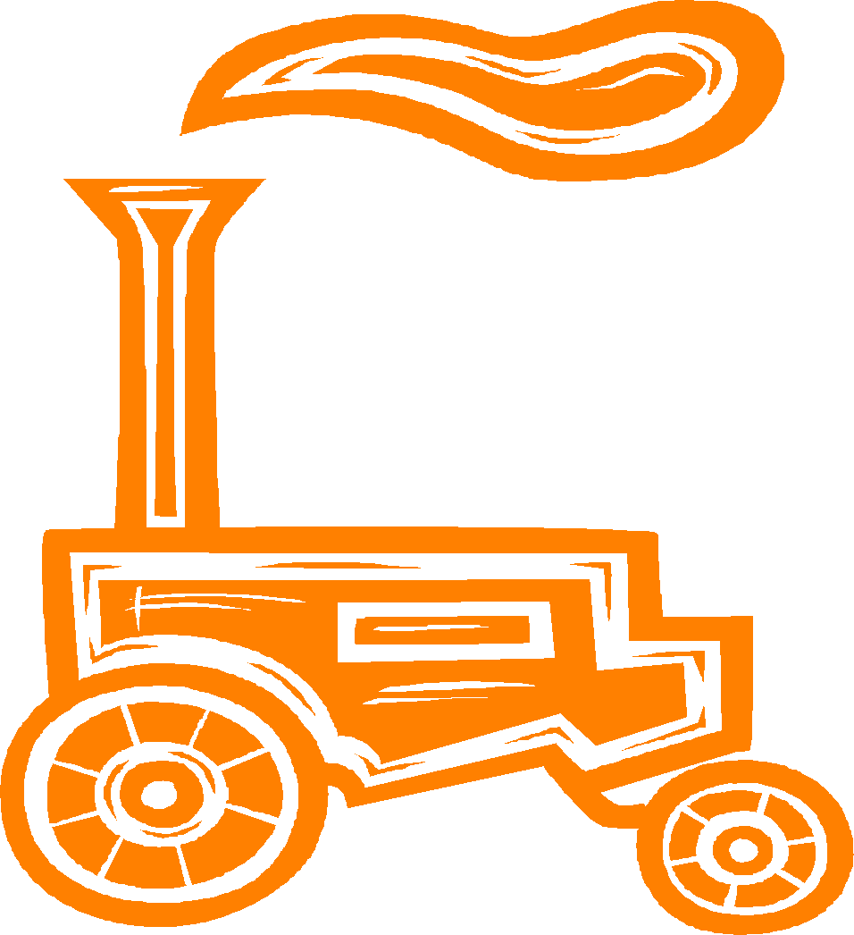
Restored: Item should be refinished/
repainted/rewired to be in
“like new” form for exhibit.

Exhibits will be judged by the following classes in each of the project areas (Original or Restored): Household Articles, Hand Tools & Artifacts, Tractors, Other Farm Machinery, Vehicles.
COUNTY PROJECT ONLY

ANIMAL POSTERS
Use 4-H Evaluation Survey
NOTE: You may choose to exhibit up to 10 entries in this project (1 per species): Beef, Cat, Dairy, Dog, Goat, Horse, Rabbit, Poultry, Sheep & Swine. Beef, Dairy, Goat, Horse, Sheep & Swine are not eligible for State Fair entry (County Only). See 4-H General Rule #20.
Clover: Choose a different chapter from the manual each year & complete at least 3 activities each year. Exhibit a poster on related information from the chapter completed. Junior & Senior: Follow Clover requirements using the grade level appropriate manual.
MAX # STATE FAIR EXHIBITS (1 PER LEVEL PER SPECIES) [12] - CAT, DOG, POULTRY, RABBIT ONLY
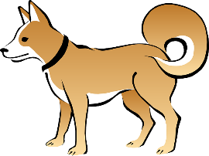
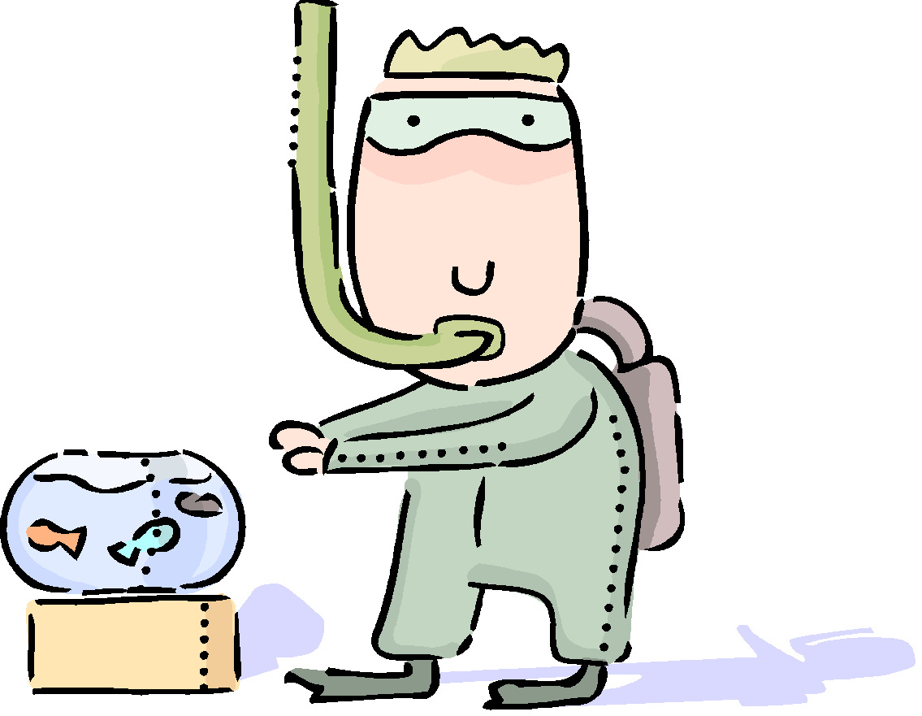
AQUATIC SCIENCE
Use 4-H Evaluation Survey
NOTE: Follow General Poster Guidelines. See 4-H General Rule #20.
Clover: Choose a different chapter from the manual each year & complete at least 3 activities each year. Exhibit a poster on related information from the chapter completed.
Junior & Senior: Follow Clover requirements using the grade level appropriate manual.
COUNTY PROJECT ONLY

ARTS & CRAFTS
Use 4-H Evaluation Survey
NOTE: Exhibits must be ready for use/hanging. No pop-tops allowed. Exhibits with inappropriate hanging devices will be disqualified. Attach to your exhibit 4-H 618A-W to explain your exhibit & your work on it.

Arts & Crafts: Basic Crafts
- Exhibit 1 OR 2 of the following: candle making, ceramics, gift wrapping or miscellaneous crafts. Miscellaneous items may not fit into any other project category. YOU MAY ENTER 2 BASIC CRAFTS EXHIBITS AS LONG AS THEY ARE NOT IN THE SAME CATEGORY.
- Exhibits are judged by grade level in each category.
- Only 1 article may be exhibited per category. A pair is considered 1 article.

Arts & Crafts: Needle Crafts
- Choose 1 of the following: knitting, embroidery, crocheting, needlepoint, crewel, candlewicking, chicken scratching, hand quilting, tatting, huck embroidery, hemstitching; also pulled, drawn & counted thread work & punch needlework. Doesn’t include latch hook, plastic canvas, machine knitting, machine quilting, or arm knitting/crocheting, as these are Basic (Misc.) Crafts categories.
- Only 1 article may be exhibited per Needle Crafts category. A pair is considered 1 article.
- Exhibits are judged by Clover, Junior & Senior levels.

Arts & Crafts: Fine Arts (Drawing OR Painting ONLY!)
Project Superintendent - Kendra Glaser (812-453-8637)
- Choose 1 or 2 of these mediums: oil, charcoal, watercolor, acrylics, ink, pencil, or pastels. Projects not using these mediums will be disqualified. YOU MAY ENTER UP TO 2 FINE ARTS EXHIBITS AS LONG AS THEY ARE NOT THE SAME MEDIUM. (Acceptable example: oil painting & pencil drawing. Unacceptable example: 2 pencil drawings)
- Exhibits are judged by Clover, Junior & Senior levels.
- Select canvas, canvas board or paper as background material for the chosen medium. Matting is expected if it is appropriate for the exhibit. Canvas art on a wooden frame is considered prepared for hanging provided that the frame has a hanger.
MAX # STATE FAIR EXHIBITS [7]
3 BASIC CRAFTS, 2 NEEDLE CRAFTS, 2 FINE ARTS
GIFT WRAPPING IS A COUNTY PROJECT ONLY.
BEEKEEPING
Use 4-H Evaluation Survey
NOTE: Choose one of the topics below. Use that topic for your title. Use a sub-title if you wish. Follow General Poster Guidelines. See 4-H General Rule #20.
- No bee hives may be exhibited.
- Honey water content will be measured.
- Fill level: honey should be filled to the jar shoulder.
- Chunk honey should go in a wide-mouth jar, preferably one specially made for chunk honey.
- Be careful to distinguish “chunk honey” (comb in jar) from “cut comb” (comb only in box).
- Honey must be collected since the previous fair.
Division I: Understanding the Honey Bee
May participate up to 2 years. Exhibit a poster on 1 of the following:
- Flowers Used to Make Honey - Display pressed flowers from 10 different Indiana plants bees use to make honey
- Uses of Honey and Beeswax
- Setting up a Bee Hive
- Safe Handling of Bees
- Any other Beekeeping related topic
Division II: Working with Honey Bees
May participate up to 2 years. Exhibit 1 of the following:
- Extracted Honey - 2 one-pound glass or clear plastic screw-top jars of extracted honey (1 pound per jar)
- Chunk Honey (comb in jar) - 2 one-pound jars (wide-mouth glass or clear plastic)
- Cut-Comb Honey - 2 one-pound boxes, 4½” x 4½”
- Working with Honey Bees - Present a topic from your manual in poster or notebook form to teach others
Division III & ABOVE: Advanced Beekeeping Methods
May participate multiple years. Exhibit an educational display about beekeeping OR exhibit 2 of the 4 kinds of honey listed:
- Extracted Honey - 2 one-pound jars (glass or clear plastic)
- Chunk Honey (comb in jar) - 2 one-pound wide mouth jars (glass or clear plastic)
- Cut-Comb Honey - 2 one-pound boxes, 4½” x 4½”
- Comb Honey - 2 sections (honey built by bees in frames of wood, usually 4 ½” x 4 ½” in size)
Division: Independent Study (Grades 9-12 only)
Choose 1 of the exhibit options listed below:
- Advanced Topic- Exhibit a beekeeping topic in poster form. Include a short manuscript, pictures, graphs, & list the works cited to describe what you did & learned. Title poster, “Advanced Beekeeping - Independent Study.”
- Mentoring- Exhibit a poster that shows how you mentored a younger 4-H member. Include your planning, time spent, the challenges & advantages of mentoring, & how the experience might be useful in your life. Photos & other documentation is encouraged. Title poster: “Advanced Beekeeping - Mentor.”
1 STATE FAIR ENTRY IN DIVISIONS I & IV
1 STATE FAIR ENTRY PER 4-H’ER IN DIVISIONS II & III (JUDGE’S CHOICE IN ALL DIVISIONS)
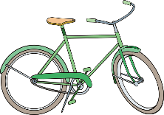
BICYCLE
Use 4-H Evaluation Survey
NOTE: Choose one of the topics below. Use that topic for your title. Use a sub-title if you wish. Follow General Poster Guidelines & see 4-H General Rule #20.
Clover: Exhibit a poster on ONE of the following:
- "You & Your Bicycle" identifying 19 parts of your bicycle on your poster
- "Bicycle Safety" explaining bicycle safety
- "The Right Tools for the Job" identifying 10 tools & listing for which part of the bicycle each tool is used
Junior: Exhibit a poster on ONE of the following:
- "Bicycle Maintenance" including a picture of (or draw directions for) one of the following jobs: (1) Adjusting bicycle brakes, (2) Aligning bicycle spokes, or (3) Cleaning & lubricating bearings.
- “Bicycles & Their Uses”
- “History of the Bicycle”
Senior: Exhibit a poster on ONE of the following:
- Bicycle racing
- Bicycle touring & camping
- Bicycle games & activities
- Some other bicycle-related topic of your choice
COUNTY PROJECT ONLY

CAKE DECORATING
Project Superintendent - Jeanette Head (812-430-2249)
Use 4-H Evaluation Survey
NOTE: Entries are judged Sunday, July 18, 2:00-4:00 PM in the Community Center.

Requirements for All Divisions
1. Exhibits are judged by divisions.
2. Any 4-H’er whose entry is selected for Indiana State Fair exhibit must make a new exhibit for the State Fair.
3. Exhibited cakes must demonstrate the minimum 5 techniques for their given level as outlined in 4-H 710A but may include higher/lower level techniques that have been mastered. Any higher/lower level techniques will not be counted as part of the minimum 5, but nevertheless will be evaluated for quality.
4. Unless otherwise specifies, you must use Royal icing.
5. All cakes must be created using a Styrofoam, foam or other solid dummy.
6. When displaying a cut-up cake or tiered cake, the exhibitor must include a diagram and description indicating how the cake was assembled. This should be attached to or written on the skills sheet.
7. All exhibits must include a completed Cake Decorating Skills Sheet (4-H 710).
8. The cake board must be neatly covered and well taped or otherwise attached underneath.

Clover: Cakes must be on a cake board approximately 3/8” thick and 2-4” larger than the cake. For example, if the cake is 8” round, then the cake board must be 10-12” round. Cakes are to be a single tier/layer, no more than 5” tall & may be round, square, or rectangular. The cake board is to be no more than 12”x12”. A minimum of 5 skills are to be demonstrated at this level. Use Cake Decorating Skills Sheet (4-H 710) & present it at judging with your cake.
Junior: Cakes must be on a cake board approximately 3/8” thick and 2-4” larger than the cake. Cakes are to be a single or double tier/layer and may be any shape. Youth may choose to decorate an inverted (upside down) character pan or create a 3-dimensional cake. It is also permissible to cut-up pieces of Styrofoam, foam, or other solid material to create a new shape, like a butterfly or castle for example. The cake board is to be no more than 24”x24”. A minimum of 5 skills are to be demonstrated at this level, & the cake may include additional skills from the Clover level. Use Cake Decorating Skills Sheet (4-H 710) & present it at judging with your cake.
Senior: Cakes must be on a cake a cake board approximately ½” thick and 4” larger than the base cake. For example, if the cake is 26” round, then the cake board must be 30” round. Cakes may be multiple layer and/or tiered and may include multiple cakes, like a wedding cake. Youth may choose to create a character or 3-dimensional cake by cutting-up pieces of Styrofoam, foam, or other solid material to create a new shape. Dowel rods, plates, etc. should be used to support multiple layers and tiers. Fondant icing and gum paste is permissible. Cakes may be any shape, no more than 36” tall, & the cake board is to be no more than 36”x36”. A minimum of 5 skills are to be demonstrated at this level, & the cake may include additional skills from the Clover & Jr. levels. Use Cake Decorating Skills Sheet (4-H 710) & present it at judging with your cake.
MAX # STATE FAIR EXHIBITS (1 PER LEVEL) [3]

CHILD DEVELOPMENT
Use 4-H Evaluation Survey & 4-H General Rule #20
Level A (Grades 3&4)
- Complete at least 3 activities in the manual, each from a different chapter. Within the 2-year period for this level, you should have completed 6 activities, at least 1 activity per chapter.
- Exhibit 1 of the following: A poster, OR a binder notebook that shows/tells what you did with 1 of the activities you completed for the year (labeled on front with name of 4-H’er, club, grade, & year in project & including a title page inside the binder naming & explaining the activity), OR a display no larger than 36” x 36” x 36” using 1 of the activities from your manual, complete with attached 5x8 Activity Card (sample on p. 40 of manual).
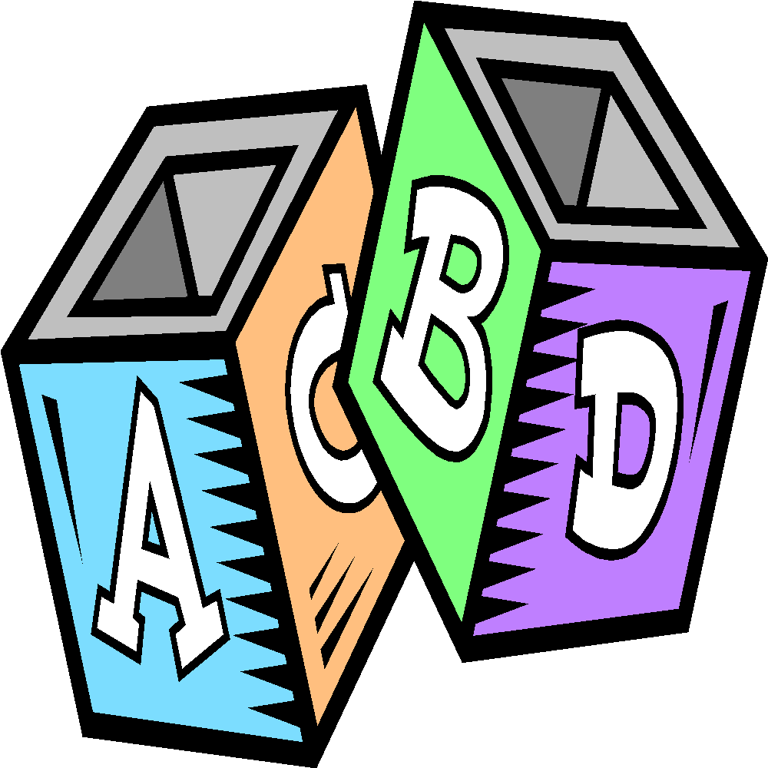
Level B (Grades 5&6)
- Follow Level A guidelines, using Level B manual.
Level C (Grades 7-9)
- Complete at least 3 activities in the manual, each from a different chapter. Within the 3-year period for this level, you should have completed 9 activities, at least one activity per chapter.
- Exhibit ONE of the following: A poster, OR a binder notebook OR a display no larger than 36” x 36” x 36” based on ONE of the activities you completed in your manual OR ONE that promotes physical, emotional or cognitive skills. If you create a display, complete an Activity Card & attach it to your exhibit. Use a 5x8 index card or larger cardstock to create your card (sample on p. 40 of manual).
Level D (Grades 10-12)
- Follow Level C guidelines, using Level D manual.
MAX # STATE FAIR EXHIBITS (1 PER LEVEL) [4]

COLLECTIONS
Use 4-H Evaluation Survey
NOTE: Completed manual must be exhibited in your notebook for this project. The original manual is added to each year with supplemental pages created by the exhibitor as years in the project progress. This allows the judge to see how your project has grown over the years. If the project grows too large & it becomes necessary to leave some of the collection at home, you MUST exhibit photo(s) of those items in your notebook. Please note the page(s) in your notebook that include photo(s) of item(s) left at home (sticky note, etc.). You’re not expected to exhibit your complete collection each year; only items you deem necessary for your display should be exhibited, along with your notebook and manual.
Clover: Exhibit a minimum of 6 labeled items as described in the manual, along with a notebook. The notebook should include: labeled items, dates, names, pictures, etc. Detailed information is helpful to the judge. If a 4-H'er is in the Clover Division for more than 1 year, at least 1 additional item must be added to the collection after the completion of the first year & until the 4-H’er enters the Junior Division.
Junior: Exhibit a minimum of 9 labeled items as described in the manual, along with a notebook as described in the Clover division. If a 4-H'er is in the Junior Division for more than 1 year, at least 1 additional item must be added to the collection after the completion of the first year in the Junior Division & until the 4-H'er enters the Senior Division.
Senior: Exhibit a minimum of 12 labeled items as described in the manual, along with a notebook as described in the Clover division. Also include in your notebook an essay about where & how your collection was started & other facts about your collection. If a 4-H'er is in this division more than 1 year, at least 1 additional item must be added to the collection after the completion of the first year in the Senior Division. Notebooks must be updated each year.
COUNTY PROJECT ONLY
COMPUTER
Use 4-H Evaluation Survey
NOTE: See 4-H General Rule #20.
Follow General Poster Guidelines.
Exhibits are to be skill-appropriate for the member’s grade level and will be judged by Clover, Junior, & Senior divisions. Youth will select one of the below subject categories to study, regardless of grade and may choose to create an exhibit demonstrating skills learned. Exhibits are to be submitted on a thumb drive securely attached to a notebook/portfolio describing accomplishments, skills learned, design ideas, budget, a summary of what was done, screenshots showing the development of the final project, etc. as the exhibitor will not be able to discuss their work with a judge. Poster OR a freestanding display board no larger than 36” x 36” x 36” may be exhibited. Youth may continue in the same subject category in subsequent years expand on the previous year’s topic, or choose a new topic. Subject categories are:

- Block-Based Programming
- Text-Based Programming
- Web Design and Computer Entrepreneurship
- Computer Forensics
- Hardware and Networking Design/Install/Repair
- Graphic Design and Computer Art
Software submitted must be compatible on both PC and Mac platforms. If additional software other than Microsoft Office Suite is required to view the member’s work, that software must be provided by the member and comply with all manufacturer copyright laws. Apps can be Android or IOS compatible. All notebooks/portfolios must include a reference list indicating where information was obtained, giving credit to the original author, to complete the 4-H member’s exhibit. This reference list should/might include web site links, people and professionals interviewed, books, magazines, etc. It is recommended this reference list be the last page of a notebook or included as part of the display visible to the public. A judge is not to discredit an exhibit for the manner in which references are listed.

Blocked-Based Programming
Clover: Create a block-based program using Scratch, Code Studio, Alice, or another graphic programming language of your choice. You should comment your work and it must include at least ten different commands. Skills this program could use are:
- Sequence
- Iteration
- Conditionals
- Variables
- Loops
- User input
- Any other similar skill
Junior: Create a block-based program using Scratch, Code Studio, Alice, or another graphic programming language of your choice. You should comment your work and it must include at least ten different commands. Skills this program could use are:
- More robust demonstration of Clover listed skills
- Modularization
- Lists
- Any other similar skill
Senior: Create a block-based program using Scratch, Code Studio, Alice, or another graphic programming language of your choice. You should comment your work and it must include at least ten different commands. Skills this program could use are:
- More robust demonstration of Jr. listed skills
- Parameters
- Recursion
- Any other similar skill

Text-Based Programming
Clover: This option is not available at this level.
Junior: Create a text-based program of your choosing using any text-based language you are comfortable in. The code should demonstrate an understanding of at least 4 of these skills:
- Commenting
- Correct syntax
- Variables
- Loops
- Conditionals
- User Input
- Lists
- Functions
- Algorithms
- Any other similar skill

Senior: Create a text-based program of your choosing using any text-based language you are comfortable in. The code should demonstrate an understanding of at least 8 of these skills:
- A more robust understanding of Junior listed skills
- Interact with databases
- Classes
- Objects
- Methods
- Inheritance
- Integrate multiple languages into one program
- Any other similar skill
Web Design and Computer Entrepreneurship
Clover: Build a businesslike website demonstrating knowledge of:
- Use a website builder to create your website
- Insert non-stock image into your site
- Use a template to achieve a unified look
- Explain CSS- what CSS is and why it’s important
- Must have at least 2 pages
- Must include all items listed above
Junior: Build a businesslike website demonstrating knowledge of:
- Create your own site or use a website builder
- Modify existing HTML
- Use HTML5
- Modify existing CSS
- Have a unified theme throughout
- Use photo editing software to create custom images
- Must have at least 5 pages
- Must include all items listed above
Senior: Build a businesslike website demonstrating knowledge of:
- Create a custom site using appropriate industry tools
- Have a responsive website
- Add useful and appropriate plugins
- Test for and eliminate bugs
- Include links for social media
- Include custom audio/video
- Must have at least 10 pages
- Must include all items listed above
Computer Forensics (id theft, online bullying, ethical use of technology, responsible social media use)
Clover: Research and create a 3-5 minute presentation on one of the following topics. Present to a group of peers and have an adult leader verify this presentation. Create a YouTube or MP4 instructional video or printed slides and notes using PowerPoint or similar presentation software.
- Media Balance and Well Being
- Privacy and Security
- Digital Footprint and Identity
- Relationships and Communication
- Cyberbullying, Digital Drama and Hate Speech
- News and Media Literacy
- Any other similar topic
Junior: Research and create a 6-8 minute presentation on one of the following topics. Present to a group of peers and have an adult leader verify this presentation. Create a YouTube or MP4 instructional video or printed slides and notes using PowerPoint or similar presentation software.
- Digital Citizenship:
  - Media Balance and Well Being
  - Privacy and Security
  - Digital Footprint and Identity
  - Relationships and Communication
  - Cyberbullying, Digital Drama & Hate Speech
  - News and Media Literacy

- Cyber Security:
  - Ethics and Society
  - Security Principles
  - Classic Cryptography
  - Malicious Software
  - Physical Security
  - Web Security
- Any other similar topic
Senior: Research and create a 10-12 minute presentation on one of the topics listed in the Jr. division of this project. Present to a group of peers and have an adult leader verify this presentation. Create a YouTube or MP4 instructional video or printed slides and notes using PowerPoint or similar presentation software.

Hardware and Networking Design/Install/Repair
Clover: Choose 1-2 items from the list below and create a report/presentation (including images) of what you did.
- Deconstruct and reconstruct a computer
- Learn and report how binary works and how computers use numbers
- Troubleshoot hardware problems
- Explore operating systems
- Investigate open source resources
- Install/upgrade operating systems
- Design a dream machine (give reasons)
- Any other similar design/install/repair
Junior: Choose 1-2 items from the list below and create a report/presentation (including images) of what you did.
- Identify network hardware
- Design a computer network
- Explain Internet Protocol
- Explain different types of servers
- Use different protocols to communicate
- Add peripherals to a network
- Secure a networked computer
- Share applications simultaneously
- Setup a Raspberry Pi or other micro-controller
- Any other similar design/install/repair
Senior: Choose 1-2 items from the list below and create a report/presentation (including images) of what you did.
- Design and implement a computer network
- Secure your network
- Understand technology needs in your community.
- Help to solve these needs by organizing a committee or team to work on identified issues.
- Teach a computer science class to younger 4-H’ers
- Build your dream computer
- Network multiple micro-controllers
- Research careers in technology
- Any other similar design/install/repair

Graphic Design and Computer Art
Clover, Junior & Senior: Use a software program to create or design an item that requires graphic design or artistry. The name and version of the software is to be included with the exhibit. Choose one of the following exhibit topics:
- Logo design
- T-shirt or apparel screen printing design
- Promotional brochure
- Marketing materials
- Computer generated art
Computer altered photos/images- Photos taken/altered by the member using a computer are to be entered in the Photography project as creative/experimental. Youth must obtain permission from the owner of the photo/image before altering someone else’s photo/image. Include copy of that permission with the exhibit to ensure there is no copyright violation.
MAX # STATE FAIR EXHIBITS (1 PER LEVEL) [3]
CONSTRUCTION TOYS
Use 4-H Evaluation Survey
NOTE: All entries are judged Sunday, July 18, 2:00-4:00 PM in the Community Center. This project allows 4-H members to create with Legos, K-Nex, Construx, Erector, Duplo blocks, craft sticks, etc.

Requirements for All Divisions
- Exhibit may be any design & must rest on a sturdy base.
- Exhibits are judged by Clover, Junior & Senior divisions.
- The 4-H member must:
- Transport and set up his/her own exhibit to/from judging and to/from the designated display area.
- Construct a different project each year.
5. Exhibits judged on: creativity; construction techniques; soundness/sturdiness; balance; and overall design.
COUNTY PROJECT ONLY

CONSUMER CLOTHING
Use 4-H Evaluation Survey
NOTE: All entries are judged Sunday, July 18, 2:00-4:00 PM in the Community Center. Bring completed notebook & wear garment(s) for judging. Judging is based on the completeness of the outfit, how you accessorized, & how the outfit fits. Exhibitors may participate in the Fashion Revue, in which only the outfit is judged. In your notebook, include a photo of you wearing your garment(s). Complete different activities each year in your manual. See 4-H General Rule #20. For personal safety concerns, notebooks should only contain name, county, grade, level, club & no personally identifiable information such as mailing address or phone number. Modeling Guidelines: Tell the judge about your outfit, what you learned, & about the activities you completed in the manual.
Clover: Complete one activity from each group in the manual. Write your answers in a notebook. Label each activity. Help purchase 1 item of clothing & 1 accessory to go with your clothing purchase.
Junior: Complete one activity from each group in the manual. Write your answers in a notebook. Label each activity. Purchase a casual or school outfit & accessorize it with new accessories or accessories you already own.
Senior: Complete one activity from each group in the manual. Write your answers in a notebook. Label each activity. If the member has completed all activities in the manual in prior years, the member is to consult with the 4-H Youth Educator to create an activity. When assembling the exhibit notebook, be sure to include a note to the judge explaining how the activity was determined and its intended objectives. Choose an outfit & accessorize it. You may purchase the outfit & accessories or use items you already own. Purchasing an outfit is encouraged but not required. Model your outfit before a group. Tell them about your activities in the project this year and how you plan to use this year’s purchases in your future wardrobe.
MAX # STATE FAIR EXHIBITS [3]
(1 NOTEBOOK PER LEVEL)

CORN PRODUCTION
Use 4-H Evaluation Survey
NOTE: Any cornstalks exhibited must have roots attached & be free from soil. The exhibit tag is to be securely tied to the stalk at primary ear height by the exhibitor.
Clover: Exhibit one stalk of corn with roots washed clean.
Junior: Exhibit one stalk of insect damaged corn with roots washed clean. Label with 3”x5” card at each site of insect damage.
Senior: Exhibit one stalk of diseased corn with roots washed clean. Label with a 3”x5” at all disease damage sites and nutrient deficiencies. Exhibit must include the Crops Record Sheet displayed in a clear report cover.
COUNTY PROJECT ONLY

CORN SCIENCE
Use 4-H Evaluation Survey
NOTE: Follow General Poster Rules. See 4-H General Rule #20.
Clover: Exhibit a poster based on an activity in the Beginner Corn Manual. On your exhibit tag, write the number of the activity on which you based your exhibit.
Junior: Exhibit a poster based on an activity in the Intermediate Corn Manual. On your exhibit tag, write the number of the activity on which you based your exhibit.
Senior: Exhibit a poster based on an activity in the Advanced Corn Manual. On your exhibit tag, write the number of the activity on which you based your exhibit.
COUNTY PROJECT ONLY

CREATE WITH A MIX
Project Superintendent - Mary Korff (812-673-4607)
Use 4-H Evaluation Survey
NOTE: Entries are judged Sunday, July 18, 2:00-4:00 PM in the Community Center. See Food Safety Rule in the 4-H General Rules section. Exhibits must be entered in disposable containers, as containers will not be returned. Label exhibit with the exhibitor’s name, name of product & serving size. Since it is illegal in Indiana for youth under 21 to purchase or consume alcoholic beverages, 4-H’ers must use recipes that do not include alcoholic beverages as an ingredient. An imitation product may be substituted.

Requirements for All Divisions
Exhibit a non-perishable item. Create your food item from a packaged, store-bought mix, using at least 2 other ingredients not already required to make the store-bought mix. On an 8 ½” x 11” sheet of paper exhibited in page protector, display the box or bag mix label showing the original preparation of the food & the new recipe you created. You may use both sides of the paper. Highlight the 2 ingredients you added. Your recipe may be invented or one you’ve taken from a cookbook & tried to recreate using a mix as the starting base. Grade level requirements are as follows:
Grade 3: 6 Brownies
Grade 4: 6 Cookie bars (A cookie recipe baked in
a cake pan & cut into bars.)
Grade 5: 6 Dropped or pressed cookies
Grade 6: 6 Muffins (No liners!)
Grade 7: 6 Biscuits
Grade 8: A loaf of quick bread (Ex.: Fruit bread)
Grade 9: A loaf of yeast bread
Grade 10: 6 Yeast rolls (Any form, not a sweet roll)
Grade 11: Sweet bread using yeast (Any form; Examples are 6 Sweet rolls, tea ring, dessert pizza, etc.)
Grade 12: Cake of any kind
COUNTY PROJECT ONLY

CREATIVE WRITING: PROSE & POETRY
Use 4-H Evaluation Survey
NOTE: Exhibits may be handwritten or typed & MUST be submitted in a 9x12 folder. Label the front of your folder with your name in the bottom right corner.
Poetry-Clover: Exhibit a poem of at least 3 stanzas.
Poetry-Junior: Exhibit a collection of 3 or more poems. Each poem must contain from 3 to 5 stanzas.
Poetry-Senior: Exhibit a collection of 5 or more poems. Each poem must contain at least 5 stanzas.
Prose-Clover: Exhibit a short story or essay that is at least one page in length.
Prose-Junior: Exhibit a short story or essay that is at least two pages in length.
Prose-Senior: Exhibit a short story or an essay that is at least three pages in length.
COUNTY PROJECT ONLY

CUPCAKE DECORATING
Use 4-H Evaluation Survey
NOTE: Entries are judged Sunday, July 18, 2:00-4:00 PM in the Community Center. See Food Safety Rule in the 4-H General Rules section.

Requirements for All Divisions
Exhibits must be entered in disposable containers, as containers will not be returned. All exhibits will be photographed for display during Fair Week & then sold at the 4-H Food Auction on Monday night of the Fair. Exhibits must be presented for judging on a solid display board that measures 3-4” larger than the cupcake display. Icing must be used; artificial items & embellishments are optional. Edible items must be attached naturally; artificial items may be attached using glue, wire, etc.

Clover: Exhibit 6 individually decorated cupcakes in a single layer. Exhibit may not exceed 18”x18”x18”.
Junior: Exhibit 12-18 cupcakes, decorated in a theme. Cupcakes may be decorated individually or as a group, as long as the theme is carried out. Exhibit may not exceed 24”x24”x24”.
Senior: Exhibit 24-36 cupcakes, decorated in a theme. Cupcakes may be decorated individually or as a group, as long as the theme is carried out. Exhibit may not exceed 30”x30”x30”.
COUNTY PROJECT ONLY
ELECTRIC
Project Superintendent - Chris Mulkey (812-845-2565)
Use 4-H Evaluation Survey
NOTE: Follow General Poster Rules. See 4-H General Rule #20. Equipment wiring boards differ from display boards in that they show hands-on wiring techniques (i.e., complete wiring of a light controlled by a 3-way switch system). Equipment wiring boards may be a maximum of 3' x 3'. Boards should be designed so that they can be displayed horizontally. Demonstrate at least 5 skills as listed in the “4-H Electric & Electronic Skills & Knowledge Chart.” A completed copy of the “Electric Exhibit Skills & Knowledge Sheet” must accompany the exhibit.

Division I/Grade3: Exhibit ONE of the following:
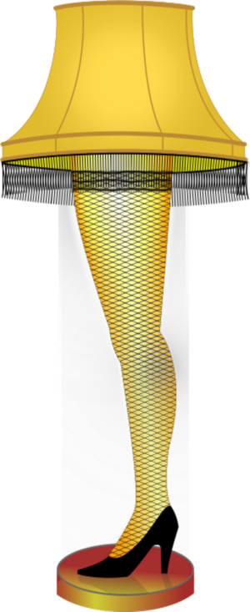
- A Circuit Board, 6” x 6”, Parallel Circuit
- Electromagnet
- Galvanometer
- Poster
- Display (appropriately sized for displayed equipment)
- Notebook/Report that covers any topic in the National 4-H Electric Curriculum Electricity Excitement Book 1 or Investigating Electricity Book 2, Purdue Extension website Level 1 activities/project sheets, or from the appropriate level of the Skills & Knowledge Chart.

Division II/Grade 4: Exhibit ONE of the following:
- Magnetic Powered Shake Flashlight with Display
- A Circuit Board, 6” x 6”, Series OR Parallel Circuit, with modifications if exhibited in Division I.
- Electromagnet
- Galvanometer
- Poster
- Display (appropriately sized for displayed equipment)
- Notebook/Report that covers any topic in the National 4-H Electric Curriculum Electricity Excitement Book 1 or Investigating Electricity Book 2, Purdue Extension website Level 2 activities/project sheets, or from the appropriate level of the Skills & Knowledge Chart.
Division III/Grade 5: Exhibit ONE of the following:
- Wiring Project- Extension Cord, Trouble Light, Wire Sizes & Uses, Plug Configurations, Test Equipment, Etc.
- Electrical Tool and Supply Kit
- Poster
- Display (appropriately sized for displayed equipment)
- Notebook/Report that covers any topic in the National 4-H Electric Curriculum Wired for Power Book 3, Purdue Extension website Level 3 activities/project sheets, or from the appropriate level of the Skills & Knowledge Chart.
Division IV/Grade 6: Exhibit ONE of the following:
- Wiring - Wire a lamp. The lamp can be a re-wired lamp or one that is built new.
- Electrical tool and supply kit
- Poster
- Display (appropriately sized for displayed equipment)
- Notebook/Report that covers any topic that is in the National 4-H Electric Curriculum Wired for Power Book 3, Purdue Extension website Level 4 activities/project sheets, or from the appropriate level of the Skills & Knowledge Chart.
Divisions V/Grades 7-12: Do EITHER an Electric Power OR Electronics Project & Exhibit ONE of the following:
- Equipment Wiring- Including but not limited to parts identification, appliance repair, lamps and other lighting, equipment wiring, control system, security system, topic that covers safety, motors/generators, electric heating, heat pumps, AC, water heaters, and other electric equipment.
- Home Wiring- Included but not limited to any circuits found in the wiring of a house or “barn,” service entrance, switching, receptacles, generator transfer circuit, safety, electrical math, and others.
- Electronic Equipment- Any project or kit containing transistors or integrated circuits or vacuum tubes such as radio, TV, computer, robot, cell phone, and others.
- Poster
- Display (appropriately sized for displayed equipment)
- Notebook/Report that covers any topic that is in the National 4-H Electric Curriculum Entering Electronics, Purdue Extension website Level 5 activities/project sheets, or from the appropriate level of the Skills & Knowledge Chart.
- Video Presentation- Create a video showing the work accomplished and skills learned. This video should include the same type of information as required in written notebook listed above. This video is to be no more than ten minutes in length and formatted as MP4 and submitted on a thumb drive. This video can also be uploaded to a YouTube account with the video being made public and the link submitted for evaluation.
MAX # STATE FAIR EXHIBITS [6]
(1) PER DIV. I-IV & (2) FROM DIV. V

ENTOMOLOGY
Use 4-H Evaluation Survey. See 4-H General Rule #20.
NOTE: Exhibit an insect collection OR a poster. Posters must follow General Poster Requirements & use the topic selected for your exhibit title. Youth must collect, mount & identify insects themselves (collected in the U.S. ONLY). Display specimens in 18” x 24” glass or Plexiglas covered box(es) orientated horizontally & labeled in the lower right hand corner (name, grade, county). When multiple boxes are used, list the box order (i.e. "box 1 of 3 boxes") and include your name, grade & county on each box. Cards A-F (for grades 3-8) & ID 401-I cards (for grades 9-12) are to be placed inside the display box in an attractive manner. All insects must be in the adult stage & be properly mounted on insect pins or be contained in vials as directed. Reference ID 401 &/or 4-H 764.

Pin Labels: Each pin or vial must contain 2 labels:
1) Top label is to include collection date, location, and collector name.
2) Bottom label is to include common name and other optional identification data.

Box Labels: Box labels (computer generated or neatly printed) are used for orders and families as required (see chart below) and are to be placed flat against the bottom of the box. Insects must be properly grouped directly under the correct order and family box label. For example, all insects belonging to a particular order must be placed under that order label. Orders to be used are listed in ID 401. If family level identification is required, the insects should be further grouped together under that family label.

One additional box (educational), based on the specific theme (see below), is required for grades 9-12, in addition to the insect collection boxes. This box can be created in any manner chosen (without the mounting, pinning or identifying restrictions specified above).

Level 1: Grade 3: Exhibit ONE of the following:
- Insect collection of 10 insects identified & pinned on cards. Only 1 collection box allowed. Include ID 401A.
- Poster according to Level 1 poster guidelines (below).
Level 1: Grade 4: Exhibit ONE of the following:
- Insect collection of 20 insects mounted (pins or vials) & identified. Only 1 collection box allowed. Identify all insects by common name. Identify 5 to order. Include ID 401B.
- Poster according to Level 1 poster guidelines (below).
Level 1: Grade 5: Exhibit ONE of the following:
- Insect collection of 30 insects mounted (pins or vials) & identified. Only 1 collection box allowed. Identify all insects by common name & identify 15 to order. Include ID 401C.
- Poster according to Level 1 poster guidelines (below).
Level 2: Grade 6: Exhibit ONE of the following:
- Insect collection of 40 insects mounted (pins or vials) & identified. Exhibit 6 orders minimum. 2 box maximum allowed. Identify all insects by common name & order. Include ID 401D.
- Poster according to Level 2 poster guidelines (below).
Level 2: Grade 7: Exhibit ONE of the following:
- Insect collection of 50 insects mounted (pins or vials) & identified. Exhibit 8 orders minimum. 2 box maximum allowed. Identify all insects by common name & order. Identify 10 to family. Include ID 401E.
- Poster according to Level 2 poster guidelines (below).
Level 2: Grade 8: Exhibit ONE of the following:
- Insect collection of 60 insects mounted (pins or vials) & identified. Exhibit 10 orders minimum. 2 box maximum allowed. Identify all insects by common name & order. Identify 30 to family. Include ID 401F.
- Poster according to Level 2 poster guidelines (below).
Level 3: Grade 9: Exhibit ONE of the following:
- Insect collection of 70 insects mounted (pins or vials) & identified. Exhibit 12 orders minimum. Identify all insects by common name, order & family. Maximum number of boxes is 3, not counting the 1 educational box that must be exhibited as well. Educational box theme- insect behavior. Include card ID 401I. Place 401I in first collection box only.
- Poster according to Level 3 poster guidelines (below).
Level 3: Grade 10: Exhibit ONE of the following:
- Insect collection of 80 insects mounted (pins or vials) & identified. Exhibit 14 orders minimum. Identify all insects by common name, order & family. Maximum number of boxes is 3, not counting the 1 educational box that must be exhibited as well. Educational box theme- insect pest management. Include card ID 401I. Place 401I in first collection box only.
- Poster according to Level 3 poster guidelines (below).
Level 3: Grade 11: Exhibit ONE of the following:
- Insect collection of 90 insects mounted (pins or vials) & identified. Exhibit 16 orders minimum. Identify all insects by common name, order & family. Maximum number of boxes is 3, not counting the 1 educational box that must be exhibited as well. Educational box theme- insects & the environment. Include card ID 401I. Place 401I in first collection box only.
- Poster according to Level 3 poster guidelines (below).
Level 3: Grade 12: Exhibit ONE of the following:
- Insect collection of 100 insects mounted (pins or vials) & identified. Exhibit 18 orders minimum. Identify all insects by common name, order & family. Max. number of boxes is 3, not counting the 1 educational box that also must be exhibited. Educational box theme- benefits of insects. Include card ID 401I. Place 401I in first collection box only.
- Poster according to Level 3 poster guidelines (below).
Level 1 Entomology Poster Guidelines
Display a poster based on ONE of the following activities:
- Big Mouth Bugs - Show the 4 different mouth types you studied. Create a chart listing the 4 mouth types, an insect with this mouth type, food they eat & where these insects might be found.
- Pit Stop - Make 2 pit traps. Use them to collect insects. Exhibit completed record sheet. Use the format given for your data collection or make your own. Include some of the insects or pictures of your trap & insects collected.
- Buz-z-zing Around - Present 3-5 ways that insects communicate. Include an insect or picture of each insect that communicates in each of the ways you describe.
- FACETnating! - Show how insects see (compound eyes) & explain how they see colors.
- Ants & Uncles - Compare insects with their non-insect relatives by completing the chart in your book (copy or make your own). Include some of the insects & their non-insect relatives or pictures of them on your poster.
- Chirp, Chirp - Watch for & listen to crickets for 5 minutes, 3 times a day, for 3 days. Include day & night observations. Record what you see & hear.

Level 2 Entomology Poster Guidelines
Display a poster based on 1 of the following activities:
- Collecting Insects - Make/use 2 of the traps described in Activities 2-5 to collect insects. Exhibit a photo of your traps & an Insect Collection Data Chart that gives the trap location (ex.: basement or backyard), date collected, & insects collected.
- Spread Your Wings and Fly - Make/use a spreading board. Exhibit 2 photos of your board & 3 butterflies or moths that you prepared using your board.
- Insect Experiments - Complete 1 of the following activities: 8, 9, or 10. Exhibit your data sheet & answers to the "Talk it Over" questions. For activities 8 & 9 include your hypothesis & a conclusive statement about your hypothesis (indicate if it was proved or disproved).
- Invasive Species Investigations - Create an exhibit about 1 (Indiana) invasive insect. Include answers to the first 8 of 13 questions on page 29 of the manual.
- A Sticky Situation - Make/use sticky traps for 4 weeks as described in Activity 13. Exhibit your data sheet & answers to the "Talk it Over" questions.
- Footprint Clues - Study the tracks of 3 different species of insect & 1 arthropod as described in Activity 14. Exhibit your data sheet & answers to the "Talk it Over" questions.
Level 3 Entomology Poster Guidelines
Display a poster based on one of the following activities:
- The Scientific Method - Use the scientific method to complete one of the problems in Activity 3. Describe what you did to complete the 5 scientific method steps. Include data & drawings or photos of your experiment.
- Transecting for Insects - Compare 3 habitats using the scientific method to determine which has the most terrestrial insect activity. Display the transect data sheet for each habitat & answer the "Talk it Over" questions.
- Please Drop In - Create your own hypothesis & collect insects in 5 pitfall traps to prove or disprove your hypothesis, as described in Activity 7. Display how you completed your experiment (including each step in the scientific method) & your data for each habitat.
- Aliens Among Us - Complete the "Natives vs. Non-natives Survey Data Sheet" by checking 2 boxes (Native or non-native & damage or no damage) for 5 native & 5 non-native insects as shown in Activity 9. Answer the "Talk it Over" questions.
- IMP - Learning and Teaching - Make an informational flier & use it to teach younger 4-H members about 5 insect pests that might be found in a home or school in your county. Exhibit your flier, lesson plan & a photo of you teaching. Answer the "Talk it Over" questions.
- Meal from a Worm - Use the scientific method to study how mealworm larvae grow. Include your hypothesis, data charts & conclusions. Answer the "Talk it Over" questions.
MAX # STATE FAIR EXHIBITS [6]
1 POSTER (3) & 1 COLLECTION (3) PER LEVEL

FAMILY CAMPING
Use 4-H Evaluation Survey
NOTE: Follow General Poster Guidelines. Choose a different exhibit option each year. See 4-H General Rule #20.
Clover: Exhibit a poster on ONE of the following:
- Show & explain 8 pictures taken during a family camping outing. Explain each picture.
- Show how to tie 3 different knots. Explain when or where each knot should be used.
- Show & explain an aspect of camping safety (i.e., first-aid, boating, swimming, etc.).
- Show 3 types of campfires & list 5 fire safety tips.
Junior: Exhibit a poster on ONE of the following:
- Show 3 campgrounds in the area. Show facilities available in the chosen campgrounds.
- Show different kinds of camping (i.e., tents, trailers, etc.). Elaborate on amount of investment.
- Show items for a first-aid kit for camping. Include a list of items and state reasons for your choice of items.
- Show at least 3 poisonous plants. List identification of plants & first-aid remedies for each.
Senior: Exhibit a poster on ONE of the following:
- Show 8 specific wildlife animals (i.e., frogs, snakes, raccoons, etc.) found near campsites. Include their habitat, what they eat, & where you might see them (i.e., in a tree, near camping area, etc.).
- Plan & exhibit a menu for 3-day outing.
- Plan & exhibit a menu for a 3-day outing using Aluminum Foil Cookery to create the main dishes.
- Plan a camping trip. Include a map showing the easiest route, type of campground, & activities available.
- Show 6 wild, edible plants. Include a recipe using at least 1 of the wild plants.
- Make a display of 3 outings you took during the year using pictures, maps, brochures, menus, etc.
COUNTY PROJECT ONLY

FARM SCENE
Project Superintendent - Dave Morlock (812-618-7089)
Use 4-H Evaluation Survey
NOTE: This project provides the opportunity to make realistic toy dioramas from custom-built or manufactured farm toys. The same scale must be used throughout the exhibit. 1/64, 1/32 or 1/16 scale toys may be used. Bases must be rigid. Plywood bases are recommended. Backdrops are optional. Create a different exhibit each year or add new pieces/features to one you created in a previous year. Attach to your exhibit 4-H 618A-W to explain your exhibit & the work you completed on it.
Level A (Grades 3&4): Exhibit is limited to field tilling, including plows, discs, or planting equipment. Roads, trees & fencing may be used. Base size may not exceed 24”x24.”
Level B (Grades 5&6): Exhibit is to concentrate on fieldwork such as tilling or crop harvesting. Animals may be incorporated into the scene, along with fence lines, roads, streams, trees & railroads. Base size may not exceed 24”x36.”
Level C (Grades 7-9): Exhibit is open to any type of farmstead, including buildings, livestock, animals, fieldwork, &/or harvesting. Base size may not exceed 36”x36.”
Level D (Grades 10-12): Exhibit an agricultural display of items other than farmsteads or farm tillage. Examples: livestock auctions, farm auctions, implement dealerships, agricultural educational events, agricultural field events, etc. Base size may not exceed 48”x48” & the exhibitor must furnish a card table of similar size to display the exhibit at the county level.
COUNTY PROJECT ONLY

FLORICULTURE
Project Superintendent - Amanda Bender
(812-457-5871)
Use 4-H Evaluation Survey
NOTE: All Entries are judged Sunday, July 18, 2:00-4:00 PM in the Community Center. Exhibit a plant/arrangement, OR a poster, OR a notebook. Choose a different exhibit option each year. Manual should accompany the exhibitor to judging. See 4-H General Rule #20.

Notebook Guidelines (All Levels)
- Use a sturdy 3-ring binder (with stiff covers) or a bound type notebook (with stiff covers). Pictures, graphics, & artwork are encouraged.
- Notebooks must meet guidelines & objectives as listed in the manual. Information printed directly off the Internet won’t be accepted. Include references where appropriate.

Poster Guidelines (All Levels)
- Follow General Poster Requirements.
- Posters should "tell a story" or be informative to the audience. Will the viewer of your poster learn something from your exhibit?
- When designing your poster, consider: lines, shapes, textures, colors & placement of items. Pictures, graphics & artwork are encouraged.
- Make sure the poster accurately meets the guidelines & objectives of the activities in the manual. Information printed directly off the Internet will not be accepted.

Level A (Grades 3 & 4): Exhibit ONE of the following:
Plant exhibit options-
- Create a flower arrangement in a simple bud vase from cut flowers you grew. Include 1-3 stems of a main flower, filler flower & greenery. Provide your own vase. Vases must be clear or white only & may be no more than 9” tall by 3” wide. The neck opening of vase cannot exceed 1.5”.
- Create a flower arrangement in a simple bud vase from fresh flowers you purchased. Include 1-3 stems of a main flower, filler flower & greenery. Provide your own vase. Vases must be clear or white only & may be no more than 9” tall by 3” wide. Neck opening cannot exceed 1.5”. Flowers should be in their natural state & not wired for display.
- Create a simple round arrangement (small, compact round cluster of flowers) with fresh flowers you grew. Including the vase, exhibit can be no larger than 12" x 12."
- Create a simple round arrangement (small, compact round cluster of flowers) with fresh flowers you purchased. Including the vase, exhibit can be no larger than 12" x 12."

Poster OR Notebook exhibit options-
- Chronicle your work in your flower garden (planning, planting, care, harvest, arrangements made with your flowers).
- Describe how you planned or designed your garden, including how you chose the kinds of flowers you chose.
- Explain how you harvested your flowers, cared for them, & used them in an arrangement.
- Explain 1 of the following: pollination - what it is, why important, different ways it occurs; transplanting - what, how, things to watch out for; the role of insects with flowers (good, bad or both); seed germination; how to care for a 'sick' plant.
- Report on an interview with a professional (what do they do, types of jobs, type of training, hours worked, etc.).
- Describe an experiment you did & the results you got.
- Describe a community service project you did related to your Floriculture project.
Level B (Grades 5 & 6): Exhibit ONE of the following:
Plant exhibit options-
- Display a mixed planter that may include herbs with foliage plants &/or flowering plants. The planter should include 3 or more kinds of plants & have been planted at least 2 months before the fair. The container exhibit space must not exceed 18” x 18” (height variable). Include 4-H 967c “Level B Plant Record” chronicling the care of your plant.
- Make an item with dried herbs or dried flowers that you grew yourself. Possible exhibits are, but are not limited to, dried flower products or a simple dried arrangement in a vase. Exhibit cannot exceed 18” x 18” (height variable).
- Display 1 house plant (foliage &/or flowering) in a container not to exceed 10” in diameter. There must be only 1 specimen plant per pot. A flowering plant may be of any color with single or double flowers. Include 4-H 967c “Level B Plant Record” chronicling the care of your plant.

Poster OR Notebook exhibit options-
- Report how you harvested your flowers &/or herbs, cared for them, dried them & used them.
- Explain 1 of the following:
- insects and your flowers and/or herbs
- starting seeds indoors - the process, pros and cons
- perennials - what are they, how are they used, benefits or drawbacks
- plant biology - form and function, growth, photosynthesis, etc.
- how to grow plants indoors - things to consider, common problems and solutions
- environmental effects related to plants (such as light, water, soil, or temperature)
- A topic from "Imagine That" - plants around the world, different cultural uses of plants, different ways you used your plants/herbs/flowers
- Investigate & describe a butterfly garden - types of plants, benefits to insects & butterflies, etc.
- Describe how you planned or designed your garden, including how you chose the kinds of plants, any problems &/or successes.
- Describe your houseplant - how you cared for it, transplanted to larger pot, any problems &/or successes
- Describe an experiment you did & the results you got.

Level C (Grades 7-9): Exhibit ONE of the following:
Plant exhibit options-
- Display a terrarium - Size of the terrarium should be no larger than 12" deep, 18" long and 16" high. Must have a cover while on exhibit. See activity information for design.
- Combination or European planter - Exhibit a container of plants (3 or more kinds of plants) that you have planted & cared for a minimum of 2 months. The container should not exceed exhibit space of 18" x 18" (height variable).
- Create 1 corsage or 2 boutonnieres made from only fresh flowers. Corsage should contain 3 or more blooms. NO artificial flowers or greenery should be used in this category. Bows & decorative items are allowed.
- Create 1 corsage or 2 boutonnieres made from silk or other artificial flowers & greenery. Can be created with mixed fresh & artificial materials, or all artificial. Bows & decorative items are allowed.
- Create a dried arrangement in a container or a specialty item (such as, but not limited to, a wreath or swag) made with dried flowers & dried plant materials. NO artificial flowers or plant materials. Bows & decorative items are allowed. Maximum size 24" x 24" (height variable).
- Create a flower arrangement using either roses or lilies as the primary component of the arrangement. Arrangement should be made with all fresh materials. NO artificial flowers or plant materials. Bows & decorative items are allowed. Exhibit must exceed 18" x 18" (height variable).

Poster OR Notebook exhibit options-
- Explain 1 of the following:
  - How you planned, chose plants, cared for, transplanted to larger pot, etc. your combination planter or terrarium
  - Vegetative propagation - how to, different types, problems and solutions, different uses of, etc.
  - Plant nutrients - what are they, why plants need them, what happens if plants have too much or too little, planters or containers vs. garden
  - The design of multiple plant containers - how to, things to consider, selecting plant materials, uses of
  - How you created your corsage or boutonnieres or dried arrangement. Be sure to include appropriate information on design principles & how they were used to create your arrangement.
  - Floral tools and materials (how to use, what they are, care of tools, different uses of tool or material).
  - Preserving cut flowers - how to, problems with, uses of &/or diseases related to cut flowers.
  - Show how you dry flowers or other plant materials &/or describe different methods &/or how, why you use them.
  - Medicinal uses & toxicity of fresh & dried flowers & plants.
- Describe an experiment you did & the results you got.
- Describe a career exploration activity you did, such as job shadowing or an interview with a professional.
- Describe a community service activity you did related to your Flowers project - what you did, why, results, etc.

Level D (Grades 10-12): Exhibit ONE of the following:
Plant exhibit options-
- Create a seasonal arrangement from only fresh flower &/or plant materials. Flowers & plant materials specific to a season or holiday should be used. For example, fall mums or spring tulips. Maximum size 24"x24"x36". Bows & decorative accessories are allowed.
- Create a seasonal arrangement that may include fresh &/or artificial flower/plant materials. Flowers & plant materials specific to a season or holiday should be used. Bows & decorative accessories are allowed. Can include wreaths, as well as traditional arrangements. Maximum size 24"x24"x36".
- Create a modern or contemporary style arrangement using fresh flower & plant materials. See manual for suggestions. Maximum size 24"x24"x36". Include a label that states what type of design you have created (botanical, pavè, parallel, free-form, abstract, etc.)
- Create a bridal bouquet. Proper display of the bouquet should be considered, but only the bouquet will be judged. Bouquet should include ONLY fresh plant materials. Bows & decorative accessories are allowed.
- Create a centerpiece for an event, such as a banquet, party, wedding, or funeral. Arrangement may be no larger than 24"x24"x36". May be made from EITHER fresh flower &/or plant materials OR artificial or silk flower &/or plant materials. Bows/decorative accessories are allowed.
- Display a plant that you propagated by tissue culture or other vegetative propagation methods, or flowering bulbs that you forced. Maximum pot size should not exceed 10" diameter. Must include 4-H 969c “Level D Plant Record” chronicling the care of your plant.

Poster OR Notebook exhibit options-
- Explain 1 of the following:
  - how you utilize different flowers to make a similar style arrangement for different seasons or how to utilize similar flowers to make different styles of arrangements.
  - the cost of arrangement &/or a cost comparison with flowers (different types flowers, different time year, etc.).
  - forcing flowers (bulbs, branches, etc.).
  - marketing in the floral industry (large or small business) &/ or a market survey and results, and how they can benefit the floral industry.
  - how to start a business related to the floral industry. You may include a business plan.
  - the origins of flowers &/or the floriculture industry around the world.
  - tissue culture, biotechnology, or traditional breeding of new flower types - what are they, how are they used, pros and cons.
  - be a plant detective - what kinds of problems might you have in growing & caring for flowers & how to solve them.
- Describe how you created your arrangement. Include information on the design principles you utilized.
- Describe an experiment you did & the results you got.
- Describe a community service activity you did related to your Flowers project: what you did, why, results, etc.
MAX # STATE FAIR EXHIBITS [26]
1 PLANT EXHIBIT PER CATEGORY PER LEVEL,
1 POSTER/NOTEBOOK EXHIBIT PER LEVEL
& 1 PROJECT INTERACT PER LEVEL
LEVEL A (5), LEVEL B (5), LEVEL C (8), LEVEL D (8)

FOOD PRESERVATION
Use Record Sheet in Manual
NOTE: All Entries are judged Sunday, July 18, 2:00-4:00 PM in the Community Center & sent home with the exhibitor following judging. Recipe card (5.5”x8.5”) is required for judging. Any ingredient that could be a potential allergen must be clearly identified. Label exhibit with name of product, quantity, date frozen & defrosting/cooking instructions. All exhibits must be made from scratch- no mixes! See Food Safety Rule in 4-H General Rules. Jarden Home Brands awards presented as available. Since it is illegal in Indiana for youth under 21 to purchase or consume alcoholic beverages, 4-H’ers must use recipes that do not include alcoholic beverages as an ingredient. An imitation product may be substituted. All canned exhibits must have the ring on the top of the jar to protect the seal.

Level A (Grades 3&4)
- Grade 3 - A package of 3 baked, snack-sized (approx. 2”-3” in size) frozen cookies. Label as outlined above.
- Grade 4 - A package of frozen berries. Label as outlined above.
Level B (Grades 5&6)
- Grade 5 - A frozen uncooked mini pizza using whole-grain pita bread, English muffin, bagel, or already prepared crust no larger than 7” in diameter with toppings of your choice. Include at least 4 MyPlate food groups on the pizza. Meat toppings must be cooked. Display on covered cardboard inside a freezer bag. Label as outlined above.
- Grade 6 - A package of any frozen vegetable or combination vegetables. Label as outlined above.
Level C (Grades 7-9)
Exhibit 1 preserved product from this list each year:
- A container of freezer jam. Label as outlined above.
- A jar of a canned tomato product using the Hot Pack Method for a boiling water bath canner. Label as outlined as above. Note: Only food preservation products made using USDA approved or Ball Blue Book recipes are acceptable.
- A jar of a canned pickled product or canned pickles. Include processing, and storage instructions. Products using a fancy pack are not accepted. Label as outlined above. Note: Only food preservation products made using USDA approved or Ball Blue Book recipes are acceptable.
Level D (Grades 10-12)
Exhibit 1 preserved product from this list each year:
- A jar of pressure canned vegetables, meat or combination product, such as soup, stew, spaghetti sauce with meat, etc. Products using a fancy pack are not accepted. Label as outlined above. Note: Only food preservation products made using USDA approved or Ball Blue Book recipes are acceptable.
- A package of a frozen entrée that contains 3 food groups from MyPlate. Label as outlined above.
- A jar of cooked jam or a reduced-sugar fruit spread. Label as outlined above.
MAX # STATE FAIR EXHIBITS (1 PER GRADE) [10]

FOODS
Use Record Sheet in Manual
NOTE: All Entries are judged Sunday, July 18, 2:00-4:00 PM in the Community Center. Recipe card (5.5”x8.5”) required for judging. See Food Safety Rule in 4-H General Rules. Any ingredient that could be a potential allergen must be clearly identified. Exhibits must be entered in disposable containers, as containers won’t be returned. Label exhibit with name of product, date, quantity & serving size. All exhibits must be made from scratch- no mixes! Jarden Home Brands awards presented as available. Since it is illegal in Indiana for youth under 21 to purchase or consume alcoholic beverages, 4-H’ers must use recipes that do not include an alcoholic beverage as an ingredient. An imitation product may be substituted.

Level A (Grades 3&4)
- Grade 3 - 3 snack-sized drop, molded or bar baked cookies (approx. 2”-3” in size). No glaze or frosting.
- Grade 4 - 3 standard size muffins that contain an ingredient that is a source of Vitamin A or C. No muffin liners.
Level B (Grades 5&6)
- Grade 5 - A square, oblong or round layer reduced-fat cake without frosting. Reduce fat using a fruit puree or baby food fruit product that does not contain yogurt.
- Grade 6 - Using a 50% whole grain flour mixture, exhibit 3 no-yeast, any shape pretzels (shaped, stick or nugget) OR 3 no-yeast sweet or savory rolled biscuits. No drop biscuits.
Level C (Grades 7-9)
Exhibit ONE product from this list each year:
- 3 yeast bread sticks or yeast rolls (any shape, medium size - not a sweet roll), using a 50% whole grain flour mixture such as whole wheat, rye, oat bran, etc. Learn how to knead bread dough by hand and allow it to rise appropriately. Do not use a home bread maker.
- A yeast bread (can be loaf or braid but not rolls) using a 50% whole grain flour mixture. Learn how to knead bread dough by hand and allow it to rise appropriately. Do not use a home bread maker.
- A package of a non-perishable, invented healthy snack (such as a granola bar, popcorn snack, trail mix, etc.) that includes at least 2 MyPlate food groups. Include your snack package & a separate folder containing a marketing plan with product name, recipe, how it will be packaged, package design, where it will be sold & suggested selling price. Style your snack for a photo shoot. Include the picture in your marketing plan.
Level D (Grades 10-12)
Exhibit ONE of these products each year:
- A single or double crust baked fruit pie (no graham cracker crust). Note: Custards, cream, cream cheese frosting & fillings, & raw egg white frosting are not acceptable in an exhibit because they are highly perishable when left at room temperatures.
- A non-perishable baked food product for a catered meal or special event in which organizers have requested low fat &/or reduced sugar items. Include your food product & a separate notebook outlining how this product is to be used at the event, menu, supplies to buy, preparation schedule, equipment, table layout, etc. A table display is optional & should be no larger than 16" deep x 22" wide x 28" high.
- Select a condition in which people have to specifically modify their eating habits (diabetes, heart disease, Celiac disease, food allergies, etc.) & prepare a non-perishable baked food product appropriate for someone with this condition. Include your food product & a notebook summarizing the condition or allergy, nutrition considerations involved with the condition, a description of your baked item and an explanation of how it fits within the nutrition considerations. Note any ingredients that could cause an allergic reaction.
MAX # STATE FAIR EXHIBITS (1 PER GRADE) [10]

FORESTRY

Use 4-H Evaluation Survey
NOTE: Follow General Poster Requirements. Choose a topic listed below. Use that topic for your exhibit title. If you exhibit leaves, they must be free of any damage. If you choose to write the leaves’ scientific names, they must be either italicized or underscored. The Genus (first name) must have the first letter capitalized. The species (second name) has no capitalization. Scientific names are required for herbariums. Choose a different topic each year. See 4-H General Rule #20.

Clover: Exhibit a poster on ONE of the following:
- Leafing Out- Comparisons (p.6&7) - Collect, dry & mount 6 different species of leaves showing leaf differences: 1 leaf with opposite arrangement & 1 with an alternate arrangement, 2 leaves with different leaf margins, a compound leaf, & simple leaf. Use 50 Trees of Indiana (4-H 15-80) as a reference & identify the leaves. Group them under the titles of "arrangement," "leaf margins," & "compound or simple." Draw (or copy the picture) & label the parts of a leaf using the diagram from the manual. Title poster, “Leafing Out - Leaf Differences.”
- Leafing Out- Collection (p.6&7) - Identify & exhibit leaves from 10 different trees that are listed in 50 Trees of Indiana (4-H 15-80). List at least 2 unique characteristics of each tree. Title your poster, “Leafing Out - Collection.”
- Hold on Tight (p.10&11) - Dig up a small plant root system & display it, with the anchor, lateral, and feeder roots identified, & the "Parts of a Tree" diagram (4-H 641B), along with a drawing of the root system.
- Down in the Dirt (p.20&21) - Collect roots from 3 different habitats: woods, near a creek, & in a pasture or prairie. (Note: Don’t use the habitats listed in your manual.) Display the roots along with the completed root test chart (copy or recreate) showing the color, size, & shape information. Include any unique features you noted.
- My Couch is a Tree? (p.30&31) - Use pictures (draw, cut from magazines, photocopied, or take photos) to show 10 things around your home that are made from wood.
- Fun in the Forest (p.32&33) - Visit a state park or forest. Take with you 50 Trees of Indiana (4-H 15-80), diagram trails you hiked, & list the types of trees you saw. Photos of you hiking/trees you saw will help tell your story.
Junior: Exhibit a poster on ONE of the following:

The Leaf Machine (p.8&9) - Copy, draw, or find a picture of a cross-section of a leaf. Label the 7 parts. Give the chemical reaction for photosynthesis, defining the chemicals: CO₂, H₂O, O₂, and C₆H₁₂O₆. Be sure to balance your equation. Draw the tree canopy, trunk, & roots (or use the tree diagram, 4-H 641B) & identify the crown, trunk (with parts; heartwood, sapwood, cambium, & bark listed), feeder roots & anchor roots.
- My State's Forests (p.14&15) - Use a map, draw, or print a picture of Indiana (www.in.gov/igic). Show where your home, school, fairgrounds & Indiana’s state forests are located. List a few facts about each state forest. Visit one & have someone take a photo of you by the entrance sign, if possible. Include photos on your poster.
- My State's Forests (p.14&15) - Use a map, draw, or print a picture of Indiana (www.in.gov/igic). Show where your home, school, fairgrounds & 5-15 state parks &/or forests are located. List some facts about each state park/ forest. Visit one. Have someone take a photo of you by the entrance sign, if possible. Include photos on your poster.
- Someone Call a (Tree) Doctor & Stop Bugging Me (p.22-25) - Collect 10 samples of tree leaves, twigs, stems, or roots damaged by insects or disease & the fruiting body or disease that caused the damage. List information about the insect or disease & the species of tree that was affected.
- Fire in the Forest (p.26&27) - Explain the Fire Triangle. Describe what happened during & after a famous forest fire. Drawings or pictures will help tell the tale.
- Growing Every Day (p.30&31) - Complete the table to calculate the volume of 5 large trees in your county. Research how to make & use a Tree Measuring Stick (FNR-4). Use that to calculate the volume of each tree. Explain why you think your results varied with the 2 methods of determining tree volume.
- Tree Planting - Plant 1-3 shade trees. Include information about the tree(s) you planted, why you chose the species you did, what are the benefits of this tree, & how tall this tree (or trees) will be when mature. Explain why you chose your planting site, where you found your planting information, what steps you followed, the hole size, care of your tree (watering and weed control), & any other information you can give. Include a picture of your tree (photo or drawing). Reference: FNR-FAQ-18-W.

Senior: Exhibit a poster on ONE of the following:
- A World of Forests (p.16&17) - Indicate the 3 major forest biomes on a copy, drawing, or picture of the world. Complete the table given in the activity.
- City Trees (p.20&21) - Complete the questions about Tree City (p.20). Show some trees (draw or use pictures) that are often used in city plantings. Explain the benefits of these trees.
- Trim the Trees (p.26&27) - Explain the 5 different kinds of tree pruning for urban trees. List some do’s & don’ts of proper pruning.
- My Boss is a Tree (p.34&35) - List 5 jobs that require knowledge of trees & forestry. Explain the training & education that is needed & what types of things you’d do if you had this job.
- Tree Planting - Present a tree planting plan for at least 100 trees. Include the type of trees you’d plant, pictures, cost, method of planting, weeding, pruning, & any additional information. Your exhibit must have a title, labels, backing, & plastic covering as required in the manual. Reference: FNR-FAQ-18-W.
- Herbarium Collection- Trees - Collect 25 terminal twigs & at least 2 leaves, if space allows (only 1 compound leaf is required), from native forest trees. Mount the specimens on 11 ½" x 16 ½" paper. One leaf on the twig must be mounted to show the back side of the leaf. Label each sheet with the following: common name, scientific name, where collected, county where collected, date collected, name of collector, & specimen number. Cover each specimen. You’re encouraged to use Extension publications, the Internet, books, & forest specialists to develop these items. NOTE: Your collection must be accessible to the judges. Do not cover it under the plastic that covers your poster. You may want to attach a folder or other holder over your poster to hold the mounted, covered specimens.
- Herbarium Collection- Shrubs - Collect 25 terminal twigs, with leaves attached, from native shrubs. Mount the specimens on 11 ½" x 16 ½" paper. One leaf on the twig must be mounted to show the back side of the leaf. Label each sheet with the following: common name, scientific name, where collected, county where collected, date collected, name of collector, & specimen number. Cover each specimen. You’re encouraged to use Extension publications, the Internet, books, & forest specialists to develop these items. NOTE: Your collection must be accessible to the judges. Don’t cover it under the plastic that covers your poster. You can attach a folder or other holder over your poster to hold the mounted, covered specimens.
- Independent Study- Mentoring - Exhibit a poster that shows how you mentored a younger 4-H member. Include your planning, the time you spent, the challenges & advantages of mentoring, & how the experience might be useful in your life. Photos & other documentation are encouraged. Title your poster “Forestry - Mentor.” You’re encouraged to use Extension publications, the Internet, books, & forest specialists to develop your exhibit.
- Independent Study- Forestry - Learn all you can about an Indiana or Eastern Deciduous forestry topic of your choice and present it on a poster. Include a short manuscript, pictures, graphs, & list the works cited to describe what you did & what you learned. Title your poster, "Advanced Forestry - Independent Study."
MAX # STATE FAIR EXHIBITS [4]
1 PER LEVEL (3) & 1 INDEPENDENT STUDY (1)

GARDEN

Project Superintendent - Mike Clem (812-845-2380)

Use 4-H Evaluation Survey
NOTE: Entries will be exhibited on plates furnished by the Posey County 4-H Council. Follow General Poster Requirements for poster exhibits. Follow 4-H-970-W for produce exhibit requirements. Vegetable entries must be labeled with common name, Latin name & variety of vegetable. Herbs must be labeled with common & Latin names. Label your exhibits “Garden Produce” &/or “Garden Education.” See 4-H General Rule #20.

Levels A (Grades 3 & 4) & B (Grades 5 & 6)
Exhibit ONE of the following Garden Produce options:
a) Single plate of a vegetable you grew (maximum of 5 different plates per exhibitor).
b) Collection of 3, 4, OR 5 plates of different vegetables you grew.
c) A pot (8" maximum) of an edible herb you grew (up to 3 different herbs in 3 pots). Planters MUST have drainage & provide for water retention (i.e., a saucer with the pot).
d) Any combination of a, b, or c.
e) Any one of the Garden Education options listed below for Levels C & D.

Levels C (Grades 7-9) & D (Grades 10-12)
Exhibit ONE Garden Produce option as listed for Levels A & B above as well as ONE of the following Garden Education options:
a) Exhibit 4 plates containing 2 cultivars of 2 different kinds of vegetables in your garden. Label the cultivars you exhibit.
b) Label & exhibit 3 unusual vegetables you grew in your garden this year. They don’t have to be covered in the manual. (Examples: spaghetti squash, head lettuce, etc.)
c) Make a poster of one of the following:
- 5 commonly found diseases in vegetable gardens, the damage caused by each & the control options for each
- 5 commonly found vegetable garden insects: beneficial &/or injurious, benefits/damage caused by each & the related management practices (how to keep the beneficial insects & control the injurious insects)
- A maximum of 10 pests (diseases, insects, weeds &/or rodents) you found in your garden this year, damage caused, control measures used & results
- A computer garden program or mobile application
- A picture story of your work in your garden this year
- Your financial record for your garden this year
- Pictures showing your experiences in hydroponics
- Various careers working with vegetables/herbs
- Types of pollinators & their importance in vegetable & fruit production
- The different types of plant parts we consume, identifying the fruit/vegetable & categorizing it by root, stem, leaf or flower.
- Different storage methods for vegetables
- How to create a raised bed
- How to create a container vegetable garden
- How herbs listed on the last page of 4-H 970-W are used & have been used throughout history. Be sure to include both culinary & medicinal uses as well as other uses, if any.
STATE FAIR EXHIBITS
1 GARDEN COLLECTION PER EXHIBITOR, 5 SINGLE VEGETABLES PER EXHIBITOR, 3 HERBS PER EXHIBITOR, 1 EDUCATIONAL EXHIBIT PER COUNTY
GENEALOGY

Project Superintendent -

Laurie Hartman (812-454-3753)

Use 4-H Evaluation Survey

NOTE: See 4-H General Rule #20. Forms are found on the Indiana 4-H website (Click on "Projects," then “Genealogy.”) If using a commercial software program, you may need to type or write in additional required information. Original legal documents are NOT to be included in the exhibit. Instead, a photocopy of any legal document is to be included in the notebook and all identifiable information except for names is to be completely marked out. Original legal documents are to be kept in a secure location by the 4-H member.

The exhibit will consist of no more than 4 tabbed notebooks for Divisions 1-4 and first-year Advanced Division:

Notebook 1- Introductory Page; Pedigree Charts; Family Group Sheets

Notebook 2- Additional Information Worksheets; Diary of My Work

Notebook 3- Any Other Documents (labeled with ancestor numbers on tab)

Notebook 4- Advanced Division Options (label each tab separately with the specific option); Diary of My Work (a second diary describing work done for each option)

If a notebook requires additional space, label it as “Notebook x, continued.”

Pages are to be placed back-to-back in sheet protectors to save space. If information for a family member is unknown, an additional information worksheet for each required ancestor is still required. Write “NIA” (no information available) in pencil for each sheet or list several ancestors on one page in proper numerical order.

Division I:
Exhibit Notebook 1 that includes the following:
- An Introduction page with a recent photo of yourself.
- Completed 3-generation pedigree chart of you, your parents, your grandparents, & ancestors 1-7. Put all surnames in capital letters & all dates in military form (18 July 1975). Give each person a number as described in the resource guide 4-H 748. Use the pedigree charts at the website or commercial software forms.
- A Family Group Sheet for your parents & each pair of grandparents. Sources of information must be filled in on the sheets. See 4-H 748 for help.
Also exhibit Notebook 2 (ancestors’ 1-7 information):
- 4 “Additional Information Worksheets”: 1 for you; 1 for your parents; 1 for each set of grandparents.
- A diary of your work
Also exhibit Notebook 3 (ancestors’ 1-7 information):
- Any documents or pictures pertaining to these 3 generations. Label documents with ancestor name & number. Photos must be labeled with ancestor name & number, plus the names & ancestor numbers, if needed, of all known people in the photo, as well as the place & date the photo was taken.
Division II:
Exhibit Notebook 1 that includes the following:
- 4-generation pedigree charts of you, your parents, grandparents, great-grandparents, & ancestors 1-15.
- A Family Group Sheet for each pair of great-grandparents. Sources of information must be filled in on the sheets. See 4-H 748 for help.
Also exhibit Notebook 2 (ancestors’ 8-15 information):
- An Additional Information Worksheet for each set of great-grandparents (total = 2 worksheets).
- A diary of your work
Also exhibit Notebook 3 (ancestors’ 8-15 information):
- Any photographs taken of tombstones of your ancestors & their children. Document location of tombstone(s) & label with ancestor name, number & date photo was taken. Rubbings are acceptable in lieu of photos.
- Any other documents or pictures pertaining to these generations, correctly labeled.
Division III:
Exhibit Notebook 1 that includes the following:
- 5-generation pedigree charts, ancestors 1-31. Computer programs generally don’t print chart numbers, so make sure you have the correct number of ancestors. If an ancestor is unknown, please indicate as UNKNOWN.
- Additional Family Group Sheets for generation 5. Sources of information must be filled in.
Also exhibit Notebook 2 (ancestors’ 16-31 info.):
- Additional Information Worksheets
- A diary of your work
Also exhibit Notebook 3 (ancestors’ 16-31 info.):
- Write an autobiography OR an essay. For the autobiography, include photos, relevant dates & important events of your life. For the essay, write about what your hopes & dreams are for the future or about the life goals you hope to attain.
- Any documents or photos pertaining to these generations, correctly labeled.
Division IV:
Exhibit Notebook 1 that includes the following:
- 6-generation pedigree charts, ancestors 1-63.
- Additional Family Group Sheets for generation 6. Sources of information must be filled in.
Also exhibit Notebook 2 (ancestors’ 32-63 info.):
- Additional Information Worksheets
- A diary of your work
Also exhibit Notebook 3 (ancestors’ 32-63 info.):
- A copy of a photo or a story of a sixth-generation ancestor. Include the date the photo was taken, how or where you found it, & what is happening in the photo or why it was taken. If this is unavailable, write a story about the historical period during which your sixth generation ancestor lived.
- Any documents or photos pertaining to these generations, correctly labeled.
Advanced Divisions (Div. V & Above):
Year 1- Exhibits Notebooks 1-4 as listed below. Year 2 & beyond- Exhibit Notebook 4 that contains Advanced Division options and a second diary of work. If additional ancestry information was found in the seventh and eighth generations, exhibit Notebook 1 noting ancestors completed this year, along with Books 2 & 3 demonstrating this year’s work.

Exhibit Notebook 1 that includes the following:
- 7-generation & 8-generation pedigree charts, ancestors 64-255
- Additional Family Group Sheets for generations 7 & 8. Sources of information must be filled in.
Also exhibit Notebook 2 (ancestors’ 64-255 info.):
- Additional Information Worksheets
- A diary of your work
Also exhibit Notebook 3 (ancestors’ 64-255 info.):
- Any documents or photos pertaining to these generations, correctly labeled.
Also exhibit Notebook 4:
- One Advanced Division Option (see below): Advanced division exhibitors must include ALL options submitted in prior years, with each option labeled with the year completed. Pedigree charts are available online for additional genealogy research. Continue to add ancestors to your pedigree charts annually. In addition, choose 1 of the following options that you have not already completed. Identify the option you are completing by its letter (i.e., Advanced Division, Year 1, Option B).
- A second diary of your work pertaining to this notebook

Advanced Division Options:
A. A migration map of your 8-generation ancestors. You should have at least one map per family line with charts or explanations of the migrations.
B. A timeline historical report of a family line. Show how this family fits into history. Document as well as possible with dates, records, places, maps, pictures, etc. Be sure to include proper labels & sources.
C. A census history of a family line. Census abstract forms can be found online. Your notebook should contain copies of the census & the completed abstract form for each census.
D. A history of your family’s religious background for any family line or lines. Include a brief history of the denomination, baptism, confirmation or profession of faith & membership records, & history of the congregations involved. Use proper labels & sources.
E. A history of your family's military service for a family line. Include supporting documents when possible.
F. A research paper on a famous ancestor. Prove your relationship to this person with documentation.
G. Complete a family line(s) back as many generations as possible beyond 8 generations. Include pictures, maps & documents with proper labels & sources.
H. A timeline historical report of another family line not previously completed. Document as well as possible, as in Option B. State at the beginning that this is a second family historical report on such ancestor.
I. A history of your family's military service for a family line not previously completed. Include supporting documents as in Option E. State at the beginning that this is a second family military history report on such ancestor.
J. Family DNA history. Include charts & explanations. Note that this can be a very expensive option.
MAX # STATE FAIR EXHIBITS [5]
(1) PER DIV. I-IV & (1) PER DIV. V & ABOVE

GEOLOGY

Use 4-H Evaluation Survey
NOTE: Follow General Poster Requirements for poster exhibits OR exhibit your specimens in an insect box, 18” x 24”, orientated horizontally. Title your exhibit based on the activity you choose. You may purchase specimens & may display rocks, fossils, & minerals from other countries. For purchased specimens, indicate where/when bought. For collected specimens, indicate the county & township where found. You may make your own labels. See the Indiana 4-H website for label format. Don’t identify specimens further than phylum & class; There is one exception to this, as fossils are identified to phylum OR class. Class should only be used for fossils of mollusks, backboned animals, & arthropods. Show a fresh rock surface whenever possible & include the specific geographical location where you would expect to find any specimens, as well as where you actually acquired it (found, purchased, etc.). See 4-H General Rule #20.

Clover: Exhibit a poster OR box based on ONE of the following:
- The Rock Cycle (Activity 2) - Explain using both words & pictures.
- Rock Types (Activities 2-4) - Display rocks from the 3 major types: igneous, sedimentary, and metamorphic.
- How Rocks Change (Activity 4) - Color & display the picture in your manual or draw & color your own on a poster. Briefly describe the earth processes that are shown.
- Rock Artwork (Activity 12) - Display your rock artwork & the story you created.
- Collections (Activity 11) - Display & identify 8 rocks.
- Making Crystal Models (Activities 14 & 15) - Display the crystal forms characteristic of most minerals (cubic, tetragonal, hexagonal, orthorhombic, monoclinic, triclinic) in a display box with their name & mineral with this form. You may color, paint or use markers on your crystal models.
- Molds & Casts (Activities 16 & 17) - Display 3 molds &/or casts in a box. Describe the steps you followed to create the molds/casts.

Junior: Exhibit a poster OR box based on ONE of the following:
- Rocks with Different Textures - Identify & display 6 rocks with 3 very different textures (2 rocks of each general type). Include 3 grades of sandpaper. Show how the differences in the sandpaper are similar to the differences in rock texture.
- Indiana Limestone - Identify & display pictures or photos of 10 buildings, sculptures, or monuments made from Indiana limestone.
- Mineral Properties & Tests - Explain crystal form, cleavage, hardness, appearance, and streak. Explain tests used in identifying specimens. Examples you might include are streak, acid, hardness, chemical analysis, and specific gravity.
- How We Use Minerals - Show 10 common products that contain minerals. Explain the minerals that are contained in these products & their useful characteristics.
- Geologic Time - Create a display to show the major geologic eras. Indicate the names, specific features, and approximate length of each.
- Indiana’s Glaciers - Show the extent of Indiana’s 3 main glaciers.
- Indiana Geology - Exhibit a map or sketch of Indiana showing at least 10 sites with interesting geological formations. Describe the formation & sketch or show a picture of the formation.
- Field Trip - Describe a geology field trip that you took. Describe where you went & what you learned. Include photos (if possible) or sketch what you saw.
- Collections - Display & identify one of the following: 8-16 minerals, fossils, or 4-8 of each (half minerals & half fossils). You may exhibit your collection only once.
Senior: Exhibit a poster OR box based on ONE of the following:
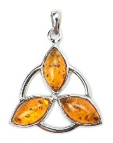
- Geology Research - Make a display to teach others about a topic you studied. Include an appropriate title, abstract (brief description of your topic), & photos, drawings, charts, or graphs that help explain your topic. Choose a new topic each year.
- Lapidary & Jewelry - Show how stones/minerals are made into polished stones & jewelry. Explain the steps involved.
- Miniatures - Display 5 miniatures in a box. Explain the benefits of collecting miniatures & how they are prepared.
- Indiana’s State Parks/Forests - Create a matching game of Indiana’s State Parks or Forests & a brief description of the game. This option should include geological features of the park or forest.
- Indiana/U.S./World Geology - Teach others about one Indiana, U.S., or World Geology topic.
- Career Exploration - Prepare a display that explains your interview with someone who needs an understanding of geology to do their job.
- Independent Study- Advanced Topic - Learn all you can about a geology topic you choose & present it on a poster. Include a short manuscript, pictures, graphs, & list the works cited to describe what you did & what you learned. Title your poster “Advanced Geology- Independent Study.”
- Independent Study- Mentoring - Exhibit a poster that shows how you mentored a younger 4-H member. Include your planning, time spent, the challenges & advantages of mentoring, & how the experience might be useful in your life. Photos & other documentation are encouraged. Title poster “Advanced Geology- Mentor.” Resources must be from educational or government entities.
MAX # STATE FAIR EXHIBITS [4]
1 PER LEVEL (3) & 1 INDEPENDENT STUDY (1)

HEALTH

Use 4-H Evaluation Survey & 4-H General Rule #20
Clover: Exhibit ONE of the following:
Grade 3
- A poster on First Aid or any other topic in your manual.
- A family first aid kit.
Grade 4
- A poster on First Aid or any other topic in your manual.
- A family first aid kit, including at least one “Make Your Own” item covered in your manual.
Grade 5
- A poster on First Aid or any other topic in your manual.
- A family first aid kit for an emergency (tornado, fire, etc.)
Junior & Senior: Exhibit ONE of the following:
Grades 6-12
- A poster on any topic covered in your manual.
- A report of 3 activities you completed in your manual.
MAX # STATE FAIR EXHIBITS (1 PER LEVEL) [3]

HOME ENVIRONMENT

Use 4-H Evaluation Survey
NOTE: Choose ONE exhibit category each year OR show how you expanded on the same option used in previous years (Portfolio & Furniture categories only). All exhibits must include the Home Environment Exhibit Card, 4-H-1011-D-W. See 4-H General Rule #20. Design boards must follow General Poster Guidelines.
Clover:
Furniture Options (Include Completed Notebook):
Include your completed notebook & exhibit one of the following options to demonstrate color, texture, &/or line & shape that would help complete a room:
- A hanging item
- A storage item or organizer item
- 3-5 accessory items for your chosen room
Design Board Options (Include Completed Notebook):
- Color the line drawing found in the manual with colored pencils. Print a line drawing available on the Indiana 4-H website. Create 3 different color schemes for the line drawing you chose. Label the type of color scheme used in each (e.g., monochromatic, analogous, complementary, warm, or cool).
- Color the line drawing found in the manual using one color option. Print a line drawing from the options available on the Indiana 4-H website: www.four-h.purdue.edu. Use color to explain dominant & supportive colors. Attach color samples to identify 2 additional color options.
- Display a floor plan for a bedroom showing line & shape where furniture would be placed. Include pictures (magazine or photos) of the furniture you’d use. We suggest using graph paper to help get the drawing close to scale & to show how line & shape work with the furniture.
Portfolio Options:
- Collect samples of different color schemes (minimum of 3). Label the type represented by each (e.g., monochromatic, analogous, complementary, warm, cool).
- Collect samples from magazines or photos of formal vs. informal balance, dominant & supportive color, & use of pattern. Include comments explaining each.
- Collect samples from magazines of 3 different furniture designs. Label each style (e.g., traditional, modern, country, formal, or retro). Include information explaining each style.
Junior:
Furniture Options (Include Completed Notebook):
Include your notebook & exhibit one of the following items demonstrating color, texture, and/or line and shape that would help complete a room:
- A piece of furniture you’ve refinished.
- A piece of furniture you’ve changed using decoupage, paint, fabric, etc.
- A cushion or a 2-piece set of cushions, preferably made by you, displayed with intended furniture.
- A window treatment, including picture of the treatment in use. Do not display on an actual window; use false walls or plywood no-glass window cutouts or make special display rods.
- A piece of furniture that you have reupholstered.
- One item that you are using for a different purpose than it was originally designed for (e.g., bedsheet used to make a window treatment, drawer used as a wall shelf).
- A collection of 3-5 similar items (baskets, wicker items, wicker furniture, bentwood furniture, etc.) that you have made &/or purchased for future use. (Ex.: a collection of baskets made to use as desk accessories or bathroom accessories, outdoor furniture & accessories, etc.)
Design Board Options (Include Completed Notebook):
For all options, use graph paper to help get the drawing close to scale & to show where the furniture/fixtures are.
- Display a floor plan for a living room, den, or family room. Include pictures (magazine or photos) of the furniture that would be used. Include paint samples &/or wall-treatment samples.
- Display a floor plan for a full bathroom (toilet, sink, and shower &/or bathtub). Include pictures (magazine or photos) of the fixtures that would be used. Include paint samples &/or wall-treatment samples & flooring samples.
- Display a floor plan for a kitchen (including appliances & sink). Include pictures (magazine, appliance brochure or photographs). Include paint samples &/or wall-treatment samples, flooring samples, & cabinet &/or countertop samples.
Portfolio Options:
- Samples of 3 different types of wall treatments with an explanation for each. Examples can include but are not limited to: paint only, wallpaper only, or combination of paint & wallpaper.
- Samples of 3 different floor treatments (pictures or flooring samples). Examples can include but are not limited to: hardwood, carpet &/or tile. Include information on the advantages/disadvantages of each. Also include information on where it would be appropriate to use each flooring type.
- Samples of 3 different cabinet/countertop combinations (pictures or samples). Examples can include but are not limited to: granite, laminate &/or stainless steel. Include information about the advantages/disadvantages of each.
- An energy-savings plan. Design an energy-savings plan for your family’s home or room(s). List the current energy use along with your plan to conserve energy. Plan should include techniques, how to conserve energy, cost savings, etc. You may add additional rooms or other plans to extend this option over a few years. Include each previous year’s work, but be sure that you indicate which information represents the current year’s work.
Senior:
Furniture Options: Follow Junior Furniture Options.
Design Board Options (Include Completed Notebook):
- Display a floor plan for a child's or teen's bedroom. Include an appropriate theme (e.g., princess, cartoon character, music group, favorite book, or special hobby). Include pictures (magazine or photos) of furniture that would be used. Floor plan should be to scale with general measurements included. Include samples of window, wall, & flooring treatments.
- Display a floor plan for a game room or family hobby room (e.g., room with pool table, ping pong table, &/or game table; home theater; or music room). Include pictures (magazine or photos) of the furniture that would be used. Floor plan should be to scale with general measurements included. Include samples of window, wall, & flooring treatments.
- Display a floor plan of master suite (bedroom & bath). Include pictures (magazine or photos) of the furniture that would be used. Floor plan should be to scale with general measurements included. Include samples of window, wall, & flooring treatments, etc. This exhibit must also include fabric samples (e.g., bedspread, window treatment).
- Display a floor plan of a one- or two-bedroom home or apartment. Include color scheme samples & furniture layouts. Floor plan should be to scale with general measurements included. Window, wall, & flooring treatment samples should be included for each room. (Pictures of furniture are not a requirement.)
Portfolio Options:
- Samples of 3 different lighting treatments. Explain how & when each is appropriate for use. Examples include but are not limited to: overhead, recessed, & table/floor lamps. Include information as it relates to energy use & efficiency.
- Samples of 3 different types of window treatments. Include information on the use of each kind & in what room each would be appropriate. Include information on the advantages/disadvantages of each. Also, include information as it relates to energy use & efficiency.
- Using the same window (size & shape), apply 3 different types of window treatments. Explain the advantages/ disadvantages of each. Explain what type of setting (formal, country, traditional, modern, etc.) would be appropriate for each treatment. Include information related to energy use & efficiency.
- A career plan. Interview an interior designer. Include the advantages/disadvantages of being a professional interior designer. Research 2 different design schools or training programs. Include the advantages/disadvantages of each program. Include the cost of attaining a degree or completing the program.
- An energy-savings plan. Design an energy-savings plan for your family's home or room(s). List the current energy use along with your plan to conserve energy. Plan should include techniques, how to conserve energy, cost savings, etc. You may add additional rooms or other plans to extend this option over a few years. Include each previous year's work, but be sure that you indicate which information represents the current year's work.
Independent Study Option:
4-H’ers who choose this option must review their ideas with their 4-H Youth Development Extension Educator &/or Project Superintendent to make sure they have selected an appropriate topic/exhibit.
MAX # STATE FAIR EXHIBITS (2 PER LEVEL) [6]

JUNIOR LEADERS
Project Superintendents - Robyn Bender (812-568-2710) & Kendra Glaser (812-453-8637)

Use 4-H Evaluation Survey
Guidelines for Participation
1. 4-H'ers in grades 7-12 are eligible to participate.
2. Members must complete service on at least 1 committee and 2 community service activities annually.
3. Members must work a minimum number of food booth shifts during Fair Week. That number will be determined once enrollment in the project is complete. At least 1 shift must be a night shift. Shifts cannot count toward fulfillment of the community service portion of the project.
4. To be nominated as a club officer, a 4-H’er must have attended at least 50% of the meetings the previous year, must be present during officer elections, & must assist with 4-H Club Officer Training the year they are elected.
5. Members should use leadership skills at your club meetings to help your Club Leaders. Set up a responsibility with your Club Leader & follow through with it.
COUNTY PROJECT ONLY

MODELS
Project Superintendent - Tim Hulsey (812-985-3987)

Use 4-H Evaluation Survey
NOTE: Entries are judged Sunday, July 18, 2:00-4:00 PM in the Community Center.
Requirements for All Divisions
- All models must be made of injected styrene plastics. Wood, paper, clay, die-cast and snap-together models are not permitted.
- Screws, Legos, and pre-painted or pre-decaled factory models are not permitted.
- At least 25% of the exhibit must be painted.
- Attach to your exhibit 4-H 618A-W to explain your exhibit & the work you completed on it.
- If the model is being built from a kit, include a copy of the instructions with the exhibit.
Clover: Build & exhibit a model from a kit. The main structure (car body, aircraft wing & fuselage, boat hull, etc.) of the model cannot be painted, but detail painting is encouraged. This may include car interiors, motors, chassis parts, aircraft marking on wings or fuselage, superstructure on ships, & so on. You may purchase "after market" items or "scratch-build" them yourself to make your exhibit more realistic.
Junior: Build & exhibit a fully painted & detailed model from a kit. Detail painting (see Div. II) is required. Extra detail (see Div. III) is required. All surfaces that can be seen must be painted. Wooden parts must be painted or varnished. Chrome & clear parts should be polished. Judging is based on neatness, cleanliness, proper assembly, realism of detail, & quality of painting.
Senior: Build & exhibit a fully painted and detailed model, from a kit or scratch built. This model must be in a display. Display must not be more than 6” wider nor more than 6” longer than the basic model. (Ex.: If the model measures 6" x 8", the display cannot be more than 12" x 14".) The display will be judged as part of the model. Objectives are to advance your modeling skills, learn to use different materials, & to learn more about expressing yourself with an original display. Judging is based on neatness, cleanliness, proper assembly, realism, & originality of the display.
MAX # STATE FAIR EXHIBITS (JUDGE’S CHOICE) [2]

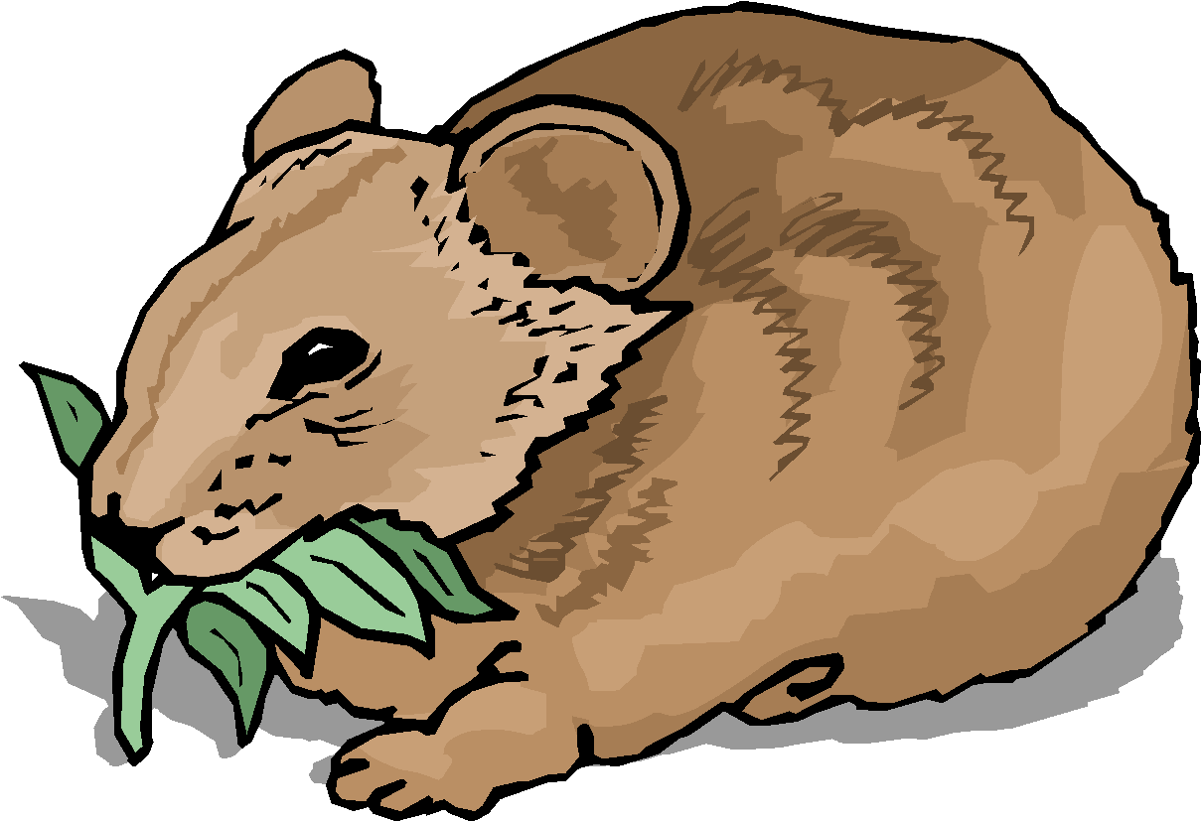
PET PALS
Use 4-H Evaluation Survey
NOTE: All Entries are judged Sunday, July 18, 2:00-4:00 PM in the Community Center. All animals must be presented for judging in a secure cage & are sent home immediately following judging. Leave for display a framed photo of your pet. Your completed manual must be presented for judging & will be sent home following judging. See 4-H General Rule #20.
Clover, Junior & Senior: Choose ONE chapter from your manual & complete at least 3 activities. Choose a different chapter each year. Exhibit a poster on related information within the chapter completed, OR exhibit ONE of the following animals: gerbil, guinea pig, bird, hamster, mouse, rat, dog or pygmy goat. 4-H EDUCATOR APPROVAL’S REQUIRED FOR ANIMALS NOT LISTED.
COUNTY PROJECT ONLY

PHOTOGRAPHY
Project Superintendent - Rachel Deno (812-838-3112)

Use 4-H Evaluation Survey
Requirements for All Divisions
1. Images must be original & taken by the 4-H member. Subjects are the choice of the photographer. It is recommended you use & exhibit standard processing size.
2. Photos must be taken since last year’s county fair.
3. All poster exhibits must follow General Poster Requirements.
4. Place standard identification label under plastic covering in lower right hand corner of exhibit.
5. Number photos 1-10.
6. Captions with photos and/or fluorescent posters are not recommended.
7. Salon prints are one print, either Black & White or Color, printed horizontally or vertically from any size negative. The print must be mounted on a standard 16’’ x 20’’ salon mount, displayed vertically & covered with plastic.
8. Sepia tone photographs (monochromatic) are entered under the Black and White classes.
9. A 4-H’er may enter 1 OR 2 exhibits in the appropriate level as long as the exhibits aren’t in the same class.

Mounting & Labeling for All Divisions
This mounting may be of any color or texture. The pictures are to be neatly and securely mounted. Dry mounting tissue is best. Salon mounts are available in most photo and art supply stores. They are available either in plain or with a cutout of the picture area. You may make your own. Matting is not required. Label each exhibit following General Poster Guidelines.

Level 1 (Grades 3-5): Choose 1 OR 2 Classes:
1. Black & White Prints
2. Color Prints
3. Cell Phone Print
Level 2 (Grades 6-8): Choose 1 OR 2 Classes:
4. Black & White Prints
5. Color Prints
6. Color Salon Print
7. Black & White Salon Print
8. Creative/Experimental-Black & White or Color Salon Print
9. Cell Phone Print
Level 3 (Grades 9-12): Choose 1 OR 2 Classes:
10. Black & White Prints 14. Creative/Experimental-
11. Color Prints Black & White &/or
12. Color Salon Print Color Salon Print
13. Black & White Salon Print 15. Cell Phone Print

LEVEL 1 - CLASS 1 - BLACK & WHITE PRINTS
EXHIBIT: 10 black & white pictures, none of which is larger than 4" x 6" nor smaller than 3½" x 5". Title your poster, "Capturing Memories." Prints may be a mix of digital &/or standard development.

LEVEL 1 - CLASS 2 - COLOR PRINTS
EXHIBIT: 10 color pictures, none of which is larger than 4" x 6" nor smaller than 3½" x 5". Title your poster, "Experiences in Color." Prints may be a mix of digital &/or standard development.

LEVEL 1 - CLASS 3 - CELL PHONE SALON PRINT
EXHIBIT: ONE black and white OR color print no smaller than 7” x 9” and no larger than 11” x 14”, printed horizontally or vertically, mounted on a standard 16” x 20” salon mount, displayed VERTICALLY and covered with a plastic sleeve. No title recommended.
LEVEL 2 - CLASS 4 - BLACK & WHITE PRINTS
EXHIBIT: 10 black & white pictures, none of which is larger than 5" x 7" nor smaller than 2" x 3½". Title your poster, "Photography is Fun." Prints may be a mix of digital &/or standard development.
LEVEL 2 - CLASS 5 - COLOR PRINTS
EXHIBIT: 10 color pictures, none of which is larger than 5" x 7" nor smaller than 2" x 3½", on any subject. Title your poster, "Adventures in Color." Prints may be a mix of digital &/or standard development.
LEVEL 2 - CLASS 6 - COLOR SALON PRINT
EXHIBIT: ONE color salon print no smaller than 7" x 9" nor larger than 11" x 14,” printed horizontally or vertically, mounted on a standard 16” x 20” salon mount, displayed VERTICALLY and covered with a plastic sleeve. No title recommended.
LEVEL 2 - CLASS 7 - BLACK & WHITE SALON PRINT
EXHIBIT: ONE black & white print no smaller than 7" x 9" nor larger than 11" x 14,” printed horizontally or vertically, mounted on a standard 16” x 20” salon mount, displayed VERTICALLY and covered with a plastic sleeve. No title recommended.
LEVEL 2 - CLASS 8 - CREATIVE/EXPERIMENTAL
SALON PRINT
EXHIBIT: ONE black & white &/or color print no smaller than 7" x 9" nor larger than 11" x 14". printed horizontally or vertically, mounted on a standard 16” x 20” salon mount, displayed VERTICALLY and covered with a plastic sleeve. No title recommended. MUST include original photograph(s) on back of mounting board & attach a listing of steps/procedures used to create the end product. Any modified image may be exhibited.
LEVEL 2 - CLASS 9 – CELL PHONE SALON PRINT
EXHIBIT: ONE black & white or color print no smaller than 7" x 9" nor larger than 11" x 14,” printed horizontally or vertically, mounted on a standard 16” x 20” salon mount, displayed VERTICALLY and covered with a plastic sleeve. No title recommended.
LEVEL 3 - CLASS 10 - BLACK & WHITE PRINTS
EXHIBIT: 10 black & white pictures, none of which is larger than 8" x 10" nor smaller than 2" x 3½". Exhibit must have a title; use your creativity. Prints may be a mix of digital, digitally enhanced &/or standard development.
LEVEL 3 - CLASS 11 - COLOR PRINTS
EXHIBIT: 10 color pictures, none of which is larger than 8" x 10" nor smaller than 2" x 3½". Exhibit must have a title; use your creativity. Prints may be a mix of digital, digitally enhanced &/or standard development.
LEVEL 3 - CLASS 12 - COLOR SALON PRINT
EXHIBIT: ONE color print no smaller than 7" x 9" nor larger than 11" x 14," printed horizontally or vertically, mounted on a standard 16” x 20” salon mount, displayed VERTICALLY and covered with a plastic sleeve. No title recommended.
LEVEL 3 - CLASS 13 - BLACK & WHITE SALON PRINT
EXHIBIT: ONE black & white print no smaller than 7" x 9" nor larger than 11" x 14,” printed horizontally or vertically, mounted on a standard 16” x 20” salon mount, displayed VERTICALLY and covered with a plastic sleeve. No title recommended.
LEVEL 3 - CLASS 14 - CREATIVE/EXPERIMENTAL
SALON PRINT
EXHIBIT: ONE black & white &/or color print no smaller than 7" x 9" nor larger than 11" x 14". printed horizontally or vertically, mounted on a standard 16” x 20” salon mount, displayed VERTICALLY and covered with a plastic sleeve. No title recommended. MUST include original photograph(s) on back of mounting board & attach a listing of steps/procedures used to create the end product. Any modified image may be exhibited.
LEVEL 3 - CLASS 15 – CELL PHONE SALON PRINT
EXHIBIT: ONE black & white or color print no smaller than 7" x 9" nor larger than 11" x 14,” printed horizontally or vertically, mounted on a standard 16” x 20” salon mount, displayed VERTICALLY and covered with a plastic sleeve. No title recommended.
MAX # STATE FAIR EXHIBITS [10]
(2) PER LEVEL 1, (4) PER LEVEL 2, (4) PER LEVEL 3

RECYCLING
Use 4-H Evaluation Survey
Clover, Junior & Senior: Exhibit an item you made from recyclables. Attach to your exhibit 4-H 618A-W to explain your exhibit & the work you completed on it.
MAX # STATE FAIR EXHIBITS (JUDGE’S CHOICE) [3]

SCRAPBOOKING
Use 4-H Evaluation Survey

NOTE: The focus of this project is to tell your story & preserve your memories of ANY topic in an organized & creative way. Memories may include any topic that is special to you (i.e., family, pets, school, etc.).

Requirements for All Divisions
1. Each scrapbook album will have a front & back cover with pages firmly attached between the covers.
2. Each member must complete a minimum of 10 scrapbook pages (5 pages front & back, for a total of 10) for judging.
3. If the scrapbook contains more than 10 pages, it will have a label that clarifies which 10 pages are to be judged. Page numbers need not be written on the album pages; instead, attach a sticky note to each page that is to be judged & number the notes 1 through 10 so that if the judge wants to comment on a certain page, a number reference is available.
4. Photos & memorabilia must be included in the scrapbook but not necessarily on each page. Some pages may contain only photos; others may contain only memorabilia. AT LEAST 1 PIECE OF MEMORABILIA must be included in your 10 pages. Memorabilia may be encased in plastic sleeves.
5. Keep in mind the proper placement of photos, etc. in your album. Your scrapbook is telling a story. Use chronology (putting things in order of occurrence) or themes to organize your scrapbook.
6. Journaling (labels, captions, stories, thoughts, ideas, etc.) should be used with your photos & memorabilia. Without journaling, over time, your photos & memorabilia will become less meaningful. Be sure to proofread!

Clover:
- Layout: 2-3 colors of paper. Stickers & die cuts may be used.
- Cropping: Straight cutting of photos using regular scissors or a paper cutter. Decorative scissors may be used.
- Journaling: Supply only basic information such as who, what, when & where. The main focus is preserving your memories, not how many stickers or papers you use!

Junior:
- Layout: More creative layout. Creative borders & lettering may be used.
- Cropping: Circle, oval & other shaped templates may be used.
- Journaling: Use captions & bulleted information to share information in short sentences. Using a variety of cropping techniques & page layouts will add interest & creativity to your album. Not everything has to be cropped. Use a nice balance.

Senior:
- Layout: May include a pop-up page, pocket page or quilt-type layout, but not every page has to be these types. Use techniques learned in previous divisions. Include a variety of layouts.
- Cropping: Silhouette cropping may be used, in addition to techniques learned in previous divisions.
- Journaling: Use bullets & captions, plus storytelling - writing your thoughts & feelings, telling a complete story or memory on each page. Not every photo has a complete story; choose the ones deserving of this when you think about page design. It’s fine to put several photos on a page & use just one of them to tell a story. Label or caption the other photos on the page. It’s easiest to tell a story if you pretend like you’re writing in your diary or sharing exciting news with your best friend.
COUNTY PROJECT ONLY

SEWING
Use 4-H Evaluation Survey

NOTE: All Entries are judged Sunday, July 12, 2:00-4:00 PM in the Community Center. Your pattern must be presented at judging. Exhibits must be covered in clear plastic for display. Please provide a hanger for your exhibit & include a completed Sewing Skills card for your level with your exhibit.

Level A (Grade 3): Include at least 2 skills in your exhibit: Insert elastic or drawstring; Sew & trim a crotch curve; Machine topstitch hems; Use a simple seam finish; or Stitch in the ditch. Attach completed Sewing Skills card.
Exhibit 1 Wearable &/OR 1 Non-Wearable listed below:
Wearable: Elastic waist shorts, pants OR skirt with fold over casing; no pockets.
Non-wearable: Simple pillow sham with lapped back opening & purchased pillow form (follow instructions in manual) OR simple tote bag with handles or drawstring.

Level A (Grade 4): Seam finishes are recommended on all exposed seams. Include at least 2 skills in the exhibit: Use interfacing; Staystitch & understitch; Apply a facing or binding; Stitch curved seams; Trim & grade seams; Work with fiberfill; or Machine topstitch hems. Attach completed Sewing Skills card.
Exhibit 1 Wearable &/OR 1 Non-Wearable listed below:
Wearable: Shorts, pants OR skirt with partial or full sewn-on waistband or waistline facing or partial elastic waistband (not a full elastic waistband) OR a simple shirt or top OR a BBQ apron.
Non-wearable: Shaped pillow with curved seams, stuffed & sewn closed OR hanging pocket organizer OR bound edge placemats (set of 4).

Level B (Grade 5): Seam finishes are recommended on all exposed seams (except knits). Interfacing, understitching and trimming should be used when appropriate. Choose at least 3 of these additional skills for each sewn exhibit: match fabric design; gather fabric; insert a zipper; use a drawstring; hand-stitch a hem; sew a simple sleeve; apply purchased trim or ribbing; sew patch or inseam pockets; use a simple lining; do a machine blind hem; apply machine topstitching; do a machine topstitched a hem; sew with knit; insert elastic; apply facings; sew buttons; apply binding; or use batting. Attach completed Sewing Skills card.
Exhibit 1 Wearable &/OR 1 Non-Wearable listed below:
Wearable: Simple shirt with sleeves OR sundress OR jumper OR simple 2-piece pajamas. A similar article is permissible provided the skills set is the same as the listed articles.
Non-wearable: Pillow lap quilt (quillow) OR structured duffel bag, tote bag OR backpack, OR sewn hat.

Level B (Grade 6): Seam finishes are recommended on all exposed seams (except knits). Interfacing, understitching and trimming should be used when appropriate. Choose at least 4 of these additional skills for each sewn exhibit: make darts; set in sleeves; insert a lapped zipper; hand-stitch a hem; make buttonholes; sew tucks or pleats; sew ruffles; hand sew buttons; apply trim; sew a simple lining; sew patch pockets; apply bindings; do a machine topstitched hem; sew facings; apply ribbings; sew a simple collar; do a machine blind hem; sew with knit; match fabric design; use fiberfill; apply machine appliqué; insert piping; apply machine topstitching; construct with a serger; or sew inseam pockets. Attach completed Sewing Skills card.
Exhibit 1 Wearable &/OR 1 Non-Wearable listed below:
Wearable: Two garments that can be worn together.
Non-wearable: Pillow sham with button or zipper closing, appliquéd design, piping or ruffle. Make your own pillow form OR tote bag with zipper or duffel bag with zipper, pockets & lining OR doll or pet clothes OR construction techniques sample notebook (following instructions in manual).

Level C (Grade 7): Seam finishes are recommended on all exposed seams (except knits). Interfacing, understitching, and trimming should be used when appropriate. Choose at least 5 of these additional skills for each sewn exhibit: make darts; set in sleeves; sew facing; apply ribbing; apply a collar; sew on buttons; use doll joints; apply inseam pockets; apply front hip pockets; match fabric design; apply trims; apply machine or hand appliqué; apply machine topstitching; insert a lapped zipper; insert an invisible zipper; insert a separating zipper; insert a fly front zipper; do machine quilting; do a hand-stitched hem; do a machine topstitched hem; do a machine blind hem; attach cuffs; apply binding; sew lining; apply ruffles; insert piping; make buttonholes; use fiberfill; apply patch pockets; use a twin needle; apply tucks/pleats; construct with a serger; or apply machine embroidery. Attach completed Sewing Skills card.
Exhibit 1 Wearable &/OR 1 Non-Wearable listed below:
Wearable: School OR sports outfit. May be one or more pieces.
Non-wearable: Dressed, jointed (with sockets) stuffed animal OR sewn item for holiday or special occasion OR construction techniques sample notebook (follow instructions in manual).

Level C (Grades 8&9): Seam finishes are recommended on all exposed seams (except knits and non-raveling specialty fabrics). Interfacing, understitching and trimming should be used when appropriate. In addition, choose at least 6 of these skills for each sewn exhibit: make darts; make tucks; add lining; add facings; add plackets; add lapels; make sleeves; add gathers; apply trim; apply ribbing; add a drawstring; use shaped seams; use fiberfill; add a waistband; add patch pockets; add front hip pockets; match fabric design; make shoulder pads; attach cuffs; make pleats; insert elastic; add boning; apply a collar; insert piping; make a neckband; add vents; sew buttons; add underlining; add ruffles; sew with knit; make button loops; do hand beading; add inseam pockets; add welt pockets; use twin needle; create bound edges; do machine or hand quilting; apply machine or hand appliqué; apply machine topstitching; insert an invisible zipper; insert a separating zipper; insert a fly front zipper; insert a lapped zipper; insert a hand picked zipper; do a machine topstitched hem; do a machine blind hem; do a hand-stitched hem; make self-covered buttons; use specialty threads; make self-enclosed seams; sew with difficult fabric; construct with a serger; make machine buttonholes; make bound buttonholes; or apply machine embroidery. Attach completed Sewing Skills card.
Exhibit 1 Wearable &/OR 1 Non-Wearable listed below:
Wearable: See below for Levels C & D exhibit options.
Non-wearable: Sewn items for your home OR construction techniques sample notebook OR sewing machine survey (follow instructions in manual).

Level D(Grades 10-12): Seam finishes are recommended on all exposed seams (except knits and non-raveling specialty fabrics). Interfacing, understitching and trimming should be used when appropriate. In addition, choose at least 6 of these skills for each sewn exhibit: make darts; make tucks; add lining; add facings; add plackets; add lapels; make sleeves; add gathers; apply trim; apply ribbing; add a drawstring; use shaped seams; use fiberfill &/or batting; add a waistband; add patch pockets; add front hip pockets; match fabric design; make shoulder pads; apply machine embroidery; attach cuffs; make pleats; insert elastic; add boning; apply a collar; insert piping; make a neckband; add vents; sew buttons; add underlining; add ruffles; sew with knit; make button loops; do hand beading; add inseam pockets; add welt pockets; use twin needle; create bound edges; hand/machine beading; do machine or hand quilting; apply machine or hand appliqué; apply machine topstitching; insert an invisible zipper; insert a separating zipper; insert a fly front zipper; insert a lapped zipper; insert a hand picked zipper; do a machine topstitched hem; do a machine blind hem; do a hand-stitched hem; make self-covered buttons; use specialty threads; make self-enclosed seams; sew with difficult fabric; construct with a serger; make machine buttonholes; make bound buttonholes; coordination of fabric for quilted item; make a reversible item; piece quilted item. Attach completed Sewing Skills card.
Exhibit 1 Wearable &/OR 1 Non-Wearable listed below:
Wearable: See below for Levels C & D exhibit options.
Non-wearable: Sewn items for your home OR construction techniques sample notebook OR sewing machine survey (follow instructions in manual).

Advanced Sewing Wearable Exhibits (Levels C & D)
DEFINITION OF AN OUTFIT: An outfit is a set of garments that when put together make a complete look - such as a one or two-piece dress, a one or two-piece pant suit, or a three-piece combination (ex: pants, vest, blouse).
- Informal or Casual Wear: An outfit of one or two pieces suitable for school, weekend, or casual, informal activities.
- Dress Up: An outfit suitable for special occasions that are not considered formal. May be an outfit of one or more pieces with or without its own costume coat or jacket (lined or unlined). This is not an outfit that would be worn to school, weekend, or casual, informal activities.
- Free Choice: An outfit comprised of garments that do not fit in the other classifications. Ex: tennis wear; swim wear; athletic or sportswear; lounge wear; riding habits; historic, dance, theatrical, or international costumes; capes; unlined coats.
- Suit or Coat: The suit consists of two pieces, including a skirt or pants, and its own lined jacket. It is not a dress with a jacket as in the “Dress Up” category. The coat is a separate lined coat. It will be judged separately as a coat with its own accessories.
- Separates: Consists of three garments that must be worn as a coordinated, complete outfit. Each piece should be versatile enough to be worn with other garments.
- Formal Wear: May be one or more pieces suitable for any formal occasion, such as a prom or a wedding.
MAX # STATE FAIR EXHIBITS [21]
WEARABLES (1 PER GRADE 3-7) [5]
WEARABLES (1 PER CATEGORY, GRADES 8-12) [6]
NON-WEARABLES (1 PER GRADE LEVEL) [10]

POSEY COUNTY 4-H FASHION REVUE
4-H members enrolled in Sewing or Consumer Clothing may participate in this optional activity. Those who participate must be privately judged before they may appear in the public Fashion Revue show. To receive awards, the 4-H member must appear in BOTH the private & public Fashion Revue events. To participate, exhibitors must follow the specific project requirements for their grade level. You may enter more than one class. Only Grade 8-12 Sewing exhibits are eligible to participate in this activity at the State level. All articles modeled in Fashion Revue must have been constructed by the 4-H member modeling that same garment or outfit. Youth qualifying to exhibit the same garment or outfit in Indiana State Fair Sewing and Fashion Revue must choose which project they wish to participate, as one cannot exhibit the same garment or outfit in both projects at the State level.
MAX # STATE FAIR EXHIBITS [6]
(1 PER WEARABLES CATEGORY, GRADES 8-12)

SMALL ENGINES
Project Superintendent - Matt Schenk (812-305-3565)
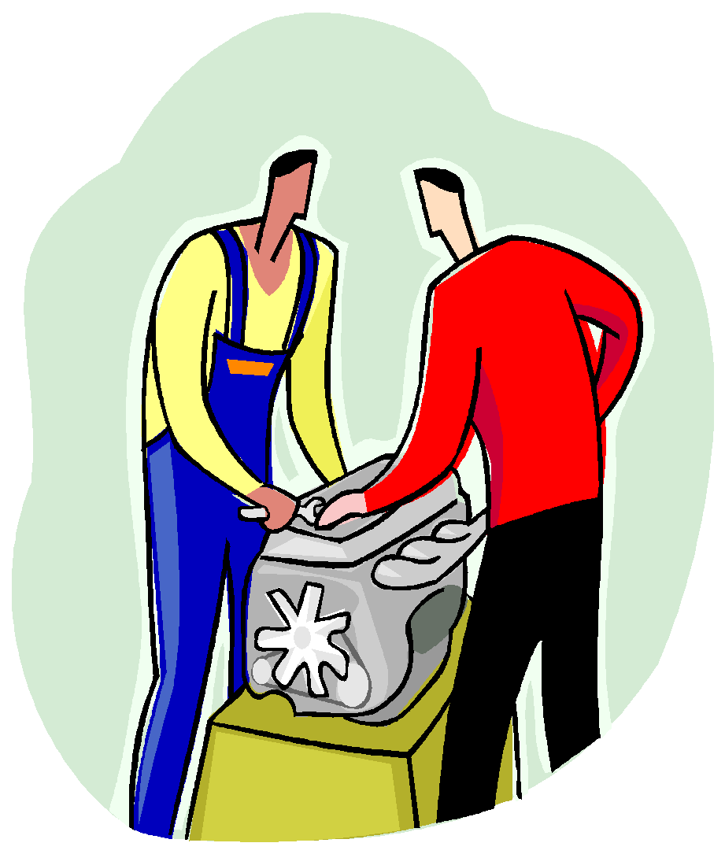
Use 4-H Evaluation Survey
NOTE: Display Boards may be no more than 36” x 36” & must be free standing & 3-dimensional with all items securely fastened & the 4-H’er’s exhibit label secured in the lower right-hand corner of the exhibit. Posters must follow General Poster Requirements. See 4-H General Rule #20.

Requirements for All Engine Displays
Actual small engine may be displayed & must be mounted on a stable base no larger than 30”x30”. For safety reasons, all fluids (fuel & oil) must be removed. Note: It’s strongly suggested that a notebook, with details & pictures of what was done to the engine, accompany the exhibit.
Clover: Complete 3 activities in the manual each year. Exhibit a poster or educational display related to what you have learned. Possible exhibits include: showing what you have learned; a display of basic tools needed to maintain a small engine; a display related to what you have learned about two-cycle engines or four-stroke engines; showing proper maintenance & care of a lawn mower; proper safety labels & procedures; parts display board with a brief explanation of the purpose of the parts & how they work; a display related to a system you learned about (filters, cooling, ignition, etc.).
Junior: Complete 3 activities in the manual each year. Exhibit a poster or educational display related to what you have learned. Possible exhibits include: comparing different types of engines; illustrating & explaining internal parts of an engine; showing how transmissions work, how to conduct a compression check, or how to adjust a carburetor according to owner’s manual & in accordance with EPA regulations; using a real small engine with a brief explanation to show steps in preparing a small engine for storage; carburetor parts display board with a brief explanation of the parts’ purpose & how they work together; income & expense record of your lawn mowing business (include costs, hours worked, income, etc.).
Senior: Complete 3 activities in the manual each year. Exhibit a poster or educational display related to what you have learned. Possible exhibits include: showing how to use diagnostic tools or how to tear down and reassemble a small engine; a display related to the electrical system of a small engine or emissions systems & future trends; showing mower blade inspection & maintenance skills; a display about careers in small engines; a display about your work in finding resources about small engines on the Internet; a display about trouble-shooting common problems; a display about small engines designs; any educational display related to what you have learned.
MAX # STATE FAIR EXHIBITS (1 PER LEVEL) [3]

SOIL & WATER SCIENCE
Use 4-H Evaluation Survey
NOTE: Choose a topic listed below. Use an appropriate exhibit title. Choose a different topic each year. Follow General Poster Guidelines. See 4-H General Rule #20.

Clover: Exhibit a poster related to an activity in the manual OR a poster OR notebook of a soil or water related experiment appropriate for your grade level.
Junior: Exhibit a poster related to an activity in the manual OR a poster OR notebook of a soil or water related experiment appropriate for your grade level.
Senior: Exhibit 1 of the following:
- A poster related to an activity in the manual
- A poster OR notebook of a soil or water related experiment appropriate for your grade level.
- Independent Study: Learn about a soil/water topic, program, facility, project, etc. & present it in poster OR notebook form. Include a short manuscript, pictures, graphs, & list the works cited to describe what you did & what you learned. Title your exhibit "Advanced Soil & Water Science - Independent Study."
- Mentoring: Exhibit a poster OR notebook that shows how you mentored a younger 4-H member(s). Include your planning, the time you spent, the challenges & advantages of mentoring, & how the experience might be useful in your life. Photos & other documentation are encouraged. Title your poster, "Advanced Soil & Water Science - Mentor."
MAX # STATE FAIR EXHIBITS [5]
1 PER LEVEL (4) & 1 INDEPENDENT STUDY (1)

SOYBEAN PRODUCTION
Use 4-H Evaluation Survey
Clover, Junior & Senior: Exhibit ONE peck of soybeans.
COUNTY PROJECT ONLY

SOYBEAN SCIENCE
Use 4-H Evaluation Survey
NOTE: Use an appropriate exhibit title. Choose a different topic each year. Follow General Poster Guidelines. See 4-H General Rule #20.
Clover: Exhibit a Division I poster option from the manual.
Junior: Exhibit a Division II poster option from the manual.
Senior: Exhibit a Division III or IV poster option in manual.
COUNTY PROJECT ONLY

SPORTFISHING
Use 4-H Evaluation Survey
NOTE: See 4-H General Rule #20. Choose a topic listed below. Use that topic for your exhibit title. Use a creative sub-title if you wish. Choose a different topic each year.
Clover: Exhibit a poster on ONE of the following:
- Let’s Go Fishing! (p. 6&7) - Complete the “Angling Self-Assessment” & practice landing a fish as described in “Playing a Fish.” Display your self-assessment & indicate what you hope to learn in this project. Draw or take photos of yourself “Playing a Fish.”
- Pop Can Casting (p.10&11) - Display a photo of you casting your pop can rig & your casting record. Optional - display a photo of you casting a regular fishing rig & your casting record with that rig.
- Hook, Line, & Sinker (p.14&15) - Display at least 2 of the rigs listed in Fishing Deeper #1. Use a drawing or a picture to show these rigs. Answer the questions (Casting Out, Working the Lure, Setting the Hook, & Landing the Fish) on your exhibit.
- Fishy Baits (p.24&25) - Complete & display cards similar to those shown (natural baits, prepared bait, & artificial flies & lures). Answer the Casting Out questions on your exhibit.
- Which Fish is it? (p.28&29) - Copy pages in manual. Use the fish & the crossword puzzle. Identify the fish & make a display that shows the correct answers in the puzzle. (Optional - enlarge the crossword puzzle).
Junior: Exhibit a poster on ONE of the following:
- A Different Spin (p.6&7) - Display a picture of yourself while casting & a completed Casting Record & Spinning Reel Parts diagram. Answer Working the Lure & Setting the Hook questions. You may copy the pages in your manual or make your own.
- A Fine Kettle of Fish (p.14&15) - Show a drawing or photo of you cooking fish. Include recipe &, if possible, photos of you cleaning &/or cooking your fish.
- Clean up the Litterbug (p.16&17) - Complete & display the chart on p.16. Draw or take photos of the fishing place that you cleaned up (before & after).
- The Woolly Bugger (p.24&25) - Take pictures or make drawings to show how a wooly bugger is made. Answer Casting Out & Working the Lure questions.
- A Fish by Design (p.32&33) - Draw, take pictures, or find pictures (Internet/magazines) to show & identify different mouth/feeding fish, body shapes, & fish with different coloration. Briefly explain (3-5 sentences/bullets) why fish have different mouths, body shapes & coloration.
Senior: Exhibit a poster on ONE of the following:
- A Reel Mess (p.6&7) - Draw, take photos, or copy the reels shown in Cleaning a Reel. Label the reels & the parts of each reel. List where you might use each. Show how you cleaned a reel using pictures or drawings.
- Designing a Skillathon Station (p.8&9) - Make 2 skillathon stations (use the suggestions on p.9 or another fishing topic of your choice). List the topic, realistic situation, task, & the materials needed. Take photographs of younger 4-H members using your stations.
- Beads, Dog Hair, & Feathers (p.10&11) - Collect materials & tie a fly. Display your fly or a photo of it. List & draw or take pictures of the 7 materials in the matching game & indicate their potential uses.
- Collecting Aquatic Insects (p.18&19) - Complete & display the chart on p.18 (copy the chart or make your own). Draw or take pictures of your kick net & your sampling procedures. Answer the questions in Casting Out & Working the Lure.
- Cast into the Future (p.24&25) - Complete the Career Investigation Record after talking with someone currently working in an area related to fish/fishing. Include a picture of the person you interviewed. Answer the questions in Casting Out, Working the Lure, Setting the Hook & Landing the Fish.
- Keep a Field Journal (p.26&27) - Reproduce or copy 3-5 Field Journal entries on your display. Include photos showing where you had the fishing experience, if possible.
- Play Know Your Fish (p.30&31) - Make a "flap" quiz to teach fish facts. Show a picture or ask a question about a fish. Give answer(s) under the flap. Choose 5 - 10 fish, using at least 5 fish from your manual. Be sure to list multiple species if the information you provide applies to more than one of the species you chose.
- Independent Study- Advanced Topic - Learn all you can about a sport fishing topic of your choice & present it on a poster. Include a short manuscript, pictures, graphs, & a list of references you used to describe what you did & what you learned. Title it "Advanced Sport Fishing- Independent Study."
- Independent Study- Mentoring - Exhibit a poster showing how you mentored a younger 4-H’er(s). Include your planning, the time you spent, the challenges & advantages of mentoring, & how the experience might be useful in your life. Photos & other documentation are encouraged. Title it "Advanced Sport Fishing - Mentor."
MAX # STATE FAIR EXHIBITS [4]
1 PER LEVEL (3) & 1 INDEPENDENT STUDY (1)
SPORTS
Use 4-H Evaluation Survey
NOTE: See 4-H General Rule #20

Clover: Exhibit a poster on ONE of the following:
- 6 pictures showing you playing a sport of your choice & explaining each photo.
- A complete sports uniform, including helmet, kneepads, etc. Label each item with name & price to allow someone not familiar with the sport to learn what equipment is needed.
- Dimensions of the playing field, court, alley, pool, etc. of the sport of your choice, being specific enough to enable someone to set up the field, court, etc., in an unmarked area.
Junior: Exhibit a poster on ONE of the following:
- 3-5 different techniques used when playing the sport you have chosen. Label each technique and have a brief description on how it does or does not help you.
- 3-5 well-known athletes in the sport you have chosen. Each athlete should have a brief description of the person, their team, & a list of their accomplishments in the chosen sport.
- 3-5 day menu with the proper nutrition requirements for an athlete in training.
Senior: Exhibit a poster on ONE of the following:
- An offensive or defensive play or position used while playing the sport of your choice. Label the name of the play/position and describe its effectiveness when playing the chosen sport.
- A 3-day workout schedule for an athlete in training for a particular sport of your choice.
- The history of a sport of your choice, including when & where the sport was first played, legendary athletes in the sport, how the sport has changed over the years, etc.
- Sports safety
- Any other sports-related topic of your choice.
COUNTY PROJECT ONLY

TRACTOR
Project Superintendent - Matt Schenk (812-305-3565)
Use 4-H Evaluation Survey
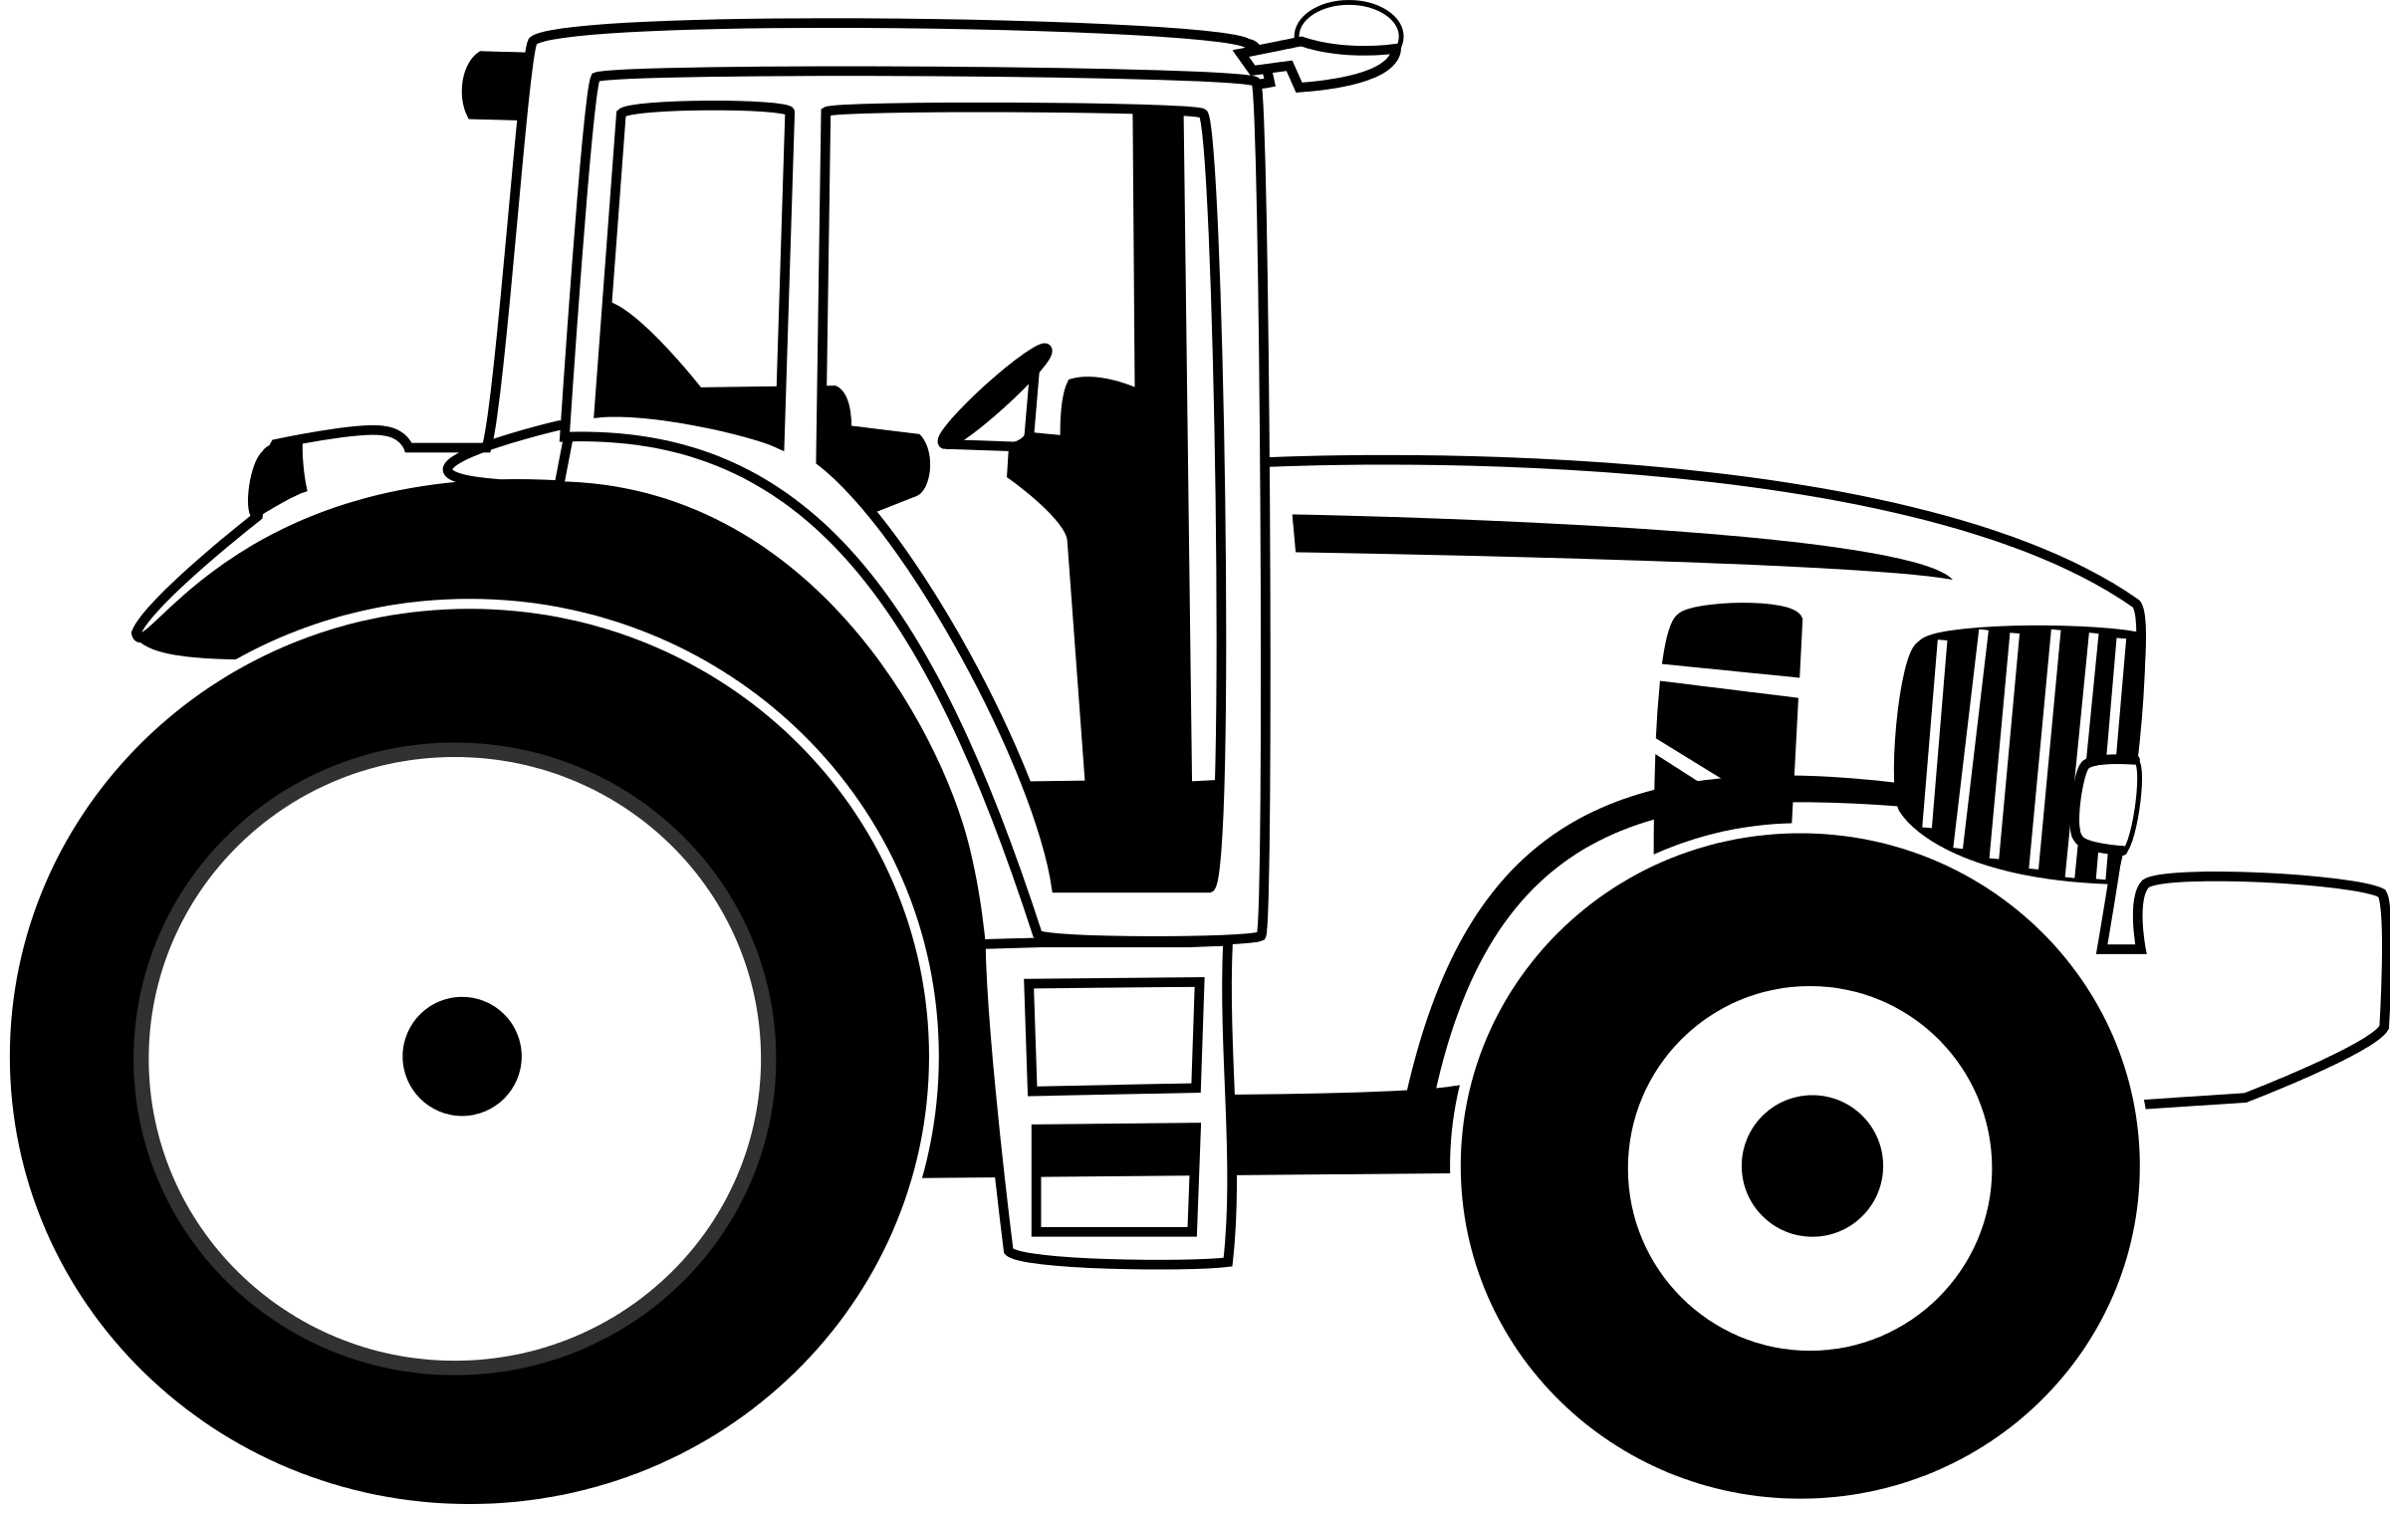
NOTE: See 4-H General Rule #20. Display boards should be 22"x28" & displayed horizontally. Label each displayed part. Specify make & model of the machinery.

Levels A-D: Choose a topic listed in your manual & exhibit ONE of the following: Poster, Notebook, OR Display board (with 3-dimensional items attached)

MAX # STATE FAIR EXHIBITS (1 PER LEVEL) [4]

TRACTOR OPERATOR'S CONTEST
NOTE: Entry deadline is May 15
Held prior to the Area Tractor Operator contest. Exhibitors may compete in one or both categories of the contest. Junior (Grades 3-7) or Senior (Grades 8-12) entries must follow State Fair guidelines. Study guides are provided .

TRAVELOGUE
Use 4-H Evaluation Survey
Clover, Junior & Senior: Make a notebook of a trip you took this year. Your notebook should include the following:
- A map of your trip. Include roads, principal cities, etc.
- Research on the interest stops of your trip. Place the interest stops in the order that you visited them.
- When possible, pictures of each interest stop. Pictures should be placed within the research.
- Your completed project manual.
COUNTY PROJECT ONLY

VETERINARY SCIENCE
Use 4-H Evaluation Survey & 4-H General Rule #20
NOTE: Follow General Poster Guidelines for poster exhibits. Displays & quiz boards may not exceed 36”x36”x36” & should use 3-dimensional objects instead of drawings or photos.
Clover: Exhibit a poster about a topic in the manual.
Junior: Exhibit a poster, display or quiz board related to a topic in the manual.
Senior: Exhibit ONE of the following:
- A teaching aid & a 2-page, typed report explaining the teaching aid you have developed.
- A poster of a project you developed with a veterinarian. Display results, recommendations, findings & conclusions of your project.
- A written, 1-page outline of a workshop or demonstration you presented.
MAX # STATE FAIR EXHIBITS (1 PER LEVEL) [3]

VIDEO GAMING & COMPUTER CODING
Use 4-H Evaluation Survey & See 4-H General Rule #20
NOTE: Both physical and digital exhibits are permitted. Youth are encouraged to use the medium that best suits their learning style. Please put digital submissions on a USB drive for ease of judging in which the exhibit is the only file on the USB drive, and the USB drive is labeled with the exhibitor’s name.
Clover, Junior & Senior: Exhibit a piece (i.e., video, animation, presentation, notebook, etc.) that represents a video gaming or computer coding aspect of interest. Youth may consider, but are not limited to, one or more of these suggested topics:
- Video Game Review
- Game System Comparison
- Coding Platform Tutorial
- Collection of Video Game Shortcuts, Passwords, and Secrets
- Benefits of Gaming/Coding
- Video Gaming/Computer Coding Culture
- Video Games as Teaching Tools
- History of Gaming/Coding
WEATHER & CLIMATE SCIENCE
Use 4-H Evaluation Survey & 4-H General Rule #20
NOTE: Choose a topic listed below. Use an appropriate exhibit title. Choose a different topic each year. Follow General Poster Guidelines.
Clover: Exhibit a poster related to an activity in the manual OR a poster OR notebook of a weather or climate related experiment appropriate for your grade level.
Junior: Exhibit a poster related to an activity in the manual OR a poster OR notebook of a weather or climate related experiment appropriate for your grade level.
Senior: Exhibit ONE of the following:
- A poster related to an activity in the manual
- A poster OR notebook of a weather or climate related experiment appropriate for your grade level.
- Independent Study: Learn about a weather/climate topic, program, facility, project, etc. & present it in poster OR notebook form. Include a short manuscript, pictures, graphs, & list the works cited to describe what you did & what you learned. Title your exhibit "Advanced Weather & Climate Science - Independent Study."
- Mentoring: Exhibit a poster OR notebook that shows how you mentored a younger 4-H member(s). Include your planning, the time you spent, the challenges & advantages of mentoring, & how the experience might be useful in your life. Photos & other documentation are encouraged. Title your exhibit "Advanced Weather & Climate Science - Mentor."
MAX # STATE FAIR EXHIBITS (1 PER LEVEL) [4]

WILDLIFE
Use 4-H Evaluation Survey & 4-H General Rule #20
NOTE: Choose an exhibit option & use the selected topic as your exhibit title. List sources for images & information presented. Follow General Poster Guidelines. Notebook exhibits are to be standard 3-ring binders.
Clover: Exhibit ONE of the following:
- A poster related to an activity from your manual
- A poster and/or notebook of a wildlife-related science experiment appropriate for grades 3-5
Junior: Exhibit ONE of the following:
- A poster related to an activity from your manual
- A poster and/or notebook of a wildlife-related science experiment appropriate for grades 6-8
Senior: Exhibit ONE of the following:
- A poster related to an activity from your manual
- A poster and/or notebook of a wildlife-related science experiment appropriate for grades 9-12
- Independent Study- Learn all you can about a wildlife topic, program, facility, project, etc. & present it in poster or notebook form. Follow all state & federal wildlife guidelines & include a short manuscript, pictures, graphs, & references you used to describe what you did & what you learned. Title your exhibit "Advanced Wildlife- Independent Study."
- Mentoring- Exhibit a poster or notebook that shows how you mentored a younger 4-H’er. Include your planning, time spent, the challenges & advantages of mentoring, & how the experience might be useful in your life. Photos & other documentation is encouraged. Title your exhibit "Advanced Wildlife- Mentor."
MAX # STATE FAIR EXHIBITS [5]
1 PER LEVEL (4) & 1 INDEPENDENT STUDY (1)

WOOD SCIENCE
Use 4-H Evaluation Survey & 4-H General Rule #20
Level A (Grades 3&4): Exhibit a poster on any topic in the manual OR an article of choice made this 4-H year demonstrating a minimum of 5 techniques as outlined in the Indiana 4-H Woodworking Tools, Techniques & Skills Chart 4-H 6875C-W. Exhibits may include higher level techniques that have been mastered; these will not be counted as part of the minimum 5 required but will be evaluated for quality. A skills sheet must be submitted with the exhibit for judging.
Levels B, C, & D: Follow Level A guidelines using the appropriate manual for your grade level.
MAX # STATE FAIR EXHIBITS [8]
1 WOOD ARTICLE (4) & 1 POSTER (4) PER LEVEL

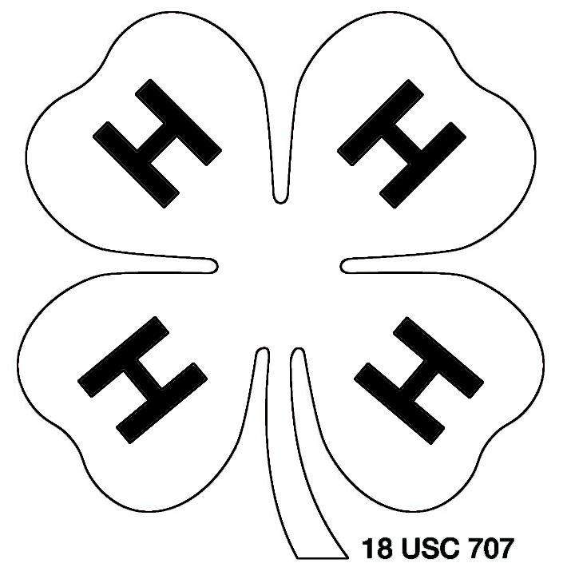

MINI 4-H GUIDELINES
The following are annual requirements for Posey County Mini 4-H participants (Youth enrolled in Grades K-2 as of January 1 of the current program year):
- Registration in 4HOnline by May 15 is required. Incomplete registrations will be deleted May 16.
- Each Mini 4-H youth may exhibit ONE handmade item & in doing so abide by 4-H entry & pick-up times. Entries are not judged competitively.
- Each Mini 4-H youth may exhibit ONE animal per species at the county level. The animal may be their own animal or one that is owned by another person, including a 4-H’er who is also exhibiting the animal. All exhibited animals must follow the same project guidelines & health requirements as listed for 4-H animals in this handbook. The exception to this rule is Mini 4-H horses/ ponies, which may be brought to the Fair for the day of the Mini 4-H Horse & Pony class & will not have access to a stall while on the grounds; these animals will be kept at the trailer in which they arrived & may not be ridden by anyone other than the Mini 4-H participant, who is to have an adult assistant at all times who is in control of the animal, per Indiana 4-H policy.
- No Mini 4-H participants or their animals may participate in the 4-H Livestock Auction.
- Mini 4-H participants exhibiting animals that weigh more than 300 pounds MUST HAVE AN ADULT ASSISTANT WHO IS IN CHARGE OF THE ANIMAL AT ALL TIMES, per Indiana 4-H policy.

4-H GENERAL ANIMAL PROJECT RULES
1. Posey County 4-H Animal projects are: Beef, Cat, Dairy, Horse & Pony, Poultry, Meat Goat, Rabbit, Sheep & Swine.
2. Entry times are as follows: Sheep & Goats- 3-5 PM on Sunday, July 18; Beef, Dairy & Swine- 7-9 AM on Monday, July 19; Horses & Ponies- 7 AM-7 PM on Monday, July 19; Poultry- 7:30-8:00 AM on Tuesday, July 20; Rabbits- 7:30-8:00 AM on Thursday, July 22, at the Livestock Arena; Cats- 12:30-1:00 PM on Wednesday, July 21. If there is a Sunday Saddle Club horse show on the grounds, horse/pony entries may stay overnight.
3. 4-H’ers are responsible for caring for their animals & keeping their pens & aisle area clean at all times. There will be twice daily well checks made by the Animal Project Superintendents, and those animals found to be without water or that have not been fed will not be allowed to sell at the livestock auction and will receive an Incomplete for the project.
4. All animals must be shown by a current youth member of Posey County 4-H for all 4-H shows.
5. Penmanship Awards for Beef, Dairy, Goats, Horse/Pony, Poultry, Rabbit, Sheep & Swine are determined by Project Superintendents. Areas of consideration are: attitude of 4-H'er; care of animal(s) & pen area; helpfulness towards other 4-H’ers. Penmanship awards are presented at the 4-H Achievement Banquet, with one winner per species. All exhibitors of a species are eligible to win this award.
6. There will be no 4-H animal re-weighs. Goats weighing less than 35 pounds will be sent home directly following weigh-in and will not be allowed to remain on the grounds, be exhibited at this year’s 4-H Goat Show, or sell in the 4-H Livestock Auction.
7. Exhibitors leasing animals must have a Posey County 4-H Lease Agreement form completed & submitted for approval to the Extension Office by May 15.
8. Show order is determined by Project Superintendents.
9. Due to health concerns, hogs not going through the 4-H Livestock Auction are asked to leave the fairgrounds within 2 hours of the completion of the 4-H Swine show. No other 4-H animals may be removed from the grounds until an hour after the livestock auction ends. Animals removed prior to this time will forfeit all awards as well as recognition of project completion.
10. Exhibitors must clean their barn(s) completely after animals are released.
11. Ribbons and awards for all 4-H animal events will be distributed at the event. It is the exhibitor’s responsibility to collect these awards by the conclusion of the event.
12. All animal exhibitors except those enrolled in the Cat project or Horse & Pony project are required to participate in annual YQCA training. Youth must complete YQCA training prior to July 1 in order to participate in this year’s county fair. Mini 4-H exhibitors are exempt.
13. Animal exhibitors must furnish their own bedding. Bedding is not allowed in the Hog Barn, & all fans must be totally enclosed. Mulch bedding is not allowed.
14. No more than 2 adults (21 years of age or older) are allowed to stay in the horse barn each night. Only 2 adults (21 years of age or older) are allowed to stay in the other barns combined. Those staying are to notify the Project Superintendents of their species prior to their stay. NO 4-H’ERS ARE ALLOWED TO STAY ON THE GROUNDS BETWEEN THE HOURS OF MIDNIGHT & 5 A.M. NO EXCEPTIONS!
15. Ideal market weights are recommended for all 4-H animal entries. See specific animal project requirements for further details.

4-H DRESS CODE
4-H animal exhibitors must wear appropriate clothing during 4-H Shows, the 4-H Livestock Auction, & when being photographed as a 4-H representative. Clothing allowed: polo style shirts; button-up shirts; sleeved, plain (no printing or logos), or 4-H shirts (tucked in- no midriff showing); clean jeans/long pants; & tennis shoes, boots or work shoes. Attire not allowed: hats, halter or tube tops, shorts (shorts = trousers not long enough to touch the tops of shoes when worn around the waist), see-through material, open toe or “sling back” shoes, sandals, or “mules.” This dress code affects all 4-H animal exhibitors except Horse & Pony, who have their own dress code. Exhibitors not wearing appropriate attire will not be allowed into the show arena.

GENERAL ANIMAL HEALTH RULES (ALL SPECIES)
Please call the Indiana State Board of Animal Health (BOAH) at 1-877-747-3038 with questions concerning animal exhibition requirements in Indiana or visit their website: www.in.gov/boah.
A. Limitations on Exhibition
This section describes limitations on exhibiting animals in Indiana. There may be other exhibition limitations that are described in the specific species requirements.
1. Failure to meet all animal health requirements will result in removal of animals from the exhibition premise.
2. The following animals are not eligible for exhibition in Indiana:
a. Animals that originate from a herd that is under quarantine.
b. An animal prohibited from exhibition under any law or order.
c. Any animal classified as a brucellosis "suspect.”
d. Animals showing symptoms of any infectious or communicable disease or that are a health hazard to people or other animals.
e. Any animal that does not meet state animal health requirements.
3. Any animal that develops or shows signs of any infectious or communicable disease during exhibition must be removed from the premise including the surrounding exhibition grounds. An owner that is disputing the exclusion of their animal from exhibition may not exhibit the animal in question pending any appeal.
4. The State Veterinarian is authorized to make the final determination as to an animal’s eligibility for exhibition. The state veterinarian may order removal of any animal from the exhibition grounds.
5. Exhibition organizers may impose health requirements in addition to those prescribed by BOAH. Added requirements may not contradict requirements imposed by BOAH.
6. Exhibition organizers may have a licensed and accredited veterinarian review animals and animal health documentation during the exhibition.
B. Certificates of Veterinary Inspection
1. For animals that originate within Indiana, contact the exhibition organizer to determine the certificate of veterinary inspection (CVI) requirement, if any.
2. For animals that originate outside the state of Indiana, the exhibitor must have a properly completed official certificate of veterinary inspection (commonly known as “health papers”) for the animal. This requirement applies to all domestic animals (except fish).
3. A certificate of veterinary inspection on any animal coming from outside Indiana for exhibition in Indiana is valid for 30 days from the date it is issued by a veterinarian.
4. Certificates of veterinary inspection accompanying animals for exhibition must be completed by a licensed and accredited veterinarian who has personally inspected the animals. CVIs must clearly include a description of each animal including the age, sex, and breed of the animal, and the official, individual identification.
5. Out-of-state swine and cattle attending an Indiana exhibition must have a pre-entry permit number noted on the certificate of veterinary inspection. Permits are available online at: www.in.gov/boah. Certificates of veterinary inspection for all out-of-state swine and cattle going to the Indiana State Fair must have the import permit number for the 2021 Indiana State Fair, “INSF21", written on the certificate.
6. Out-of-state poultry and hatching eggs attending an Indiana exhibition must be accompanied by one of the following documents. a. An official certificate of veterinary inspection completed by a licensed and accredited veterinarian within 30 days immediately prior to the animals entering Indiana. b. If the poultry or hatching eggs are from a flock participating in the National Poultry Improvement Plan (NPIP), they may move with the appropriate NPIP inspection/testing/participation certificate or records.
7. All out-of-state cervids (deer and elk) must have a permit approved by BOAH at least 5 business days before the movement into the state. Contact BOAH cervid programs to obtain a pre-entry permit.
8. A copy of the official certificate of veterinary inspection for each animal exhibited must be on file at the State Veterinarian's office prior to the opening day of the exhibition.
C. Identification
All exhibition animals must be permanently and individually identified by an acceptable method. Official ear tags are tags approved by the USDA. Official ear tags must bear the US shield to be considered official identification (official ear tags placed before March 11, 2015 that do not have the US shield will be accepted.) Official identification acceptable for specific species of livestock exhibited in Indiana are as follows:
CATTLE
• 840 tags may or may not be RFID (radio frequency identification), 15 digits, beginning with 840
• NUES (brite) tags, steel or plastic
• Official USDA program tags, such as orange calfhood vaccination tags
SHEEP & GOATS
• Scrapie program flock tags
• Electronic implant (goats only), for breed-registered animals only when noted on registration paperwork
• Tattoo, if accompanied by registration papers with tattoo noted
• Tattoo of the scrapie flock ID number along with an individual animal ID number
• Wethers younger than 18 months of age must bear a unique, permanent ID of any form (not necessarily an official/scrapie tag)
SWINE
• Official 840 ear tag (electronic-RFID or visual tag)
• NUES tag, plastic or steel
• Official Premises ID Number (“PIN”) tag**
**NOTE: Official PIN tags MUST include a premises number and unique animal ID imprinted by the manufacturer. (Standard PIN tags usually do not include an individual ID number; therefore, owners need to specify when ordering.)
• Ear notch, if the ear notch has been recorded in the book of record of a purebred registry association
• Tattoo, if the tattoo is registered with a swine registry association
HORSES
• Physical description of the animal including: name, age, breed, color, gender, distinctive markings, cowlicks, scars, blemishes, biometric measures, brands, tattoos, etc.
• Digital photographs
• USDA-approved electronic implant (microchip)
D. Testing
All tests required for exhibition must be conducted at the Animal Disease Diagnostic Laboratory (ADDL) at Purdue University, a laboratory approved by the Indiana State Board of Animal Health or a state or federal-approved laboratory.

4-H LIVESTOCK AUCTION RULES
- Only the following owned livestock species & their by-products are eligible for the 4-H Livestock Auction: Beef, Sheep, Swine, Dairy & Meat Goats. No leased animals or their by-products are eligible.
- Each 4-H member may sell no more than 2 lots. Lots may be the same or different species.
- Packer support prices are established prior to the sale.
- Sale order will be determined by the 4-H Livestock Auction Committee.
- Those 4-H members wishing to participate in the 4-H Livestock Auction will be randomly assigned a sale number according to the sale order.
- All animals sold at the auction MUST go directly to the packer or processor designated by the 4-H Livestock Auction Committee. All animals sold will be transported to the slaughter destination by designated 4-H Livestock Auction Committee transportation. Auction sale is final.
- Buyers may pay for purchase(s) at the sale, or a bill for the amount due will be sent to them at a later date. Total due is requested to be paid within 30 days of the auction.
- SWINE: Grand & Reserve Grand Champion Swine exhibitors will receive 15 cents above the support price. All other Swine exhibitors will receive 10 cents above the support price. Remaining premiums will be divided among Swine exhibitors participating in the auction.
- BEEF: Grand & Reserve Grand Champion Beef exhibitors will receive 10 cents above the support price. All other Beef exhibitors will receive 5 cents above the support price. Remaining premiums will be divided among Beef exhibitors participating in the auction. Only steers can sell.
10. LAMB: Grand & Reserve Grand Champion Lamb exhibitors will receive 15 cents above the support price. All other Lamb exhibitors will receive 10 cents above the support price. Remaining premiums will be divided among Lamb exhibitors participating in the auction. Only market lambs can sell.
11. DAIRY: Proceeds from the sale of all 4-H Dairy Products will be divided among Dairy exhibitors participating in the auction. One gallon of milk can be sold per animal.
12. MEAT GOAT: Grand & Reserve Grand Champion Meat Goat exhibitors will receive 15 cents above the support price. All other Meat Goat exhibitors will receive 10 cents above the support price. Remaining premiums will be divided among Meat Goat exhibitors participating in the auction. Only market wethers can sell.
13. A nominal fee will be deducted from each sale to defray costs associated with the 4-H Livestock Auction. This fee will be set by the Posey County 4-H Council.
14. A livestock auction entry card is required from each 4-H member at weigh-in, declaring which of their animals will sell at the auction. Changes to this card will not be accepted after 9 PM Wednesday, July 21. The 4-H member MUST be the person selling his/her animals in the auction as is listed on this card. 4-H Council will not issue auction checks to any member who does not sell his/her animals as listed on this card, and 4-H members who withdraw their animal(s) after 9 PM Wednesday, July 21, will be banned from selling animal(s) at next year’s 4-H Livestock Auction.
15. Substitute showmen are allowed for medical emergencies only. They must be pre-approved by the 4-H Youth Educator.
16. Only animals that have been properly identified by May 15 in 4HOnline & in Fair Entry by June 15 & exhibited by a current Posey County 4-H member at this year’s county fair are eligible to be sold at this event.

4-H SUPREME SHOWMANSHIP RULES
- The first place Senior Showman for each market area — Beef, Dairy, Meat Goat, Sheep, and Swine — will show one of each of these animals in this event.
- Grading will be on a point system, and the event will have one first place winner and one second place winner. Scores will not be made public.
- Supreme Showmanship first place winners can compete in future county 4-H showmanship contests for individual species but not in 4-H Supreme Showmanship again at the county level.
- If the Senior Division Showmanship winner declines or is ineligible to participate in this event, the next highest placing senior showman shall represent the species.
- If a contestant shows more than one species, the contestant is required to represent the species of the first animal shown.
- The Project Superintendent of each species is responsible for securing animals, as well as the proper show equipment, for each contestant. All animals used in the contest may not belong to any participant, his/her family members or raised with a participant’s animal. If an animal following into this category must be used, the participant will be provided an animal other than his/her own.
- Animals will be assigned randomly by the Animal Project Superintendents shortly before each round of the contest begins.
- Each round will be judged according to guidelines and practices of acceptable showmanship for that species.
- Contestants are responsible for securing training relevant to this event prior to the contest.
10. The contestant with the highest score shall be the Supreme Showman first place winner. The contestant with the second highest score shall be the second-place winner. Judge’s results will be tallied by the 4-H Extension Educator and kept confidential. In the event of a conflict of interest, the 4-H Council President will fill this role. A tiebreaker may be requested at the judge’s discretion.

4-H ANIMAL PROJECT REQUIREMENTS
BEEF
Project Superintendent - Cody Pate (812-270-1024)
Use Livestock Record Sheet
NOTE: Mulch bedding is not allowed. Exhibitors must furnish their own bedding & dispose of all bedding on or before Saturday, July 18.
- All Beef steers offered for exhibit will be weighed, divided into weight classes & judged accordingly.
- Steers must have been born after January 1, 2020.
- The Grand Champion Steer will be selected from the Champions of the respective steer classes.
- A 4-H’er may exhibit no more than 6 steers, 6 heifers, and 3 dairy feeder steers per year.
- Heifer Classes (Purebred & Commercial):
a. Junior heifer calves born Jan. 1 to March 31, 2021
b. Senior heifer calves born Sept. 1 to Dec. 31, 2020
c. Summer yearlings born May 1 to Aug. 31, 2020
d. Spring yearlings born March 1 to April 30, 2020
e. Junior yearlings born Jan. 1 to February 29, 2020
f. Senior yearlings born Sept. 1 to Dec. 31, 2019
- All female Beef animals entered in “Heifer Purebred” classes must have a registration certificate from their National Association in hand at check-in in order to be eligible to show. If no registration certificate is presented or the animal identification information doesn’t match the animal being entered, the female will be entered in a Commercial Heifer class.
- Entries must be properly entered in 4HOnline by May 15 and in Fair Entry by June 15.
- Posey County exhibition requires an 840-RFID tag for all cattle. See the ISF handbook or the latest Clover Connection for additional requirements for ISF entry.

BEEF HEALTH REQUIREMENTS
1. SEE GENERAL ANIMAL HEALTH RULES.
2. Cattle from Indiana do not need a brucellosis test or a tuberculosis test for exhibition in Indiana.
3. Cattle from states that are not designated tuberculosis free by USDA must meet additional requirements for entry into Indiana. Contact the Indiana State Board of Animal Health for specific information.
4. Cattle from outside the state do not need a brucellosis test as long as the state of origin is classified as brucellosis free by USDA.
5. All cattle, including Indiana cattle, that are to be offered for sale at an exhibition must have the necessary testing and other requirements completed within 30 days prior to the sale date.
BEEF CLASSES
Steers
Class 1
Class 2
Class 3
Class 4
Class 5
Class 6
Class 7
Res. Gr. Champ. Steer
Grand Champion Steer
Heifers
Angus Heifer
Hereford Heifer
Simmental Heifer
Limousin Heifer
Commercial Heifer
Res. Gr. Champ. Heifer
Grand Champ. Heifer

BEEF SHOWMANSHIP
Judged by Senior, Junior, Clover divisions.

OPEN BEEF SHOW
Entry fee: $10 for Posey County residents; $25 all others.
Exhibitors showing only at the Open Beef Show will be allowed to remove their animals from the fairgrounds immediately following the conclusion of the Open Beef Show. Animals brought from outside Indiana must be accompanied by an official Certificate of Veterinary Inspection (CVI). The CVI may not be more than 30 days old & must clearly include a description of each animal, the age, sex, & breed of the animal, & the official identification for the animal. Animals from within Indiana do not need a CVI. All animals entered in “Purebred” classes must have a registration certificate from their National Association in hand at time of check-in in order to be eligible to show. (Monday morning for 4-H entries; 3 PM day of show for non-4-H entries. Class designations will not be changed after this time.) If no registration certificate is presented at registration or if the animal identification information does not match the animal being entered, the animal will be entered in commercial classes. Only those females born after January 1 of the current year will be eligible to show in the Purebred or Commercial Heifer classes. In addition, all animals must have one of the three forms of USDA-approved identification that are recognized by BOAH & found on page 63 of this handbook.

Open Heifer Classes
1. Junior heifer calves born Jan. 1 to March 31, 2021
2. Senior heifer calves born Sept. 1 to Dec. 31, 2020
3. Summer yearlings born May 1 to Aug. 31, 2020
4. Spring yearlings born March 1 to April 30, 2020
5. Junior yearlings born Jan. 1 to February 29, 2020
6. Senior yearlings born Sept. 1 to Dec. 31, 2019

Steers will be shown by BREED (to be broken down after entries are made). There must be 3 animals of the same breed to make a class; if there are less than 3, the animals will show in an AOB class.

Open Beef Show Awards
Sponsored by Tri-County Cattlemen's Association
Trophies will be given to class winners, Grand Champions & Reserve Grand Champions.
Grand Champion Steer $75.00
Reserve Grand Champion Steer $50.00
Grand Champion Heifer $75.00
Reserve Grand Champion Heifer $50.00

CAT
Project Superintendent -
Shirley Wentzel (812-598-1459)
Use 4-H Evaluation Survey
- Exhibit your (family’s) cat at the 4-H Cat Show.
- All cats must be brought to the show in an enclosed cage or carrying case. A cardboard box is unacceptable. Cats are to be taken out of their carriers only for judging. If a cat is taken out of its carrier at any other time, its owner will be disqualified.
- Each cat must wear a collar & leash. Harnesses cannot be used because they interfere with judging.
- Judges consider how 4-H members carry, hold, & handle their cats. Cats will be judged on health, cleanliness, grooming & general condition.
- Cats are released after judging is complete.
- A 4-H member may show a maximum of 2 cats. Each cat may be shown in only one class.
- You may choose to show your cat(s) at the State Fair.
- You must carry with you to the show your cat’s current & completed Indiana 4-H cat vaccination form (4-H-777-W).
- Entries must be properly entered in 4HOnline by May 15 and in Fair Entry by June 15.

CAT HEALTH REQUIREMENTS
  - SEE GENERAL ANIMAL HEALTH RULES.
  - Each cat presented for exhibition must be accompanied by a CVI or other statement that is signed by a licensed and accredited veterinarian and that indicates the vaccinations each animal has been given. A CVI may be used to document vaccinations but is not required for cats within Indiana.
  - All cats 3 months of age and older must be vaccinated for rabies by a licensed and accredited veterinarian in accordance with the state rabies vaccination law.
  - Indiana 4-H imposes mandatory 4-H cat vaccination requirements beyond the BOAH requirements. They are listed on the Indiana 4-H cat vaccination form (4-H-777-W).

CAT CLASSES
Adult Long-haired, Adult Short-haired, General Kitten
Reserve Grand Champion & Grand Champion Cat

Adult: Cat of 8 months of age or older
Kitten: Cats ages 4-8 months old on show date.
Long-haired: Cats whose coat has long top hairs, with a thick wooly undercoat. The hair length on a cat’s tail is used as a determining factor. Hair length is usually 1½” or more.
Short-haired: Cats whose coat has only short hairs with a smooth texture. Tail hair is usually less than 1½” long.

CAT SHOWMANSHIP
Judged by Senior, Junior, Clover divisions.

DAIRY
Project Superintendent -
Al Schmitz (812-483-4020)
Use Livestock Record Sheet
1. Heifers will be exhibited according to their age.
2. Production or registration papers must be presented to the Project Superintendent upon unloading.
3. Posey County exhibition requires an 840-RFID tag for all cattle. See the ISF handbook or the latest Clover Connection for additional requirements for ISF entry.
4. Entries must be properly entered in 4HOnline by May 15 and in Fair Entry by June 15.

DAIRY HEALTH REQUIREMENTS
- SEE GENERAL ANIMAL HEALTH RULES.
2. Follow the Beef Health Requirements.

DAIRY CLASSES
Spring Calf: Born on or after March 1, 2021
Winter Calf: Born between December 1,
2020, and February 28, 2021
Fall Calf: Born between September 1, 2020, and November 30, 2020
Summer Yearling Heifer: Born between June 1, 2020, and August 31, 2020
Spring Yearling Heifer: Born between March 1, 2020, and May 30, 2020
Winter Yearling Heifer: Born between December 1, 2019, and February 28, 2020
Fall Yearling Heifer: Born between September 1, 2019, and November 30, 2019
Cow: Under 3 years old as of September 1, 2021
Aged Cow: Over 3 years old as of
September 1, 2021
Dry Cow
Reserve Grand Champion Dairy
Grand Champion Dairy

DAIRY SHOWMANSHIP
Judged by Senior, Junior, Clover divisions.
HORSE & PONY
Project Superintendent -
Cheryl Deig (812-568-5447)
Use Horse & Pony Record Sheet
- Horse & Pony Project Helmet Safety Policy: All 4-H exhibitors are required to wear a properly fitted ASTM or SEI standard F1163 (or above) certified helmet whenever mounted or driving at any Indiana 4-H Horse & Pony event/show/activity. The 4-H member is responsible to see that this headgear is properly fitted with the approved harness fastened in place. Original tags must be present in all helmets.
- Animals may be co-enrolled by siblings only.
- In order to show in a riding class, a 4-H’er must show in at least one of the in-hand (halter) classes.
- A Champion will be chosen for each class at the judge’s discretion. Each division will have a Grand Champion & Reserve Grand Champion, except for Showmanship & divisions with just one class.
- No 4-H’er may participate in a Horse & Pony 4-H event (practice, show, or other 4-H activity) until the member’s enrollment for the current year is complete & approved in 4HOnline. A 4-H Horse & Pony approved volunteer must be present at the event before participation can occur.
- A 4-H member may lose riding privileges at the discretion of 4-H Horse & Pony Club Leaders.
- All riders must be wearing approved headgear BEFORE mounting. Failure to do so will result in the 4-H member losing the opportunity to exhibit for one year.
8. All 4-H Horse & Pony members must wear appropriate boots & clothing when involved in a 4-H Horse & Pony event (practice, show, or other 4-H activity). See the current state 4-H Horse & Pony handbook for further guidelines.
9. All stall walls on the fairgrounds are to be left uncovered (no sheets or other full-wall coverings), except for 2 stalls which will be designated by the Project Superintendent as changing rooms for 4-H members during the 4-H Horse & Pony Show.
10. Only mounted walking & trotting is allowed in the warm-up area prior to the show. You may lunge your animal in this area at any gait.
11. A 4-H’er may exhibit no more than 2 horses/ponies per year.
12. Failure to follow these guidelines may result in dismissal from the project at the discretion of the 4-H Youth Educator.
13. Fair awards will be delivered to members in this project following final stall checks by their Club Leader.
14. Entries must be properly entered in 4HOnline by May 15 and in Fair Entry by June 15.

HORSE & PONY HEALTH REQUIREMENTS
- SEE GENERAL ANIMAL HEALTH RULES.
- Horses coming from outside of Indiana for exhibition must test negative for EIA (Coggins test) within 12 months of the date of exhibition & be accompanied by an official CVI that indicates the date and results of the EIA test.
- The following applies to horses coming from Indiana for exhibition: CVI & EIA testing are not required.
- Indiana 4-H imposes mandatory 4-H horse & pony vaccination requirements beyond BOAH’s requirements. They are listed on the Indiana 4-H horse & pony vaccination form (4-H-1031-W).

HORSE & PONY CLASSES
Division I: Halter
Class 1. Western type mare - 56" and under
Class 2. Western type mare - over 56"
Grand & Res. Grand Champion: Division I
Division II: Halter
Class 3. Western type gelding - 56" and under
Class 4. Western type gelding - over 56"
Grand & Res. Grand Champion: Division II
Division III: Showmanship at Halter
Class 5. Senior Western (Grades 9-12)
Class 6. Junior Western (Grades 6-8)
Class 7. Clover Western (Grades 3-5)
Division IV: Mini 4-H (Kindergarten-Grade 2)
Entries must be registered in 4HOnline by May 15.
Class 8. Lead Line
Division V: First Year Member Walk Trot
Not eligible to show in any other riding divisions.
Class 9. First Year Member Walk/Trot
Division VI: Trail
Class 10. Senior Trail
Class 11. Junior Trail
Class 12. Clover Trail
Grand & Res. Grand Champion: Div. VI
Division VII: Showmanship at Halter
Class 13. Senior English (Grades 9-12)
Class 14. Junior English (Grades 6-8)
Class 15. Clover English (Grades 3-5)
Division VIII: USDF (English) Dressage
Class 16. USDF Intro Test B (All Ages) Walk/Trot
Class 17. USDF Intro Test C (All Ages) Walk/Trot/Canter
Division IX: Show Jumping
Class 18. Ground Poles
Class 19. Cross Rails
Class 20. 18” Rails
Division X: WDAA (Western) Dressage
Class 21. WDAA Intro Level Test 2 (All Ages) Walk/Trot
Division XI: Western Pleasure
Class 22. Senior Western Pleasure
Class 23. Junior Western Pleasure
Class 24. Clover Western Pleasure
Grand & Res. Grand Champion: Div. XI
Division XII: Ranch Pleasure
Class 25. Senior Ranch Pleasure
Class 26. Junior Ranch Pleasure
Class 27. Clover Ranch Pleasure
Grand & Res. Grand Champion: Div. XII
Division XIII: Ranch Riding
Class 28. Senior Ranch Riding
Class 29. Junior Ranch Riding
Class 30. Clover Ranch Riding
Grand & Res. Grand Champion: Div. XIII
Division XIV: Western Riding
Class 31. Senior Western Riding
Class 32. Junior Western Riding
Class 33. Clover Western Riding
Grand & Res. Grand Campion: Div. XIV
Division XV: Reining
Class 34. Senior Reining
Class 35. Junior Reining
Class 36. Clover Reining
Grand & Res. Grand Champion: Div. XV
Division XVI: Contesting
Class 37. Senior Keyhole
Class 38. Junior Keyhole
Class 39. Clover Keyhole
Class 40. Senior Speed & Action
Class 41. Junior Speed & Action
Class 42. Clover Speed & Action
Class 43. Senior Poles
Class 44. Junior Poles
Class 45. Clover Poles
Class 46. Senior Barrels
Class 47. Junior Barrels
Class 48. Clover Barrels
Class 49. Senior Flags
Class 50. Junior Flags
Class 51. Clover Flags
Class 52. Senior Arena Race
Class 53. Junior Arena Race
Class 54. Clover Arena Race
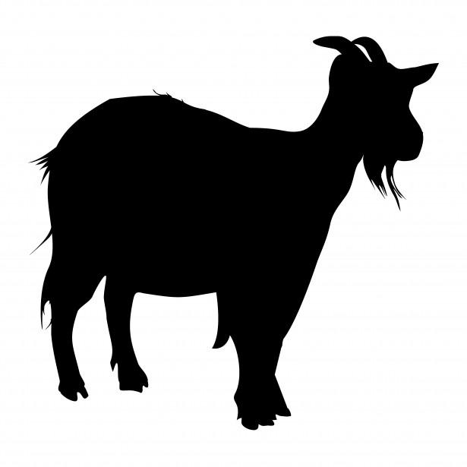
MEAT GOAT
Project Superintendent -
Hannah Duncan (812-575-9983)
Use Livestock Record Sheet

MEAT GOAT HEALTH REQUIREMENTS
- SEE GENERAL ANIMAL HEALTH RULES.
- NO BUCK MEAT GOATS ARE ALLOWED.
3. Posey County 4-H exhibition requires all non-registered animals to have a 5-digit county tag or official Scrapie tag. Registered does must have a breed registry tattoo. See the ISF handbook or the latest Clover Connection for additional requirements for ISF entry.
- Goats may be exhibited with or without horns.
- No goat may be exhibited showing signs of ringworm.
- All goats must meet the minimum weight requirement of 35 pounds per animal. Those weighing less than 35 pounds will not be allowed to show or sell at the 4-H Livestock Auction & must be taken home that same day.
- Entries must be properly entered in 4HOnline by May 15 and in Fair Entry by June 15.

MEAT GOAT CLASSES

Division I: Meat Goat Wethers
- All wethers must be shown with all 8 milk teeth in place. Those without milk teeth will not be allowed to show or sell at the Posey County 4-H Fair and must be taken home that same day.
- Wethers must be slick shorn at a uniform length above the hock & knee. Fitting in an attempt to alter or enhance appearance is prohibited.
- Wethers are shown by weight. Weight classes are determined after all animals are weighed at entry.
- All breeds of Meat Goats are eligible.
- Exhibitors may exhibit a maximum of 4 wethers.
- All champion & reserve champion wethers will compete for Grand & Reserve Grand Champion Meat Goat Wether.
Division II: Meat Goat Does
- Exhibitors may exhibit 2 entries per class.
- Breeding classes by age are: Junior Does: 3-12 months of age; Yearling Does: 12-24 months of age; Senior Does: 24 months of age and older
- All class champions & reserve champion does will compete for Grand & Reserve Grand Champion Meat Goat Doe.

MEAT GOAT SHOWMANSHIP
Judged by Senior, Junior, Clover divisions.

POULTRY & EGG
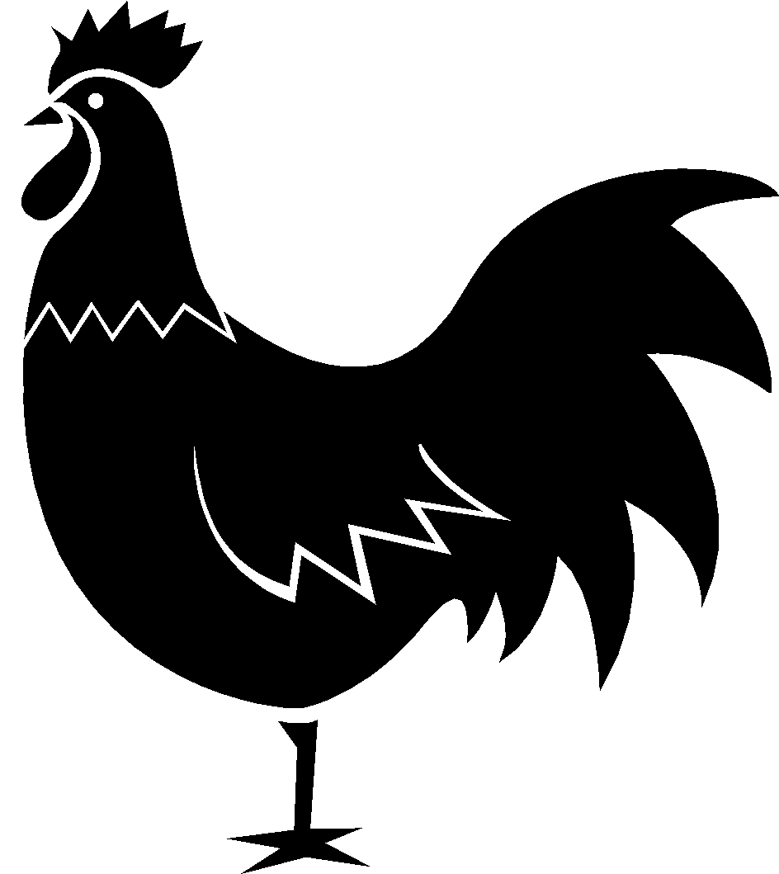
Project Superintendents -
Laura Kuhn (812-575-9163) &
Anna Thompson (812-449-0688)
Use Poultry Record Sheet

EGG PROJECT EXHIBIT GUIDELINES
Use 4-H Evaluation Survey
Exhibits may be entered on Sunday, July 18, 2:00-4:00 PM in the Exhibit Building during project check-in or on Tuesday, July 20, 7:30-8:00 AM in the Poultry Barn. Display 6 eggs in a foam carton, labeled with the exhibitor’s name. Eggs are judged in the following 3 classes: white shell eggs, brown shell eggs, all other colored shells. One champion will be selected for each of the 3 classes. A 4-H’er may exhibit one entry of 6 eggs per class for a total of 18 eggs. Eggs must be produced by the 4-H’er’s own flock. Eggs are judged on uniformity of color & shape, weight, shell texture & condition. If a bird isn’t producing at fair time, the completed manual may suffice as the substitute exhibit.
COUNTY PROJECT ONLY
POULTRY PROJECT EXHIBIT GUIDELINES
- Exhibited birds should be owned, raised & cared for by the 4-H member.
- Individual bird identification is not required for entry but is highly desirable.
- All hens exhibited should be in production at fair time.
- Each 4-H member may exhibit up to 3 pens but no more than 7 total birds. If you exhibit larger birds than 4-H Council's pens will accommodate, you must provide your own pens.
- Pullets, Cockerels, Young Ducks, Young Drakes, Young Goose, and Young Gander are less than one year of age. Hens, Cocks, Old Ducks, Old Drakes, Old Goose, and Old Gander are more than one year of age.
- All breeds must be properly identified. All birds must be enrolled in the appropriate category prior to the show.
- The show will be judged by the APA (American Poultry Association) Standards of Perfection.
- If an animal is entered as part of a pen, it cannot be shown in any other class.
- Blood testing will take place prior to exhibition and is required.
- All exhibitors must use approved feeders & water containers. No loose, lightweight plastic containers are allowed. Feeders & water containers must be securely attached to cages.
- After showing, exhibitors will choose 2 of their birds to stay on the grounds for exhibit until 2 PM Friday of Fair Week; all other birds will be dismissed immediately following exhibition & must be taken home.
- No Fighting Cocks allowed.
- Entries must be properly entered in 4HOnline by May 15 and in Fair Entry by June 15.

POULTRY HEALTH REQUIREMENTS
- SEE GENERAL ANIMAL HEALTH RULES.
- Indiana defines poultry as: chickens, turkeys, ostriches, emus, rheas, cassowaries, waterfowl (domesticated fowl that normally swim, such as ducks, geese & swans), & game birds (domesticated fowl such as pheasants, pea fowl, partridge, quail, grouse, & guineas).
- No individual identification is required for exhibition in Indiana.
- All poultry presented for exhibition except waterfowl must meet ONE of the following requirements:
  - Test negative for pullorum-typhoid within 90 days prior to the date of their exhibition.
  - Be hatched from eggs originating from certified NPIP pullorum-typhoid clean flocks.
  - Originate from a flock that is certified NPIP pullorum-typhoid clean.

POULTRY CLASSES

Purebred Chicken Classes (1 bird = 1 entry):
Divisions are Cock, Hen, Cockerel, & Pullet. Classes within each category are as follows:
Large Fowl (Chickens)
American, Asiatic, English, Mediterranean, Any Other Purebred Not Listed, Fancy Class
Bantams (Single combed, clean legged breed; Rose combed, clean legged breed; Any other combed, clean legged breed; Any feather legged breed, Fancy Class)
Waterfowl (Any standard breed duck or goose)
Turkeys (Any standard breed turkey)
Pigeons (Any Ming, Commercial, or Fancy breed)
Market Poultry (Any white ear lobed crossbred egg type; Any red ear lobed crossbred egg type; Any meat type chicken)

Game Birds (Pea fowl, Pheasants, or Quail)
Pet Class Standard breed quality is not judged. This class is judged based on handling ability and tameness of bird, condition of bird, and the youth’s knowledge of care for the bird by the judge asking questions.
Pen Classes (Judged Separately):
Market (Meat) Poultry Pen Class A pen consists of 3 birds (all the same sex & breed) as uniform in appearance as possible. Each chicken must weigh between 3-8 lbs. Each turkey must weigh between 14-30 lbs.
Laying Hen Pen Class 3 laying hens or pullets are entered and judged on egg production – capacity, body conformation, sexual maturity, health and pen uniformity.
Breeding Pen Must consist of 3 birds: 1 rooster & 2 hens or 1 cockerel & 2 pullets

Grand & Reserve Grand Champion Poultry

POULTRY SHOWMANSHIP
Judged by Senior, Junior, Clover divisions.

RABBIT
Project Superintendents -
Shawn & Robin Price (812-319-4117)
Use Rabbit Record Sheet
- Purebred rabbits will be judged by the current ARBA standard of perfection for their respective breed. Mixed breed rabbits will show in the Grade classes & will be judged by the current ARBA Rules as far as confirmation & faults but not color & markings.
- Each 4-H member may exhibit ONE rabbit per class.
- No cedar shavings are allowed, as some rabbits are allergic to the material.
- You may choose to exhibit your rabbit at the State Fair. Contact the 4-H Youth Educator by emailing maycm@purdue.edu for more information.
- Each exhibitor is responsible for carrying his/her rabbit to & from the judging table.
- All rabbits must be identified by a permanent tattoo or a permanent marker in their left ear.
- No does with litters are allowed to exhibit.
- Meat Pen Class entries count as one rabbit.
- Rabbits will be dismissed immediately following exhibition & must be taken home at that time.
- Check-in and show will be held in the livestock arena.
- Entries must be properly entered in 4HOnline by May 15 and in Fair Entry by June 15.

RABBIT HEALTH REQUIREMENTS
- SEE GENERAL ANIMAL HEALTH RULES.
- No rabbits may be exhibited showing signs of an infectious or communicable disease.

RABBIT CLASSES
All breed & grade classes are divided by these age levels: Senior Buck (over 8 months of age); Senior Doe (over 8 months of age); Intermediate Buck (6-8 months of age); Intermediate Doe (6-8 months of age); Junior Buck (under 6 months of age); Junior Doe (under 6 months of age).

Recognized Breed Classes
American, American Fuzzy Lop, American Sable, Angora, Belgian Hare, Beveren, Britannia Petite, Californian, Champagne D’Argent, Checkered Giant, Chinchilla, Cinnamon, Crème D’Argent, Dutch Dwarf Hotot, English Spot, Flemish Giant, Florida White, Harlequin, Havana, Himalayan, Hotot, Jersey Wooly, Lilac, Lop, Mini Lop, Mini Rex, Mini Satin, Netherland Dwarf, New Zealand, Palomino, Polish, Rex, Rhinelander, Satin, Silver, Silver Fox, Silver Marten, Thrianta, Tan.
Fancy Breed Classes
Lionheads
Grade Classes
Any other rabbit not belonging in the above-listed classes.
Meat Pen Class
3 rabbits of the same kind, weighing 5 pounds or less each & not over 10 weeks old. These rabbits cannot show in any other class & will be penned together in 1 pen.
Grand Champion (Best in Show)
Reserve Grand Champion (Reserve Best in Show)
Best of Breed Champion
Best Opposite Sex of Breed Champion
Best Grade Champion
Best Opposite Sex Grade Champion
Champion Meat Pen
Reserve Champion Meat Pen
RABBIT SHOWMANSHIP
Judged by Senior, Junior, Clover divisions.
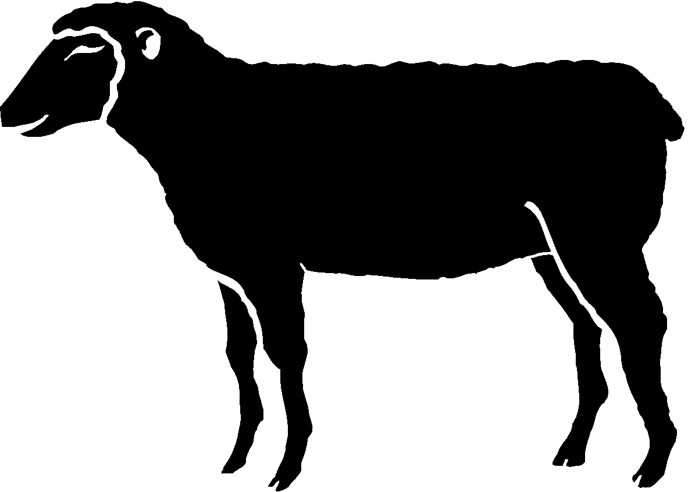
SHEEP
Project Superintendent -
Roger Simpson (812-459-6588)
Use Livestock Record Sheet

SHEEP HEALTH REQUIRMENTS
- SEE GENERAL ANIMAL HEALTH RULES.
2. Posey County 4-H exhibition requires all non-registered animals to have a 5-digit county tag or official Scrapie tag. Registered ewes must have ID that matches their registration papers (official Scrapie tag or tattoo). See the ISF handbook or the latest Clover Connection for additional requirements for ISF entry.
3. Blankets must be removed from all sheep & all wethers must be presented slick shorn for inspection at arrival.
4. No sheep may be exhibited that are showing signs of being infected with ringworm.
5. Entries must be properly entered in 4HOnline by May 15 and in Fair Entry by June 15.

SHEEP CLASSES
Division I: Junior Ram Lambs
- Exhibitors may exhibit 1 animal per class.
- Animals must be born after Jan. 1 of the current year.
- Breed champions will compete for Grand & Reserve Grand Champion Junior Ram Lamb.
Division II: Breeding Ewes
- Exhibitors may exhibit a maximum of 2 animals per category per breed.
- Jr. Ewe Lambs & Yearling Ewe classes will be determined by the 4-H Council upon completion of entries. Single Jr. Ewe Lambs are born after Jan. 1 of the current year. Yearling Ewes are born before Jan. 1 of the current year & are still less than 2 years old at the time of exhibition.
- Breed champions will compete for Grand & Reserve Grand Champion Breeding Ewe.
Division III: Pair of Junior Ewe Lambs
- Exhibitors may exhibit a maximum of one pair.
- There will be a maximum of 8 pairs per class.
- Age requirements are the same as Single Junior Ewe Lambs (listed above).
- All breeds will be shown together.
Division IV: Pair of Yearling Ewes
- Follow the same guidelines as listed for Division III.
Division V: Market Lambs
- Exhibitors may exhibit a maximum of 2 market lambs per weight class. .
- Lambs must be born after January 1 of the current year.
- Market lambs will be shown in weight classes.
- All market lambs must be slick shorn.
- There will be a minimum of 5 animals per class.
- Class champions will compete for Grand & Reserve Grand Champion Market Lamb.
Division VI: Pair of Market Lambs
- Exhibitors may exhibit a maximum of 1 pair of market lambs.
- There will be a maximum of 8 pairs per class.
Division VII: Wool Breed
- Exhibitors may exhibit a maximum of 3 wool breed animals.
- There will be a maximum of 5 animals per class.
- Judging is based on 60% wool & 40% conformation.

SHEEP SHOWMANSHIP
Judged by Senior, Junior, Clover divisions.

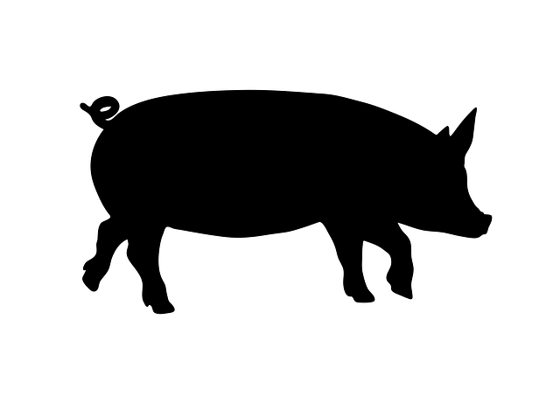
SWINE
Project Superintendent -
Tom Lang (812-480-6345)
Use Livestock Record Sheet
- Pigs must be farrowed after January 1 of current year.
- A 4-H member may exhibit up to 2 gilts &/or up to 2 barrows, for a maximum of 4 hogs per member.
- Slick clipping or body shaving of 4-H barrows & gilts is prohibited. Animals that are slick clipped or body shaved will not be allowed to exhibit. A minimum of ½” of hair on the body of hogs is preferred by the packers that purchase & process these animals. Hogs having less than ½” of hair on their body may be condemned by the processor. 4-H members won’t receive carcass payment for animals that are condemned.
- Due to health concerns, hogs not going through the 4-H Livestock Auction should leave the fairgrounds within 2 hours of the completion of the 4-H Swine show.
- Entries must be properly entered in 4HOnline by May 15 and in Fair Entry by June 15.

SWINE HEALTH REQUIREMENTS
1. SEE GENERAL ANIMAL HEALTH RULES.
2. Posey County 4-H exhibition requires an 840-RFID tag & ear notch. See the ISF handbook or the latest Clover Connection for additional requirements for ISF entry.
3. Testing: Swine that originate within Indiana do not need a brucellosis test or a pseudorabies test for exhibition in Indiana. Swine that originate outside of Indiana do not need a brucellosis test or pseudorabies test as long as the state of origin is classified as brucellosis AND pseudorabies free by the USDA.
4. A CVI is required for swine from outside of Indiana.

SWINE CLASSES
- Classes will be determined by the number of entries and divided into classes by weight.
- Barrow Class champions will compete for Grand & Reserve Grand Champion Barrow.
- Gilt Class champions will compete for Grand & Reserve Grand Champion Gilt

SWINE SHOWMANSHIP
Judged by Senior, Junior, Clover divisions.

Learning by Doing!

2020 POSEY COUNTY 4-H
LIVESTOCK AUCTION DONORS

Alan & Dan Bender Farm
Azteca Milling
Tom & Susan Benton
Rick & Tracy Burks
Clem Dassel & Company
CountryMark
Wendell & Dale Crumbacher
Joe & Maria Eisterhold
Mary Eisterhold
Eisterhold Farms LLC
Expressway
Farm Credit Services
Hawthorne Animal Clinic
Hoehn Farms, Inc.
Tim & Johlene Hoenert
Hoosier Boosters
KB Autoworks. Inc.
Bill & Ruth Ann Lang
Lang Farms, Inc.
Lupfer Ag. Solutions
Martins Farm Drainage
Dennis & Michele Motz
Bret & Trudy Moye
Mulkey Farms, Inc.
Nix Metals
Ryan & Carrie Parmenter
Posey County Co-op
Posey County Farm Bureau
Redman Brothers
David Ries
Steve Reineke
Ries Farms, Inc.
Hans Schmitz
Schneider Funeral Home
Roger & Jaime Simpson
Simpson Seed Service/Stewart Seeds
Superior Ag.
Jeff Tepool
Joe & Ann Tepool
Kent & Susan Wenderoth
Susan Wildeman
WIN Energy REMC

******************************************

POSEY COUNTY 4-H YOUTH MEMBERS SAY “THANK YOU!”
TO THESE LIVESTOCK AUCTION DONORS WHO STEPPED UP IN 2020 TO SUPPORT THEM, DESPITE NOT HAVING AN IN-PERSON FAIR DUE TO COVID-19.

******************************************
EXTENSION HOMEMAKERS'
OPEN CLASS EXHIBIT GUIDELINES
Committee Chairs:
Town & Country, Linda Temme
Movers, Shakers & Modern Homemakers, Rachel Rainey
- All entries are received on Sunday, July 18, 2:00-4:00 PM.
- Open Class Exhibits will be judged Monday morning, July 19.
- Entries may not be checked out before Friday, July 23 at 1:00 PM. Please pick up your exhibits between 1:00 and 6:00 PM that night. Extension Staff & Homemakers are not responsible for items left after 6:00 PM.
- There will be an entry fee of $1 per item.
- If an article is not listed below, it may not be entered for display except in Department XI (Miscellaneous).
- Ribbons will be given to all exhibits. One Special Merit ribbon may be awarded in each category for excellence, with $2 prize money accompanying this ribbon. Each article will be judged on its own merit.
- The decisions of the judges will be final.
- Management will not be responsible for any losses or damages that may occur to the exhibited articles. All exhibits must have been made since the 2020 Posey County 4-H Fair.
- Persons of any age or place of residence are eligible to enter one or more classes. The exhibitor must make the article, or the article may be the work of several people, including the exhibitor.
10. Unless otherwise specified, all food items will be auctioned Monday evening at the 4-H Food Auction. A small portion of the food will be used for judging and display purposes. Food items should be entered on paper plates or aluminum pie pans, as they will not be returned.
11. Food exhibits must follow the 4-H Food Safety Rules. Home-canned fruits, vegetables, or meats are not permitted in products.
12. Recipes must be provided for Dept. VI-Foods.

DEPT. I - SEWING (By Machine)
Garment Construction
Machine Embroidery
Pillows & Pillowcases
Totes, Purses & Bags
Table Runners & Wall Hangings
Miscellaneous
DEPT. II - NEEDLEWORK (By Hand)
Afghans
Crocheted Articles
Counted Cross Stitch
Embroidery (includes crewel work)
Knitting
Smocking
Miscellaneous
DEPT. III - QUILTING
A. Hand Quilted
Embroidered
Machine
Hand
Machine Pieced
Hand Pieced
Appliqué
B. Machine Quilted
Embroidered
Machine
Hand
Machine Pieced
Hand Pieced
Appliqué
C. Small Quilted Articles
Baby Quilts
Throws
Pillows
Table Runners
Wall Hangings
Painted/Preprinted Panels
D. Joint Effort Quilts
Hand Quilted
Embroidered
Machine
Hand
Machine Pieced
Hand Pieced
Appliqué
Machine Quilted
Embroidered
Machine
Hand
Machine Pieced
Hand Pieced
Appliqué
E. MISCELLANEOUS
QUILTING

DEPT. IV - FINE ARTS
Painting- Acrylic, Oil, Water Color
Pastel & Chalk
Pencil Drawing
Pen & Ink Drawing
Sculpture
Miscellaneous
DEPT. V - CRAFTS

A. FABRIC (Not Sewn)
Decorative Flowers
Purses
Soft Structure Articles
Pillows
Sweatshirts
Miscellaneous
B. PAINTING
Textile
Tole Painting
Ceramics
China Painting
Paint-By-Number
Miscellaneous

C. OTHER CRAFTS
Christmas Ornaments
Connectable Building Blocks
Gourd Art
Hanging Decorations
Metal Crafts
Models
Rugs
Scrapbook/Memory Book
Table Centerpieces
Wood Carving
Wood Craft
Wreaths
Miscellaneous
D. RECYCLED CRAFTS OR ART
E. CRAFTS MADE BY CHILDREN

DEPT. VI - FOODS

A. BREAD
Sweet Yeast Bread (6)
Yeast Bread (loaf or 6 rolls)
Quick Bread (loaf, 6
muffins, 6 biscuits, etc.)
Bread Machine
Miscellaneous
B. CAKES
White
Yellow
Chocolate
Sponge
Angel Food
Chiffon
Decorated (appearance only)
Miscellaneous

C. CAKES (CREATED WITH A MIX)
White
Yellow
Chocolate
Sponge
Miscellaneous
D. CANDY
Fudge (6)
Divinity (6)
Miscellaneous (6)
E. PIES (No custard or cream)
Fruit
Miscellaneous
f. COOKIES
Drop (6) Bar (6)
Molded (6) Cut-Out (6)
Refrigerator (6) Other (6)
DEPT. VII - FLOWERS
Specimen Display (single flower) Fresh Flowers bouquet
Dried Flowers Terrariums
Plants
DEPT. VIII - FURNITURE
Upholstering Caning
Refinishing Construction
DEPT. IX - FOOD PRESERVATION
Fruit Jellies, Jams & Preserves Pickles
Juice Vegetables Salsa Wine
DEPT. X - MOUNTED PHOTOGRAPHY
A. BLACK & WHITE B. COLOR C. DIGITALLY ALTERED
Landscape Landscape Landscape
Still Life* Still Life* Still Life*
Portrait Portrait Portrait
Action Action Action
*Inanimate/unmovable object; i.e. flowers, vases, etc.
DEPT. XI - MISCELLANEOUS
A. Collections B. Any item not listed in any other department.
DEPT. XII - CROPS

A. CORN
Stalk
1-Gallon Jar
B. SOYBEANS
3 Plants with roots
1-Gallon Jar
C. WHEAT
20 heads, 10” long
1-Gallon Jar
D. SUNFLOWER
1 head

DEPT. XIII - GARDEN

Beets (5)
Beans (Plate of 20 Pods)
Cabbage (1 Head)
Cantaloupe (1)
Corn (5 Ears)
Carrots (5)
Cucumbers (5)
Eggplant (1)
Peas (Plate of 20 Pods)
Peppers (5)
Onion (5)
Potatoes (5)
Squash (1 Large or 5 Small)
Tomatoes (5)
Watermelon (1)
Other Vegetables
Fruits
Best Basket Display -
Five (5) or more
kinds of vegetables

