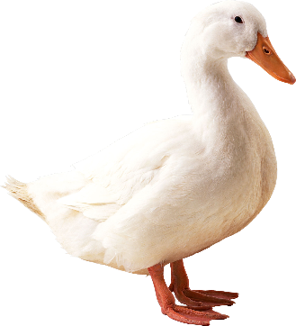
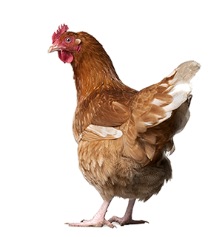
2022 Pike County 4-H
Poultry Enrollment Form
One 4-H Member per form
4-H Member’s Name: ___________________________________________________________
Phone Number: _________________________ Email: _________________________________
 | NAME/NUMBER ID OF BIRD | SPECIES | CLASS | SEX & AGE CLASS | OFFICE
Ex. | Birdie | Barred Rock | Exhibition Hen | F; Pullet
1
2
3
4
5
6
7
8
9
10
11
12
13
14
Please refer to the 2022 Pike County 4-H Scoop for more detailed information.
The 4-H member and parent/guardian signatures certify that these animals are currently in the 4-H member’s possession and are under their care as their 4-H project. Both the parent/guardian and the 4-H member have read the information included within this form along with the rules and regulations in the Pike County 4-H Scoop. The information above is complete and accurate.
_______________________________ _____________ _______________________________ _____________
Date
Signature of Parent/Guardian
Date
Signature of 4-H Member

