This simulation game teaches students how invasive may affect plant populations.
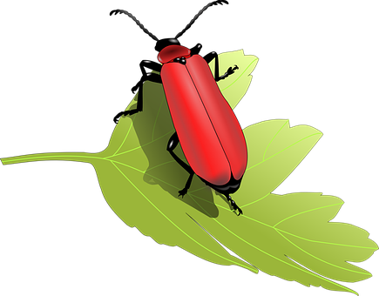

PARTICIPANTS:
- Plants: hold 10 leaves; plants must remain stationary and give up leaves one at a time
- Insects: take single leaf and move to new plant: may not stay at one plant and eat all its leaves
- Predators: When tagged by a predator, insects are out of the game and must sit down
No running!

ROUNDS (Each round = ~1 minute)

1. ROUND ONE:
Normal Populations of Native Species
-Two-thirds of the class: plants
-Three-fourths of the remaining students: native insects
-Remaining students: predators which eat insects
(Class of 20 would have 2 predators, 5 insects, and the rest are plants)
2. ROUND TWO:
Invasive Insects
Discuss how invasive insects often do not have natural predators and reproduce in greater numbers.
-Students who were plants will remain plants, and those who were insects are now invasive insects. Predators will become invasive insects as well, since invasive species are prolific.

3. ROUND THREE:
Use of Pesticides
-Students remain in role as plants or insects.
-Plants should gather 5 leaves marked with X on bottom to denote presence of pesticides and 5 with no X. Do not allow insects to know whether they are getting a marked leaf.
-If insects “eat” a pesticide-marked leaf they are out.

After each round
- Determine how many plants were “healthy” together as a class and decide if invasive species were an issue for the plant population.
Plant condition score:

- 7-10 leaves, healthy plant
- 4-6 leaves, moderate condition
- 1-3, severe damage
- 0 leaves, dead plant

Discussion Questions
- Which scenario yielded the highest number of healthy plants? Why?
- Why are invasive species dangerous to farmers/gardeners/foresters?
- How might diversification of plants help farmers/gardeners/foresters?
- How did pesticides affect the pest populations? How did they help the plants? What is the downside to using pesticides exclusively?
- What is the benefit of quarantine? What is the downside to farmers/gardeners/foresters trying to sell their products?
- What other solutions should be used to control invasive species and protect plants?

Variation Ideas
- Quarantine: Spread plants out as before and designate an area of the room for an insect quarantine. This area may contain some plants, but not all of them. Insects may not leave the quarantined zone.
- Diversification of Plants: Instead of plants being the same species, mark leaves to designate “type” of plant. Insects can only eat one type of plant, such as circles, to illustrate why invasive species are especially devastating to certain species or specific crops.
- Predators & Pesticides: demonstrate how predatory insects can be affected by pesticides
- Quarantine Inspection: Have “insects” try to sneak out of quarantine while some students act as “inspection officials.”

