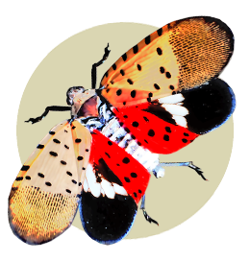
Invasive Species are living things introduced to a place they don’t normally belong which cause harm.
- Plants: Asian honeysuckles, multiflora rose, autumn olive, Callery pear, kudzu
- Insects: emerald ash borer, spotted lanternfly, Asian long-horned beetle, spongy moth
- Animals: Asian carp, zebra mussel, European starling, feral swine, jumping worms
- Diseases: Dutch elm disease, boxwood blight, soybean rust, chestnut blight, oak wilt

Invasive species can threaten our environment, economy, and health. They may:
- Push out native species - and place some at increased risk of extinction
- Reduce biological diversity
- Kill forest trees
- Damage crops
- Cost industry and government millions of dollars in treatment expenses
- Endanger personal health (stings - imported fire ant; meningitis - giant African snails; rash - poison hemlock)

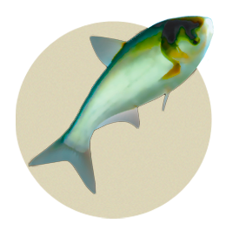
How they spread:

- Baggage
- Plants and plant parts
- Internet sales
- Firewood
- Outdoor gear
- RVs
- Moving
- Pet release

What can I do?
- Clean, Drain, Dry.
  - Clean mud and plants from boots, bikes, boats, fishing hear, and sports equipment
  - Drain water from boats and watercraft
  - Let gear dry before using in a new place
- Don’t move firewood.
- Be a responsible traveler: don’t bring plants, produce, seeds, or soil from trips and check for hitchhiking insects.
- Garden wisely by choosing native or non-invasive plants for landscaping and remove invasive plants from your yard.
- Don’t release pets into the wild, including fish, reptiles, and snails.
- Check purchases: use caution when buying plants online.
- Report sightings of new invasive species to DNR. Early detection reduces spread.
- Volunteer for “weed wrangles” or other events.

