3-14-2024 Feature



By Dena M. Held

County Extension Director & Extension Educator – 4-H Youth Development

Martin County

Text | 812-653-2089

Voice | 812-295-2412

E-mail | [heldd@purdue.edu](mailto:heldd@purdue.edu)

Purdue University, Indiana Counties and U.S. Department of Agriculture Cooperating

An Affirmative Action/Equal Opportunity Institution

**4-h member Jones attends 4-H Day at the indiana Statehouse repsenting MARTIN County**

Phoebe Jones, Martin County 4-H Member and 7th grade student at Loogootee Middle School, recently attended 4-H Day at the Statehouse.

In regards to the educational program, Jones said “I went to the 4-H Statehouse Day to represent Martin County. I learned more about how our state government runs. The Day was a great learning experience and a lot of fun. I definitely plan on attending again, because I had fun, learned a lot, and the food was great!”

She went on to say, “Other kids should plan on attending with me next year because it is a free day out of school, they will learn about our state policies and how laws are made, and it’s a great opportunity to connect with others like themselves.”

As part of learning civic engagement across disciplines in building college and career pathways, Jones and others had the opportunity to visit the Integrated STEM breakout session. The session included representatives from Crane Naval Base, the Joint Hypersonics Transition Office, Crane Army Ammunition Activity (CAAA), Naval Surface Warfare Center (NSWC) and The National Security Innovation Network (NSIN).

“It was an honor to share information about NSA Crane and all of our Team Crane partners and commands to both the 4-H Students and state leaders. The installation is excited to provide opportunities for STEM and career awareness events and to continue to engage communities, schools, and the state in collaborative initiatives in the future.” – Mark Dobbs, NSA Crane Community Planning Liaison Officer.

Installation Public Affairs Officer for NSA Crane Bruce Drake shared, “It was a pleasure to meet all the 4-H Student Ambassadors from around the state who came to Indianapolis and learn from them what they are looking for in future STEM positions and how Naval Support Activity Crane and its partnered Army and Navy commands that are on the installation may meet their desires to work within those fields here in the State of Indiana.”

Jones is the daughter of Sarha Jones and Dakota Simmerman. Jones is an avid 4-H member, where she proudly shares that 4-H is a great place where kids can come together to learn how to problem solve, work together, and have a good time.

Pictured below left to right:

Bruce Drake, Public Affairs Officer, Navy Support Activity Crane; 4-H Member Phoebe Jones &

Mark Dobbs, NSA Crane Community Planning Liaison Officer.

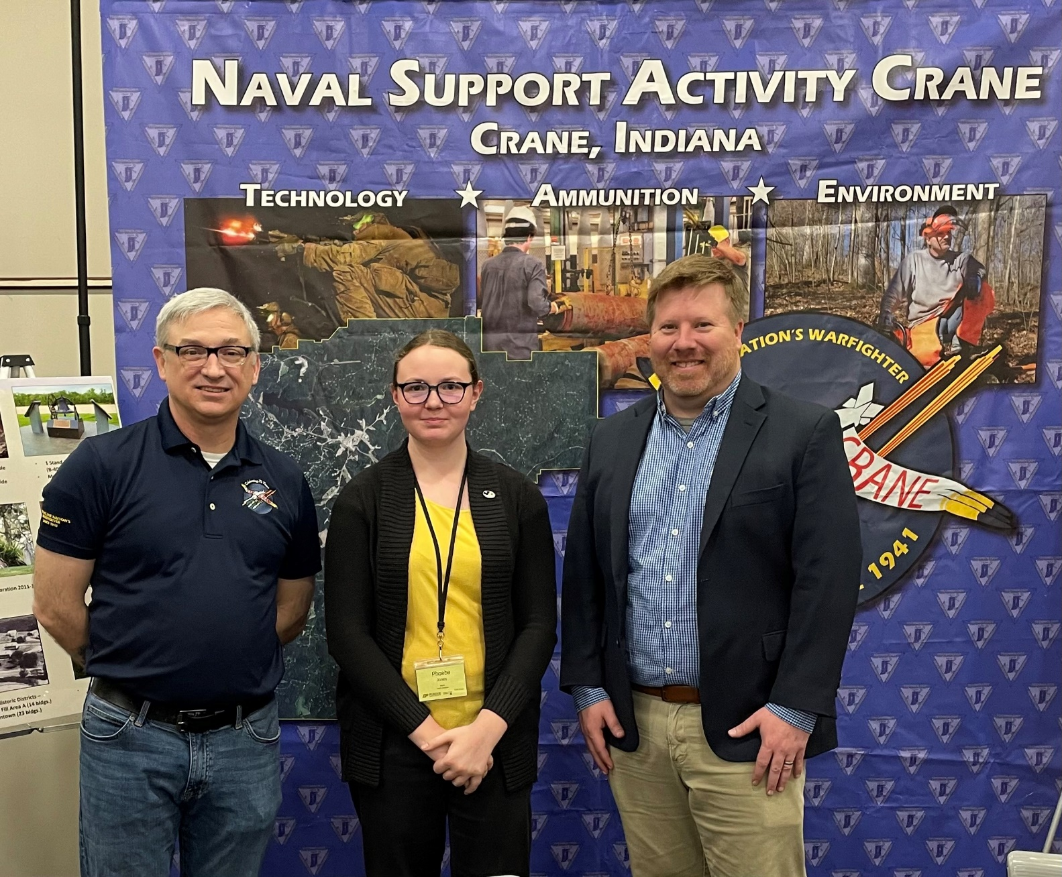

This Purdue Extension Martin County highlight is provided to help all learn

about specific programs, opportunities, and experiences.

Purdue University & Extension

hope you will choose to be part of Extension…. where there is Opportunity4All!