6-23-2024



Martin County 4-H Shooting Sports Feature

June 2024

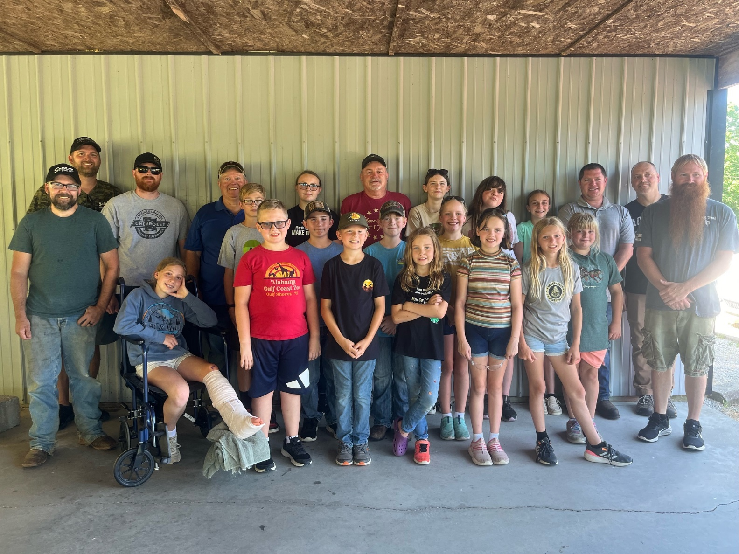

The Martin County 4-H Shooting Sports Club competed in the County 4-H Shoot Off in June.

Pictured are 4-H volunteers and 4-H members:

Robert Dages, Ivy Phillips, Jase Dages, Silas Sanders, Elizabeth Jones, Harper Tinkle, Kimber Padgett, Oliver Padgett, Harry Richer, Cash Hembree, Hadley Tinkle, Lily Phillips, Nick Hembree.

Robert Dages, Tyler Stivers, Corey Padgett, Charlie Brown, Phoebe Jones, Mark Sims, Delilah Stivers, Elysse Brown, Brylee Bateman, CJ Brown, Jason Tinkle.

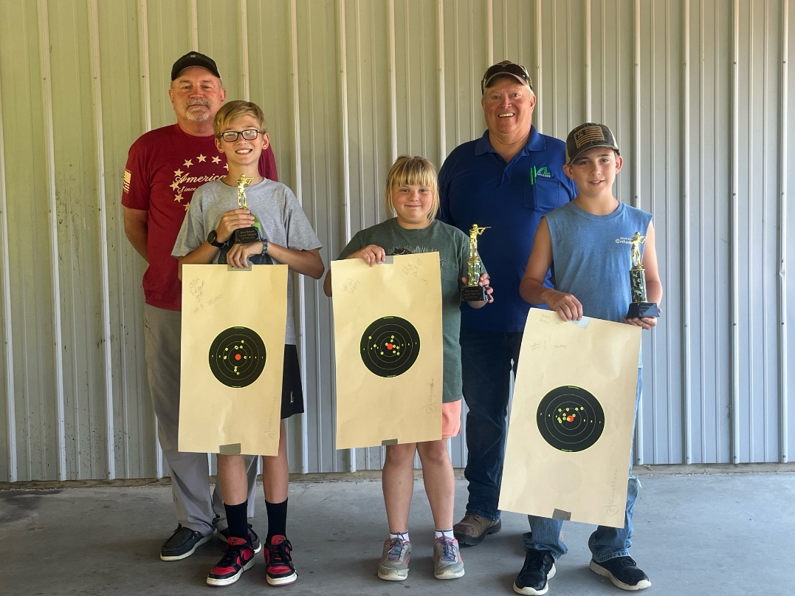

Left to right front row 3rd place Oliver Padgett 96 out of 100, 2nd place Lilly Phillips score 96 out of 100 closest to bullseye tie breaker, 1st place Harry Richer score 97 out of a 100.

Back Row Mark Sims 4-H Shooting Sports Coordinator, Charlie Padgett 4-H Rifle Instructor.

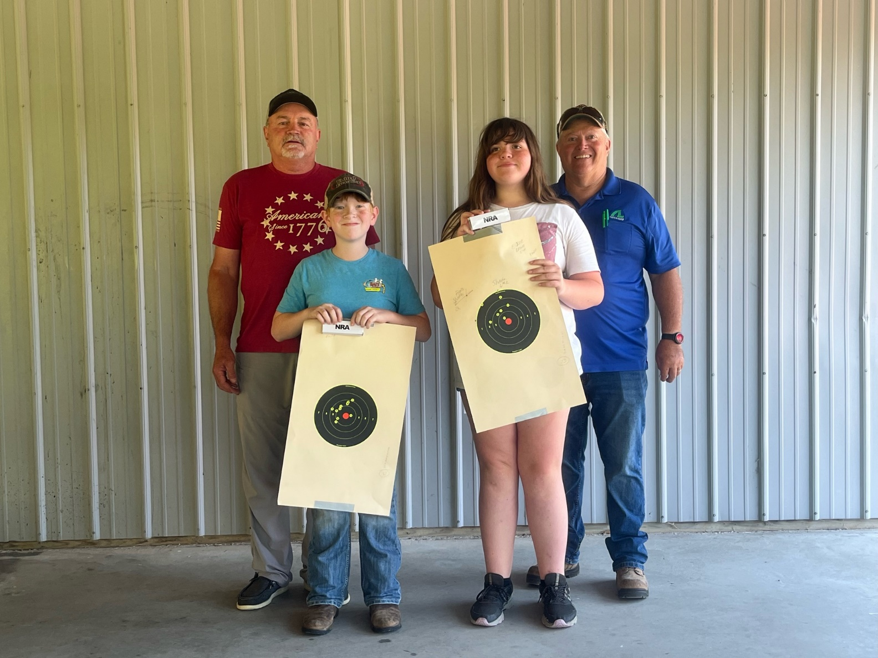

High point winners' junior division NRA pocketknife Cash Hembree, Elyse Brown.

Back Row Mark Sims 4-H Shooting Sports Coordinator, Charlie Padgett 4-H Rifle Instructor.

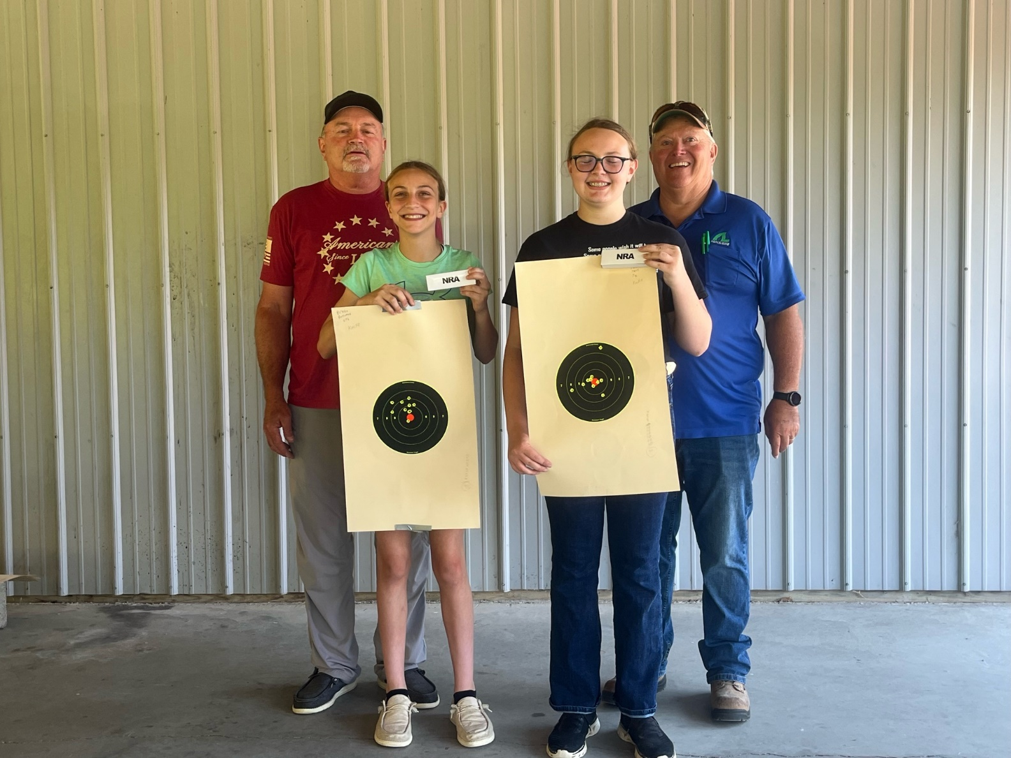

High Point winners Intermediate Division NRA pocketknife. Brylee Bateman, Phoebe Jones.

Back Row Mark Sims 4-H Shooting Sports Coordinator, Charlie Padgett 4-H Rifle Instructor.

Purdue University, Indiana Counties and U.S. Department of Agriculture Cooperating

An Affirmative Action/Equal Opportunity Institution

This Purdue Extension Martin County feature column is provided to celebrate adults who work with youth to make the best better!

We hope you too will choose to be part of Extension and 4-H .…. where there is Opportunity4All!