4-19-2024

This Purdue Extension Martin County feature is provided to help all learn
about programs & opportunities. We highlight the people, events and programs from Purdue University Extension. We hope you will choose to be part of Extension….where there is Opportunity4All!

MARTIN COUNTY 4-H YOUTH PERFORMING ARTS CONTEST HELD IN
CONJUNCTION WITH THE MARTIN COUNTY CHILDREN’S MENTAL HEALTH FAIR

The Martin County 4-H Youth Performing Arts Contest & the Martin County Children’s Mental Health Fair was held on Thursday, April 18th at The Martin County 4-H Fairgrounds & Event Center. More than twenty vendors and upwards of 100 attendees enjoyed the youth performances presented by twenty-one 4-H members. Everyone shared in resources knowledge growth to support children’s health & wellness. It was a fun evening with immense cooperation and collaboration to bloom together in this springtime! The Hidden in Plain Sight trailer was incorporated and available all evening for adults to tour and learn about some devastating trends in child drug and alcohol abuse.

The Jolly Jug Rox Club, led by Mimi Hawkins, Audra Deckard, & Rhonda Sanders presented “Are You Smarter Than A 4-H'er,” a seven-minute skit featuring Club Members: Riley Andis, Aydan Haulk, William Hert, Hunter Hilderbrand, Eyan Hovis, Elizabeth Jones, Phoebe Jones, Ray Money, Lucas Neideffer, Acelynn Rice, Casper Rice, Anniston Taylor, Lane Taylor, Luke Troutman, Wes Troutman, Alysse Wadsworth, Nathaniel White, & Sabastian White.

A Curtain Musical Act was presented by 4-Her Eva Ringwald titled “Beauty and The Beast Instrumental. ”

A Curtain Non-Musical Act was presented by 4-Her’s Elizabeth Jones & Phoebe Jones titled “Bedtime Chaos.”

All three Martin County acts are qualified to advance to Area 3 Contest. Congratulation’s performers!

The Area 3 Contest will be held Friday, May 3, 2024 at Jasper Middle School Auditorium 3600 N Portersville Rd. Jasper, Indiana and is open to the public beginning at 6:15 p.m. CT/7:15 p.m. EST. Judges at this contest will select two acts and one alternate to perform at Purdue University 4-H Round Up in June.

Thank you to Edward Jones / Brent Courter and RTC Communications for their financial support of the event. The Martin County Children’s Mental Health Fair was brought to Martin County by The Family Health Center with support from FSSA Division of Mental Health & Addiction, Purdue Extension and Martin County 4-H.

About Performing Arts: 4-H Performing Arts Event is an entertaining event designed to allow 4-H members to exhibit their talent in a fun way. Categories include musical, non-musical, and group acts. Examples of a 4-H Performing Arts acts include singing, dancing, playing a musical instrument, and performing a funny skit. A limited number of performances at an area event are invited to perform at 4-H Round-Up.

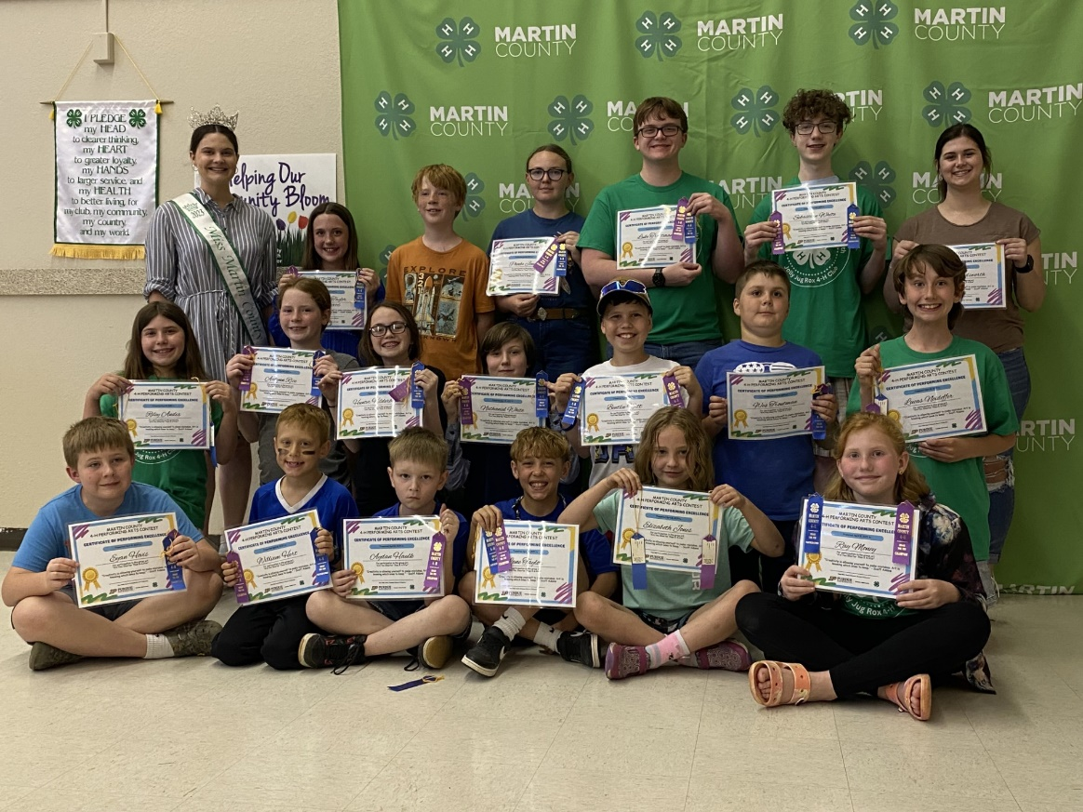

Pictured are members of the group act “Are You Smarter than a 4-H?” skit. Eyan Hovis, William Hert, Aydan Haulk, Lane Taylor, Elizabeth Jones, Ray Money, Riley Andis, Acelynn Rice, Hunter Hilderbrand, Nathaniel White, Bentlee Witt, Wes Troutman, Lucas Neideffer, Miss Martin County 2023 Cheaney Archer, Anniston Taylor, Casper Rice , Phoebe Jones, Luke Troutman, Sabastian White, & Alysse Wadsworth.

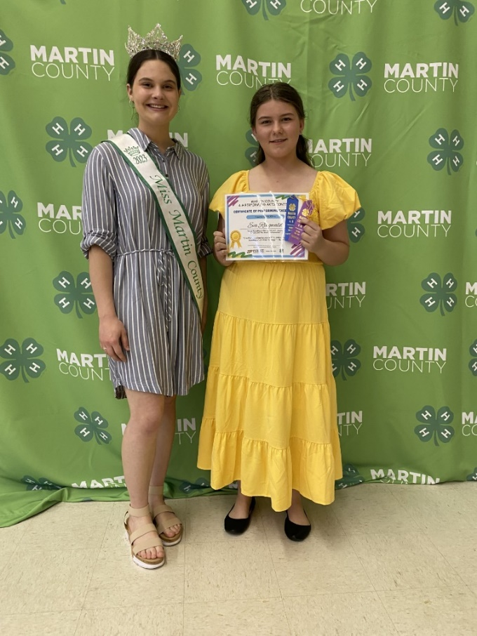
Eva Ringwald and Miss Martin County 2023 Cheaney Archer.

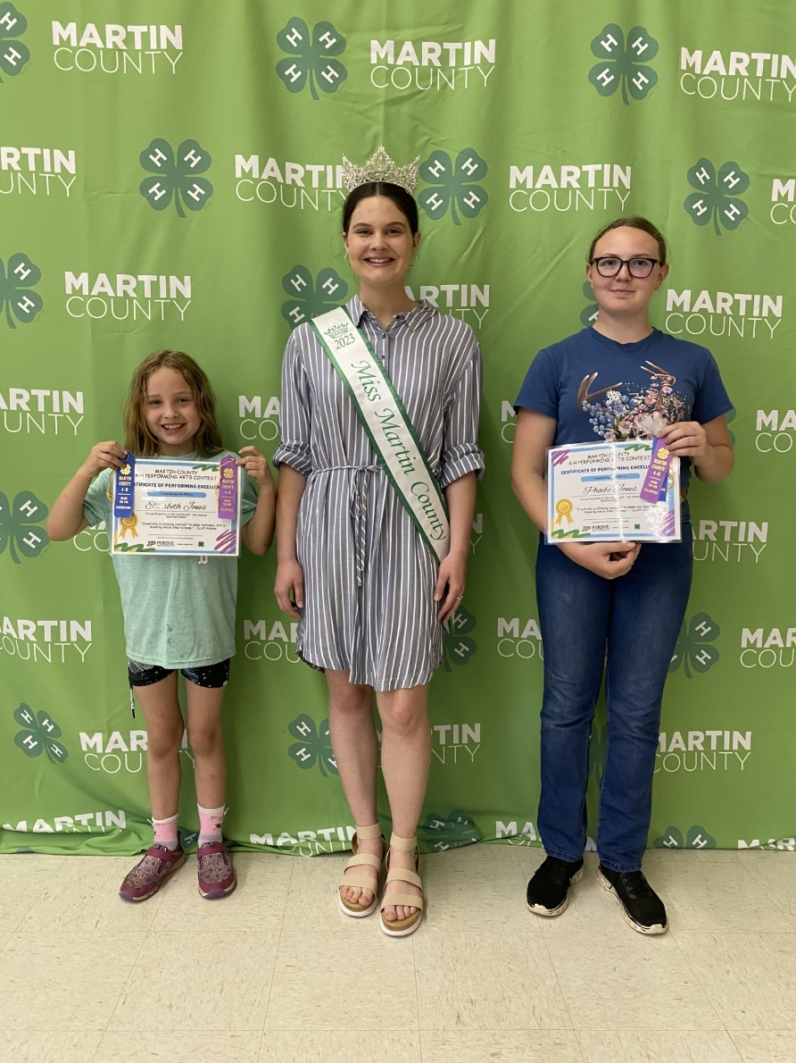
Elizabeth Jones, Miss Martin County 2023 Cheaney Archer, and Phoebe Jones.

By Dena M. Held
County Extension Director & Extension Educator
Martin County
Text | 812-653-2089
Voice | 812-295-2412
E-mail | heldd@purdue.edu

Purdue University, Indiana Counties and U.S. Department of Agriculture Cooperating
An Affirmative Action/Equal Opportunity Institution

