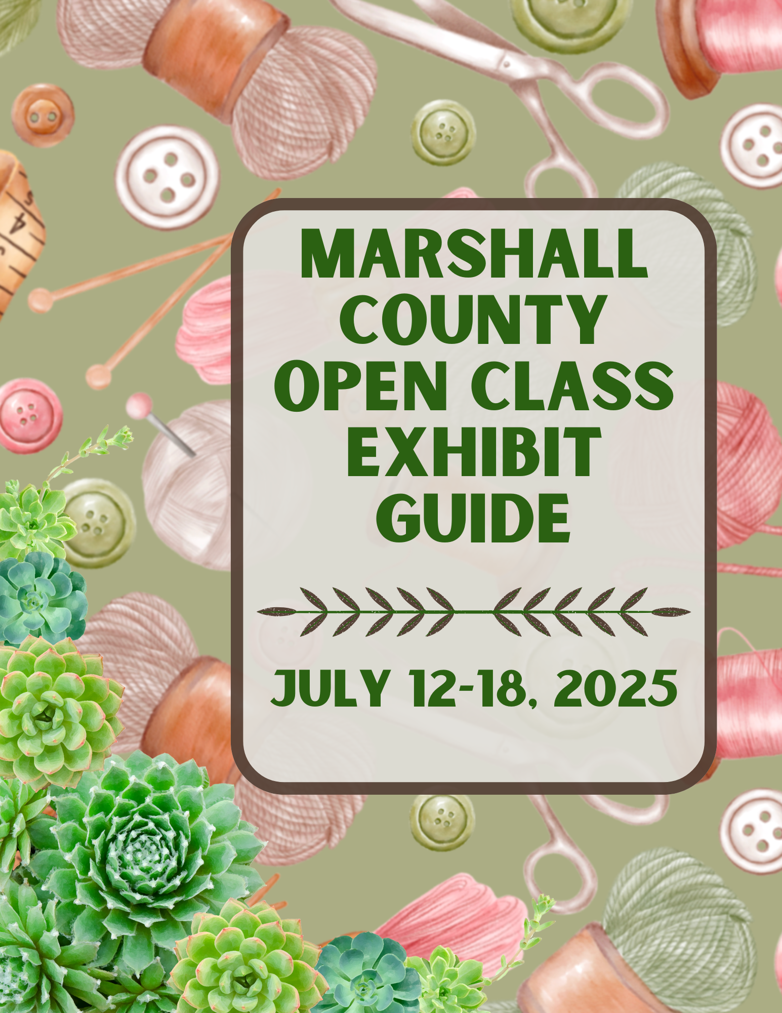

OPEN CLASS RULES AND REGULATIONS

- Rules and regulations must be followed as stated or exhibits will not be accepted at check-in. Several changes have been made to this exhibit guide so please read and follow these rules.
- Open to anyone, not just Marshall County residents, who are not participating in 4-H.
- Articles for exhibit must have been completed in the last three years, not previously exhibited at the Marshall County Fair, and made solely by the exhibitor unless otherwise stated.
- Food Preservation items must have been preserved within the last 12 months.
- Exhibitors may enter as many items as you like, however, some departments and sections have limited entry numbers.
- Items must be placed in the appropriate category. Miscellaneous categories are for items that do not fit in any other specific category. Superintendent may change an item’s category if they deem it more suitable for another.
- Artwork containing content and/or subject matter termed objectionable by the Open Class Superintendent will not be displayed.
- Your items will be handled with care; however, Marshall County Fair is not responsible for items that are damaged while on display during the fair.
- Entry sheets and score sheets along with the judge’s comments will be placed in a locked file until exhibits are released.
- No item can be entered with a “For Sale” sign or price tag on it.
- Entry dates and times:
FRIDAY, JULY 11, 2025
9:00 AM – 12:00 PM - ALL Entries will be accepted in the Open Class Building at the fairgrounds in Argos. No late entries will be accepted!
12:30 PM – Closed Judging for ALL exhibits will take place

SATURDAY, JULY, 11, 2025
5:00 PM – 9:00 PM Exhibits may begin to be viewed

FRIDAY, JULY, 18, 2025
9:00 AM – 11:00 AM – Release of ALL Exhibits. We are not responsible for items not claimed by 11:00 AM!

Open Class Superintendent

Donna Kubacki, Superintendent 574-220-6708

If you have any questions, please contact Donna Kubacki.

Please Remember:
All entry forms for Open Class, Bake-A-Rama, and Ice Cream Crank Off, along with the Exhibit Guide, are available on the Purdue Extension website: https://extension.purdue.edu/Marshall under Health and Human Science

Little Hands
■ For children who have not entered 3rd grade. Older children, grade 3 and above, should enter the same exhibits as adults.

☺ Handcrafts ☺ Fiber Art
☺ Cookies ☺ Vegetables
☺ Flowers ☺ Scrapbooking
☺ Collectibles ☺ Model Building
☺ Creative Arts

Christmas at the Fair
■ Any Christmas themed item MUST be entered under this department.
► Fiber Arts
50 – Clothing
51 – Quilted or Pieced Article
52 – Other

► Needle Arts
60 – Counted Cross Stitch
61 – Crochet
62 – Knit
63 – Embroidery
64 – Other

► Christmas Arts
70 – Ceramics
71 – Tree Ornament(s)
72 – Table Top Scene (not to exceed 30”x30”)
73 – Wall or Door Decoration (not over 42” sq., ready to hang)
74 – Wooden Craft (not to exceed 6” in height)
75 – Wreath
76 – Other

Basic Crafts
►Ceramics (single item or related set, no more than 5 items)
100 – Painted
101 – Glazed
102 – Hand Formed
103 – Other

►Home Decorations
110 – Wall or Door Decoration (other than fabric or wreath, (ready to hang)
111 – Table Centerpiece
112 – Fabric – no sewing
113 – Wreath (ready to hang)
114 – Diamond Art
115 – Other

►Decorative Crafts
120 – Glass Etching
121 – Bird House - other than wood
122 – Decorated Gourds – not birdhouse
123 – Paper Crafting
124 – Leathercraft
125 – Other

►Construction Crafts
130 – Bead Work – scarves, flowers, baskets, etc
131 – Handcrafted Jewelry
132 – Baskets (all kinds)
133 - Other

►Woodworking
140 – Woodcrafts – small item (18”)
141 – Woodcrafts – large item (18” and over)
142 – Bird House – new or used wood
143 – Bird Feeder – new or used wood
144 – Refurbished
145 – Other

►Painting & Drawing
160 – Paint by Number (ready to hang)
161 – Preprinted Pattern (any media, (ready to hang)
162 – Painted Clothing
163 – Folk Art Painting – framed, (ready to hang)
164 – Tube Painting
165 – Stenciling – any article
166 – Other

►Pottery
170 – Earthenware
171 – Polymer Clay
172 – Other

►Recycling
180 – Wall or Door Decoration – small item (under 18”) (ready to hang)
181 – Wall or Door Decoration – large item (18” and over) (ready to hang)
182 – Table Centerpieces
183 – Wreath
184 – Furniture
185 – Other

Fine Arts
Artwork containing content and/or subject matter termed objectionable by the Open Class Superintendent will not be displayed.
►Painting & Drawing
(Original work only. All exhibits must be ready for hanging with eyelets and wire. Incomplete mounts or frayed wire will not be accepted).
■Painting
Canvas paintings should have a finished look of either clean white edges or fully painted edges.
200 – Acrylic
201 – Watercolor
202 – Oil
■Drawing
Artwork should be framed and ready to be hung.
203 – Pencil
204 – Ink
205 – Other
►Photography
■ Any photograph not meeting these guidelines will be disqualified.
■Salon Print
Minimum image area of 8” x 10” to a maximum of 16” x 20” printed horizontally or vertically. The print must be mounted on a standard 16” x 20” salon mount, foam board displayed VERTICALLY and covered with plastic. Salon plastic sleeves can be purchased at the Extension Office at a minimal cost. No matting allowed.
210 – Photography – black & white – 1 salon print
211 – Photography – color – 1 salon print

■Multiple Prints
From 2 up to 10 pictures, 4’ x 6’ or 5’ x 7’, printed horizontally or vertically. The prints must be mounted on a background foam board 22” x 28”, displayed HORIZONTALLY, with foam board and covered with plastic sleeve.
212 – Photography – black & white – prints
213 – Photography – color – prints

Fiber Arts
■ Please enter all afghans, regardless of stitch type, in afghan section.
►Knitting
300 – Single article of clothing - sweater, vest, etc.
301 – Set of 2 or 3 Pieces - scarf, hat, gloves or mittens
302 – Other

►Crocheting
310 – Single article of clothing - sweater, vest, etc.
311 – Set of 2 or 3 Pieces - scarf, hat, gloves or mittens
312 – Filet
313 – Tablecloth or Spreads
314 – Doilies
315 – Other

►Afghans
320 – Knit
321 – Crochet
322 – Mixed stitch
323 – Other

►Counted Cross Stitch
(Size refers to stitched design only – not to include excess fabric, mat or framing. All framed exhibits must be ready for hanging with eyelets and wire. Incomplete mounts or frayed wire will not be accepted).
330 – Picture or Wall Hanging (11”x14” and under)
331 – Picture or Wall Hanging (larger than 11”x14”)
332 – Other

►Embroidery
340 – Traditional Floss, (24”x24” or under)
341 – Traditional Floss, (larger than 24”x24”)
342 – Nontraditional Floss and Mixed Threads
343 – Silk Ribbon
344 – Other

►Weaving
350 - Articles of Clothing
351 - Any flat piece of loomed work done on a warp
352 – Raw fibers- unconstructed
353 - Other

►Rugs
360 – Hooked
361 – Braided
362 – Mixed
363 – Other

►Miscellaneous Needle Art
370 – Any item - crewel, latch hook, tatting, etc.

Quilts
■ Must be quilted, clean, and in good condition. This refers to all quilts, including infants. Please have quilts folded right side out, ready for judging.
►Appliqué
400 – Hand Quilted
401 – Machine Quilted
402 – Wall Hanging, Hand Quilted
403 – Wall Hanging, Machine Quilted
404 – Quilted by Someone Else

►Pieced
410 – Hand Quilted
411 – Machine Quilted
412 – Wall Hanging - hand quilted
413 – Wall Hanging - machine quilted
414 – Paper Pieced/Foundation Piecing
415 – Quilted by Someone Else

►Combination of Appliqué & Pieced
420 – Hand Quilted
421 – Machine Quilted
422 – Wall Hanging - hand quilted
423 – Wall Hanging - machine quilted
424 – Quilted by Someone Else

►Combination of Embroidery
430 – Hand Quilted
431 – Machine Quilted
432 – Wall Hanging - hand quilted
433 – Wall Hanging - machine quilted
434 – Quilted by Someone Else

►Miscellaneous
450 – Any quilt pieced but not quilted by exhibitor
451 – Any hand quilted quilt not pieced by exhibitor
452 – Wearing Apparel - quilted
453 – Pillow - quilted
454 – Placemats, Wall Hangings, etc. - quilted
455 – Purse or Totes
456 – Other

►Knotted
470 – Comforters
471 – Lap Quilts
472 – Other

Clothing and Sewing
CLOTHING SHOULD BE ON HANGERS & COVERED WITH PLASTIC BAG.
►Clothing
500 – Dress
501 – Pants, Skirt or Trousers
502 – Blouse, Top or Shirt
503 – Separates (2 or more pieces)
504 – Lounge or Sleepwear
505 – Active Sportswear
506 – Suit or Coat
507 – Sweatshirt or T-shirt - reconstructed
508 – Special Occasion
509 – Blazer or Sports Jacket
510 – Other

►Appliqué
520 – Hand Appliqué
521 – Machine Appliqué
522 – Both

►Miscellaneous
530 – Doll
531 – Stuffed Article
532 – Purses/Bags
533 – Recycled Clothing
534 – Other

Foods
■ For food competitions: Filling, frosting, glazing, pie filling, and meringue, (whether uncooked or cooked) are not permitted to contain cream cheese, sour cream, heavy cream, whipped cream or half-and-half as the nature of these products increases the moisture content and water activity of the food. Foods with a higher moisture content and water activity can be ideal growing conditions for food borne pathogens, even if the ingredient is part of a batter and baked. Additionally, raw milk, raw milk products or uncooked eggs/egg whites are not permitted. Eggs/egg whites that have been cooked to 160 degrees F (i.e. pasteurized or included as part of a batter and baked) are acceptable. No home-canned fruits, vegetables, or meats are permitted in products. Recipes must be provided that show which ingredients were used in each part of the product. Contestants should carefully wash their hands and make sure that their hands do not have any open cuts before preparing foods. Contestants should not be preparing food exhibits for competition within 48 hours of recovering from any illness. Whenever possible, baked products should be transported and stored in chilled coolers (41 degrees F).
■ Judges and individuals who will consume products from county and state competitions should be informed that they are at risk for foodborne illness since the established policy cannot guarantee that an entry which may be a "potentially hazardous food" has been properly prepared or handled before, during or following the competition. Tasting of a food product is solely at the discretion of the judge. Judges are NOT to taste any low-acid or acidified preserved food, like green beans or tomato products, and are discouraged from tasting any other home preserved food. Consumers of competitive food exhibits being sold at auction or used for hospitality purposes should be notified they could be at risk for foodborne illness since the established policy cannot guarantee that an entry which may be a “potentially hazardous food” has been properly prepared or handled before, during, or following the competition.
■ Please bring recipe printed or typed on 8½ x 11 paper for judging. DO NOT INCLUDE PERSONAL INFORMATION ON RECIPE. Food must be covered to avoid airborne contamination.
■ All baked goods not handled by the judge or displayed will be sold at the Sweet Tooth Bake Sale following judging.
■ Store bought mixes are not permitted in the creation of any recipes except for those in the special cake category.
■ All foods MUST be displayed on stiff foil covered cardboard, unless otherwise stated. It MUST be COMPLETELY COVERED BY INSERTING in a re-sealable bag or cake box.

►Cookies
6 cookies on an 8-9 inch stiff, foil covered cardboard. Bar cookies approximately 1”x2”.
600 – Brownies/Bar
601 – Drop Cookies
602 – Filled or Shaped
603 – Other

►Cake Decorating
Cake forms are required. Display board, cake form, including decorations, not to exceed 24” high. Cake board not to exceed 18” in diameter. Frosting recipe required on 8 ½ x 11 sheet of paper.
Description of what each decoration is made of must be listed.
610 – Any Occasion

►Cakes
Place each cake on stiff, foil-covered cardboard or cake board. Cream frostings are not acceptable.
620 – Angel Food / Chiffon - unfrosted
621 – Chocolate
622 – White
623 – Bundt
624 –Other

►Pies
Bake pies in disposable aluminum foil pie pans. Whipped cream toppings or cream cheese toppings are not acceptable. Home canned fruit is not acceptable. Crust must be homemade.
630 – Fruit
631 – Nut
632 – Other

►Breads
No packaged or premade dough. Each exhibit should be placed on stiff, foil covered cardboard.
■Yeast Bread
640 – Any Kind
■Yeast Dough
641 – Any Sweet / Dinner Roll (6)
642 – Other
■Machine Breads
643 – Any Kind

►Quick Breads
Placed on stiff, foil-covered cardboard.
650 – Fruit / Nut / Vegetable
651 – Muffins (6 not baked in muffin papers)
652 – Coffee Cake
653 – Other

►Candy
6 pieces on stiff, foil covered cardboard. No tofu may be included.
660 – Any Fudge
661 – Molded
662 – Other

►Made from Mix- Enhanced
670 – Cookies / Bars
671 – Cake
672 – Quick Breads
673 – Other

Food Preservation
■ Must be in plain, standard jelly glasses or standard canning jars (no salad dressing or peanut butter jars, etc.) with new lids and rings.
■ Recipes must be submitted for all food preservation categories printed or typed on an 8 ½ x 11 paper with the exhibit, including processing method, time & temp according to USDA recommendations. Contact the Extension Office for the current USDA canning regulations and head space. No personal information (name, etc.) on recipe.
■ Mark containers with the name of the item and the month and year of processing.
■ Food Preservation items must have been preserved within 12 months.

►Section 1
700 – Jams
701 – Jellies
702 – Honey
703 - Other

►Section 2
710 – Fruit
711 – Vegetable
712 - Other

►Section 3
720 – Soups
721 – Canned Meat (including mincemeat)
722 – Juices
723 - Other

►Section 4
730 – Pickled Food

►Section 5
740 – Relishes
741 – Sauces
742 – Other

►Section 6
750 – Dehydrated Food

Plants & Flowers
■ All exhibits must be homegrown by the exhibitor. After judging, exhibits may be freshened at the discretion of the exhibitor. Potted plants should have been potted at least 2-3 months before the fair. Pots/containers are an integral part of judging – they should “fit” the style of plant. Can be single plant or variety.

There is a three (3) entry limit per section number in this department. No personal vases will be used.

►Potted Plants (including hanging baskets)
800 – Foliage Plants
801 – Succulents
802 – Flowering House Plants (includes African Violets)
803 – Terrariums
804 – Potted Garden Flowers
805 – Other

►Cut Single Stem Garden Flowers
Flowers: Singular
810 – Zinnia
811 – Marigold
812 – Petunia
813 – Bee Balm
814 – Rose
815 – Other

Flowers: Multiple Petals
820 – Sunflower
821 – Coneflower
822 – Dahlia
823 – Poppy
824 – Rudbeckia
825 – Daisy
826 –Other

Flowers: Multiple Florets
830 – Foxglove
831 – Geranium
832 – Hosta
833 – Hydrangea
834 – Phlox
835 – Other

Flowers: Bulbs
840 – Asiatic Lily
841 – Daylily
842 – Lucifer
843 – Tubers
844 – Corms
845 – Other

Gardening
■ All exhibits must be homegrown by exhibitor. Garden produce should be fully mature. VARIETY OF
VEGETABLES ON ENTRY TAG REQUIRED. This is helpful for judging. Plates for exhibits will be furnished. DO NOT wash or scrub! (Examples of varieties: Big Boy Tomato, Black Beauty Eggplant, Burpless Cucumber, Seneca Daybreak Corn.)

►Collections
900 – 3 Kohlrabi
901 – 3 Red Beets
902 – 3 Potatoes (Red, White or Other)
903 – 3 Onions (Yellow, White, Red, or Other)
904 – 3 Carrots
905 – 3 Cucumbers (Pickling or Other)
906 – 3 Tomatoes (Regular, Salad, or Other)
907 – 9 Cherry Tomatoes
908 – 3 Peppers (Green, Yellow Banana, Hot, or Other)
909 – 3 Ears Corn (Sweet, Indian, Popping)
910 – 10 Beans (Yellow Wax, Green, Other)
911 – 3 Other

►Singles
920 – 1 Head Cabbage (green or red)
921 – 1 Eggplant
922 – 1 Squash (zucchini, summer, winter, other)
923 – 1 Head Broccoli
924 – 1 Head Cauliflower
925 – Other

►Potted Fruits & Vegetables
Must be bearing fruit or vegetables
930 – Single Potted Plant
931 – Potted Collection

►Herbs
Must be grown by the exhibitor.
940 – Single Stem (mint, basil, tarragon, etc.)
941 – Dried
942 – Other Annual
943 – Other Perennial/Biennial
944 – Single Potted Plant
945 – Potted Collection
946 – Other

Open Class Activities:
Not only is there a wide variety of competitive classes within the Open Class Exhibit Building, there are also additional activities that exhibitors are encouraged to try including the Bake-A-Rama and Ice Cream Crank Off. Each of these activities has a specific set of rules that participants are expected to acknowledge.

Peach:
Get out the recipe books and try that unique new baked creation. Then bring it to the Bake-A-Rama on Wednesday, July 16, 2025 at the Marshall County Fairgrounds. Entries will be accepted in the Open Class Building from 9am – 12 noon with open judging beginning at 12:30pm. This year’s categories include cookies or bars, cakes, pies, quick breads or muffins and crisps or cobblers. Cash prizes are awarded to 1st, 2nd, and 3rd place winners in each category, as well as the overall Grand Champion and Reserve Grand Champion. These items will be auctioned off at 6:00 PM. Safe food preparation guidelines must be observed. Stop by the Extension Office today and pick up an entry form that includes all the rules and regulations or visit our website.

Butter Pecan Ice Cream Crank Off:
Each year the Marshall County Dairy Association sponsors a homemade ice cream crank off. This year’s crank off will take place on Sunday, July 13, 2025. Check-in is 12:30 – 1:00 PM, with cranking beginning at 1:00 PM. All entrants must be finished by 3:00 PM. Prize money is awarded to the winners. Safe food preparation guidelines must be observed.

Things you need to know…

Enter as many items as you like as there is no longer a one item per section number limit except the following categories: Flowers and Gardening.

FRIDAY, JULY 11, 2025
9:00 AM – 12:00 PM - ALL Entries will be accepted in the Open Class Building at the fairgrounds in Argos. No late entries will be accepted!
12:30 PM – Closed Judging for ALL exhibits will take place

FRIDAY, JULY 11, 2025
5:00 PM – 9:00 PM Exhibits may be viewed

FRIDAY, JULY, 18, 2025
9:00 AM – 11:00 AM – Release of ALL Exhibits.
We are not responsible for items not claimed by 11:00 AM!

Volunteers Needed
The Marshall County Open Class Exhibits are coordinated by gracious volunteers. However, we can always use more hands! Please consider donating a couple hours of your time. To volunteer, call Donna Kubacki at 574-220-6708.
Thank you!

Exhibitor #
ENTRY FORM FOR THE 2025 OPEN CLASS EXHIBITS

PLEASE FILL OUT THIS FORM AND TAKE WITH YOU WHEN YOU ENTER PROJECTS
DO NOT RETURN THIS FORM TO THE EXTENSION OFFICE

NAME:___________________________________PHONE:_____________________________
ADDRESS:____________________________________________________________________
CITY:_____________________ZIP:________________________TOWNSHIP:_______________

DEPARTMENT  (Title in the box) | DIVISION  (Title after the arrow) | SECTION  (Number) | CLASS  (Word after the number) | ARTICLE  (If item needs more description than class)
FOOD | PIES | 630 | FRUIT | APPLE
GARDENING | COLLECTIONS | 910 | CUCUMBERS | BURPLESS
CHRISTMAS AT THE FAIR | CHRISTMAS ITEM | 70 | CERAMICS | SANTA CLAUS

Name of person picking up the exhibit:

_________________________________________________________________________________________

ENTRY FORMS MUST BE FILLED OUT PRIOR TO BRINGING IN ENTRIES
NO LATE ENTRIES ACCEPTED AT THE FAIR

SHEET MAY BE COPIED

EXAMPLES

DEPARTMENT  (Title in the box) | DIVISION  (Title after the arrow) | SECTION  (Number) | CLASS  (Word after the number) | ARTICLE  (If item needs more description than class)

COMMENTS:
SHEET MAY BE COPIED

