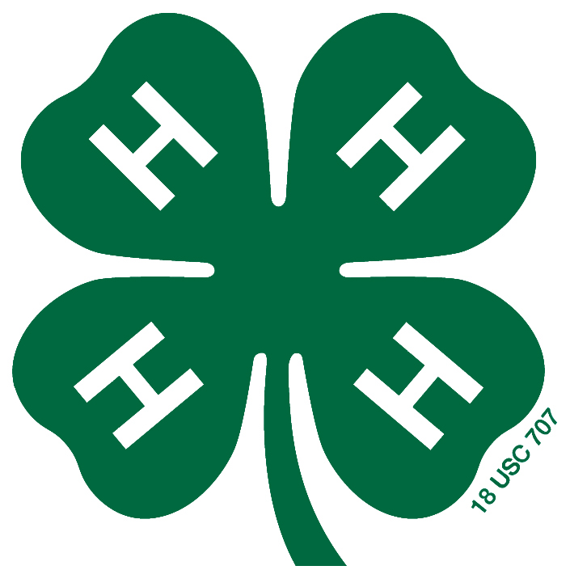
2026 MADISON COUNTY 4-H FAIR SCHEDULE

***SCHEDULE OF EVENTS IS SUBJECT TO CHANGE***

Friday, July 10 All projects must be entered into FairEntry

Sunday, July 12 Madison County Fair Queen Program, 4-H Building, Exhibit Hall

Friday, July 17 All events in the 4-H Building, Exhibit Hall
8:30 AM – 9:00 AM Check-in for Sewing and Wearable Arts Construction
9:00 AM Sewing and Wearable Arts Construction Judging (bring narration forms)
10:30 AM Check-in for Consumer Clothing (judge arrives at 9 for notebook)
11:00 AM Consumer Clothing Judging
After Judging Modeling Practice (optional for any fashion revue participants)
6:00 PM Fashion Revue Check-in
6:30 PM Fashion Revue: Wearable Arts, Consumer Clothing Awards, Jr. Sewing, Sr. Sewing

Saturday, July 18
9:00 AM Rabbit Set-up, Rabbit Barn
10:00 AM Set-up for Dog Show, Beef Barn

Sunday, July 19
9:30 AM 4-H Tractor Operator Contest Registration
10:00 AM 4-H Tractor Operator Skills Contest, East Parking Lot
2:00 PM Aerospace (Rocketry) Launch, 4-H Fairgrounds

Monday, July 20
8:30 AM – 9:00 AM Check-in for Mini 4-H Presentation (Non-Livestock), 4-H Building, Exhibit Hall
9:00 AM Mini 4-H Presentation (Non-Livestock), 4-H Building, Exhibit Hall
Dog Show, Beef Barn

Tuesday, July 21
8:30 AM – 9:00 AM Check-in
9:00 AM Exhibit Hall Judging Projects:
Animal Education | Health
Beekeeping | Reading
Child Development | Shooting Sports
Collections | Soil & Water Science
Computer Science | Sport Fishing
Entomology | Sports
Forestry | Veterinary Science
Genealogy | Weather & Climate Science
Geology | Wildlife
**PLEASE NOTE** ALL Exhibit Hall Projects checked in after noted check in time will not be considered for anything higher than a blue ribbon
Wednesday, July 22
9:00 AM Exhibit Hall Judging – Rolling Judging – Exhibitors will Sign Up for Judging Time
Projects:
Aerospace | Needlecraft (Handwork)
Basic & Miscellaneous Crafts | Photography
Fine Arts | Recycling
Gift Wrapping | Scrapbooking
Llama/Alpaca Fiber Craft & Posters | Self-Determined
Model Craft

5:00 PM Fairgrounds Set-up, everyone is encouraged to help
Tents may be set at the conclusion of Fairgrounds Set-up

Thursday, July 23
8:30 AM – 9:00 AM Check-in
9:00 AM Exhibit Hall Judging Projects:
Construction Toys (Legos) & Architectural Replica (Farm Scenes, etc.) | Home Environment
Crops (Corn, Hay and Forages, Small Grains, Soybeans) | Welding
Electric | Woodworking

12:30 – 1:00 PM Check-in
1:00 PM Exhibit Hall Judging Projects: Foods (Baked, Preserved, Microwave Foods)

1:30 PM- 2:00 PM Check-in
2:00 PM Exhibit Hall Judging Projects:
Cake Decorating | Floriculture
Cupcake Decorating | Garden

Friday, July 24
All Day Livestock tack may arrive and be set-up
6:00 PM – 9:00 PM Beef Admitted
Dairy Admitted
Goat Admitted
Sheep Admitted
6:00 PM – 10:00 PM Swine Admitted
**PLEASE NOTE** ALL Exhibit Hall Projects checked in after noted check in time will not be considered for anything higher than a blue ribbon
Saturday, July 25
6:00 AM – 4:00 PM Beef Admitted
Dairy Admitted
6:00 AM – 12:00 PM Goats Admitted
Sheep Admitted
6:00 AM – 9:30 AM Swine Admitted
8:30 AM – 10:00 AM Swine Check-in
9:00 AM – 2:00 PM Poultry Check-in
Rabbit Check-in
9:00 AM Pocket Pets, Check-in time, 4-H Building, Exhibit Hall
9:30 AM Pocket Pets Judging, 4-H Building, Exhibit Hall - Released after Show
10:30 AM 4-H Cat Show Registration, 4-H Building, Exhibit Hall
11:00 AM 4-H Cat Show Judging, 4-H Building, Exhibit Hall
12:00 PM – 2:00 PM Goat Check-in
Sheep Check-in
3:00 PM – 5:00 PM Beef Check-in
Dairy Check-in
4:00 PM – 6:00 PM Exhibit Hall Open to Public, 4-H Building
6:00 PM Mini 4-H Livestock Show (Swine, Sheep, Goats, Beef, Dairy)
10-yr Member Recognition and Awards

Sunday, July 26
9:00 AM Swine Show
9:00 AM Poultry Mini 4-H Show, Commercial classes, Pigeon Show, Showmanship, Poster, Eggs and Crafts
2:00 PM Madison County 4-H Parade Sponsored by Alexandria Kiwanis
2:00 PM – 5:00 PM 4-H Building, Exhibit Hall Open
3:30 PM Swine Championship Drive (or later, at least 90 minutes after completion of showmanship heats)
4:00 PM Rabbit Mini 4-H Show, and Rabbit Ambassador Contest/Showmanship, Rabbit Craft Judging
6:00 PM Horse & Pony Jr/Sr Ambassador Awards, Horse & Pony Arena
7:00 PM Corn Hole & Kickball Tournaments, Sign in at Show Arena
9:00 PM All sale pigs must be moved to North Barn

Monday, July 27
9:00 AM Poultry Show (Exhibition Classes)
Swine tear-down for Beef Show
10:00 AM – 8:00 PM 4-H Building, Exhibit Hall Open
12:00 PM Goat Olympics, Skill-a-thon, and Costume Class, Show Arena
3:30 PM Beef Show

Tuesday, July 28
9:00 AM Rabbit Show
Sheep Show
10:00 AM – 8:00 PM 4-H Building, Exhibit Hall Open
11:00 AM – 9:00 PM Animal Education Center Open, North Swine Barn
2:00 PM Dairy Show
6:00 PM Madison County Extension Homemakers Food Auction, Exhibit Hall
6:30 PM Sheep Championship Drive

Wednesday, July 29
9:00 AM Dairy Goat Show
10:00 AM – 8:00 PM 4-H Building, Exhibit Hall Open
11:00 AM – 9:00 PM Animal Education Center Open, North Swine Barn
2:00 PM Meat Goat Show
6:00 PM - 7:00 PM Poultry members Barn/Pen clean up beginning at 6:00 and tear down at 7:00 PM
7:00 PM Rabbit members Barn clean up and tear down

Thursday, July 30
8:00 AM Deadline for removal of all tents from the Horse and Pony Make-up Arena Area
10:00 AM – 8:00 PM 4-H Building, Exhibit Hall Open
11:00 AM – 9:00 PM Animal Education Center Open, North Swine Barn
1:00 PM 4-H Horse and Pony BARN SET-UP ONLY (No animals or trailers)
5:00 PM 4-H Supreme Showmanship Contest, Show Arena
6:00 PM 4-H Livestock Auction, Show Arena

Friday, July 31
8:00 AM Llamas/Alpacas Admitted
9:00 AM 4-H Horse and Pony Show, Horse Arena
10:00 AM – Noon 4-H Building, Exhibit Hall Open
10:00 AM 4-H Llama and Alpaca “Fun” Show, Show Arena
11:00 AM – 9:00 PM Animal Education Center Open, North Swine Barn
2:00 PM – 6:00 PM EXHIBIT HALL PROJECT RELEASE
Unclaimed projects WILL BE DISCARDED, please make arrangements for your project to be picked up.

Saturday, Aug 1
9:00 AM 4-H Horse and Pony Show Continues, Horse Arena
4-H Llama and Alpaca Show, Show Arena; Released following show

