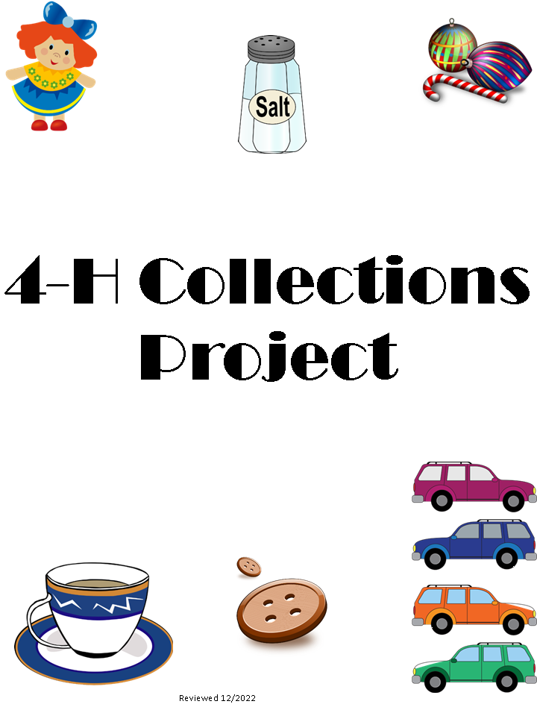

Special thanks to Jackson, Monroe, Allen, Hendricks and other County Offices of Purdue Extension for providing the information for this manual.

It is the policy of the Purdue University Cooperative Extension Service that all persons have equal opportunity and access to its educational programs, services, activities, and facilities without regard to race, religion, color, sex, age, national origin or ancestry, marital status, parental status, sexual orientation, disability or status as a veteran. Purdue University is an Affirmative Action institution. This material may be available in alternative formats.

Purdue Extension Johnson County
484 N. Morton Street
Franklin, IN 46131

COLLECTIONS
Collections can be defined as the gathering of similar items, articles, objects, etc. All young people collect items from time to time. Many people have developed interesting hobbies by starting a collection. This 4-H project can help you start or continue a collection that you find interesting.
The objectives of this project are to help the 4-H’er to:

- Learn to appreciate the fun of collecting items and showing them to family and friends.
- Learn to keep complete and accurate records.
- Learn how to care for and store items in their collection.
- Learn to appreciate the historic, scientific or economic value of the items collected.
- Help develop a lifelong interest.

Reasons to Collect:
• It is fun to look for specific items for your collection and it makes you feel good to see your collection grow.
• It is educational, because it introduces you to new people, places and things as you find items for your collection.
• It may add to your appreciation of your heritage.
• It may make you more aware of the world around you.
• It may sharpen your imagination.
• It may help you meet other collectors.
• It may not cost any money.
• It you have fun collecting, then why not share your enjoyment with others.

What You Can Collect:

You may choose any type of article you desire. Here are some suggestions but the choices are unlimited:
Buttons | Cups & Saucers | Stamps | Pitchers | Pencils
Matchbooks | Flowers | Dishes | Arrow Heads | Rocks
Spoons | Models | Dolls | Coins | Antiques
Leaves | Glass | Bottles | Horses | Salt Shakers
Bottle Caps | Baseball Cards | Comic Books | Magnets | Ornaments

Check the public library if you need information about your collection. They have books on many different types of collections.
Storing Your Collection:
It is wise to select a special place in your home to store your collection. This may be in your own room or one you share. A sturdy cardboard box, shelves, a notebook, or bulletin board would be appropriate depending upon your collection.
If you arrange your collection attractively, you will be proud to display your collection to your friends and family. If they know of your interest, perhaps they will contribute items to your collection! Perhaps you and other collectors can trade items each of you have no need of.
It is also important to learn to label your collection accurately and neatly. As you prepare for the fair, practice arranging your exhibit in a manner that is artistic and neat. Be creative!

Keeping Records:
Many collections start as a hobby. Later, the collection may become more than just a fun way to spend your time. Many baseball cards that are ten or twenty years old are worth several dollars. Other things may be of value to only you. Whatever the case, you will want to know where, how and when you collected the item.
The only way to be sure of where an item came from is to keep a record. The record sheet that follows is an excellent way to keep a record of your collection.
For collections that you have already started, complete the record to the best of your ability. From then on, enter an item as soon as you receive it. For new collections enter each item as soon as you receive it. In that way there will never be any question as to where or how you came to have the item in your collection.
The Collector’s Log should be removed from the manual and placed in a binder or notebook and displayed with your exhibit.

Your Story on Your Collection:
Your notebook will need a story about your collection. This story must be on a sheet of 8 ½” x 11” paper (lined or unlined). It can be written in ink or typed. The Beginner Division should not exceed 100 words; Intermediate and Advanced should not exceed 150 words.
Each member must write their own story, with assistance in editing or typing only. Stories should be titled and titles should mention the item being collected. Your story should tell how and why your collection started. Tell where you keep your collection at home. Tell some interesting facts about your items and why you value them. You might want to tell about the history of your items and how you hope to continue your collection.

Exhibit Guidelines:

Division/Grade:
Beginner – Grades 3, 4, 5
Intermediate – Grades 6, 7, 8
Advanced – Grades 9, 10, 11, 12

Exhibit six representative sample of your collection from one category. (You must exhibit six (6) different items form your collection each year.) Each exhibited item should be labeled with a number, which should correspond to the item number in the Collector’s Log.
In addition, a notebook or folder must be exhibited that includes a Story, Collector’s Log, and Project Question Sheet. (These items may be computer generated).
Space size should not exceed 36” x 36” x36”. Any collection display that would exceed that space will need to be exhibited as photos in a notebook or on a standard poster.
See Poster/Notebook/Display Board Guidelines in the Johnson County 4-H Handbook.
NOTE: No knives, guns, or other weapons may be displayed; pictures of weapons may be displayed instead.
Your collection may be exhibited in a box, on a poster, in a notebook, on a display board, or in any other manner that is attractively displayed.

The Fair Board, 4-H Council and Extension Office cannot take responsibility for the damage, loss, or theft of a collector’s exhibit. It is therefore recommended that valuable objects be protected in a display case or left at home. A complete collection could be shown using photographs, if the items are valuable or too large to display. Photos should be securely mounted and labeled in a notebook.

4-H Collector’s Log
Item Number | Name or description of article  (Be complete) | Date Purchased or Added | Approximate Cost or Value | Location of Purchase or Find/History of Item

Note: Use additional page if necessary. This should show your complete collection and not just the six (6) items that are part of this year’s exhibit.

Project Question Sheet

Why do you enjoy collecting these items?

Where were some of your articles made or manufactured? Remember that some companies make containers or parts for other companies.

How do you plan to add to your collection?

Where did you purchase or find most of your articles?

Do you expect your collection to become more valuable and why?

Would you ever sell your collection?

Should other people be interested in collecting this item and why?

What is your favorite article?

Have you purchased any books about your collection? If so, please list them.

My Collection Story

