Tell A Homemaker

Letter From the county president

Dear Homemakers,
As we approach summer, I know I am busy making plans for the season. I am working not only on vacation plans to the Smokey Mountains, but also my summer reading list as well. I am hoping for a slightly less busy summer than my spring. After the cold of winter and the dampness of spring rains, I am actually looking forward to some warmer weather and sunshine.
A lot of things have been happening or going to be happening with Jackson County Homemakers. We had a great time not only with a Cinco De Mayo celebration but also recognizing our accomplishments and work this past year with Achievement Night in May. Elisa Reed and Misty Stuckwisch were our cultural arts winners and their projects will be displayed and judged at our State Conference this month. Good Job ladies!!! A big thank you to everyone who came out and attended as well as to those who planned the evening.
I also want to congratulate Miss Sydney Bush (Seymour High School) and Mr. Caden Wischmeier (Brownstown Central High School) as this year’s recipients of our Health and Human Sciences Scholarships. We wish both of you and the entire Class of 2026 blessings and congratulations on this important milestone in your lives.
Summer is also the start of a new year for Extension Homemakers as well. I will be attending this year’s State Conference later this month and I am looking forward to sharing all kinds of information with you in our next newsletter.
A new year means a new theme/logo as well. Our new State President, Michelle Robert has chosen “The Heart of IEHA: continuing Education, Leadership Development, Volunteer Community Support.” The theme this year gets to the “Heart” of IEHA which is our threefold mission of education, leadership development, and volunteerism.
Our Jackson County Fair board has once again asked us for help in monitoring the Fine Arts building during fair week. This just requires sitting in the building and making sure no one bothers the exhibits. It is a pretty easy thing to do and you get to do a lot of visiting!!!!! If there are not enough volunteers to monitor the building, the building may not be able to be open as scheduled. I know the fair board was very, very appreciative of our volunteers last summer. If you are able to help, please reach out to Ruth Ann Hendrix to sign up.
This new year of Home Ec also brings with it a new fund raiser for us as well. We will be sponsoring a Fruit Pie Contest & Auction at our county fair. This year pie challenge (if you will) is Cherry Pie! So, if you bake a fabulous cherry pie bring it out the fair this year. There are more details for this in the flyer included in the newsletter and also look for details in this year’s fair book as well.
Proceeds from this will be split between us for our scholarship program and the Jackson County Fair Queen Pageant Program. This is just another way we live out mission of Home Extension of continuing education, leadership development and volunteer community support!
You should also be receiving our new program books for this year. Please look this little book over as it has all kind of important information and dates in it as well. I want to remind everyone, that as we move through the summer, it our county’s turn to host the fall district meeting. The Bedford Fall District Meeting will be on Monday September 28, 2026 at the Joe Jackson Hotel/Community Building in Vallonia. Please make plans to attend and meet other wonderful ladies from our district and be watching for more information in our August Newsletter.
The last bit of county news I need to share with you all, is that our Extension Educator, Molly Marshall as stepped down from the extension service to pursue other things and we wish her well on her new endeavors and a big thank you for all of her support of our program and clubs. This also means that going forward our Extension office will be undergoing some staffing changes as the extension service throughout the state is being restructured. With this being said I am asking that our club presidents and our county officers please be vigilant is sharing information related to our programming. Your efforts will go a long way in helping our extension office work through the upcoming changes.
As we look forward to summer, I hope you all will take time this summer to celebrate our nation’s 250th Birthday!!! We live in an amazing and beautiful country. I highly suggest trying to visit a national park or state park this summer and just take in the beaty. This summer as we celebrate, let us remember just how fortunate we are to live in this great nation.
Looking forward to a great year and getting to “Heart of IEHA!”
Mandy Otte
President, Jackson County Extension Homemakers


Inside this issue
Letter from the County President …………....….....1
Save the Date…………..….2
Jewelry Project ……....….3
Membership Minute…….4
26-27 Officer……………….5
Clubs’ meeting minutes ……………………………..6-12
Park Hop………………13-16
Stock the Trailer…………17
Pie Contest…………..……18
Summer Fun Word Scramble………………..…19
Word Search…………..…20
Recipe……………………...21
26-27 Calendar………….22
26-27 Theme……………23

June 2026
This year our county theme will be the same as IEHA’s theme, “the heart of IEHA”
STATE CONFERENCE

JUNE 15-17, 2026

THE SEASON LODGE IN NASHVILLE, IN

2026 FALL BEFORD DISTRICT MEETING

MONDAY, SEPTEMBER 28, 2026

Joe Jackson Hotel
VALLONIA, IN




IEHA Cultural Arts Special Project 2026-27 Jewelry


Use your creativity! We look forward to seeing what you can create to enhance your wardrobe!

IEHA Cultral Arts Committee
The 2026-27 Cultural Arts Special Project will be Jewelry. Items such as necklaces, bracelet, rings, earrings, brooches may be made from any medium, using any technique. Whether it is strung beads or a woven brooch, there is sure to be an item for any age that you will want to create.

Display materials will be allowed, if you wish, but cannot exceed 12 inches by 12 inches by 12 inches.





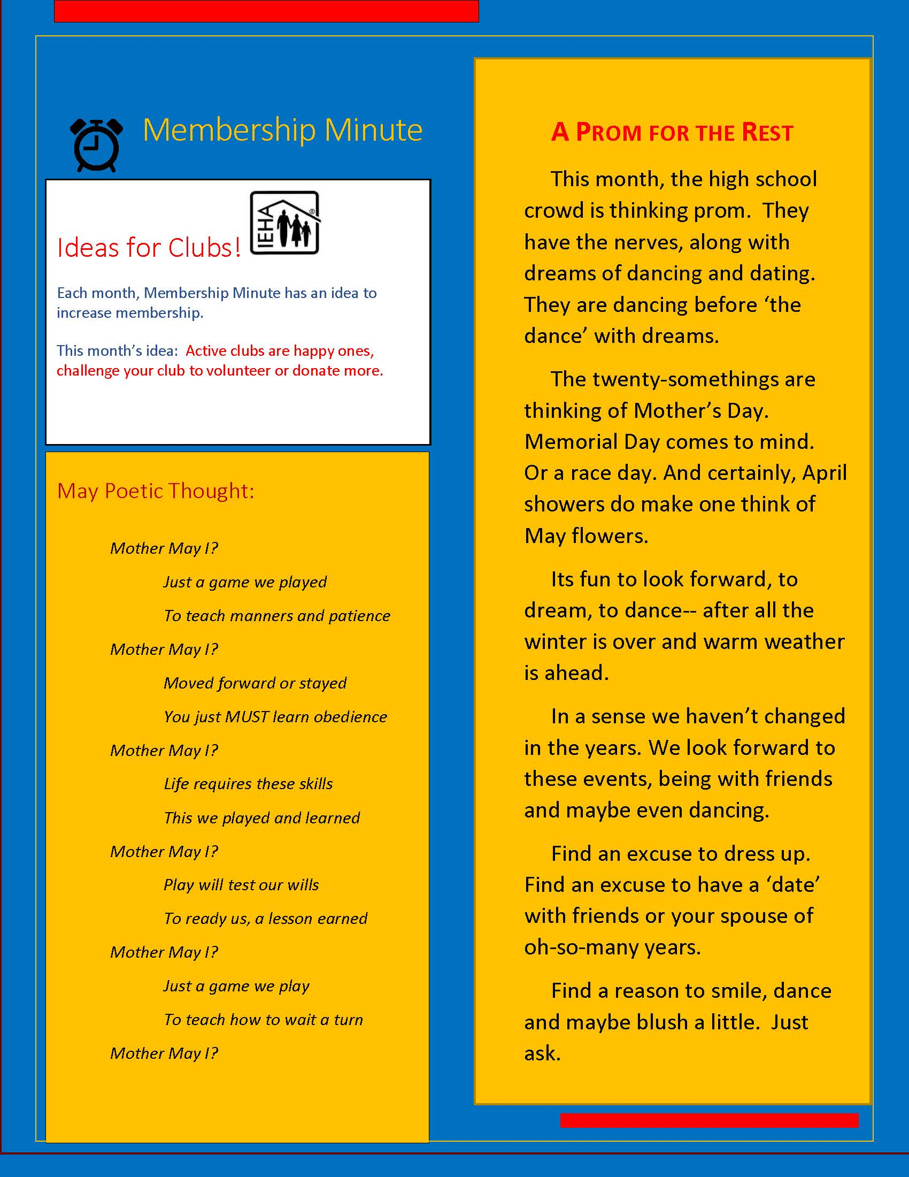



Thank you to our 2025-2026 Officers!

Presidents’ — Sheryl Ault and Mandy Otte
Treasurer — Skye Zakrzewski
Secretary – Karen Hendrix
Advisor — Misty Stuckwisch

Congratulations to our 2026-2027 Officers!

President — Mandy Otte
Vice President – Misty Stuckwisch
Treasurer — Skye Zakrzewski
Secretary—Karen Hendrix

Achievement Night Minutes
May 5th, 2026
Members from six Extension Homemakers clubs met for their Spring Achievement night on May 5th at Redeemer Lutheran church. Kum Join Us hosted the dinner and the theme was Cinco de Mayo. Clubs also attending were Freetown Friends, Craft, Play, Connect, Jamestown Get together, Homestead Traditions, Manos Unidos, Creando Juntos which means Hands United, Creating Together.
Misty Stuckwisch was in charge of decorations and did not disappoint. The tables were decorated with colorful Hispanic table runners and colorful tissue paper flowers made by members from Craft, Play Connect. This is a new club with Mom and kid activities. There were also Word Finds on colorful cardstock on each table to add even more color.
Mandy Otte, our County President, welcomed everyone and opened with a prayer before our meal and Club Creed, Collect and Pledge of Allegiance. Mandy and Erin left numbered snippets from History.com on the tables that were read in order explaining to us the true meaning of Cinco de Mayo.
Cinco De Mayo is often thought of as Mexico's Independence Day but actually commemorates an underdog victory that reshaped the course of American history. The May 5th holiday marks Mexico's 1862 triumph over French forces at the Battle of Puebla.
After Mexico's civil war, named the War of Reform, ended in 1862, Mexico was virtually broke and owed tens of millions of dollars to foreign debtors. Newly elected President Juarez suspended payment of all foreign debt for two years prompting a backlash from Spain, France and Great Britain. The United States was too preoccupied with the Civil War to enforce the Monroe Doctrine and troops from the three countries began arriving in Veracruz in late 1861. Spain and Britain almost immediately withdrew, but about 6,000 French troops backed by Mexico's vanquished conservative leaders pushed inland toward the capital. On May 4th, the overconfident French troops, not even bothering to properly prepare their artillery, lost the conflict due to heavy casualties in their uphill charges on the morning of May 5th. History.com has more on this war and the United States involvement for those who want to learn more.
Molly Marshall, our Extension Educator, spoke of news from the Extension office. First being her departure and new venture. Three summer interns were hired. I hope they can fill her shoes. She will be greatly missed.
Mandy discussed all the groups involved around IEHA, including Nvon which is a National Volunteer Outreach Program. All the programs revolve around leadership, volunteering and education. For more on this, visit Purdue University Extension. You can also find a complete list of our Jackson County clubs and meeting times. New members are always welcome.
Sheryl Ault, outgoing County President was recognized for her year as President and also for co-chairing alongside Mandy this past year. Recognition of current officers and Blue and/or Gold Awards were presented to all six clubs. What a great accomplishment.
The Scholarship Committee has completed their process and a $500.00 scholarship will be presented to a student from Seymour High School and also from Brownstown Central on their prospective Awards Day. This next year we hope to add another with the proceeds from the new Pie Contest and Auction at the Jackson County Fair. More on this to follow in coming months. The Scholarships are available to anyone entering the culinary, health services or education fields. Check with your school counselor for details.
Curt Schleibaum, Tech Director at Seymour Community Schools spoke about Internet Safety. We're all being bombarded with texts, calls, emails all saying we're going to be arrested for unpaid tolls, we've won a trip, even the late-night phone call saying our grandchild has been arrested and needs bail money. Wow! If these scammers would put that time into actual work to benefit society, we'd be so much better off.
First off, nothing is free. If they're asking you to run to your local drug store to purchase a money card to pay that bail money or fine, your local sheriff doesn't accept that type of payment nor will they request it from you in a call, text or email.
Curt passed out actual emails and text conversations and asked us to figure out which ones were legit and which were fake. Some were easy and others looked like some I know we've all received ourselves. He told us to never verify something from an email sent but to log into the actual site. They can lead you down a dark hole if you hit that key in the email. Also look for misspelled words, capital letters when there shouldn't be and the .com, .org, .gov. These are easy ways to spot fake emails. You should also add a multi factor second authentication. If your username, password is involved in a security breach this will help. Hopefully only you know this number.
If you're unsure whether your email has been involved in a security breach, you can check this website, https://haveibeenpwned.com. I checked this out today. it's quite easy to do and you can add your email to be notified of future breaches. Thank You Curt for your fifteen minutes that turned into thirty. It was all so informative and much appreciated.
Until next month, enjoy your family and friends and we'll be back next month with our chats around the table.

Kum Join Us Meeting Minutes
March 2026:
So happy to once again get together with our Kum Join Us members on March 3rd at Borchers. Carol Mansfield and Karen Brigdon were our hostesses and brought a wide assortment of meats and cheeses with delicious crackers, one cracker brand was even gluten free. Karen Brigdon, although she was unable to attend due to school obligations, made two kinds of scrumptious brownies. So much for watching our calories at these meetings.
Olga opened our meeting with the Club Creed and our Pledge of Allegiance followed by our attendance question, what is your favorite pie? Considering the Jackson County clubs are sponsoring a pie contest/auction this year at the Jackson County 4-H Fair this was a great question. More news on that to follow once details are finalized. In answer to the roll call question, pecan was our favorite with cherry a close second.
The recipe in our booklet for March was Leprechaun Bait. A few tales ensued about marshmallows and crunch berries disappearing from a few boxes of cereal in certain household pantries and leaving only the dry cereal. No one laid claim to the disappearance but there were a few chuckles and some finger pointing.

The secretary's and treasurer's reports were read. We were asked to be thinking of a Fair Queen candidate to sponsor. Application deadline is getting close so if you know of someone, please contact the Extension office at 812-358-6101. This is a great experience and our club gives a gift card or money to help with expenses.

Achievement night is planned for May 5th at Redeemer Lutheran Church beginning at 6 pm. Considering this fall on Cinco de Mayo, our club decided to have a taco bar. Other clubs are asked to bring a side dish or dessert along with their projects to be judged and hopefully sent on to the State Conference in June. Due to all the scams we're all seeing whether in emails, phone calls or texts, our guest speaker may possibly be an IT person to teach us how to better protect us. We will also collect non-perishable food items and paper products for our local pantries at that meeting.

All County members are invited to the Spring District meeting at the Purdue Extension Harrison County office in Corydon, Tuesday April 7, registration beginning at 9 am. Lunch cost is $10. and is due by March 27th. Their theme is our country's 250th anniversary. I can't wait to see how they celebrate this.

Kum Join Us has planned an outing on April 11th to Schimpff's Confectionery in Jeffersonville. Plans are to leave by 11am for ready for lunch upon arrival. Our members always have fun things to do and places to visit.

Erin Otte, a teacher and newest member, gave our lesson on tornado preparedness as this is the beginning of our tornado season. She explained the differences between a watch and a warning in easy terms. She said to think of a tornado watch as a taco bar. You have all the ingredients for your taco or in this instance a tornado but your taco (tornado) hasn't been made yet. A warning on the other hand means that taco is stuffed full and ready to devour.
She brought along a to go kit that included charging cords, battery operated radio, extra clothes, maybe a blanket. You don't know how long power will be out so have some food and water also and documents you may need to prove your identity if the devastation is extremely bad. Michelle mentioned shoes, always have your shoes on during a tornado watch. You don't want to be walking around afterward and end up in the hospital due to something sharp you stepped on.
We all need to use common sense, most times, these storms accompanying tornadoes produce damaging hail large enough to damage roofs or vehicles. Can you imagine what would happen if that hit you? Stay inside in an interior room or closet. Use pillows to protect yourself. Stay away from windows. Bring your pets inside if possible. I know that my dog is right by my side before a storm is even on the horizon. Somehow, they know long before we do.
Most of us get weather notifications on our cell phones. Heed these warnings. Your life or the lives of your loved ones may depend on it. For more information, visit weather.gov/safety/tornado.

Carol gave our devotions from The Word in Season distributed by augsburgfortress.org. It was entitled Midwives of God's future. It says we participate in a great drama. We come to life in the secret counsel of God and conclude in the creation of a new heaven and a new earth. The infinite love of God is uniting all things in a final unity, filled with life and peace. Jesus called it the kingdom of God.
Isaiah understood God's holy future and cast a vision to fire our hope and strengthen our hearts so that we might experience a world filled with God's love. As midwives of God's blessed future, we can do what the saints of every age have done, pouring our love into the days of our lives, seeking justice, showing mercy, learning to forgive and live in peace. Every day, the drama continues, and we take our places, sharing or resisting the plot, which is love, always love. If you'd like to learn more on this, read Isaiah 65:17-25.
Kum Join Us meets the second Tuesday of each month at St. Paul Lutheran church, Borchers at 6:30 pm. Why not join us for some fun and interesting chats around the table. It may just take you back to your childhood.

April 2026:
What a beautiful drive to Borchers for our April 7th, Kum Join Us Homemaker club meeting. Farmers were busy burning everything left in the fields from the recent flooding and boy, what a gorgeous sunset. God is good!
Misty Stuckwisch hosted our meeting and served some tasty sausage balls, a delicious cherry swirl pie/cake and a sweet and savory Chex mix. She admitted she usually makes her own Chex mix but was quite impressed with the amount of chocolate on this particular brand she purchased.
Olga opened our meeting with the Club Creed and Pledge of Allegiance followed by roll call. She asked each of us our favorite memory or tradition for Easter. I think everyone remembered the cute little dresses, lace anklets and straw purses. Some were lucky enough to wear white gloves. I think everyone commented about church services that week and being with family. I hope you all have wonderful memories of Easter with your families.

Michelle Wood gave our treasurer's report and I read the secretary's report from March. Olga asked once again if anyone knew of someone to sponsor for the Fair Queen this year. This is a wonderful opportunity. If you know of someone, please contact the Purdue Extension Office at 812-358-6101 and they can assist you. Time is running out to get those applications in.

There were so many conversations tonight it was hard to stay on track. Plans for our outing to Schimpfs on April 11th were finalized. Mandy and I gave a quick rundown of the district meeting we attended earlier that day in Corydon discussing conferences and all the fun things to do at this three-day event in June.

Kum Join Us is hosting the County Achievement night May 5th at Redeemer Lutheran Church. Registration begins at 6 pm. We will be collecting food items and paper products for Anchor House along with hygiene items to be distributed to local schools.

Misty's daughter, Macey, printed a flyer to be distributed and once finalized will announce a new event at the Jackson County Fair. A pie contest/auction open to anyone whether a professional or just a pie person will be held this year at the Jackson County Fair. This year's pie flavor is cherry. There will be more news to follow on this. We're hoping it will be big. Who doesn't love fresh baked pie?

Mandy gave a short lesson on the benefits of hobbies from the WVU Extension. As we age we all need something to occupy our minds and improve our physical, cognitive and emotional well-being. Hobbies help us physically to maintain mobility, strength and coordination. They can keep our brain active and delay cognitive decline while also reducing loneliness, anxiety and depression. They also provide opportunities for social connections. It can be as simple as joining a Homemaker's club. We're always looking for new members in all seven clubs within our county and oh the fun we have.

Misty gave our devotions from a book written by Sarah Young entitled Jesus Calling. This devotion was about the Potter and the clay. We were designed before the foundation of the world. Each day is arranged and His love is at work in every event in our life. Some days our will and God's flow smoothly together. We tend to feel in control of our life when our wills are in harmony. Other days, we may feel as if we're swimming upstream, against God's purposes. Stop and seek His Face. The opposition you feel may be from God, or it may be from the evil one. Talk with God. Let His Spirit guide you through treacherous waters. As you move through the turbulent stream with Him, let circumstances mold you into the one He desires you to be. Say yes to your Potter as you go through your day.

Do things in your life sometimes not go as planned? Just know that we are the clay to be molded by our loving God. What a wonderful devotion from Isaiah 64:8 and Psalm 27:8.

Kum Join Us for our chats around the table the first Tuesday of each month beginning at 6:30pm at Borchers. We never know what funny stories will be shared to remind us of days gone by or what song may just pop out of someone's mouth as they enter a room. It's always an interesting bunch with lots of laughs. We can't wait to see you.
Homestead Traditions Meeting Minutes
March 17, 2026:
Alex Wall opened our meeting with the Club Creed and Pledge of Allegiance. Members were asked their favorite flavor of pie. With the Jackson County Extension Homemakers hosting the inaugural pie contest/auction at our county fair beginning this summer, it was a great question. Check this season's fair booklet for details.

Surprisingly, everyone had a different favorite ranging from peach and ginger to whatever pie Susie Alstatt is making which is generally her famous chocolate bourbon. I'd love to try that one. What's your favorite pie flavor?

Ruth Ann Hendrix gave our devotion from a book entitled "Daily Companion for Caregivers" by Allen E. Wright. Ruth Ann, who is a death doula, she brings comfort to others during their end of life. The devotion reminded us that the things in life that make the most difference are not things but people and relationships. As a person who cares for others, think of all the people that you have been a source of mercy, peace and love for. Rejoice that God has used you to bring some hope in this world.

With our meeting being on St. Patrick's Day, Bianca Wilson baked some delicious Irish soda bread to share and gummy bears. Of course, Alex always makes some cute little holiday goodies for us and this meeting was no different with a cute little pot of almond candy kisses.

Susie brought quilts made by ladies at Borchers for us to tack during the meeting. She read to us about Lutheran World Relief. LWF partners with churches in their quilt ministry. The quilts, once completed will be distributed throughout the world. Since 1945, 28 million quilts have been sent to 136 countries and just last year more than 800,000 quilts and kits were distributed in 15 countries. This is an amazing activity for anyone wanting to participate. You can contact their team at 410-230-2708 or quiltsandkits@lwr.org to get your own team together to help in this amazing project.

I read the minutes from the February meeting. Now that this new club officially has officers, unfortunately this will be my last article for Homestead traditions. I will be passing the reins to Bianca Wilson as I'm sure she will do a fabulous job.

Plans were discussed about the Spring district meeting on April 7th and also the Achievement night hosted by Kum Join Us on May 5th. What a fun event they have planned with the meeting falling on Cinco de Mayo. Taco bar anyone?
The Fall District meeting will be hosted by the Jackson County Homemakers and is still in the planning stages but talks of a tour of Fort Vallonia are possibly in the works. What fun!

Ruth Ann spoke briefly about the cloth envelopes that members are sewing for Riley Cheer Guild. These are keepsake envelopes for parents of children who miscarry to have something to carry home little keepsakes. Another 84 were mailed last week.

She also discussed the pie contest at the fair this summer. Volunteers are always needed to make our fair a success and once again, our clubs have been asked to volunteer a few hours to our Family Arts Building. Without this volunteer help, the building cannot be open to view all the wonderful displays everyone has worked so hard on all year.

Join us for our chats around the table. There's always some interesting tidbit someone is willing to share and we never know where that tidbit takes us but it's always an adventure. Contact the Extension Office at 812-358-6101 for info on a club near you.

Lawrence County Meeting Minutes
January 2026:
The Lawrence County Homemakers had their December meeting as the celebrating of their 1 year and just relaxed. The January meeting was canceled due to weather. The next meeting will be starting work on the Heritage Festival Home and Family Arts exhibit/competition for June at Stonegate Arts and Education center. We will be making a list of categories to offer and list of possibilities on sponsors to contact.

Craft, Play, Connect
Met twelve times - played, walked, splashed, connected, shared information and concerns, crafted, sometimes sang songs - from four people to 12 people, depending on the day. We went to Muscatatuck National Wildlife Refuge, a state forestry, several town parks, a local office. We made essential oil bug spray, Valentine & Easter cards, collected leaves, painted, made flower bouquets and exchanged our five favorite things,
Ate some nuts, cheese sticks, Slim Jims, carrots, grapes, blueberries, soups, crackers, and pizza. Drank some water. Shared food.
Contact Skye 812.528.3654 or Bianca 317.383.7055
Mostly mothers & young children. Monday evenings.

Jamestown Get-together
We meet monthly, the date depends on schedules. The meetings are posted in their monthly calendars. We have done crafts including cookbooks, the grief envelopes, cards, ornaments. We do the pledge, the creed, have education sessions – last month we did Indiana – our state bird and so on. The peony is our state flower. We also did the session on crockpots.
Tuesday afternoons, contact Ruth Ann Hendrix 812.707.1452

Brown ESL and new homemakers’ group
English classes are offered for all at Brown Elementary School. We meet Tuesdays at 10 AM when school is in session. Retired teachers teach and help, provide snacks and childcare. We just started a homemaker’s group. Folks from Su Casa are helping with crafts and snacks. We need more volunteers for this, please contact me if you are interested. Ruth Ann 812.707.1452



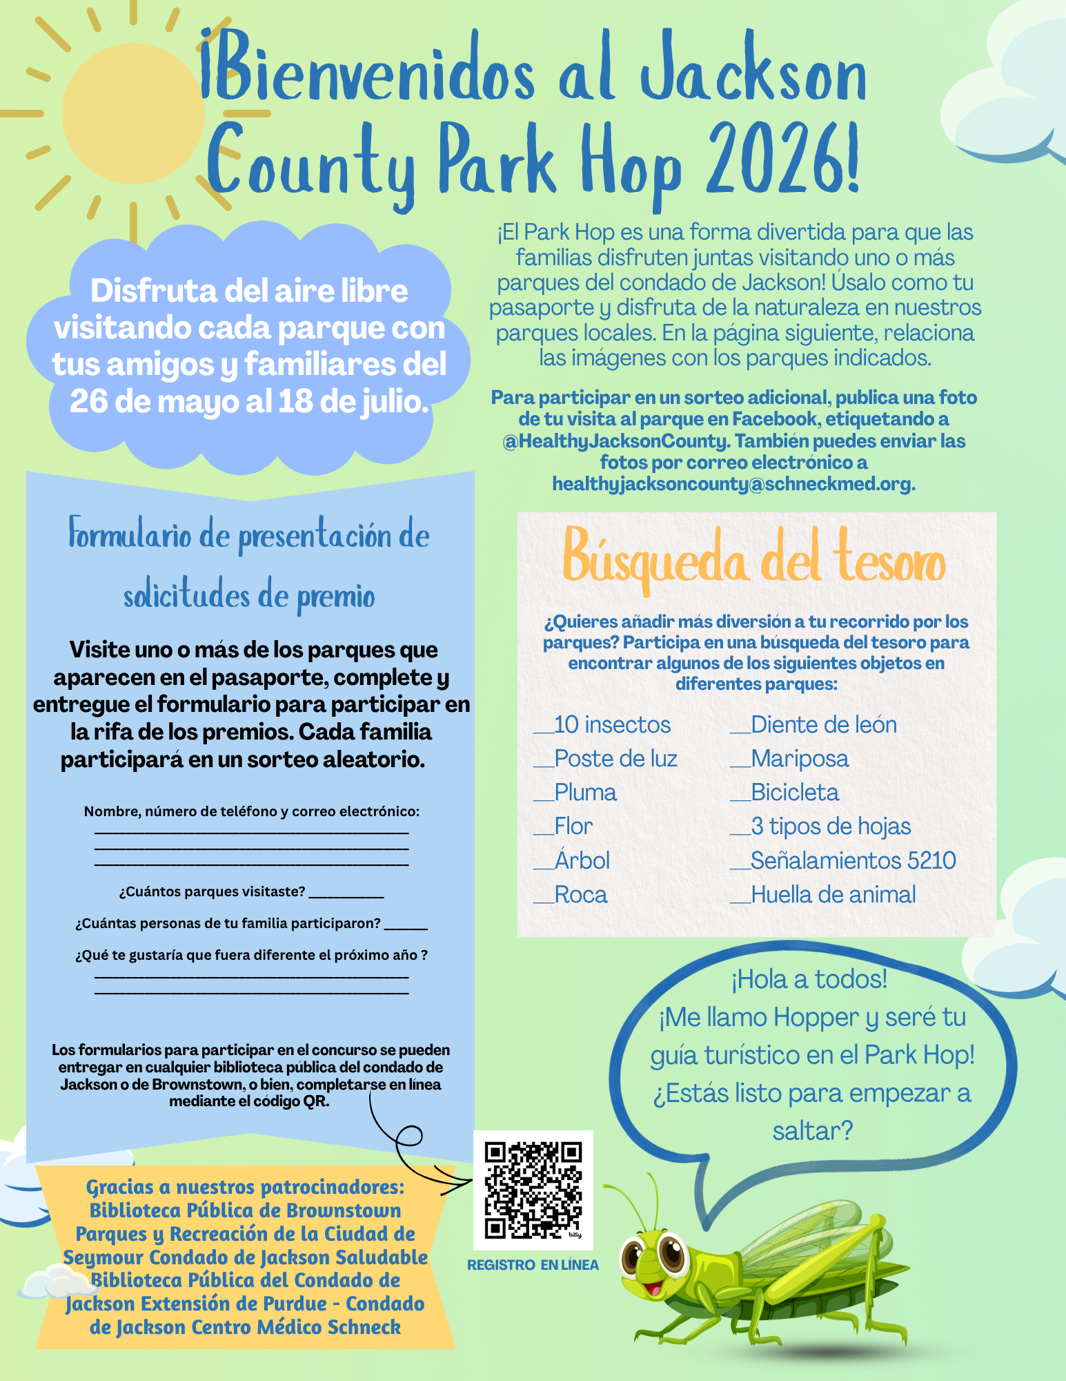
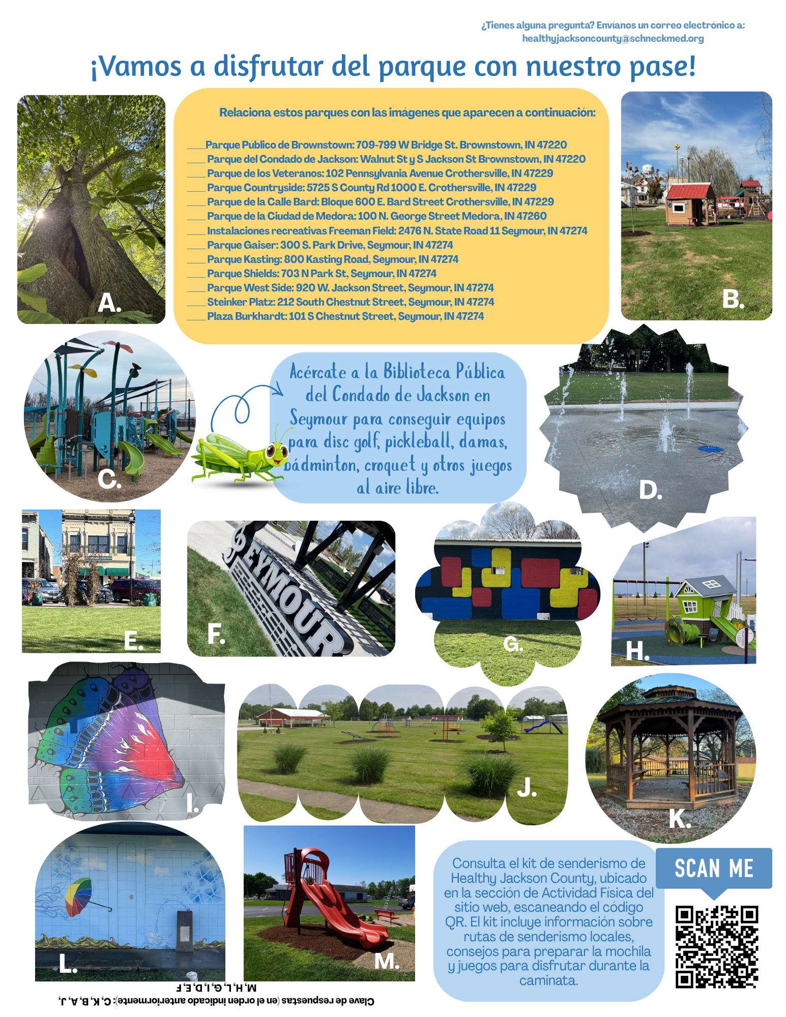

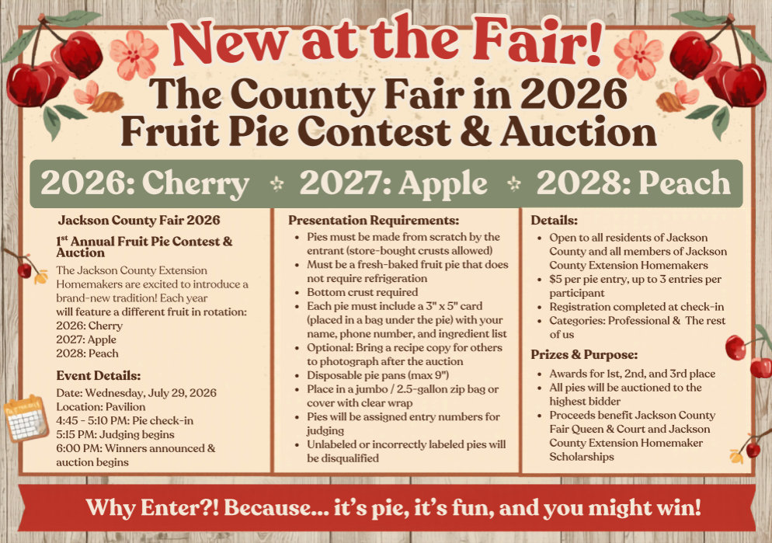
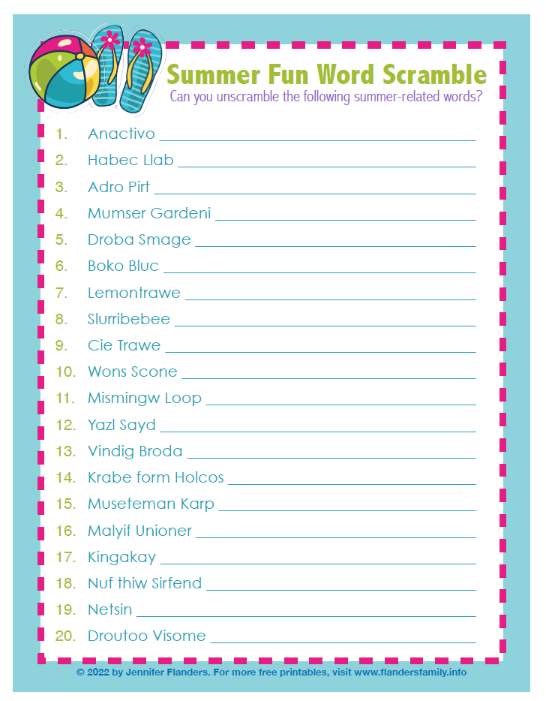
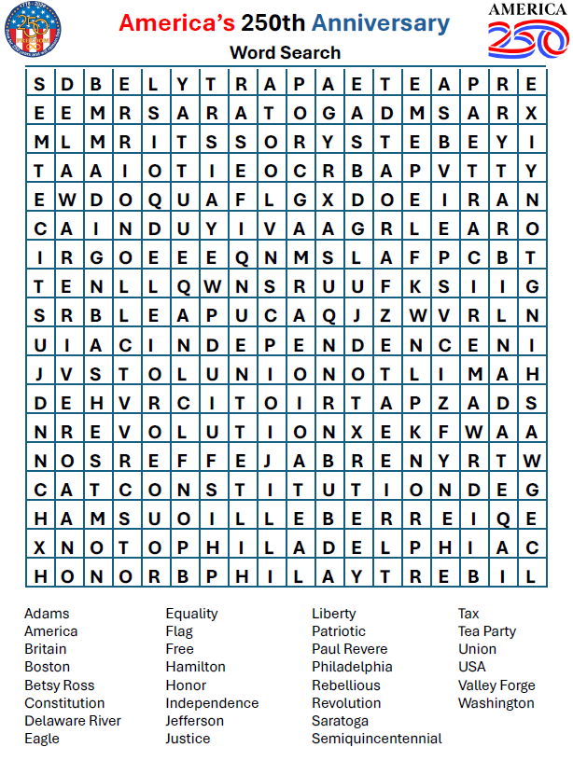
Recipe

Mini Fruit Pizzas

1 pkg. (24 cookies) Pillsbury Refrigerated Sugar Cookies
1 pkg. 8oz. cream cheese, softened
2 T. frozen limeade concentrate, thawed
1.2 cup powdered sugar
10 strawberries, quartered
1 Kiwi peeled & cut into slices
½ cup blueberries (fresh)
½ cup raspberries (fresh)

Bake cookies as directed on package. Cool 10 minutes or until completely cooled. Meanwhile, in a medium bowl, combine cream cheese, limeade concentrate and powdered sugar: beat until smooth. Spread each cooled cookie with 1 Tbls. cream cheese mixture. Arrange fruit on top of each. Serve immediately or cover and refrigerate up to 2 hours.

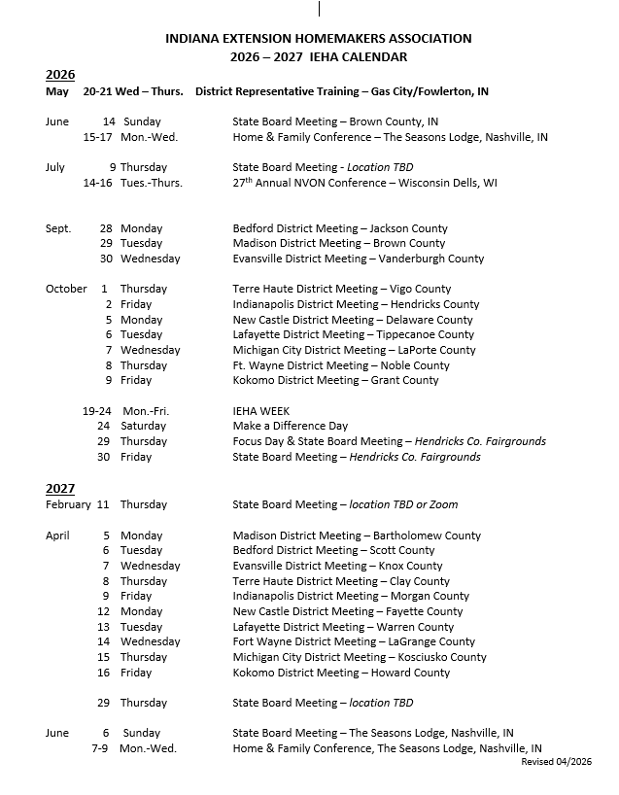
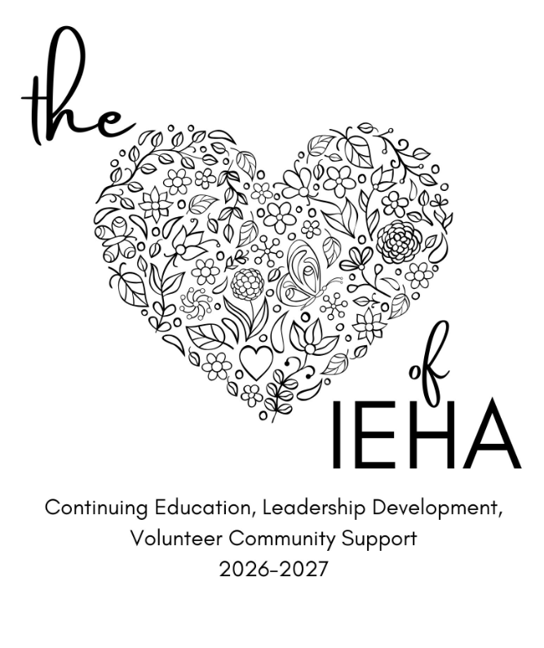
2026 – 2027 Theme

