April 19, 2024

Dear 4-H Llama Members,

Enclosed you will find your 2024 Animal Location Form that must be completed and turned in to the Extension Office by May 15. If you are just showing at the Hamilton County 4-H Fair this is all that needs to be done at this time. A county fair class registration form must be turned into the Extension Office by July 1 to show at the county fair.

Indiana State Fair 4-H Show
If you own your llama or lease a llama and you are the only 4-H member showing this llama, you may participate in the Indiana State Fair 4-H Show per State Fair rules. You must complete llama animal identification by May 15 at in.4honline.com. Visit the Indiana State Fair website for state fair rules and entry deadline.

If you have any questions, please contact Lisa Hanni at the Extension Office at (317) 776-0854 or Project Superintendent Marilyn Nenni at 317-514-5767.

Sincerely,
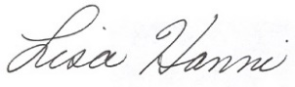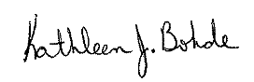

Lisa Hanni Kathleen J. Bohde
Program Assistant Extension Educator
Ag/Youth 4-H Youth Development

KJB:meh
CC: Marilyn Nenni

Animal Location Form

4-H members must turn in a 2024 Animal Location Form to the Extension Office by May 15.

