April 19, 2024

Dear 4-H Horse & Pony Member,

All Horse and Pony members will use in.4honline.com to complete Horse and Pony Identification this year by May 15. Enclosed is an instruction sheet to help walk you through the process.

Horse lease forms MUST be uploaded in 4honline OR turned into the Extension Office by May 15.

Don’t forget Indiana 4-H has adopted a Horse and Pony Vaccination form that members will need to bring with them to 4-H workshops, shows, and fair.

HORSE AND PONY INDIANA STATE FAIR RULES:

- Visit the Indiana State Fair website for state fair rules and entry deadline.

Please contact a leader or the Project Superintendent, Susan Byer, at 317-374-5799 or the Extension Office at 317-776-0854 if you have any questions.

Sincerely,
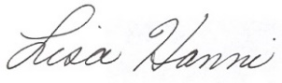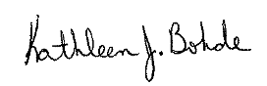

Lisa Hanni Kathleen J. Bohde
Program Assistant Extension Educator
Ag/Youth 4-H Youth Development

KJB:meh
cc: Susan Byer

Animal Location Form

4-H members must turn in a 2024 Animal Location Form to the Extension Office by May 15.

