April 19, 2024

Dear 4-H Bucket Calf Member,

Just a reminder, you are enrolled in the Bucket Calf project and if you wish to show at the 2024 Hamilton County 4-H Fair your calf must be enrolled by May 15, 2024. To enroll the animal, you must complete the Dairy Feeder Steers ID enrollment at in.4honline.com. Even if your bucket calf is a beef calf, select the breed as “cross bred county only.” You also need to stop by the Extension Office and pick up an ear tag number for that animal before May 15.

Note: The Board of Animal Health (BOAH) is not requiring participants to have animal health forms for the County and State Fair. Animals will be physically inspected prior to entering the barn and may be rejected or removed due to health issues at anytime during the fair.

INDIANA 4-H QUALITY LIVESTOCK CARE: 4-H’ers planning to exhibit beef cattle, dairy cattle, swine, sheep, meat goats, dairy goats, poultry or rabbits MUST BE CERTIFIED through Indiana 4-H Quality Livestock Care training (in-person option) OR Youth for the Quality Care of Animals Program (YQCA) (online option). 4-H’ers must be re-certified annually. See enclosed flyer for more information.

If you have any questions, contact Bucket Calf Superintendent Kathleen Herr (317-694-8729) or the
Extension Office at (317-776-0854).

Sincerely,
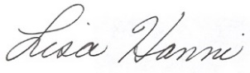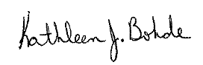

Lisa Hanni Kathleen J. Bohde
Program Assistant Extension Educator
Ag/Youth 4-H Youth Development

KJB: meh
cc: Kathleen Herr

Animal Location Form

4-H members must turn in a 2024 Animal Location Form to the Extension Office by May 15.

