Arts and Crafts Project Manual

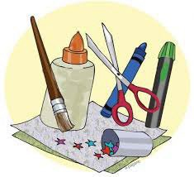

Purdue University is an equal opportunity/equal access/affirmative action institution.

Welcome to the Franklin County 4-H Arts and Crafts project! You may choose from the following subcategories. Exhibitors may enter in as many subcategories as they wish, but only one exhibit per subcategory. Refer to the Franklin County 4-H Handbook to learn more about rules and guidelines. Use this project manual as a reference for project ideas and to learn more about the project.
- Basketry
- Gift Wrapping
- Recycling
- Pottery
- Scrapbooking
- Beading
- Ceramics
- Contemporary Ceramics
- Holiday Decor
- Latch Hook
- Sewing Craft
- String Art
- Miscellaneous Arts and Crafts

Basketry

THE STORY OF BASKET WEAVING
Basket weaving, or basketry, is one of our very oldest crafts. Perhaps a primitive woman who lived in the dawn of humanity gathered a few stems or vines and twisted them together, starting the first basket.
Later this elementary knowledge of weaving was applied to other fibers and led to the development of cloth weaving. The field of ceramics may well have developed from basket weaving, too, as we know that people of many cultures wove baskets, then pressed a layer of wet clay inside them and baked them in a fire until the basket material burned away, leaving a clay pot.
Among the ancient specimens of basketry is a piece of coiled basketry lining from a grain storage pit in Egypt which dates back to 12,000 B.C. North American Indians wove seines of reed-like material and used them to catch fish for food and for fertilizing their crops. Primitive South Americans made such tightly woven baskets that they served as water containers and the water was heated by dropping in hot stones.
Long years ago the inhabitants of the Tigris and Euphrates river valleys made basket-like boats which were light and easy to handle. Some of these were covered with tightly stretched animal hides.
Ancient Greeks made baskets to use in their religious services, for harvesting grain and for babies’ cradles. To be cradled thus was considered an omen of future wealth and prosperity. The Gauls made basketry carts large enough to be pulled by two horses for traveling, and also wove shields to serve as armor when they went into battle.
The Bible tells us that the Israelites were commanded to offer the first fruits of their land in baskets as sacrifices. The wealthy people had containers made from silver and gold in the form of baskets, while the poorer classes made baskets of willows. The baby Moses was found in a basket made of bulrushes, daubed with pitch.
Baskets have played their part in the love affairs of people of many lands. One story tells how the Lord Mayor of London during the reign of Queen Elizabeth had his daughter imprisoned because she wished to marry a man not approved by her father. Her lover arranged to have her smuggled out in a large bread basket and they were married.
In Germany it was a custom for girls to lower a basket by a cord from their windows to receive gifts from their lovers. When an unwelcome suitor appeared, the maiden let down a basket with a loose bottom which would fall out when the present was put inside. Later girls expressed their distaste for unwelcome lovers by sending them a basket without a bottom and the phrase “to

give a basket” was used to mean giving a refusal. Today we sometimes hear the phrase “fell through” used to refer to a plan that failed.

BASKET WEAVING TODAY
A growing interest in crafts, plus the widespread use of basketry in fashion accessories and interior decorating, has led to the popularity of basket making today. People are weaving articles of all types and sizes – from tiny little baskets (to be filled with artificial flowers and worn as earrings) to place mats, bread baskets, planters, purses – and even big items like fireside baskets, magazine racks and folding screens! Basket weaving is enjoyable for many reasons .
It’s SIMPLE – anyone can do it!
It’s INEXPENSIVE – requires no costly, hard-to-get-tools!
It’s PERSONALIZED – every craftsman achieves slightly different results! It’s QUICK – holds the interest of even the most impatient craftsman!
It’s CHALLENGING – intricate designs make it fun for the person who likes to spend more time on each craft article!

BASKET WEAVING MATERIALS
People of many countries have long used their own native materials for making baskets. Perhaps you have seen baskets made of pine needles, bamboo, sweet grasses, raffia and straw. Our rural grandparents split thin layers of hickory and soaked these strips well to weave sturdy baskets for carrying feed and for other farm uses. They also braided clean, smooth corn husks together to form mats and small baskets.
Small sassafras trees can be used to make baskets by cutting the tree, stripping away the bark, and then pounding the trunk to loosen thin layers of wood. These are peeled from the trunk and woven while they are still damp.
Willow shoots or native vines, such as the wild honeysuckle, can also be made into baskets. Gather long pieces and allow them to dry if you want your basket to have the rustic look the bark gives. If you want a smoother-looking basket with a rich color, boil the pieces to transfer the color from the bark to the pith, then peel the bark away. Soak before weaving.
One of the easiest materials for the beginner to use is basket reed. It is made from rattan, a tropical vine growing in wet, hot areas. The vines range from 1/8 inch to one inch in diameter and may be up to five hundred feet in length. They become attached to trees by sharp thorns on the under-side of their leaves. The vine is harvested and allowed to stand until the bark can be peeled away. Next, the inner bark is cut off in long, thin strips. These strips are shiny and smooth on the outside and are used to weave seats in chairs and to make rattan furniture.

Basket reed is made from the center, or pith, of the vine. It may be round, oval or flat. The round reed is most popular. Reed is made in standard sizes ranging from No. 00 to No. 15, with the smaller size having the smaller diameter. Extra large sizes are available for handles and heavy spokes. Spokes are usually about two sizes larger than the weavers.

SELECTING REED
Reeds vary in quality. It is best to choose firm reed that has a smooth surface.
Reeds vary in color also. Some people like to use various shades in a basket to give an interesting effect. However, if you want your basket to be of one color you will need to select your reed carefully. Dark reeds are best suited for baskets which will be enameled or stained. Many handicraft companies now carry a good line of basket reed.

CARE AND PREPARATION OF REED
Reed is sold mostly in one-pound hanks. The cost per pound is greatest for the small diameter reed. It is best to buy reed in quantities which you can use up soon, since it becomes brittle with age. Hang the reed in a cool dark place until you are ready to use it.
Put the reed in luke-warm water about 15 minutes before it is needed. Weavers should be wound into circles about 8 to 10 inches in diameter for soaking, to prevent tangling. Avoid using hot water or prolonged soaking, because either of these will cause the reed to become rough- textured and brittle. If the reed becomes dry while it is being used, moisten it with a sponge or dip it in the warm water.

EQUIPMENT NEEDED
Equipment for making beginners’ baskets can be very simple. You will need . . .
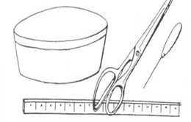
- Tub or large kettle to soak the reed.
- Slender, sharp tool – such as an ice pick, nut pick or nail.
- Cutting tool – heavy shears, sharp knife, pliers with cutting edge or pruning shears.
- Ruler.

COLORING REED
Reed may be colored before it is woven into baskets. The true craftsman may wish to develop his own dyes, using poke berries for shades of purple, walnut hulls for tawny browns, etc. Ordinary fabric dyes will also work well. If you wish to have different shades of the same color to give your basket a tweedy effect, put the reed into the dye in several different lots and let each stand until it has absorbed the color. Each successive lot will be a lighter shade.
Hang the reed to dry after dyeing and moisten it again when you are ready to weave. This will keep excess dye from staining your hands.

FINISHING
When you have completed the weaving of your basket, you will want to remove the small fuzzy fibers which have been worked loose from the reed by trimming them with scissors.

Under and Over Weave
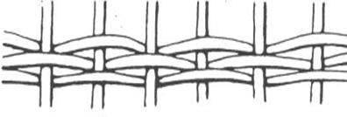

This is sometimes called a “simple” weave, or “randing.” A weaver goes under one spoke and over the next. It is usually used with an uneven number of spokes.
With an even number of spokes it is necessary to weave one row, then start a new weaver behind the first spoke to the left of the one used as a starting point for the first row. The two weavers may be used alternately, with each row beginning one spoke to the left of the previous row.

Double Under and Over Weave
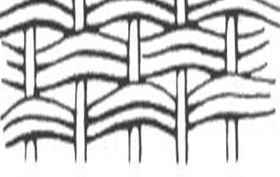
This is also called “slewing.” Using two weavers, work in the same manner as in Under and Over Weave. Keep the two weavers lying flat and smooth, and keep an even tension on both weavers so they lie parallel. Three or more weavers can also be used.
If there are an even number of spokes, two sets of two weavers must be used alternately as described for Under and Over Weave.
For an interesting variation, use this weave with double spokes held parallel.

Japanese Weave
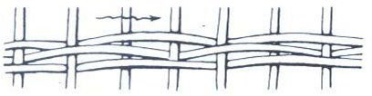
Weave with one weaver going over two spokes, then under the third. Repeat. This gives a diagonal effect.
You may use two or more weavers held parallel for this weave, to achieve a different texture. Japanese weave is not used when the number of spokes is a multiple of three.

Single pairing Weave
Insert two weavers behind two adjacent spokes, or fold one weaver and slip the loop over the first spoke. Weave with both weaver ends, crossing the two between each two spokes. Be sure the weavers cross in the same direction each time.

Double Pairing Weave
Using two weavers held parallel, proceed as in Single Pairing Weave. If desired, pairs of parallel spokes may be used as in illustration.

Pairing Arrow Weave
After making one row of Single Pairing Weave, make a second row – but twist weavers in opposite direction. This is sometimes used as a border or trimming weave.

BORDERS
Basket borders are formed from the ends of spokes. There are three kinds – open, closed and braided. You will want to choose a style that is rigid and strong enough for the kind of basket you are making.
If some spokes are too short to form the border, clip them off even with the last row of weaving and, using the ice pick to open a space, force the end of a new spoke down along each old, cut spoke. Insert the new spoke at least 1” downward.
When borders are too deep, they look awkward and out of proportion. If necessary, cut off ends of spokes to make your border an appropriate width. Always dampen spokes before forming borders.

Open Borders
Open borders are formed by bending the spokes over one another to form loops. This results in a decorative, lacy finish suitable for mats, small flower baskets, etc. This border adds little strength to the basket.
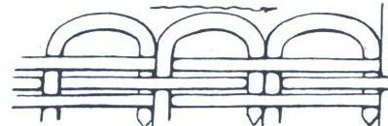
To form a simple open border, bend each spoke over in turn and press the end of it down along the side of the next spoke. This will be easy to do if you open a space for each spoke with your ice pick first.
To give a more lacy effect, try carrying each spoke end past the spoke next to it and pressing it down beside the second spoke. Or skip two spokes and insert it behind the third.
Be sure all spoke ends pass their adjacent spokes on the same side, either all on the inside of the basket or all on the outside.

Closed Borders
Closed borders are more tightly woven and give a stronger, more substantial looking finish. They are formed by twisting or rolling the ends of the spokes so that they interlock.

The simplest closed border is made by carrying each spoke end in front of the spoke to its right and then behind the second spoke to its right. Draw the border down as tightly as desired and clip off spoke ends, leaving enough to hold each end in place, after the reed has dried.

Braided Borders
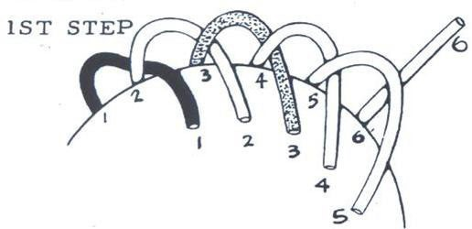
Braided borders are more difficult to make, but most people think they are well worth the effort. They are quite strong, since the spoke ends twine and re-twine.

The first step in making a 4-strand braided border is to carry each spoke behind the spoke to its right, turning the end of the spoke in toward the center of the basket. Go completely around the basket with each step before starting the next step.
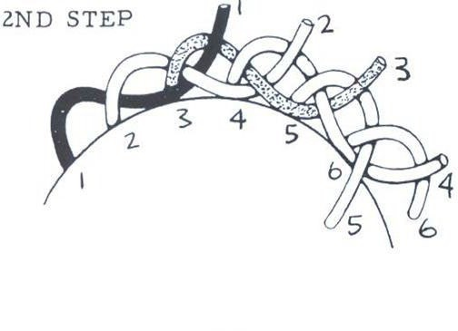
Second, carry each spoke end in front of the next spoke to its right, turning end out away from center of basket.
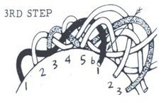

In the third step, the end of each spoke follows the course of the next spoke to its right (the third from where the spoke started) lying on the outside of this spoke. The end will again point toward then center of the basket.
In the final step, turn the end of the spoke outward and down through the braid. This would mean that the end of spoke number 1 would go through the space marked with an arrow in the sketch of Step 3.
Pull all ends even and tight, let dry, and clip away excess at ends of spokes.

STARTING TO WEAVE
Insert the left end of a weaver behind a spoke, as shown in illustration. Weave from left to right.
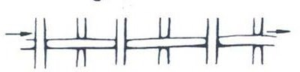

Carry the weaver lightly in your right hand, avoiding too much tension on it. Use your left hand to press the rows of weaving together so that there will be no open spaces between the rows. (If you are left-handed, you may want to reverse these directions.) When you have finished your basket, trim the starting end of the weaver smoothly on the inside of the basket.

PIECING WEAVERS
There are two common methods of piecing. The open piecing is very simple and may be used where it will not show. The finishing end of the first weaver (A) and the starting end of the second weaver (B) are overlapped behind a spoke.
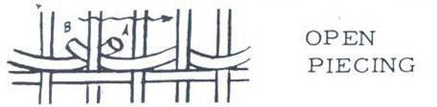
When the basket is finished, all rough ends are trimmed smoothly, on a slant.

Closed piecing gives a smoother and stronger finish. Trim the finishing end of the first weaver
- so that it extends ½” to ¾” past a spoke. Bend the weaver sharply where it passes the spoke, and insert an ice pick or other sharp tool down beside the spoke, moving it back and forth to open a space for the end of the weaver. Push end of weaver down into this space.
Use ice pick in similar fashion on the other side of the same spoke to open a space. Insert ½” to
¾” of the beginning end of the second weaver (D) bend it sharply and continue weaving as before. Piece weavers so that they overlap on the back or “wrong” side of the basket.

FINISHING WEAVING
The finishing end of the last weaver may be handled in either of the methods described for piecing.

IVY BASKET
Here’s a good basketry project for your first attempt. It is quickly made, inexpensive, practical – and a pre-school child can do it with a little supervision!

You will need the equipment listed previously, plus a waterproof coating material (such as shellac or varnish), a small piece of plywood, 11 spokes of number 4 reed cut 10 inches long, 3 or 4 weavers of number 2 reed, a 3 – ½” flower pot, a pencil and some sandpaper.
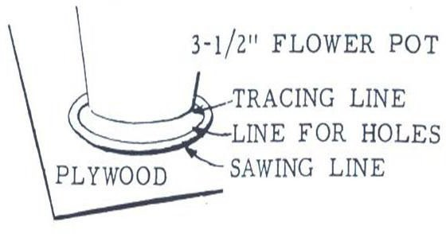
Trace around the bottom of the pot, then draw one line ¼” outside the tracing and a second line
½” outside the tracing. Saw on the outer line, and drill 11 holes to fit the spokes on the ¼” line. Sand the plywood until it is smooth and give it several coats of the water-proofing solution.
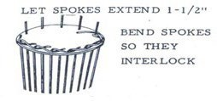
Now you are ready to start making your basket.
Step 1: Insert the spokes so they extend about 1½” through the plywood disc. Keep them from falling out by holding them together at the long ends.
Step 2: Starting with any spoke, bend the short end of the spoke out and to the right so that it is flat against the plywood and passes in front of the spoke to its right. Now bend the end of the first spoke so it locks behind the second spoke to its right. Continue until all spokes are fastened down. When you have finished you will not be able to tell which was the first spoke turned down; they will all look the same.
Turn the base and spokes over so you can put the flower pot inside the long ends of the spokes. Spread the spokes evenly around the pot.
Start weaving by inserting a weaver behind one spoke as described under “Beginning Weaves” and then follow the steps below:
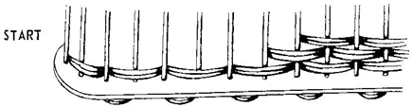

Figure C

Step 3: For the double over and under weave, use 2 parallel wavers, carried as one, in front of one spoke (Fig. C), back of next, and so on to the right.
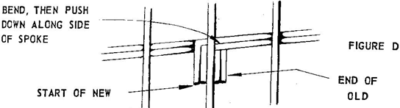
Continue weaving until 2 inches high. Keep sides perpendicular to bottom. Step 4: To finish, first soak projecting spokes to keep them pliable.
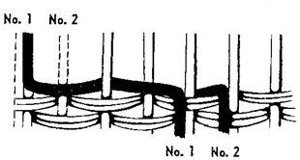
Figure E

Bend down No. 1 spoke, weave using the over and under weave, in front of next spoke, behind next, in front of next spoke (as in Fig. E). While weaving each spoke, flatten spoke to top of basket.
Step 5: After basket dries, apply shellac, varnish, or whatever finish is desired.

Gift Wrapping
Through this project you will learn how to wrap all types of gifts, beautifully and appropriately for every individual and for every occasion.
Everyone likes to receive a gift. The way it is wrapped and presented is almost as important as the choice of the gift itself. An attractive package expresses not only the good taste of the person giving it, but also his thoughtfulness toward the friend being honored. It provides something beautiful and tantalizing to enliven the occasion.
On the other hand, a sloppily wrapped package, or one too gaudy or too skimpy, indicates poor taste, indifference, or lack of skill – and inevitably detracts from the pleasure intended. This does not imply that much has to be spent on materials. Even if you use the simplest papers, the package should be neat, without untidy wrinkles or bulges; the ribbon of suitable width and color for the paper chosen; and the trimming artistically arranged on the package.
Learning to wrap gifts is like learning to cook. You must do it. There are some rules to guide you, but like cooking, real skill comes with practice. As you try your hand not only will you develop the finger dexterity required, but you will also develop wrapping and trimming ideas that are completely your own. You will have the greatest fun wrapping gifts; and there will be the satisfaction that in each case you have produced a little work of art all your own.

Most items you will need for gift wrapping are small and inexpensive. Everyone is conscious of the need for Christmas wrappings, but it is the occasional gift – birthdays, graduations, anniversaries, weddings, babies – which find many of us unprepared. To avoid last minute searches, keep a supply of a few well chosen gift wrapping materials in readiness. Basic supplies should include plain tissues in assorted soft colors; a few rolls of plain or colored cellophane, a few rolls of gold, silver, and other metallic colors; and a varied assortment of printed designs. When you know that you have the necessary materials, you have the incentive for doing something effective and interesting for special occasions.
Any gift looks better in a box; the box protects it and keeps it fresh and attractive. It is much easier to wrap a boxed gift. Many boxes can be used more than once if kept clean and fresh looking.
Throughout the year, cut out the illustrations you like best from your favorite magazines. Many wrapping suggestions given include the addition of a pasted-on illustration; a painting, flowers, etc. Keep these ideas in a folder, for ready use.
REMEMBER: The package with a professionally wrapped look is much more tempting and exciting to open than one haphazardly tied together.

PREPARING THE GIFT
Remove the price tag. If the item is wrinkled, press it. If the gift needs dusting, polishing, decorating, or trimming, do whatever is required.
BOXING THE GIFT
If no box comes with the gift, be sure to select one that is the right size. If the box is too small, the contents will bulge and the wrapping may burst. If the box is too large, the contents may slide around inside and break or become wrinkled.

If the gift is clothing or material items, line the box with tissue as shown in figure 1:
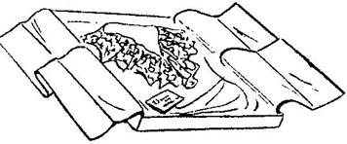

Figure 1. Box lined with tissue.
Note:

The tissue is folded in the center.

SELECTING THE PAPER
The choice of the paper is largely an individual matter. However, certain basic rules should be observed for the best results. Use small designs on smaller packages. Use large designs and vivid colors on large boxes. Diagonal stripes, vertical lines, geometric figures, scenes, and any of the plain softer colors are ideal for the large package.
Paper comes in a wide variety of types, colors, designs, and qualities. There are rolls and packages. If you use a lot of paper, there is less waste when you cut just what you need from a roll; but for the single gift or small box or two, the package containing folded sheets is more economical.

When using rolled sheets of paper for wrapping, unroll all the sheets, place roller on right side and reroll. This reverses the curl and makes the sheets lie flat. If the folded paper is deeply creased, press out with warm iron before using.
In the advanced division you will make your own paper. Different ideas may be found in instructions for the advanced division.

When selecting the paper, these questions should be asked:
  - Does the paper suit the occasion?
  - Does the paper take into account the age and gender of the receiver?
  - What paper is available?
  - Is there enough paper to wrap the gift?
  - Is the design in proportion with the size of the box?

Once the paper has been selected, then it’s time to start wrapping.

WRAPPING THE GIFT
The secret of making a neat package lies in the way you handle the paper. Don’t bundle the box with a lot of excess at the ends and corners. Cut the paper to proper size. Draw it smoothly around the package and hold it with tape while you fold the ends in as flat and smooth as possible. If there is excess bulk, simply cut it off with the shears. A neatly papered box is a “must” to show off your ribbons, bows and accessories.

BEGINNERS

Wrapping a square or rectangular box:
    - Tape the lid to the box to prevent bulges and to add firmness to the box.
    - Lay the box upside down on the paper. If the paper has a pattern or printed message, make sure the design is properly centered on the box so that is shows off to best advantage.
    - Estimate the amount of paper required to go completely around the overlap. Allow enough in width to overlap 2 to 4 inches. Paper should extend at the ends no more than three-fourths the depth of the box.
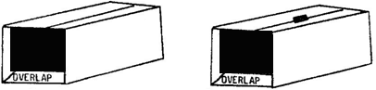
    - Lap one edge of paper over the other and tape in place as indicated in figure 2 and figure 3.
Figure 2. Lap edge over Figure 3. Tape lap in place

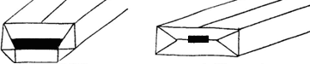
    - Beginning on one end, fold the top flap down toward the center. The side flaps are then folded toward the center and finally the bottom flap is brought up and taped in place.

Figure 4. Fold top flap down then side flaps in.
Figure 5. Fold bottom flap up and tape in place.

    - This procedure is repeated on the other end, being sure that the paper is kept tight.
    - Complete your package with ribbon and bows which are explained later in the manual.

INTERMEDIATE

Wrapping the lid and box separately
Some boxes, not deep enough to need two papers, may be covered by wrapping the lid and box separately.

- To cover the box, cut paper two inches wider than the box and long enough to reach around it.
- Spread paste along the top and bottom edges of the box, then wrap the band of paper completely around the four sides.
- Clip the corners.
- Fold 1 inch of the paper over the top over edge of the box and paste it to the inside. Fold 1 inch under the box at the bottom and paste lightly to hold edges fast.
- Cover the lid with the same or contrasting paper, allowing 1 inch to fold inside the lid. Secure with thin layer of paste.
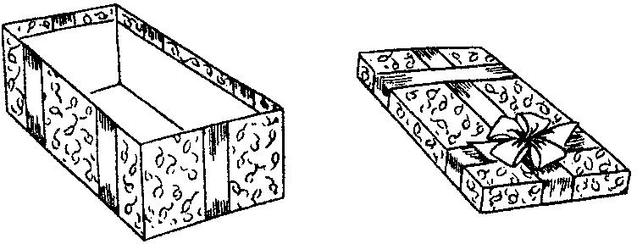
- Clip at the corners and make a neat overlap. When dry, the box and lid can be decorated as shown in figure 6.

Figure 6. Decorated box and lid

You can also combine papers for unusual effects; printed paper on box, plain on lid and vice versa; or plain color on half of box, another plain color on the other half, or the same color all over, relying on the ribbon alone to give it contrast.

Wrapping a suit or deep box
- Before wrapping a suit box, make the box rigid. If necessary you may add a piece of stiff cardboard to the top and bottom or ends, and tape the edges so that they will hold securely. If the box bulges, tie cord tightly around the box before wrapping or the paper will tear when the box is handled.

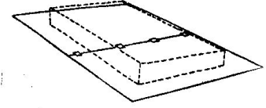
- Two layers of paper will give added strength. If one sheet of paper will not reach around the box, overlap two sheets to get the necessary length and paste or secure edges with tape as shown in figure 7.

- Wrap the bottom of the box first.
Figure 7. If needed overlap two sheets to get enough length

- Splice two more sheets for the top. Wrap the top next. Now you are ready to add your trimmings.

- To add novelty effect, you may use plain and print paper. OR you may paste the edges of three or four sheets of paper together to form one large piece. Wrap it around the box in the usual manner. Use your imagination for the right effect.

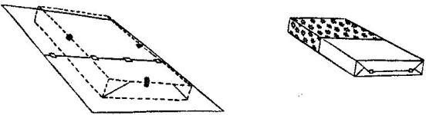
- The deep box may require two sections of paper. Set the box right side up on the wrong side of the paper. Bring the sides up as far as the paper will come, and hold with tape. Fold the ends and tape.

Figure 8. A deep box may need two sections of paper.

- Turn the box upside down on the second sheet of paper and cover the lid, sides, and ends. Allow the paper edges to overlap about 2 inches. Cut away excess paper, if any, and save for small packages. The edges where the paper laps should be covered with ribbon.

- On many boxes the paper is not quite long enough to meet or lap. In this case, cut an extra piece of paper and paste it to the bottom of the box. Then wrap as usual. The ribbon trimming can be arranged to cover the place where the paper was spliced.
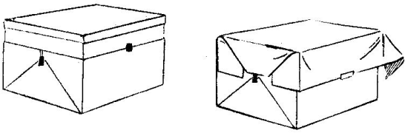
Figure 9.

Wrapping Cylinder Shapes
For smooth ends,
- Trace the ends of the cylinder and cut out two circles of the wrapping paper.
- Wrap the cylinder with wrapping paper allowing an overlap on both ends. Tape securely.
- Fold the overlap at the ends (sometimes cutting is necessary) and paste down. (Be careful not to get paste on the gift.)
- Paste the circles over the folds.
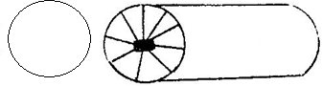
Figure 10. For smooth ends on cylinder shaped packages.

To wrap a cylinder shaped package:
- Cut paper slightly longer then the cylinder to be covered.
- Roll the paper around the cylinder and seal.
- Fold the ends neatly as shown.
- Cover with a large seal or circle cut out of the wrapping paper OR leave one end of the paper long and tie, then fringe by cutting the paper into narrow strips and add stars or other designs. If cellophane is used, the ends can be fluffed.
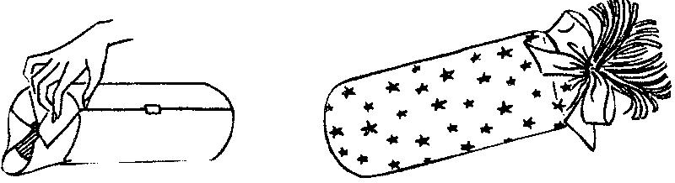
Figure 10. Finishing the ends.

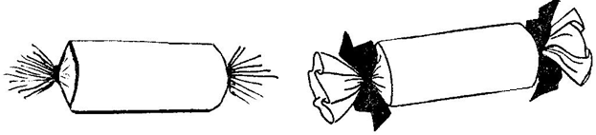
- Fringed ends can be made by wrapping the paper around the cylinder, allowing enough paper for the ends to be gathered and tied. Tape securely in the middle of the paper. Gather paper at the ends and tie securely. Cut the ends in strips to make the fringe.
Figure 11. Fringed ends.

You may want to make your cylinder package more personalized by using the wrapped cylinder as a base and make some object from it, such as a truck, a fire engine, a clown, a drum, or many other things. Be creative. Use your imagination.

ADVANCED

Design and use your own wrappings
In this division, you must design your own wrapping paper and accessories. No commercial gift wrapping supplies are allowed.
Give that gift a special wrap with gift paper you create with only a small expenditure of time, energy, and money. You can print reams of your own unique gift wrapping paper. Using shelf paper and paper towels, in both white and pastel colors, print your own designs using one of several methods – roller painting, string pulling, vegetable, fruits, and utensil printing, and dip dying, or any other idea you come up with.

Roller Printing – Use different widths of rollers to decorate rolls of shelf paper. To achieve startling effects, follow these directions.
- Allow yourself an adequate work area. A 3 to 6 foot table or sawhorses with boards are ideal.
- Pour a variety of water based paints into bowls or saucers, and lay out newspaper to protect the floor.
- Unroll the shelf paper into 3 to 6 foot lengths, cut it with scissors, and begin painting the design.
- One roller is all you need to create bold stripes. Alternate the widths of the stripes by using the rollers edge to make a very narrow stripe, or create a checkerboard motif by rolling a roller for a few inches and then lifting it from the paper. The fact that the color blocks are uneven is far from a drawback it contributes to the primitive look.
- Use two rollers of different widths simultaneously to cover the entire area of the paper with contrasting colors. Try using two rollers of the same width running them crisscross, vertically, or horizontally along the shelf paper. Just experiment with the rollers and see what you come up with.
- After you have finished the roller prints, lay the lengths of paper on the floor for a few minutes to let the colors set. While they are still damp, pick up each piece separately and hang it over a clothes line. Leave the pieces overnight for drying. When dry, roll them together for future package wrappings.

String Pulling – String pulling is a very ancient method of decorating paper.
- Again, use shelf paper or ordinary brown wrapping paper.
- Cut off one or two yards of paper (here shorter lengths of paper are handier to work with).
- Assemble ordinary postal string or heavier twine if you wish, to make thicker outlines. Cut the string not longer than an arms length. (You will be coiling some of the string on the paper with the rest hanging over). Dip the string in poster paint, squeeze out the excess and lay it in swirls and loops on the paper.
- Fold a square of newspaper over the coiled string, exerting a gentle pressure with the left hand. Quickly pull the string, which extends from between the newspaper and the shelf paper, toward you with one continuous motion.
- Remove the newspaper and let the design dry thoroughly.
- Do not use more than two colors.

Fruit, Vegetable, and Utensil Print Paper – Fruit, vegetables, and utensil print paper can feature a wild collection of fruits, vegetables, and utensils than can be found in most supermarkets any time of the year. To make these papers, use some new variations of the well-known potato printing technique.

- For potato printing, cut the vegetable in half and make a few notches with a paring knife. If the potato is not particularly shapely, trim the edges into desired outline. Dip the potato in paint and press it to the paper. For a striking effect, alternate rows of vegetable print with hands made from a roller.

- After you have mastered the potato print, graduate to other fruits and vegetables. Try a cabbage cut in wedges, a Bermuda onion cut in half, or make wagon wheels from lemon slices.
- Also try designs made with kitchen hardware – wire whisks, cookie cutters, and gelatin molds.

Kitchen Paper Toweling and Liquid Dye – These make simple but sensational shadow designs. The end results will resemble an expensive batik or tie-dyed paper and best of all you can turn out yards of superb-looking paper in a few hours.
- To make a large amount of this type of wrapping paper, take the cardboard core from the inside of a regular size roll of paper toweling.
- Reroll about ¾ of the paper towels tightly.
- Fill a small basin with ½ cup dye and equal amount of water. For lighter shades, double the amount of water.
- Repeat the process with another color.
- Immerse one end of the paper towels in one color, letting it remain in the solution for about one minute.
- Wearing gloves, remove the toweling from the dye and squeeze out excess liquid.
- Repeat the process with another color at the other end of the toweling.
- Unroll the paper carefully and loop it over a clothesline for drying.

For a shorter length of dip-dyed wrapping paper, you’ll find that folding six or eight of the squares into a very small compact square and immersing each corner in a different color of dye for 30 seconds will produce a feathery effect. OR fold paper toweling into triangles, and dip the corners of the triangle.

If you are the kind of person who really likes to get your hands into a project, making gift wrapping paper provides you with an excellent opportunity. Here are a few fun ideas for your consideration.

  - Dip the palm of your hand in poster paint and make handprints all over shelf paper or brown wrapping paper.
  - When you think you have mastered this, try making bear tracks across the paper. To do this, dip just the palm of your hand in poster paint, make your palm print on the paper, and dip your fingers in the paint and print them just above your palm print.
  - Try making footprints on snow-white shelf paper. This design is created by a clenched fist print, four fingers, and a thumbprint. Splash them at random all over the paper or arrange them so that they appear to march over or around the gift box.

These different ideas should give you a few ideas of your own. Put them into action by working on your own personalized gift wrapping paper. The work will seem like play! You will also discover ideas to use in place of bows and ribbons. You might use in place of ribbon and bows – yarn, strips of fabric, pine cones, small articles, felt, burlap flowers, fabric flowers, etc.

SELECTING THE RIBBON FOR THE PACKAGE
Choose the color that harmonizes or contrast with the paper, and a width that is in proportion to the size of the box. The wider ribbons are used on large boxes. In place of one strip of wide

ribbon, you may substitute two or three rows of narrow ribbon; or you may use the wide ribbon across one side with two or three rows of narrow ribbon across the end.

Do not use ribbon so wide that it will cover most of the design on the paper. If the paper has a distinct motif which has been properly centered on the package, use the ribbon across the ends of corners so that it does not cover the pattern on the paper. Use narrow ribbon on small packages.
Do not combine too many kinds of ribbon or too many colors or widths on one package or it will appear cluttered. Be especially careful to select appropriate colors and widths of ribbon if you are using a printed paper. If in doubt, always keep the effect simple.

TYING THE RIBBON ON THE PACKAGE
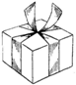
In applying the ribbon, line and balance should be considered. The ribbon should be applied to conform to the size and shape of the box (centered on a square box; toward the top of a long, thin box, etc.) Ribbons should be smooth, straight, and evenly spaced.

The most common method of tying a ribbon on a package is:
- Lay one end of ribbon on top of the box in the center.
- Hold with thumb of left hand, leaving 4 to 5 inches of end free.
- With the right hand, wrap the ribbon around the ends of the box, cross at right angles, and wrap around the sides of the box.
- Bring to the center and tie in a hard knot. Cut the ribbon, leaving two ends from 4 to 6 inches for attaching the bow.

Figure 12. Common Bows

- NOTE: The bow should always be made separately and then attached to the package.

Vary the placement of the ribbon by winding it around one end and along one side, or by tying separate pieces around each end of the box. Paste or tape ribbon ends to hold. The ribbon may also be wound around the side of the box.
To tie the box in a diagonal effect:
- Hold the ribbon with the thumb at center of the top end of the box, bring across the top left corner, then under the lower left corner to the bottom center.
- Now bring the ribbon up across the lower right corner and under the upper right to the starting point.
- Tie in a double knot at or near the starting point.
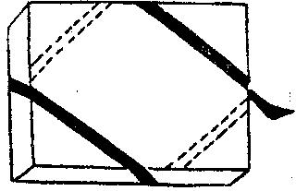
- To make the double diagonal effect, turn the box and continue, crossing the other two corners.

Box Top

Figure 13. Diagonal effect

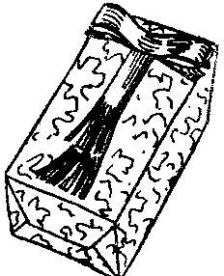Ribbon may be attached to the top of the box only. Lay it on exactly as you want it to look. Lift the ribbon, one piece at a time, and touch the box lightly with a brush dipped in paste. Place the ribbon on the paste and let it dry. Don’t use too much paste or it will show through the ribbon. You may also fasten ribbon to the package with Scotch tape hinges.

Figure 14. Ribbon on top only.

A Scotch tape hinge is made by folding a short piece of tape in half, with the smooth side inside. Stick one half to the package, the upper half to
ribbon or paper. Press down! This hinge is useful for holding ribbon loops, bands, or ends in position, for holding paper folds in place, and for keeping packages together in group arrangements.

Figure 15. Additional ideas.
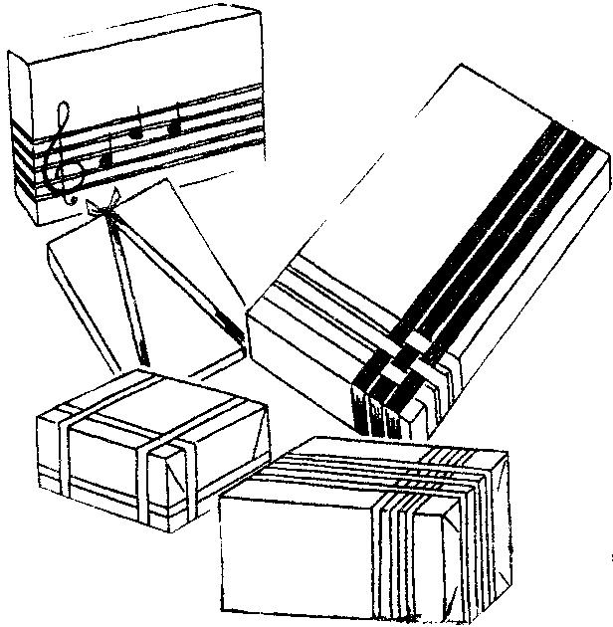
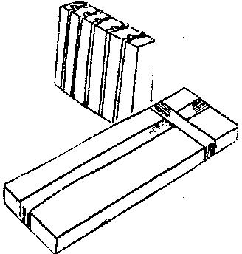
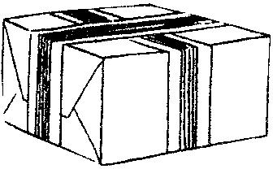

Making Bows
The bow adds the finishing touch to a package. At one time or another, all of us have looked at a beautiful gift package, in stores perhaps, and longed for the ability to make our own packages look as perfect. Actually there are only a few basic bows, but from these it is possible to develop endless variations. By following a few fundamental rules as to color, proportion, methods of looping, gathering, tying ribbon – and by PRACTICE – everyone can learn to make attractive bows.

To gain confidence in yourself, and to develop the deft touch that is so important in making bows, a good idea is to practice first with tissue paper cut into strips of different lengths and widths so that you can learn how to get the exact size and shape you want. When you are working with ribbon, you cannot remake a bow without having it lose some of the crisp freshness that is part of its charm.
Here are a few general tips for successful bow making:
- Always make the bow separately and then tie it onto the package.
- Make loops in proper proportion to the width of the ribbon. The narrower the ribbon, the shorter each individual loop should be, and the more loops you need to have a puffy bow.

- Be lavish with ribbon and make plenty of loops. In general, keep loops the same size. Special effects with long and short loops are also possible.
- When pinching ribbon together to form loops, make tiny pleats or gathers.
- If you are using ribbon with a right and wrong side, be sure to keep the right side out at all times by turning the ribbon as necessary before making a loop.
- Do not handle the ribbon more than is absolutely necessary.
- Wind bows tightly in the center with fine wire, thread, or narrow ribbon. For fluffy upright loops and with laminated ribbons wire gives best results.
- Fluff out the loops with your fingers and arrange in a symmetrical and attractive manner.
As you can see, bow making is a skill that anyone can do.
KNOTLESS BOW: (Self-sticking ribbon) – Cut a strip of ribbon and stick together on the ends. Double over. Repeat again and place in opposite position. Length of strips can be varied so that they get shorter when the bow is ended.
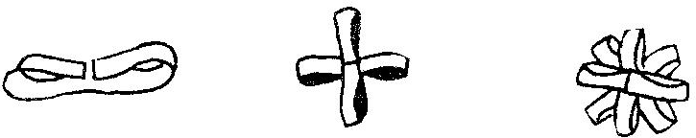
Figure 16. Knotless Bow

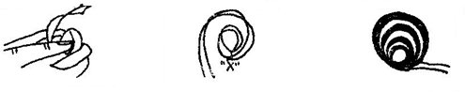
CIRCLE BOW: (Self-sticking ribbon) – Moisten the end of ribbon and form a small circle. Continue going around enlarging circles and attaching at the beginning point until you reach the desired size. Circle bows can be combined to make sure things as butterflies. Use your imagination.

Figure 17. Circle Bow

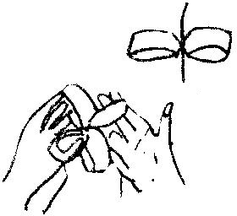
POMPOM BOW: Begin with a large circle of ribbon which you continue going around for at least ten times. Flatten the circle and cut wedges into each side in the middle. Tie securely with thread at the wedges. To open, slip the individual loops and twist down and forward. Repeat until all loops are free.

Figure 18. Pompom Bow

BEGINNERS BOW: Take very thin ribbed ribbon and begin by making a figure eight with ribbon between thumb and small finger. Continue until the thickness is that which is desired. Tie bow securely where ribbon meets. Puff up ribbon and curl by rubbing on one side of the scissors.
Figure 19. Beginners Bow
FLAT BOW: Cut a piece of paper about the length you desire the bow
to be. Begin by stapling ribbon to the paper. Loop and staple again close to the first one. This can be repeated again and again, varying the size of the loop to create effect desired.
Figure 20. Flat Bow

Another variation is to loop the ribbon back and forth, decreasing the size of the loop – using as many loops as desired. End by wrapping once around the center of the bow.

Figure 21. Flat Bow variation
NOTE: Ribbons should be reversible and self-sticking!

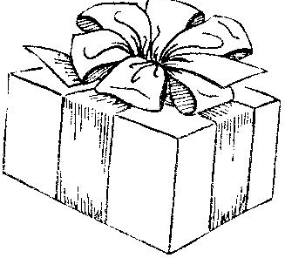
The GLAMOUR BOW, as the one on this package, requires 2-3/4 yards of 2-inch wide ribbon. Three and one-half inches from one end, pinch gathers in the ribbon and hold it between the thumb and fingers of the left hand (figure 23).
Figure 22. Glamour Bow

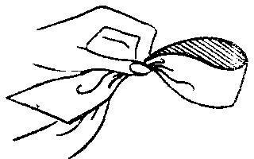
Seven inches from this point, pinch gathers again and bring-up to the first gathers to form a loop 3-1/2 inches long (figure 24).
Figure 23. Pinch gathers in the ribbon Figure 24. Form a loop

If the ribbon has a right and wrong side, keep the right side out by turning the ribbon under the thumb and fingers as loops are made. With the right hand continue making loops in the same

way until you have twelve loops (six up and six down) and an extra end about 3-1/2 inches long. Wind wire or thread around the gathers to hold them in place.
When making this bow, adjust the length of the loops accordingly to the width of the ribbon. If the ribbon is 3 inches wide, you will need 2-1/4 yards to make ten loops. If the ribbon is 1-1/2 inches wide, it will take 2-3/4 yards to make sixteen loops. If the ribbon is ½ inch wide, you will need 3-1/2 yards to make a bow of twenty-eight loops. In other words, the narrower the ribbon, the more loops necessary to make an attractive bow.
You may find it easier to make smaller bows and group two or three together to form one large bow.

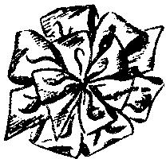
GLAMOUR BOW VARIATIONS:

TWIN BOW: A glamour bow made from ½ inch ribbon can be nested on the center of a larger one made from 2 or 3 inch ribbon. Use contrasting colors or kinds of ribbon.

Figure 25. Twin Bow

26. Carriage Bow
CARRIAGE BOW: Use 3-inch ribbon and make a glamour bow which has only six loops and two ends. Tie in center with narrow ribbon and arrange loops to form a circle. Make a second bow (using same or contrasting colors) having only four loops and lay it on the top of the first bow (center on center). Tie both bows together and attach to package.

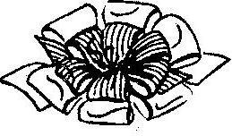
DOUBLE BOW: Make bow as in carriage bow but use a different kind of ribbon for the smaller, center bow. For instance, you can use tinsel on satin, gold on green, silver center bow on big blue bow, etc. You may also use a striped bow on a plain-colored larger one.
KNOTTED BOW: Use ribbon 1-1/2 to 2 inches wide about 2 yards long. Make a mark every 10 inches. Tie a soft, loose knot at every other mark. Pinch gathers on the mark between knots and make loops as for original glamour bow. (Knot should come at the center of the loop.) This is especially attractive in gauzy tinsel ribbon or soft satin. When made from baby ribbon with knots about 5 to 6 inches apart and with twenty or thirty loops in all, you have a beautiful rosette.

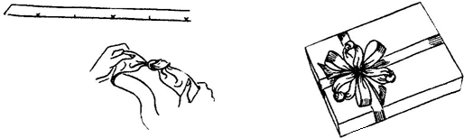

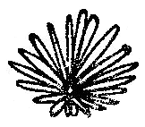
The NARROW RIBBON GLAMOUR BOW is made in the same manner as the original glamour bow, but the ribbon selected should be less than 1 inch wide, and loops should be short and numerous (twenty to thirty). In this particular instance, be sure to wind center tightly with wire so loops will stand upright.

Figure 28. Narrow Ribbon Glamour Bow

LOOP BOW: This resembles a wheel. It requires two yards of ½ inch ribbon – preferably firm or stiff, such as cellophane, laminated, metallic, grosgrain, or ribbonette. Ribbon must be alike on both sides.
Make a 3 or 4 inch loop about 5 or 6 inches from one end. Do not pinch together. Continue looping ribbon back and forth, making each loop directly under the one above, until you have made fourteen to sixteen loops. Wind fine wire around the center, taking care not to crush edges. Lay on the package and spread loops apart at the center to form a perfect circle. Fasten to the box by pinning through the center, or use Scotch tape hinges.
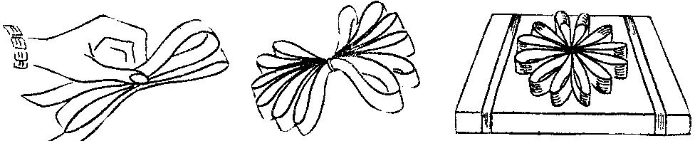
Figure 29. Loop Bow
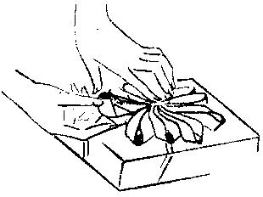The circle effect may also be obtained by making two bows of fewer loops each and joining them back to back on the package to form the circles.

Figure 30. Flat Edge Bow
To make a FLAT EDGE BOW turn the loop inside out by pushing the bottom edge of the loop into center bringing up and back to original position.

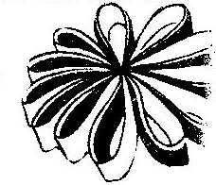TWO TONE BOW: If the ribbon has a right and wrong side, place two different colors of the same width ribbon with wrong sides together and make a flat edge bow. A lovely color effect will result.

gure 31. Two Tone Bow

TWISTED EDGE: Push the loop in toward the center. Push the top edge down and under so that it turns inside out, to give the twisted effect. Use ribbonette or crinkle-tie.
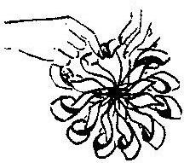
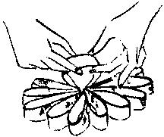

LONG AND SHORT: Follow directions given for making the loop bow, but instead of winding the wire around the center, wind it nearer the top so that the upper set of loops will be shorter.
This long and short version can be used as is, or the shorter loops may be bent down over the longer ones. It is especially pretty when made in two-tone colors.

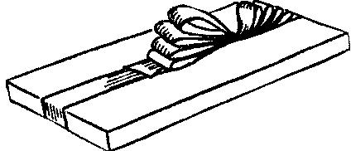
GRADUATED LOOPS – When making graduated loops, start with a short loop and make each succeeding loop a little longer. Tie in center.

Figure 33. Graduated Loops

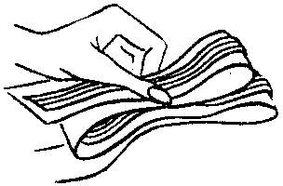
TWO IN ONE BOW: Lay narrow ribbon on top of a different color or kind of ribbon in a wider width and form a bow. This will result in an interesting difference between the top and bottom loops.
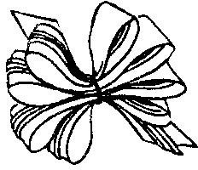
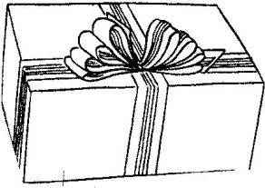
Figure 34. Two in One Bow

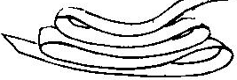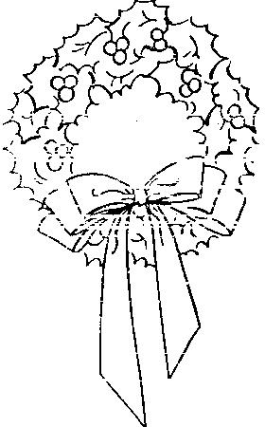LAYER BOW: For this bow, ribbon must be alike on both sides (moiré, grosgrain, metallic, tinsel, double-faced satin). Lay ribbon on a flat surface and fold loops back and forth on top of one another, making each one shorter than the one beneath. Tie firmly around the center and attach to the package. One and a quarter yards of ribbon will make a nice bow which has three loops on each side.

Figure 35. Layer Bow

If you wish to make this bow of ribbon having a right and wrong side, it may be done by cutting ribbon into graduated lengths and folding as shown on this wreath bow.

Fold the ends to the center and glue or stitch. Lay the longest piece on the bottom and arrange the other pieces in layers. Tie all together at center, then cover the center with a small piece of ribbon.
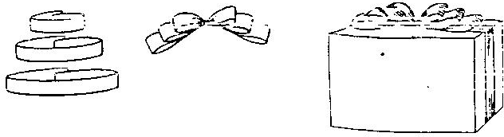
Figure 36. Layer Bow on wreath

Figure 37. Layer Bow using ribbon with different sides

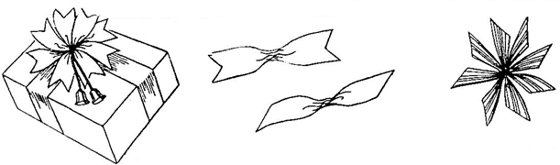
PINWHEEL BOW: From 1 inch ribbon cut four pieces, each 5-1/2 inches long. Wind thread around the center of each piece and tie tightly. Arrange the four pieces in wheel form and tie together. Cut ends diagonally, in fishtail shape or with pinking shears.

Figure 38. Pinwheel Bow

You might also cut the ribbon into short lengths. Group five to six pieces (or ten to twelve double lengths) together, and wind wire around the center. Ends may be fringed or notched. If tinsel or crinkle-tie is used, the ends may be curled. You may use odds and ends of various colors and kinds of ribbon to make effective use of leftovers.

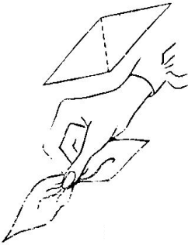
39. Poinsettia Bow
POINSETTIA BOW: For a medium-sized poinsettia bow, use a red satin ribbon with a very crisp finish, between 2 and 3 inches wide. If the ribbon is 2 inches wide, measure off with pins along the selvage at 2 inch spaces the whole length of the ribbon; if 3 inches wide, the pins should be placed 3 inches apart. Next, cut across ribbon on diagonal lines to form petals (figure 40).
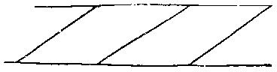
Figure 40. Poinsettia Bow, cut diagonal lines to make petals

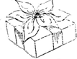
Pinch gathers along the straight grain of the ribbon as indicated by dotted lines in figure 41. Hold gathers in place by twisting tightly with thread. Arrange three petals to form a six-pointed flower. Fill in the center with a knot of yellow baby ribbon or with a yellow flower center.

Figure 41. Pinch gathers
This type of bow will find many uses when decorating at Christmas. Also because it will lie flat, it is ideal for packages to be mailed.

2. Poinsetta Bow on package

HAIR BOW: Place ribbon on S or double-S shape, keeping right side up. Cover with the open hand and gather ribbons together between the first and second fingers. Tie in the center and attach to package. Slip a bobby pin under the loop on the back of bow, then it is all ready to be worn in the hair also. This is a pretty bow for any feminine gift and is especially suitable for children’s packages.

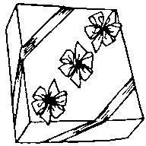

Figure 43. Hair Bow

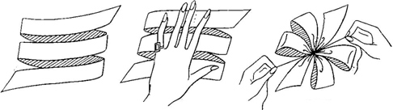
Figure 44. Hair Bow

WREATH BOW: Requires 2-1/2 yards of ribbon 4 to 5 inches wide. Cut the ribbon into the following lengths: 16 inches, 20 inches, and 24 inches. The 30 inch piece remaining is used for ends.
Fold ends of each piece to the center, overlap, and hold in place with two or three stitches. Arrange loops in layers and pinch all centers together. Tie securely with narrow ribbon or wire. Tie the 30 inch piece around the center, knotting it in back , and allow ends to fall as steamers. You can also use only one or two loops if preferred.
The glamour bow made with only two or four loops, may be used as a wreath bow by the addition of long streamer ends.
PUSSY CAT BOW: To make this bow, cross ends over as shown. Wind the center with thread or wire. If desired, center may be covered with narrow baby ribbon of matching or contrasting color and ornament tied in.
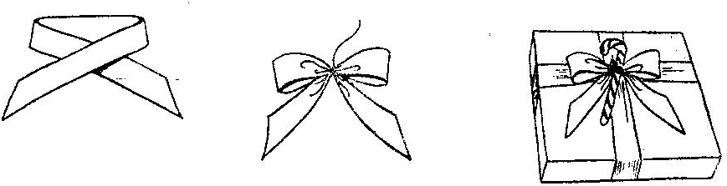
Figure 45. Pussy Cat Bow

FIGURE-8 BOW: Work ribbon back and forth in loops in the form of a figure 8. The bow shown is made with a silver tinsel ribbon which has a firm body. You may find it easier to make the bow in reverse position. Turn the bow upside down and make the figure 8 small to start with, making each one successfully larger.
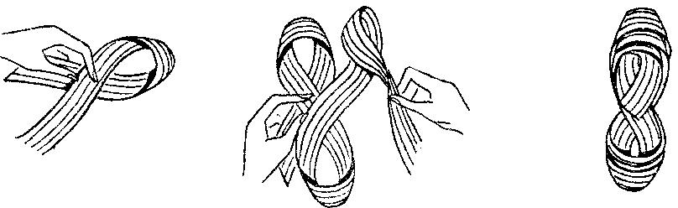
Figure 46. Figure 8 Bow

PIN ON BOW: Another type of tied bow is quickly made as follows:
Use 24 inches of ribbon and make a loop 3 inches long about 3 or 4 inches from one end. Pinch gathers and hold between thumb and finger of right hand. Pick up longer end near this point

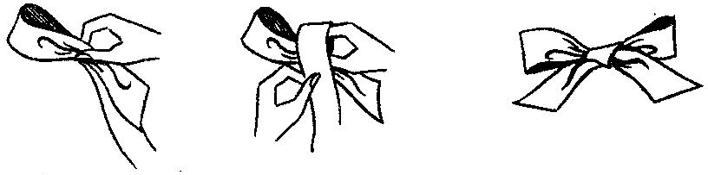
and bring it around under the finger of right hand and up over the fingernail. Then down under the center and push with left thumb through a space between right hand fingernail and the ribbon that covers it. Catch the loop thus formed with the right thumb and finger as you let go of the first loop. Pull both loops to tighten knot.
Figure 47. Pin On Bow

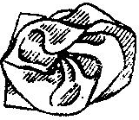RUFFLE BOW – Ruffle one edge of a 27 inch length of ribbon 2 or 3 inches wide and shape ruffle into a rose. This can be used instead of a bow.

Figure 48. Ruffle Bow

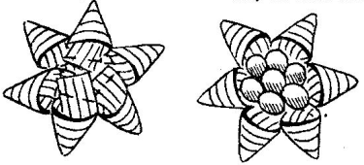
STAR TRIM – Use 1-1/2 inch width ribbon. Cut 4 inch pieces and fold in funnel shape by lapping ends to form petals. Arrange petals to form a star and stitch ends together. This is novel on packages and also makes pretty place cards at a party table. It may be filled with candy or ornaments.

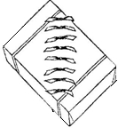
Figure 49. Star Trim

KNOTTED TRIM – Tie a knot in the center of short lengths of ribbon and pin or tape to package. This is a good way to use up odds and ends.
Figure 50. Knotted Trim

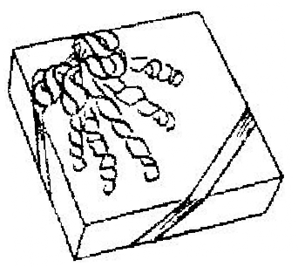CURL TRIM – Tinsel or paper-type ribbon may be curled by drawing it over the back of a knife blade. The more metallic thread there is in the ribbon, the greater the curl. Gold or silver metallic ribbon curls very tightly, while gauzy tinsel makes soft, fluffy curls. Crinkle-tie and ribbonette also curl easily.
Figure 51. Curl Trim

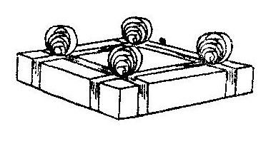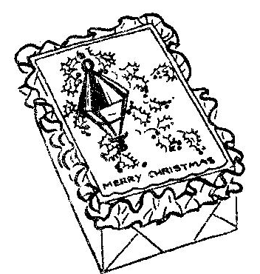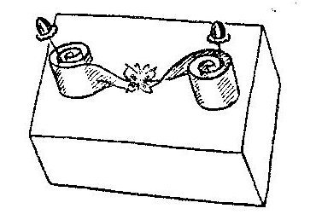ADDING DECORATIVE TRIMMINGS – Many beautiful and unusual packages may be created by combining bows with other trimmings and by the use of novel arrangements.

Recycling

In the 4-H Recycling project, you’ll learn to redefine waste by finding alternative uses for items. Recycling projects can be thought of as either OLD RECYCLING or MODERN DAY RECYCLING. Examples might include:
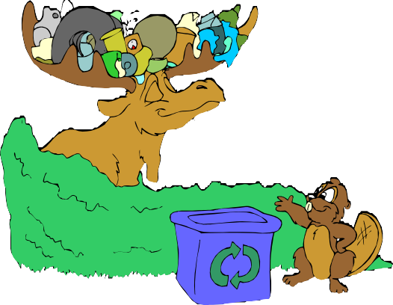
- Quilts from old clothing
- Rag rugs
- Feed sack dish towels
- Clothing out of curtains
- Curtains out of old sheets
- Milk crate shelving
- Metal art
- Barn siding picture frames
- 2-liter bottle bird feeders
- Candle holders from jars, etc.
- Wind chimes from silverware, etc.

Recycling means the reuse of materials that we have thrown away. We can recycle glass, aluminum, tin, paper, plastics and many other materials. Recycling can mean shredding old cans and cars and melting the pieces to make new metal for new cans and new cars. It can also mean crushing bottles into tiny glass bits and melting these bits to make new glass.

There are two main reasons for recycling:

- America is running low on raw materials to make new products. By using the same materials over and over again, we save our natural resources.

- Recycling helps us eliminate some of our growing piles of trash. When we throw used bottles and cans away, they become trash. Since there are more people in America today, there is also much more trash. Getting rid of that trash is a big problem. By recycling, we reuse our trash, which solves part of the problem.

RECYCLING

Recycling is frequently in the news. We are told that it is the responsible thing to do, but why?

Recycling conserves natural resources, saves energy and reduces the amount of trash going to landfills. Conserving our natural resources doesn’t mean not using them, it means using the wisely and sparingly. Recycling involves collecting reusable materials that have been thrown away, processing and distributing them for reuse. In most cases it takes less energy to prepare materials for reuse than to produce new items. Natural resources, such as trees, water, metal ores and oil are conserved through recycling.
Materials from these natural resources are recycled and used again. Almost everything can be recycled in some way. Major groupings include paper, aluminum, glass, organic materials and plastics.

THE CAN MAN

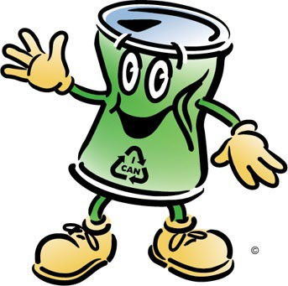
Hi! Let me introduce myself. I am an aluminum can. My name is Canbe Recycled, and I’m here to tell you what happens when I meet the Can Man.

If you want to change the way you look, what do you do? Do you change clothes? Do you change makeup? When you want to buy new clothes, where do you go? To a store or the mall?
When we beverage cans want to change our appearance, we do it a
little differently—and we depend on people like you to help us. Let me explain by telling you about the first time I met the Can Man.

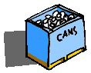It was a warm day, and I was resting in the grass after someone had finished drinking my soda pop and tossed me there. I was getting hot and afraid someone might kick me or throw me in a trash can never to be seen again.

Suddenly my thoughts were interrupted by the voice of a man saying, “What have we here? A throw-away can? You can’t lie in my yard!” Then Pete Neat picked me up and took me to his garage where he had a big trash bag sitting in a box. I was plenty scared, I tell you!

“Don’t be afraid, little can,” he said, “I’ll take you to the Can Man and get you some new clothes. We’ll just recycle you. Won’t that be nice?” Then he put me into the bag with a lot of other cans like myself. I didn’t know what recycle meant, but I liked the idea of new clothes.

The next day, Mr. Neat took all of us to what he called a recycling center where we met the Can Man. All of us were weighed, and Mr. Neat got some money for taking us there. “Goodbye, cans,” he said, “I hope you like your new clothes.” Away he went.

After he left, we were placed on a big moving belt and we passed under a magnet. All of us aluminum cans moved right over the top, but a few steel cans that were there by mistake were attracted by the magnet and were dropped away from us. At the end of the ride, we all went into a shredder where we were cut up into little pieces so we would take up less space. I felt a little funny, but it didn’t hurt a bit.

Next we went into something called a smelter where we were melted into pure aluminum. Do you know that this process saves 95% of the energy needed to make new aluminum from bauxite ore? And the reused aluminum is just as good as new metal!

Once we were liquid metal, we got our new clothes, that is, we were formed into new products. I became a can again, but some of my friends became aluminum foil, and some became baking pans and TV dinner trays.

Tomorrow I will go to the beverage company to be filled and taken to the store for you to buy, but today I wanted to explain to you about the Can Man, and how you can help all of us aluminum products get new clothes. That’s what recycling means—it means to save natural resources by giving them new clothes and using them again. When we throw away, we waste.

All aluminum is recyclable. It takes only 24 cans to make a pound; if several of people work together, you could collect lots of cans and other things made of aluminum.

I guess that’s all I wanted to tell you today—except that we cans, just like you, really love to get new clothes.

When you see us lying around empty, please recycle us so we can have new clothes to wear. Otherwise, we get buried in landfills or we become ugly litter in yards and streets.

We’re counting on you to help clean up the environment, to save landfill space and to save natural resources all at the same time by recycling. So pick me up the next time you see me.

UNDERSTANDING RECYCLING

Activity: For questions 1-5, put the letter of the correct answer in the blank to the left of each question. There is one best answer for each question. Then write out answers to questions 6-7.

1. The Can Man represents:
(a) a recyclable can; (b) the person who saves cans; (c) the person who recycles cans to make them new again; (d) the person who changes clothes.

2. Canbe Recycled is:
(a) the narrator of the story; (b) an aluminum can; (c) a recycling machine;
(d) both a and b.

3. As Canbe Recycled was placed with other cans, they moved up a belt to be separated from steel cans by a:
(a) magnet; (b) shredder; (c) water; (d) both b and c.

4. When Canbe Recycled talks about getting new clothes, this is a metaphor for:
(a) shredding cans; (b) the recycling process; (c) saving energy; (d) looking funny.

5. When you recycle cans, you:
(a) save landfill space; (b) are littering; (c) save scarce resources; (d) “both a and c.

- What is a “narrator” as mentioned in question 2 above?

- The “metaphor” in this story could be stated as follows: Recycling is compared to:

- What is another metaphor for recycling?

CAN IDENTIFICATION
Did You Know?
- A used aluminum can is recycled and back on the grocery shelf as a new can in as little as 60 days!
- More aluminum goes into beverage cans than any other product and we use over 80,000,000,000 aluminum cans every year!
- Used aluminum beverage cans are the most recycled item in the U.S.A.
- There is no limit to the number of times aluminum can be recycled.
(recycling-revolution.com/recycling-facts.html)

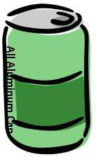
Here is a quick guide for finding out what material your cans are made from: ALUMINUM CANS:
- Are NOT attracted by magnets.
- Almost all of these cans say “All Aluminum Can” on the side.
- No seam.
- If the bottom of the can is round and shiny, then it is aluminum.
- Shiny, silver, smooth.
- Lightweight.
- Aluminum cans, if you look closely, are finely brushed on the bottom.
- Printing is usually directly on the can as opposed to a paper label.

BIMETAL CANS:

- Are attracted by magnets.
- Bottom has a rim.
- If you look closely, the bottom is not finely brushed. It is usually spray painted.
- It may or may not have a seam.

TINNED STEEL CANS:

- 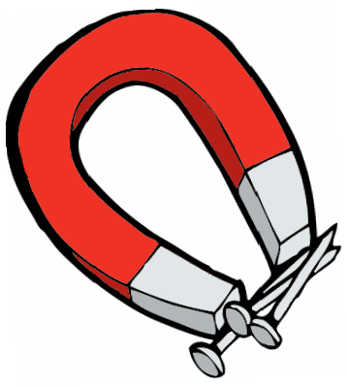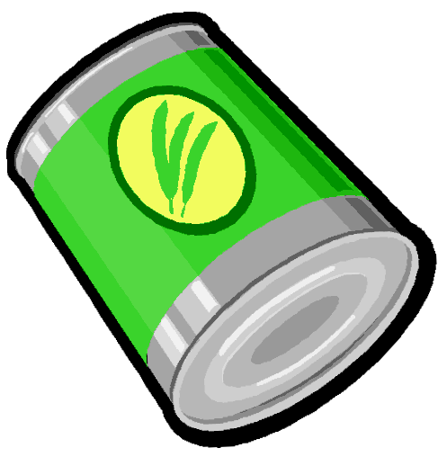Are attracted by magnets.
- Has a seam.
- Is heavier weight than aluminum.
- Usually has rings or ribbing on the can.
- Normally has a paper label.

EXTRUDED STEEL CANS:

- Are attracted by magnets. (This is the only reliable test)
- Has no seam.
- Is lightweight.
- Has no bottom rim.

What’s In Your Garbage?

Mostly recyclable materials! Most Americans produce 5 pounds of trash per day. Of those 5 pounds, 87% is recyclable.

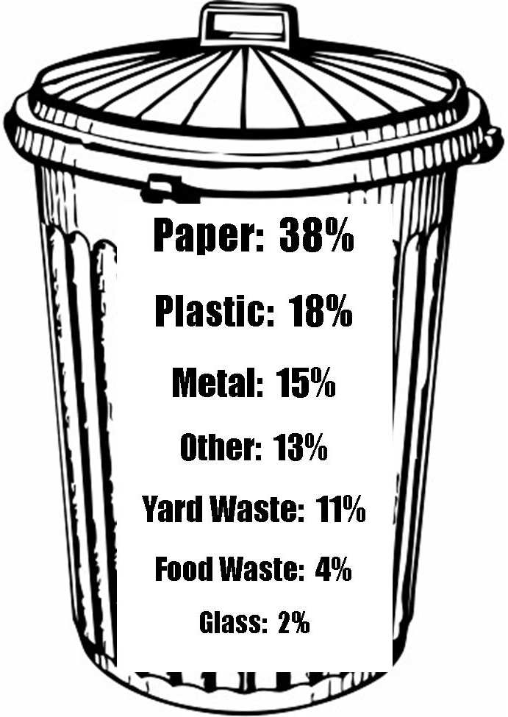
Here is the average trash can:

Did You Know?
- Every ton of plastic bottles recycled saves about 3.8 barrels of oil!
- Americans use 2,500,000 plastic bottles every hour!
- Recycling plastic saves twice as much energy as burning it in an incinerator.
(recycling-revolution.com/recycling-facts.html)

Home Garbage Survey

Activity: In this activity you will learn to recognize which items in your garbage are recyclable or reusable, then you can learn to reduce the amount of waste that is thrown away. Recycling is an easy habit to form. By learning what materials can be recycled in your community and changing your buying habits, you and your family can help reduce waste in Indiana.

Here’s what to do:
- Track your family’s waste for one week. Include trash from the bedroom, kitchen and family/living room. If you already recycle, keep track of the items in your recycle bin as well.
- Determine which category each piece of trash would be considered: paper, glass, newspaper, aluminum, plastic, etc.)
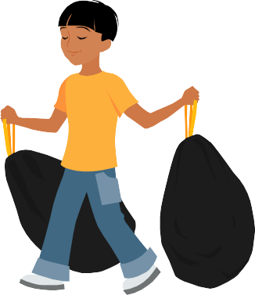
- Count the pieces of garbage or recyclables and record the total number of each item on the table on the next page. After you’ve counted the garbage, be sure to dispose of it properly; try to recycle what you can!
- At the end of the week, total each column.
- How much of your trash was recyclable?
Did You Know?
The Mobro 4000 was a barge made infamous in 1987 for hauling the same load of trash from New York to Belize and back until a way was found to dispose of the garbage.

HOME GARBAGE SURVEY: SURVEY YOUR TRASH

Day | Aluminum | Paper | Newspaper | Glass | Tin  Cans | Plastic | Magazines | # Pieces  Recyclable
Sunday
Monday
Tuesday
Wednesday
Thursday
Friday
Saturday
Totals

Now that you know what is in your trash can, you can be a part of the solution!

LANDFILLS

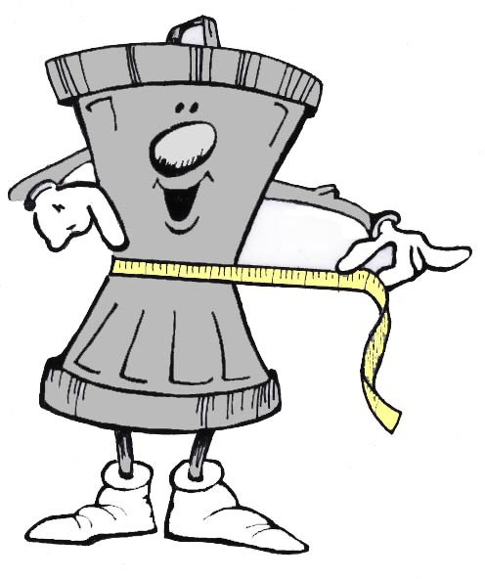
Hoosiers produce about 13.5 million tons of garbage each year and bury more than 60% of it in landfills (2004 data, biocycle.com report). As we produce more waste, we run out of places to bury it. There are only about 35 municipal solid waste landfills left in Indiana, with over two million tons of our landfill trash coming from other states each year, causing current landfills to steadily reach capacity (IDEM Data). New facilities are being built, but they are often difficult to establish due to public opposition. There is also one waste-to-energy plant in Indiana that turns garbage into electricity!

Many feel that recycling is a hassle and not worth the time. Some think that it’s easier to throw garbage away and let it be hauled to a landfill. But many of the things we throw away can be recycled, and recycling is one way to reduce our dependency on landfills. If each of us recycled household generated newspaper, glass, aluminum and plastics, we could reduce the amount of material going into landfills significantly!

Recycling requires only a small amount of space and a few minutes per day.
Did You Know? During WWI, recycling straps from corsets created enough metal to build two battle ships!
Reserve some space under the sink or in the corner of the garage as a home recycling center. Use a cardboard box or grocery bag for cans, another for glass, one for plastics and one for newspapers. Old habits can be hard to break. At first you may have to remind yourself not to throw away recyclables, but after a using your recycling containers a few times, instead of the garbage can, you will be on your way to creating new recycling-conscious habits.

BUILDING A LANDFILL

There is more to a landfill than just dumping the garbage on day after day. Landfill operators have many rules and regulations to follow to ensure that our water and air stay safe from pollution.

Activity: In this activity you will learn the important parts and functions of a modern landfill, while making an edible product.

Ingredient | Represents
1 Chocolate Pie Crust | Clay Liner
2 Ounces Red Licorice Whips or Laces | Leachate Collection Tubes
1 Cup Graham Cracker Crumbs | Sand and Gravel Liners
1 Cup Prepared Instant Vanilla Pudding | Garbage
½ Cup Chocolate Chips | Garbage
½ Cup Peanuts | Garbage
½ Cup Raisins | Garbage
1 Cup Prepared Instant Chocolate Pudding | Soil
Coconut (Dyed with green food coloring) | Grass

Directions for building a safe and tasty landfill:
- Start with the chocolate pie crust. It represents the clay liner at the bottom of the landfill. The clay is used to keep leaching liquids from percolating down rapidly into the water table.
- Lay the red licorice whips across the bottom and sides of the pie crust. The licorice represents the lines or tubes that collect the leachate and carry it to a water treatment plant.
- Press graham cracker crumbs around and over the licorice “pipes.” This represents the sand and gravel layer that lest the leachate flow into the licorice “pipes.”
- Mix the raisins, chocolate chips, and peanuts into the vanilla pudding and spread a thin layer of this “garbage” mixture into the bottom of the pie.
- Spread a thin layer of chocolate pudding, over the vanilla “garbage” layer. Every day, landfill operators cover the garbage with a layer of soil.
- Spread another layer of vanilla garbage, topped with chocolate soil. Finish layering with the chocolate layer.
- Top the whole pie with the coconut “grass” to represent a landfill that has been revegetated.
- Now your safe and tasty landfill is ready to eat!

Once a landfill reaches it’s capacity, they are revegetated with grass. Often the land is reclaimed and used for parks, golf courses, and sports fields. Buildings can also be built on old landfills as long as proper precautions are in place for methane capture. For example, Sydney Olympic Park, the primary venue for the 2000 Summer Olympic Games, was built atop an industrial wasteland that included landfills (wikidpedia.com).

PREPARING YOUR RECYCLABLES

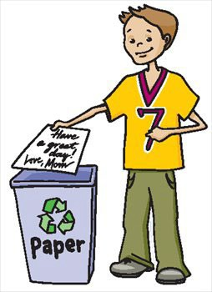
To make it easier on recycling centers, they appreciate separating recyclables before arrival. This is easily done in bags or boxes. The following is a list of accepted recyclables from the Franklin County Recycling Center and how to sort and prepare them.

Paper Products
  - Corrugated Cardboard and Paperboard (cereal boxes): Boxes should be broken down and flattened.
  - Newspaper: Must be dry and bundled. Please do not use paper or plastic bags.
  - Mixed Paper: Office, computer paper, junk mail. Keep dry.
  - Magazines: Materials including magazines, and unwanted phone books. Must be kept dry and bundled.

Plastic Bottles
  - PETE or #1 Bottles: Soft drink, soda bottles, etc. Please rinse.
  - HDPE or #2 Bottles: Milk and Juice jugs, detergent and bleach containers. Please rinse.

Metals And Aluminum
  - Aluminum: Soft drink and other beverage cans. Please rinse and separate from metal cans.
  - Steel/Tin: Food, soup, vegetables, etc. Please wash.
  - Scrap Metal: Remove gas tanks, fuels, batteries from appliances. No wire fencing.

Glass
  - Glass Bottles: All glass food and beverage bottles: clear, green brown. Please rinse.

Batteries
  - Car Batteries: Must not be cracked. Cells must be capped.
  - Rechargeable Batteries: Rechargeable batteries are accepted. Please no alkaline batteries.

Other Notes
  - Pop Tabs: Be sure to collect your pop tabs…different groups collect them and donate them to the Ronald McDonald house to be recycled. The money earned helps families of sick children stay close by while they are hospitalized. Schools, Kiwanis Clubs and Extension Homemaker Clubs are just a few of the groups that support this effort.
  - Product Labels: Schools get money for educational supplies from Campbell Soup labels (also found on many other products, check labelsforeducation.com for a complete list) as well as “Box Tops For Education” found on many cereals and other products (check boxtops4education.com for a complete list of participating products.) Save these for your local schools!

Problem Wastes accepted at the Franklin County Recycling Center include:

Refrigerants
  - Acceptable items include: Refrigerators, air conditioners, freezers, dehumidifiers, etc. ($20 fee)

Electronics
  - Computers & Monitors: limit of two
  - Stereos, DVD Players, Phones, VCR’s, Printers, Scanners
  - 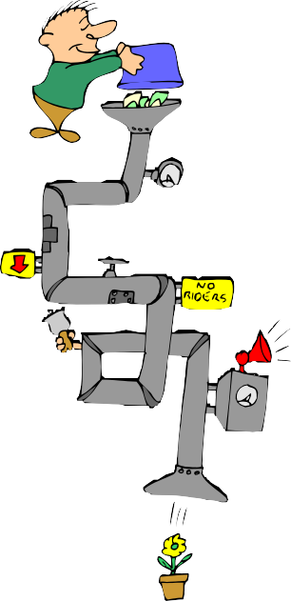Televisions

Oil, Filters, Antifreeze
  - Limit: 5 gallons of motor oil

Paints
  - Limit: 10 gallons of oil based. No latex paint.

Used Tires
  - Automobile/Pick up Trucks: Limit 10 ($3 each on or off rim)

Household Hazardous Waste is accepted only at the Southeastern Indiana Solid Waste District in Madison, IN.
  - Containers must be labeled.
  - Must call ahead for a drop off appointment.
  - Acceptable Items Include: Cleaning supplies, pesticides, fertilizers, acids and bases, oxidizers, flammable liquids, mercury and fluorescent lamps (limit of 8).

Items NOT accepted at the Franklin County Recycling Center include:
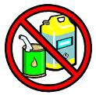
- Materials from business or industry
- Boxes that are not broken down
- Propane or fuel tanks
- Household hazardous waste
- Window or plate glass
- Paper that is wet or not bundled

REUSE CENTER

Franklin County also has a “Reuse Center” at the recycling center. This provides an alternative way for unwanted but useable items to be recycled. All items left at the reuse center are available to any Franklin County resident at no cost. The center does not accept upholstered items. Items that are accepted include:

- Appliances
- Tables
- Electronics
- Books
- Shelving
- Screens
- Toys
- Clothing
  - Windows
  - Tools
  - Fitness Equipment
  - Knick Knacks, etc.

LOCAL PLACES TO RECYCLE
This symbol indicates that the item is recyclable.
This symbol indicates that the product or packaging is made from recycled materials.

Franklin County residents can recycle year round at the Franklin County Recycling & Reuse Center, located on US 52, just west of Brookville, phone 765-647-6710. Hours are Monday–Saturday, 8:30 AM–3:00 PM.

Southeastern Indiana Solid Waste District (SISWD) in Madison, IN: Get more information by calling 800-99-SISWD or visiting siswd.com

TRUE RECYCLING

If you want to be a “true recycler” it is also important to buy goods that are made from and packaged in recycled materials when possible.

Here are some common recycling symbols to look for:
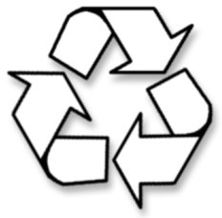

DID YOU KNOW?
By recycling 1 ton of paper you save:
- 17 trees
- 463 gallons of oil
- 3.06 cubic yards of landfill space
- 6953 gallons of water
- 587 pounds of air pollution
- 4077 Kilowatt hours of energy

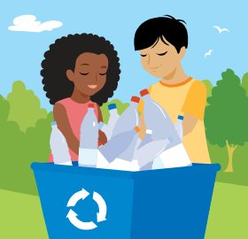
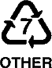IDENTIFYING PLASTICS

There are about 50 different kinds of plastics used to make products that we use every day, such as telephones, plumbing and packaging. The main types of plastic that consumers deal with are PED (#1) and HDPE (#2). In many cases it is difficult to tell one kind of plastic from another, so the plastics industry introduced a coding system. Look on the bottom of each plastic container you buy for an imprinted recycling symbol with a number from 1-7 in the middle. Each number from 1-6 represents a different plastic; a 7 means it cannot be recycled.

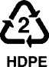Activity: Find plastic products around your house. Look for the recycling symbol and find the number in the middle. List those products next to the appropriate number below. How many different kinds of plastics can you find?

Poly(ethylene terephthalate)
High-density Polyethylene
Poly(vinyl cloride)
Low-density Polyethylene
Polypropylene
Polystyrene
Other

PACKAGING PRE-CYCLING

When you are shopping, think of packaging as part of the product, you get what you pay for. If the packaging is designed to be thrown away immediately, all you’re getting for your money is cleverly-designed garbage.
DID YOU KNOW?
Nearly $1 out of every $10 spent for food and beverages in
the United States pays for packaging?

Packaging makes up about 1/3 of what Americans throw away. Pre-cycling is a very important part of any recycling effort.

Activity: The next time you to the grocery story, take a digital camera along. Walk all through the store, select 10 items to take pictures of, then list the items below and complete the chart by placing an “x” in each box that applies to each item.

Item Descriptions:
1.
2.
3.
4.
5.

6.
7.
8.
9.
10.

Item # | 1 | 2 | 3 | 4 | 5 | 6 | 7 | 8 | 9 | 10
Is the packaging colorful?
Is the package wrapped in clear plastic?
Is the product boxed?
How many layers of packaging does the product appear to have?
Does the product have either type of recycling symbol?

Why do we need packaging on the products we buy?

List 4 examples of common packaging materials:
1.
2.

3.
4.

TONS OF TRASH

Activity: If the average person throws away about 5 pounds of trash every day…figure this….

- How much trash do you throw away in one week?  - How much trash do you throw away in one year?  - How many people are in your family | (5 x 7) =  (A x 52)=  = | A.  B.  C.
4. How much trash does your family throw away in one year? | (B x C) = | D.
5. If you threw away one less pound of trash each day, how much trash would you throw away in one year? | (B-365) = | E.
6. If each person in your family threw away one less pound of trash each day, how much trash would your family throw away in one year? | (C x E) = | F.
7. What difference does 1 pound make in your family? | (D - E) = | G.

There are about 6 million people living in Indiana and over 300 million people in the United States. Just think if each person reduced the amount of trash they throw away each day by 1 pound, what a difference that would make, in a day, a week, or a year!

HAZARDOUS WASTE

A hazardous waste is waste that poses substantial or potential threats to public health or the environment and generally exhibits one or more of these characteristics:

- Ignitable: Ignitable wastes can create fires under certain conditions, are spontaneously combustible, or have a flash point less than 60 °C (140 °F). Examples include waste oils and used solvents.
- Corrosive: Corrosive wastes are acids or bases (pH less than or equal to 2, or greater than or equal to 12.5) that are capable of corroding metal containers, such as storage tanks, drums, and barrels. Battery acid is an example.
- Reactive: Reactive wastes are unstable under "normal" conditions. They can cause explosions, toxic fumes, gases, or vapors when heated, compressed, or mixed with water. Examples include lithium-sulfur batteries and explosives.
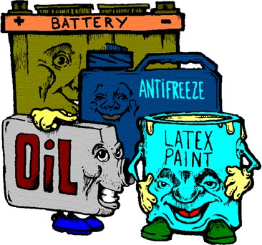
- Toxic: Toxic wastes are those containing concentrations of certain substances in excess of regulatory thresholds which are expected to cause injury or illness to human health or the environment.

These wastes may be found in different physical states such as gaseous, liquids, or solids. Furthermore, a hazardous waste is a special type of waste because it cannot be disposed of by common means like other by- products of our everyday lives. Depending on the physical state of the waste, treatment and solidification processes might be available. In other
cases, however, there is not much that can be done to prevent harm. (wikipedia.com)

COMPOSTING

According to epa.gov, yard trimmings and food residuals together make up 23 % of the
U.S. waste stream. The best way to help this number decrease is by composting.

Composting is how nature recycles. It is the breakdown of organic materials, such as food or yard waste, into soil. Bacteria, yeasts and fungi are the organisms responsible for the decomposition of these materials. Compost is great for your garden or yard, and it’s easy to do. There are many different composting bins on the market, or you could build one yourself out of scrap materials (another great way to recycle.)

- Animal manure
- Cardboard rolls
- Clean paper

What to Compost - The IN List
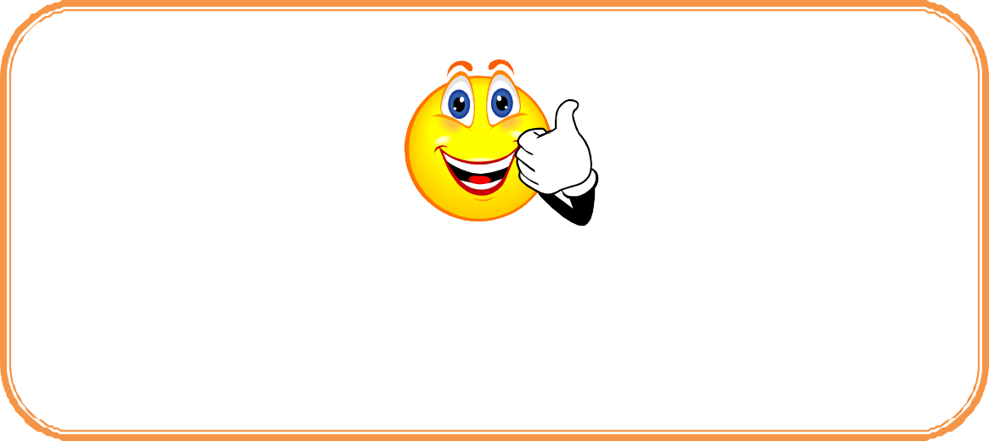
  - Hay and straw
  - Houseplants
  - Leaves

- Coffee grounds and filters
- Cotton rags
- Dryer and vacuum cleaner lint
- Eggshells
- Fireplace ashes
- Fruits and vegetables
- Grass clippings
- Hair and fur
- Nut shells
- Sawdust
- Shredded newspaper
- Tea bags
- Wood chips
- Wool rags
- Yard trimmings

What Not to Compost - The OUT List Leave Out/Reason Why
- Black walnut tree leaves or twigs
Releases substances that might be harmful to plants
- Coal or charcoal ash
Might contain substances harmful to plants
- Dairy products (e.g., butter, egg yolks, milk, sour cream, yogurt)
Create odor problems and attract pests such as rodents and flies
- Diseased or insect-ridden plants
Diseases or insects might survive and be transferred back to other plants
- Fats, grease, lard, or oils
Create odor problems and attract pests such as rodents and flies
- Meat or fish bones and scraps
Create odor problems and attract pests such as rodents and flies
- Pet wastes (e.g., dog or cat feces, soiled cat litter)
Might contain parasites, bacteria, germs, pathogens, and viruses harmful to humans
- Yard trimmings treated with chemical pesticides Might kill beneficial composting organisms

COMPOST COLUMN

The composting process is depends on many different factors, such as the amount of moisture and air, temperature, light, source of bacteria and fungi, and the nature of the rotting material. For example, under ordinary circumstances, a soft banana peel will rot much faster than a piece of wood. However, old banana peels kept in a dark freezer will decompose much slower than a piece of wood in a warm, moist environment.

The presence or absence of air (oxygen) is one of the most important factors in composting. Modern landfills seal garbage deep in the earth, excluding air and moisture and preventing microorganisms from working. Composting allows air and moisture to speed up the natural biodegradation process.
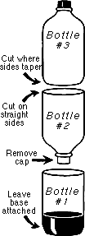
Activity: Make a composting column to see the biodegradation process first hand! Materials:
- Three 2-liter plastic pop bottles, rinsed with labels removed.
- Permanent Marker
- Craft Knife
- Scissors
- Clear Tape and Electrical or Duct Tape
- Netting, nylon or other mesh fabric
- Rubber Band
- Two Cups Garden Soil plus: Organic material for composting, such as food scraps, leaves, newspapers and grass clippings
- Thermometer
- Measuring Cup
- Microscope

Directions:
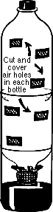
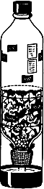
- Remove the labels from all three bottles. Cut them and assemble as illustrated.
- Cut out 3-4 windows (air holes) in the top 2 bottles, the approximate diameter of your thumb. Cover windows with nylon stocking or mesh material and tape to hold firmly.
- Place nylon socking over middle bottle opening and secure with a rubber band.
- Place soil in the middle bottle. Bury vegetable or fruit scraps, grass, newspaper, etc. in the soil. (Note: the smaller the pieces, the faster they will decompose.)
- Add just enough water to moisten the soil and allow a few drops to drain into the bottom of the column.
- Replace the top bottle making sure the windows remain uncovered to allow air flow in and out of the compost column.
- During monitoring, keep soil moist by recycling the compost water from the bottom to the top bottle.
- Occasionally turn the soil with a spoon.
- Record your observations on the chart on the next page.

Compost Column Observation Chart
Date | Temperature | Odor (if any) | Amount of water in bottom | Evidence of Organisms | Observations

Experiments: If you want to do more than just observe changes in your compost column, here are some experiments to try.
- Weigh the column daily and graph the change in weight as the compost develops.
- Monitor and graph the amount of water used by the column daily. Do this by subtracting the volume of water collected at the bottom from the volume of water you've added to the top.
- Measure the temperature of the column daily and graph it.
- Take notes about the appearance of the trash in the column daily. How long does it take to decompose?
- Collect the drainage water and look at it under a microscope to see the microscopic organisms that live in the compost.
- Make identical columns with different amounts and types of garbage or soil and record the differences. See what decomposes faster.

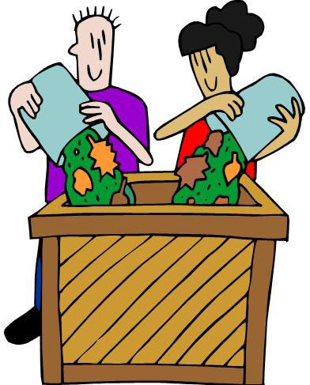

REMEMBER THE 5 R’S

Reduce the amount of waste we produce.
  - Buy only what you need
  - Buy economy size or bulk packaging
  - Avoid disposable products.
  - Bring your own bags to the grocery store.
  - Choose boxes with gray interior (recycled paperboard).
  - Look for recycle symbol or the words “made from recycled materials” when shopping
  - Choose products packaged in recyclable materials
  - When possible, choose product packaging that is easiest to recycle (such as glass instead of plastic)

Reuse as much as possible.
  - Use products that are made to be used many times, such as cloth diapers, cloth napkins, sponges, towels and rags, dishes, rechargeable batteries, etc.
  - Use the blank back sides of paper for scratch paper
  - Purchase used goods at second hand stores, garage sales, auctions, antique shops and flea markets.

Reject over packaging and environmentally hazardous products.
  - Avoid over-packaged goods.
  - Avoid non-recyclable packaging and containers.
  - Choose non-aerosol spray containers.
  - Avoid disposable products.

Repair broken items instead of replacing them.
  - Mend clothes
  - Repair broken appliances.
  - Make repairs promptly, before damage progresses.
  - Service vehicles regularly to maintain good condition.

Recycle the products that are recyclable.
  - Identify the recycling centers in your community.
  - Identify the garages and service stations that will accept and recycle used motor oil.
  - Identify local businesses (doctors, dentists, nursing homes, daycares, etc.) that accept used magazines.
  - Donate used clothing, furniture, etc.
  - Have a neighborhood or family garage sale annually to recycle unwanted items.
  - Trade in old appliances and vehicles when possible.
  - Be familiar with recyclable materials: glass, aluminum, newspaper, etc.

SOLID WASTE CHECKLIST

Activity: How many of these things do you and your family do? Place an “x” in the appropriate column for those practices you and your family do on a regular basis.
There is room to add some of your own.

 | I  do now | I do some- times | I  might do | I don’t want to do | I  can’t do
1. Use paper plates and cups instead of plastic.
2. Use reusable plates and cups instead of disposable.
3. Buy glass and aluminum containers instead of plastic.
4. Write on both sides of paper before recycling it.
5. Buy paper towels, napkins, and toilet paper made from 100% recycled fibers.
6. Give used magazines to nursing homes and hospitals.
7. Say, “Thanks, I don’t need a bag.” When buying small items.
8. Purchase items in bulk to cut down on packaging.
9. Buy eggs in paper rather than foam cartons.
10. Buy juice in concentrate rather than big plastic containers.
11. Use canvas bags at the grocery store.
12. Leave grass clippings on the lawn to reduce yard waste.
13. Make a compost pile in your yard and turn yard wastes into fertilizer.
14. Save newspapers for recycling.
15. Use plastic bags over and over.
16. Use a lunch box or reusable lunch bag to school.
17. Plant trees.
18. Fix or recycle things instead of throwing them out.
19. Donate outgrown clothes to others.
20. Share or trade books and games with your friends.
21. Use old panty hose to tie up tomato, pepper and other plants.
22. Recycle used motor oil by taking it to a garage or
auto parts store.
23. Turn out lights when leaving a room.
24.
25.
26.
27.
28.
29.
30.

Each of us can do our part in helping to reduce the amount of solid waste going into our landfills. After completing the checklist what habits did you and your family change?

